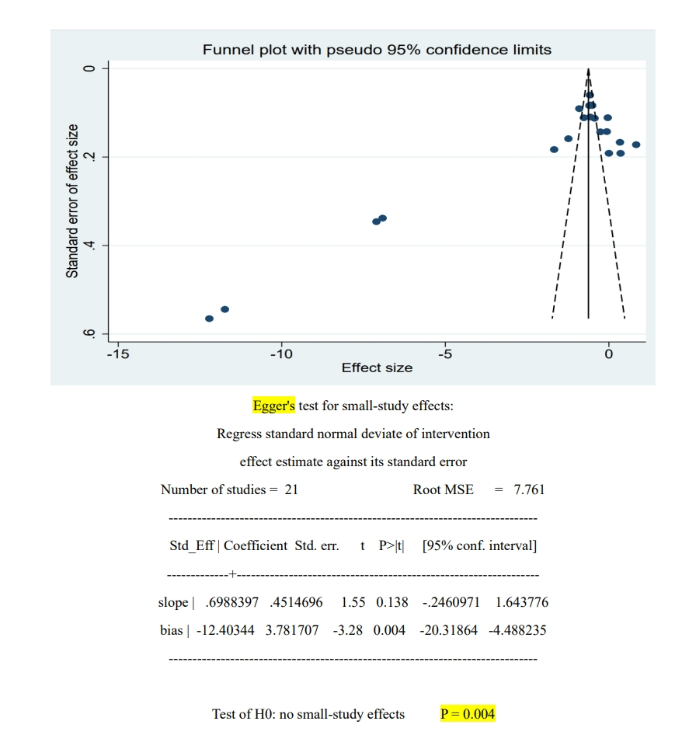
Figure 1: publication bias results(Funnel Plot and Egger's Test: Evaluation of Intervention Impact on Dental Plaque

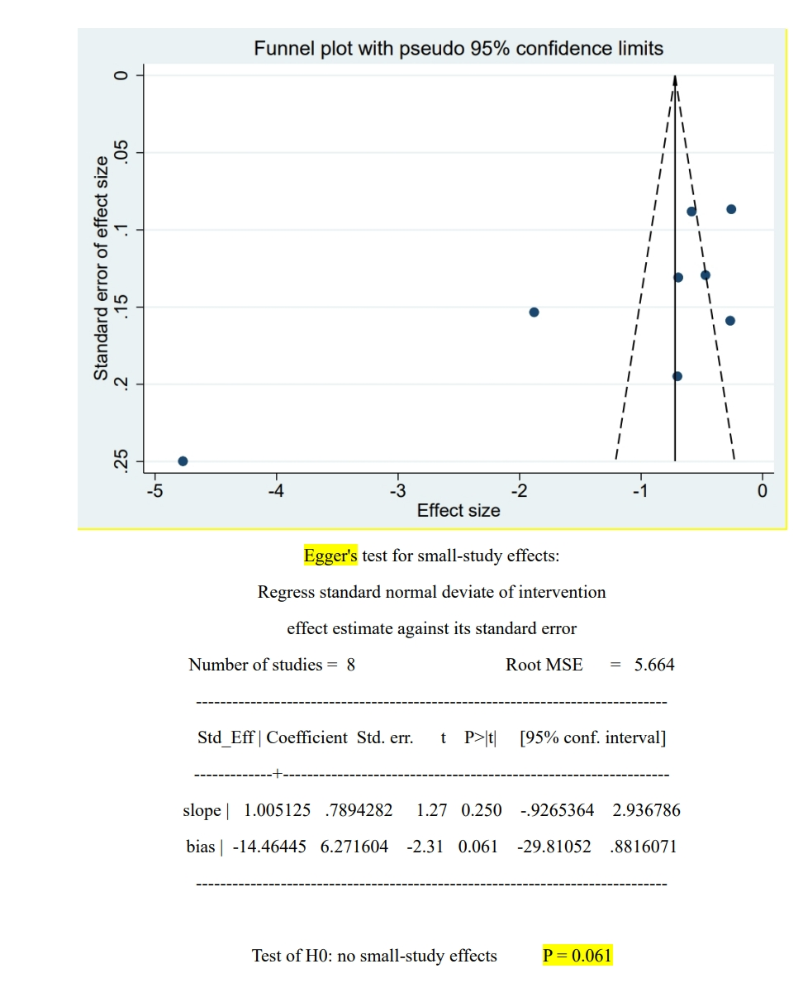
Figure 2: publication bias results(Funnel Plot and Egger's Test: Evaluation of Intervention Impact on Periodontal Health

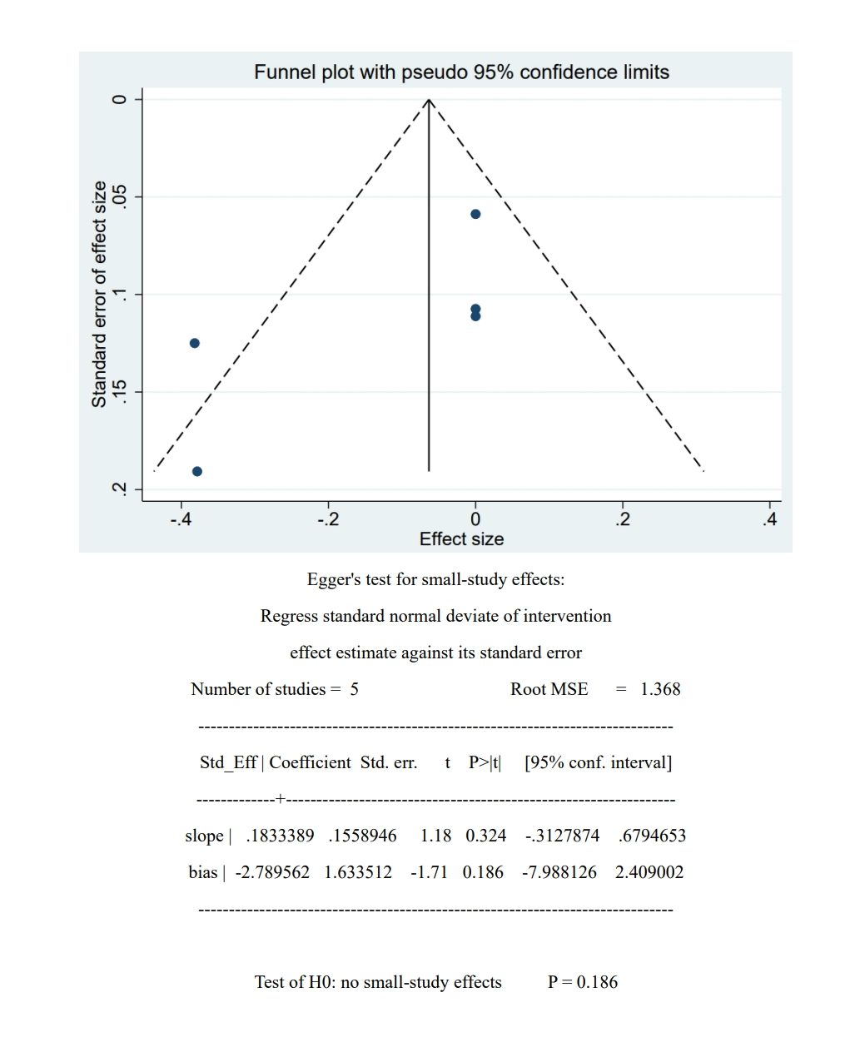
Figure 3: publication bias results(Funnel Plot and Egger's Test: Evaluation of Intervention Impact on DMFT
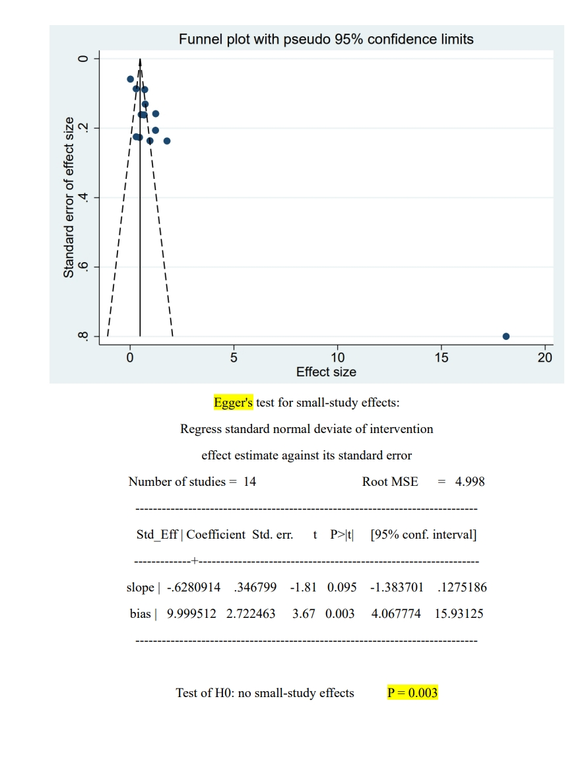
Figure 4: publication bias results(Funnel Plot and Egger's Test: Evaluation of Intervention Impact on Self-efficacy related to oral
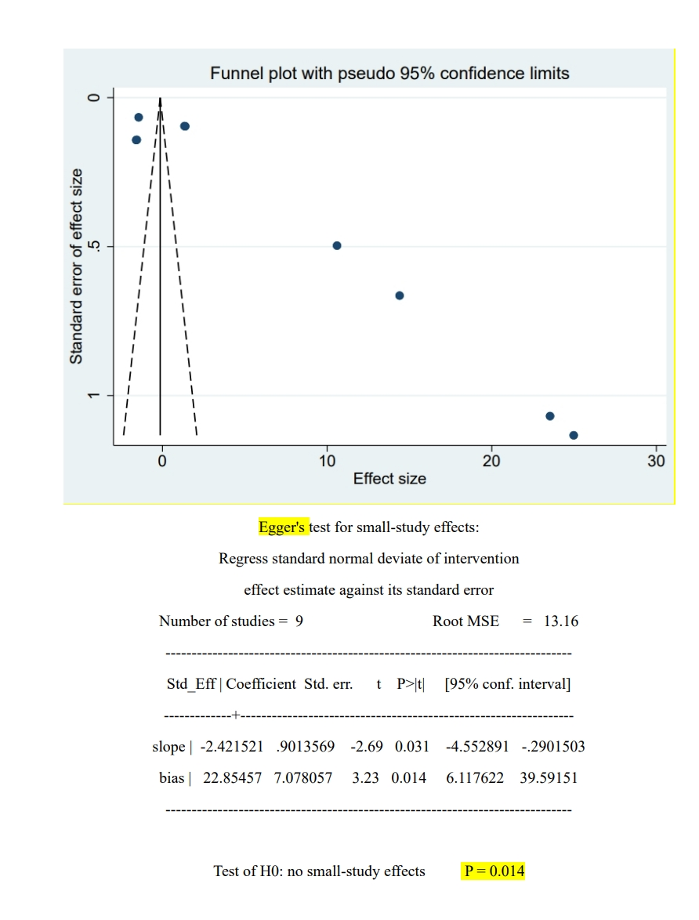
Figure 5: publication bias results(Funnel Plot and Egger's Test: Evaluation of Intervention Impact on OHRQoL

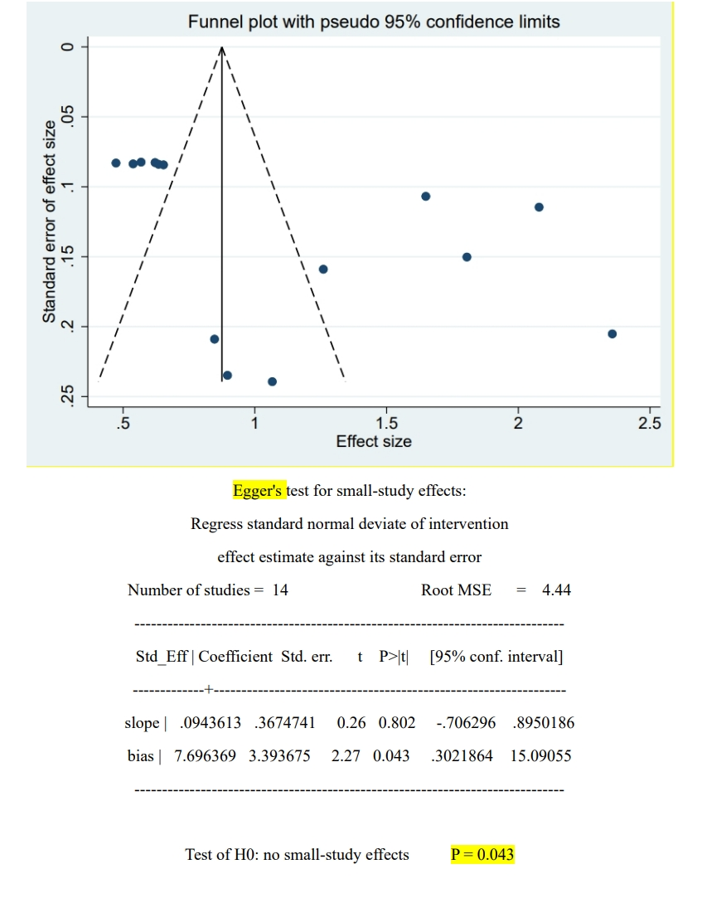
Figure 6: publication bias results(Funnel Plot and Egger's Test: Evaluation of Intervention Impact on Oral Health Knowledge
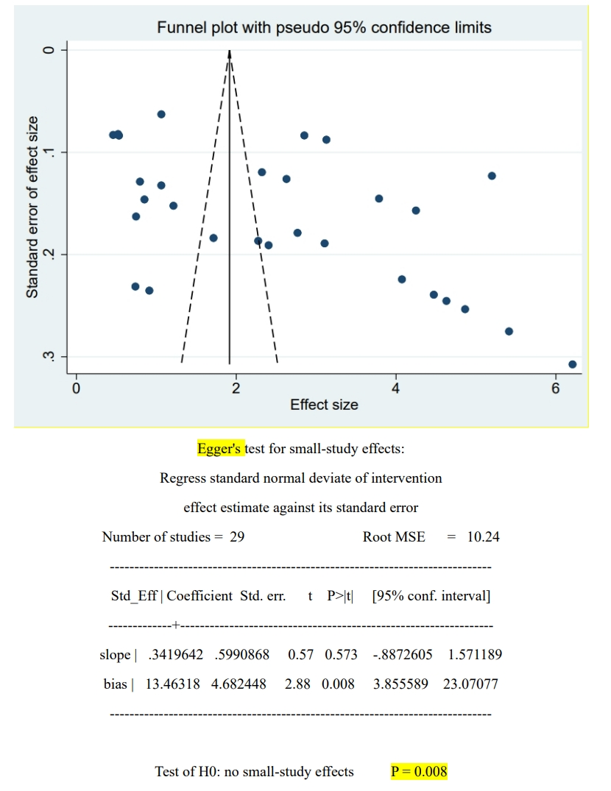
Figure 7: publication bias results(Funnel Plot and Egger's Test: Evaluation of Intervention Impact on Oral Health Behavior
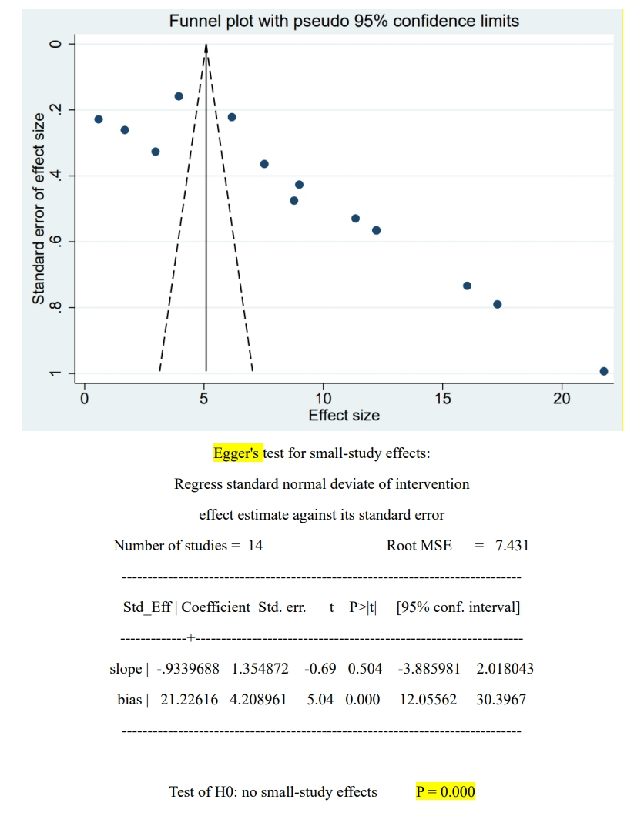
Figure 8: publication bias results(Funnel Plot and Egger's Test: Evaluation of Intervention Impact on Oral Health attitude

