Title:
Prognosis of intentional replantation for periapical periodontitis teeth: a systematic review and meta-analysis

Appendix A: Search Strategies

Ovid MEDLINE(R) and Epub Ahead of Print, In-Process, In-Data-Review & Other Non-Indexed Citations, Daily and Versions 1946 to June 03, 2024
# ▲ | Searches | Results
1 | exp Dentistry/ or exp Tooth Diseases/ or Oral Health/ or exp Tooth/ | 549513
2 | (dental or tooth* or teeth or molar* or premolar* or bicuspid* or incisor* or canine* or cuspid*).mp. | 825365
3 | Transplantation/ or Transplantation, Autologous/ or Transplants/ or Autografts/ or Transplant Donor Site/ or Replantation/ | 79234
4 | (replant* or reimplant* or reinsert* or reposition* or retransplant* or transplant* or graft* or autotransplant* or autograft*).mp. | 1120085
5 | (1 or 2) and (3 or 4) | 37265
6 | Tooth Replantation/ | 2109
7 | 5 or 6 | 37265
8 | ((intention* or intend*) adj5 (extract* or remov* or exodont*)).mp. | 1071
9 | ((intention* or intend*) adj5 (replant* or reimplant* or reinsert* or reposition* or retransplant* or transplant* or graft* or autotransplant* or autograft*)).mp. | 1256
10 | 8 or 9 | 2280
11 | 7 and 10 | 311
12 | ((intention* or intend*) adj3 (replant* or reimplant*)).mp. | 277
13 | 11 or 12 | 320
14 | (animals not humans).sh. | 5193682
15 | 13 not 14 | 305

Embase 1974 to 2024 June 03
# ▲ | Searches | Results
1 | exp dentistry/ or exp dental procedure/ or exp tooth disease/ or dental health/ or exp tooth/ | 521071
2 | (dental or tooth* or teeth or molar* or premolar* or bicuspid* or incisor* or canine* or cuspid*).mp. | 808587
3 | transplantation/ or autotransplantation/ or exp autograft/ or donor site/ or retransplantation/ | 217738
4 | (replant* or reimplant* or reinsert* or reposition* or retransplant* or transplant* or graft* or autotransplant* or autograft*).mp. | 1628405
5 | (1 or 2) and (3 or 4) | 41684
6 | tooth replantation/ | 351
7 | 5 or 6 | 41684
8 | ((intention* or intend*) adj5 (extract* or remov* or exodont*)).mp. | 1430
9 | ((intention* or intend*) adj5 (replant* or reimplant* or reinsert* or reposition* or retransplant* or transplant* or graft* or autotransplant* or autograft*)).mp. | 1804
10 | 8 or 9 | 3179
11 | 7 and 10 | 269
12 | ((intention* or intend*) adj3 (replant* or reimplant*)).mp. | 234
13 | 11 or 12 | 280
14 | (animal* not human*).sh,hw. | 4964729
15 | 13 not 14 | 266

EBM Reviews
EBM Reviews - Cochrane Database of Systematic Reviews 2005 to May 29, 2024
EBM Reviews - ACP Journal Club 1991 to May 2024
EBM Reviews - Database of Abstracts of Reviews of Effects 1st Quarter 2016
EBM Reviews - Cochrane Clinical Answers May 2024
EBM Reviews - Cochrane Central Register of Controlled Trials April 2024
EBM Reviews - Cochrane Methodology Register 3rd Quarter 2012
EBM Reviews - Health Technology Assessment 4th Quarter 2016
EBM Reviews - NHS Economic Evaluation Database 1st Quarter 2016
# ▲ | Searches | Results
1 | exp Dentistry/ or exp Tooth Diseases/ or Oral Health/ or exp Tooth/ | 30640
 | EBM Reviews - Cochrane Database of Systematic Reviews <2005 to May 29, 2024> | 0
 | EBM Reviews - ACP Journal Club <1991 to May 2024> | 0
 | EBM Reviews - Database of Abstracts of Reviews of Effects <1st Quarter 2016> | 0
 | EBM Reviews - Cochrane Clinical Answers <May 2024> | 0
 | EBM Reviews - Cochrane Central Register of Controlled Trials <April 2024> | 30405
 | EBM Reviews - Cochrane Methodology Register <3rd Quarter 2012> | 0
 | EBM Reviews - Health Technology Assessment <4th Quarter 2016> | 108
 | EBM Reviews - NHS Economic Evaluation Database <1st Quarter 2016> | 127
2 | (dental or tooth* or teeth or molar* or premolar* or bicuspid* or incisor* or canine* or cuspid*).mp. | 59275
 | EBM Reviews - Cochrane Database of Systematic Reviews <2005 to May 29, 2024> | 911
 | EBM Reviews - ACP Journal Club <1991 to May 2024> | 29
 | EBM Reviews - Database of Abstracts of Reviews of Effects <1st Quarter 2016> | 764
 | EBM Reviews - Cochrane Clinical Answers <May 2024> | 142
 | EBM Reviews - Cochrane Central Register of Controlled Trials <April 2024> | 57091
 | EBM Reviews - Cochrane Methodology Register <3rd Quarter 2012> | 75
 | EBM Reviews - Health Technology Assessment <4th Quarter 2016> | 134
 | EBM Reviews - NHS Economic Evaluation Database <1st Quarter 2016> | 129
3 | Transplantation/ or Transplantation, Autologous/ or Transplants/ or Autografts/ or Transplant Donor Site/ or Replantation/ | 2920
 | EBM Reviews - Cochrane Database of Systematic Reviews <2005 to May 29, 2024> | 0
 | EBM Reviews - ACP Journal Club <1991 to May 2024> | 0
 | EBM Reviews - Database of Abstracts of Reviews of Effects <1st Quarter 2016> | 0
 | EBM Reviews - Cochrane Clinical Answers <May 2024> | 0
 | EBM Reviews - Cochrane Central Register of Controlled Trials <April 2024> | 2781
 | EBM Reviews - Cochrane Methodology Register <3rd Quarter 2012> | 0
 | EBM Reviews - Health Technology Assessment <4th Quarter 2016> | 73
 | EBM Reviews - NHS Economic Evaluation Database <1st Quarter 2016> | 66
4 | (replant* or reimplant* or reinsert* or reposition* or retransplant* or transplant* or graft* or autotransplant* or autograft*).mp. | 76526
 | EBM Reviews - Cochrane Database of Systematic Reviews <2005 to May 29, 2024> | 1710
 | EBM Reviews - ACP Journal Club <1991 to May 2024> | 376
 | EBM Reviews - Database of Abstracts of Reviews of Effects <1st Quarter 2016> | 1618
 | EBM Reviews - Cochrane Clinical Answers <May 2024> | 202
 | EBM Reviews - Cochrane Central Register of Controlled Trials <April 2024> | 70817
 | EBM Reviews - Cochrane Methodology Register <3rd Quarter 2012> | 91
 | EBM Reviews - Health Technology Assessment <4th Quarter 2016> | 580
 | EBM Reviews - NHS Economic Evaluation Database <1st Quarter 2016> | 1132
5 | (1 or 2) and (3 or 4) | 4143
 | EBM Reviews - Cochrane Database of Systematic Reviews <2005 to May 29, 2024> | 132
 | EBM Reviews - ACP Journal Club <1991 to May 2024> | 3
 | EBM Reviews - Database of Abstracts of Reviews of Effects <1st Quarter 2016> | 68
 | EBM Reviews - Cochrane Clinical Answers <May 2024> | 6
 | EBM Reviews - Cochrane Central Register of Controlled Trials <April 2024> | 3921
 | EBM Reviews - Cochrane Methodology Register <3rd Quarter 2012> | 1
 | EBM Reviews - Health Technology Assessment <4th Quarter 2016> | 4
 | EBM Reviews - NHS Economic Evaluation Database <1st Quarter 2016> | 8
6 | Tooth Replantation/ | 20
 | EBM Reviews - Cochrane Database of Systematic Reviews <2005 to May 29, 2024> | 0
 | EBM Reviews - ACP Journal Club <1991 to May 2024> | 0
 | EBM Reviews - Database of Abstracts of Reviews of Effects <1st Quarter 2016> | 0
 | EBM Reviews - Cochrane Clinical Answers <May 2024> | 0
 | EBM Reviews - Cochrane Central Register of Controlled Trials <April 2024> | 20
 | EBM Reviews - Cochrane Methodology Register <3rd Quarter 2012> | 0
 | EBM Reviews - Health Technology Assessment <4th Quarter 2016> | 0
 | EBM Reviews - NHS Economic Evaluation Database <1st Quarter 2016> | 0
7 | 5 or 6 | 4143
 | EBM Reviews - Cochrane Database of Systematic Reviews <2005 to May 29, 2024> | 132
 | EBM Reviews - ACP Journal Club <1991 to May 2024> | 3
 | EBM Reviews - Database of Abstracts of Reviews of Effects <1st Quarter 2016> | 68
 | EBM Reviews - Cochrane Clinical Answers <May 2024> | 6
 | EBM Reviews - Cochrane Central Register of Controlled Trials <April 2024> | 3921
 | EBM Reviews - Cochrane Methodology Register <3rd Quarter 2012> | 1
 | EBM Reviews - Health Technology Assessment <4th Quarter 2016> | 4
 | EBM Reviews - NHS Economic Evaluation Database <1st Quarter 2016> | 8
8 | ((intention* or intend*) adj5 (extract* or remov* or exodont*)).mp. | 1069
 | EBM Reviews - Cochrane Database of Systematic Reviews <2005 to May 29, 2024> | 387
 | EBM Reviews - ACP Journal Club <1991 to May 2024> | 3
 | EBM Reviews - Database of Abstracts of Reviews of Effects <1st Quarter 2016> | 541
 | EBM Reviews - Cochrane Clinical Answers <May 2024> | 0
 | EBM Reviews - Cochrane Central Register of Controlled Trials <April 2024> | 131
 | EBM Reviews - Cochrane Methodology Register <3rd Quarter 2012> | 2
 | EBM Reviews - Health Technology Assessment <4th Quarter 2016> | 2
 | EBM Reviews - NHS Economic Evaluation Database <1st Quarter 2016> | 3
9 | ((intention* or intend*) adj5 (replant* or reimplant* or reinsert* or reposition* or retransplant* or transplant* or graft* or autotransplant* or autograft*)).mp. | 290
 | EBM Reviews - Cochrane Database of Systematic Reviews <2005 to May 29, 2024> | 17
 | EBM Reviews - ACP Journal Club <1991 to May 2024> | 2
 | EBM Reviews - Database of Abstracts of Reviews of Effects <1st Quarter 2016> | 4
 | EBM Reviews - Cochrane Clinical Answers <May 2024> | 0
 | EBM Reviews - Cochrane Central Register of Controlled Trials <April 2024> | 262
 | EBM Reviews - Cochrane Methodology Register <3rd Quarter 2012> | 0
 | EBM Reviews - Health Technology Assessment <4th Quarter 2016> | 3
 | EBM Reviews - NHS Economic Evaluation Database <1st Quarter 2016> | 2
10 | 8 or 9 | 1355
 | EBM Reviews - Cochrane Database of Systematic Reviews <2005 to May 29, 2024> | 404
 | EBM Reviews - ACP Journal Club <1991 to May 2024> | 5
 | EBM Reviews - Database of Abstracts of Reviews of Effects <1st Quarter 2016> | 543
 | EBM Reviews - Cochrane Clinical Answers <May 2024> | 0
 | EBM Reviews - Cochrane Central Register of Controlled Trials <April 2024> | 391
 | EBM Reviews - Cochrane Methodology Register <3rd Quarter 2012> | 2
 | EBM Reviews - Health Technology Assessment <4th Quarter 2016> | 5
 | EBM Reviews - NHS Economic Evaluation Database <1st Quarter 2016> | 5
11 | 7 and 10 | 23
 | EBM Reviews - Cochrane Database of Systematic Reviews <2005 to May 29, 2024> | 7
 | EBM Reviews - ACP Journal Club <1991 to May 2024> | 0
 | EBM Reviews - Database of Abstracts of Reviews of Effects <1st Quarter 2016> | 1
 | EBM Reviews - Cochrane Clinical Answers <May 2024> | 0
 | EBM Reviews - Cochrane Central Register of Controlled Trials <April 2024> | 15
 | EBM Reviews - Cochrane Methodology Register <3rd Quarter 2012> | 0
 | EBM Reviews - Health Technology Assessment <4th Quarter 2016> | 0
 | EBM Reviews - NHS Economic Evaluation Database <1st Quarter 2016> | 0
12 | ((intention* or intend*) adj3 (replant* or reimplant*)).mp. | 4
 | EBM Reviews - Cochrane Database of Systematic Reviews <2005 to May 29, 2024> | 1
 | EBM Reviews - ACP Journal Club <1991 to May 2024> | 0
 | EBM Reviews - Database of Abstracts of Reviews of Effects <1st Quarter 2016> | 0
 | EBM Reviews - Cochrane Clinical Answers <May 2024> | 0
 | EBM Reviews - Cochrane Central Register of Controlled Trials <April 2024> | 3
 | EBM Reviews - Cochrane Methodology Register <3rd Quarter 2012> | 0
 | EBM Reviews - Health Technology Assessment <4th Quarter 2016> | 0
 | EBM Reviews - NHS Economic Evaluation Database <1st Quarter 2016> | 0
13 | 11 or 12 | 24
 | EBM Reviews - Cochrane Database of Systematic Reviews <2005 to May 29, 2024> | 7
 | EBM Reviews - ACP Journal Club <1991 to May 2024> | 0
 | EBM Reviews - Database of Abstracts of Reviews of Effects <1st Quarter 2016> | 1
 | EBM Reviews - Cochrane Clinical Answers <May 2024> | 0
 | EBM Reviews - Cochrane Central Register of Controlled Trials <April 2024> | 16
 | EBM Reviews - Cochrane Methodology Register <3rd Quarter 2012> | 0
 | EBM Reviews - Health Technology Assessment <4th Quarter 2016> | 0
 | EBM Reviews - NHS Economic Evaluation Database <1st Quarter 2016> | 0

Scopus
((TITLE-ABS-KEY((dental or tooth* or teeth or molar* or premolar* or bicuspid* or incisor* or canine* or cuspid*) and (replant* or reimplant* or reinsert* or reposition* or retransplant* or transplant* or graft* or autotransplant* or autograft*)) AND TITLE-ABS-KEY((intention* or intend*) w/5 (extract* or remov* or exodont* or replant* or reimplant* or reinsert* or reposition* or retransplant* or transplant* or graft* or autotransplant* or autograft*))) OR TITLE-ABS-KEY((intention* or intend*) w/3 (replant* or reimplant*))) AND NOT INDEX(medline or embase)
Results = 90

Web of Science Core Collection (1900-present)
Data updated 2024-06-02
(TS=((dental or tooth* or teeth or molar* or premolar* or bicuspid* or incisor* or canine* or cuspid*) and (replant* or reimplant* or reinsert* or reposition* or retransplant* or transplant* or graft* or autotransplant* or autograft*)) AND TS=((intention* or intend*) near/5 (extract* or remov* or exodont* or replant* or reimplant* or reinsert* or reposition* or retransplant* or transplant* or graft* or autotransplant* or autograft*))) OR TS=((intention* or intend*) near/3 (replant* or reimplant*))
Results = 271

Inspec® (1969-present)
Data updated 2024-05-31
(TS=((dental or tooth* or teeth or molar* or premolar* or bicuspid* or incisor* or canine* or cuspid*) and (replant* or reimplant* or reinsert* or reposition* or retransplant* or transplant* or graft* or autotransplant* or autograft*)) AND TS=((intention* or intend*) near/5 (extract* or remov* or exodont* or replant* or reimplant* or reinsert* or reposition* or retransplant* or transplant* or graft* or autotransplant* or autograft*))) OR TS=((intention* or intend*) near/3 (replant* or reimplant*))
Results = 5

KCI-Korean Journal Database (1980-present)
Data updated 2024-05-31
(TS=((dental or tooth* or teeth or molar* or premolar* or bicuspid* or incisor* or canine* or cuspid*) and (replant* or reimplant* or reinsert* or reposition* or retransplant* or transplant* or graft* or autotransplant* or autograft*)) AND TS=((intention* or intend*) near/5 (extract* or remov* or exodont* or replant* or reimplant* or reinsert* or reposition* or retransplant* or transplant* or graft* or autotransplant* or autograft*))) OR TS=((intention* or intend*) near/3 (replant* or reimplant*))
Results = 25

SciELO Citation Index (2002-present)
Data updated 2024-05-31
(TS=((dental or tooth* or teeth or molar* or premolar* or bicuspid* or incisor* or canine* or cuspid*) and (replant* or reimplant* or reinsert* or reposition* or retransplant* or transplant* or graft* or autotransplant* or autograft*)) AND TS=((intention* or intend*) near/5 (extract* or remov* or exodont* or replant* or reimplant* or reinsert* or reposition* or retransplant* or transplant* or graft* or autotransplant* or autograft*))) OR TS=((intention* or intend*) near/3 (replant* or reimplant*))
Results = 7

WHO Global Index Medicus
tw:(dental or tooth* or teeth or molar* or premolar* or bicuspid* or incisor* or canine* or cuspid*) and tw:(replant* or reimplant* or reinsert* or reposition* or retransplant* or transplant* or graft* or autotransplant* or autograft*) and tw:(intention* or intend*)
Results = 80
LILACS (Americas) (47)
WPRIM (Western Pacific) (26)
IMSEAR (South-East Asia) (6)
IMEMR (Eastern Mediterranean) (1)

WHO International Clinical Trials Registry Platform (ICTRP)
(dental or tooth* or teeth or molar* or premolar* or bicuspid* or incisor* or canine* or cuspid*) and (replant* or reimplant* or reinsert* or reposition* or retransplant* or transplant* or graft* or autotransplant* or autograft*) and (intention* or intend*)
Results = 9

ClinicalTrials.gov
Condition/disease = tooth OR teeth OR dental
Intervention/treatment = intentional replantation OR intentional reimplantation
Results = 1

SinoMed-Chinese Biomedical Literature (CBM)
序号 | 检索表达式 | 结果 | 时间
4 | (#3) AND (#2) AND (#1) | 43 | 22:45:57
3 | "意向"[常用字段:智能] OR "蓄意"[常用字段:智能] | 6004 | 22:45:50
2 | "牙"[常用字段] OR "齿"[常用字段] | 224192 | 22:45:31
1 | "移植"[常用字段] OR "再植"[常用字段] | 248494 | 22:44:55

Appendix B: Risk of bias assessment tools - QUIPS tool (Quality in Prognosis Studies)
Signalling questions
Domain 1: Study Participation
1.1 The source population or population of interest is adequately described for key characteristics (LIST).
1.2 The sampling frame and recruitment are adequately described, including methods to identify the sample sufficient to limit potential bias (number and type used, e.g., referral patterns in health care)
1.3 Period of recruitment is adequately described
1.4 Place of recruitment (setting and geographic location) are adequately described
1.5 "Inclusion and exclusion criteria are adequately described (e.g., including explicit diagnostic criteria or “zero time” description)."
1.6 There is adequate participation in the study by eligible individuals
1.7 The baseline study sample (i.e., individuals entering the study) is adequately described for key characteristics (LIST).
Domain 2: Study Attrition
2.1 Response rate (i.e., proportion of study sample completing the study and providing outcome data) is adequate.
2.2 Attempts to collect information on participants who dropped out of the study are described.
2.3 Reasons for loss to follow-up are provided.
2.4.1 Participants lost to follow-up are adequately described for key characteristics (LIST).
2.4.2 There are no important differences between key characteristics (LIST) and outcomes in participants who completed the study and those who did not.
Domain 3: Prognostic Factor Measurement
3.1 A clear definition or description of 'PF' is provided (e.g., including dose, level, duration of exposure, and clear specification of the method of measurement).
3.2.1 Method of PF measurement is adequately valid and reliable to limit misclassification bias (e.g., may include relevant outside sources of information on measurement properties, also characteristics, such as blind measurement and limited reliance on recall).
3.2.2 Continuous variables are reported or appropriate cut-points (i.e., not data-dependent) are used.
3.3 The method and setting of measurement of PF is the same for all study participants.
3.4 Adequate proportion of the study sample has complete data for PF variable.
3.5 Appropriate methods of imputation are used for missing 'PF' data.
Domain 4: Outcome Measurement
4.1 A clear definition of outcome is provided, including duration of follow-up and level and extent of the outcome construct.
4.2 The method of outcome measurement used is adequately valid and reliable to limit misclassification bias (e.g., may include relevant outside sources of information on measurement properties, also characteristics, such as blind measurement and confirmation of outcome with valid and reliable test).
4.3 The method and setting of outcome measurement is the same for all study participants.
Domain 5: Study Confounding
5.1 All important confounders, including treatments (key variables in conceptual model: LIST), are measured.
5.2 Clear definitions of the important confounders measured are provided (e.g., including dose, level, and duration of exposures).
5.3 Measurement of all important confounders is adequately valid and reliable (e.g., may include relevant outside sources of information on measurement properties, also characteristics, such as blind measurement and limited reliance on recall).
5.4 The method and setting of confounding measurement are the same for all study participants.
5.5 Appropriate methods are used if imputation is used for missing confounder data.
5.6.1 Important potential confounders are accounted for in the study design (e.g., matching for key variables, stratification, or initial assembly of comparable groups).
5.6.2 Important potential confounders are accounted for in the analysis (i.e., appropriate adjustment).
Domain 6: Statistical Analysis and Reporting
6.1 There is sufficient presentation of data to assess the adequacy of the analysis.
6.2.1 The strategy for model building (i.e., inclusion of variables in the statistical model) is appropriate and is based on a conceptual framework or model.
6.2.2 The selected statistical model is adequate for the design of the study.
6.3 There is no selective reporting of results.
Reference
Hayden JA, van der Windt DA, Cartwright JL, Côté P, Bombardier C. Assessing bias in studies of prognostic factors. Ann Intern Med. 2013 Feb 19;158(4):280-6. [DOI: 10.7326/0003-4819-158-4-201302190-00009; PMID: 23420236.]

Appendix C: Excluded studies and Reason for Exclusion (27 studies with 33 reports)
Study ID | References | Reason for exclusion
Andreasen 1966 | [1] Andreasen JO, Hjorting-Hansen E. Replantation of teeth. I. Radiographic and clinical study of 110 human teeth replanted after accidental loss. Acta Odontologica Scandinavica 1966;24(3):263-286. [DOI: 10.3109/00016356609028222; PubMed: 5225449]  [2] Andreasen JO, Hjorting-Hansen E. Replantation of teeth. II. Histological study of 22 replanted anterior teeth in humans. Acta Odontologica Scandinavica 1966;24(3):287-306. [DOI: 10.3109/00016356609028223; PubMed: 5225450] | Aimed to evaluate the effects of intentional replantation on traumatized teeth
Araújo 2016 | [3] Araújo VLC. Intentional reimplantation. Portugal: Universidade Fernando Pessoa, 2016. [ISBN: 9798363529122] | A review
Gonda 1990 | [4] Gonda F, Nagase M, Chen RB, Yakata H, Nakajima T. Replantation: an analysis of 29 teeth. Oral Surgery, Oral Medicine, and Oral Pathology 1990;70(5):650-655. [DOI: 10.1016/0030-4220(90)90417-q; PubMed: 2234886] | Not a study on intentional replantation
Grossman 1982 | [5] Grossman LI. Intentional replantation of teeth: a clinical evaluation. Journal of the American Dental Association 1982;104(5):633-639. [DOI: 10.14219/jada.archive.1982.0252; PubMed: 6951864] | Case report
Grzanich 2017 | [6] Grzanich D, Rizzo G, Silva RM. Saving natural teeth: intentional replantation-protocol and case series. Journal of Endodontics 2017;43(12):2119-2124. [DOI: 10.1016/j.joen.2017.08.009; PubMed: 29061357] | Case series, only three cases
Ingolfsson 1998 | [7] Ingolfsson AER. The feasibility of intentional replantation of endodontically treated teeth. Journal of Dental Research 1998;77(5):1329. [DOI: 10.1177/00220345980770051101] | No full text
Jadhav 2016 | [8] Jadhav GR, Mittal P, Dharmani U. Management of developmental anomalies in maxillary lateral incisors: a case series. Saudi Endodontic Journal 2016;6(2):92-97. [DOI: 10.4103/1658-5984.180623] | Case series, only four cases
Ji 2023 | [9] Ji H, Ren L, Han J, Wang Q, Xu C, Fan Y, Zhang W, Ge X, Meng X, Yu F. Tooth autotransplantation gives teeth a second chance at life: a case series. Heliyon 2023;9(4):e15336. [DOI: 10.1016/j.heliyon.2023.e15336; PubMed: 37123930, PMC10133767] | Case series, only three cases
Jin 2010 | [10] Jin MU. Clinical evaluation of intentional replantation. The Journal of the Korean Dental Association 2010;48(4):288-296. [DOI: 10.22974/jkda.2010.48.4.005] | A review
Kim 2018 | [11] Kim Y, Lee D, Kim DV, Kim SY. Analysis of cause of endodontic failure of C-shaped root canals. Scanning 2018;2516832. [DOI: 10.1155/2018/2516832; PubMed: 30595786, PMC6286757] | Only teeth with failed treatment were included
Kinomoto 2013 | [12] Kinomoto Y, Asahi Y, Hayashi M. Intentional tooth replantation for the treatment of endodontic disease. The Journal of Japan Endodontic Association 2013;34(1):1-10. [DOI: 10.20817/jeajournal.34.1_1] | Aim to evaluate intentional replantation on endodontic disease
Marques-Ferreira 2011 | [13] Marques-Ferreira M, Rabaça-Botelho MF, Carvalho L, Oliveiros B, Palmeirão-Carrilho EV. Autogenous tooth transplantation: evaluation of pulp tissue regeneration. Medicina Oral, Patologia Oral y Cirugia Bucal 2011;16(7):e984-989. [DOI: 10.4317/medoral.16926; PubMed: 21743431] | Not belong to intentional replantation
Okaguchi 2019 | [14] Okaguchi M, Kuo T, Ho YC. Successful treatment of vertical root fracture through intentional replantation and root fragment bonding with 4-META/MMA-TBB resin. Journal of the Formosan Medical Association 2019;118(3):671-678. [DOI: 10.1016/j.jfma.2018.08.004; PubMed: 30145002] | Case series, only six cases
Pereira 2022 | [15] Pereira B, Pires MD, Baruwa AO, Martins JNR, Ginjeira A. Intentional replantation of severely compromised teeth. Giornale Italiano di Endodonzia 2022;36(1):151-158. [DOI: 10.32067/GIE.2021.35.02.47; EMBASE: 2018883622] | Case series, only four cases
Pohl 2005 | [16] Pohl Y, Wahl G, Filippi A, Kirschner H. Results after replantation of avulsed permanent teeth. III. Tooth loss and survival analysis. Dental Traumatology 2005;21(2):102-110. [DOI: 10.1111/j.1600-9657.2004.00299.x; PubMed: 15773889]  [17] Pohl Y, Filippi A, Kirschner H. Results after replantation of avulsed permanent teeth. I. Endodontic considerations. Dental Traumatology 2005;21(2):80-92. [DOI: 10.1111/j.1600-9657.2004.00297.x; PubMed: 15773887]  [18] Pohl Y, Filippi A, Kirschner H. Results after replantation of avulsed permanent teeth. II. Periodontal healing and the role of physiologic storage and antiresorptive-regenerative therapy. Dental Traumatology 2005;21(2):93-101. [DOI: 10.1111/j.1600-9657.2004.00298.x; PubMed: 15773888]  [19] Pohl Y, Filippi A, Tekin U, Kirschner H. Periodontal healing after intentional auto-alloplastic reimplantation of injured immature upper front teeth. Journal of Clinical Periodontology 2000;27(3):198-204. [DOI: 10.1034/j.1600-051x.2000.027003198.x; PubMed: 10743867] | Aim to research replantation of avulsed permanent teeth
Rivereau 2021 | [20] Rivereau LM. Reimplante Intencional em Endodontia: Revisão Narrativa. Portugal: Universidade Fernando Pessoa, 2021. [ISBN: 9798358436824] | A retrospective review
Simon 1974 | [21] Simon JH, Kimura JT. Maintenance of alveolar bone by the intentional replantation of roots. Oral Surgery, Oral Medicine, and Oral Pathology 1974;37(6):936-945. [DOI: 10.1016/0030-4220(74)90446-0; PubMed: 4524893] | Aim to research post-extraction resorption of alveolar bone
Tan 2017 | [22] Tan X, Zhang L, Zhou W, Li Y, Ning J, Chen X, Song D, Zhou X, Huang D. Palatal radicular groove morphology of the maxillary incisors: a case series report. Journal of Endodontics 2017;43(5):827-833. [DOI: 10.1016/j.joen.2016.12.025; PubMed: 28343927] | Case series, only eight cases
Umer 2022 | [23] Umer F, Motiwala MA, Jamal S. Intentional replantation: an underused modality? Dental Update 2022;49(9):757-763. [DOI: 10.12968/denu.2022.49.9.757] | Case series, only three cases
Weigl 1998 | [24] Weigl P, Lauer HC, Brommer J. Effect of nutritive storage medium on intentional replanted teeth - a perspective clinical trial. Journal of Dental Research 1998;77(2 suppl):873. [DOI: 10.1177/0022034598077S201] | Not a study on intentional replantation
Weine 1980 | [25] Weine FS. The case against intentional replantation. Journal of the American Dental Association 1980;100(5):664-668. [DOI: 10.14219/jada.archive.1980.0227; PubMed: 6928908]  [26] Braydich RJ Jr, Albu GM. Intentional replantation (Letters to the editor). Journal of the American Dental Association 1980;101(3):444-446. [DOI: 10.14219/jada.archive.1980.0320; PubMed: 10604740]  [27] Grossman LI. Intentional replantation (Letters to the editor). Journal of the American Dental Association 1980;101(1):11-12. [DOI: 10.14219/jada.archive.1980.0324; PubMed: 6930428] | Case report, about against intentional replantation
Yamaguchi 2018 | [28] Yamaguchi M, Noiri Y, Itoh Y, Komichi S, Yagi K, Uemura R, Naruse H, Matsui S, Kuriki N, Hayashi M, Ebisu S. Factors that cause endodontic failures in general practices in Japan. BMC Oral Health 2018;18(1):70. [DOI: 10.1186/s12903-018-0530-6; PubMed: 29703201, PMC5924503] | Retrospective study, aim to analysis factors cause endodontic failures
Yoon 2018 | [29] Yoon J, Cho BH, Bae J, Choi Y. Anatomical analysis of the resected roots of mandibular first molars after failed non-surgical retreatment. Restorative Dentistry and Endodontics 2018;43(2):e16. [DOI: 10.5395/rde.2018.43.e16; PubMed: 29765897, PMC5952055] | Retrospective study, not a study on intentional replantation
Zhu 2015 | [30] Zhu YN, Yang WD, Abbott PV, Martin N, Wei WJ, Li JJ, Chen Z, Wang WM. The biomechanical role of periodontal ligament in bonded and replanted vertically fractured teeth under cyclic biting forces. International Journal of Oral Science 2015;7(2):125-130. [DOI: 10.1038/ijos.2014.51; PubMed: 25214360, PMC4817551] | Retrospective study, not a study on intentional replantation
Choi 1988 | [31] Choi BH. A clinical evaluation of 60 intentionally replanted teeth. Taehan Ch'ikkwa Uisa Hyophoe chi 1988;26(4):359-366. [PubMed: 3269377] | No full text
Koenig 1988 | [32] Koenig KH, Nguyen NT, Barkhordar RA. Intentional replantation: a report of 192 cases. General Dentistry 1988;36(4):327-331. [PubMed: 3166437] | No full text
Maddalone 2008a | [33] Maddalone M, Bellinzona A, Lanza M, Castellano P. Intentional replantation of mandibular molars. Dental Cadmos 2008;76(9):23-32. | No full text

Appendix D: Characteristics and Risk-of-Bias Assessment of Included Studies (39 studies with 49 reports)

Abid 2010
Methods | Study Design | Prospective cohort study, one-armed
Methods | Study Period | Not reported
Methods | Location | Mosul, Iraq
Methods | Number of centers | 1
Methods | Follow-up | Up to 2 years
Methods | Setting | Department of Oral and Maxillofacial surgery, Dental College, Mosul University
Methods | Funding source | Not reported
Participants | Inclusion criteria | Quote: “(1) Medically fit patients as certain systemic problems interfere with normal healing mechanisms. (2) Non-smoking patient as it interferes with normal physiological healing. (3) Lower first or second premolar and first molar teeth with clinical and radiographical evidence of periapical radiolucency (abscess, granuloma, cyst).”
Participants | Exclusion criteria | Not reported
Participants | Number of enrolled | 20 patients (Male/Female = 8/12), age ranged from 18 to 45  20 teeth
Outcomes | Primary outcome | 1. Pain Level (based on the VAS, follow-up duration up to 2 years)  2. Toot Mobility (degree I-III, follow-up duration up to 2 years)  3. Sinus (absence or presence, follow-up duration up to 2 years)
Outcomes | Secondary outcome | 1. Root resorption and ankylosis (absence or presence, follow-up duration up to 2 years)
Notes | Sample size calculation | Not reported
Notes | Baseline comparability | Not reported

Risk of Bias (QUIPS)
Domain | Signalling questions | Response | Reviewers' judgement
Study Participation | 1.1 | N | Moderate
Study Participation | 1.2 | N | Moderate
Study Participation | 1.3 | N | Moderate
Study Participation | 1.4 | Y | Moderate
Study Participation | 1.5 | P | Moderate
Study Participation | 1.6 | Y | Moderate
Study Participation | 1.7 | N | Moderate
Study Attrition | 2.1 | Y | Low
Study Attrition | 2.2 | U | Low
Study Attrition | 2.3 | U | Low
Study Attrition | 2.4 | Y | Low
Study Attrition | 2.4 | Y | Low
Prognostic Factor Measurement | 3.1 | U | High
Prognostic Factor Measurement | 3.2 | U | High
Prognostic Factor Measurement | 3.2 | U | High
Prognostic Factor Measurement | 3.3 | U | High
Prognostic Factor Measurement | 3.4 | U | High
Prognostic Factor Measurement | 3.5 | U | High
Outcome Measurement | 4.1 | Y | Low
Outcome Measurement | 4.2 | U | Low
Outcome Measurement | 4.3 | Y | Low
Study Confounding | 5.1 | U | High
Study Confounding | 5.2 | U | High
Study Confounding | 5.3 | U | High
Study Confounding | 5.4 | U | High
Study Confounding | 5.5 | U | High
Study Confounding | 5.6 | U | High
Study Confounding | 5.6 | U | High
Statistical Analysis and Reporting | 6.1 | Y | Low
Statistical Analysis and Reporting | 6.2 | Y | Low
Statistical Analysis and Reporting | 6.2 | U | Low
Statistical Analysis and Reporting | 6.3 | Y | Low
Abbreviations: Y = yes, P = partial, N = no, U = unsure.

Reference
[1] Abid WK. Post-surgical outcomes and prognosis of intentionally replanted lower posterior teeth. Al-Rafidain Dental Journal 2010;10(2):332-340. [DOI: 10.33899/rden.2010.9012]

Asgary 2014
Methods | Study Design | Prospective cohort study, one-armed
Methods | Study Period | Not reported
Methods | Location | Tehran, Iran
Methods | Number of centers | 1
Methods | Follow-up | 8 months to 30 months
Methods | Setting | Iranian Center for Endodontic Research, Research Institute of Dental sciences, Shahid Beheshti University of Medical Sciences
Methods | Funding source | Not reported
Participants | Inclusion criteria | Not reported
Participants | Exclusion criteria | Not reported
Participants | Number of enrolled | 20 patients (Male/Female = 8/12), age ranged from 18 to 45  20 teeth
Outcomes | Primary outcome | 1. Success Rate (follow-up duration not reported)  2. Survival Rate (follow-up duration not reported)
Outcomes | Secondary outcome | Not reported
Notes | Sample size calculation | Not reported
Notes | Baseline comparability | Not reported

Risk of Bias (QUIPS)
Domain | Signalling questions | Response | Reviewers' judgement
Study Participation | 1.1 | Y | Moderate
Study Participation | 1.2 | N | Moderate
Study Participation | 1.3 | N | Moderate
Study Participation | 1.4 | Y | Moderate
Study Participation | 1.5 | N | Moderate
Study Participation | 1.6 | Y | Moderate
Study Participation | 1.7 | N | Moderate
Study Attrition | 2.1 | Y | Low
Study Attrition | 2.2 | U | Low
Study Attrition | 2.3 | U | Low
Study Attrition | 2.4 | U | Low
Study Attrition | 2.4 | Y | Low
Prognostic Factor Measurement | 3.1 | Y | Low
Prognostic Factor Measurement | 3.2 | Y | Low
Prognostic Factor Measurement | 3.3 | Y | Low
Prognostic Factor Measurement | 3.4 | Y | Low
Prognostic Factor Measurement | 3.5 | U | Low
Outcome Measurement | 4.1 | Y | Low
Outcome Measurement | 4.2 | U | Low
Outcome Measurement | 4.3 | Y | Low
Study Confounding | 5.1 | U | Moderate
Study Confounding | 5.2 | U | Moderate
Study Confounding | 5.3 | U | Moderate
Study Confounding | 5.4 | Y | Moderate
Study Confounding | 5.5 | U | Moderate
Study Confounding | 5.6 | U | Moderate
Study Confounding | 5.6 | U | Moderate
Statistical Analysis and Reporting | 6.1 | Y | Moderate
Statistical Analysis and Reporting | 6.2 | U | Moderate
Statistical Analysis and Reporting | 6.2 | U | Moderate
Statistical Analysis and Reporting | 6.3 | U | Moderate
Abbreviations: Y = yes, P = partial, N = no, U = unsure.

Reference
[1] Asgary S, Alim Marvasti L, Kolahdouzan A. Indications and case series of intentional replantation of teeth. Iranian Endodontic Journal 2014;9(1):71-78. [PubMed: 24396380, PMC3881306]

Baltacioglu 2011
Methods | Study Design | Case series
Methods | Study Period | Not reported
Methods | Location | Trabzon, Turkey
Methods | Number of centers | 1
Methods | Follow-up | Up to 1 year
Methods | Setting | Karadeniz Technical University, Department of Periodontology
Methods | Funding source | Not reported
Participants | Inclusion criteria | Quote：“The teeth to be replanted had to have at least 60% periodontal bone loss, at least 6-mm-deep periodontal pockets, and a Grade III mobility according to the Miller classification.” And “no systemic disease or allergy problem, no contraindication for periodontal surgery, presence of at least one tooth with extraction indicated because of severe periodontal destruction, and patient preference for retaining the tooth over extraction.”
Participants | Exclusion criteria | Not reported
Participants | Number of enrolled | 11 patients (Male/Female = 6/5), mean age 37.73±13.95, ranged from 13 to 53  20 teeth
Outcomes | Primary outcome | 1. Clinical Attachment Level (follow-up duration up to 12 months).  2. Probing Depth (follow-up duration up to 12 months).  3. Bone Gain (follow-up duration up to 12 months).
Outcomes | Secondary outcome | 1. Gingival Recession (follow-up duration up to 12 months).  2. Root Resorption and Ankylosis (absence or presence, follow-up duration up to 12 months).
Notes | Sample size calculation | Not reported
Notes | Baseline comparability | Not reported

Risk of Bias (QUIPS)
Domain | Signalling questions | Response | Reviewers' judgement
Study Participation | 1.1 | Y | Low
Study Participation | 1.2 | N | Low
Study Participation | 1.3 | N | Low
Study Participation | 1.4 | Y | Low
Study Participation | 1.5 | Y | Low
Study Participation | 1.6 | Y | Low
Study Participation | 1.7 | Y | Low
Study Attrition | 2.1 | P | Moderate
Study Attrition | 2.2 | U | Moderate
Study Attrition | 2.3 | U | Moderate
Study Attrition | 2.4 | Y | Moderate
Study Attrition | 2.4 | Y | Moderate
Prognostic Factor Measurement | 3.1 | P | Moderate
Prognostic Factor Measurement | 3.2 | U | Moderate
Prognostic Factor Measurement | 3.2 | U | Moderate
Prognostic Factor Measurement | 3.3 | U | Moderate
Prognostic Factor Measurement | 3.4 | Y | Moderate
Prognostic Factor Measurement | 3.5 | Y | Moderate
Outcome Measurement | 4.1 | Y | Low
Outcome Measurement | 4.2 | Y | Low
Outcome Measurement | 4.3 | Y | Low
Study Confounding | 5.1 | U | High
Study Confounding | 5.2 | U | High
Study Confounding | 5.3 | U | High
Study Confounding | 5.4 | U | High
Study Confounding | 5.5 | U | High
Study Confounding | 5.6 | U | High
Study Confounding | 5.6 | U | High
Statistical Analysis and Reporting | 6.1 | Y | Moderate
Statistical Analysis and Reporting | 6.2 | Y | Moderate
Statistical Analysis and Reporting | 6.2 | Y | Moderate
Statistical Analysis and Reporting | 6.3 | U | Moderate
Abbreviations: Y = yes, P = partial, N = no, U = unsure.

Reference
[1] Baltacioglu E, Tasdemir T, Yuva P, Celik D, Sukuroglu E. Intentional replantation of periodontally hopeless teeth using a combination of enamel matrix derivative and demineralized freeze-dried bone allograft. 2011;31(1):75-81. [PubMed: 21365029]

Bender 1993
Methods | Study Design | Case series
Methods | Study Period | Not reported
Methods | Location | Philadelphia, Pennsylvania, USA
Methods | Number of centers | Not reported
Methods | Follow-up | Up to 22 years
Methods | Setting | Division of Endodontics, Albert Einstein Medical Center
Methods | Funding source | Not reported
Participants | Inclusion criteria | Not reported
Participants | Exclusion criteria | Not reported
Participants | Number of enrolled | 31 teeth
Outcomes | Primary outcome | 1. Overall Success Rate (follow-up duration up to 22 years)  2. Success Rate (follow-up duration up to 22 years)
Outcomes | Secondary outcome | 1. Root Resorption (follow-up duration up to 22 years)  2. Gingival Periodontal Pockets (follow-up duration up to 22 years)
Notes | Sample size calculation | Not reported
Notes | Baseline comparability | Quote: “A total of 34 teeth were intentionally replanted mainly for endodontic failures, such as persistent periapical radiolucency, presence of fistulae after conventional or surgical treatment, and persistent chronic pain after root canal filling. The number and types of replanted teeth are mbulated in Table I.”

Risk of Bias (QUIPS)
Domain | Signalling questions | Response | Reviewers' judgement
Study Participation | 1.1 | Y | Moderate
Study Participation | 1.2 | U | Moderate
Study Participation | 1.3 | U | Moderate
Study Participation | 1.4 | U | Moderate
Study Participation | 1.5 | U | Moderate
Study Participation | 1.6 | Y | Moderate
Study Participation | 1.7 | Y | Moderate
Study Attrition | 2.1 | Y | Moderate
Study Attrition | 2.2 | U | Moderate
Study Attrition | 2.3 | Y | Moderate
Study Attrition | 2.4 | N | Moderate
Study Attrition | 2.4 | Y | Moderate
Prognostic Factor Measurement | 3.1 | N | Moderate
Prognostic Factor Measurement | 3.2 | U | Moderate
Prognostic Factor Measurement | 3.2 | U | Moderate
Prognostic Factor Measurement | 3.3 | U | Moderate
Prognostic Factor Measurement | 3.4 | U | Moderate
Prognostic Factor Measurement | 3.5 | U | Moderate
Outcome Measurement | 4.1 | Y | Moderate
Outcome Measurement | 4.2 | U | Moderate
Outcome Measurement | 4.3 | U | Moderate
Study Confounding | 5.1 | U | High
Study Confounding | 5.2 | U | High
Study Confounding | 5.3 | U | High
Study Confounding | 5.4 | U | High
Study Confounding | 5.5 | U | High
Study Confounding | 5.6 | U | High
Study Confounding | 5.6 | U | High
Statistical Analysis and Reporting | 6.1 | Y | Low
Statistical Analysis and Reporting | 6.2 | Y | Low
Statistical Analysis and Reporting | 6.2 | Y | Low
Statistical Analysis and Reporting | 6.3 | U | Low
Abbreviations: Y = yes, P = partial, N = no, U = unsure.

Reference
[1] Bender IB, Rossman LE. Intentional replantation of endodontically treated teeth. Oral Surgery, Oral Medicine, and Oral Pathology 1993;76(5):623-630. [DOI: 10.1016/0030-4220(93)90073-d; PubMed: 8247504]

Chen 2022
Methods | Study Design | Retrospective cohort study, one-armed
Methods | Study Period | January 2016 to December 2020
Methods | Location | Hefei, Anhui Province, China
Methods | Number of centers | 1
Methods | Follow-up | 1 year to 4 years
Methods | Setting | Municipal Stomatological Hospital Hefei
Methods | Funding source | Not reported
Participants | Inclusion criteria | Quote: “(1) No systemic disease and no contraindications to alveolar surgery; (2) The affected tooth has undergone complete root canal treatment but the treatment has failed; (3) Micro-apical surgery cannot be performed due to limitations in vision, anatomy, and other factors; (4) Good periodontal condition (mobility is 0 or I degree, and there is at most one site with a probing depth greater than 5mm and less than 8mm); (5) No residual roots or crowns, and the adjacent teeth are normal; (6) The patient has a strong desire to keep the tooth.”
Participants | Exclusion criteria | Quote: “(1) Poor oral hygiene, poor periodontal condition, II or III degree loose teeth, probing depth greater than 5 mm at multiple sites; (2) The root bifurcation angle of the affected tooth is large or the root is curved, and preoperative evaluation makes it difficult to completely extract the tooth; (3) The patient refuses the treatment plan or has poor compliance; (4) In cases where the root is broken during the extraction process or cracks are found on the root surface during the operation, the tooth is directly extracted without replantation; (5) There are contraindications to alveolar surgery such as severe systemic diseases and pregnancy.”
Participants | Number of enrolled | 14 patients (Male/Female = 8/6), mean age 31.29±6.68, ranged from 21 to 44  14 teeth
Outcomes | Primary outcome | 1. Success Rate (defined by the absence of symptoms such as pain and discomfort, and the teeth achieving good functional status, follow-up duration up to 21.25±9.57 months)
Outcomes | Secondary outcome | 1. Cumulative Survival Rate (follow-up duration of 1, 2, 3 and 4 years)  2. Root Mobility
Notes | Sample size calculation | Not reported
Notes | Baseline comparability | Quote: “A total of 14 affected teeth from 14 patients who met the inclusion criteria were collected for intentional replantation, with an average follow-up time of (21.25±9.57) months. Among the 14 patients, there were 8 males and 6 females with an average age of (31.29±6.68) years (age range 21-44 years), 5 maxillary teeth and 9 mandibular teeth; 5 premolars and 9 molars. (Table 1, Figure 2)”

Risk of Bias (QUIPS)
Domain | Signalling questions | Response | Reviewers' judgement
Study Participation | 1.1 | Y | Low
Study Participation | 1.2 | U | Low
Study Participation | 1.3 | Y | Low
Study Participation | 1.4 | Y | Low
Study Participation | 1.5 | Y | Low
Study Participation | 1.6 | Y | Low
Study Participation | 1.7 | Y | Low
Study Attrition | 2.1 | Y | Low
Study Attrition | 2.2 | N | Low
Study Attrition | 2.3 | N | Low
Study Attrition | 2.4 | N | Low
Study Attrition | 2.4 | N | Low
Prognostic Factor Measurement | 3.1 | U | Moderate
Prognostic Factor Measurement | 3.2 | Y | Moderate
Prognostic Factor Measurement | 3.2 | U | Moderate
Prognostic Factor Measurement | 3.3 | Y | Moderate
Prognostic Factor Measurement | 3.4 | U | Moderate
Prognostic Factor Measurement | 3.5 | U | Moderate
Outcome Measurement | 4.1 | Y | Low
Outcome Measurement | 4.2 | Y | Low
Outcome Measurement | 4.3 | Y | Low
Study Confounding | 5.1 | Y | Moderate
Study Confounding | 5.2 | U | Moderate
Study Confounding | 5.3 | Y | Moderate
Study Confounding | 5.4 | Y | Moderate
Study Confounding | 5.5 | U | Moderate
Study Confounding | 5.6 | U | Moderate
Study Confounding | 5.6 | U | Moderate
Statistical Analysis and Reporting | 6.1 | Y | Low
Statistical Analysis and Reporting | 6.2 | Y | Low
Statistical Analysis and Reporting | 6.2 | Y | Low
Statistical Analysis and Reporting | 6.3 | Y | Low
Abbreviations: Y = yes, P = partial, N = no, U = unsure.

Reference
[1] Chen W. A retrospective study on intentional replantation for refractory periapical periodontitis tooth (Master's thesis). Hefei, China: Anhui Medical University, 2022. [DOI: 10.26921/d.cnki.ganyu.2022.000550]

Cho 2016
Methods | Study Design | Prospective cohort study, one-armed
Methods | Study Period | March 2000 to December 2010
Methods | Location | Seoul, Korea
Methods | Number of centers | 1
Methods | Follow-up | 6 months to 12 years
Methods | Setting | Department of Conservative Dentistry at the College of Dentistry, Yonsei University
Methods | Funding source | Not reported
Participants | Inclusion criteria | Quote：“Included were teeth with post-treatment AP where orthograde retreatment and apical surgery were considered unfeasible or were declined by the patient.”
Participants | Exclusion criteria | Quote：“Teeth with divergent roots or with broken down coronal tooth structure were excluded because of fracture risk during extraction. To focus the study primarily on teeth presenting with endodontic disease, we excluded teeth with preoperative periodontal defects≥6 mm, root perforation, root resorption, developmental groove, or subcrestal root caries."
Participants | Number of enrolled | 196 patients  196 teeth
Outcomes | Primary outcome | 1. Survival Rate (no periapical radiolucency, no evidence of external root resorption or ankylosis, no signs/symptoms, and probing depth <6 mm, follow-up duration of 6 months to 12 years)  2. Failure Rate (follow-up duration of 6 months to 12 years)
Outcomes | Secondary outcome | 1. Persistent or Emerged Periapical Radiolucency  2. Root Resorption  3. Ankylosis
Notes | Sample size calculation | Not reported
Notes | Baseline comparability | Quote：“Interexaminer agreement regarding preoperative periapical lesions, root-filling adequacy, postoperative periapical lesions, and external root resorption ranged from k = 0.94 to 0.97, suggesting very good agreement."

Risk of Bias (QUIPS)
Domain | Signalling questions | Response | Reviewers' judgement
Study Participation | 1.1 | Y | Low
Study Participation | 1.2 | Y | Low
Study Participation | 1.3 | Y | Low
Study Participation | 1.4 | Y | Low
Study Participation | 1.5 | Y | Low
Study Participation | 1.6 | Y | Low
Study Participation | 1.7 | Y | Low
Study Attrition | 2.1 | Y | Moderate
Study Attrition | 2.2 | N | Moderate
Study Attrition | 2.3 | N | Moderate
Study Attrition | 2.4 | N | Moderate
Study Attrition | 2.4 | U | Moderate
Prognostic Factor Measurement | 3.1 | N | Moderate
Prognostic Factor Measurement | 3.2 | Y | Moderate
Prognostic Factor Measurement | 3.2 | U | Moderate
Prognostic Factor Measurement | 3.3 | Y | Moderate
Prognostic Factor Measurement | 3.4 | Y | Moderate
Prognostic Factor Measurement | 3.5 | U | Moderate
Outcome Measurement | 4.1 | Y | Low
Outcome Measurement | 4.2 | Y | Low
Outcome Measurement | 4.3 | Y | Low
Study Confounding | 5.1 | N | High
Study Confounding | 5.2 | N | High
Study Confounding | 5.3 | N | High
Study Confounding | 5.4 | N | High
Study Confounding | 5.5 | N | High
Study Confounding | 5.6 | N | High
Study Confounding | 5.6 | N | High
Statistical Analysis and Reporting | 6.1 | Y | Low
Statistical Analysis and Reporting | 6.2 | Y | Low
Statistical Analysis and Reporting | 6.2 | Y | Low
Statistical Analysis and Reporting | 6.3 | Y | Low
Abbreviations: Y = yes, P = partial, N = no, U = unsure.

Reference
[1] Cho SY, Lee Y, Shin SJ, Kim E, Jung IY, Friedman S, Lee SJ. Retention and healing outcomes after intentional replantation. Journal of Endodontics 2016;42(6):909-915. [DOI: 10.1016/j.joen.2016.03.006; PubMed: 27086045]

Cho 2017
Methods | Study Design | Retrospective cohort study, one-armed
Methods | Study Period | March 2000 to December 2014
Methods | Location | Seoul, Korea
Methods | Number of centers | 1
Methods | Follow-up | 6 months to 10 years
Methods | Setting | Department of Conservative Dentistry, Yonsei University Dental Hospital
Methods | Funding source | Not reported
Participants | Inclusion criteria | Quote：“Included were all types of teeth with apical periodontitis, nonsurgical retreatment, and for which apical surgery was considered infeasible or had failed. The included teeth had 1 or 2 preoperative periodontal pockets ≥ 6 mm among 6 sites per tooth (mesio-buccal, mid-buccal, distobuccal, mesio-lingual, mid-lingual, and distolingual).”
Participants | Exclusion criteria | Quote：“Root forms were confirmed on preoperative periapical radiographs and cone-beam computed tomography, and teeth with divergent roots were excluded because of fracture risk during extraction. Teeth with 3 or more pockets ≥ 6 mm, any vertical mobility or horizontal mobility ≥ 2 mm, developmental grooves, or root cracks were excluded.”
Participants | Number of enrolled | 103 patients  103 teeth
Outcomes | Primary outcome | 1. Survival Rate (reduction in number and depth of periodontal pockets, decrease in size of periapical radiolucency, absence of external root resorption, and no signs/symptoms, follow-up duration up to 4 years)
Outcomes | Secondary outcome | 1. Failure Rate (maintenance or worsening of number or depth of periodontal pockets compared with preoperative status, sustained or increased size of periapical radiolucency, evidence of external root resorption, or presence of signs/symptoms, follow-up duration up to 4 years)
Notes | Sample size calculation | Not reported
Notes | Baseline comparability | Not reported

Risk of Bias (QUIPS)
Domain | Signalling questions | Response | Reviewers' judgement
Study Participation | 1.1 | Y | Low
Study Participation | 1.2 | N | Low
Study Participation | 1.3 | Y | Low
Study Participation | 1.4 | Y | Low
Study Participation | 1.5 | Y | Low
Study Participation | 1.6 | Y | Low
Study Participation | 1.7 | Y | Low
Study Attrition | 2.1 | Y | Moderate
Study Attrition | 2.2 | N | Moderate
Study Attrition | 2.3 | N | Moderate
Study Attrition | 2.4 | N | Moderate
Study Attrition | 2.4 | U | Moderate
Prognostic Factor Measurement | 3.1 | P | Moderate
Prognostic Factor Measurement | 3.2 | Y | Moderate
Prognostic Factor Measurement | 3.2 | U | Moderate
Prognostic Factor Measurement | 3.3 | Y | Moderate
Prognostic Factor Measurement | 3.4 | Y | Moderate
Prognostic Factor Measurement | 3.5 | U | Moderate
Outcome Measurement | 4.1 | Y | Low
Outcome Measurement | 4.2 | Y | Low
Outcome Measurement | 4.3 | Y | Low
Study Confounding | 5.1 | N | High
Study Confounding | 5.2 | N | High
Study Confounding | 5.3 | N | High
Study Confounding | 5.4 | N | High
Study Confounding | 5.5 | N | High
Study Confounding | 5.6 | N | High
Study Confounding | 5.6 | N | High
Statistical Analysis and Reporting | 6.1 | Y | Low
Statistical Analysis and Reporting | 6.2 | Y | Low
Statistical Analysis and Reporting | 6.2 | Y | Low
Statistical Analysis and Reporting | 6.3 | U | Low
Abbreviations: Y = yes, P = partial, N = no, U = unsure.

Reference
[1] Cho SY, Lee SJ, Kim E. Clinical outcomes after intentional replantation of periodontally involved teeth. Journal of Endodontics 2017;43(4):550-555. [DOI: 10.1016/j.joen.2016.11.024; PubMed: 28215343]

Choi 2014
Methods | Study Design | Retrospective cohort study, one-armed
Methods | Study Period | 2008 to 2011
Methods | Location | Seoul, Korea
Methods | Number of centers | 1
Methods | Follow-up | 7 months to 53 months
Methods | Setting | Department of Conservative Dentistry of the Seoul National University-Bundang Hospital
Methods | Funding source | Not reported
Participants | Inclusion criteria | Quote: “Inclusion criteria were defined as those teeth (i) for which nonsurgical root canal retreatment failed to alleviate symptoms,(ii) in which a fractured instrument could not be removed or bypassed, (iii) in which the calcified canal with persistent symptomatic apical periodontitis was not negotiated, (iv) for which periradicular surgery was not feasible because anatomical structures (e.g. the inferior alveolar nerve, maxillary sinus and dense cortical bone) limited accessibility and made it difficult to perform periradicular surgery, (v) for which excessive bone reduction was anticipated during periradicular surgery because of the size of the periapical lesion and (vi) for which previous periradicular surgery had failed.”
Participants | Exclusion criteria | Quote: “Abutment teeth for fixed bridges or removable dentures were not included because of fixation difficulties after surgery. Teeth with periodontal disease, horizontal and vertical cracks, and radiographic evidence of iatrogenic perforation were not included. Teeth with divergent roots hampering safe extraction were also excluded.”
Participants | Number of enrolled | 285 patients (Male/Female = 121/164), mean age 41.2±14.3, ranged from 11 to 77  287 teeth
Outcomes | Primary outcome | 1. Survival Rate (healing of the area around the root of the tooth, as evidenced by absence of periapical radiolucency and normal function without symptoms, follow-up duration averaged 25.4 ± 9.3 months)
Outcomes | Secondary outcome | 1. Impact of Preoperative Orthodontic Extrusion on Survival Rates (evaluation of how preoperative orthodontic extrusion impacts the survival rate of teeth compared to non-extruded teeth, follow-up duration up to 53 months for non-extruded teeth and 33 months for extruded teeth)
Notes | Sample size calculation | Not reported
Notes | Baseline comparability | Not reported

Risk of Bias (QUIPS)
Domain | Signalling questions | Response | Reviewers' judgement
Study Participation | 1.1 | Y | Low
Study Participation | 1.2 | Y | Low
Study Participation | 1.3 | Y | Low
Study Participation | 1.4 | Y | Low
Study Participation | 1.5 | Y | Low
Study Participation | 1.6 | Y | Low
Study Participation | 1.7 | N | Low
Study Attrition | 2.1 | Y | Low
Study Attrition | 2.2 | U | Low
Study Attrition | 2.3 | U | Low
Study Attrition | 2.4 | U | Low
Study Attrition | 2.4 | Y | Low
Prognostic Factor Measurement | 3.1 | P | Moderate
Prognostic Factor Measurement | 3.2 | U | Moderate
Prognostic Factor Measurement | 3.2 | U | Moderate
Prognostic Factor Measurement | 3.3 | Y | Moderate
Prognostic Factor Measurement | 3.4 | U | Moderate
Prognostic Factor Measurement | 3.5 | U | Moderate
Outcome Measurement | 4.1 | Y | Low
Outcome Measurement | 4.2 | Y | Low
Outcome Measurement | 4.3 | Y | Low
Study Confounding | 5.1 | N | High
Study Confounding | 5.2 | N | High
Study Confounding | 5.3 | N | High
Study Confounding | 5.4 | N | High
Study Confounding | 5.5 | N | High
Study Confounding | 5.6 | N | High
Study Confounding | 5.6 | N | High
Statistical Analysis and Reporting | 6.1 | Y | Low
Statistical Analysis and Reporting | 6.2 | Y | Low
Statistical Analysis and Reporting | 6.2 | Y | Low
Statistical Analysis and Reporting | 6.3 | Y | Low
Abbreviations: Y = yes, P = partial, N = no, U = unsure.

Reference
[1] Choi YH, Bae JH, Kim YK, Kim HY, Kim SK, Cho BH. Clinical outcome of intentional replantation with preoperative orthodontic extrusion: a retrospective study. International Endodontic Journal 2014;47(12):1168-1176. [DOI: 10.1111/iej.12268; PubMed: 24527674]
[2] Choi YH, Bae JH, Kim YK. Atraumatic safe extraction for intentional replantation. The Journal of the Korean Dental Association 2010;48(7):531-537. [DOI: 10.22974/jkda.2010.48.7.004]
[3] Choi YH, Bae JH. Clinical evaluation of a new extraction method for intentional replantation. Journal of Korean Academy of Conservative Dentistry 2011;36(3):211-218. [DOI: 10.5395/JKACD.2011.36.3.211]
[4] Choi YH. Short-term clinical outcome of intentionally replanted posterior molars. Journal of Korean Academy of Conservative Dentistry 2011;36(1):12-18. [DOI: 10.5395/JKACD.2011.36.1.12]

Cunliffe 2020
Methods | Study Design | Case series
Methods | Study Period | Not reported
Methods | Location | Manchester, UK
Methods | Number of centers | 1
Methods | Follow-up | 3 months to 28 months
Methods | Setting | Restorative Department, University Dental Hospital of Manchester
Methods | Funding source | Not reported
Participants | Inclusion criteria | Not reported
Participants | Exclusion criteria | Not reported
Participants | Number of enrolled | 13 patients (Male/Female = 5/8), age ranged from 33 to 76  13 teeth
Outcomes | Primary outcome | 1. Survival Rate (evaluation of tooth retention post-replantation, follow-up durations up to 28 months)
Outcomes | Secondary outcome | Not reported
Notes | Sample size calculation | Not reported
Notes | Baseline comparability | Quote: “Table 2 outlines the cases discussed in this case series.”

Risk of Bias (QUIPS)
Domain | Signalling questions | Response | Reviewers' judgement
Study Participation | 1.1 | Y | Moderate
Study Participation | 1.2 | N | Moderate
Study Participation | 1.3 | N | Moderate
Study Participation | 1.4 | N | Moderate
Study Participation | 1.5 | Y | Moderate
Study Participation | 1.6 | Y | Moderate
Study Participation | 1.7 | N | Moderate
Study Attrition | 2.1 | Y | Low
Study Attrition | 2.2 | U | Low
Study Attrition | 2.3 | U | Low
Study Attrition | 2.4 | U | Low
Study Attrition | 2.4 | U | Low
Prognostic Factor Measurement | 3.1 | N | High
Prognostic Factor Measurement | 3.2 | N | High
Prognostic Factor Measurement | 3.2 | N | High
Prognostic Factor Measurement | 3.3 | N | High
Prognostic Factor Measurement | 3.4 | N | High
Prognostic Factor Measurement | 3.5 | N | High
Outcome Measurement | 4.1 | N | High
Outcome Measurement | 4.2 | N | High
Outcome Measurement | 4.3 | N | High
Study Confounding | 5.1 | N | High
Study Confounding | 5.2 | N | High
Study Confounding | 5.3 | N | High
Study Confounding | 5.4 | N | High
Study Confounding | 5.5 | N | High
Study Confounding | 5.6 | N | High
Study Confounding | 5.6 | N | High
Statistical Analysis and Reporting | 6.1 | N | High
Statistical Analysis and Reporting | 6.2 | N | High
Statistical Analysis and Reporting | 6.2 | N | High
Statistical Analysis and Reporting | 6.3 | U | High
Abbreviations: Y = yes, P = partial, N = no, U = unsure.

Reference
[1] Cunliffe J, Ayub K, Darcey J, Foster-Thomas E. Intentional replantation - a clinical review of cases undertaken at a major UK dental school. British Dental Journal 2020;229(4):230-238. [DOI: 10.1038/s41415-020-1988-6; PubMed: 32855480]

Demiralp 2003
Methods | Study Design | Prospective cohort study, one-armed
Methods | Study Period | Not reported
Methods | Location | Ankara, Turkey
Methods | Number of centers | 1
Methods | Follow-up | Up to 6 months
Methods | Setting | Department of Periodontology, Faculty of Dentistry, Hacettepe University
Methods | Funding source | Not reported
Participants | Inclusion criteria | Quote: “1. no systemic disorders, general good health, no known allergies; 2. no contraindication for periodontal surgery; 3. 50% or more radiographic bone loss, 5 mm or deeper periodontal pockets and type-3 mobility according to Miller’s classification; 4. presence of at least one tooth with indication of extraction due to advanced periodontal destruction; 5. preference of the patients retaining the tooth rather than extraction.”
Participants | Exclusion criteria | Not reported
Participants | Number of enrolled | 13 patients (Male/Female = 6/7), mean age 43.8, ranged from 35 to 52  15 teeth
Outcomes | Primary outcome | 1. Probing Depth (follow-up duration up to 6 months)  2. Bone Loss (follow-up duration up to 6 months)
Outcomes | Secondary outcome | 1. Gingival Recession (follow-up duration up to 6 months)  2. Root Resorption (absence or presence, follow-up duration up to 6 months)  3. Ankylosis (absence or presence, follow-up duration up to 6 months)
Notes | Sample size calculation | Not reported
Notes | Baseline comparability | Not reported

Risk of Bias (QUIPS)
Domain | Signalling questions | Response | Reviewers' judgement
Study Participation | 1.1 | P | Low
Study Participation | 1.2 | N | Low
Study Participation | 1.3 | N | Low
Study Participation | 1.4 | Y | Low
Study Participation | 1.5 | Y | Low
Study Participation | 1.6 | Y | Low
Study Participation | 1.7 | N | Low
Study Attrition | 2.1 | Y | Low
Study Attrition | 2.2 | U | Low
Study Attrition | 2.3 | U | Low
Study Attrition | 2.4 | U | Low
Study Attrition | 2.4 | U | Low
Prognostic Factor Measurement | 3.1 | U | Moderate
Prognostic Factor Measurement | 3.2 | U | Moderate
Prognostic Factor Measurement | 3.2 | U | Moderate
Prognostic Factor Measurement | 3.3 | U | Moderate
Prognostic Factor Measurement | 3.4 | U | Moderate
Prognostic Factor Measurement | 3.5 | U | Moderate
Outcome Measurement | 4.1 | Y | Low
Outcome Measurement | 4.2 | U | Low
Outcome Measurement | 4.3 | Y | Low
Study Confounding | 5.1 | P | Moderate
Study Confounding | 5.2 | U | Moderate
Study Confounding | 5.3 | U | Moderate
Study Confounding | 5.4 | U | Moderate
Study Confounding | 5.5 | U | Moderate
Study Confounding | 5.6 | U | Moderate
Study Confounding | 5.6 | U | Moderate
Statistical Analysis and Reporting | 6.1 | Y | Moderate
Statistical Analysis and Reporting | 6.2 | Y | Moderate
Statistical Analysis and Reporting | 6.2 | U | Moderate
Statistical Analysis and Reporting | 6.3 | U | Moderate
Abbreviations: Y = yes, P = partial, N = no, U = unsure.

Reference
[1] Demiralp B, Nohutçu RM, Tepe DI, Eratalay K. Intentional replantation for periodontally involved hopeless teeth. Dental Traumatology 2003;19(1):45-51. [DOI: 10.1034/j.1600-9657.2003.00084.x; PubMed: 12656855]

Emmertsen 1966
Methods | Study Design | Retrospective cohort study, one-armed
Methods | Study Period | 1949 to 1958
Methods | Location | Copenhagen, Denmark
Methods | Number of centers | 1
Methods | Follow-up | Up to 13 years
Methods | Setting | The Department of Oral Surgery and Department of Oral Pathology, Royal Dental College, Copenhagen
Methods | Funding source | Not reported
Participants | Inclusion criteria | Quote: “The replantations were carried out on molars with periapical infections, where conventional root-filling was found impossible because of inaccessible canals.”
Participants | Exclusion criteria | Not reported
Participants | Number of enrolled | 90 patients (Male/Female = 45/55)  100 teeth
Outcomes | Primary outcome | 1. Occurrence Rate of Root Resorption (categorized into no resorption, replacement resorption, and inflammatory resorption, follow-up duration up to 13 years)
Outcomes | Secondary outcome | 1. Healing of Periapical Infection (evaluation of periapical healing, determined by the re-establishment of normal lamina dura around the apex, follow-up duration up to 13 years).
Notes | Sample size calculation | Not reported
Notes | Baseline comparability | Quote: “The age distribution and the distribution according to tooth type are shown in Table I and 11.”

Risk of Bias (QUIPS)
Domain | Signalling questions | Response | Reviewers' judgement
Study Participation | 1.1 | Y | Moderate
Study Participation | 1.2 | N | Moderate
Study Participation | 1.3 | Y | Moderate
Study Participation | 1.4 | N | Moderate
Study Participation | 1.5 | N | Moderate
Study Participation | 1.6 | Y | Moderate
Study Participation | 1.7 | N | Moderate
Study Attrition | 2.1 | Y | Low
Study Attrition | 2.2 | U | Low
Study Attrition | 2.3 | U | Low
Study Attrition | 2.4 | U | Low
Study Attrition | 2.4 | U | Low
Prognostic Factor Measurement | 3.1 | P | Moderate
Prognostic Factor Measurement | 3.2 | U | Moderate
Prognostic Factor Measurement | 3.2 | U | Moderate
Prognostic Factor Measurement | 3.3 | U | Moderate
Prognostic Factor Measurement | 3.4 | U | Moderate
Prognostic Factor Measurement | 3.5 | U | Moderate
Outcome Measurement | 4.1 | N | High
Outcome Measurement | 4.2 | U | High
Outcome Measurement | 4.3 | U | High
Study Confounding | 5.1 | U | High
Study Confounding | 5.2 | U | High
Study Confounding | 5.3 | U | High
Study Confounding | 5.4 | U | High
Study Confounding | 5.5 | U | High
Study Confounding | 5.6 | U | High
Study Confounding | 5.6 | U | High
Statistical Analysis and Reporting | 6.1 | Y | Moderate
Statistical Analysis and Reporting | 6.2 | U | Moderate
Statistical Analysis and Reporting | 6.2 | U | Moderate
Statistical Analysis and Reporting | 6.3 | U | Moderate
Abbreviations: Y = yes, P = partial, N = no, U = unsure.

Reference
[1] Emmertsen E, Andreasen JO. Replantation of extracted molars. A radiographic and histological study. Acta Odontologica Scandinavica 1966;24(3):327-346. [DOI: 10.3109/00016356609028225; PubMed: 5225452]
[2] Emmertsen E. Replantation of extracted molars. Preliminary report. Oral Surgery, Oral Medicine, and Oral Pathology 1956;9(1):115-122. [DOI: 10.1016/0030-4220(56)90182-7; PubMed: 13297373]

Filippi 2006
Methods | Study Design | Retrospective cohort study
Methods | Study Period | Not reported
Methods | Location | Basel, Switzerland
Methods | Number of centers | 1
Methods | Follow-up | 24 months to 68 months
Methods | Setting | Department of Oral Surgery, School of Dental Medicine, University of Basel
Methods | Funding source | Not reported
Participants | Inclusion criteria | Quote: “ankylosis at an early stage or affecting only a circumscribed area of the root (the latter characterized by normal Periotest® scores but infraocclusion) was diagnosed”
Participants | Exclusion criteria | Not reported
Participants | Number of enrolled | 16 patients, mean age 14.4, age ranged from 7 to 23  16 teeth
Outcomes | Primary outcome | 1. Recurrence Rate of Ankylosis (negative Periotest® scores and/or altered percussion sound, follow-up duration 24–68 months, average of 52.3 months)
Outcomes | Secondary outcome | Not reported
Notes | Sample size calculation | Not reported
Notes | Baseline comparability | Not reported

Risk of Bias (QUIPS)
Domain | Signalling questions | Response | Reviewers' judgement
Study Participation | 1.1 | Y | Moderate
Study Participation | 1.2 | N | Moderate
Study Participation | 1.3 | N | Moderate
Study Participation | 1.4 | N | Moderate
Study Participation | 1.5 | Y | Moderate
Study Participation | 1.6 | Y | Moderate
Study Participation | 1.7 | N | Moderate
Study Attrition | 2.1 | Y | Low
Study Attrition | 2.2 | U | Low
Study Attrition | 2.3 | U | Low
Study Attrition | 2.4 | U | Low
Study Attrition | 2.4 | U | Low
Prognostic Factor Measurement | 3.1 | P | Moderate
Prognostic Factor Measurement | 3.2 | U | Moderate
Prognostic Factor Measurement | 3.2 | U | Moderate
Prognostic Factor Measurement | 3.3 | U | Moderate
Prognostic Factor Measurement | 3.4 | U | Moderate
Prognostic Factor Measurement | 3.5 | U | Moderate
Outcome Measurement | 4.1 | Y | Low
Outcome Measurement | 4.2 | Y | Low
Outcome Measurement | 4.3 | U | Low
Study Confounding | 5.1 | U | High
Study Confounding | 5.2 | U | High
Study Confounding | 5.3 | U | High
Study Confounding | 5.4 | U | High
Study Confounding | 5.5 | U | High
Study Confounding | 5.6 | U | High
Study Confounding | 5.6 | U | High
Statistical Analysis and Reporting | 6.1 | Y | Low
Statistical Analysis and Reporting | 6.2 | Y | Low
Statistical Analysis and Reporting | 6.2 | Y | Low
Statistical Analysis and Reporting | 6.3 | U | Low
Abbreviations: Y = yes, P = partial, N = no, U = unsure.

Reference
[1] Filippi A, Pohl Y, von Arx T. Treatment of replacement resorption by intentional replantation, resection of the ankylosed sites, and Emdogain - results of a 6-year survey. Dental Traumatology 2006;22(6):307-311. [DOI: 10.1111/j.1600-9657.2005.00363.x; PubMed: 17073922]
[2] Filippi A, Pohl Y, von Arx T. Treatment of replacement resorption with Emdogain - a prospective clinical study. Dental Traumatology 2002;18(3):138-143. [DOI: 10.1034/j.1600-9657.2002.00078.x; PubMed: 12154769]
[3] Filippi A, Pohl Y, von Arx T. Treatment of replacement resorption with Emdogain - preliminary results after 10 months. Dental Traumatology 2001;17(3):134-138. [DOI: 10.1034/j.1600-9657.2001.017003134.x; PubMed: 4677179]

Furusawa 2008
Methods | Study Design | Case series
Methods | Study Period | Not reported
Methods | Location | Tokyo, Japan
Methods | Number of centers | 2
Methods | Follow-up | 32 months to 78 months
Methods | Setting | Departments of Operative Dentistry or General Dentistry at Tokyo Dental College Chiba Hospital or Suidobashi Hospital
Methods | Funding source | Not reported
Participants | Inclusion criteria | Not reported
Participants | Exclusion criteria | Not reported
Participants | Number of enrolled | 30 patients (Male/Female = 7/23), mean age 41, ranged from 13 to 68  30 teeth
Outcomes | Primary outcome | 1. Success or Survival Rate (follow-up duration up to 6 years and 6 months).
Outcomes | Secondary outcome | Not reported
Notes | Sample size calculation | Not reported
Notes | Baseline comparability | Not reported

Risk of Bias (QUIPS)
Domain | Signalling questions | Response | Reviewers' judgement
Study Participation | 1.1 | Y | Low
Study Participation | 1.2 | N | Low
Study Participation | 1.3 | N | Low
Study Participation | 1.4 | Y | Low
Study Participation | 1.5 | Y | Low
Study Participation | 1.6 | Y | Low
Study Participation | 1.7 | Y | Low
Study Attrition | 2.1 | Y | Low
Study Attrition | 2.2 | Y | Low
Study Attrition | 2.3 | Y | Low
Study Attrition | 2.4 | Y | Low
Study Attrition | 2.4 | Y | Low
Prognostic Factor Measurement | 3.1 | Y | Low
Prognostic Factor Measurement | 3.2 | Y | Low
Prognostic Factor Measurement | 3.2 | U | Low
Prognostic Factor Measurement | 3.3 | Y | Low
Prognostic Factor Measurement | 3.4 | Y | Low
Prognostic Factor Measurement | 3.5 | Y | Low
Outcome Measurement | 4.1 | Y | Low
Outcome Measurement | 4.2 | Y | Low
Outcome Measurement | 4.3 | Y | Low
Study Confounding | 5.1 | U | High
Study Confounding | 5.2 | U | High
Study Confounding | 5.3 | U | High
Study Confounding | 5.4 | U | High
Study Confounding | 5.5 | U | High
Study Confounding | 5.6 | U | High
Study Confounding | 5.6 | U | High
Statistical Analysis and Reporting | 6.1 | Y | Low
Statistical Analysis and Reporting | 6.2 | Y | Low
Statistical Analysis and Reporting | 6.2 | Y | Low
Statistical Analysis and Reporting | 6.3 | P | Low
Abbreviations: Y = yes, P = partial, N = no, U = unsure.

Reference
[1] Furusawa M, Onuki M, Hosokawa S, Oosako M, Hayakawa H, Nemoto U, Sekine J, Yoshida T, Watanabe M. Treatment of refractory apical periodontitis with intentional tooth replantation: a clinical follow-up study. The Japanese Journal of Conservative Dentistry 2008;51(4):403-410. [DOI: 10.11471/shikahozon.51.403]

Goel 1983
Methods | Study Design | Retrospective cohort study, one-armed
Methods | Study Period | Not reported
Methods | Location | Lucknow, India
Methods | Number of centers | 1
Methods | Follow-up | Not reported
Methods | Setting | the outpatient department of the Dental College and Hospital in Lucknow
Methods | Funding source | Not reported
Participants | Inclusion criteria | Quote: “Then cases were selected for replantation only if radiographs demonstrated one or more of the following conditions: (1) a large region of rarefaction or a cyst; (2) partly or fully calcified root canals with an area of rarefaction; (3) sharply curved root canals which could not be negotiated; (4) the presence of broken pieces of instruments in the root canal; (5) root canal treatment failure where it was difficult to remove the root canal filling.”
Participants | Exclusion criteria | Quote: “Only mandibular molars were included in this study. Maxillary molars were excluded because of their close proximity to the sinus; the anterior teeth, which offer a better approach for apical surgery, were also excluded.”
Participants | Number of enrolled | 44 patients, age ranged from 15 to 35  44 teeth
Outcomes | Primary outcome | 1. Biting Force (follow up duration of 2 months, 4 months and 6 months)
Outcomes | Secondary outcome | 1. Mean Biting Force of Replanted Teeth
Notes | Sample size calculation | Not reported
Notes | Baseline comparability | Not reported

Risk of Bias (QUIPS)
Domain | Signalling questions | Response | Reviewers' judgement
Study Participation | 1.1 | Y | Moderate
Study Participation | 1.2 | N | Moderate
Study Participation | 1.3 | N | Moderate
Study Participation | 1.4 | Y | Moderate
Study Participation | 1.5 | P | Moderate
Study Participation | 1.6 | N | Moderate
Study Participation | 1.7 | N | Moderate
Study Attrition | 2.1 | Y | Moderate
Study Attrition | 2.2 | U | Moderate
Study Attrition | 2.3 | U | Moderate
Study Attrition | 2.4 | U | Moderate
Study Attrition | 2.4 | U | Moderate
Prognostic Factor Measurement | 3.1 | Y | Moderate
Prognostic Factor Measurement | 3.2 | U | Moderate
Prognostic Factor Measurement | 3.2 | U | Moderate
Prognostic Factor Measurement | 3.3 | U | Moderate
Prognostic Factor Measurement | 3.4 | U | Moderate
Prognostic Factor Measurement | 3.5 | U | Moderate
Outcome Measurement | 4.1 | Y | Moderate
Outcome Measurement | 4.2 | U | Moderate
Outcome Measurement | 4.3 | U | Moderate
Study Confounding | 5.1 | U | High
Study Confounding | 5.2 | U | High
Study Confounding | 5.3 | U | High
Study Confounding | 5.4 | U | High
Study Confounding | 5.5 | U | High
Study Confounding | 5.6 | U | High
Study Confounding | 5.6 | U | High
Statistical Analysis and Reporting | 6.1 | Y | Low
Statistical Analysis and Reporting | 6.2 | Y | Low
Statistical Analysis and Reporting | 6.2 | Y | Low
Statistical Analysis and Reporting | 6.3 | U | Low
Abbreviations: Y = yes, P = partial, N = no, U = unsure.

Reference
[1] Goel BR, Satish C, Suresh C, Goel S. Clinical evaluation of gold foil as an apical sealing material for replantation. Oral Surgery, Oral Medicine, and Oral Pathology 1983;55(5):514-518. [DOI: 10.1016/0030-4220(83)90238-4; PubMed: 6346202]

Grossman 1966
Methods | Study Design | Retrospective cohort study, one-armed
Methods | Study Period | Not reported
Methods | Location | Philadelphia, Pennsylvania, USA
Methods | Number of centers | Not reported
Methods | Follow-up | 2 years to 11 years
Methods | Setting | The School of Dental Medicine, University of Pennsylvania
Methods | Funding source | Not reported
Participants | Inclusion criteria | Quote: “1. When an instrument has been broken in the root canal; 2. When there is mechanical obstruction of the root canal, for example, a pulp stone or glass bead that cannot be removed; 3. When a perforation of the root is present that cannot easily be walled off; 4. When the root canal is calcified or partly calcified making it impossible to enter with a root canal instrument, and an area of rarefaction is present; 5. When a large region of rarefaction o r a cyst is present on a posterior tooth, and root resection is not feasible; 6. When internal or external resorption has perforated the apical portion of the root, and resection cannot easily be done; 7. When a root canal has been grossly overfilled and is irritating the periapical tissues; 8. When the canal is sharply curved and cannot be negotiated; 9. When the root canal is bifurcated as it approaches the root apex and cannot be negotiated; 10. W en a foreign body is lying free in the periapical tissue and is acting as an irritant, for example, an excess piece of gutta-percha that has broken off from the main stem, or a grossly overfilled canal, or root canal cement, or when an absorbent point has been pushed completely through the apical foramen, and so on.”
Participants | Exclusion criteria | Quote: “The contraindications to intentional replantation are (1) periodontal involvement with extensive mobility of the tooth; (2 ) a labial or buccal plate that is destroyed or missing; (3 ) septal bone (at the bifurcation) that is destroyed or missing in a case involving posterior teeth, and (4) likelihood that extraction of the tooth will fracture the crown.”
Participants | Number of enrolled | 45 patients, mean age 27.5  45 teeth
Outcomes | Primary outcome | 1. Survival Rate (follow up duration up to 11 years)  2. Failure Rate (follow up duration up to 11 years)
Outcomes | Secondary outcome | Not reported
Notes | Sample size calculation | Not reported
Notes | Baseline comparability | Quote: “In 26, or more than half of the 45 teeth (58 percent), the reason for the replantation was a broken instrument in the root canal; in 9 teeth (20 percent), the root canal(s) was blocked or calcified, and a region of rarefaction was present; in 4 (10 percent), a perforation was present; in 2 teeth (4 percent), molten metal had blocked the root canal. Pain after filling the canals and an extremely curved canal were other reasons for the intentional replantation operation. Most of the teeth replanted were lower molars, but upper molars and upper and lower bicuspids were also represented in small numbers.”

Risk of Bias (QUIPS)
Domain | Signalling questions | Response | Reviewers' judgement
Study Participation | 1.1 | U | Moderate
Study Participation | 1.2 | N | Moderate
Study Participation | 1.3 | N | Moderate
Study Participation | 1.4 | Y | Moderate
Study Participation | 1.5 | P | Moderate
Study Participation | 1.6 | Y | Moderate
Study Participation | 1.7 | N | Moderate
Study Attrition | 2.1 | Y | Moderate
Study Attrition | 2.2 | U | Moderate
Study Attrition | 2.3 | U | Moderate
Study Attrition | 2.4 | U | Moderate
Study Attrition | 2.4 | U | Moderate
Prognostic Factor Measurement | 3.1 | Y | Moderate
Prognostic Factor Measurement | 3.2 | U | Moderate
Prognostic Factor Measurement | 3.2 | U | Moderate
Prognostic Factor Measurement | 3.3 | U | Moderate
Prognostic Factor Measurement | 3.4 | U | Moderate
Prognostic Factor Measurement | 3.5 | U | Moderate
Outcome Measurement | 4.1 | Y | Moderate
Outcome Measurement | 4.2 | U | Moderate
Outcome Measurement | 4.3 | U | Moderate
Study Confounding | 5.1 | U | High
Study Confounding | 5.2 | U | High
Study Confounding | 5.3 | U | High
Study Confounding | 5.4 | U | High
Study Confounding | 5.5 | U | High
Study Confounding | 5.6 | U | High
Study Confounding | 5.6 | U | High
Statistical Analysis and Reporting | 6.1 | Y | Low
Statistical Analysis and Reporting | 6.2 | Y | Low
Statistical Analysis and Reporting | 6.2 | N | Low
Statistical Analysis and Reporting | 6.3 | U | Low
Abbreviations: Y = yes, P = partial, N = no, U = unsure.

Reference
[1] Grossman LI. Intentional replantation of teeth. Journal of the American Dental Association 1966;72(5):1111-1118. [DOI: 10.14219/jada.archive.1966.0125; PubMed: 5218062]

Hayashi 2004
Methods | Study Design | Retrospective cohort study, one-armed
Methods | Study Period | August 1994 to September 2001
Methods | Location | Osaka, Japan
Methods | Number of centers | 1
Methods | Follow-up | 4 months to 76 months
Methods | Setting | Department of Conservative Dentistry of Osaka University Dental Hospital
Methods | Funding source | Not reported
Participants | Inclusion criteria | Quote: “All the teeth were diagnosed as vertically fractured”
Participants | Exclusion criteria | Not reported
Participants | Number of enrolled | 26 patients (Male/Female = 5/21), age ranged from 21 to 73  26 teeth
Outcomes | Primary outcome | 1. Success Rate (defined as being clinically acceptable in all evaluating characteristics without any clinical symptoms, demonstrating regeneration of the surrounding periodontal tissue radiographically and improving in the periodontal probing depth at the fracture site, follow up duration up to 6 years)  2. Survival Rate (A case in which periradicular radiolucency was unchanged or a periodontal pocket remained in a previously detected area was considered functional if it was without other clinical symptoms, follow up duration up to 6 years)  3. Failure Rate (A failure needed retreatment or extraction. If a deep pocket greater than 5 mm was found hat had not been detected previously, or the periradicular radiolucency increased, the case was considered a failure, follow up duration up to 6 years)
Outcomes | Secondary outcome | 1. Maximum Depth of Periodontal Probing along Fracture Line  2. X-ray Appearance of Bone Defect
Notes | Sample size calculation | Not reported
Notes | Baseline comparability | Quote: “Conditions of the treated teeth were recorded in terms of type and extension of fracture, reconstruction methods, thickness of roots, and operation time, as shown in Table 1.”

Risk of Bias (QUIPS)
Domain | Signalling questions | Response | Reviewers' judgement
Study Participation | 1.1 | P | Low
Study Participation | 1.2 | N | Low
Study Participation | 1.3 | Y | Low
Study Participation | 1.4 | Y | Low
Study Participation | 1.5 | Y | Low
Study Participation | 1.6 | Y | Low
Study Participation | 1.7 | Y | Low
Study Attrition | 2.1 | Y | Low
Study Attrition | 2.2 | P | Low
Study Attrition | 2.3 | Y | Low
Study Attrition | 2.4 | Y | Low
Study Attrition | 2.4 | Y | Low
Prognostic Factor Measurement | 3.1 | Y | Low
Prognostic Factor Measurement | 3.2 | Y | Low
Prognostic Factor Measurement | 3.2 | U | Low
Prognostic Factor Measurement | 3.3 | Y | Low
Prognostic Factor Measurement | 3.4 | Y | Low
Prognostic Factor Measurement | 3.5 | Y | Low
Outcome Measurement | 4.1 | Y | Moderate
Outcome Measurement | 4.2 | U | Moderate
Outcome Measurement | 4.3 | Y | Moderate
Study Confounding | 5.1 | U | High
Study Confounding | 5.2 | U | High
Study Confounding | 5.3 | U | High
Study Confounding | 5.4 | U | High
Study Confounding | 5.5 | U | High
Study Confounding | 5.6 | U | High
Study Confounding | 5.6 | U | High
Statistical Analysis and Reporting | 6.1 | Y | Low
Statistical Analysis and Reporting | 6.2 | Y | Low
Statistical Analysis and Reporting | 6.2 | Y | Low
Statistical Analysis and Reporting | 6.3 | U | Low
Abbreviations: Y = yes, P = partial, N = no, U = unsure.

Reference
[1] Hayashi M, Kinomoto Y, Takeshige F, Ebisu S. Prognosis of intentional replantation of vertically fractured roots reconstructed with dentin-bonded resin. Journal of Endodontics 2004;30(3):145-148. [DOI: 10.1097/00004770-200403000-00005; PubMed: 15055431]
[2] Hayashi M, Kinomoto Y, Miura M, Sato I, Takeshige F, Ebisu S. Short-term evaluation of intentional replantation of vertically fractured roots reconstructed with dentin-bonded resin. Journal of Endodontics 2002;28(2):120-124. [DOI: 10.1097/00004770-200202000-00018; PubMed: 11833684]

Hou 2016
Methods | Study Design | Case series
Methods | Study Period | 1995 to 2014
Methods | Location | Kaohsiung, Province of Taiwan, China
Methods | Number of centers | 1
Methods | Follow-up | 60 months to 144 months
Methods | Setting | Not reported
Methods | Funding source | Not reported
Participants | Inclusion criteria | Not reported
Participants | Exclusion criteria | Not reported
Participants | Number of enrolled | 17 patients, mean age 48.2±7.5, age ranged from 35 to 65  17 teeth
Outcomes | Primary outcome | 1. Success Rate (follow up duration 3 months, 6 months 1 years and up to the end of the study)  2. Failure Rate (follow up duration 3 months, 6 months 1 years and up to the end of the study)
Outcomes | Secondary outcome | 1. SOT (secondary occlusal trauma) Occurrence Rate  2. Tooth Mobility  3. Ankylosis Occurrence Rate  4. Bone Defects Improvement Rate
Notes | Sample size calculation | Not reported
Notes | Baseline comparability | Quote: “Seventeen replanted teeth (13 maxillary and four mandibular) were included in the present study. Nine maxillary replanted teeth were located in the anterior region, while the other seven were premolars on both jaws. One molar with a mesial root resection was on the lower jaw (case 13).”

Risk of Bias (QUIPS)
Domain | Signalling questions | Response | Reviewers' judgement
Study Participation | 1.1 | Y | Low
Study Participation | 1.2 | N | Low
Study Participation | 1.3 | Y | Low
Study Participation | 1.4 | Y | Low
Study Participation | 1.5 | N | Low
Study Participation | 1.6 | Y | Low
Study Participation | 1.7 | Y | Low
Study Attrition | 2.1 | Y | Low
Study Attrition | 2.2 | Y | Low
Study Attrition | 2.3 | Y | Low
Study Attrition | 2.4 | Y | Low
Study Attrition | 2.4 | Y | Low
Prognostic Factor Measurement | 3.1 | Y | Low
Prognostic Factor Measurement | 3.2 | Y | Low
Prognostic Factor Measurement | 3.2 | U | Low
Prognostic Factor Measurement | 3.3 | Y | Low
Prognostic Factor Measurement | 3.4 | Y | Low
Prognostic Factor Measurement | 3.5 | Y | Low
Outcome Measurement | 4.1 | Y | Low
Outcome Measurement | 4.2 | Y | Low
Outcome Measurement | 4.3 | Y | Low
Study Confounding | 5.1 | P | Moderate
Study Confounding | 5.2 | U | Moderate
Study Confounding | 5.3 | U | Moderate
Study Confounding | 5.4 | U | Moderate
Study Confounding | 5.5 | U | Moderate
Study Confounding | 5.6 | U | Moderate
Study Confounding | 5.6 | U | Moderate
Statistical Analysis and Reporting | 6.1 | Y | Low
Statistical Analysis and Reporting | 6.2 | Y | Low
Statistical Analysis and Reporting | 6.2 | Y | Low
Statistical Analysis and Reporting | 6.3 | U | Low
Abbreviations: Y = yes, P = partial, N = no, U = unsure.

Reference
[1] Hou GL, Hou LT, Weisgold A. Survival rate of teeth with periodontally hopeless prognosis after therapies with intentional replantation and perioprosthetic procedures - a study of case series for 5-12 years. Clinical and Experimental Dental Research 2016;2(2):85-95. [DOI: 10.1002/cre2.25; PubMed: 29744154, PMC5839187]

Hu 2004
Methods | Study Design | Case series
Methods | Study Period | Not reported
Methods | Location | Zhenjiang, Province of Jiangsu, China
Methods | Number of centers | 1
Methods | Follow-up | Up to 3 years
Methods | Setting | Department of Stomatology, The 359th hospital of PLA
Methods | Funding source | Not reported
Participants | Inclusion criteria | Not reported
Participants | Exclusion criteria | Not reported
Participants | Number of enrolled | 38 patients (Male/Female = 29/9), age ranged from 15 to 54  38 teeth
Outcomes | Primary outcome | 1. Success Rate (No discomfort, can chew, no looseness, X-ray shows that root apex resorption has stopped, follow up duration 1 months, 3 months, 6 months, 1 years, 2 years and 3 years)  2. Survival Rate (Occasionally there is mild discomfort, chewing is possible, no looseness or I degree looseness, percussion (-), X-ray shows apical absorption, periapical lesions are alleviated compared with the original lesions., follow up duration 1 months, 3 months, 6 months, 1 years, 2 years and 3 years)  3. Failure Rate (There is often discomfort, pain when chewing, and (+) on percussion. X-rays show enlarged shadows in the apical area., follow up duration 1 months, 3 months, 6 months, 1 years, 2 years and 3 years)
Outcomes | Secondary outcome | Not reported
Notes | Sample size calculation | Not reported
Notes | Baseline comparability | Not reported

Risk of Bias (QUIPS)
Domain | Signalling questions | Response | Reviewers' judgement
Study Participation | 1.1 | Y | Moderate
Study Participation | 1.2 | N | Moderate
Study Participation | 1.3 | N | Moderate
Study Participation | 1.4 | Y | Moderate
Study Participation | 1.5 | N | Moderate
Study Participation | 1.6 | Y | Moderate
Study Participation | 1.7 | U | Moderate
Study Attrition | 2.1 | Y | Low
Study Attrition | 2.2 | Y | Low
Study Attrition | 2.3 | Y | Low
Study Attrition | 2.4 | Y | Low
Study Attrition | 2.4 | Y | Low
Prognostic Factor Measurement | 3.1 | Y | Moderate
Prognostic Factor Measurement | 3.2 | P | Moderate
Prognostic Factor Measurement | 3.2 | U | Moderate
Prognostic Factor Measurement | 3.3 | P | Moderate
Prognostic Factor Measurement | 3.4 | Y | Moderate
Prognostic Factor Measurement | 3.5 | Y | Moderate
Outcome Measurement | 4.1 | Y | Low
Outcome Measurement | 4.2 | P | Low
Outcome Measurement | 4.3 | Y | Low
Study Confounding | 5.1 | U | High
Study Confounding | 5.2 | U | High
Study Confounding | 5.3 | U | High
Study Confounding | 5.4 | U | High
Study Confounding | 5.5 | U | High
Study Confounding | 5.6 | U | High
Study Confounding | 5.6 | U | High
Statistical Analysis and Reporting | 6.1 | Y | Moderate
Statistical Analysis and Reporting | 6.2 | U | Moderate
Statistical Analysis and Reporting | 6.2 | U | Moderate
Statistical Analysis and Reporting | 6.3 | U | Moderate
Abbreviations: Y = yes, P = partial, N = no, U = unsure.

Reference
[1] Hu K, Zhang SN, Xiang HQ. The clinical effects of replantation on treatment of serious periapical periodontitis of molar. Clinical Medical Journal of China 2004;11(5):859-860. [DOI: 10.3969/j.issn.1008-6358.2004.05.071]

Jang 2016
Methods | Study Design | Retrospective cohort study, one-armed
Methods | Study Period | June 2002 to November 2015
Methods | Location | Seoul, Korea
Methods | Number of centers | 1
Methods | Follow-up | Up to 11 years
Methods | Setting | Department of Conservative Dentistry, Yonsei University Dental Hospital
Methods | Funding source | Not reported
Participants | Inclusion criteria | Quote: “Indications for intentional replantation were as follows: 1. Teeth treated with nonsurgical RCT but still showing signs and symptoms of nonhealing, such as persistent pain or sinus tract. 2. Teeth that could not be properly treated with apical microsurgery because of anatomic limitations, such as proximity to the mental nerve, thick buccal bone, and low accessibility for repair of the radicular groove or endodontic perforation.”
Participants | Exclusion criteria | Quote: “Contraindications for intentional replantation were as follows: 1. Teeth in which nonsurgical RCT had failed but apical microsurgery was available. 2. Teeth diagnosed as having a vertical root fracture before or during intentional replantation.”
Participants | Number of enrolled | 41 patients (Male/Female = 12/29)  41 teeth
Outcomes | Primary outcome | 1. Survival Rate (follow up duration 1, 3, 6, and 12 months and then every year)  2. Failure Rate (follow up duration 1, 3, 6, and 12 months and then every year)
Outcomes | Secondary outcome | Not reported
Notes | Sample size calculation | Not reported
Notes | Baseline comparability | Not reported

Risk of Bias (QUIPS)
Domain | Signaling questions | Response | Reviewers' judgement
Study Participation | 1.1 | Y | Low
Study Participation | 1.2 | N | Low
Study Participation | 1.3 | Y | Low
Study Participation | 1.4 | Y | Low
Study Participation | 1.5 | Y | Low
Study Participation | 1.6 | Y | Low
Study Participation | 1.7 | Y | Low
Study Attrition | 2.1 | Y | Low
Study Attrition | 2.2 | Y | Low
Study Attrition | 2.3 | Y | Low
Study Attrition | 2.4 | Y | Low
Study Attrition | 2.4 | Y | Low
Prognostic Factor Measurement | 3.1 | Y | Low
Prognostic Factor Measurement | 3.2 | P | Low
Prognostic Factor Measurement | 3.2 | U | Low
Prognostic Factor Measurement | 3.3 | Y | Low
Prognostic Factor Measurement | 3.4 | Y | Low
Prognostic Factor Measurement | 3.5 | Y | Low
Outcome Measurement | 4.1 | Y | Low
Outcome Measurement | 4.2 | P | Low
Outcome Measurement | 4.3 | Y | Low
Study Confounding | 5.1 | P | Moderate
Study Confounding | 5.2 | U | Moderate
Study Confounding | 5.3 | U | Moderate
Study Confounding | 5.4 | U | Moderate
Study Confounding | 5.5 | U | Moderate
Study Confounding | 5.6 | U | Moderate
Study Confounding | 5.6 | U | Moderate
Statistical Analysis and Reporting | 6.1 | Y | Low
Statistical Analysis and Reporting | 6.2 | Y | Low
Statistical Analysis and Reporting | 6.2 | Y | Low
Statistical Analysis and Reporting | 6.3 | U | Low
Abbreviations: Y = yes, P = partial, N = no, U = unsure.

Reference
[1] Jang Y, Lee SJ, Yoon TC, Roh BD, Kim E. Survival rate of teeth with a C-shaped canal after intentional replantation: a study of 41 cases for up to 11 years. Journal of Endodontics 2016;42(9):1320-1325. [DOI: 10.1016/j.joen.2016.05.010; PubMed: 27421974]

Kawanami 2001
Methods | Study Design | Retrospective cohort study, one-armed
Methods | Study Period | Not reported
Methods | Location | Sapporo City, Hokkaido, Japan
Methods | Number of centers | 1
Methods | Follow-up | Not reported
Methods | Setting | Dental Hospital of Hokkaido University, Japan
Methods | Funding source | Not reported
Participants | Inclusion criteria | Not reported
Participants | Exclusion criteria | Not reported
Participants | Number of enrolled | 10 patients, mean age 50.9±9.1, age ranged from 39 to 63  10 teeth
Outcomes | Primary outcome | 1. Probing Pocket Depth (PPD, measurement at baseline, 3 months, 1, 2 and 3 years)  2. Alteration of Gingival Recession (AGR, measurement at baseline, 3 months, 1, 2 and 3 years)
Outcomes | Secondary outcome | 1. Radiographic Bone Level Ratio (RBLR)
Notes | Sample size calculation | Not reported
Notes | Baseline comparability | Quote: “Ten teeth with hopeless prognoses because of extensive alveolar bone loss and deep pockets extending to the apexes on one or two surfaces were selected for this investigation.”

Risk of Bias (QUIPS)
Domain | Signaling questions | Response | Reviewers' judgement
Study Participation | 1.1 | Y | Low
Study Participation | 1.2 | N | Low
Study Participation | 1.3 | N | Low
Study Participation | 1.4 | Y | Low
Study Participation | 1.5 | Y | Low
Study Participation | 1.6 | Y | Low
Study Participation | 1.7 | Y | Low
Study Attrition | 2.1 | Y | Low
Study Attrition | 2.2 | Y | Low
Study Attrition | 2.3 | Y | Low
Study Attrition | 2.4 | Y | Low
Study Attrition | 2.4 | Y | Low
Prognostic Factor Measurement | 3.1 | Y | Low
Prognostic Factor Measurement | 3.2 | Y | Low
Prognostic Factor Measurement | 3.2 | U | Low
Prognostic Factor Measurement | 3.3 | Y | Low
Prognostic Factor Measurement | 3.4 | Y | Low
Prognostic Factor Measurement | 3.5 | Y | Low
Outcome Measurement | 4.1 | Y | Low
Outcome Measurement | 4.2 | Y | Low
Outcome Measurement | 4.3 | Y | Low
Study Confounding | 5.1 | U | High
Study Confounding | 5.2 | U | High
Study Confounding | 5.3 | U | High
Study Confounding | 5.4 | U | High
Study Confounding | 5.5 | U | High
Study Confounding | 5.6 | U | High
Study Confounding | 5.6 | U | High
Statistical Analysis and Reporting | 6.1 | Y | Low
Statistical Analysis and Reporting | 6.2 | Y | Low
Statistical Analysis and Reporting | 6.2 | Y | Low
Statistical Analysis and Reporting | 6.3 | U | Low
Abbreviations: Y = yes, P = partial, N = no, U = unsure.

Reference
[1] Kawanami M, Sugaya T, Gama H, Tsukuda N, Tanaka S, Kato H. Periodontal healing after replantation of intentionally rotated teeth with healthy and denuded root surfaces. Dental Traumatology 2001;17(3):127-133. [DOI: 10.1034/j.1600-9657.2001.017003127.x; PubMed: 11499762]

Kingsbury 1971
Methods | Study Design | Retrospective cohort study, one-armed
Methods | Study Period | July 1966 to July 1969
Methods | Location | Vallejo, Calif, USA
Methods | Number of centers | Not reported
Methods | Follow-up | 1 year to 3 years
Methods | Setting | Not reported
Methods | Funding source | Not reported
Participants | Inclusion criteria | Not reported
Participants | Exclusion criteria | Not reported
Participants | Number of enrolled | 106 patients (Male/Female = 35/71), mean age 25, ranged from 7 to 60  151 teeth
Outcomes | Primary outcome | 1. Success Rate (follow-up duration up to 3 years)
Outcomes | Secondary outcome | 1. Incidence of Root Resorption (follow-up duration up to 3 years)
Notes | Sample size calculation | Not reported
Notes | Baseline comparability | Not reported

Risk of Bias (QUIPS)
Domain | Signaling questions | Response | Reviewers' judgement
Study Participation | 1.1 | U | Low
Study Participation | 1.2 | N | Low
Study Participation | 1.3 | Y | Low
Study Participation | 1.4 | N | Low
Study Participation | 1.5 | Y | Low
Study Participation | 1.6 | Y | Low
Study Participation | 1.7 | Y | Low
Study Attrition | 2.1 | Y | Moderate
Study Attrition | 2.2 | N | Moderate
Study Attrition | 2.3 | P | Moderate
Study Attrition | 2.4 | N | Moderate
Study Attrition | 2.4 | N | Moderate
Prognostic Factor Measurement | 3.1 | Y | Moderate
Prognostic Factor Measurement | 3.2 | U | Moderate
Prognostic Factor Measurement | 3.2 | U | Moderate
Prognostic Factor Measurement | 3.3 | U | Moderate
Prognostic Factor Measurement | 3.4 | Y | Moderate
Prognostic Factor Measurement | 3.5 | U | Moderate
Outcome Measurement | 4.1 | Y | Low
Outcome Measurement | 4.2 | U | Low
Outcome Measurement | 4.3 | U | Low
Study Confounding | 5.1 | U | High
Study Confounding | 5.2 | U | High
Study Confounding | 5.3 | U | High
Study Confounding | 5.4 | U | High
Study Confounding | 5.5 | U | High
Study Confounding | 5.6 | U | High
Study Confounding | 5.6 | U | High
Statistical Analysis and Reporting | 6.1 | Y | Moderate
Statistical Analysis and Reporting | 6.2 | U | Moderate
Statistical Analysis and Reporting | 6.2 | Y | Moderate
Statistical Analysis and Reporting | 6.3 | U | Moderate
Abbreviations: Y = yes, P = partial, N = no, U = unsure.

Reference
[1] Kingsbury BC Jr, Wiesenbaugh JM Jr. Intentional replantation of mandibular premolars and molars. Journal of the American Dental Association 1971;83(5):1053-1057. [DOI: 10.14219/jada.archive.1971.0425; PubMed: 5286134]
[2] Glick DH. Intentional replantation of mandibular premolars and molars - reply (Responds to article). Journal of the American Dental Association 1972;84(3):475. [DOI: 10.14219/jada.archive.1972.0122]

Lee 2012
Methods | Study Design | Retrospective cohort study, one-armed
Methods | Study Period | January 2005 to December 2007
Methods | Location | Seoul, Korea
Methods | Number of centers | 1
Methods | Follow-up | 12 months to 36 months
Methods | Setting | Department of Conservative Dentistry, Seoul National University Dental Hospital
Methods | Funding source | Not reported
Participants | Inclusion criteria | Quote：“Molars with persistent pain or symptoms that did not respond to nonsurgical retreatment.” and “Cases were selected according to the following conditions: the patient did not have a systemic disease such as uncontrollable diabetes mellitus that may have had negative effects on the healing process. The supporting structures had to have a sufficient amount of bone to retain the replanted tooth, with at least half of the root surrounded by bone in the preoperative radiograph. "
Participants | Exclusion criteria | Quote：“A tooth with vertical mobility was excluded from indications for the IR procedure.”
Participants | Number of enrolled | 79 patients  79 teeth
Outcomes | Primary outcome | 1. Success Rate (follow up duration once a week for 2 months and then followed up twice a year after the 2-month evaluation)  2. Failure Rate (follow up duration once a week for 2 months and then followed up twice a year after the 2-month evaluation)
Outcomes | Secondary outcome | 1. Periapical Lesion absence or presence
Notes | Sample size calculation | Not reported
Notes | Baseline comparability | Not reported

Risk of Bias (QUIPS)
Domain | Signaling questions | Response | Reviewers' judgement
Study Participation | 1.1 | Y | Low
Study Participation | 1.2 | P | Low
Study Participation | 1.3 | Y | Low
Study Participation | 1.4 | Y | Low
Study Participation | 1.5 | Y | Low
Study Participation | 1.6 | Y | Low
Study Participation | 1.7 | Y | Low
Study Attrition | 2.1 | Y | Moderate
Study Attrition | 2.2 | N | Moderate
Study Attrition | 2.3 | N | Moderate
Study Attrition | 2.4 | N | Moderate
Study Attrition | 2.4 | N | Moderate
Prognostic Factor Measurement | 3.1 | Y | Low
Prognostic Factor Measurement | 3.2 | Y | Low
Prognostic Factor Measurement | 3.2 | Y | Low
Prognostic Factor Measurement | 3.3 | Y | Low
Prognostic Factor Measurement | 3.4 | Y | Low
Prognostic Factor Measurement | 3.5 | U | Low
Outcome Measurement | 4.1 | Y | Low
Outcome Measurement | 4.2 | Y | Low
Outcome Measurement | 4.3 | Y | Low
Study Confounding | 5.1 | U | High
Study Confounding | 5.2 | U | High
Study Confounding | 5.3 | U | High
Study Confounding | 5.4 | U | High
Study Confounding | 5.5 | U | High
Study Confounding | 5.6 | U | High
Study Confounding | 5.6 | U | High
Statistical Analysis and Reporting | 6.1 | Y | Low
Statistical Analysis and Reporting | 6.2 | Y | Low
Statistical Analysis and Reporting | 6.2 | Y | Low
Statistical Analysis and Reporting | 6.3 | Y | Low
Abbreviations: Y = yes, P = partial, N = no, U = unsure.

Reference
[1] Lee W, Shon WJ, Baek SH, Kum KY, Kim HC. Outcomes of intentionally replanted molars according to preoperative locations of periapical lesions and the teeth. Journal of Dental Sciences 2012;7(2):125-129. [DOI: 10.1016/j.jds.2012.03.008]

Lee 2014
Methods | Study Design | Retrospective cohort study, one-armed
Methods | Study Period | March 2000 to July 2010
Methods | Location | Seoul, Korea
Methods | Number of centers | 1
Methods | Follow-up | 3 months to 21 months
Methods | Setting | Department of Conservative Dentistry at the Yonsei University College of Dentistry
Methods | Funding source | Not reported
Participants | Inclusion criteria | Quote: “(1) No systemic disease and no contraindication for periodontal surgery. (2) The presence of at least one tooth meeting the indications for tooth extraction due to severe periodontal destruction: At least a 6-mm probing depth, minimum 60% radiographic periodontal bone loss, and grade III mobility according to Miller’s classification. (3) Patient preference to retain the tooth rather than undergo extraction.”
Participants | Exclusion criteria | Not reported
Participants | Number of enrolled | 27 patients (Male/Female = 17/10), mean age 49.78, ranged from 24 to 72  27 teeth
Outcomes | Primary outcome | 1. Survival Rate (No extracted, follow up duration 3 months, 6 months, 9 months and 1year)  2. Failure Rate (Extracted, follow up duration 3 months, 6 months, 9 months and 1year)
Outcomes | Secondary outcome | 1. Bone Loss Ratio  2. Bone Gain Ratio
Notes | Sample size calculation | Not reported
Notes | Baseline comparability | Not reported

Risk of Bias (QUIPS)
Domain | Signaling questions | Response | Reviewers' judgement
Study Participation | 1.1 | Y | Low
Study Participation | 1.2 | N | Low
Study Participation | 1.3 | Y | Low
Study Participation | 1.4 | Y | Low
Study Participation | 1.5 | Y | Low
Study Participation | 1.6 | Y | Low
Study Participation | 1.7 | Y | Low
Study Attrition | 2.1 | Y | Low
Study Attrition | 2.2 | Y | Low
Study Attrition | 2.3 | Y | Low
Study Attrition | 2.4 | Y | Low
Study Attrition | 2.4 | Y | Low
Prognostic Factor Measurement | 3.1 | Y | Low
Prognostic Factor Measurement | 3.2 | U | Low
Prognostic Factor Measurement | 3.2 | U | Low
Prognostic Factor Measurement | 3.3 | Y | Low
Prognostic Factor Measurement | 3.4 | Y | Low
Prognostic Factor Measurement | 3.5 | Y | Low
Outcome Measurement | 4.1 | Y | Low
Outcome Measurement | 4.2 | Y | Low
Outcome Measurement | 4.3 | Y | Low
Study Confounding | 5.1 | P | Moderate
Study Confounding | 5.2 | U | Moderate
Study Confounding | 5.3 | U | Moderate
Study Confounding | 5.4 | U | Moderate
Study Confounding | 5.5 | U | Moderate
Study Confounding | 5.6 | U | Moderate
Study Confounding | 5.6 | U | Moderate
Statistical Analysis and Reporting | 6.1 | Y | Low
Statistical Analysis and Reporting | 6.2 | Y | Low
Statistical Analysis and Reporting | 6.2 | Y | Low
Statistical Analysis and Reporting | 6.3 | Y | Low
Abbreviations: Y = yes, P = partial, N = no, U = unsure.

Reference
[1] Lee EU, Lim HC, Lee JS, Jung UW, Kim US, Lee SJ, Choi SH. Delayed intentional replantation of periodontally hopeless teeth: a retrospective study. Journal of Periodontal and Implant Science 2014;44(1):13-19. [DOI: 10.5051/jpis.2014.44.1.13; PubMed: 24616829, PMC3945391]
[2] Kim YK, Kim DJ, Lee EU, Lim HC, Lim JS, Jung UW, Yun JH, Kim ES, Lee SJ, Choi SH. Delayed intentional replantation: new approach for periodontal regeneration and establishment of theoretical background. The Journal of the Korean Dental Association 2015;53(7):485-499. [DOI: 10.22974/jkda.2015.53.7.005]

Li 2016
Methods | Study Design | Case series
Methods | Study Period | January 2012 to December 2012
Methods | Location | Chengdu, Province of Sichuan, China
Methods | Number of centers | 1
Methods | Follow-up | Up to 1 year
Methods | Setting | State Key Laboratory of Oral Diseases, Dept. Of Conservative Dentistry and Endodontics, West China Hospital of Stomatology, Sichuan University
Methods | Funding source | Not reported
Participants | Inclusion criteria | Quote: “Patients who have not been cured by root canal treatment or retreatment and have difficulty in accessing microapical surgery, have healthy periodontium, have alveolar bone resorption not exceeding one-half of the root, and have no surgical contraindications.”
Participants | Exclusion criteria | Quote: “Poor periodontal condition and poor oral hygiene; Tooth mobility greater than 1 degree; Large root bifurcation, root curvature 15 degrees.”
Participants | Number of enrolled | 14 patients (Male/Female = 6/8), mean age 40  14 teeth
Outcomes | Primary outcome | 1. Tooth Mobility (I degree, II degree and III degree, follow up duration up to 1year)
Outcomes | Secondary outcome | 1. Percussion Pain (follow up duration up to 1year)
Notes | Sample size calculation | Not reported
Notes | Baseline comparability | Not reported

Risk of Bias (QUIPS)
Domain | Signaling questions | Response | Reviewers' judgement
Study Participation | 1.1 | N | Moderate
Study Participation | 1.2 | N | Moderate
Study Participation | 1.3 | Y | Moderate
Study Participation | 1.4 | Y | Moderate
Study Participation | 1.5 | Y | Moderate
Study Participation | 1.6 | Y | Moderate
Study Participation | 1.7 | N | Moderate
Study Attrition | 2.1 | Y | Low
Study Attrition | 2.2 | U | Low
Study Attrition | 2.3 | U | Low
Study Attrition | 2.4 | U | Low
Study Attrition | 2.4 | U | Low
Prognostic Factor Measurement | 3.1 | Y | Moderate
Prognostic Factor Measurement | 3.2 | U | Moderate
Prognostic Factor Measurement | 3.2 | U | Moderate
Prognostic Factor Measurement | 3.3 | U | Moderate
Prognostic Factor Measurement | 3.4 | Y | Moderate
Prognostic Factor Measurement | 3.5 | Y | Moderate
Outcome Measurement | 4.1 | Y | Moderate
Outcome Measurement | 4.2 | U | Moderate
Outcome Measurement | 4.3 | U | Moderate
Study Confounding | 5.1 | U | High
Study Confounding | 5.2 | U | High
Study Confounding | 5.3 | U | High
Study Confounding | 5.4 | U | High
Study Confounding | 5.5 | U | High
Study Confounding | 5.6 | U | High
Study Confounding | 5.6 | U | High
Statistical Analysis and Reporting | 6.1 | U | Moderate
Statistical Analysis and Reporting | 6.2 | U | Moderate
Statistical Analysis and Reporting | 6.2 | U | Moderate
Statistical Analysis and Reporting | 6.3 | U | Moderate
Abbreviations: Y = yes, P = partial, N = no, U = unsure.

Reference
[1] Li X, Jia CR, Zhao XX. A analysis of nursing cooperation during intentional replantation microsurgery. International Journal of Stomatology 2016;43(4):409-411. [DOI: 10.7518/gjkq.2016.04.010]

Li 2022
Methods | Study Design | Retrospective cohort study, one-armed
Methods | Study Period | April 2017 to August 2021
Methods | Location | Hefei, Province of Anhui, China
Methods | Number of centers | 1
Methods | Follow-up | 4 months to 39 months
Methods | Setting | the Department of Endodontics, School of Stomatology, Anhui Medical University
Methods | Funding source | Not reported
Participants | Inclusion criteria | Not reported
Participants | Exclusion criteria | Not reported
Participants | Number of enrolled | 10 patients (Male/Female = 4/6), age ranged from 10 to 29  10 teeth
Outcomes | Primary outcome | 1. Survival Rate (follow up duration 1, 3, 6, and 12 months and then annually thereafter)  2. Failure Rate (follow up duration 1, 3, 6, and 12 months and then annually thereafter)
Outcomes | Secondary outcome | 1. Pocket Depth  2. Tooth Mobility  3. Root Resorption Occurrence Rate
Notes | Sample size calculation | Not reported
Notes | Baseline comparability | Quote: “The affected teeth were 7 maxillary lateral incisors, 1 maxillary canine, 1 mandibular central incisor, and 1 mandibular lateral incisor. Table 1 provides the details of the included cases.”

Risk of Bias (QUIPS)
Domain | Signaling questions | Response | Reviewers' judgement
Study Participation | 1.1 | Y | Low
Study Participation | 1.2 | N | Low
Study Participation | 1.3 | Y | Low
Study Participation | 1.4 | Y | Low
Study Participation | 1.5 | Y | Low
Study Participation | 1.6 | Y | Low
Study Participation | 1.7 | Y | Low
Study Attrition | 2.1 | Y | Low
Study Attrition | 2.2 | U | Low
Study Attrition | 2.3 | U | Low
Study Attrition | 2.4 | U | Low
Study Attrition | 2.4 | U | Low
Prognostic Factor Measurement | 3.1 | Y | Low
Prognostic Factor Measurement | 3.2 | U | Low
Prognostic Factor Measurement | 3.2 | U | Low
Prognostic Factor Measurement | 3.3 | Y | Low
Prognostic Factor Measurement | 3.4 | Y | Low
Prognostic Factor Measurement | 3.5 | Y | Low
Outcome Measurement | 4.1 | Y | Low
Outcome Measurement | 4.2 | U | Low
Outcome Measurement | 4.3 | Y | Low
Study Confounding | 5.1 | P | Moderate
Study Confounding | 5.2 | U | Moderate
Study Confounding | 5.3 | U | Moderate
Study Confounding | 5.4 | P | Moderate
Study Confounding | 5.5 | U | Moderate
Study Confounding | 5.6 | U | Moderate
Study Confounding | 5.6 | U | Moderate
Statistical Analysis and Reporting | 6.1 | Y | Moderate
Statistical Analysis and Reporting | 6.2 | U | Moderate
Statistical Analysis and Reporting | 6.2 | U | Moderate
Statistical Analysis and Reporting | 6.3 | Y | Moderate
Abbreviations: Y = yes, P = partial, N = no, U = unsure.

Reference
[1] Li N, Xu H, Kan C, Zhang J, Li S. Retrospective study of intentional replantation for type IIIb dens invaginatus with periapical lesions. Journal of Endodontics 2022;48(3):329-336. [DOI: 10.1016/j.joen.2021.12.010; PubMed: 34999093]

Luo 2024
Methods | Study Design | Retrospective cohort study, two-armed
Methods | Study Period | September 2012 to November 2022
Methods | Location | Chengdu, Province of Sichuan, China
Methods | Number of centers | 1
Methods | Follow-up | 1 year to 10 years
Methods | Setting | West China Hospital of Stomatology, Sichuan University
Methods | Funding source | Not reported
Participants | Inclusion criteria | Quote: “communication of endodontic periodontal lesions, root bifurcation lesion of grade III or less, grade II or less mobility, 50% or less radiographic bone loss, 6 mm or shallower periodontal pockets and 4 mm or less attachment loss.”
Participants | Exclusion criteria | Quote: “Data from clinical and radiographic examinations were considered, and teeth with vertical root fractures detected preoperatively and intraoperatively, as well as cases with less than 1 year of follow-up (excluding tooth extractions), were excluded.”
Participants | Number of enrolled | 100 patients (Male/Female = 33/67), mean age 35.8±12.1, ranged from 20 to 60  100 teeth
Outcomes | Primary outcome | 1. Survival Rate (follow up duration 1 week, 1, 3, 6, and 12 months, and annually thereafter)  2. Failure Rate (follow up duration 1 week, 1, 3, 6, and 12 months, and annually thereafter)
Outcomes | Secondary outcome | 1. Periodontal Involvement Occurrence Rate  2. Root Resorption Occurrence Rate  3. Tooth Fractur Occurrence Rate  4. Persistent apical periodontitis Occurrence Rate
Notes | Sample size calculation | Not reported
Notes | Baseline comparability | Not reported

Risk of Bias (QUIPS)
Domain | Signalling questions | Response | Reviewers' judgement
Study Participation | 1.1 | Y | Moderate
Study Participation | 1.2 | U | Moderate
Study Participation | 1.3 | Y | Moderate
Study Participation | 1.4 | Y | Moderate
Study Participation | 1.5 | Y | Moderate
Study Participation | 1.6 | Y | Moderate
Study Participation | 1.7 | N | Moderate
Study Attrition | 2.1 | Y | Low
Study Attrition | 2.2 | U | Low
Study Attrition | 2.3 | U | Low
Study Attrition | 2.4 | U | Low
Study Attrition | 2.4 | U | Low
Prognostic Factor Measurement | 3.1 | U | Moderate
Prognostic Factor Measurement | 3.2 | U | Moderate
Prognostic Factor Measurement | 3.2 | U | Moderate
Prognostic Factor Measurement | 3.3 | U | Moderate
Prognostic Factor Measurement | 3.4 | U | Moderate
Prognostic Factor Measurement | 3.5 | U | Moderate
Outcome Measurement | 4.1 | Y | Low
Outcome Measurement | 4.2 | Y | Low
Outcome Measurement | 4.3 | Y | Low
Study Confounding | 5.1 | U | High
Study Confounding | 5.2 | U | High
Study Confounding | 5.3 | U | High
Study Confounding | 5.4 | U | High
Study Confounding | 5.5 | U | High
Study Confounding | 5.6 | U | High
Study Confounding | 5.6 | U | High
Statistical Analysis and Reporting | 6.1 | Y | Low
Statistical Analysis and Reporting | 6.2 | Y | Low
Statistical Analysis and Reporting | 6.2 | Y | Low
Statistical Analysis and Reporting | 6.3 | Y | Low

Reference
Luo Y, Li J, Liu L, Ye L, Song D, Huang D. Comparison of the Outcome of Intentional Replantation in Teeth with or without Periodontal Involvement: A Retrospective Study. J Endod. 2024 Apr;7:S0099-2399(24)00225-5. [DOI: 10.1016/j.joen.2024.03.013; PubMed: 38588976]

Lyu 2023
Methods | Study Design | Retrospective cohort study, two-armed
Methods | Study Period | December 2018 to February 2021
Methods | Location | Zaozhuang, Province of Shandong, China
Methods | Number of centers | 1
Methods | Follow-up | 3 years to 8 years
Methods | Setting | Zaozhuang Stomatological Hospital, Shandong Province
Methods | Funding source | Not reported
Participants | Inclusion criteria | Quote: “Refractory apical periodontitis: teeth in which the apical surgical path cannot be established, teeth adjacent to important anatomical structures, root canal wall perforations that cannot be repaired by apical surgery, teeth with abnormal tooth development and complex root canal morphology, and teeth in which the end of the root canal post is < 3mm away from the apex.”
Participants | Exclusion criteria | Not reported
Participants | Number of enrolled | 51 patients (Male/Female = 28/23), mean age 28.62±13.41, ranged from 11 to 46  51 teeth
Outcomes | Primary outcome | 1. Success Rate (follow up duration 2 weeks, 1 month, 3 months, 6 months, and 1 year, 2 years, 3 years, or longer)  2. Survival Rate (follow up duration 2 weeks, 1 month, 3 months, 6 months, and 1 year, 2 years, 3 years, or longer)  3. Failure Rate (follow up duration 2 weeks, 1 month, 3 months, 6 months, and 1 year, 2 years, 3 years, or longer)
Outcomes | Secondary outcome | Not reported
Notes | Sample size calculation | Not reported
Notes | Baseline comparability | Quote: “There was no significant difference in gender, age and other general data between the two groups (P>0.05), and they were comparable. See Table 1.”

Risk of Bias (QUIPS)
Domain | Signalling questions | Response | Reviewers' judgement
Study Participation | 1.1 | Y | Low
Study Participation | 1.2 | N | Low
Study Participation | 1.3 | Y | Low
Study Participation | 1.4 | Y | Low
Study Participation | 1.5 | P | Low
Study Participation | 1.6 | Y | Low
Study Participation | 1.7 | P | Low
Study Attrition | 2.1 | Y | Low
Study Attrition | 2.2 | U | Low
Study Attrition | 2.3 | U | Low
Study Attrition | 2.4 | U | Low
Study Attrition | 2.4 | U | Low
Prognostic Factor Measurement | 3.1 | U | Moderate
Prognostic Factor Measurement | 3.2 | N | Moderate
Prognostic Factor Measurement | 3.2 | N | Moderate
Prognostic Factor Measurement | 3.3 | N | Moderate
Prognostic Factor Measurement | 3.4 | N | Moderate
Prognostic Factor Measurement | 3.5 | N | Moderate
Outcome Measurement | 4.1 | Y | Moderate
Outcome Measurement | 4.2 | U | Moderate
Outcome Measurement | 4.3 | U | Moderate
Study Confounding | 5.1 | N | High
Study Confounding | 5.2 | N | High
Study Confounding | 5.3 | N | High
Study Confounding | 5.4 | N | High
Study Confounding | 5.5 | N | High
Study Confounding | 5.6 | N | High
Study Confounding | 5.6 | N | High
Statistical Analysis and Reporting | 6.1 | Y | Low
Statistical Analysis and Reporting | 6.2 | Y | Low
Statistical Analysis and Reporting | 6.2 | Y | Low
Statistical Analysis and Reporting | 6.3 | U | Low

Reference
吕显艳. Clinical study of intentional tooth replantation in the treatment of refractory periapical periodontitis [意向牙再植术在难治性根尖周炎治疗中的临床效果研究]. China Prac Med Apr. 2023;18(8):50-52. [DOI: 10.14163/j.cnki.11-5547/r.2023.08.014]

Nizam 2016
Methods | Study Design | Retrospective cohort study, one-armed
Methods | Study Period | January 2010 to February 2013
Methods | Location | Izmir, Turkey
Methods | Number of centers | 1
Methods | Follow-up | Up to 12 months
Methods | Setting | Department of Endodontology, School of Dentistry, Ege University
Methods | Funding source | Not reported
Participants | Inclusion criteria | Inclusion criteria: (i) having VRF in a root filled maxillary single-rooted tooth, (ii) with clinically detectable fracture lines, (iii) presenting dislocated fragments or fragments that separated during the surgery, (iv) not containing more than two separated fragments, (v) having no history of previous periodontal or endodontic surgical intervention, (vi) being >18 years of age, and (vii) systemically healthy.
Participants | Exclusion criteria | Not reported
Participants | Number of enrolled | 26 patients (Male/Female = 11/15), age ranged from 27 to 55  27 teeth
Outcomes | Primary outcome | 1. Plaque Index (follow up duration baseline, 6 and 12 months)  2. Gingival Index (follow up duration baseline, 6 and 12 months)  3. Probing Depth (follow up duration baseline, 6 and 12 months)  4. Clinical Attachment Level (follow up duration baseline, 6 and 12 months)
Outcomes | Secondary outcome | 1. PAI score
Notes | Sample size calculation | Not reported
Notes | Baseline comparability | Not reported

Risk of Bias (QUIPS)
Domain | Signalling questions | Response | Reviewers' judgement
Study Participation | 1.1 | Y | Moderate
Study Participation | 1.2 | U | Moderate
Study Participation | 1.3 | Y | Moderate
Study Participation | 1.4 | Y | Moderate
Study Participation | 1.5 | Y | Moderate
Study Participation | 1.6 | Y | Moderate
Study Participation | 1.7 | U | Moderate
Study Attrition | 2.1 | Y | Low
Study Attrition | 2.2 | U | Low
Study Attrition | 2.3 | Y | Low
Study Attrition | 2.4 | Y | Low
Study Attrition | 2.4 | Y | Low
Prognostic Factor Measurement | 3.1 | U | Moderate
Prognostic Factor Measurement | 3.2 | U | Moderate
Prognostic Factor Measurement | 3.2 | U | Moderate
Prognostic Factor Measurement | 3.3 | Y | Moderate
Prognostic Factor Measurement | 3.4 | U | Moderate
Prognostic Factor Measurement | 3.5 | U | Moderate
Outcome Measurement | 4.1 | Y | Low
Outcome Measurement | 4.2 | Y | Low
Outcome Measurement | 4.3 | Y | Low
Study Confounding | 5.1 | U | High
Study Confounding | 5.2 | U | High
Study Confounding | 5.3 | U | High
Study Confounding | 5.4 | U | High
Study Confounding | 5.5 | U | High
Study Confounding | 5.6 | U | High
Study Confounding | 5.6 | U | High
Statistical Analysis and Reporting | 6.1 | Y | Low
Statistical Analysis and Reporting | 6.2 | Y | Low
Statistical Analysis and Reporting | 6.2 | Y | Low
Statistical Analysis and Reporting | 6.3 | Y | Low
Abbreviations: Y = yes, P = partial, N = no, U = unsure.

Reference
[1] Nizam N, Kaval ME, Gürlek Ö, Atila A, Çalışkan MK. Intentional replantation of adhesively reattached vertically fractured maxillary single-rooted teeth. International Endodontic Journal 2016;49(3):227-236. [DOI: 10.1111/iej.12444; PubMed: 25726945]

Park 2017
Methods | Study Design | Retrospective cohort study, one-armed
Methods | Study Period | January 2009 to December 2016
Methods | Location | Gwangju, Korea
Methods | Number of centers | 1
Methods | Follow-up | Up to 63 months
Methods | Setting | Dental clinic of Chonnam National University
Methods | Funding source | Not reported
Participants | Inclusion criteria | Not reported
Participants | Exclusion criteria | Not reported
Participants | Number of enrolled | 50 patients (Male/Female = 32/18), mean age 9.1±16.4  50 teeth
Outcomes | Primary outcome | 1. Survival Rate (follow-up duration up to 63 months)
Outcomes | Secondary outcome | 1. Failure Rate (follow-up duration up to 63 months)
Notes | Sample size calculation | Not reported
Notes | Baseline comparability | Not reported

Risk of Bias (QUIPS)
Domain | Signalling questions | Response | Reviewers' judgement
Study Participation | 1.1 | Y | Low
Study Participation | 1.2 | P | Low
Study Participation | 1.3 | Y | Low
Study Participation | 1.4 | Y | Low
Study Participation | 1.5 | U | Low
Study Participation | 1.6 | Y | Low
Study Participation | 1.7 | Y | Low
Study Attrition | 2.1 | Y | Low
Study Attrition | 2.2 | U | Low
Study Attrition | 2.3 | U | Low
Study Attrition | 2.4 | U | Low
Study Attrition | 2.4 | U | Low
Prognostic Factor Measurement | 3.1 | Y | Moderate
Prognostic Factor Measurement | 3.2 | U | Moderate
Prognostic Factor Measurement | 3.2 | U | Moderate
Prognostic Factor Measurement | 3.3 | Y | Moderate
Prognostic Factor Measurement | 3.4 | Y | Moderate
Prognostic Factor Measurement | 3.5 | Y | Moderate
Outcome Measurement | 4.1 | Y | Low
Outcome Measurement | 4.2 | Y | Low
Outcome Measurement | 4.3 | Y | Low
Study Confounding | 5.1 | U | High
Study Confounding | 5.2 | U | High
Study Confounding | 5.3 | U | High
Study Confounding | 5.4 | U | High
Study Confounding | 5.5 | U | High
Study Confounding | 5.6 | U | High
Study Confounding | 5.6 | U | High
Statistical Analysis and Reporting | 6.1 | Y | Low
Statistical Analysis and Reporting | 6.2 | Y | Low
Statistical Analysis and Reporting | 6.2 | U | Low
Statistical Analysis and Reporting | 6.3 | U | Low
Abbreviations: Y = yes, P = partial, N = no, U = unsure.

Reference
[1] Park JH, Hwang SA, Yoon SJ, Kang BC, Lee KM, Lee JS. Retrospective study of intentional tooth replantation. Oral Biology Research 2017;41(4):201-206. [DOI: 10.21851/obr.41.04.201712.201]

Park 2023
Methods | Study Design | Retrospective cohort study, one-armed
Methods | Study Period | April 2015 to August 2016
Methods | Location | Yongin, Korea
Methods | Number of centers | 1
Methods | Follow-up | Not reported
Methods | Setting | Jukjeon Dental Hospital of Dankook University
Methods | Funding source | Not reported
Participants | Inclusion criteria | Quote: “1. No severe systemic disease (hypertension, osteoporosis, diabetes mellitus, etc.); 2. Fifty percent or more radiographic bone loss, 5 mm or deeper probing depth (PD) and grade III mobility due to severe periodontal destruction (Miller’s classification: measured as M0–M3, where M0 is physiologic mobility, M1 is slightly increased mobility, M2 is considerably increased mobility without impairment of function, and M3 is extreme mobility); 3. The mobility of the adjacent teeth was less than grade II and the distance between teeth was less than 2 mm; 4. Patient preference for tooth retention rather than extraction.”
Participants | Exclusion criteria | Not reported
Participants | Number of enrolled | 14 patients (Male/Female = 8/6), mean age 46.79  14 teeth
Outcomes | Primary outcome | 1. Bone Height Change
Outcomes | Secondary outcome | 1. Pain (Visual Analogue Scale (0–10))  2. Probing Depth  3. Bleeding on Probing  4. Tooth Mobility
Notes | Sample size calculation | Not reported
Notes | Baseline comparability | Quote: “Fourteen teeth of these patients were selected for IR, which included extraction of the periodontally involved tooth (Table 1).”

Risk of Bias (QUIPS)’
Domain | Signalling questions | Response | Reviewers' judgement
Study Participation | 1.1 | Y | Low
Study Participation | 1.2 | U | Low
Study Participation | 1.3 | Y | Low
Study Participation | 1.4 | Y | Low
Study Participation | 1.5 | Y | Low
Study Participation | 1.6 | Y | Low
Study Participation | 1.7 | Y | Low
Study Attrition | 2.1 | Y | Low
Study Attrition | 2.2 | U | Low
Study Attrition | 2.3 | U | Low
Study Attrition | 2.4 | U | Low
Study Attrition | 2.4 | U | Low
Prognostic Factor Measurement | 3.1 | Y | Moderate
Prognostic Factor Measurement | 3.2 | Y | Moderate
Prognostic Factor Measurement | 3.2 | U | Moderate
Prognostic Factor Measurement | 3.3 | Y | Moderate
Prognostic Factor Measurement | 3.4 | Y | Moderate
Prognostic Factor Measurement | 3.5 | Y | Moderate
Outcome Measurement | 4.1 | Y | Low
Outcome Measurement | 4.2 | Y | Low
Outcome Measurement | 4.3 | Y | Low
Study Confounding | 5.1 | U | High
Study Confounding | 5.2 | U | High
Study Confounding | 5.3 | U | High
Study Confounding | 5.4 | U | High
Study Confounding | 5.5 | U | High
Study Confounding | 5.6 | U | High
Study Confounding | 5.6 | U | High
Statistical Analysis and Reporting | 6.1 | Y | Low
Statistical Analysis and Reporting | 6.2 | Y | Low
Statistical Analysis and Reporting | 6.2 | Y | Low
Statistical Analysis and Reporting | 6.3 | Y | Low
Abbreviations: Y = yes, P = partial, N = no, U = unsure.

Reference
[1] Park SH, Paek SH, Kim B, Lee JT. Assessment of bone height changes based on the cone-beam computed tomography following intentional replantation for periodontally compromised teeth. Medicina 2023;59(1):40. [DOI: 10.3390/medicina59010040; PubMed: 36676664, PMC9864039]

Raghoebar 1999
Methods | Study Design | Retrospective cohort study, one-armed
Methods | Study Period | Not reported
Methods | Location | Groningen, Netherlands
Methods | Number of centers | 1
Methods | Follow-up | Not reported
Methods | Setting | Department of Oral and Maxillofacial Surgery, University Hospital Groningen
Methods | Funding source | Not reported
Participants | Inclusion criteria | Not reported
Participants | Exclusion criteria | Not reported
Participants | Number of enrolled | 29 patients (Male/Female = 16/13), mean age 33±11.9, ranged from 20 to 47  29 teeth
Outcomes | Primary outcome | 1. Survival Rate (follow up duration range 12 to 131 months)  2. Failure Rate (follow up duration range 12 to 131 months)
Outcomes | Secondary outcome | Not reported
Notes | Sample size calculation | Not reported
Notes | Baseline comparability | Not reported

Risk of Bias (QUIPS)
Domain | Signalling questions | Response | Reviewers' judgement
Study Participation | 1.1 | Y | Moderate
Study Participation | 1.2 | N | Moderate
Study Participation | 1.3 | N | Moderate
Study Participation | 1.4 | Y | Moderate
Study Participation | 1.5 | N | Moderate
Study Participation | 1.6 | Y | Moderate
Study Participation | 1.7 | P | Moderate
Study Attrition | 2.1 | Y | Moderate
Study Attrition | 2.2 | U | Moderate
Study Attrition | 2.3 | U | Moderate
Study Attrition | 2.4 | U | Moderate
Study Attrition | 2.4 | U | Moderate
Prognostic Factor Measurement | 3.1 | Y | Moderate
Prognostic Factor Measurement | 3.2 | P | Moderate
Prognostic Factor Measurement | 3.2 | U | Moderate
Prognostic Factor Measurement | 3.3 | U | Moderate
Prognostic Factor Measurement | 3.4 | Y | Moderate
Prognostic Factor Measurement | 3.5 | Y | Moderate
Outcome Measurement | 4.1 | Y | Moderate
Outcome Measurement | 4.2 | U | Moderate
Outcome Measurement | 4.3 | U | Moderate
Study Confounding | 5.1 | U | High
Study Confounding | 5.2 | U | High
Study Confounding | 5.3 | U | High
Study Confounding | 5.4 | U | High
Study Confounding | 5.5 | U | High
Study Confounding | 5.6 | U | High
Study Confounding | 5.6 | U | High
Statistical Analysis and Reporting | 6.1 | U | Moderate
Statistical Analysis and Reporting | 6.2 | U | Moderate
Statistical Analysis and Reporting | 6.2 | U | Moderate
Statistical Analysis and Reporting | 6.3 | U | Moderate
Abbreviations: Y = yes, P = partial, N = no, U = unsure.

Reference
[1] Raghoebar GM, Vissink A. Results of intentional replantation of molars. Journal of Oral and Maxillofacial Surgery 1999;57(3):240-244. [DOI: 10.1016/s0278-2391(99)90667-5; PubMed: 10077194]

Saida 2018
Methods | Study Design | Prospective cohort study, one-armed
Methods | Study Period | Not reported
Methods | Location | Saitama, Japan
Methods | Number of centers | Not reported
Methods | Follow-up | 2 years
Methods | Setting | Not reported
Methods | Funding source | Not reported
Participants | Inclusion criteria | Quote: "completion of etiologic periodontal treatment (motivation, oral hygiene instruction, and scaling and root planning) and root canal treatment, systemically healthy, no contraindication for periodontal surgery, and not taking medications known to affect periodontal status." And quote "The teeth to be replanted had to fulfill all of the following criteria: presence of a severe periodontal-endodontal lesion (i.e. primary endodontic lesions with secondary periodontic involvement, periodontic lesions, and “true” combined lesions defined by Simon et al) , with ≥ 10 mm PD and attachment loss, mobility (up to Grade II according to the Miller classification), radiographic bone loss to the root apex or beyond the apex on at least one interdental space which appeared difficult to perform a complete debridement, absence of extensive root perforations, cemental tear and root fracture, and presence of the neighboring tooth/teeth for the fixation of the replanted tooth/teeth."
Participants | Exclusion criteria | Not reported
Participants | Number of enrolled | 17 patients (Male/Female = 8/9), mean age 55.5 ± 10.2, ranged from 40 to 73  17 teeth
Outcomes | Primary outcome | 1. Success Rate (follow up duration 12 and 24 months)  2. Survival Rate (follow up duration 12 and 24 months)  3. Failure Rate (follow up duration 12 and 24 months)
Outcomes | Secondary outcome | 1. Bone Level Gain Rati  2. Clinical Attachment Level  3. Gingival Recessions Ratio  4. Probing Depth
Notes | Sample size calculation | Not reported
Notes | Baseline comparability | Not reported

Risk of Bias (QUIPS)
Domain | Signalling questions | Response | Reviewers' judgement
Study Participation | 1.1 | Y | Moderate
Study Participation | 1.2 | N | Moderate
Study Participation | 1.3 | N | Moderate
Study Participation | 1.4 | N | Moderate
Study Participation | 1.5 | Y | Moderate
Study Participation | 1.6 | Y | Moderate
Study Participation | 1.7 | Y | Moderate
Study Attrition | 2.1 | Y | Low
Study Attrition | 2.2 | U | Low
Study Attrition | 2.3 | U | Low
Study Attrition | 2.4 | U | Low
Study Attrition | 2.4 | U | Low
Prognostic Factor Measurement | 3.1 | Y | Low
Prognostic Factor Measurement | 3.2 | Y | Low
Prognostic Factor Measurement | 3.2 | U | Low
Prognostic Factor Measurement | 3.3 | Y | Low
Prognostic Factor Measurement | 3.4 | Y | Low
Prognostic Factor Measurement | 3.5 | Y | Low
Outcome Measurement | 4.1 | Y | Low
Outcome Measurement | 4.2 | Y | Low
Outcome Measurement | 4.3 | U | Low
Study Confounding | 5.1 | U | High
Study Confounding | 5.2 | U | High
Study Confounding | 5.3 | U | High
Study Confounding | 5.4 | U | High
Study Confounding | 5.5 | U | High
Study Confounding | 5.6 | U | High
Study Confounding | 5.6 | U | High
Statistical Analysis and Reporting | 6.1 | Y | Low
Statistical Analysis and Reporting | 6.2 | Y | Low
Statistical Analysis and Reporting | 6.2 | Y | Low
Statistical Analysis and Reporting | 6.3 | U | Low
Abbreviations: Y = yes, P = partial, N = no, U = unsure.

Reference
[1] Saida H, Fukuba S, Miron R, Shirakata Y. Efficacy of flapless intentional replantation with enamel matrix derivative in the treatment of hopeless teeth associated with endodontic-periodontal lesions: a 2-year prospective case series. Quintessence International 2018;49(9):699-707. [DOI: 10.3290/j.qi.a40782; PubMed: 30027173]

Shan 2005
Methods | Study Design | Retrospective cohort study, one-armed
Methods | Study Period | May 1995 to June 2001
Methods | Location | Jinan, Province of Shandong, China
Methods | Number of centers | 1
Methods | Follow-up | Up to 2 years
Methods | Setting | School of Stomatology, Shandong University
Methods | Funding source | Not reported
Participants | Inclusion criteria | Quote: “Clinical examination showed that the affected tooth had different degrees of deep and narrow periodontal pockets, the looseness was <I°, the roots of the longitudinally folded teeth were complete, there was no obvious alveolar bone absorption, the shadow of the root tip was <5mm, and the longitudinally broken line could be observed by the gross eye.”
Participants | Exclusion criteria | Not reported
Participants | Number of enrolled | 14 patients (Male/Female = 8/6), mean age 35  14 teeth
Outcomes | Primary outcome | 1. Success Rate (follow up duration 1 week, 2 months, 3 months, 6 months 1 year and 2 years)  2. Survival Rate (follow up duration 1 week, 2 months, 3 months, 6 months 1 year and 2 years)  3. Failure Rate (follow up duration 1 week, 2 months, 3 months, 6 months 1 year and 2 years)
Outcomes | Secondary outcome | Not reported
Notes | Sample size calculation | Not reported
Notes | Baseline comparability | Not reported

Risk of Bias (QUIPS)
Domain | Signalling questions | Response | Reviewers' judgement
Study Participation | 1.1 | Y | Moderate
Study Participation | 1.2 | N | Moderate
Study Participation | 1.3 | Y | Moderate
Study Participation | 1.4 | Y | Moderate
Study Participation | 1.5 | Y | Moderate
Study Participation | 1.6 | Y | Moderate
Study Participation | 1.7 | U | Moderate
Study Attrition | 2.1 | Y | Low
Study Attrition | 2.2 | U | Low
Study Attrition | 2.3 | U | Low
Study Attrition | 2.4 | U | Low
Study Attrition | 2.4 | U | Low
Prognostic Factor Measurement | 3.1 | U | Moderate
Prognostic Factor Measurement | 3.2 | U | Moderate
Prognostic Factor Measurement | 3.2 | U | Moderate
Prognostic Factor Measurement | 3.3 | U | Moderate
Prognostic Factor Measurement | 3.4 | U | Moderate
Prognostic Factor Measurement | 3.5 | U | Moderate
Outcome Measurement | 4.1 | Y | Low
Outcome Measurement | 4.2 | U | Low
Outcome Measurement | 4.3 | Y | Low
Study Confounding | 5.1 | U | High
Study Confounding | 5.2 | U | High
Study Confounding | 5.3 | U | High
Study Confounding | 5.4 | U | High
Study Confounding | 5.5 | U | High
Study Confounding | 5.6 | U | High
Study Confounding | 5.6 | U | High
Statistical Analysis and Reporting | 6.1 | U | Moderate
Statistical Analysis and Reporting | 6.2 | U | Moderate
Statistical Analysis and Reporting | 6.2 | U | Moderate
Statistical Analysis and Reporting | 6.3 | U | Moderate
Abbreviations: Y = yes, P = partial, N = no, U = unsure.

Reference
[1] 单秀莉, 林志勇, 姚丽. 意向性再植术治疗根管充填后牙完全纵折. 山东医药 [Shandong Medical Journal] 2005;45(35):47-48. [DOI: 10.3969/j.issn.1002-266X.2]

Shon 2011
Methods | Study Design | Retrospective cohort study, one-armed
Methods | Study Period | January 2005 to December 2007
Methods | Location | Seoul, Korea
Methods | Number of centers | 1
Methods | Follow-up | 6 months to 3 years
Methods | Setting | Department of Conservative Dentistry, Dental Research Institute, Seoul National University School of Dentistry
Methods | Funding source | Not reported
Participants | Inclusion criteria | Quote: “Records of all patients were screened retrospectively for intentional replantation procedures performed on mandibular second molar teeth with radiographically diagnosed to have a root with C-shaped canal system.”
Participants | Exclusion criteria | Not reported
Participants | Number of enrolled | 51 patients  52 teeth
Outcomes | Primary outcome | 1. Success Rate (follow up duration 3, 6, 9, 12 months and twice a year)  2. Survival Rate (follow up duration 3, 6, 9, 12 months and twice a year)  3. Failure Rate (follow up duration 3, 6, 9, 12 months and twice a year)
Outcomes | Secondary outcome | Not reported
Notes | Sample size calculation | Not reported
Notes | Baseline comparability | Quote: “Table 1. Summary of the cases for the treatment outcome, presence of preoperative periapical lesion and cause of the root canal treatment failure that required intentional replantation.”

Risk of Bias (QUIPS)
Domain | Signalling questions | Response | Reviewers' judgement
Study Participation | 1.1 | Y | Low
Study Participation | 1.2 | N | Low
Study Participation | 1.3 | Y | Low
Study Participation | 1.4 | Y | Low
Study Participation | 1.5 | U | Low
Study Participation | 1.6 | Y | Low
Study Participation | 1.7 | Y | Low
Study Attrition | 2.1 | Y | Low
Study Attrition | 2.2 | U | Low
Study Attrition | 2.3 | P | Low
Study Attrition | 2.4 | Y | Low
Study Attrition | 2.4 | Y | Low
Prognostic Factor Measurement | 3.1 | Y | Low
Prognostic Factor Measurement | 3.2 | Y | Low
Prognostic Factor Measurement | 3.2 | U | Low
Prognostic Factor Measurement | 3.3 | Y | Low
Prognostic Factor Measurement | 3.4 | Y | Low
Prognostic Factor Measurement | 3.5 | U | Low
Outcome Measurement | 4.1 | Y | Low
Outcome Measurement | 4.2 | Y | Low
Outcome Measurement | 4.3 | Y | Low
Study Confounding | 5.1 | U | High
Study Confounding | 5.2 | U | High
Study Confounding | 5.3 | U | High
Study Confounding | 5.4 | U | High
Study Confounding | 5.5 | U | High
Study Confounding | 5.6 | U | High
Study Confounding | 5.6 | U | High
Statistical Analysis and Reporting | 6.1 | Y | Low
Statistical Analysis and Reporting | 6.2 | Y | Low
Statistical Analysis and Reporting | 6.2 | Y | Low
Statistical Analysis and Reporting | 6.3 | Y | Low
Abbreviations: Y = yes, P = partial, N = no, U = unsure.

Reference
[1] Shon WJ, Kum KY, Baek SH, Lee WC. A retrospective study of the intentionally replanted mandibular second molars with C-shaped root canal configurations. Journal of Korean Academy of Conservative Dentistry 2011;36(1):19-25. [DOI: 10.5395/JKACD.2011.36.1.19]

Wang 2023
Methods | Study Design | Retrospective cohort study, one-armed
Methods | Study Period | January 2019 to December 2020
Methods | Location | Bengbu, Province of Anhui, China
Methods | Number of centers | 1
Methods | Follow-up | Up to 18 months
Methods | Setting | Department of Stomatology, Second Affiliated Hospital of Bengbu Medical College
Methods | Funding source | Not reported
Participants | Inclusion criteria | Quote: “① The affected tooth has a deep periodontal pocket (PD＞5mm) and is II-III degree loose; ② The patient has good plaque control (plaque occupancy rate <20%); ③ The adjacent teeth are I-II degree loose, and there is no excessive gap between the affected tooth and the adjacent teeth (＞2mm); ④ The patient has a strong desire to retain the affected tooth; ⑤ Strong compliance and can tolerate periodontal surgery; ⑥ Normal immune and coagulation functions; ⑦ No systemic diseases.”
Participants | Exclusion criteria | Quote: “① Poor oral hygiene and poor self-plaque control ability; ② Multiple consecutive teeth with mobility > Ⅱ degree; ③ Uncontrolled systemic diseases; ④ Smoking; ⑤ Periodontal surgery within the past 2 years; ⑥ Poor patient compliance, failure to return for regular follow-up visits or failure to cooperate with surgery.”
Participants | Number of enrolled | 50 patients (Male/Female = 26/24), age ranged from 39 to 52  50 teeth
Outcomes | Primary outcome | 1. Success Rate (follow up duration 3, 6, 9 and 18 months)  2. Survival Rate (follow up duration 3, 6, 9 and 18 months)  3. Failure Rate (follow up duration 3, 6, 9 and 18 months)
Outcomes | Secondary outcome | 1. Probing Depth  2. Gingival Recession  3. Bone Loss Ratio  4. Tooth Mobility
Notes | Sample size calculation | Not reported
Notes | Baseline comparability | Not reported

Risk of Bias (QUIPS)
Domain | Signalling questions | Response | Reviewers' judgement
Study Participation | 1.1 | Y | Moderate
Study Participation | 1.2 | U | Moderate
Study Participation | 1.3 | Y | Moderate
Study Participation | 1.4 | Y | Moderate
Study Participation | 1.5 | Y | Moderate
Study Participation | 1.6 | Y | Moderate
Study Participation | 1.7 | U | Moderate
Study Attrition | 2.1 | Y | Low
Study Attrition | 2.2 | Y | Low
Study Attrition | 2.3 | Y | Low
Study Attrition | 2.4 | Y | Low
Study Attrition | 2.4 | Y | Low
Prognostic Factor Measurement | 3.1 | U | High
Prognostic Factor Measurement | 3.2 | U | High
Prognostic Factor Measurement | 3.2 | U | High
Prognostic Factor Measurement | 3.3 | U | High
Prognostic Factor Measurement | 3.4 | U | High
Prognostic Factor Measurement | 3.5 | U | High
Outcome Measurement | 4.1 | Y | Low
Outcome Measurement | 4.2 | Y | Low
Outcome Measurement | 4.3 | Y | Low
Study Confounding | 5.1 | U | High
Study Confounding | 5.2 | U | High
Study Confounding | 5.3 | U | High
Study Confounding | 5.4 | U | High
Study Confounding | 5.5 | U | High
Study Confounding | 5.6 | U | High
Study Confounding | 5.6 | U | High
Statistical Analysis and Reporting | 6.1 | Y | Low
Statistical Analysis and Reporting | 6.2 | Y | Low
Statistical Analysis and Reporting | 6.2 | Y | Low
Statistical Analysis and Reporting | 6.3 | Y | Low
Abbreviations: Y = yes, P = partial, N = no, U = unsure.

Reference
[1] Wang M, Xu L, Zhu YN, Liu Q, Li JC. The application of intentional replantation in the treatment of severe periodontitis. Chinese Journal of Aesthetic Medicine 2023;32(8):136-139. [DOI: 10.15909/j.cnki.cn61-1347/r.005823]

Wu 2021
Methods | Study Design | Retrospective cohort study, one-armed
Methods | Study Period | June 2006 to December 2018
Methods | Location | Taichung, Province of Taiwan, China
Methods | Number of centers | 1
Methods | Follow-up | 6 months to 120 months
Methods | Setting | Division of Endodontics and Periodontics, Department of Stomatology at Taichung Veterans General Hospital
Methods | Funding source | Not reported
Participants | Inclusion criteria | Quote：“The indications consisted of those teeth that had been accepted nonsurgical root canal treatment (NSRCT), nonsurgical root canal retreatment or periapical surgery, but signs and symptoms of non-healing were not subsided or persistence in periapical radiolucency.”
Participants | Exclusion criteria | Quote：“Patients under the age of 20 and those follow-up intervals less than 6 months were excluded from the study.”
Participants | Number of enrolled | 273 patients  289 teeth
Outcomes | Primary outcome | 1. Survival Rate (follow up duration 1, 3, 6, and 12 months, and then every year thereafter)  2. Failure Rate (follow up duration 1, 3, 6, and 12 months, and then every year thereafter)
Outcomes | Secondary outcome | 1. Periodontal Involvement Occurrence Rate  2. External Root Resorption Occurrence Rate  3. Tooth Fracture Occurrence Rate
Notes | Sample size calculation | Not reported
Notes | Baseline comparability | Not reported

Risk of Bias (QUIPS)
Domain | Signalling questions | Response | Reviewers' judgement
Study Participation | 1.1 | Y | Low
Study Participation | 1.2 | N | Low
Study Participation | 1.3 | Y | Low
Study Participation | 1.4 | Y | Low
Study Participation | 1.5 | Y | Low
Study Participation | 1.6 | Y | Low
Study Participation | 1.7 | Y | Low
Study Attrition | 2.1 | Y | Moderate
Study Attrition | 2.2 | U | Moderate
Study Attrition | 2.3 | U | Moderate
Study Attrition | 2.4 | U | Moderate
Study Attrition | 2.4 | U | Moderate
Prognostic Factor Measurement | 3.1 | Y | Moderate
Prognostic Factor Measurement | 3.2 | Y | Moderate
Prognostic Factor Measurement | 3.2 | U | Moderate
Prognostic Factor Measurement | 3.3 | Y | Moderate
Prognostic Factor Measurement | 3.4 | Y | Moderate
Prognostic Factor Measurement | 3.5 | U | Moderate
Outcome Measurement | 4.1 | Y | Low
Outcome Measurement | 4.2 | Y | Low
Outcome Measurement | 4.3 | Y | Low
Study Confounding | 5.1 | P | Moderate
Study Confounding | 5.2 | U | Moderate
Study Confounding | 5.3 | Y | Moderate
Study Confounding | 5.4 | Y | Moderate
Study Confounding | 5.5 | U | Moderate
Study Confounding | 5.6 | U | Moderate
Study Confounding | 5.6 | U | Moderate
Statistical Analysis and Reporting | 6.1 | Y | Low
Statistical Analysis and Reporting | 6.2 | Y | Low
Statistical Analysis and Reporting | 6.2 | Y | Low
Statistical Analysis and Reporting | 6.3 | Y | Low
Abbreviations: Y = yes, P = partial, N = no, U = unsure.

Reference
[1] Wu SY, Chen G. A long-term treatment outcome of intentional replantation in Taiwanese population. Journal of the Formosan Medical Association 2021;120(1 Part 2):346-353. [DOI: 10.1016/j.jfma.2020.05.017]

Yu 2004
Methods | Study Design | Cases series
Methods | Study Period | 2000 to 2003
Methods | Location | Shanghai, China
Methods | Number of centers | 1
Methods | Follow-up | Up to 2 years
Methods | Setting | the Stomatology Department of Huashan Hospital
Methods | Funding source | Not reported
Participants | Inclusion criteria | Quote: “Only vertically fractured posterior teeth that had no severe bone defect by radiographic examination were included jn the study. The patients were required to be free of cardiovascular disease, liver disease, nephropathy, diabetes mellitus and psychological problems. In addition, they had to have good oral hygiene and be willing to follow instructions.”
Participants | Exclusion criteria | Not reported
Participants | Number of enrolled | 60 patients (Male/Female = 26/34), age ranged from 36 to 74  64 teeth
Outcomes | Primary outcome | 1. Gingival Bleeding Occurrence Rate (follow up duration 6 months, 1 year and 2 years)  2. Gingival Swelling and Pain Occurrence Rate (follow up duration 6 months, 1 year and 2 years)  3. Pus Discharge Occurrence Rate (follow up duration 6 months, 1 year and 2 years)  4. Tooth Mobility (follow up duration 6 months, 1 year and 2 years)  5. Pain to Percussion Occurrence Rate (follow up duration 6 months, 1 year and 2 years)
Outcomes | Secondary outcome | Not reported
Notes | Sample size calculation | Not reported
Notes | Baseline comparability | Not reported

Risk of Bias (QUIPS)
Domain | Signalling questions | Response | Reviewers' judgement
Study Participation | 1.1 | Y | Moderate
Study Participation | 1.2 | U | Moderate
Study Participation | 1.3 | Y | Moderate
Study Participation | 1.4 | Y | Moderate
Study Participation | 1.5 | Y | Moderate
Study Participation | 1.6 | Y | Moderate
Study Participation | 1.7 | U | Moderate
Study Attrition | 2.1 | Y | Low
Study Attrition | 2.2 | U | Low
Study Attrition | 2.3 | U | Low
Study Attrition | 2.4 | U | Low
Study Attrition | 2.4 | U | Low
Prognostic Factor Measurement | 3.1 | Y | Low
Prognostic Factor Measurement | 3.2 | Y | Low
Prognostic Factor Measurement | 3.2 | U | Low
Prognostic Factor Measurement | 3.3 | Y | Low
Prognostic Factor Measurement | 3.4 | Y | Low
Prognostic Factor Measurement | 3.5 | Y | Low
Outcome Measurement | 4.1 | Y | Low
Outcome Measurement | 4.2 | Y | Low
Outcome Measurement | 4.3 | Y | Low
Study Confounding | 5.1 | U | High
Study Confounding | 5.2 | U | High
Study Confounding | 5.3 | U | High
Study Confounding | 5.4 | U | High
Study Confounding | 5.5 | U | High
Study Confounding | 5.6 | U | High
Study Confounding | 5.6 | U | High
Statistical Analysis and Reporting | 6.1 | Y | Moderate
Statistical Analysis and Reporting | 6.2 | Y | Moderate
Statistical Analysis and Reporting | 6.2 | U | Moderate
Statistical Analysis and Reporting | 6.3 | U | Moderate
Abbreviations: Y = yes, P = partial, N = no, U = unsure.

Reference
[1] Yu LY, Xu BY, Wu B, Chang Q, Fang YR, Yamamoto K, Inoue M, Inoue M, Suwa F. Clinical research on treatment of vertically fractured posterior teeth by intentional replantation using dentin bonding and composite resin. Journal of Osaka Dental University 2004;38(2):101-107. [DOI: 10.18905/jodu.38.2_101]

Zhang 2020a
Methods | Study Design | Cases series
Methods | Study Period | December 2014 to January 2018
Methods | Location | Xi'an, Province of Shanxi, China
Methods | Number of centers | 1
Methods | Follow-up | Up to c18 months
Methods | Setting | Department of periodontics at Stomatology Hospital of Xi’an Jiao Tong University
Methods | Funding source | Not reported
Participants | Inclusion criteria | Quote: “(1) No systemic diseases and contraindications for periodontal surgery. (2) The probing depth (PD) of the teeth reached the apex or even deeper and the teeth showed grade III mobility due to severe periodontal destruction. (3) The mobility of the adjacent teeth was less than grade II and the distance between was less than 2 ml. (4) Patients had a strong desire to preserve their hopeless teeth.”
Participants | Exclusion criteria | Quote：“Those whose teeth were with residual roots and crowns or had orthodontic treatment plan should be excluded.”
Participants | Number of enrolled | 48 patients (Male/Female = 27/21), mean age 7.52 ± 6.54  48 teeth
Outcomes | Primary outcome | 1. Survival Rate (follow up duration 1, 2, 3, 6, 9, and 18 months)  2. Failure Rate (follow up duration 1, 2, 3, 6, 9, and 18 months)
Outcomes | Secondary outcome | 1. Tooth Mobility Occurrence Rate  2. Ankylosis Occurrence Rate  3. Probing Depth  4. Bone Loss Ratio
Notes | Sample size calculation | Not reported
Notes | Baseline comparability | Not reported

Risk of Bias (QUIPS)
Domain | Signalling questions | Response | Reviewers' judgement
Study Participation | 1.1 | Y | Moderate
Study Participation | 1.2 | U | Moderate
Study Participation | 1.3 | Y | Moderate
Study Participation | 1.4 | Y | Moderate
Study Participation | 1.5 | Y | Moderate
Study Participation | 1.6 | Y | Moderate
Study Participation | 1.7 | U | Moderate
Study Attrition | 2.1 | Y | Low
Study Attrition | 2.2 | U | Low
Study Attrition | 2.3 | U | Low
Study Attrition | 2.4 | U | Low
Study Attrition | 2.4 | U | Low
Prognostic Factor Measurement | 3.1 | Y | Low
Prognostic Factor Measurement | 3.2 | Y | Low
Prognostic Factor Measurement | 3.2 | U | Low
Prognostic Factor Measurement | 3.3 | Y | Low
Prognostic Factor Measurement | 3.4 | Y | Low
Prognostic Factor Measurement | 3.5 | Y | Low
Outcome Measurement | 4.1 | Y | Low
Outcome Measurement | 4.2 | Y | Low
Outcome Measurement | 4.3 | Y | Low
Study Confounding | 5.1 | Y | Moderate
Study Confounding | 5.2 | U | Moderate
Study Confounding | 5.3 | U | Moderate
Study Confounding | 5.4 | U | Moderate
Study Confounding | 5.5 | U | Moderate
Study Confounding | 5.6 | U | Moderate
Study Confounding | 5.6 | U | Moderate
Statistical Analysis and Reporting | 6.1 | Y | Low
Statistical Analysis and Reporting | 6.2 | Y | Low
Statistical Analysis and Reporting | 6.2 | Y | Low
Statistical Analysis and Reporting | 6.3 | Y | Low
Abbreviations: Y = yes, P = partial, N = no, U = unsure.

Reference
[1] Zhang JY, Luo N, Miao D, Ying X, Chen Y. Intentional replantation of periodontally involved hopeless teeth: a case series study. Clinical Oral Investigations 2020;24(5):1769-1777. [DOI: 10.1007/s00784-019-03039-z; PubMed: 31410671]
[2] Zhang JY, Luo N, Miao D, Ying X, Chen Y. Clinical study on intentional replantation for periodontally involved hopeless teeth. International Journal of Stomatology 2019;46(4):400-406. [DOI: 10.7518/gjkq.2019064]

Zhang 2020b
Methods | Study Design | Retrospective cohort study, one-armed
Methods | Study Period | June 2017 to August 2018
Methods | Location | Yinchuan, Province of Ningxia, China
Methods | Number of centers | 1
Methods | Follow-up | 6 months
Methods | Setting | Department of Periodontal and Oral Mucosal Disease, Yinchuan Stomatology Hospital, Ningxia Medical University
Methods | Funding source | Not reported
Participants | Inclusion criteria | Quote: “① Healthy adults, aged 20-70 years old, without systemic diseases; ② No history of smoking; ③ Not pregnant or breastfeeding; ④ The affected tooth has periodontal pockets deep to the apex due to periodontal infection or periapical retrograde periodontal infection, with degree III looseness, and X-rays show severe periodontal bone destruction. Conventional treatment cannot be used to retain the tooth, and extraction is recommended; ⑤ After being fully informed that the tooth is in poor condition and needs to be extracted, the patient still strongly requests to retain the tooth, and at the same time accepts the risk of needing to extract the tooth after treatment failure; ⑥ The overall looseness of the tooth after fixation with the adjacent teeth is less than degree I.”
Participants | Exclusion criteria | Quote: “① The affected tooth is a residual root, residual crown or full crown restoration; ② The affected tooth has obvious occlusal trauma or obvious dental crowding; ③ The patient refuses treatment or has poor compliance.”
Participants | Number of enrolled | 25 patients (Male/Female = 12/13), mean age 43.28 ± 11.75  30 teeth
Outcomes | Primary outcome | 1. Probing Depth (follow up duration 1, 2, 3, 6, 9 and 18 months)  2. Gum Recession Ratio (follow up duration 1, 2, 3, 6, 9, and 18 months)  3. Bone Loss Ratio (follow up duration 1, 2, 3, 6, 9, and 18 months)
Outcomes | Secondary outcome | Not reported
Notes | Sample size calculation | Not reported
Notes | Baseline comparability | Not reported

Risk of Bias (QUIPS)
Domain | Signalling questions | Response | Reviewers' judgement
Study Participation | 1.1 | Y | Moderate
Study Participation | 1.2 | U | Moderate
Study Participation | 1.3 | Y | Moderate
Study Participation | 1.4 | Y | Moderate
Study Participation | 1.5 | Y | Moderate
Study Participation | 1.6 | Y | Moderate
Study Participation | 1.7 | U | Moderate
Study Attrition | 2.1 | Y | Low
Study Attrition | 2.2 | Y | Low
Study Attrition | 2.3 | Y | Low
Study Attrition | 2.4 | Y | Low
Study Attrition | 2.4 | Y | Low
Prognostic Factor Measurement | 3.1 | U | Moderate
Prognostic Factor Measurement | 3.2 | U | Moderate
Prognostic Factor Measurement | 3.2 | U | Moderate
Prognostic Factor Measurement | 3.3 | U | Moderate
Prognostic Factor Measurement | 3.4 | U | Moderate
Prognostic Factor Measurement | 3.5 | U | Moderate
Outcome Measurement | 4.1 | Y | Low
Outcome Measurement | 4.2 | Y | Low
Outcome Measurement | 4.3 | Y | Low
Study Confounding | 5.1 | U | High
Study Confounding | 5.2 | U | High
Study Confounding | 5.3 | U | High
Study Confounding | 5.4 | U | High
Study Confounding | 5.5 | U | High
Study Confounding | 5.6 | U | High
Study Confounding | 5.6 | U | High
Statistical Analysis and Reporting | 6.1 | Y | Low
Statistical Analysis and Reporting | 6.2 | Y | Low
Statistical Analysis and Reporting | 6.2 | Y | Low
Statistical Analysis and Reporting | 6.3 | U | Low
Abbreviations: Y = yes, P = partial, N = no, U = unsure.

Reference
[1] Zhang JL, Wang XF, Wang X, An YJ, Hou YL, Dai L, Liu J. Preliminary study on the application of intentional replantation in the treatment of severe periodontitis. Journal of Ningxia Medical University 2020;42(10):1042-1046. [DOI: 10.16050/j.cnki.issn1674-6309.2020.10.017]

Appendix E: Summary of findings tables (SoF tables)
Comparison | Outcomes  (experimental group versus control group) | Number of participants (studies) | Certainty of the evidence (GRADE) | Survival Rate Ratio  (95% CI)
1. Baseline characteristics
1.1 Prognostic factors: Age | 1.1.1 Older (age > 25) versus younger (age ≤ 25) | 38 participants  (1 CS) | ⊕○○○  Very Low^{a, b} | 0.73 [0.53, 0.99] *
1.1 Prognostic factors: Age | 1.1.2 Older (age > 31) versus younger (age ≤ 31) | 43 participants  (2 RCS1s) | ⊕○○○  Very Low^{a, b} | 1.06 [0.82, 1.36]
1.1 Prognostic factors: Age | 1.1.3 Older (age > 35) versus younger (age ≤ 35) | 67 participants  (2 RCS1s) | ⊕○○○  Very Low^{a, c} | 0.69 [0.32, 1.49]
1.1 Prognostic factors: Age | 1.1.4 Older (age > 39) versus younger (age ≤ 39) | 200 participants  (1RCS2, 1PCS1, 1 RCS1, 1 CS) | ⊕○○○  Very Lowª | 0.98 [0.86, 1.12]
1.1 Prognostic factors: Age | 1.1.5 Older (age > 40) versus younger (age ≤ 40) | 339 participants  1PCS1, 2 RCS1s, 1 CS) | ⊕○○○  Very Lowª | 0.97 [0.86, 1.10]
1.1 Prognostic factors: Age | 1.1.6 Older (age > 50) versus younger (age ≤ 50) | 17 participants  (1 CS) | ⊕○○○  Very Low^{b} | 1.26 [0.85, 1.86]
1.2 Prognostic factors: CPEL | 1.2 Presence versus absence | 207 participants  (1RCS2, 1 RCS1) | ⊕⊕○○  Lowª | 0.80 [0.67, 0.95] *
1.3 Prognostic factors: Sinus tract | 1.3 Presence versus absence | 370 participants  (1 RCS2, 3 RCS1s) | ⊕⊕○○  Lowª | 0.87 [0.76, 1.00]
1.4 Prognostic factors: Jaw | 1.4 Maxillary versus mandibular | 547 participants  (1 RCS2, 2 PCS1s, 5 RCS1s, 2 CSs) | ⊕⊕○○  Lowª | 0.97 [0.90, 1.04]
1.5 Prognostic factors: Probing pocket depth | 1.5.1 Deeper (PPD ≥ 5 mm) versus shallow (PPD < 5 mm) | 215 participants  (1 RCS1) | ⊕⊕○○  Low | 1.01 [0.78, 1.31]
1.5 Prognostic factors: Probing pocket depth | 1.5.2 Deeper (PPD > 5 mm) versus shallow (PPD ≤ 5 mm) | 14 participants  (1 RCS1) | ⊕○○○  Very Low^{b} | 0.90 [0.55, 1.48]
1.5 Prognostic factors: Probing pocket depth | 1.5.3 Deeper (PPD > 6 mm) versus shallow (PPD ≤ 6 mm) | 41 participants  (1 RCS1) | ⊕○○○  Very Low^{b} | 0.89 [0.64, 1.23]
2. Intraoperative characteristics
2.1 Prognostic factors: Extraoral time | 2.1.1 Longer time (time > 10 min) versus shorter time (time ≤ 10 min) | 20 participants  (1 PCS1) | ⊕○○○  Very Low^{b} | 1.15 [0.84, 1.58]
2.1 Prognostic factors: Extraoral time | 2.1.2 Longer time (time > 15 min) versus shorter time (time ≤ 15 min) | 106 participants  (3 RCS1s) | ⊕○○○  Very Low^{a, b} | 0.81 [0.63, 1.04]
2.1 Prognostic factors: Extraoral time | 2.1.3 Longer time (time > 30 min) versus shorter time (time ≤ 30 min) | 215 participants  (1 RCS1) | ⊕⊕○○  Low | 0.94 [0.76, 1.16]
2.2 Prognostic factors: Splint Method | 2.2 Resin wire splint versus suture splint | 75 participants  (2 RCS1s) | ⊕○○○  Very Low^{a, c} | 1.08 [0.66, 1.78]
2.3 Prognostic factors: Root-end filling material | 2.3.1 Endocem/Super EBA versus MTA | 330 participants  (3 RCS1s) | ⊕○○○  Very Low^{a, c} | 0.95 [0.61, 1.49]
2.3 Prognostic factors: Root-end filling material | 2.3.2 IRM versus MTA | 46 participants  (1 RCS1) | ⊕⊕○○  Low^{b} | 1.09 [0.64, 1.85]
2.3 Prognostic factors: Root-end filling material | 2.3.3 iRoot BP versus MTA | 100 participants  (1 RCS2) | ⊕⊕○○  Lowª | 1.13 [0.90, 1.40]
Abbreviations: RCS2 = retrospective cohort study, two-armed, PCS1 = prospective cohort study one-armed, RCS1= retrospective cohort study one-armed, CS = cases series, CPEL = combined periodontal-endodontic lesions
Footnotes:
a. Downgraded two levels due to very serious risk of bias (high risk of bias in included studies);
b. Downgraded two levels due to very serious imprecision (small sample sizes);
c. Downgraded two levels due to very serious inconsistency (substantial and very substantial heterogeneity).
* P < 0.05.

Appendix F: A list of the table and main figures:
Table 1. Characteristics of included studies: characteristics contain study design, study period, study location, participant information, and follow-up information of the included studies.
Figure 1. PRISMA 2020 flow diagram for this systematic review: flow diagram contains the identification, screening, inclusion, and exclusion of studies and reasons for exclusion.
Figure 2. Risk of bias graph: review authors' judgements about each risk of bias item presented as percentages across all included studies.
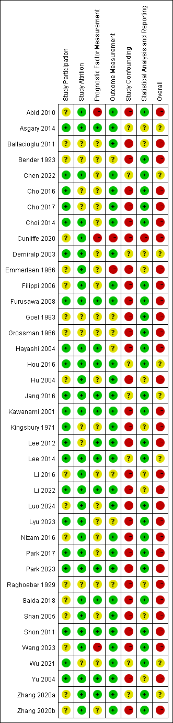
Figure 3. Time-varying pooled survival rate: pooled survival rates within different time points across included studies.

Appendix Figures (Forest plots)

Appendix Figure 1. Risk of bias graph: review authors' judgements about each risk of bias item presented as percentages across all included studies.
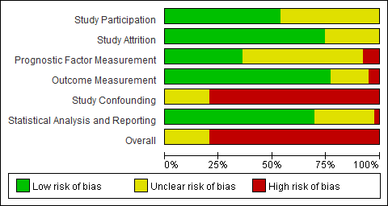

Appendix Figure 2. Forest plot of overall survival rate.
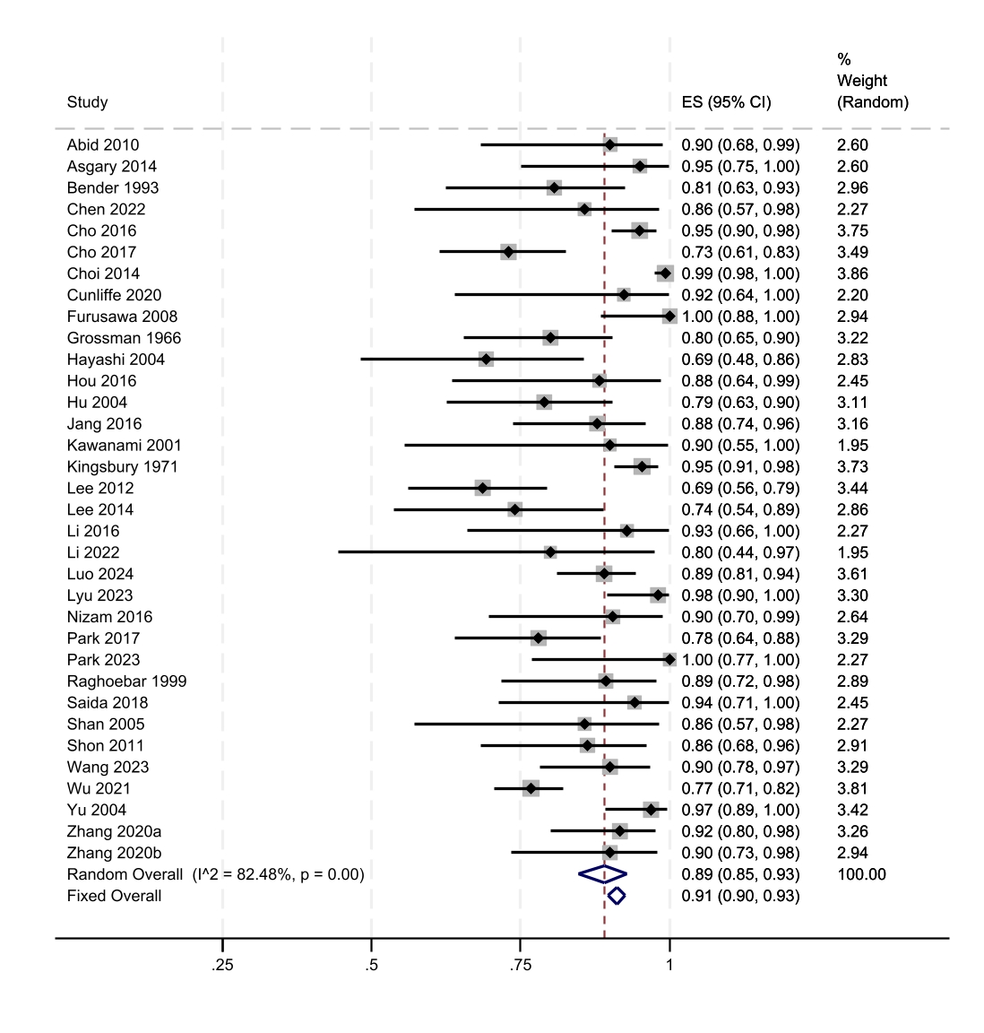

Appendix Figure 3. Forest plot of 3-month survival rate.

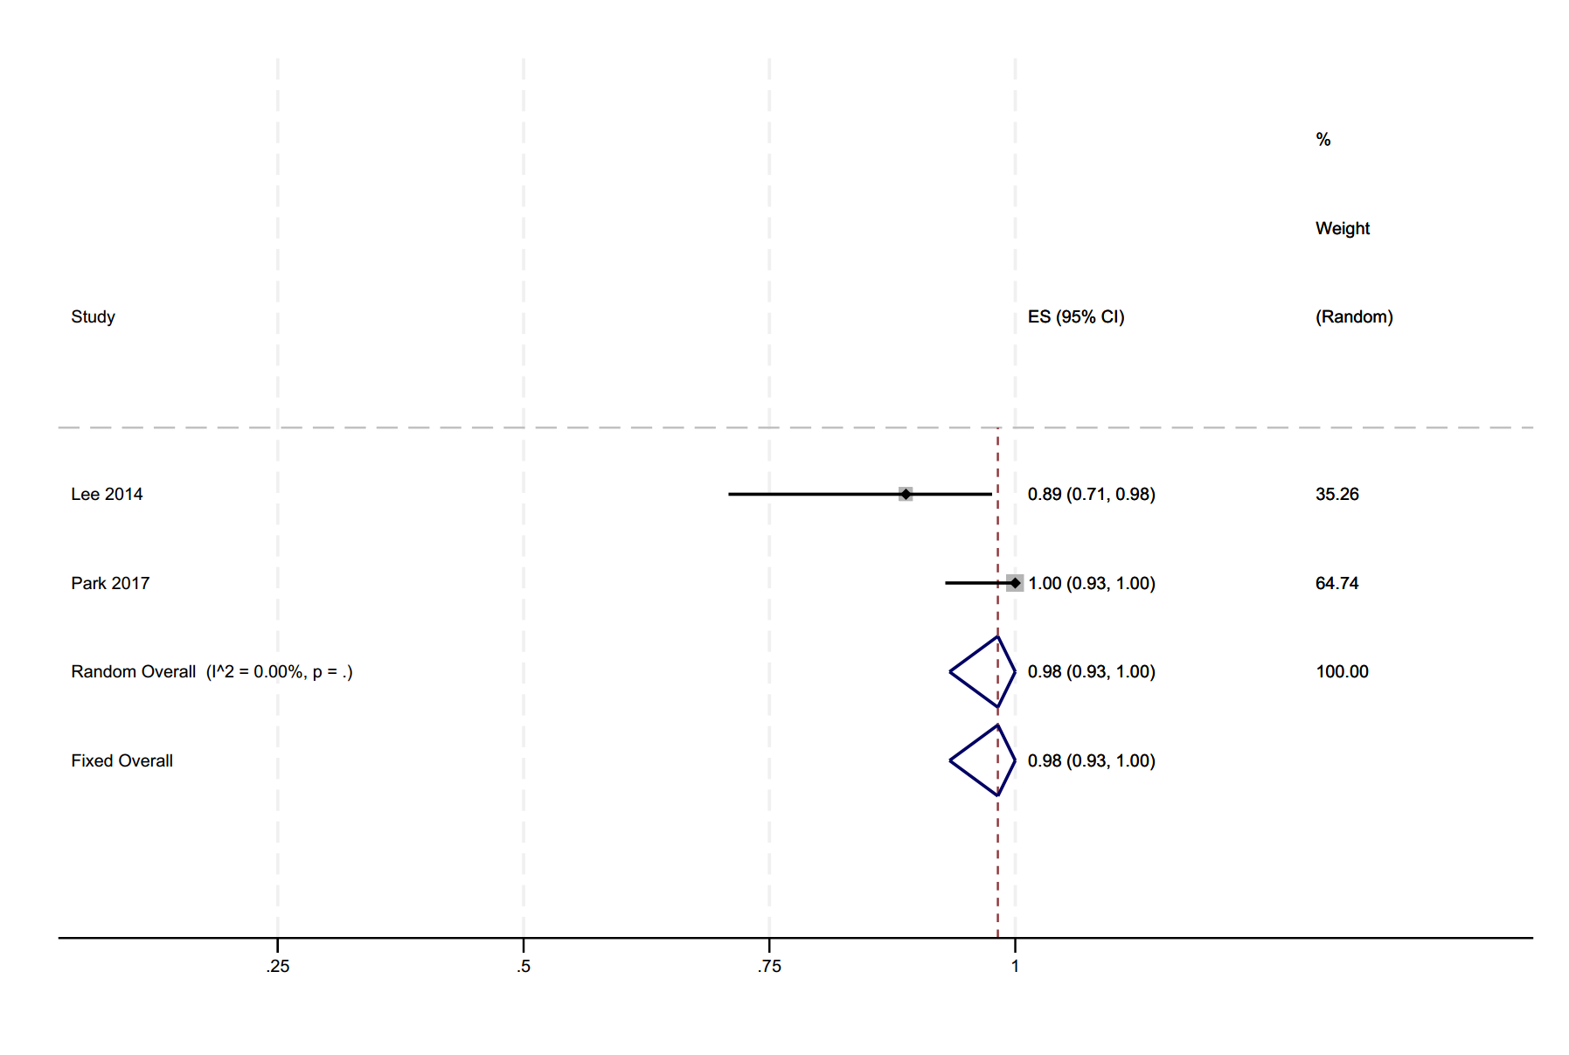

Appendix Figure 4. Forest plot of 6-month survival rate.
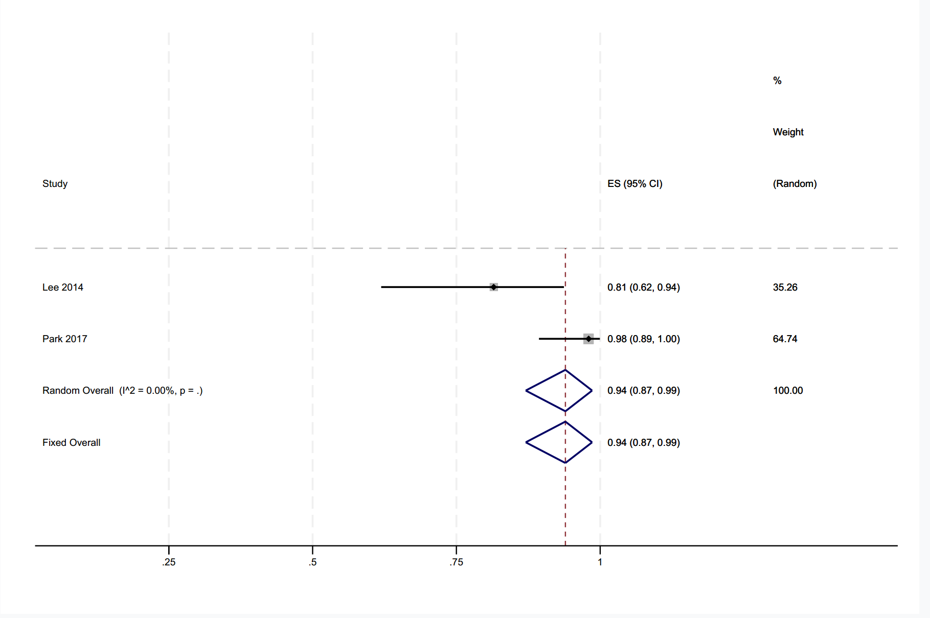

Appendix Figure 5. Forest plot of 9-month survival rate.
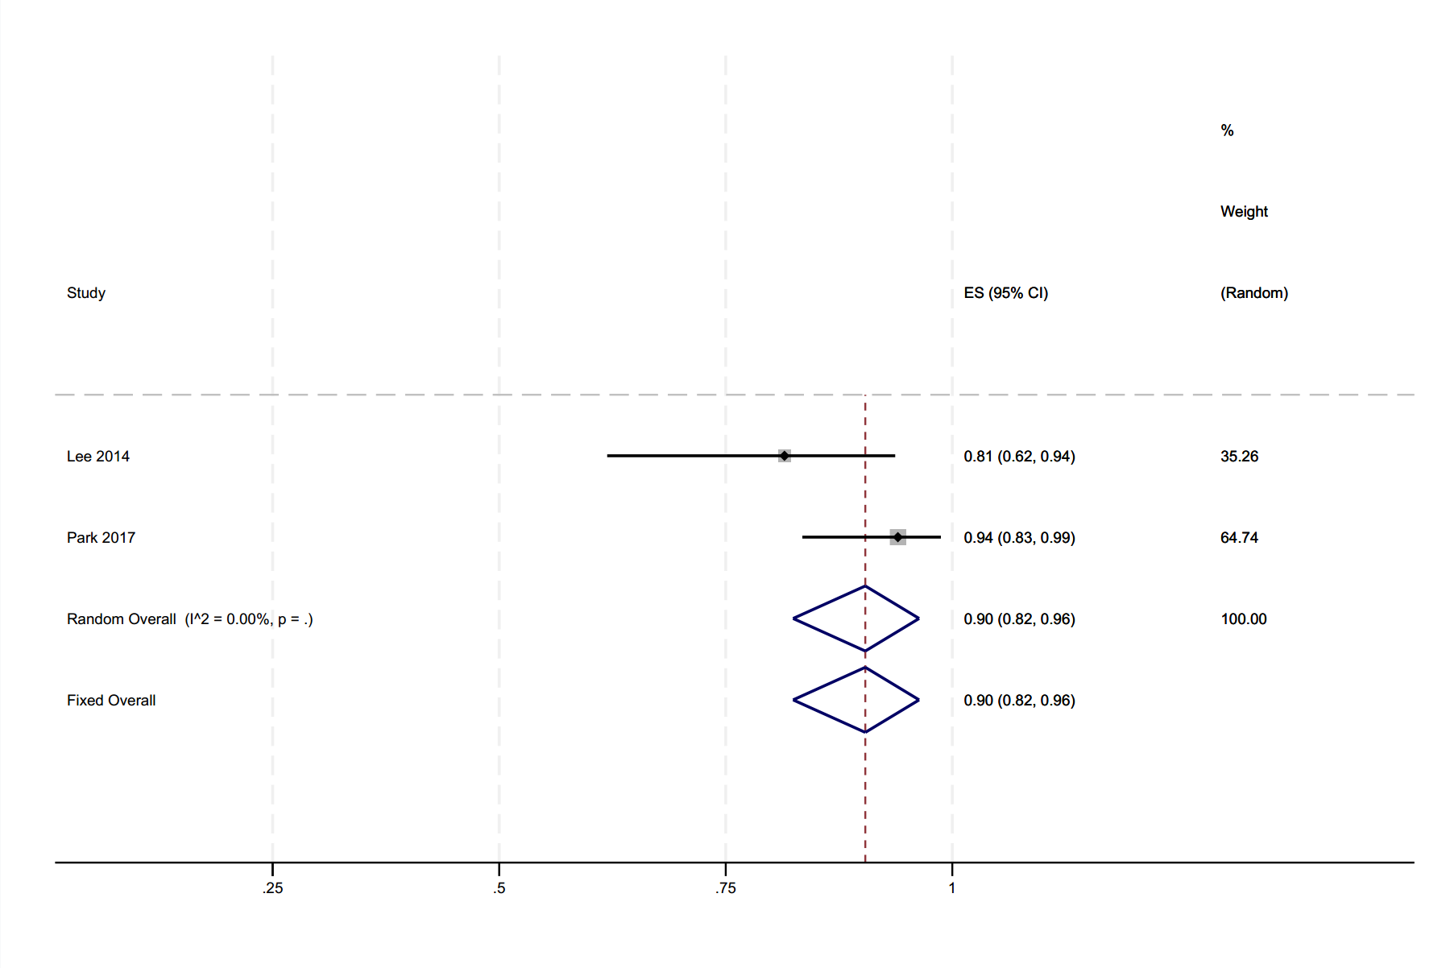

Appendix Figure 6. Forest plot of 1-year survival rate.
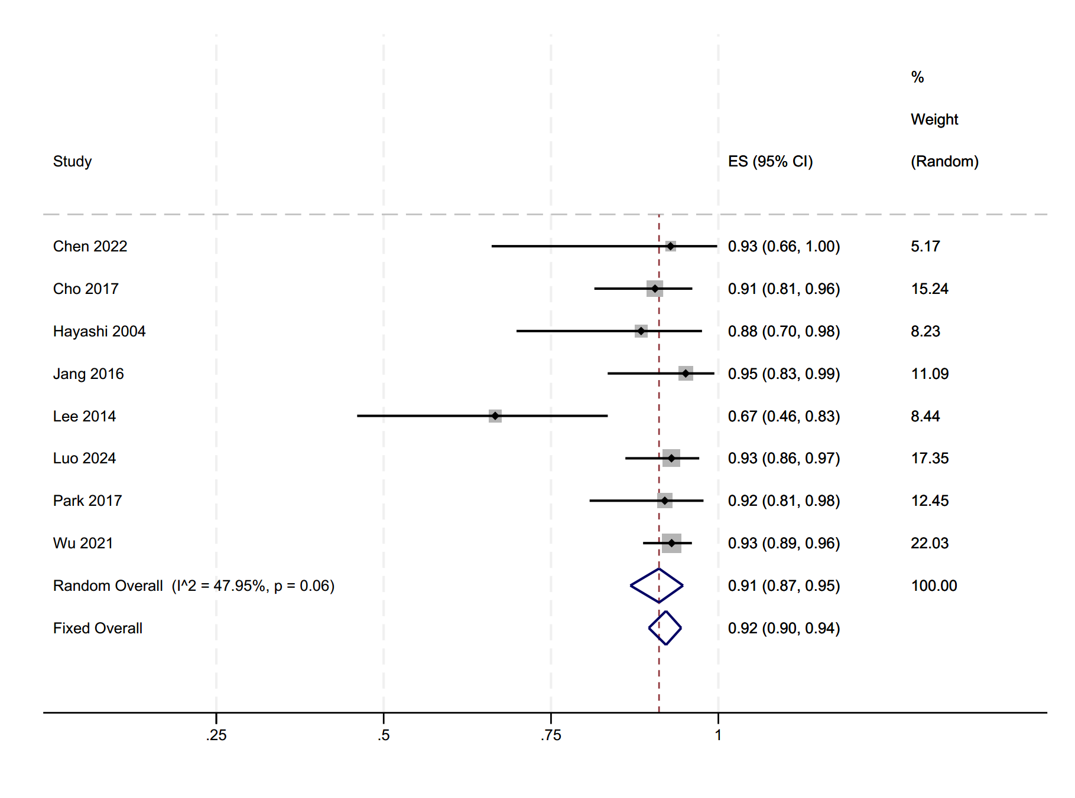

Appendix Figure 7. Forest plot of 2-year survival rate.
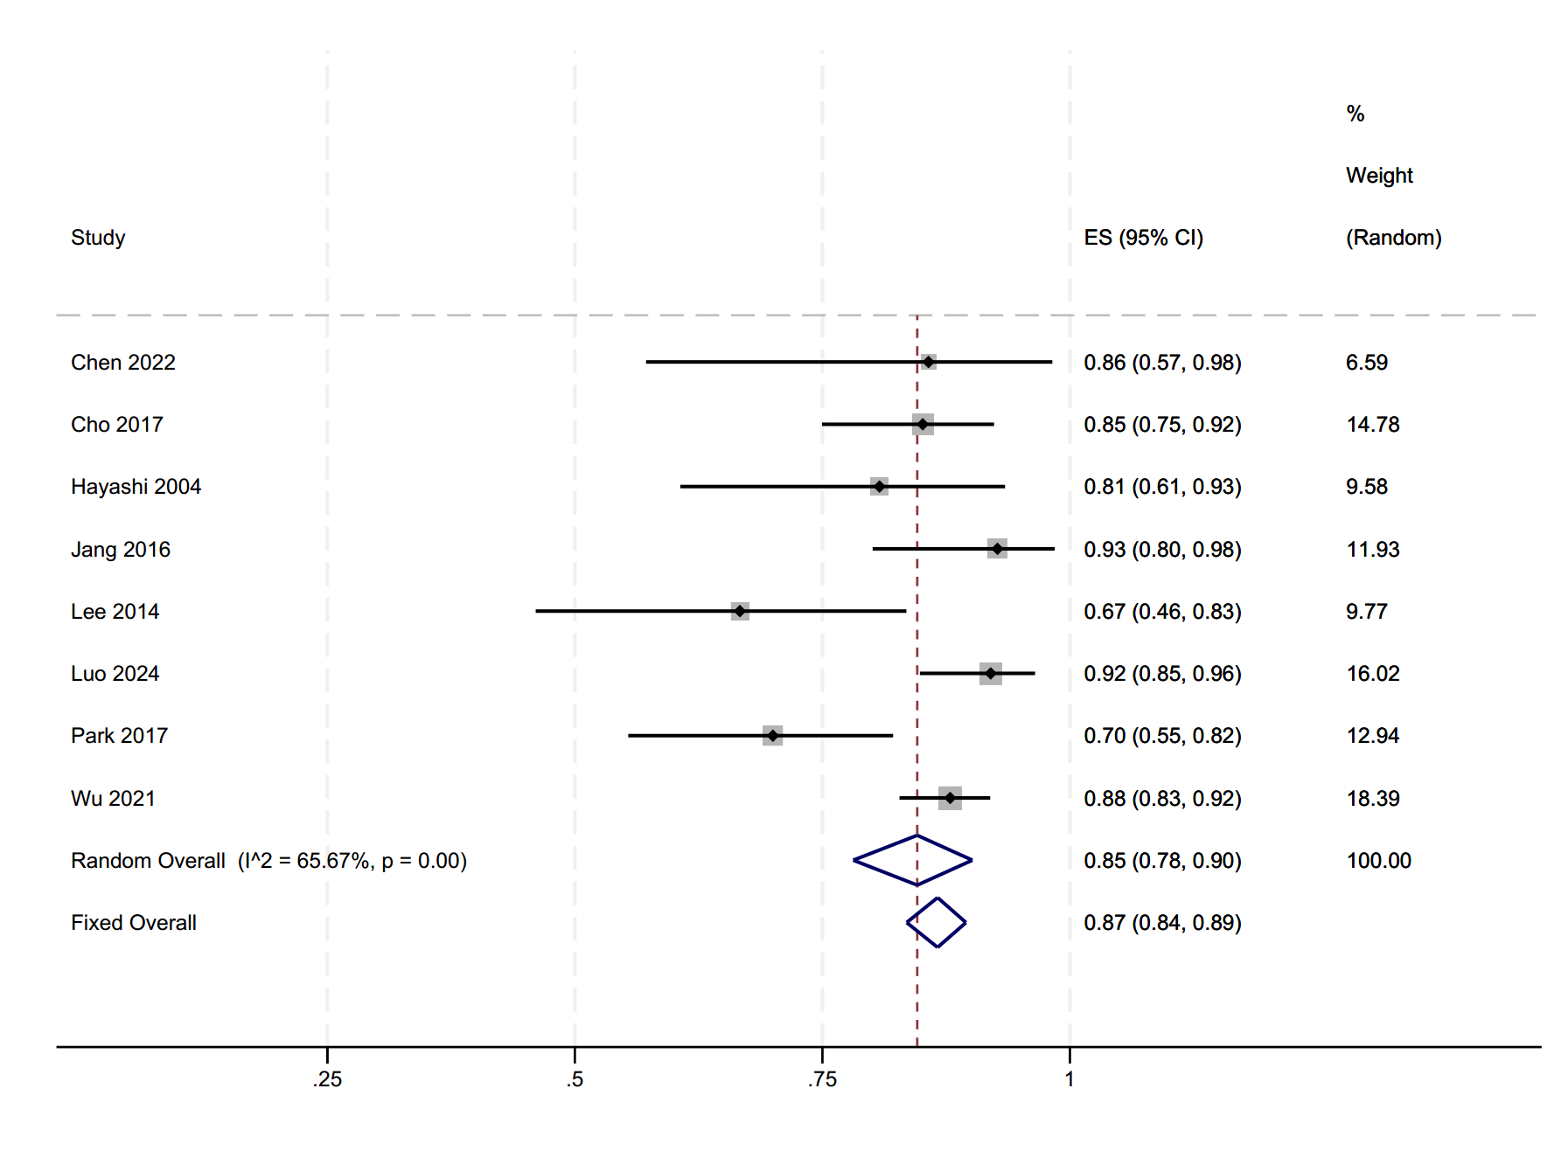

Appendix Figure 8. Forest plot of 3-year survival rate.
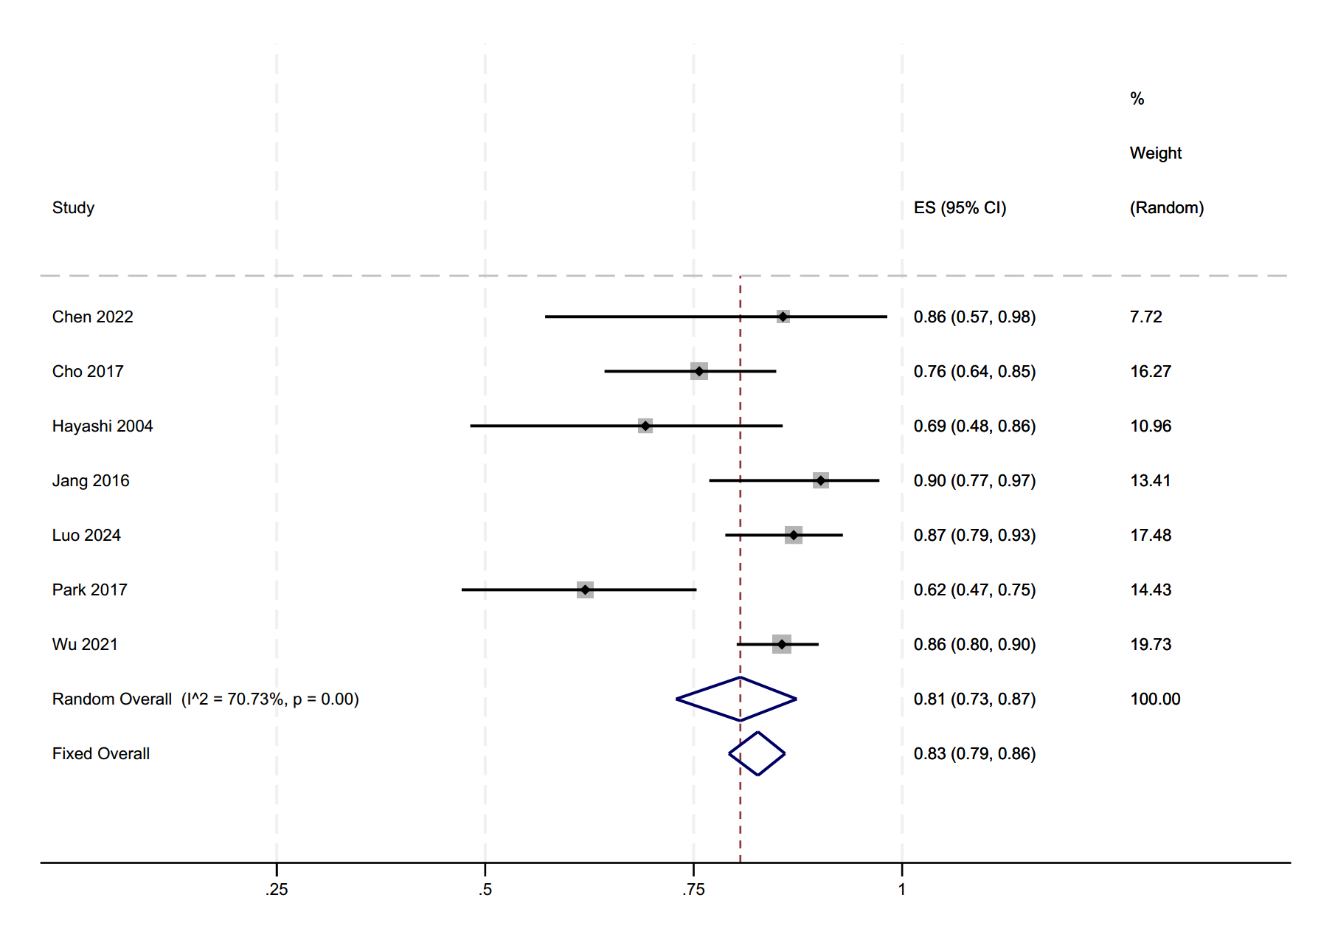

Appendix Figure 9. Forest plot of 4-year survival rate.
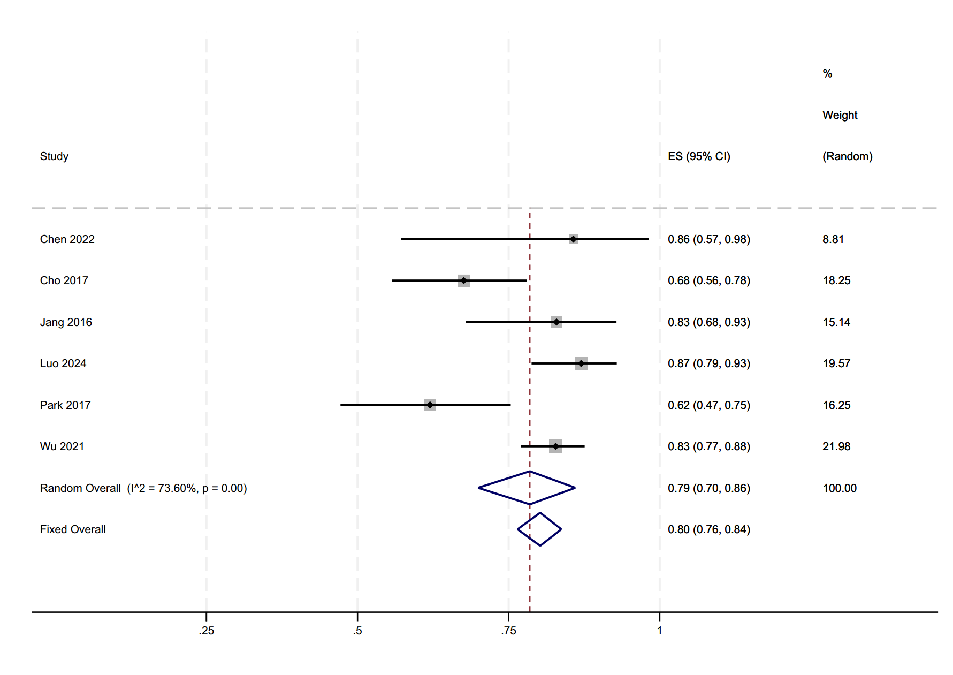

Appendix Figure 10. Forest plot of 5-year survival rate.
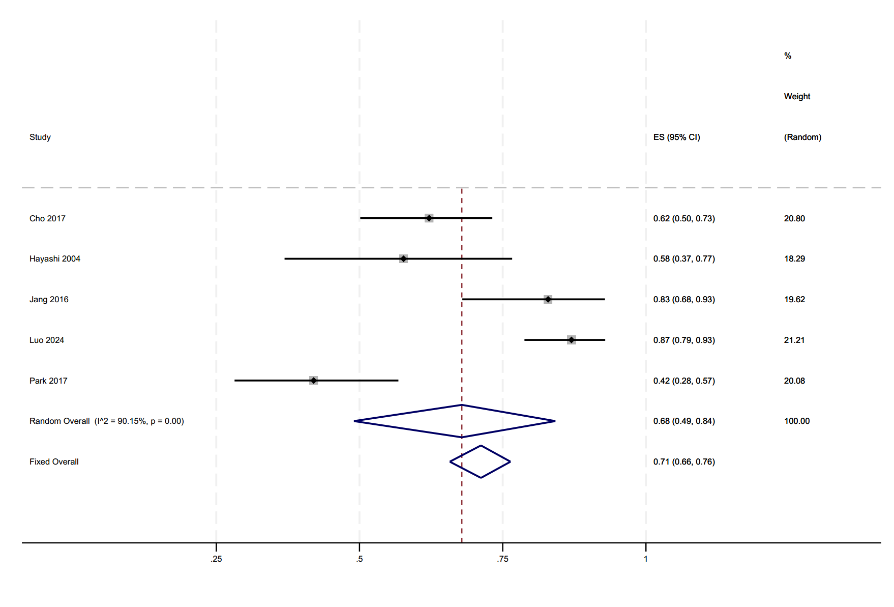

Appendix Figure 11. Forest plot of 6-year survival rate.
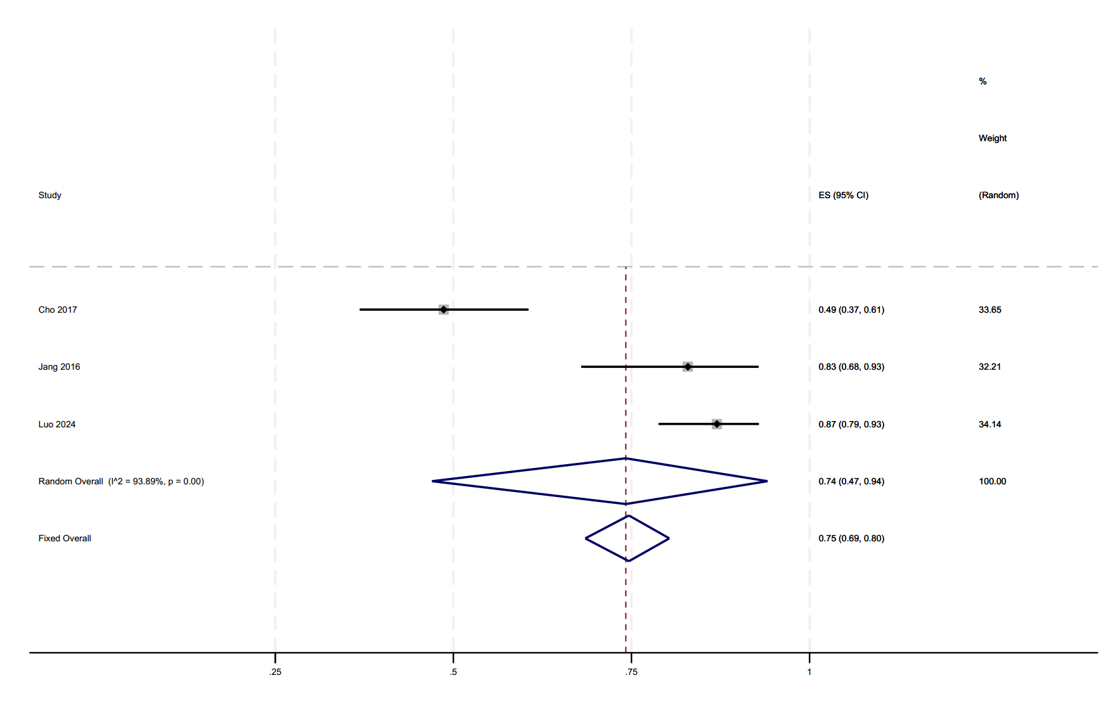

Appendix Figure 12. Forest plot of 7-year survival rate.
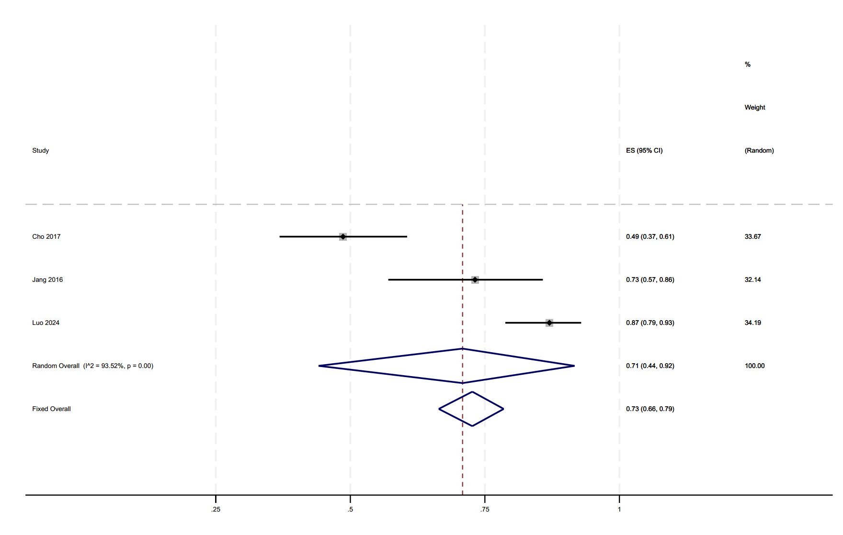

Appendix Figure 13. Forest plot of 8-year survival rate.
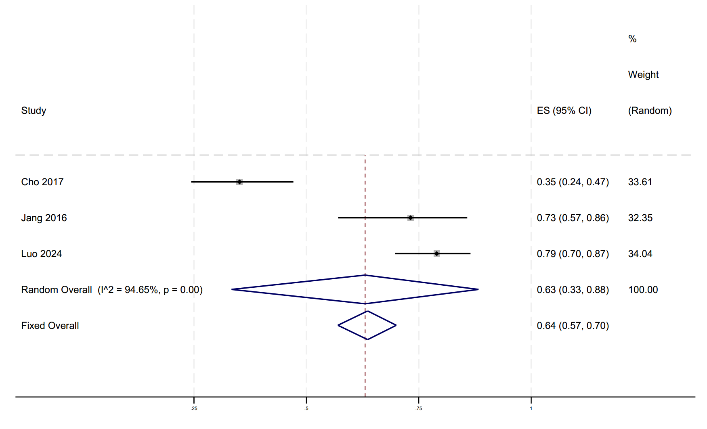

Appendix Figure 14. Forest plot of overall success rate.
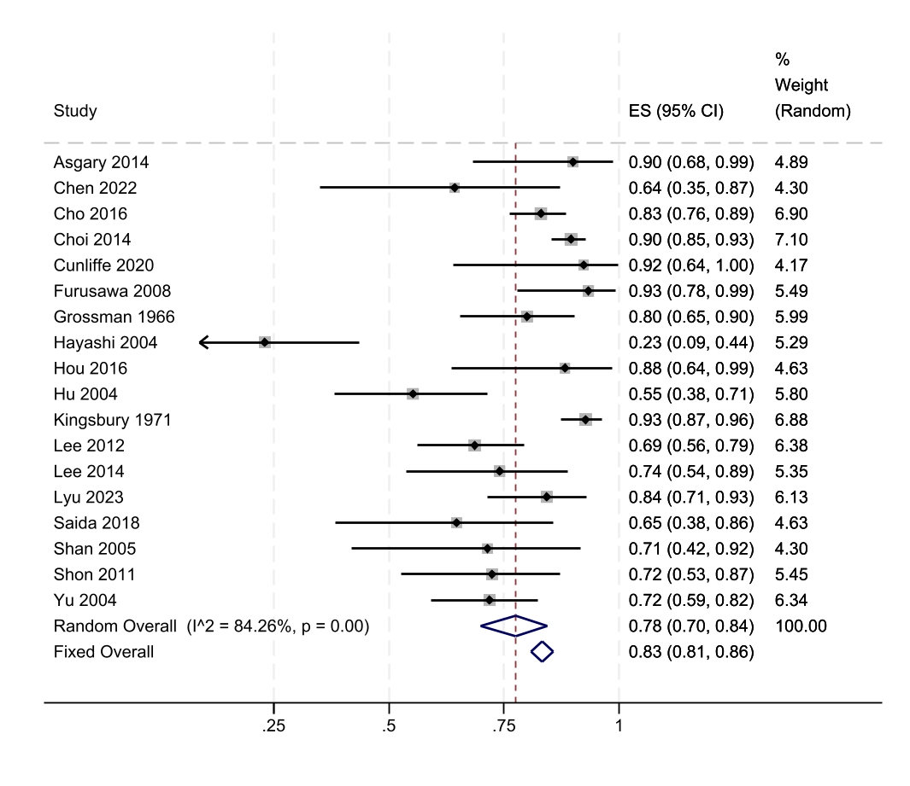

Appendix Figure 15. Forest plot of incidence proportion of ankylosis
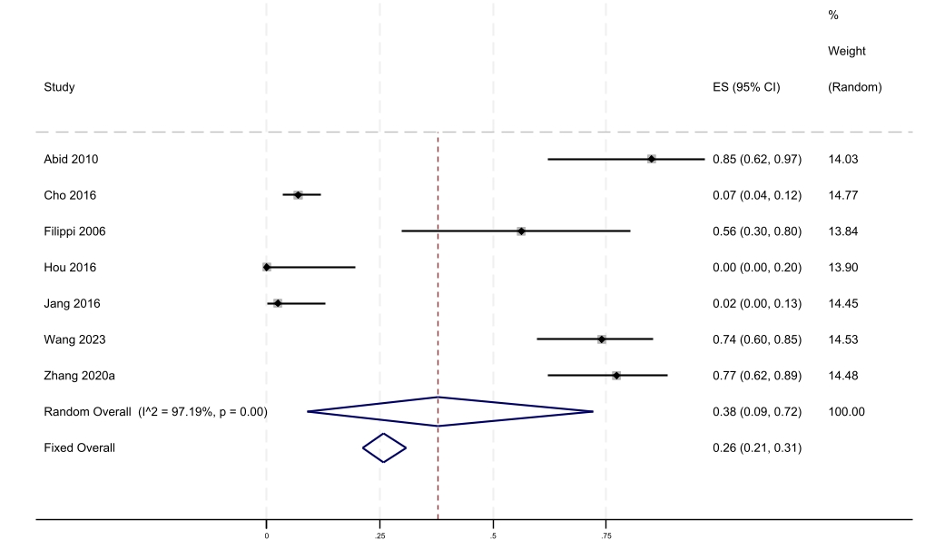

Appendix Figure 16. Forest plot of Comparison 1 (Age: survival rate ratio of older over younger)
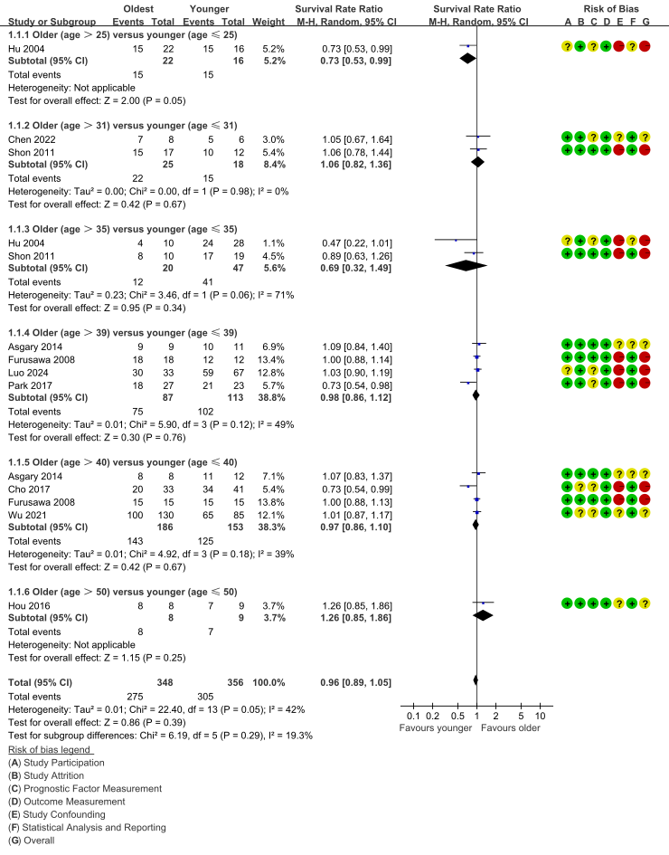

Appendix Figure 16S. Forest plot of Comparison 1 (Sensitivity analysis)
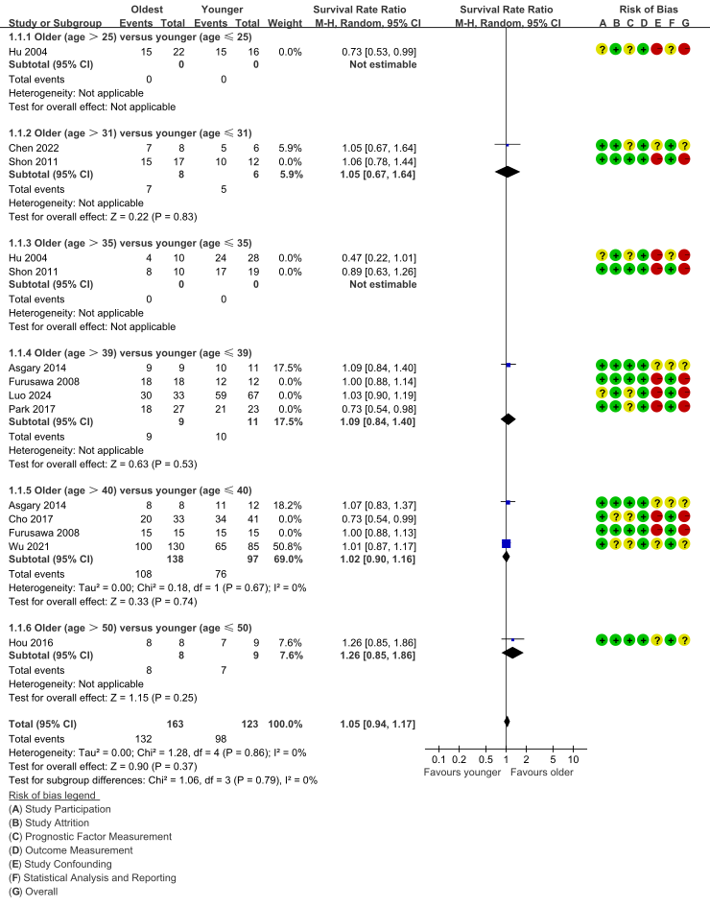

Appendix Figure 17. Forest plot of Comparison 2 (Combined periodontal-endodontic lesions: survival rate ratio of presence over absence)
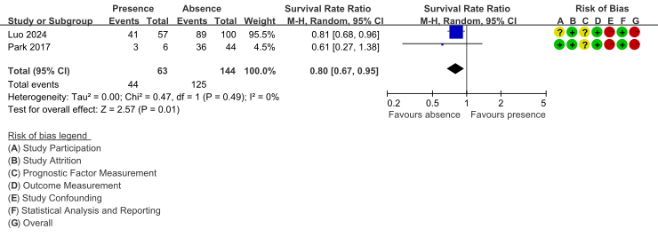

Appendix Figure 18. Forest plot of Comparison 3 (Sinus tract: survival rate ratio of presence over absence)
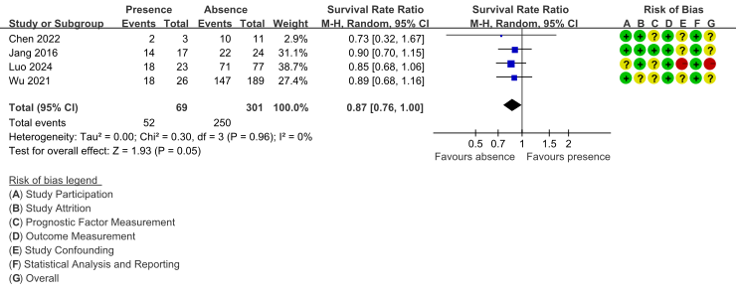

Appendix Figure 18S. Forest plot of Comparison 3 (Sensitivity analysis)
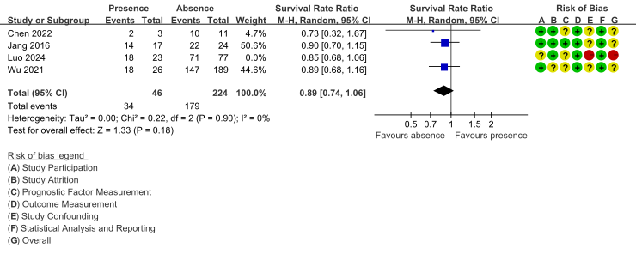

Appendix Figure 19. Forest plot of Comparison 4 (Jaw: survival rate ratio of maxillary over mandibular)
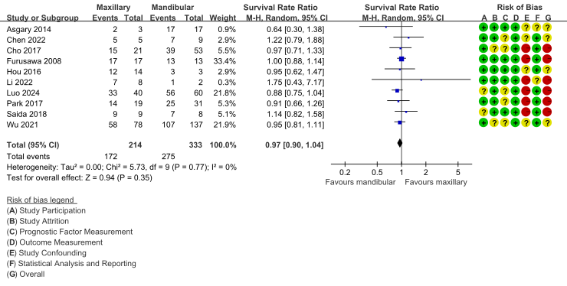

Appendix Figure 19S. Forest plot of Comparison 4 (Sensitivity analysis)
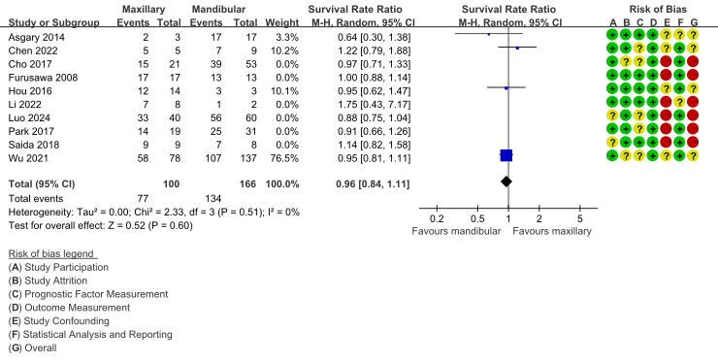

Appendix Figure 20. Forest plot of Comparison 5 (Probing pocket depth: survival rate ratio of deeper over shallower)
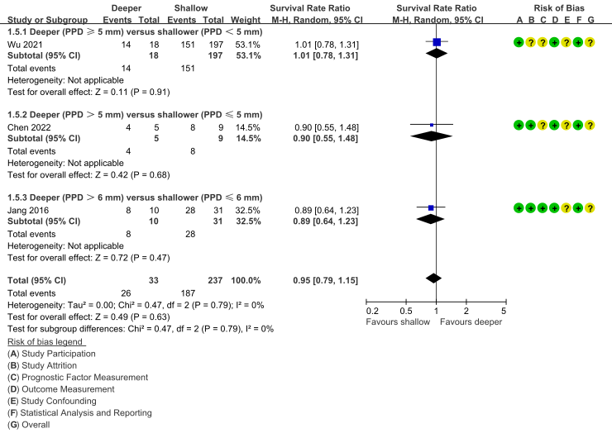

Appendix Figure 21. Forest plot of Comparison 6 (Extraoral time: survival rate ratio of longer time over shorter time)
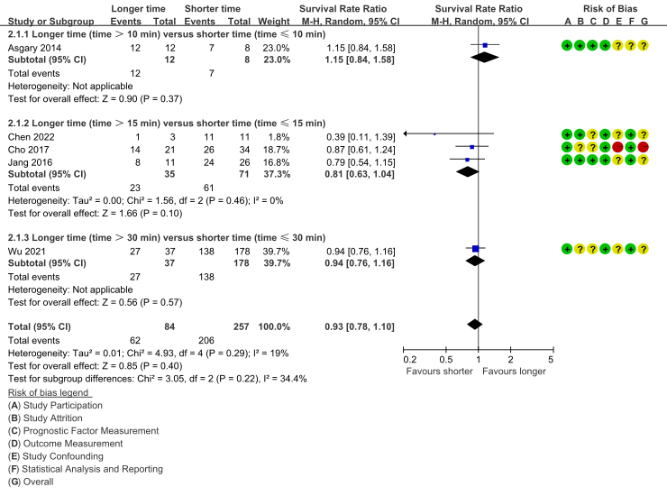

Appendix Figure 21S. Forest plot of Comparison 6 (Sensitivity analysis)
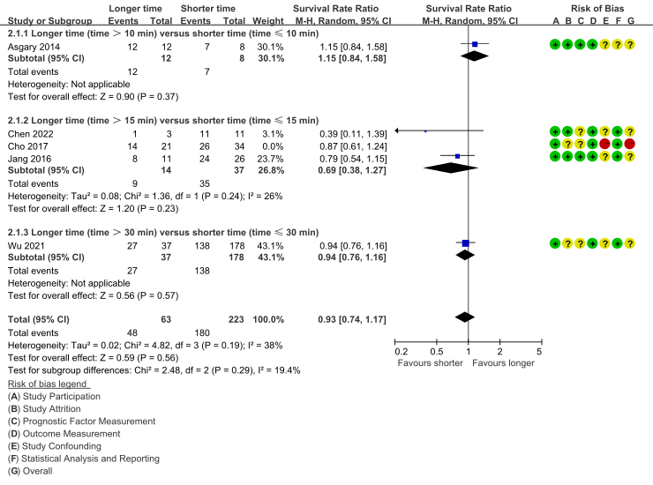

Appendix Figure 22. Forest plot of Comparison 7 (Splint method: survival rate ratio of resin wire splint over suture splint)
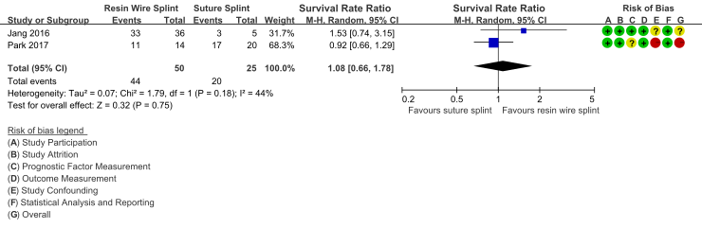

Appendix Figure 22S. Forest plot of Comparison 7 (Sensitivity analysis)
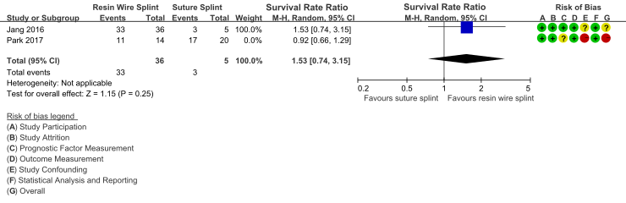

Appendix Figure 23. Forest plot of Comparison 8 (Root-end filling materials: survival rate ratio of other materials over MTA)
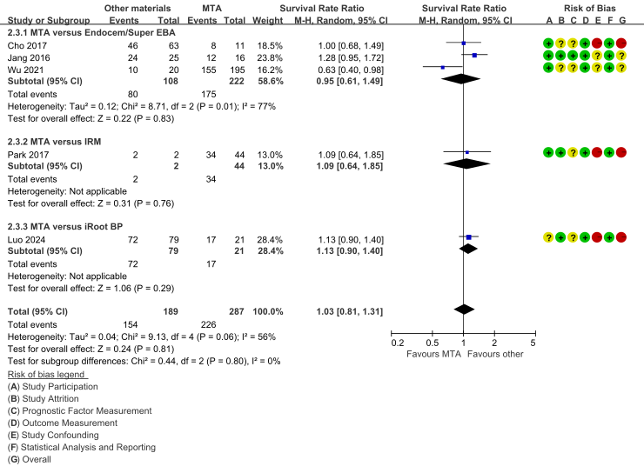

Appendix Figure 23S. Forest plot of Comparison 8 (Sensitivity analysis)
