Professional question answering
Prompt: As a doctor with rich experience in oral implantology, please combine the latest guidelines and research results to answer this question for me. Thank you.

Step 1: Prompt presetting
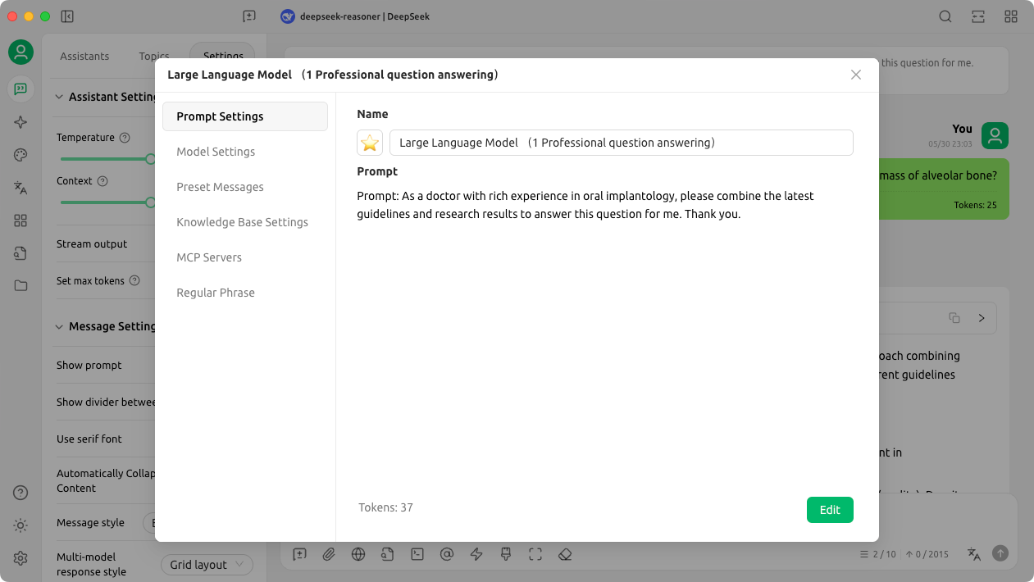
Step 2: Adjust model settings
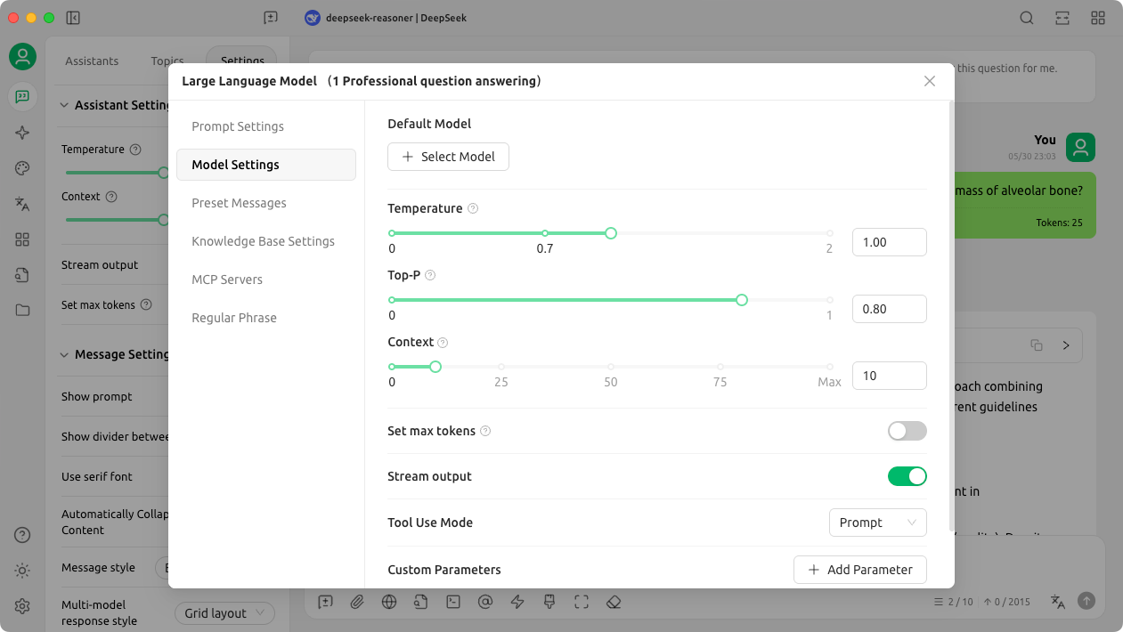
Step 3: Task implementation
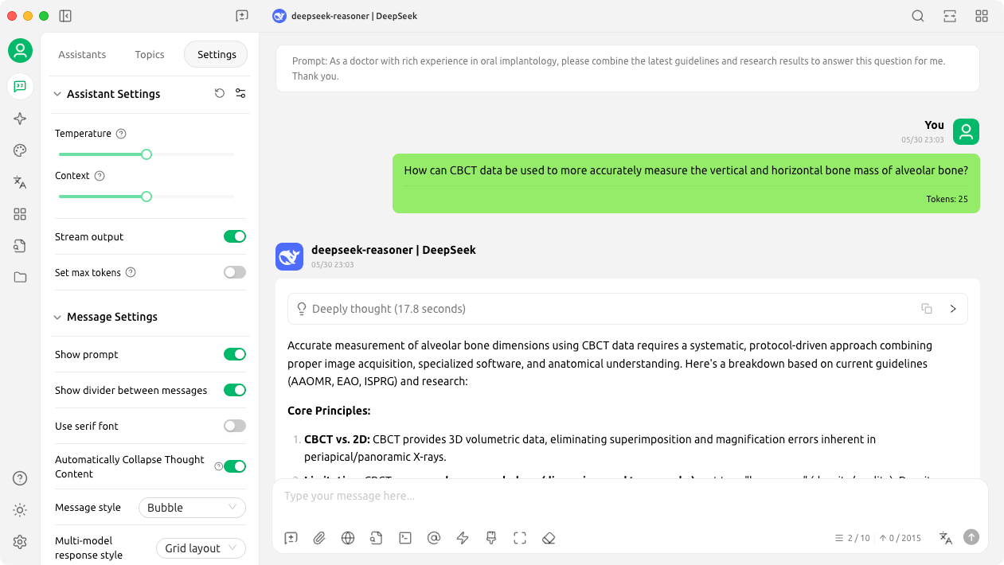

Case analysis
Prompt: As a doctor with rich experience in oral implantology, please make a detailed disease diagnosis, treatment plan design and treatment risk assessment for this case, and make a comprehensive summary and thinking of this case combined with relevant professional knowledge. Relevant literature can be cited to support your answer. Thank you.

Step 1: Prompt presetting
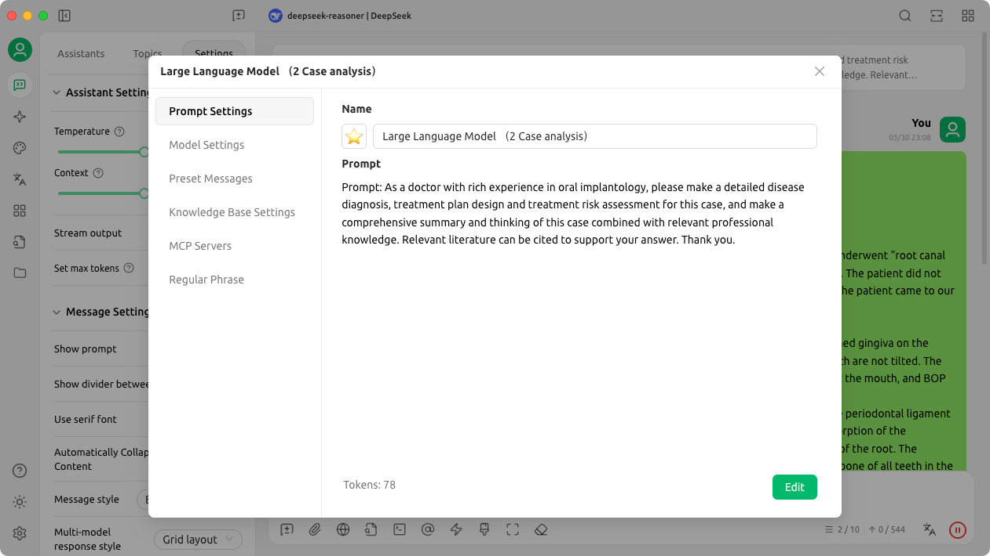
Step 2: Adjust model settings
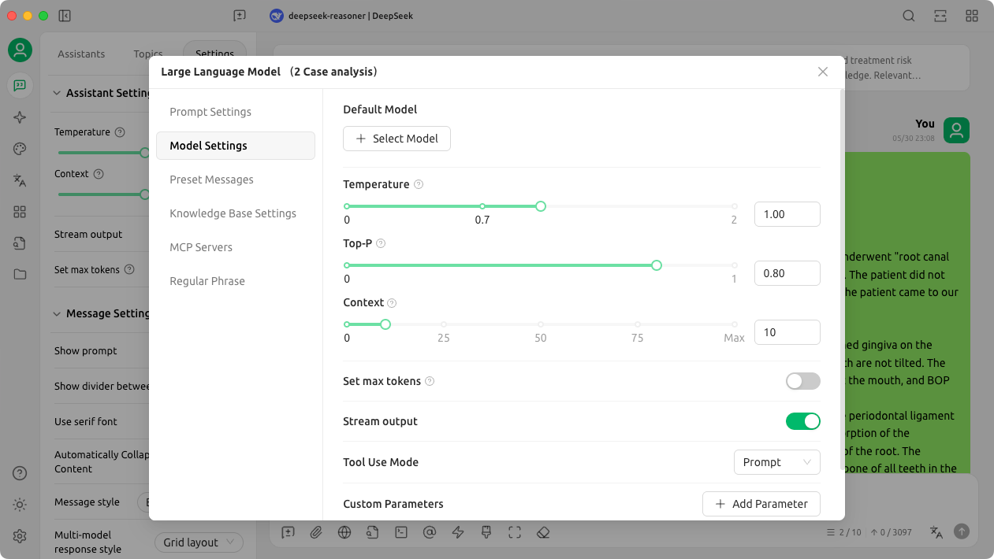
Step 3: Task implementation
