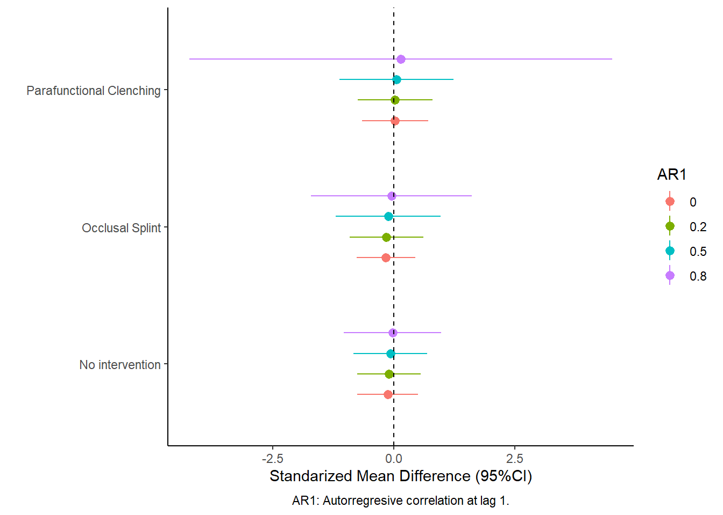
Supplementary material. Figure 1: Control vs. biofeedback group sensitivity analysis.

Supplementary material. Table 1: Confounding variables effect.
 | Coefficient (SE) | 95%CI | t (p valueª)
Age | -0.278 SE(0.621) | -5.086, 4.53 | t(1.276)=-0.448, p=0.719
Pain duration (months) | 0.005 SE(0.008) | -0.099, 0.11 | t(1.009)=0.616, p=0.648
Male/female ratio | -2.216 SE(5.35) | -43.413, 38.981 | t(1.28)=-0.414, p=0.737
SE: Standard error; 95%CI: 95% confidence interval.
ªsignificant if p<0.05 (shown in red).

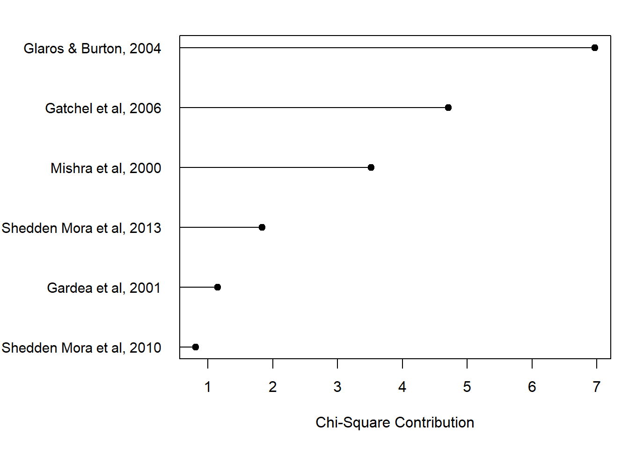
Supplementary material. Figure 2: Inconsistency studies contribution plot.
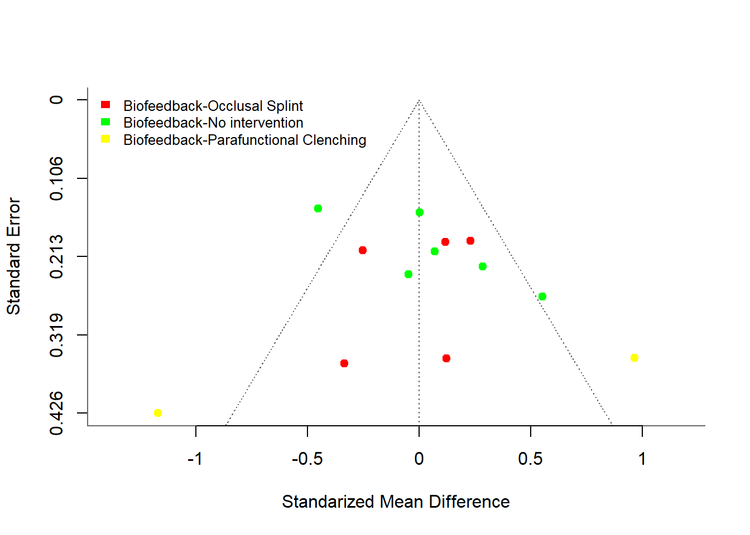
Supplementary material. Figure 3: Publication bias pairwise-comparisons funnel plots.

