Fig. 1. C-shaped canal prevalence of mandibular first premolar

Fig. 2. C-shaped canal prevalence in the mandibular second premolar

Fig. 3. C-shaped canal prevalence in the mandibular first molar
Fig. 4. C-shaped canal prevalence in the mandibular second molar

Fig. 5. C-shaped canal prevalence in the mandibular third molar

Fig. 6. C-shaped canal prevalence in the maxillary first molar

Fig. 7. C-shaped canal prevalence in the maxillary second molar

Fig. 8. C-shaped canal prevalence in the mandibular first premolar in female and male

Fig. 9. C-shaped canal prevalence in the mandibular second premolar in female and male

Fig. 10. C-shaped canal prevalence in the mandibular first molar in female and male

Fig. 11. C-shaped canal prevalence in the mandibular second molar in female and male
Fig. 12. C-shaped canal prevalence in the mandibular first premolar on the right and left sides

Fig. 13. C-shaped canal prevalence in the mandibular second molar on the right and left sides

Fig. 14. Classification of C-shaped canals of the mandibular first premolar in the coronal section

Fig. 15. Classification of C-shaped canals of the mandibular first premolar in the mid-section

Fig. 16. Classification of C-shaped canals of the mandibular first premolar in the apical section

Fig. 17. Classification of C-shaped canals of the mandibular first molar in the coronal section

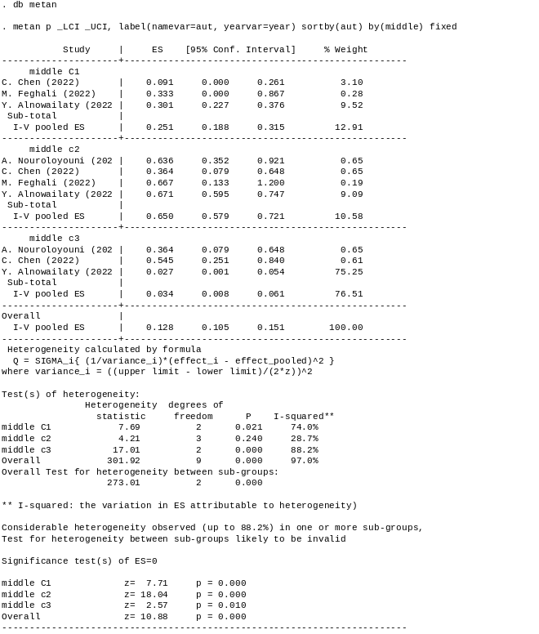
Fig. 18. Classification of C-shaped canals of the mandibular first molar in the mid-section

Fig. 19. Classification of C-shaped canals of the mandibular first molar in the apical section

Fig. 20. Classification of C-shaped canals of the mandibular second molar in the coronal section

Fig. 21. Classification of C-shaped canals of the mandibular second molar in the mid-section

Fig. 22. Classification of C-shaped canals of the mandibular second molar in the apical section

Fig. 23. Distribution of the mandibular first premolar with a C-shaped canal by the continent

Fig. 24. Distribution of the mandibular second premolar with a C-shaped canal by the continent

Fig. 25. Distribution of the mandibular first molar with a C-shaped canal by the continent

Fig. 26. Distribution of the mandibular second molar with a C-shaped canal by the continent

Fig. 27. Distribution of the maxillary first molar with a C-shaped canal by the continent

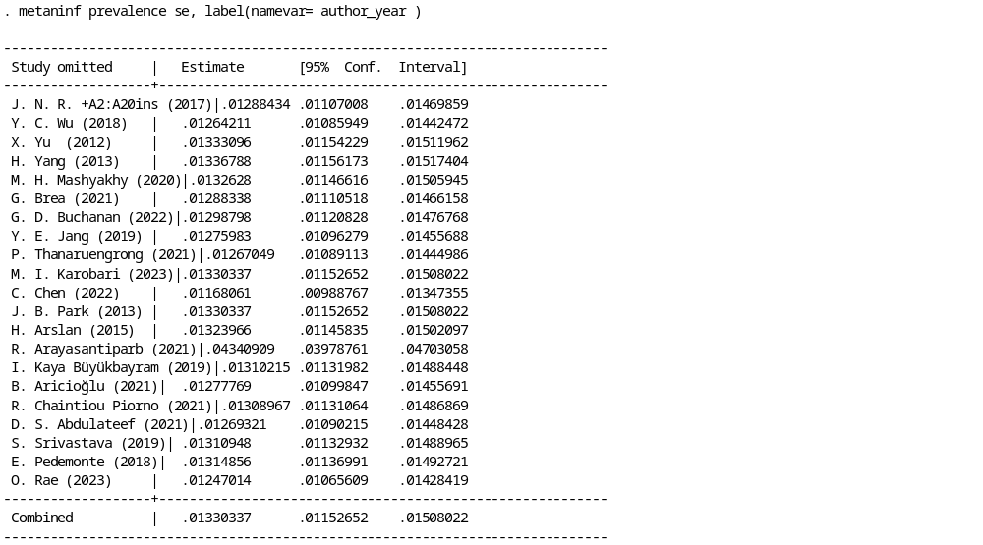
Fig. 28. Sensitivity analysis for mandibular first premolar

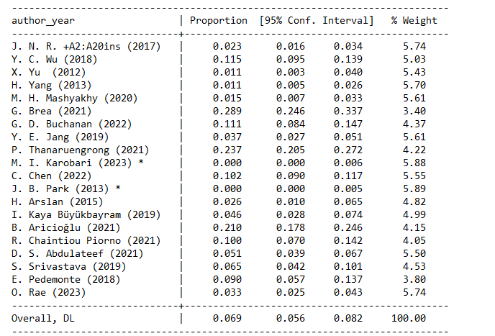
Fig. 29. Sensitivity analysis for mandibular first premolar after exclusion of R. Arayasantiparb (2021)

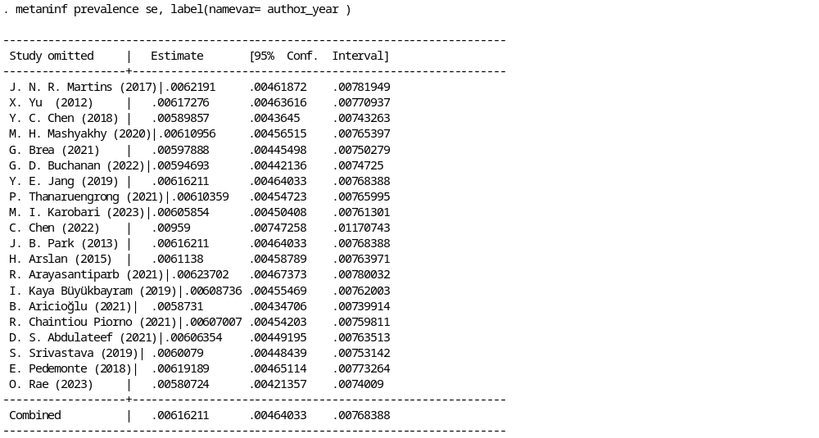
Fig. 30. Sensitivity analysis for mandibular second premolar

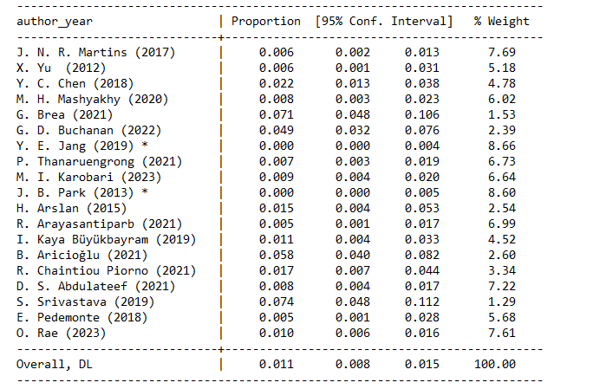
Fig. 31. Sensitivity analysis for mandibular second premolar after exclusion of C. Chen (2022)

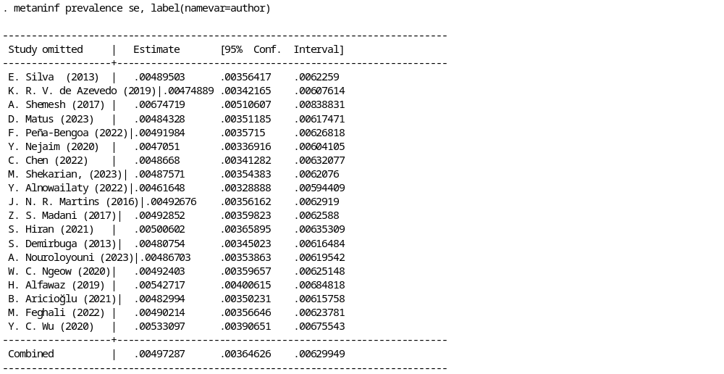
Fig. 32. Sensitivity analysis for mandibular first molar

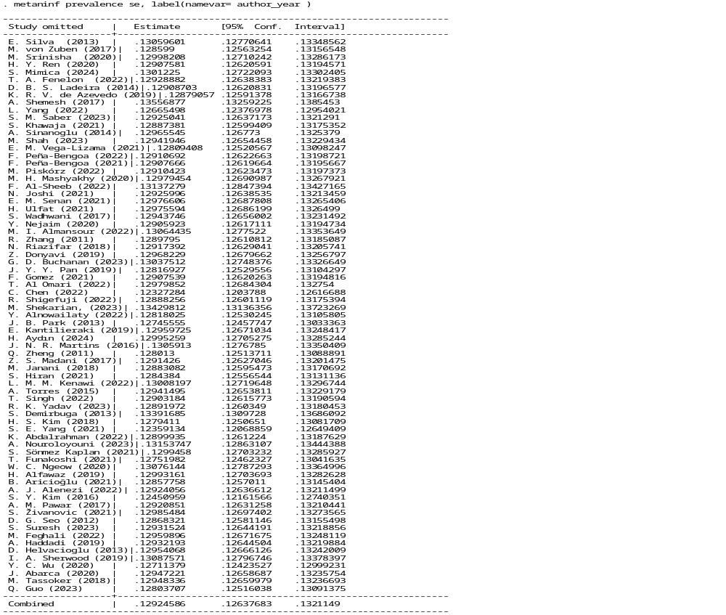

Fig. 33. Sensitivity analysis for mandibular second molar

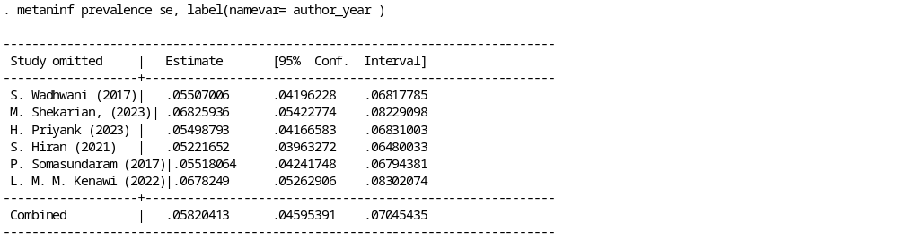
Fig. 34. Sensitivity analysis for mandibular third molar

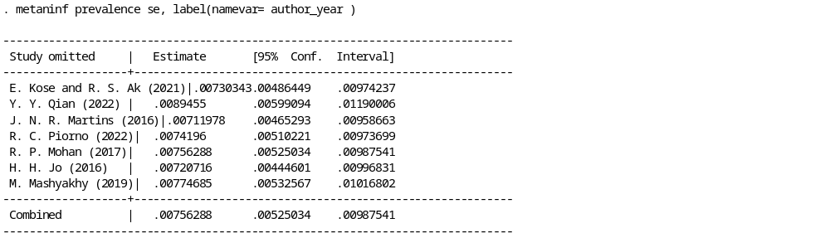
Fig. 35. Sensitivity analysis for maxillary first molar

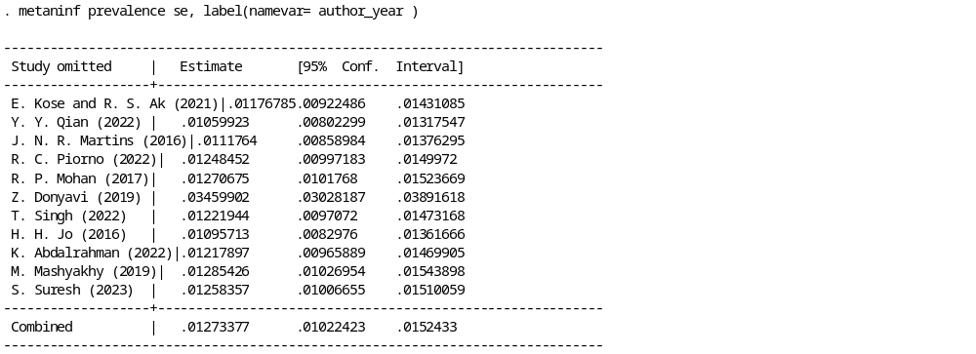
Fig. 36. Sensitivity analysis for maxillary second molar

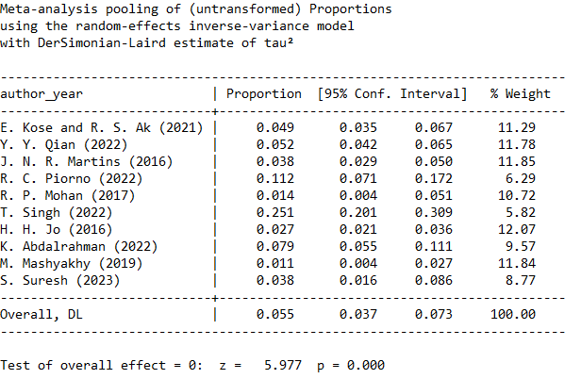
Fig. 37. Sensitivity analysis for maxillary second molar after exclusion of Z. Donyavi (2019)

