Supplementary Material
Carnosic acid alleviated periodontitis by inhibiting ferroptosis via the Nrf2/GPX4 pathway
Jiatong Zou ^{1,2}, Rui Wang ^{1,2}, Jiahui Yu ^{1,2}, Xiantao Chen ^{1,2}, Qi Zhao ^{1,2}, Yushen Li ^{1,2}, Yifei Dai ^{1,2}, Jiajun Xin ^{1,2}, Bowei Wang ³*, Zhihui Liu ^{1,2} *

¹Hospital of Stomatology, Jilin University, Changchun 130021, People's Republic of China.
²Jilin Provincial Key Laboratory of Tooth Development and Bone Remodeling, Changchun 130021, People's Republic of China.
³The Second Hospital of Jilin University, Changchun 130041, People's Republic of China.

Jiatong Zou, E-mail: zoujt22@mails.jlu.edu.cn
*Correspondence authors:
E-mail: liu_zh@jlu.edu.cn (Zhihui Liu), wangbw@jlu.edu.cn (Bowei Wang)
Supplementary table 1. The primer sequences for the RT-qPCR analysis.
Primer | Sequence (forward) | Sequence (reverse)
m-GADPH | AATGGTGAAGGTCGGTGTGAACG | TCGCTCCTGGAAGATGGTGATGG
m-Nrf2 | GCATAGAGCAGGACATGGAGCAAG | ACTGATGGCAGCGGAGGAAGG
m-GPX4 | CATGCCCGATATGCTGAGTGTGG | ACTGATGGCAGCGGAGGAAGG
m-SLC7A11 | CCTCTGACGATGGTGATGCTCTTC | GGTGCTGAATGGGTCCGAGTAAAG
m- FTH1 | TGCCATCAACCGCCAGATCAAC | ATTCAGCCCGCTCTCCCAGTC
R- GADPH | CCGCATCTTCTTGTGCAGTG | GAGAAGGCAGCCCTGGTAAC
R-Nrf2 | GCCTTCCTCTGCTGCCATTAGTC | TGCCTTCAGTGTGCTTCTGGTTG
R-GPX4 | AATTCGCAGCCAAGGACATCG | ATTCGTAAACCACACTCGGCGTA
R-SLC7A11 | TGCTGCCTACACAAAGACGTT | CGCCTTGCCCTTTAAGTATTCACC
R- FTH1 | GAACCAGCGAGGTGGACGAATC | TAGCCAGTTTGTGAAGTTCCAGTAGTG
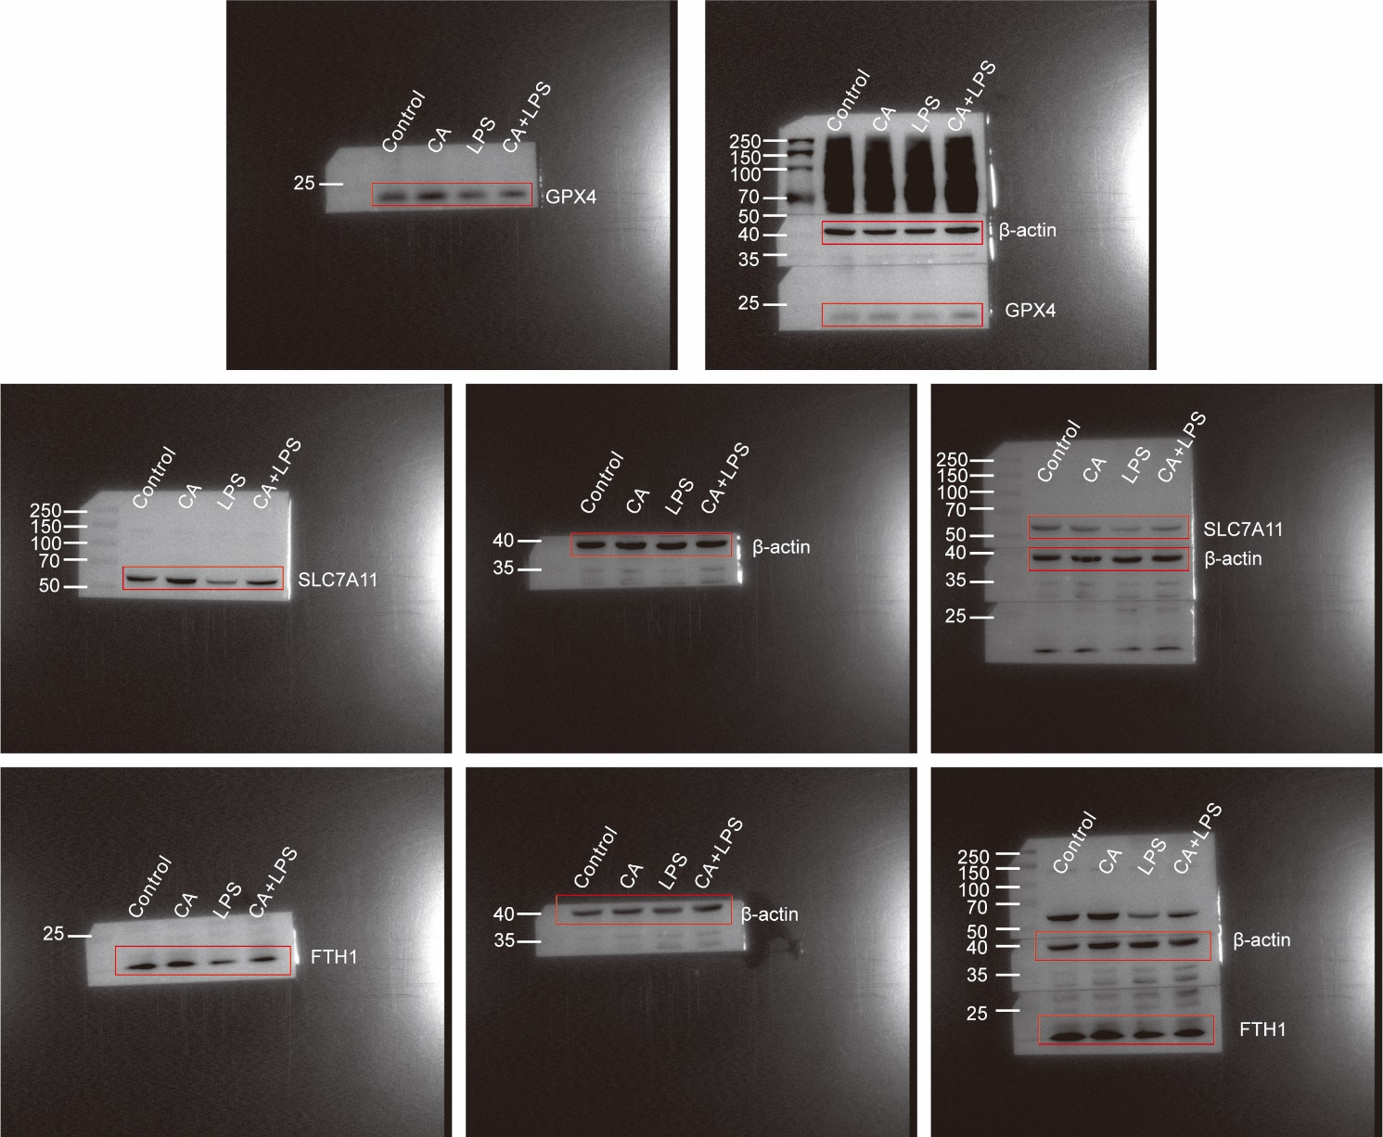
Supplementary Figure S1. The original blots of GPX4, SLC7A11, and FTH1 are presented.
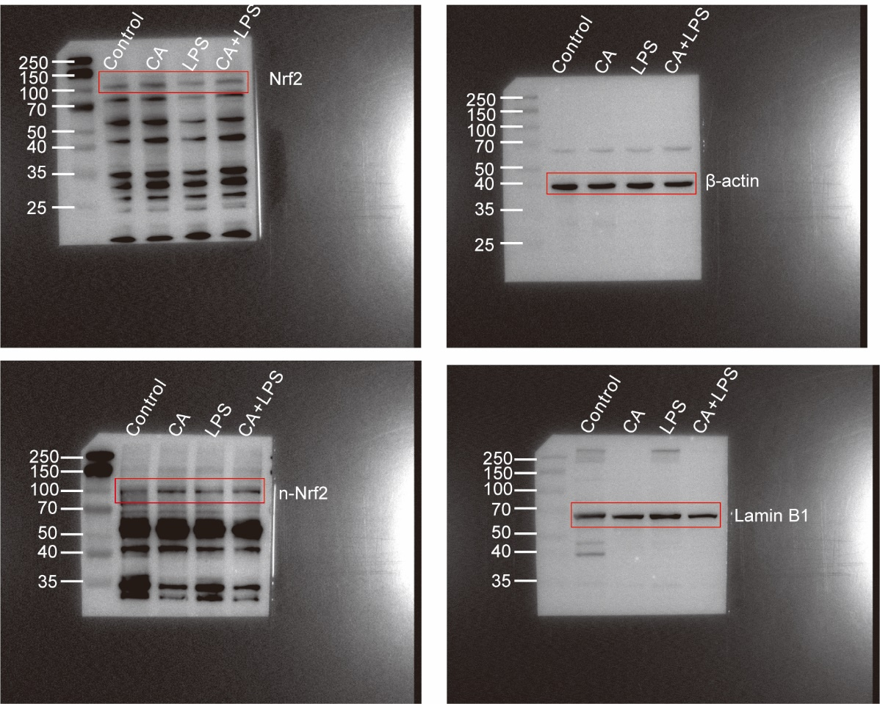
Supplementary Figure S2. The original blots of Nrf2 and n-Nrf2 are presented.
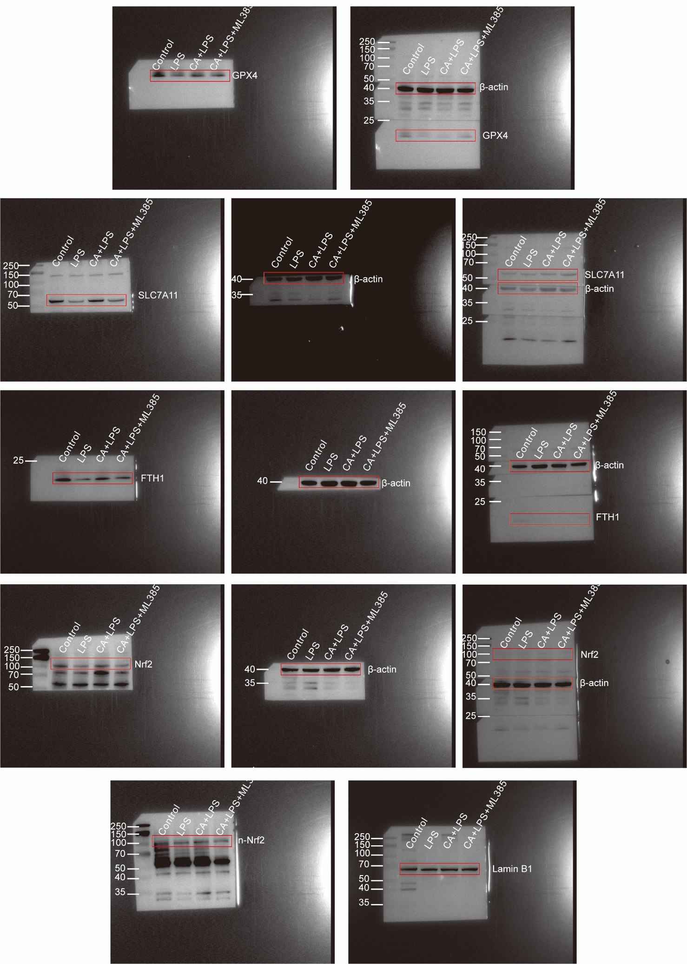
Supplementary Figure S3. The original blots of GPX4, SLC7A11, FTH1, Nrf2, and n-Nrf2 are presented.

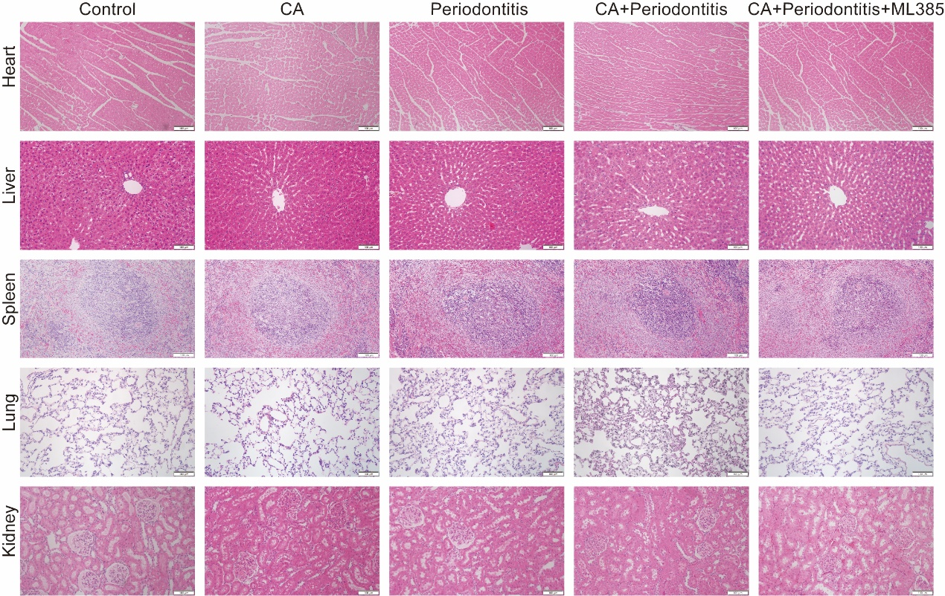
Supplementary Figure S4. CA and ML385 have good biosafety in rats. H&E staining of rat heart, liver, spleen, lung, and kidney. Scale bar: 100 μm.

