Use of Artificial Intelligence in Oral Radiology: A Multicenter Cross-Sectional Study in Egypt
Nora Saif ^{1,2*}, Ahmed Elkoumi ³ and Abeer K Shaalan ⁴
¹ Faculty of Dentistry, Cairo University, Egypt
² Lead researcher, EMRA Lab (Egyptian Maxillofacial Radiology Alliance)
³ Faculty of Oral and Dental Medicine, Egyptian Russian University (ERU), Cairo, Badr City, Egypt
⁴ Centre for Oral, Clinical & Translational Sciences, Faculty of Dentistry, Oral & Craniofacial Sciences, King’s College London, Guy’s Hospital, Tower Wing, London, United Kingdom

* Corresponding author: Nora Saif (nora.taha@dentistry.cu.edu.eg)

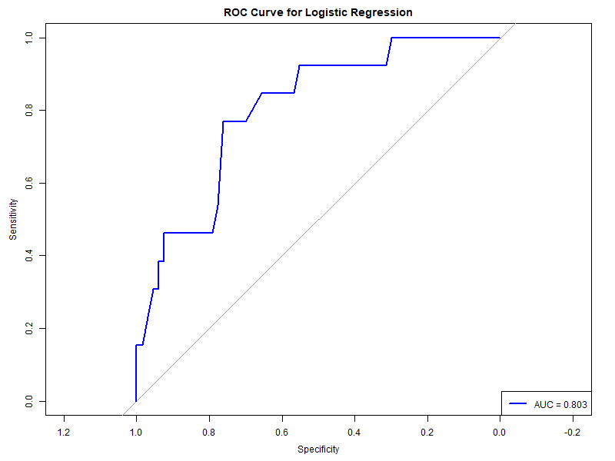
Supplementary Fig. 1. ROC curve of the multivariable logistic regression model illustrating the potential factors that may impact AI knowledge among dentists.

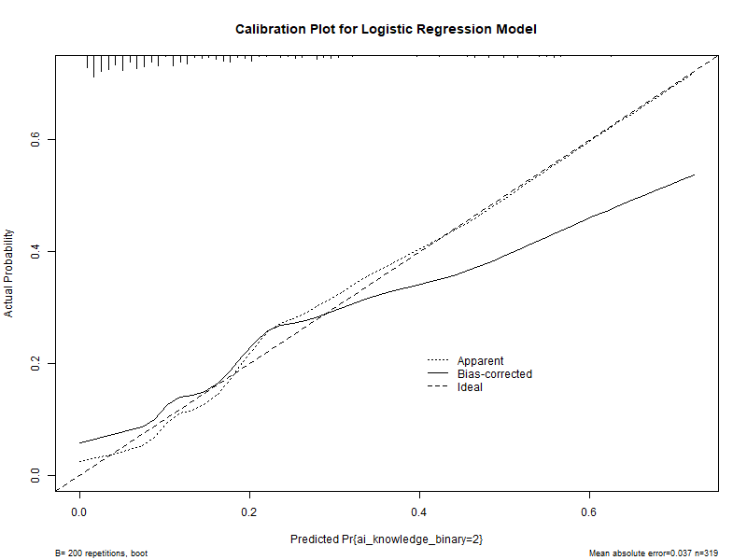

Supplementary Fig. 2. Calibration plot of the multivariable logistic regression model demonstrating a strong agreement between predicted and observed values.

Use of Artificial Intelligence in Oral Radiology: A Multicenter Cross-Sectional Study in Egypt

The survey aims to assess knowledge and perceptions of AI applications in dental imaging among Egyptian dentists. It also aims to identify the needs and challenges of implementing this transformative technology into education, training, and clinical practice.

Information Leaflet

The questionnaire will take approximately 5-10 minutes to complete. Confidentiality: All data will be collected anonymously with no identifiable markers of the participants. Information will be kept confidential and stored on a secure server. Participation and withdrawal: Contribution to the service evaluation is voluntary and you may decline to participate without consequence. Once the questionnaire has been completed, however, you will be unable to withdraw from the study. Contact details: If you have any questions or if you require any further information, please contact: Dr Nora Saif: nora.taha@dentistry.cu.edu.eg

Demographics

What is your age range?
  - <30
  - 30-49
  - >50

What is your gender?
  - Male
  - Female

What is your highest qualification?
  - BSc
  - MSc
  - PhD

Experience/years of practice
  - 0-5 yrs
  - 6-10 yrs
  - 11-15 yrs
  - >15

I am currently primarily working in
  - Private practice
  - Academia
  - National health institute

What is your field of speciality?
  - GP
  - Specialist (oral radiologist)
  - Specialist (other)
  - Other

How do you describe yourself?
  - I am a practitioner only
  - I am a decision maker who can implement policies

Respondents' Knowledge of Artificial Intelligence (AI)

How do you feel about AI?
  - Excited
  - Aware of challenges
  - Worried about the impact
  - I don't know enough
  - Neutral

How well do you understand what AI means?
  - I have no idea
  - Only basics I knew from media
  - Familiar but not enough to apply it in practice
  - Understand and practice AI

How did you develop your AI knowledge?
  - Self-taught
  - Completed AI education/training
  - Conferences/workshop
  - No knowledge
  - From company sales/representatives

AI knowledge and education
 | Agree | Neutral | Disagree
All dental curricula should include at least some basic knowledge of AI
Current conferences contain enough sessions related to AI
Practical AI training will equip workers with knowledge and confidence
Universities and practices should be innovative in integrating AI into education

Perceptions of AI integration into practice

How do you perceive the following statements:
 | Agree | Neutral | Disagree
AI will revolutionize oral radiology
AI will revolutionize dentistry in general
AI will have a better diagnostic ability than a clinically experienced oral radiologist
The human oral radiologist will be replaced in the future by AI
AI will be used in oral radiology applications and image production such as quality control, dose selection, and image interpretation

Does your workplace/organization have a strategy for AI?
  - YES
  - NO
  - I have no idea
  - A strategy is under development

AI practice and challenges

What AI applications do you believe would be beneficial for your dental practice/specialty?
  - Automated detection of pathologies in imaging exams
  - Automated final diagnosis from imaging exams
  - Detection of periapical lesions
  - Image processing (e.g. cephalometric tracing, tooth numbering, delineation of anatomical structures)
  - Prediction, detection and prognosis of oral cancer
  - Detection and prediction of periodontal diseases
  - Patient files and data management
  - Clinical decision making (e.g. selection and positioning of dental implant, risk evaluation for third molar extraction)
  - Image post processing (e.g. image enhancement, artifact reduction)
  - Patient education
  - Post-operative follow up of treatment outcome

Which of the following factors do you believe are hindering the integration of AI in your practice/institution?
 | Agree | Neutral | Disagree
Knowledge
Skill development
Availability of education and training courses in AI
Hard to implement in work and practice
Financial cost

The following are considered challenges regarding AI implementation. How do you view the significance of these challenges?
 | Very significant | Significant | Non significant
Integration of IT and computer science in radiology education and curriculum
Collaboration between educators, administrators and radiologists
Presence of leaders and decision makers who can transform AI applications in radiology work
The lack of regulatory policy which governs AI use
The lack of assigned responsibility for consequences of AI-based decisions

