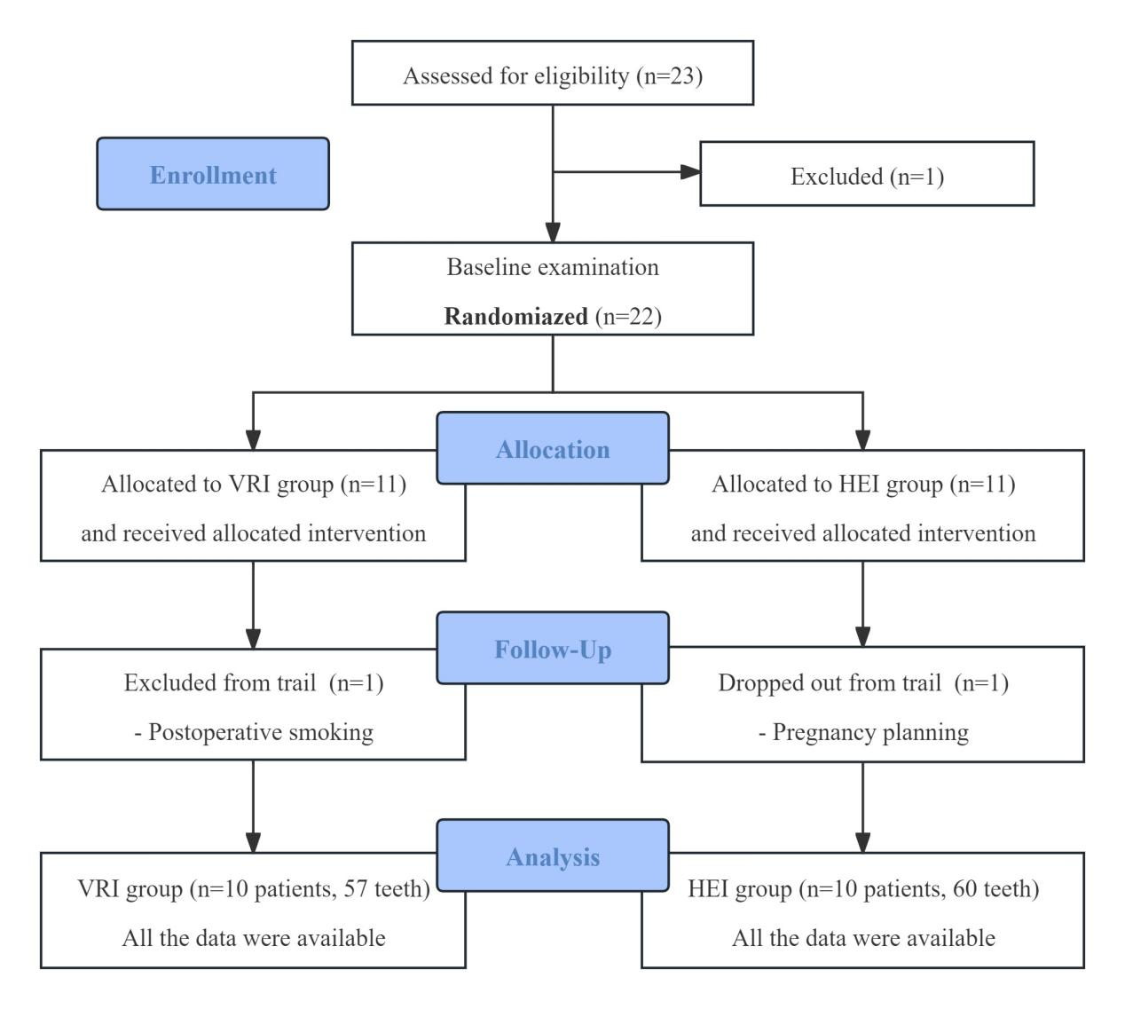Figure S2. CONSORT flow diagram of this trial

