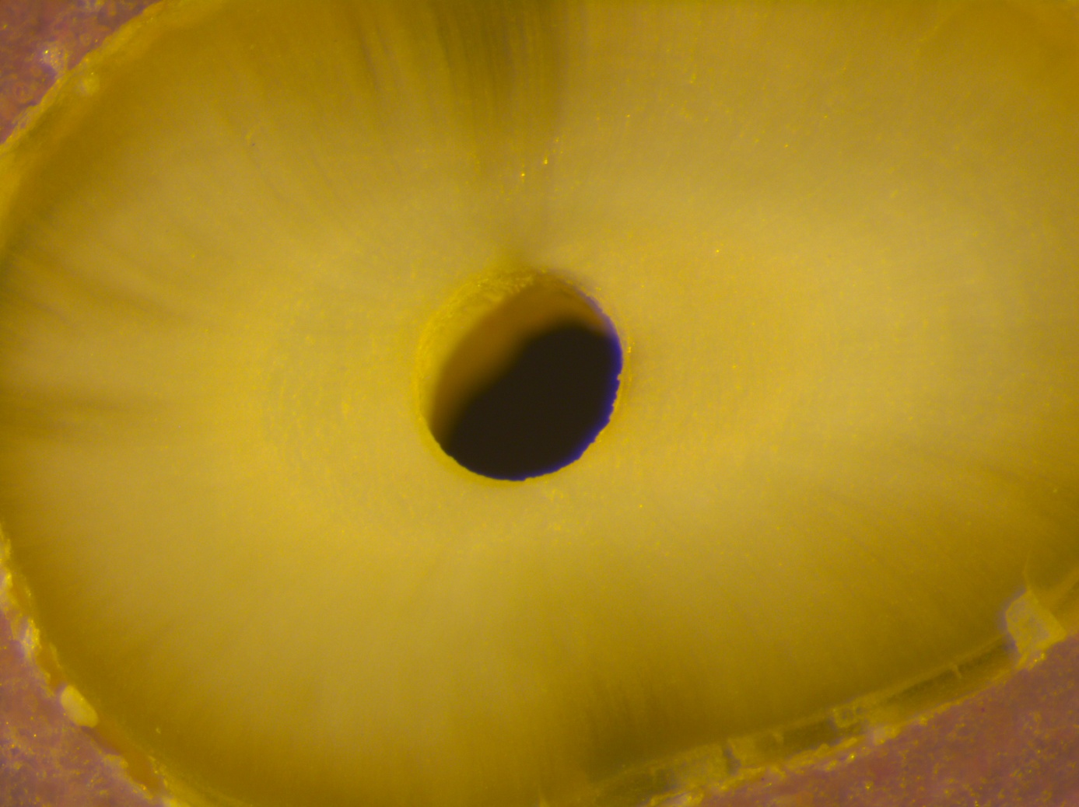
Fig. 1 a
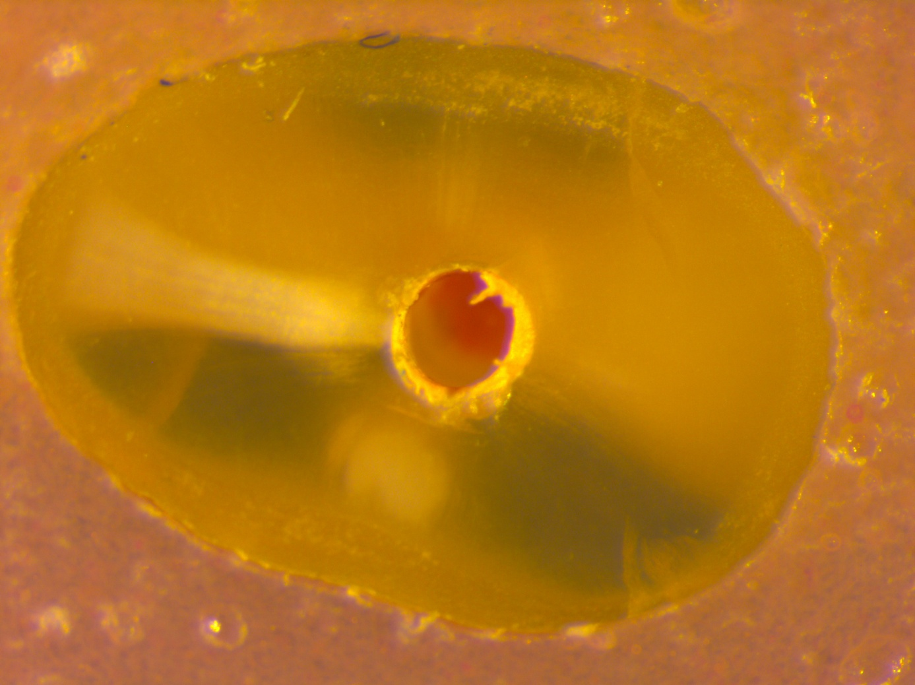
Fig. 1 b
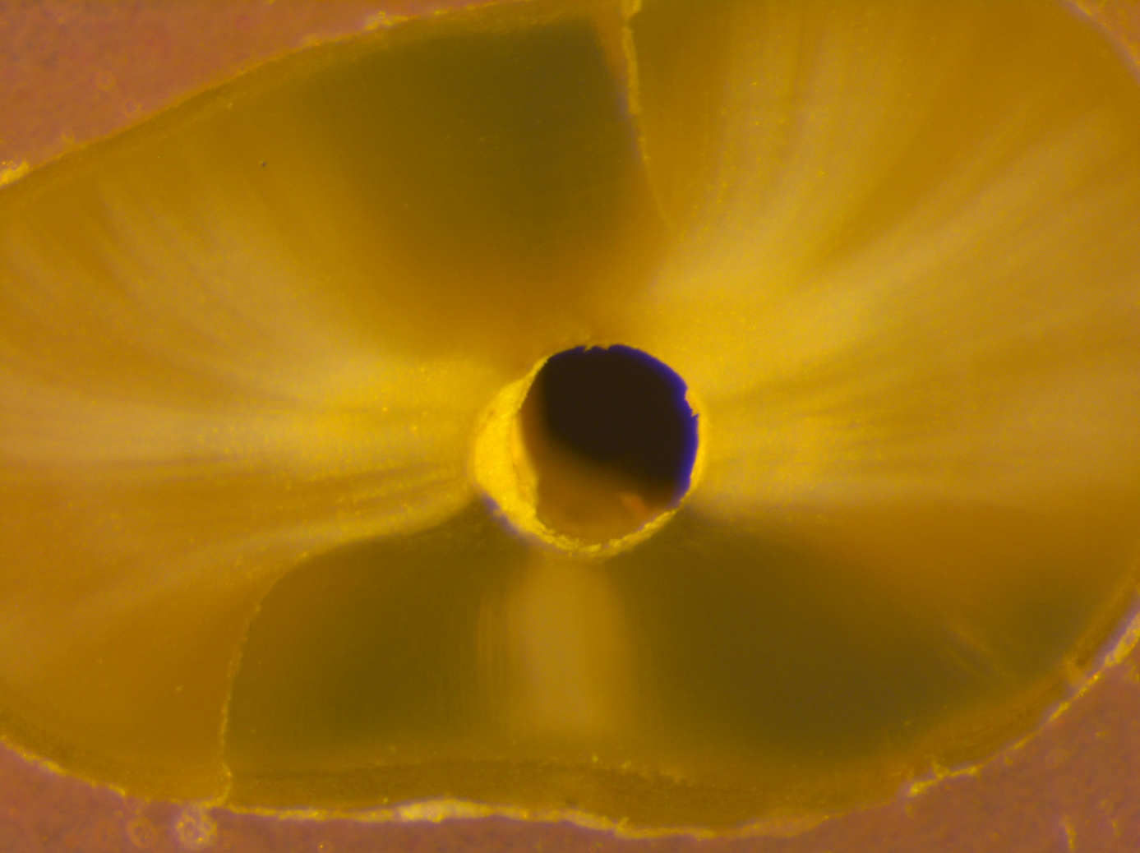
Fig. 1 c
Fig. 2

Fig. 7 Group B1 Coronal

Fig. 7 Group B1 Medial

Fig. 7 Group B1 Apical

Fig. 7 Group B2 Coronal

Fig. 7 Group B2 Medial

Fig. 7 Group B2 Apical

Fig. 7 Group B3 Coronal

Fig. 7 Group B3 Medial

Fig. 7 Group B3 Apical

Fig. 7 Group B4 Coronal

Fig. 7 Group B4 Medial

Fig. 7 Group B4 Apical

