TITLE PAGE
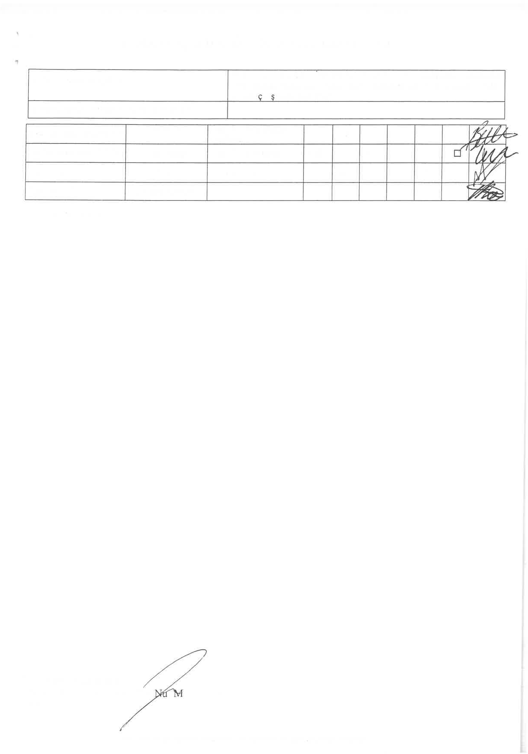
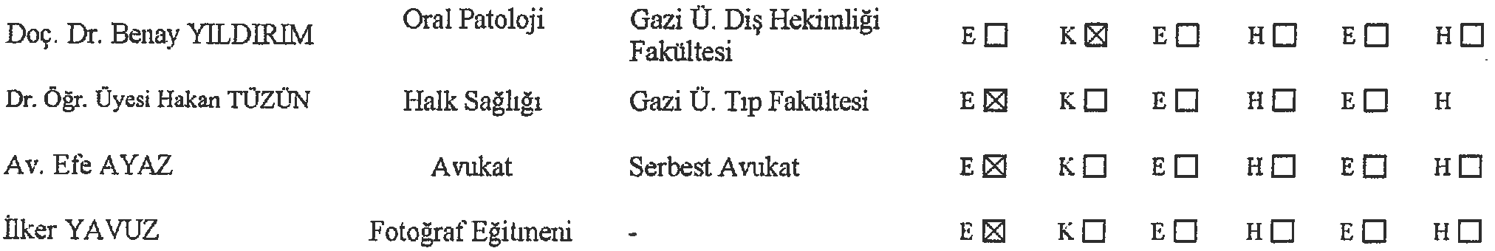
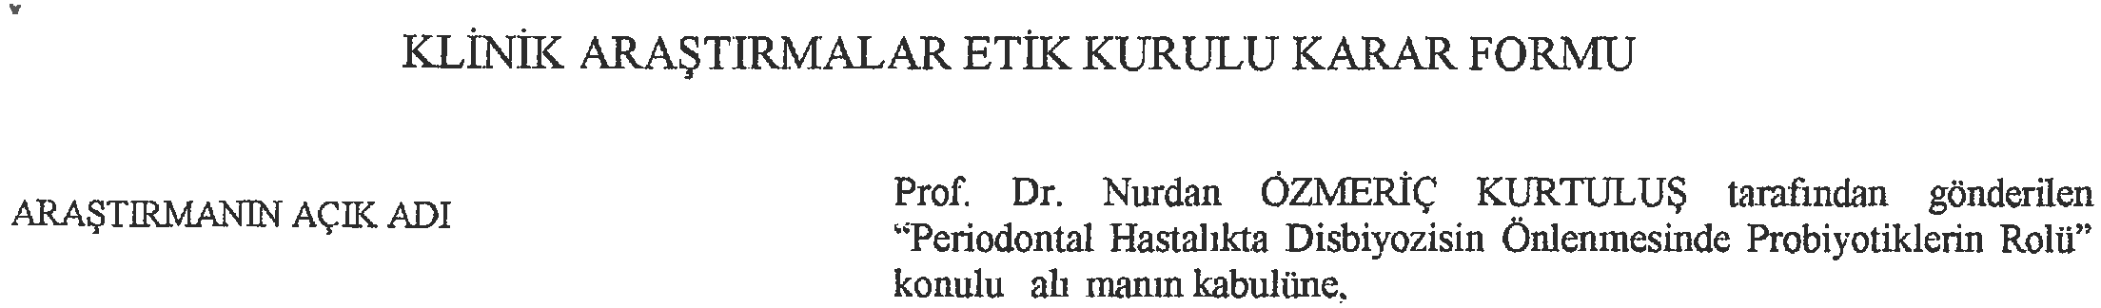



Title: Assessment of Gingival and Aesthetic Parameters after Applying the Laterally Closed Tunnel Approach to the Treatment of Isolated Gingival Recessions: A Case Series
Manuscript Type: Case Series
Running Title: Assessment of the Laterally Closed Tunnel Approach
Tugba Sahin^{1*}
¹ Division of Periodontology, Faculty of Dentistry, Abant Izzet Baysal University, Bolu, Turkey; sahintugba1432@gmail.com, Ass. Prof., DDS, phD, 0000-0002-8133-9406
*Corresponding author: Tugba Sahin; Ass. Prof., DDS, phD; Abant Izzet Baysal University, Faculty of Dentistry, Division of Periodontology, 14030, Gölköy, Bolu, Turkey; Mobile phone: +90505 4643419; e-mail: sahintugba1432@gmail.com;
Keywords: gingival thickness; gingival recession; keratinized tissue thickness; laterally closed tunnel; root coverage aesthetic score

