Influence of saliva substitutes on Candida albicans biofilm formation: an in vitro study

Supporting information’s

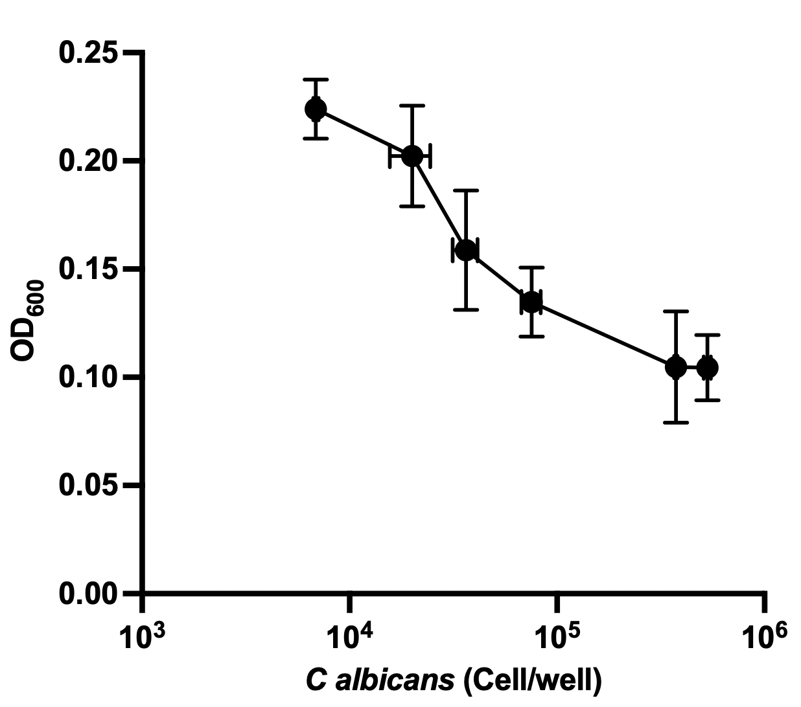

Figure S1 : Effect of Candida albicans concentration at inoculation on the biofilm growth. C. albicans biofilm growth was tested in a 96 well plate upon 24h incubation by the measure of the optical density at 600 nm.
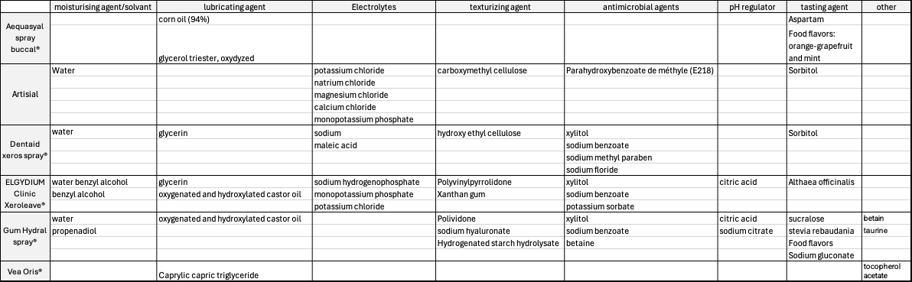

Table S1 : Salivary substitutes composition as stated in the documentation given by the furnishers.

