Fig. S1 The schematic illustration of the microwave plasma system for generating plasma-activated water (PAW). The setup includes a magnetron with a power supply, isolator, directional coupler, 2-stub tuner, and WR-340 waveguide connected to a quartz discharge tube with swirl gas input and ignitor. Plasma effluent was cooled and bubbled into water, with excess gas released through a urea water trap.

Fig. S2 Time-dependent changes in (a) nitrate (NO₃⁻), (b) nitrite (NO₂⁻), (c) H₂O₂, (d) pH, (e) conductivity, and (f) oxidation–reduction potential (ORP) of PAW during storage up to 14 days after manufacturing. Data are presented as mean ± standard deviation (SD; n = 3 independent PAW batches). Concentrations of NO₃⁻, NO₂⁻, and H₂O₂ rapidly declined within the first few days and reached near-baseline levels by day 14, while pH slightly decreased and both conductivity and ORP remained stable during storage.

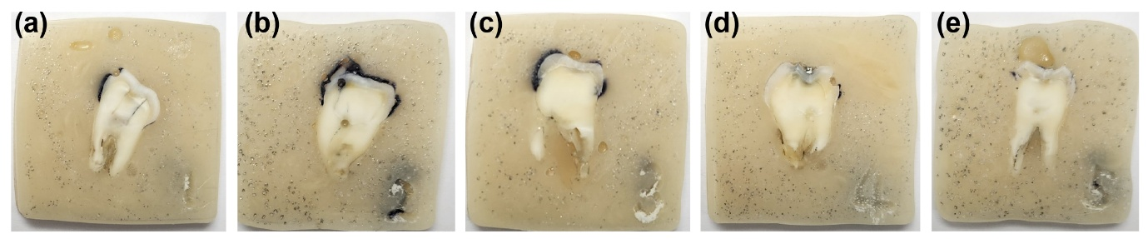
Fig. S3 Representative images of standardized tooth samples prepared for mechanical and structural evaluations. Extracted human teeth were embedded in epoxy resin, sectioned longitudinally, and polished to a mirror finish (1 µm).

Fig. S4 (a) Cell viability of three human oral cell lines (HSC-2, Ca9-22, and YD-10B) after treatment with plasma-activated water (PAW, pH 3) and the control, as assessed using the MTT assay. (b) Survival rates (%) of each cell line evaluated by flow cytometry. Data are presented as mean ± SD from n = 3 biological replicates. * p < 0.05, ** p < 0.01 based on the Kruskal–Wallis test with Dunn’s post hoc correction. (c–e) Representative flow cytometry plots of HSC-2 cells treated with (c) DW, (d) PAW (pH 3), and (e) chlorhexidine (CHX), showing distributions of viable (Q4) and apoptotic/necrotic (Q1) cells. PAW (pH 3) treatment maintained high viability (> 70 %) comparable to DW and significantly higher than CHX, indicating minimal cytotoxicity under the tested conditions.

Fig. S5 Cell viability of (a) human gingival fibroblasts (HGFs) and (b) immortalized human oral keratinocytes (HOK-16B) after exposure to plasma-activated water (PAW) at HCl-adjusted DW (pH 3.0) and pH 5.91, and to distilled water (DW, pH 3), as evaluated using the Cell Counting Kit-8 assay. Data are presented as mean ± SD from n = 6 biological replicates. *** P < 0.001 versus DW (pH 6.8), analyzed using one-way ANOVA followed by Tukey’s post hoc test. The minor reduction in cell viability observed with PAW treatment was partly attributed to its low pH.

