Table S1 Search strategy for PubMed
No. | Search term | Results
#1 | orthodontics[MeSH Terms] OR (orthodontic*[Title/Abstract] OR movement*[Title/Abstract] OR “fix appliance*”[Title/Abstract] OR invisalign[Title/Abstract] OR aligner*[Title/Abstract]) | 488,995
#2 | root resorption[MeSH Terms] OR ((root[Title/Abstract] OR teeth[Title/Abstract] OR tooth[Title/Abstract]) AND (resorp*[Title/Abstract] OR resorb*[Title/Abstract] OR length*[Title/Abstract] OR volume*[Title/Abstract] OR shorten*[Title/Abstract])) | 51,784
#3 | #1 AND #2 | 6,141
#4 | low level laser therapy[MeSH Terms] OR phototherapy[MeSH Terms] OR (photobiomodulation[Title/Abstract] OR biostimulation[Title/Abstract] OR LLLT[Title/Abstract] OR PBM[Title/Abstract] OR PBT[Title/Abstract] OR diode*[Title/Abstract] OR LED[Title/Abstract] OR laser*[Title/Abstract] OR semiconductor*[Title/Abstract]) | 1,142,055
#5 | #3 AND #4 | 291
#6 | dose*[All Fields] OR dosage*[All Fields] OR energy[All Fields] OR density[All Fields] OR power*[All Fields] OR irradiance*[All Fields] OR "spot size*"[All Fields] OR "beam area"[All Fields] OR "irradiation time"[All Fields] OR "exposure time"[All Fields] OR radiant*[All Fields] OR pulse*[All Fields] OR frequency[All Fields] OR wavelength*[All Fields] | 9,739,997
#7 | #5 AND #6 | 114

Table S2 Search strategy for Web of Science
No. | Search term | Results
#1 | TS=(orthodontic* or movement* or "fix appliance*" or invisalign or aligner*) | 1,037,875
#2 | TS=((root* or teeth or tooth) and (resorp* or resorb* or length* or volume* or shorten*)) | 125,954
#3 | #1 AND #2 | 7,457
#4 | TS=("low level laser therapy" or photobiomodulation or phototherapy or biostimulation or LLLT or PBM or PBT or diode* or LED* or laser* or semiconductor*) | 2,970,246
#5 | #3 AND #4 | 453
#6 | ALL=(dose*or dosage* or energy or density or power* or irradiance* or "spot size*" or "beam area" or "irradiation time" or "exposure time" or radiant* or pulse* or frequency or wavelength*) | 14,290,410
#7 | #5 AND #6 | 176
Table S3 Search strategy for Cochrane Library
No. | Search term | Results
#1 | MeSH descriptor: [Orthodontics] explode all trees | 3,683
#2 | (orthodontic* or movement or “fix appliance” or invisalign or aligner):ti,ab,kw | 45,381
#3 | #1 or #2 | 46,363
#4 | MeSH descriptor: [Root Resorption] explode all trees | 211
#5 | ((root or tooth) and (resorp* or resorb* or length or volume or shorten)):ti,ab,kw | 5,289
#6 | #4 or #5 | 5,289
#7 | #3 and #6 | 863
#8 | MeSH descriptor: [Low-Level Light Therapy] explode all trees | 1,687
#9 | MeSH descriptor: [Phototherapy] explode all trees | 5,013
#10 | (photobiomodulation or PBM or PBT or LLLT or biostimulation or diode or LED or laser or semiconductor):ti,ab,kw | 69,141
#11 | #8 or #9 or #10 | 71,737
#12 | #7 and #11 | 110
#13 | (dose or dosage or energy or density or power or irradiance or “spot size” or “beam area” or “irradiation time” or “exposure time” or radiant or pulse or frequency or wavelength) | 717,180
#14 | #12 and #13 | 62

Table S4 Search strategy for Embase via Ovid
No. | Search term | Results
1 | exp orthodontics/ | 40,566
2 | (orthodontic$ or movement$ or "fix appliance$" or invisalign or aligner$).mp. [mp=title, abstract, heading word, drug trade name, original title, device manufacturer, drug manufacturer, device trade name, keyword heading word, floating subheading word, candidate term word] | 737,799
3 | ((root$ or tooth or teeth) and (resorp$ or resorb$ or length$ or volume$ or shorten$)).mp. | 83,733
4 | 1 or 2 | 737,799
5 | 3 and 4 | 8,150
6 | exp low level laser therapy/ or exp phototherapy/ | 133,805
7 | (photobiomodulation or PBM or PBT or LLLT or biostimulation or diode$ or LED$ or laser$ or semiconductor$).mp. | 1,518,995
8 | 6 or 7 | 1,594,335
9 | 5 and 8 | 420
10 | (dose$ or dosage or energy or density or power or irradiance or "spot size" or "beam area" or "irradiation time" or "exposure time" or radiant$ or pulse$ or frequency or wavelength$).mp. | 8,020,814
11 | 9 and 10 | 155

Table S5 Search strategy for MEDLINE via Ovid
No. | Search term | Results
1 | exp orthodontics/ | 58,504
2 | (orthodontic$ or movement$ or "fix appliance$" or invisalign or aligner$).mp. [mp=title, abstract, heading word, drug trade name, original title, device manufacturer, drug manufacturer, device trade name, keyword heading word, floating subheading word, candidate term word] | 632,255
3 | ((root$ or tooth or teeth) and (resorp$ or resorb$ or length$ or volume$ or shorten$)).mp. | 49,027
4 | 1 or 2 | 639,680
5 | 3 and 4 | 6,429
6 | exp low level laser therapy/ | 8,220
7 | exp Phototherapy/ or exp Low-Level Light Therapy/ | 59,965
8 | (photobiomodulation or PBM or PBT or LLLT or biostimulation or diode$ or LED$ or laser$ or semiconductor$).mp. | 842,547
9 | 6 or 7 or 8 | 882,741
10 | 5 and 9 | 291
11 | (dose$ or dosage or energy or density or power or irradiance or "spot size" or "beam area" or "irradiation time" or "exposure time" or radiant$ or pulse$ or frequency or wavelength$).mp. | 5,332,961
12 | 10 and 11 | 98

Table S6 Search strategy for Scopus
No. | Search term | Results
1 | (TITLE-ABS-KEY (orthodontic* OR movement OR {fix* appliance} OR invisalign OR aligner) AND TITLE-ABS-KEY ((root OR tooth) AND (resorp* OR resorb* OR length OR volume OR shorten*)) AND TITLE-ABS-KEY ({low level laser therapy} OR photobiomodulation OR phototherapy OR biostimulation OR LLLT OR PBM OR PBT OR diode* OR LED* OR laser OR semiconductor*) AND ALL (dose OR dosage OR energy OR density OR power* OR irradiance OR {spot size} OR {beam area} OR {irradiation time} OR {exposure time} OR radiant* OR pulse OR frequency OR wavelength)) | 288

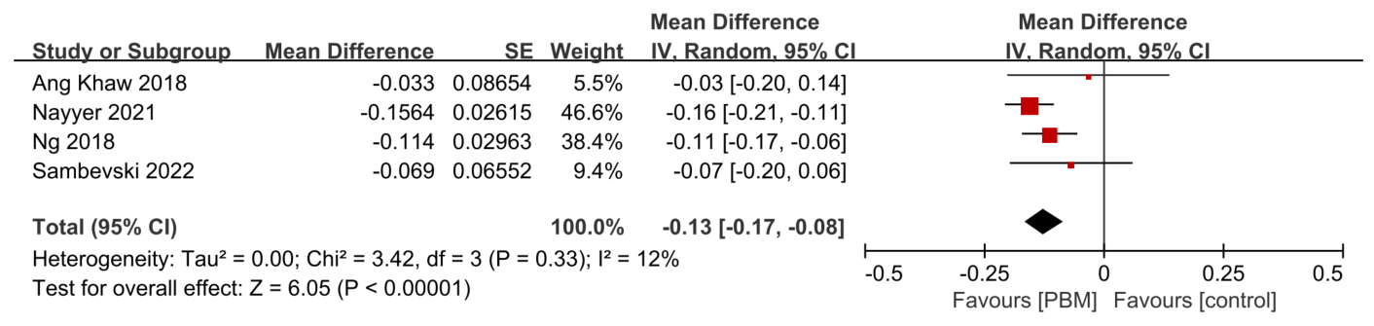
Fig. S1 Sensitivity analysis of meta-analysis in mean total crater volume (mm³) of OIIRR. The results did not change with a within-person correlation setting as 0.30 (p < 0.00001), suggesting a robust result.

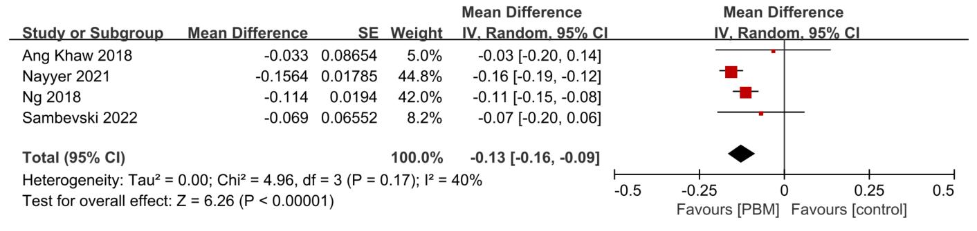
Fig. S2 Sensitivity analysis of meta-analysis in mean total crater volume (mm³) of OIIRR. The results did not change with a within-person correlation setting as 0.70 (p < 0.00001), suggesting a robust result.

