Supplementary data
Table S1. Inclusion and exclusion criteria.
Inclusion criteria | Exclusion criteria
- Adult male and female patients aged between 19 and 80 years.  - Patients with at least 14 remaining teeth in the maxilla and mandible.  - Patients with at least one quadrant containing both a canine and a first molar among the remaining teeth. | - Patients who have taken antibiotics within the past three months.  - Patients with fewer than 14 total remaining teeth in the maxilla and mandible.  - Patients who have received scaling or periodontal treatment within the past six months.  - Patients who lack sufficient cooperation, making accurate sample collection in the dental unit chair difficult.  - Patients deemed unsuitable for study participation by the researcher owing to ethical concerns or potential impacts on study results.

Table S2. Questionnaire: SHCN Patient Intake Form (English Version).
1. Patient Information
Item | Response Format
Gender | ☐ Male ☐ Female ☐ Other
Age | ________ years old
2. Medical and Disability-Related Information
Item | Response Format
Type of disability | ☐ Intellectual disability  ☐ Autism spectrum disorder  ☐ Neurological disorder  ☐ Others: ____________
Specific diagnosis (if any) | _________________________________________
Other diagnosed conditions (e.g., hypertension, diabetes, cardiovascular diseases) | _________________________________________
Current medications (e.g., anticoagulants, antiplatelet agents, osteoporosis medications) | _________________________________________
Alcohol consumption | ☐ Yes ☐ No
Smoking status | ☐ Current smoker ☐ Former smoker ☐ Never smoked
3. Oral Health and Caregiver Support
Item | Response Format
Level of cooperation during dental treatment | ☐ Cooperative ☐ Partially cooperative (only simple treatments are possible)  ☐ Uncooperative (only examination possible)  ☐ Almost all treatments are impossible
Need for caregiver support in oral hygiene | ☐ Brushing independently  ☐ Brushing with caregiver’s assistance  ☐ Brushing done entirely by caregiver
Patient’s current residence | ☐ Home ☐ Home + School/Welfare facility (daytime) ☐ Facility/Group home (day + night) ☐ Other: __________
Primary caregiver | ☐ Parents ☐ Siblings, children, spouse, or other family ☐ Relatives ☐ Professional caregiver  ☐ Self (no assistance needed)
Dietary type | ☐ Regular diet including hard food  ☐ Soft food ☐ Porridge/liquid diet  ☐ Other ______
Toothbrushing assistance | ☐ Self alone ☐ Self with assistance  ☐ Assisted by others  ☐ Rarely brushes teeth
Toothbrushing frequency and duration | ☐ More than twice a day, ≥3 minutes  ☐ More than twice a day, 1–2 minutes  ☐ Once a day ☐ Once every few days

Table S3. Summary of probing depth (PD) changes before and after treatment (N=32).
Tooth Type | Visit | Mean PD (mm) ± SD | ΔPD
Canine | 1st visit | 3.06 ± 0.97
Canine | 3rd visit | 2.61 ± 0.85 | -0.45
First molar | 1st visit | 3.55 ± 1.09
First molar | 3rd visit | 2.91 ± 1.05 | -0.65

Table S4. Individual probing depth (PD) values at mesial, middle, and distal sites of canines and first molars.
Number | Visit Day | Tooth | Mesial PD (mm) | Middle PD (mm) | Distal PD (mm)
1 | 1st | Canine | 2 | 1 | 3
1 | 1st | First molar | 3 | 2 | 3
1 | 3rd | Canine | 2 | 1 | 3
1 | 3rd | First molar | 3 | 2 | 3
2 | 1st | Canine | 4 | 3 | 5
2 | 1st | First molar | 4 | 3 | 4
2 | 3rd | Canine | 4 | 3 | 4
2 | 3rd | First molar | 3 | 3 | 4
3 | 1st | Canine | 2 | 3 | 3
3 | 1st | First molar | 4 | 3 | 3
3 | 3rd | Canine | 2 | 2 | 3
3 | 3rd | First molar | 2 | 2 | 3
4 | 1st | Canine | 4 | 2 | 5
4 | 1st | First molar | 4 | 3 | 5
4 | 3rd | Canine | 3 | 1 | 4
4 | 3rd | First molar | 3 | 3 | 3
5 | 1st | Canine | 3 | 2 | 3
5 | 1st | First molar | 5 | 4 | 9
5 | 3rd | Canine | 4 | 3 | 4
5 | 3rd | First molar | 9 | 6 | 6
6 | 1st | Canine | 3 | 3 | 3
6 | 1st | First molar | 3 | 3 | 3
6 | 3rd | Canine | 2 | 3 | 3
6 | 3rd | First molar | 3 | 3 | 3
7 | 1st | Canine | 5 | 2 | 4
7 | 1st | First molar | 3 | 3 | 5
7 | 3rd | Canine | 4 | 1 | 3
7 | 3rd | First molar | 3 | 2 | 4
8 | 1st | Canine | 3 | 2 | 4
8 | 1st | First molar | 4 | 3 | 4
8 | 3rd | Canine | 3 | 2 | 4
8 | 3rd | First molar | 4 | 3 | 4
9 | 1st | Canine | 4 | 5 | 5
9 | 1st | First molar | 5 | 5 | 5
9 | 3rd | Canine | 3 | 3 | 3
9 | 3rd | First molar | 3 | 2 | 3
10 | 1st | Canine | 3 | 2 | 3
10 | 1st | First molar | 4 | 3 | 4
10 | 3rd | Canine | 3 | 2 | 3
10 | 3rd | First molar | 4 | 3 | 4
11 | 1st | Canine | 4 | 3 | 4
11 | 1st | First molar | 4 | 3 | 4
11 | 3rd | Canine | 3 | 2 | 3
11 | 3rd | First molar | 3 | 2 | 3
12 | 1st | Canine | 4 | 2 | 3
12 | 1st | First molar | 3 | 3 | 4
12 | 3rd | Canine | 3 | 2 | 2
12 | 3rd | First molar | 2 | 2 | 3
13 | 1st | Canine | 3 | 1 | 3
13 | 1st | First molar | 2 | 2 | 3
13 | 3rd | Canine | 3 | 1 | 3
13 | 3rd | First molar | 2 | 2 | 2
14 | 1st | Canine | 3 | 3 | 3
14 | 1st | First molar | 2 | 2 | 3
14 | 3rd | Canine | 2 | 2 | 2
14 | 3rd | First molar | 2 | 2 | 2
15 | 1st | Canine | 3 | 2 | 3
15 | 1st | First molar | 3 | 4 | 4
15 | 3rd | Canine | 4 | 3 | 5
15 | 3rd | First molar | 3 | 3 | 5
16 | 1st | Canine | 2 | 1 | 3
16 | 1st | First molar | 3 | 2 | 3
16 | 3rd | Canine | 2 | 1 | 3
16 | 3rd | First molar | 3 | 2 | 3
17 | 1st | Canine | 4 | 4 | 3
17 | 1st | First molar | 5 | 4 | 5
17 | 3rd | Canine | 3 | 2 | 3
17 | 3rd | First molar | 3 | 3 | 3
18 | 1st | Canine | 5 | 3 | 4
18 | 1st | First molar | 4 | 6 | 5
18 | 3rd | Canine | 4 | 2 | 3
18 | 3rd | First molar | 3 | 3 | 4
19 | 1st | Canine | 3 | 2 | 3
19 | 1st | First molar | 4 | 3 | 6
19 | 3rd | Canine | 2 | 2 | 3
19 | 3rd | First molar | 3 | 3 | 4
20 | 1st | Canine | 2 | 2 | 3
20 | 1st | First molar | 4 | 3 | 5
20 | 3rd | Canine | 3 | 2 | 3
20 | 3rd | First molar | 2 | 3 | 3
21 | 1st | Canine | 4 | 3 | 4
21 | 1st | First molar | 3 | 3 | 4
21 | 3rd | Canine | 3 | 1 | 3
21 | 3rd | First molar | 2 | 2 | 3
22 | 1st | Canine | 5 | 3 | 3
22 | 1st | First molar | 3 | 3 | 3
22 | 3rd | Canine | 3 | 2 | 3
22 | 3rd | First molar | 3 | 3 | 3
23 | 1st | Canine | 3 | 2 | 4
23 | 1st | First molar | 4 | 4 | 4
23 | 3rd | Canine | 2 | 3 | 3
23 | 3rd | First molar | 3 | 3 | 4
24 | 1st | Canine | 3 | 2 | 3
24 | 1st | First molar | 3 | 3 | 3
24 | 3rd | Canine | 2 | 1 | 2
24 | 3rd | First molar | 3 | 1 | 2
25 | 1st | Canine | 3 | 1 | 2
25 | 1st | First molar | 3 | 2 | 3
25 | 3rd | Canine | 3 | 1 | 3
25 | 3rd | First molar | 3 | 2 | 3
26 | 1st | Canine | 3 | 3 | 4
26 | 1st | First molar | 4 | 3 | 4
26 | 3rd | Canine | 3 | 2 | 3
26 | 3rd | First molar | 4 | 2 | 2
27 | 1st | Canine | 2 | 2 | 3
27 | 1st | First molar | 2 | 2 | 2
27 | 3rd | Canine | 2 | 2 | 2
27 | 3rd | First molar | 2 | 2 | 2
28 | 1st | Canine | 3 | 3 | 4
28 | 1st | First molar | 4 | 3 | 4
28 | 3rd | Canine | 3 | 1 | 3
28 | 3rd | First molar | 3 | 2 | 3
29 | 1st | Canine | 4 | 2 | 3
29 | 1st | First molar | 4 | 3 | 3
29 | 3rd | Canine | 3 | 1 | 3
29 | 3rd | First molar | 3 | 1 | 2
30 | 1st | Canine | 5 | 2 | 3
30 | 1st | First molar | 5 | 2 | 4
30 | 3rd | Canine | 3 | 2 | 2
30 | 3rd | First molar | 3 | 2 | 3
31 | 1st | Canine | 3 | 3 | 3
31 | 1st | First molar | 3 | 2 | 3
31 | 3rd | Canine | 3 | 3 | 3
31 | 3rd | First molar | 3 | 3 | 3
32 | 1st | Canine | 2 | 3 | 5
32 | 1st | First molar | 4 | 3 | 5
32 | 3rd | Canine | 4 | 2 | 3
32 | 3rd | First molar | 3 | 2 | 3

Table S5. Primer and probe sequences of target bacteria with BLAST validation results used in this study.
Disease  association | Risk level | Bacterial species | Primer/Probe | Probe sequence | Amplicon (bp) | On-target accession | Non-target hits
Periodontal  disease | High | Aa | AaLtF14  AaLtR11  AaLtP13 | CGGTGGAGAAGGAAATGATATTTATG  ATTGCCGTTACGCTCAAATG  FAM-CCACACTATTACGGAACATAGCGGTG-BHQ-1 | 139 | NZ_CP085096.1 | None  (Bacteria/Human)
Periodontal  disease | High | Pg | PghaF14  PghaR13  PghaP11B | GCAGGGTCAGAAAGTAACGCTC  CGATCCGTTTTACTTCACGG  HEX-CCGAGCGCAAAGAAGGCAGAA-BHQ-1 | 80 | NC_010729.1 | None  (Bacteria/Human)
Periodontal  disease | High | Tf | TfKpF13  TfKpR12  TfKpP11 | CCGGCGGTTTCCTGTAGTAGA  ACTTCGTCCGTTGCAGGGTT  TEXAS RED-CTCCCTTCACCCTCTCGCCG-BHQ-2 | 68 | NC_016610.1 | None  (Bacteria/Human)
Periodontal  disease | High | Td | TdopF13  TdopR13  TdopP01 | CATCTCTTGATGCAGCCGAAG  GTCAGGGCTTACAACATAGTCGTC  Cy5-TGGCGGAAGGAAAACAAGCC-BHQ-2 | 98 | NC_002967.9 | None  (Bacteria/Human)
Periodontal  disease | Intermediated | Fn | FnChF15  FnChR13  FnChP12 | GACATCTTAGGAATGAGACAGAGATG  CAGCCATGCACCACCTGTCT  TEXAS RED-CAGTGTCCCTTCGGGGAAACCT-BHQ-2 | 73 | NZ_CP028101.1 | F. polymorphum,  F. vincentii,  F. periodonticum,  F. hwasookii,  F. pseudoperiodonticum,  F. canifelinum
Periodontal  disease | Intermediated | Pn | PngyF12  PngyR13  PngyP11 | GCAAGAACGTGATGACGGGA  ATTTCGCAGTCTTTGGGATCT TT  Cy5-TTGCCAGGAAAACTTGCCGA-BHQ-2 | 79 | NZ_CP072339.1 | None  (Bacteria/Human)
Periodontal  disease | Intermediated | Pi | PipiF12  PipiR13  Pi194P13H | CCACCAACGACAACCTTCCA  TCTACTGCTTCGAGCGCAC  HEX-CAAGACAATCTCCGACGGAACGTT-BHQ-1 | 130 | NZ_CP019301.1 | None  (Bacteria/Human)
Periodontal  disease | Intermediated | En | EnglF01  EnglR01  EnglP01 | ATCCACAACAAAAGCGGCCT  AGGAATGTCCGGAGCAGGAA  HEX-CAAACCAATCTGCAGCATGGG-BHQ-1 | 157 | AZKM01000029.1 | None  (Bacteria/Human)
Periodontal  disease | Intermediated | Pm | PmF-30  PmR-30  Pm16S30 | AAACGACGATTAATACCACATGAGAC  ACTGCTGCCTCCCGTAGGA  TEXAS RED-TCAAAGATTTATCGGTGTAAGAAGGGCTCGC-BHQ-2 | 201 | NZ_LR134472.1 | None  (Bacteria/Human)
Periodontal  disease | Intermediated | Cr | CrgrF14  CrgrR12  CrgrP01 | GCGAAGTAGTGAGCGAAGAG  GCCTGCGCCATTTACGATA  FAM-CAAGCGTGATCATCGACAAGGATAACA-BHQ-1 | 119 | NZ_CP012543.1 | None  (Bacteria/Human)
Periodontal  disease | Low | Ec | EcISRF-21  EcISRR-21  EcISRP21 | AGGCGACGAAGGACGTGTAA  ATCACCGGATCAAAGCTCTATTG  Cy5-CGTGTAAGCCTGCGAAAAGCATCG-BHQ-2 | 69 | NZ_LT906482.1 | E. exigua,  E. halliae
Dental  caries | - | Sm | Forward  Reverse  Probe | GCCTACAGCTCAGAGATGCTATTCT  GCCATACACCACTCATGAATTGA  TGGAAATGACGGTCGCCGTTATGAA | 114 | NZ_CP077404.1 | S. troglodytae
Dental  caries | - | Ss | Forward  Reverse  Probe | GTGTCTCAGTCCCAGTGTGG  GATAGCTAATACCGCATAAGAGGAGT  TCAGATGGACCTGCGTTGTATTA | 174 | NZ_CP029490.1 | None  (Bacteria/Human)
Aa: Aggregatibacter actinomycetemcomitans; Pg: Porphyromonas gingivalis; Tf: Tannerella forsythia; Td: Treponema denticola; Fn: Fusobacterium nucleatum; Pn: Prevotella nigrescens; Pi: Prevotella intermedia; En: Eubacterium nodatum; Pm: Parvimonas micra; Cr: Campylobacter rectus; Ec: Eikenella corrodens; Sm: Streptococcus mutans; Ss: Streptococcus sobrinus

Table S6. Patient characteristics by disability type.
 |  | Total  (n=47) | ID  (n=19) | ASD  (n=10) | ND  (n=11) | Etc  (n=7) | P-value
Age  (Mean, +/-) |  | 34.62±11.95 | 31.05±4.72 | 25.60±4.13 | 46.45±15.31 | 38.57±10.95 | 0.0007
Gender | Male | 32 | 13 | 9 | 7 | 3 | 0.2605
Gender | Female | 15 | 6 | 1 | 4 | 4
Meal type | Regular | 38 | 15 | 9 | 7 | 7 | 0.4130
Meal type | Soft | 8 | 4 | 1 | 3 | 0
Meal type | Liquid | 1 | 0 | 0 | 1 | 0
Brushing  subject | Self alone | 22 | 12 | 3 | 3 | 4 | 0.0417
Brushing  subject | Self with assistance | 13 | 4 | 6 | 2 | 1
Brushing  subject | Assisted by others | 12 | 3 | 1 | 6 | 2
Brushing  frequency | Twice a day or more, 3 minutes | 18 | 4 | 4 | 5 | 5 | 0.6952
Brushing  frequency | Twice a day or more, 1-2 minutes | 22 | 11 | 5 | 4 | 2
Brushing  frequency | Once a day | 4 | 2 | 1 | 1 | 0
Brushing  frequency | Every few days | 2 | 1 | 0 | 1 | 0
Brushing  frequency | No information | 1 | 1 | 0 | 0 | 0
Caregiver | Parents | 26 | 8 | 6 | 8 | 4 | 0.0411
Caregiver | Family members | 5 | 2 | 1 | 0 | 2
Caregiver | Assistant | 7 | 4 | 1 | 2 | 0
Caregiver | Other | 2 | 2 | 0 | 0 | 0
Caregiver | Self | 2 | 2 | 0 | 0 | 0
Caregiver | Parents/Family members | 1 | 0 | 1 | 0 | 0
Caregiver | Parents/Assistant | 4 | 1 | 1 | 1 | 1
ID: intellectual disabilities; ASD: autism spectrum disorder; ND: neurological disorders; Etc: other disabilities.

Table S7. Bacterial species showing significant variations across visits categorized by disability type.
Disability | ID |  |  | ASD |  |  | ND
visit | 1st-2nd | 1st-3rd | 2nd-3rd | 1st-2nd | 1st-3rd | 2nd-3rd | 1st-2nd | 1st-3rd | 2nd-3rd
Aggregatibacter actinomycetemcomitans | ns | ns | ns | ns | ns | ns | ns | ns | ns
Porphyromonas gingivalis | * | ns | * | ns | ns | ns | ns | ns | ns
Tannerella forsythia | ns | ns | ns | ns | ns | ns | ns | ns | ns
Treponema denticola | ** | * | * | ns | ns | ns | ns | ns | ns
Fusobacterium nucleatum | ** | ns | ** | ns | ns | ns | * | * | ns
Prevotella intermedia | ns | ns | ns | ns | ns | ns | ns | ns | ns
Prevotella nigrescens | ns | ns | ns | * | ns | * | ns | ns | ns
Parvimonas micra | ns | ns | ns | * | ns | ns | ns | ns | ns
Eubacterium nodatum | ns | ns | ns | ns | ns | ns | ns | ns | ns
Campylobacter rectus | ns | ns | ns | ns | ns | ns | ns | ns | ns
Eikenella corrodens | ns | * | ns | ns | ns | ns | ns | ns | *
Streptococcus sobrinus | ns | ns | ns | ns | ns | ns | ns | ns | ns
Streptococcus mutans | ns | ns | ns | ns | ns | ns | ns | ns | ns
ID: intellectual disabilities; ASD: autism spectrum disorder; ND: neurological disorders.
***: p-value<0.001, **: p-value<0.01, *: p-value<0.05, ns: not significant

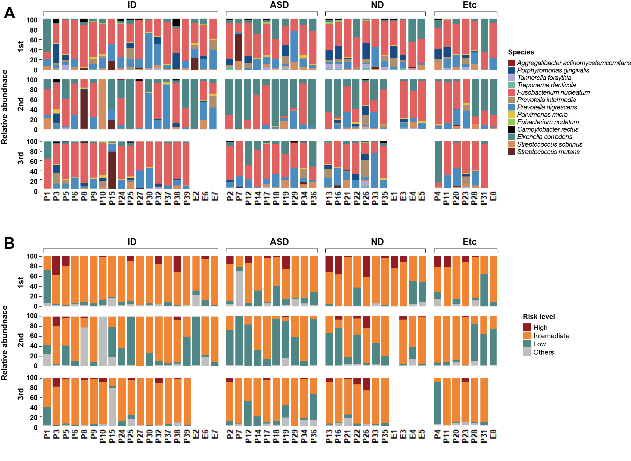 Figure S1. Microbial composition profiles of individual patients.
The bacterial distribution of individual patients is presented across visits and disability types. (A) Each color represents a specific bacterial species. (B) Groups are categorized by periodontal disease risk. White spaces indicate uncollected samples owing to missed follow-up visits.

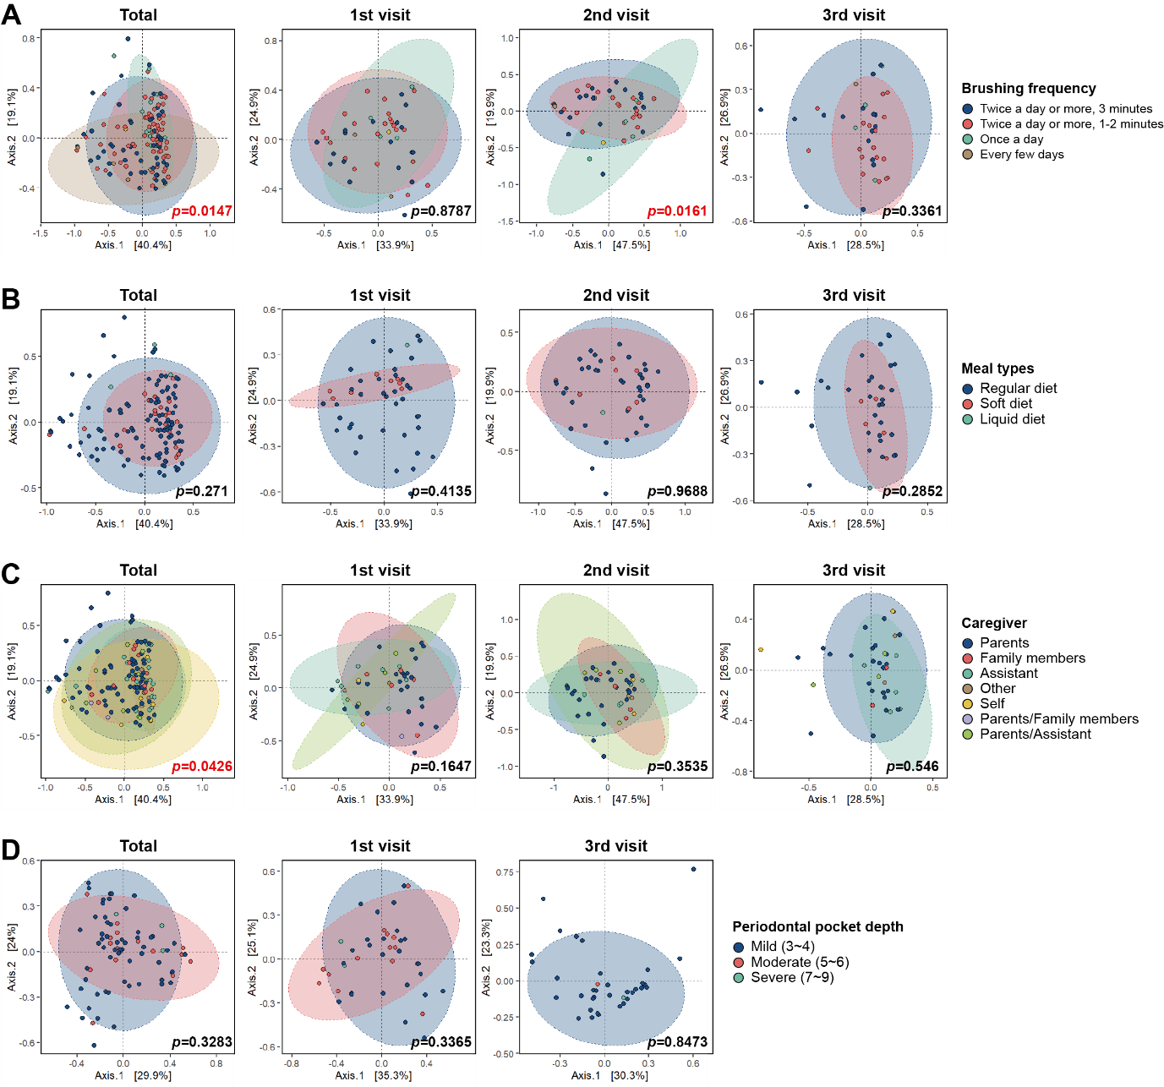 Figure S2. Analysis of microbial community similarity between groups based on clinical information.
Each principal coordinate analysis (PCoA) plot shows microbial community distribution based on different clinical variables: (A) brushing frequency, (B) meal type, (C) caregiver involvement, and (D) periodontal pocket depth. The axes represent the percentage of variance explained by each component. The ellipses indicate the 95% confidence intervals for each group, and points represent individual samples. Different colors represent distinct clinical groupings, as indicated in the legend on the right side of the figure. The p-values provided in each plot, calculated using permutational analysis of variance (PERMANOVA), indicate the significance of group separation for each clinical variable.

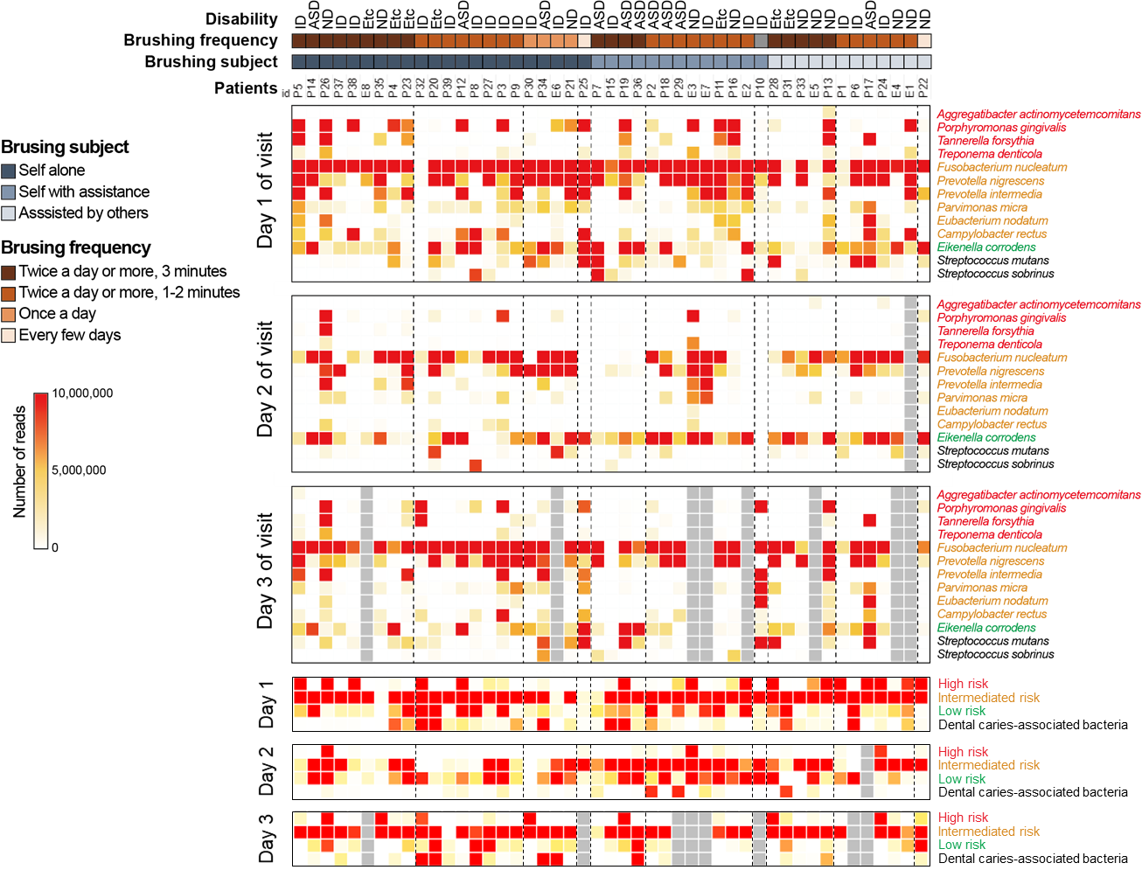
Figure S3. Distribution of selected bacterial species abundance in individual patients based on disability types and brushing patterns.
The heatmap shows the actual abundance distribution of selected bacterial species across individual patients categorized by brushing habits on different visit days. The x-axis represents individual patients, whereas the y-axis lists bacterial species or their periodontal risk groupings, with color intensity indicating abundance levels. Patients are grouped based on their brushing habits, with blue gradient boxes representing the brushing subject and brown gradient boxes showing brushing frequency. The disability type for each patient is indicated at the top of the heatmap. Gray boxes indicate instances where follow-up samples were not collected because of missed visits.

