Graph 1. Film thickness values (µm) obtained from single and double-layer applications of Clearfil Tri-S Bond and G2-Bond Universal systems.
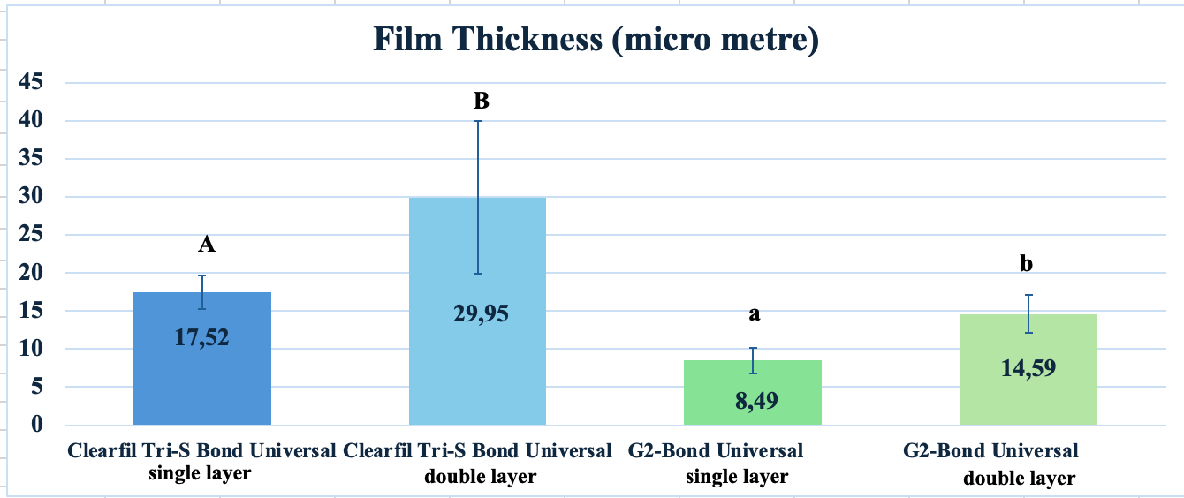
Graph 2. Immediate and after thermalcycles mean microtensile bond strength (µTBS) values and standard deviations for single and double-layer applications of Clearfil Tri-S Bond Universal and G2-Bond Universal.
