Effect of Preparation Design on the Fracture Behavior of 3D-Printed Restorations
in an In-Vitro Tooth Wear Model
Authors: Thao Ly Nguyen-Thi¹, Thien Man Tran¹, Huyen Phuong Tran-Thi¹, Phuong Mai Nguyen-Ho², Thanh Tin Do³, Minh-Huy Dang ¹*
Affiliations:
¹ Faculty of Odonto- Stomatology, Hue University of Medicine and Pharmacy, Hue University, Hue City, Vietnam
² Center of Odonto- Stomatology, Hue Central Hospital, Hue City, Vietnam
³ Faculty of Dentistry, Duy Tan University, Da Nang City, Vietnam
Corresponding author:
Dr. Minh-Huy Dang
Faculty of Odonto- Stomatology, Hue University of Medicine and Pharmacy, Hue University, Vietnam
Email: dangminhhuy@hueuni.edu.vn
Phone: +84935757093
ORCID: 0000-0002-6910-9333

Supplementary Materials
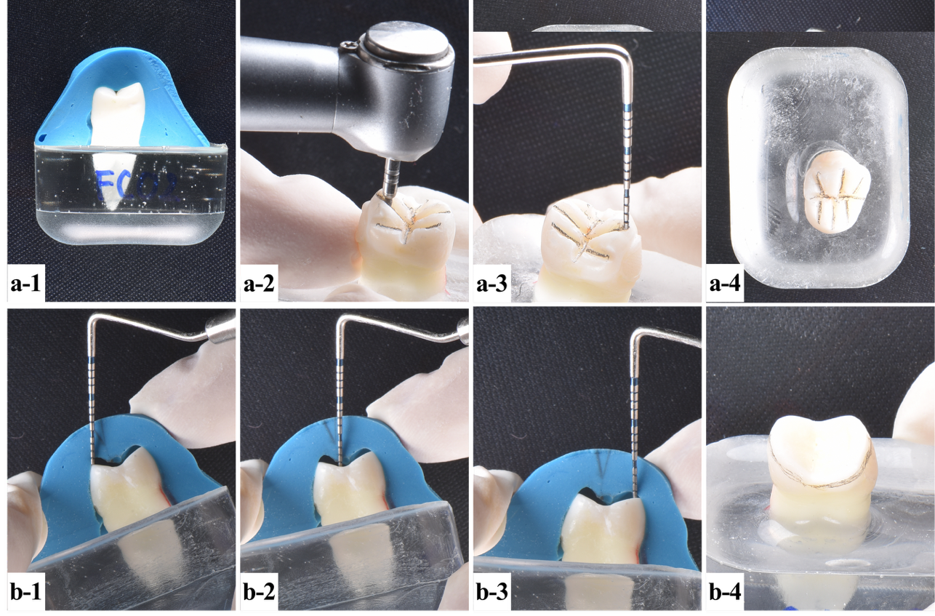
Figure S1. Occlusal reduction of 1-1.2 mm to replicate the tooth wear process
a-1. Silicone index; a-2. Making 1.0 mm-depth cuts to guide the uniform occlusal reduction using Komet bur PrepMarker FG DM10 314.009; a-3. Verifying groove depth using a periodontal probe; a-4. Reducing the occlusal surface by joining the depth cut grooves using Komet bur 855D.314.016 and 8370.314.030; b1-4. Verifying the occlusal reduction using the silicone index
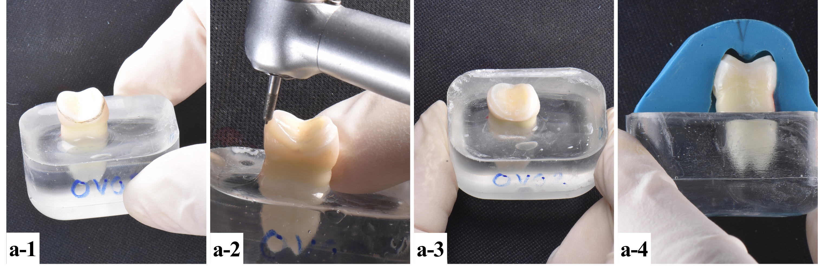
Figure S2 (a1-4). Overlay preparation
a1,2. Creating a 0.5-mm chamfer finish line using Komet bur 8849P.314.016; a3,4. Verifying of the preparation using the silicone index
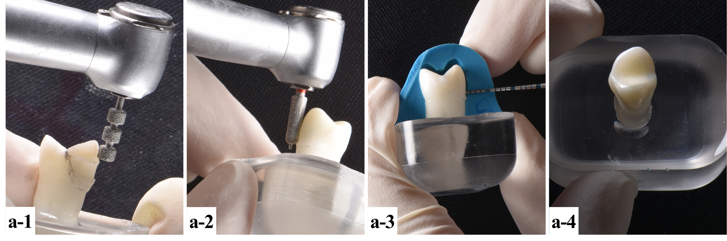
Figure S3 (a1-4, b1-4). Veneerlay preparation
a1,2. Making 0.8 mm-depth cuts to guide the uniform buccal reduction using NTI bur 834L-027M-FG then creating a 0.8mm chamfer finish line using NTI bur 998-021SC-FG; a3,4. Verifying the preparation using the silicone index
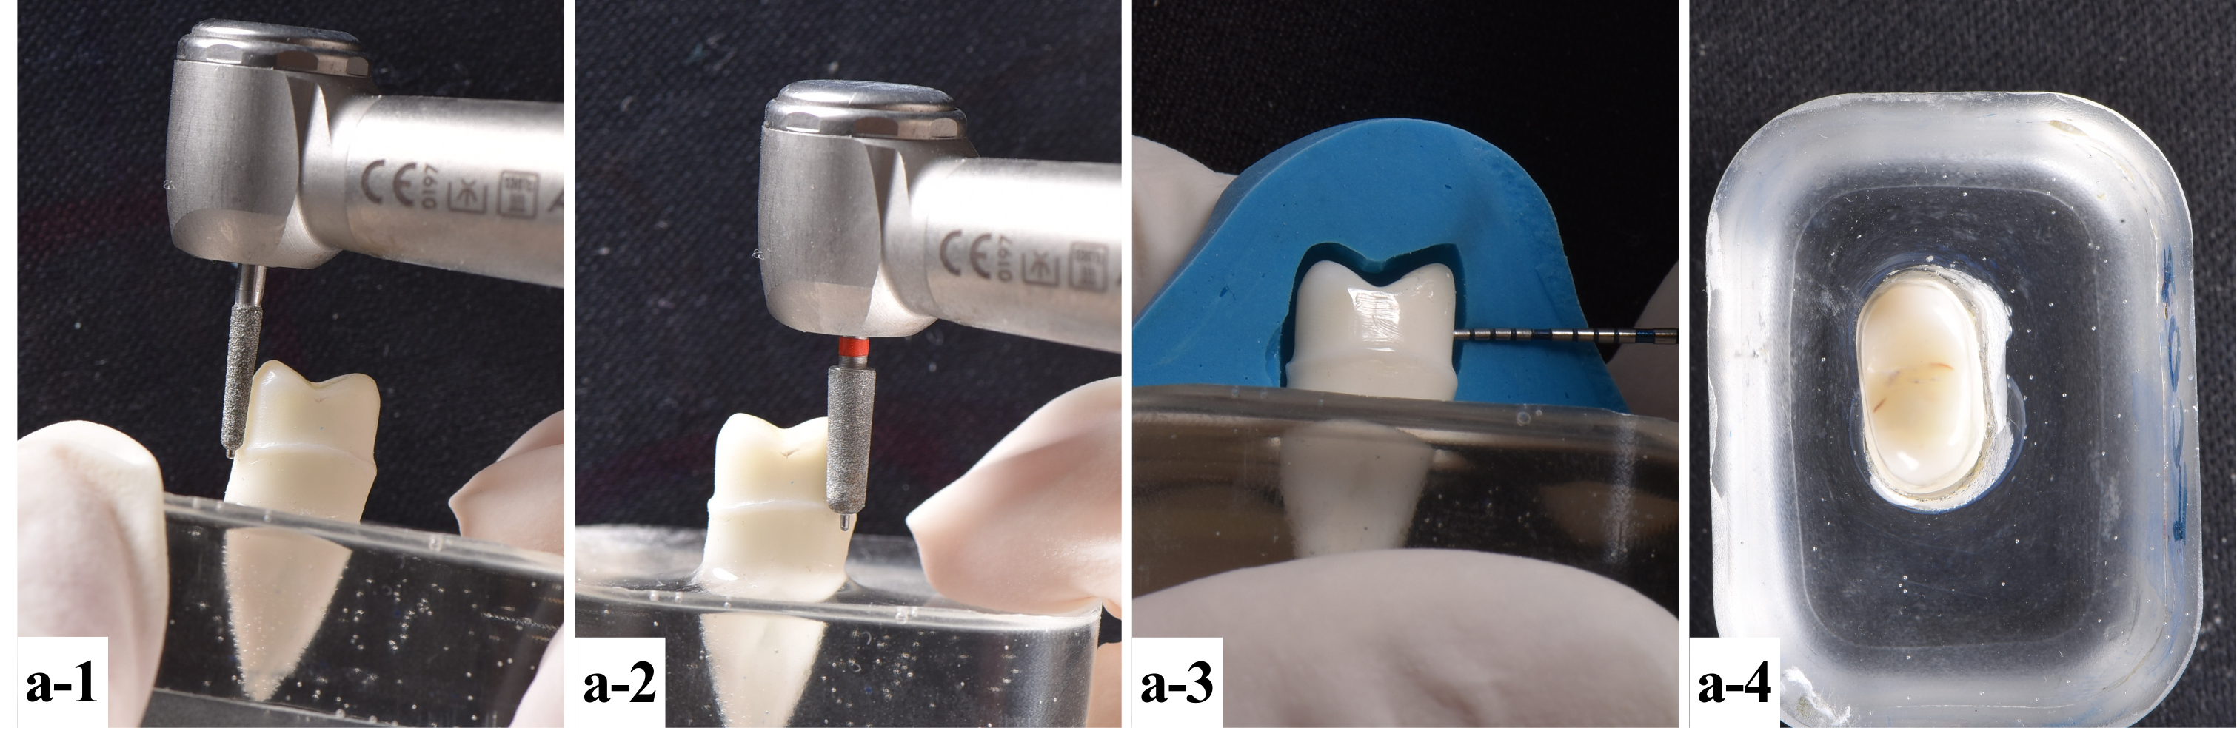
Figure S4 (a1-4). Full crown preparation
a1,2. Making 0.8 mm-depth cuts to guide the uniform circumferential reduction using NTI bur 834L-027M-FG and then creating 0,8mm chamfer finish line using NTI bur 998-021SC-FG; a3,4. Verifying of the preparation using the silicone index
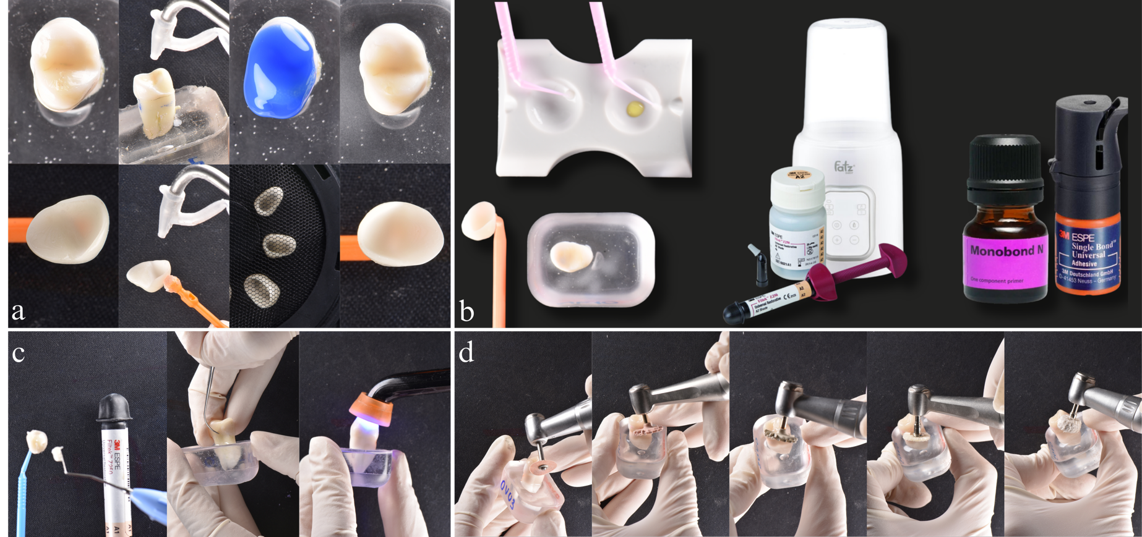
Figure S5 (a, b, c, d). Adhesive cementation
(a), (b) Tooth and restoration conditioning; (c) Cementation; (d) Finishing and polishing
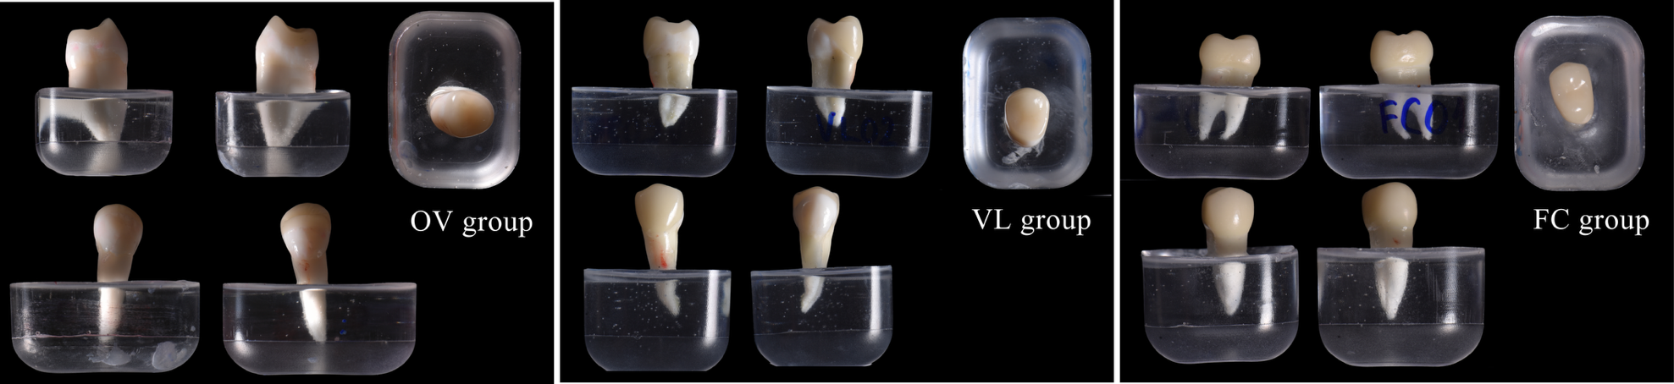
Figure S6. Restored groups
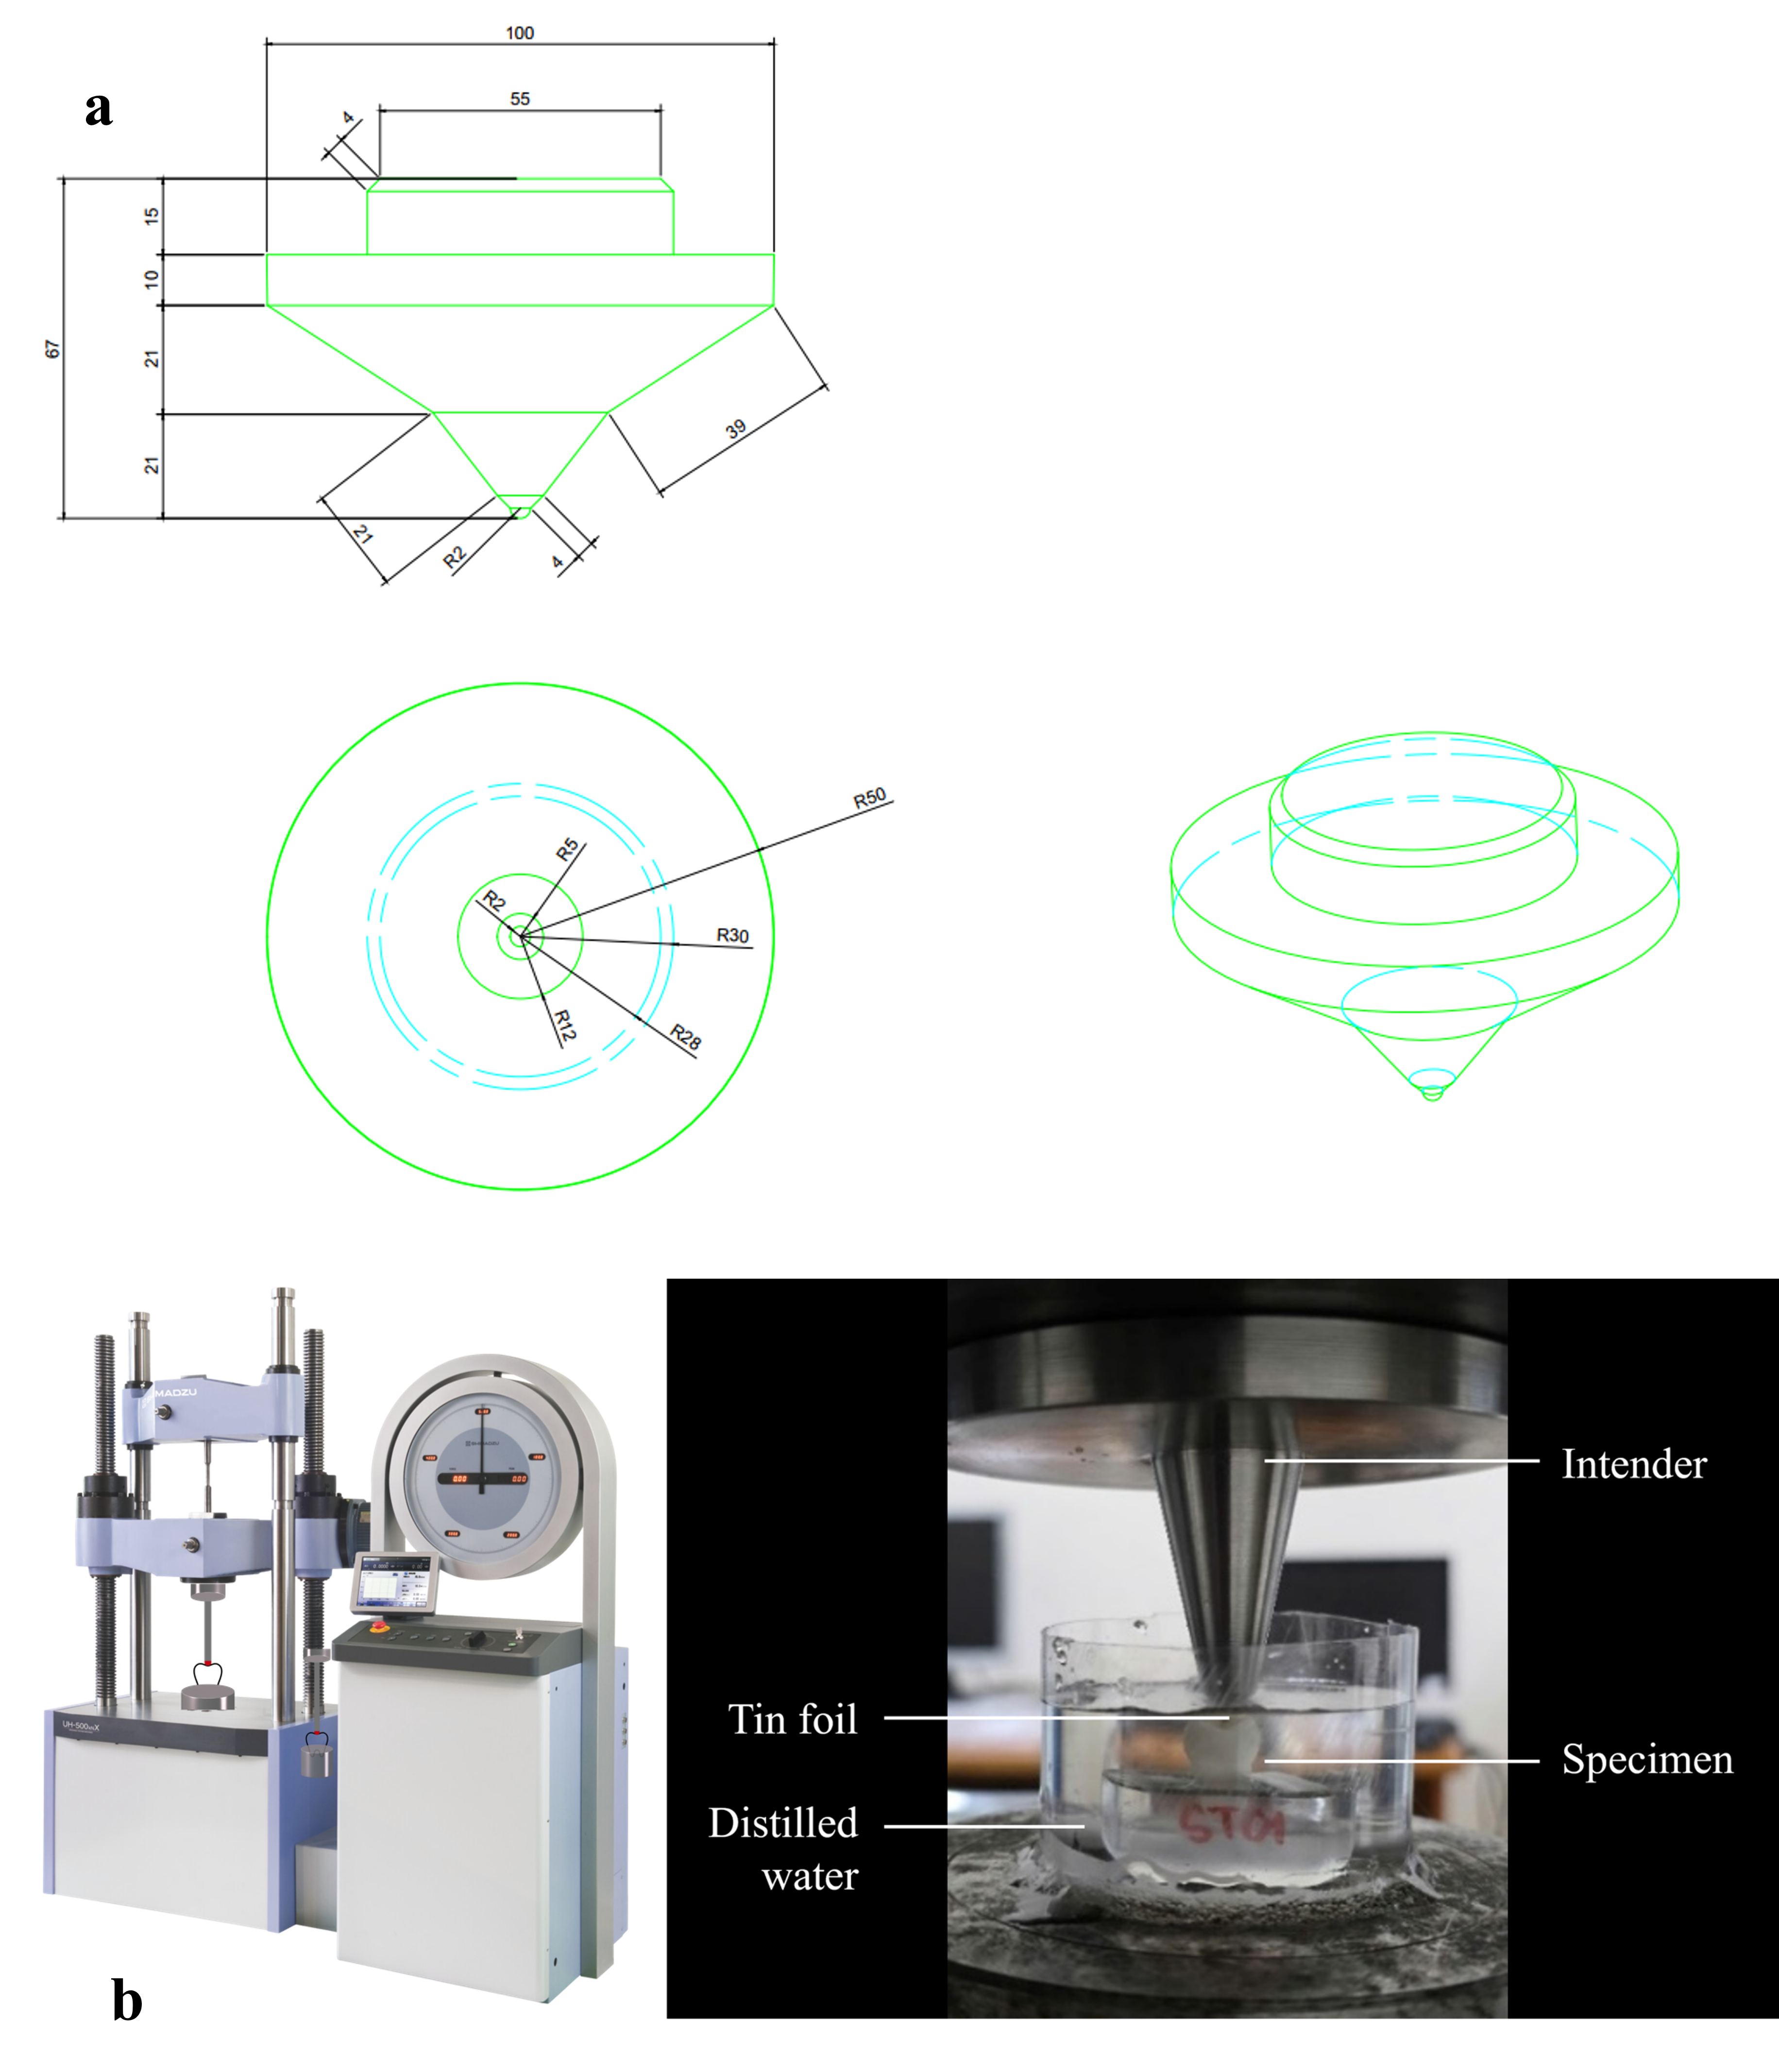
Figure S7 (a, b). (a) Intender design and (b) experimental set-up for the in vitro compressive load test using a universal testing machine (Shimadzu UH-500kNXh)
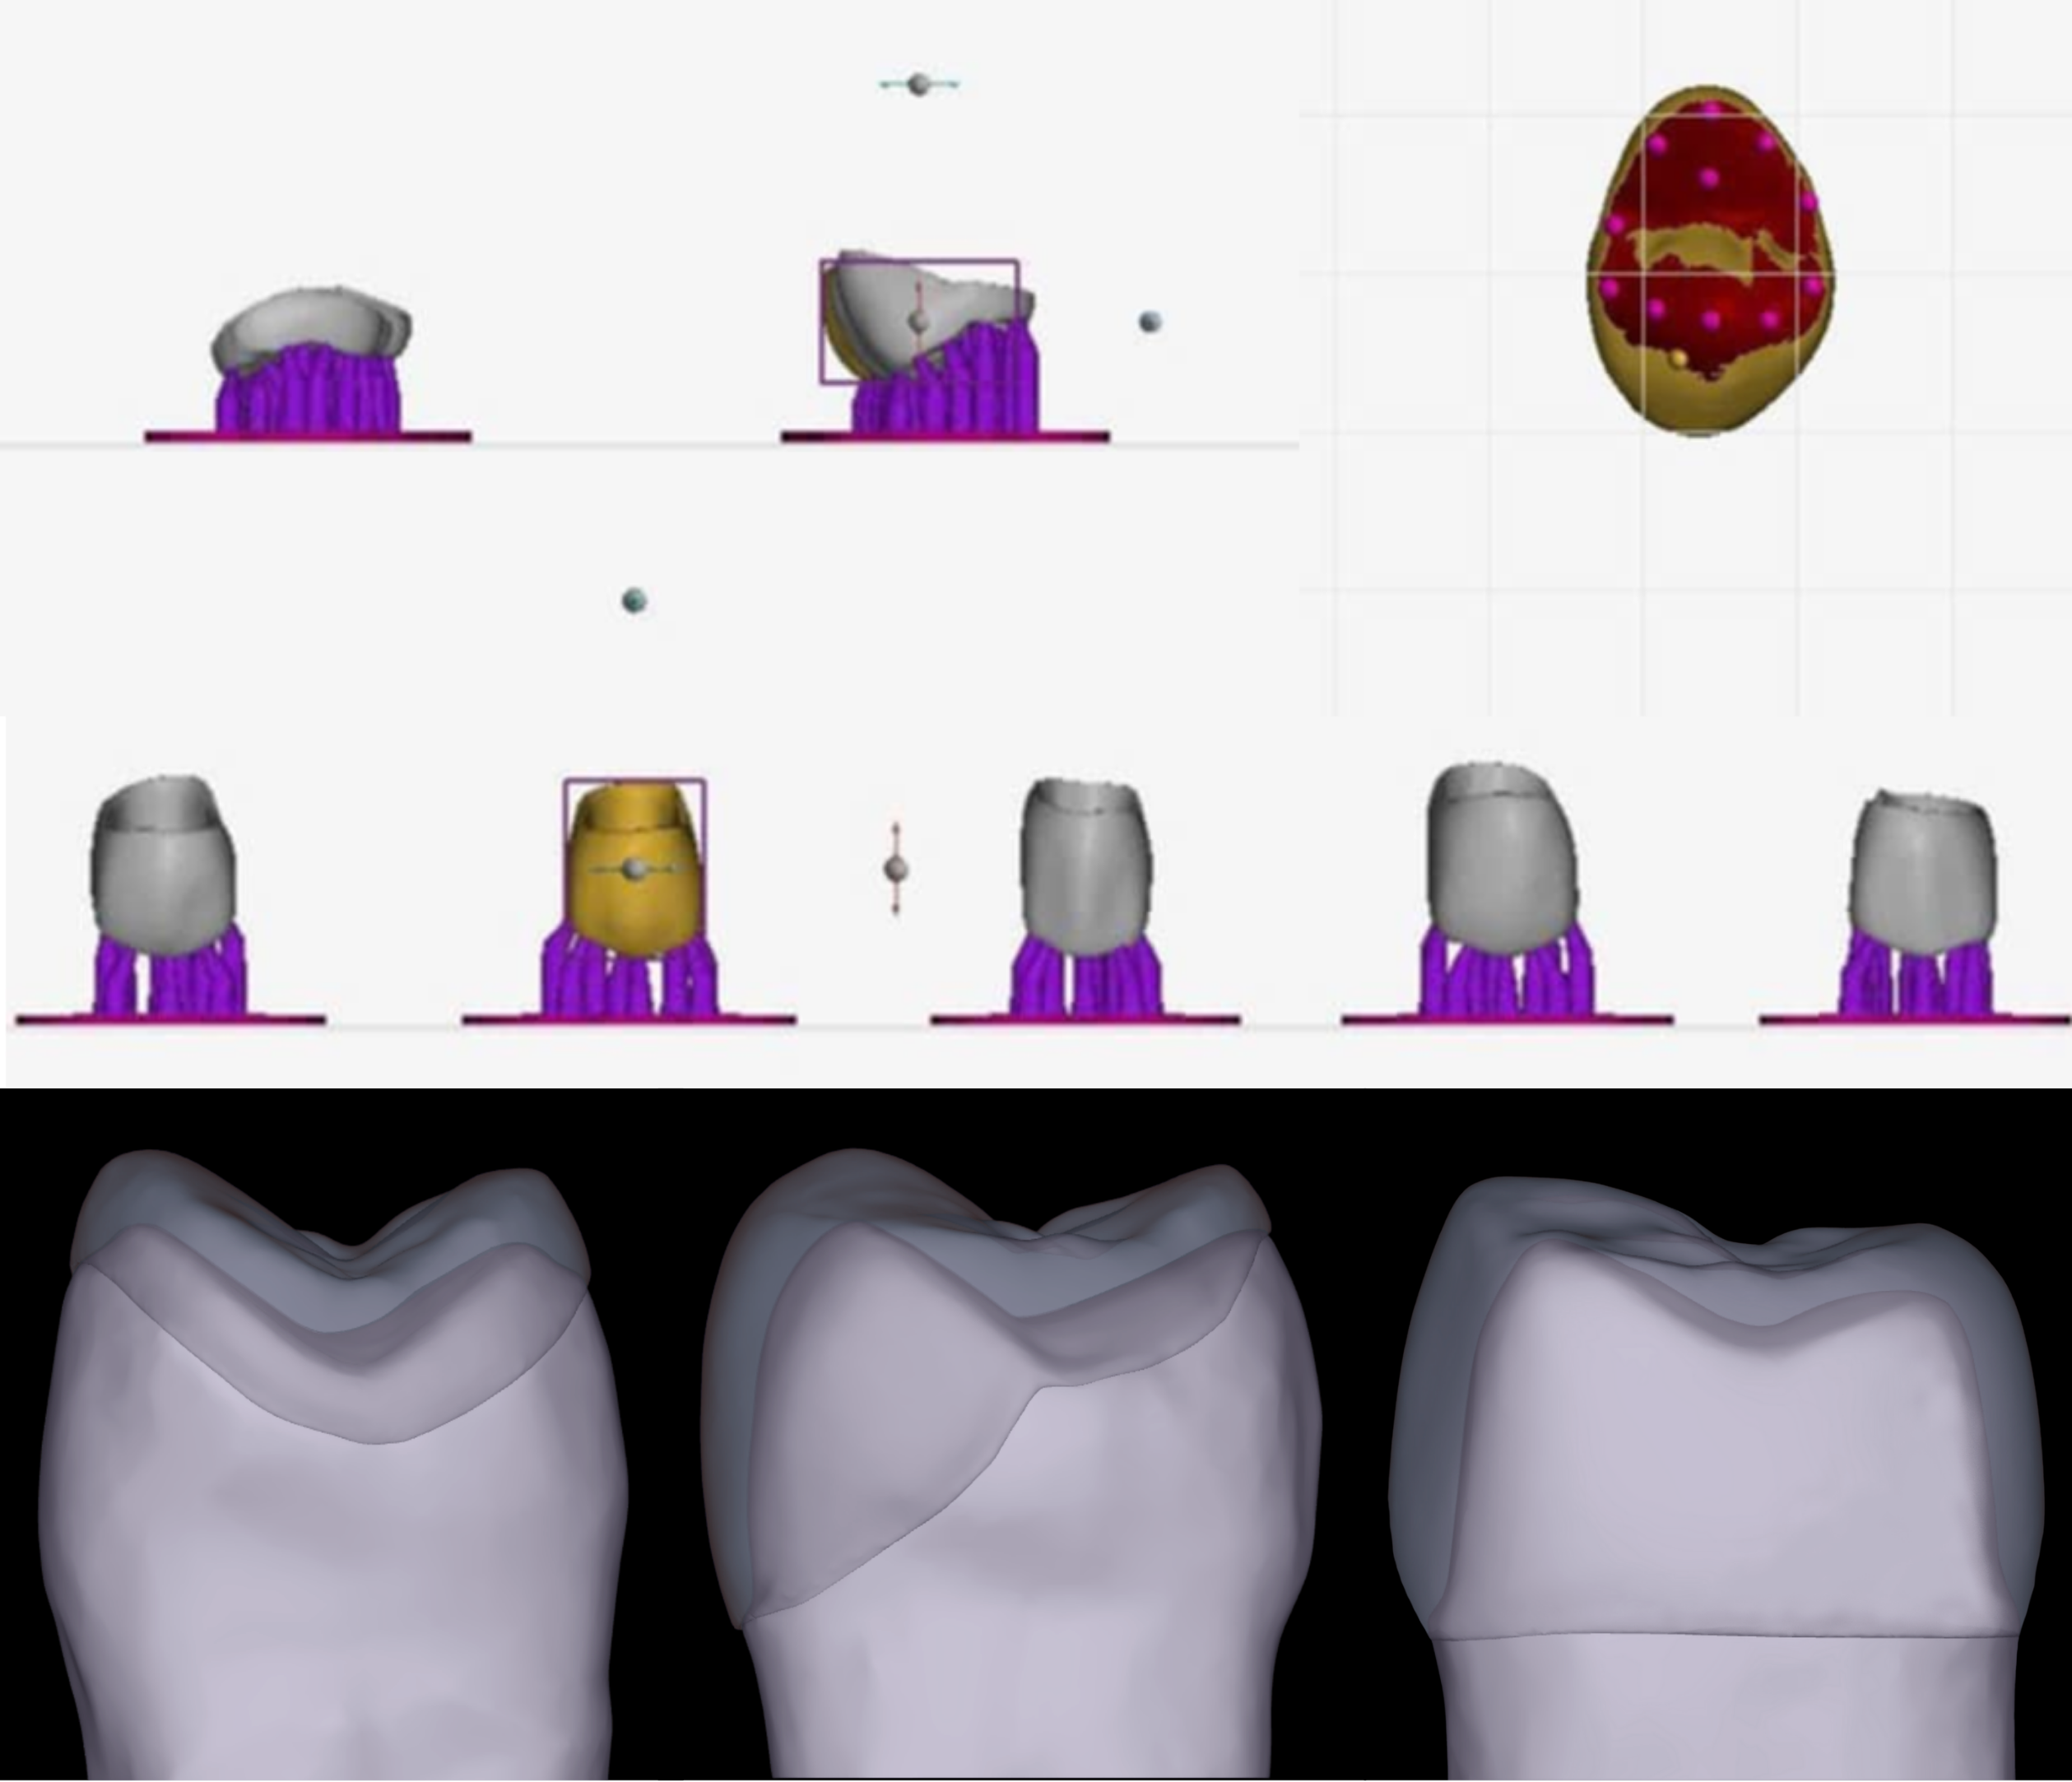
Figure S8. Restoration design and positioning of support tips

