Supplementary Materials
Comparative antimicrobial efficacy of three intracanal medicaments in an in vitro Enterococcus faecalis root canal infection model

Ali Hasan¹, Hanan Mohammad², Maher Darwish^{3,4*}, Mayssam Khaddam¹, Asmahan Zainab⁵
¹Department of Endodontics and Restorative Dentistry, Faculty of Dentistry, Latakia University, Latakia, Syria
²Institute of Pharmaceutical Technology and Regulatory Affairs, Faculty of Pharmacy, University of Szeged, H-6720 Szeged, Hungary
³Department of Pharmaceutical Chemistry and Drug Control, Faculty of Pharmacy, Wadi International University, Homs, Syria
⁴Department of Optics and Quantum Electronics, University of Szeged, Dóm Sq. 9, H-6720 Szeged, Hungary
⁵Department of Botany, Faculty of Science, Latakia University, Latakia, Syria
*Corresponding author
Dr. Maher Darwish, Ph.D: Email: darwish_maher@ymail.com
https://orcid.org/0000-0001-5368-6243
Department of Pharmaceutical Chemistry and Drug Control, Faculty of Pharmacy, Wadi International University, Homs, Syria

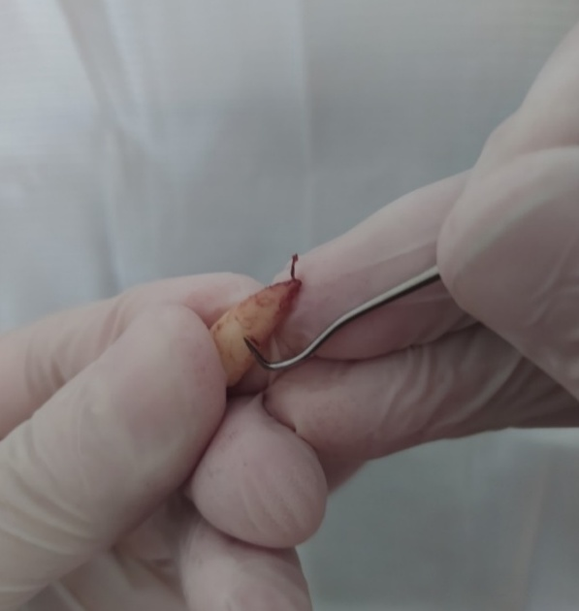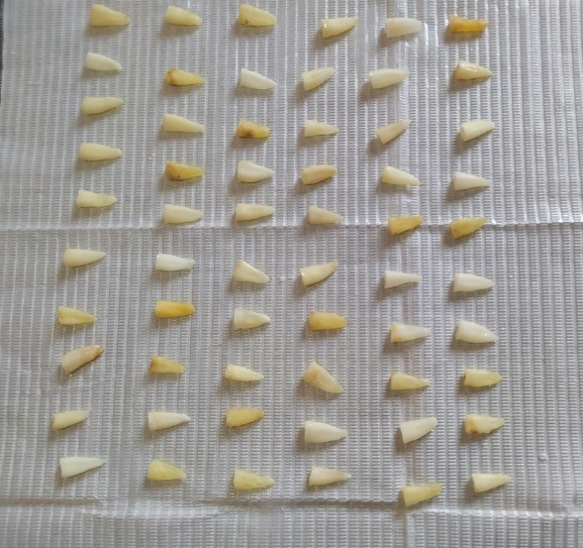
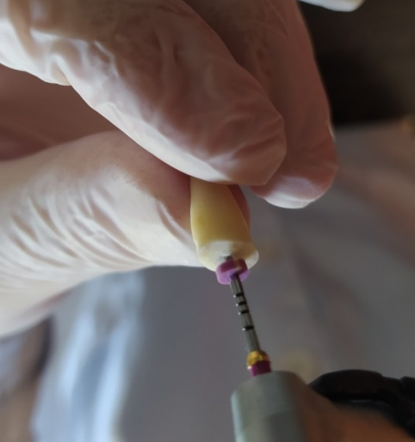 | 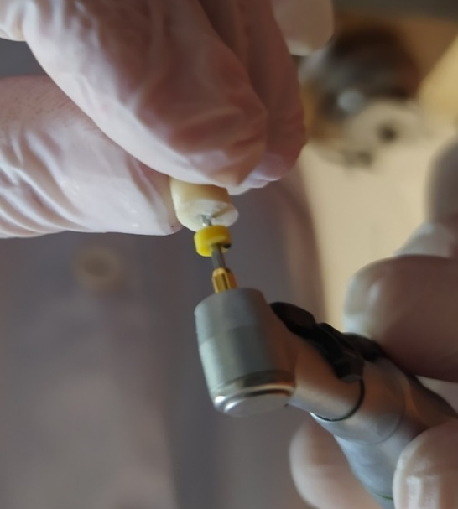
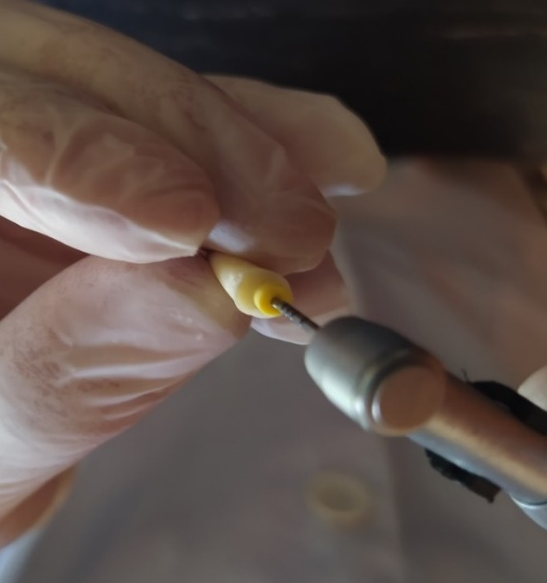 | 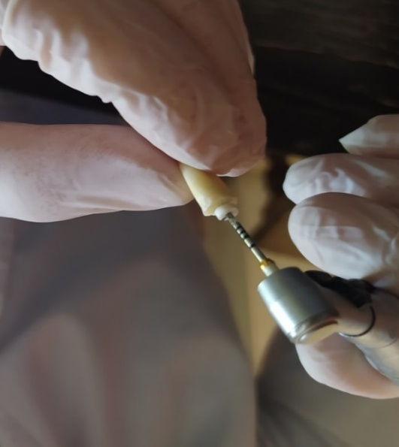
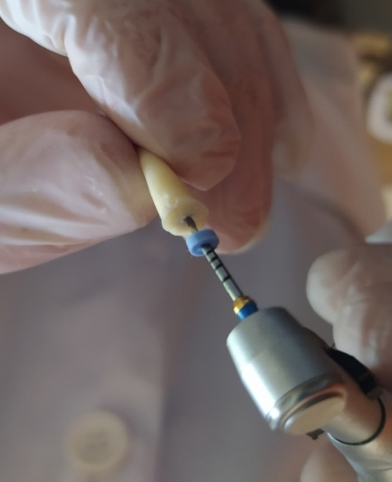 | 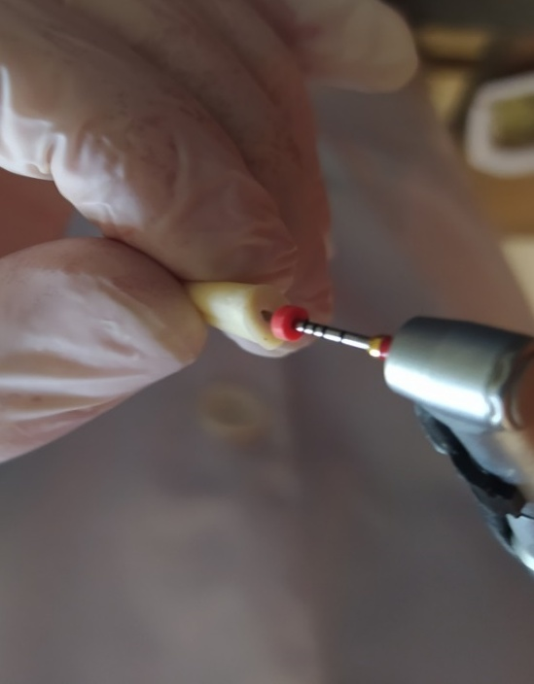

Figure S1: Sequential preparation of root canals using the ProTaper Universal rotary file system. The standardized instrumentation protocol included shaping files (SX, S1, S2) followed by finishing files (F1, F2, F3), achieving a final apical preparation of size 30, 0.09 taper. Irrigation with 5.25% NaOCl was performed between each file change.

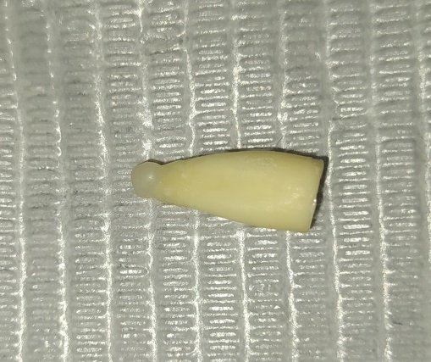
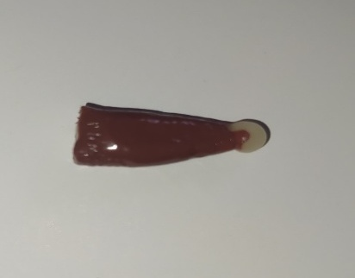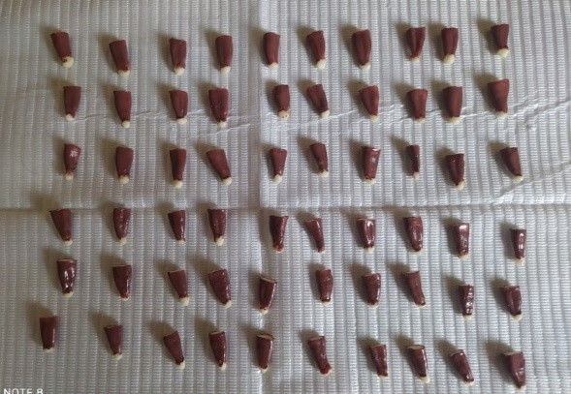
Figure S2: Specimen preparation showing (A) apical closure with flowable composite resin to prevent bacterial leakage, and (B) external root surface coating with two layers of red nail varnish to eliminate the possibility of external microbial contamination during the incubation period.

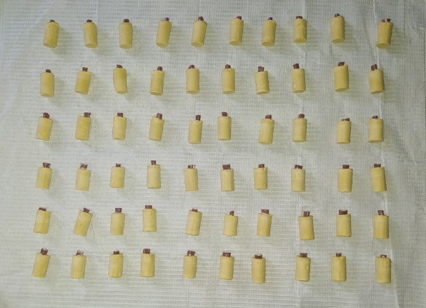
Figure S3: Prepared specimens embedded in gypsum molds for stable handling during subsequent microbiological procedures. The coronal access was sealed with temporary restorative material (Cavit) after placement of a cotton pellet.

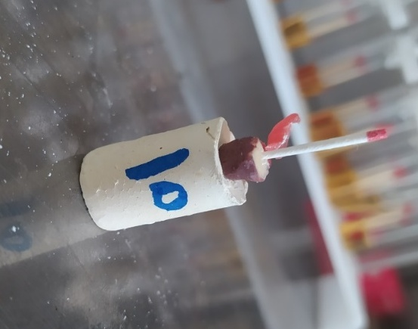 | 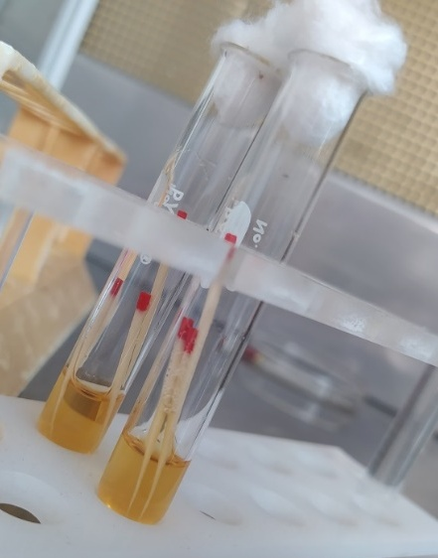
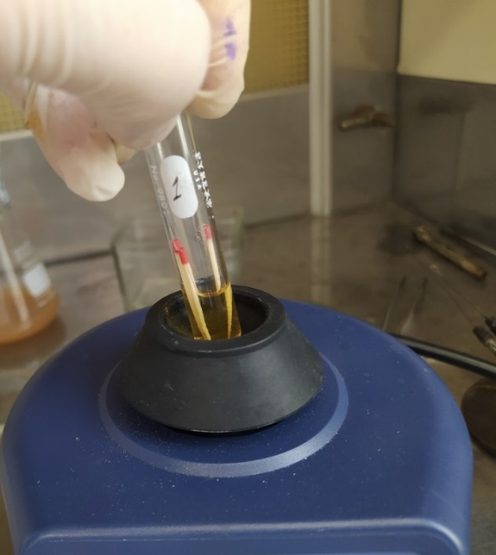

Figure S5: Bacterial sampling procedure showing (A) swab collection using sterile paper points inserted to the full working length, (B) repeated sampling (three paper points per canal) to obtain an accurate representation of the bacterial load, and (C) transfer of paper points to glass tubes containing sterile peptone water for subsequent vortexing and serial dilution.

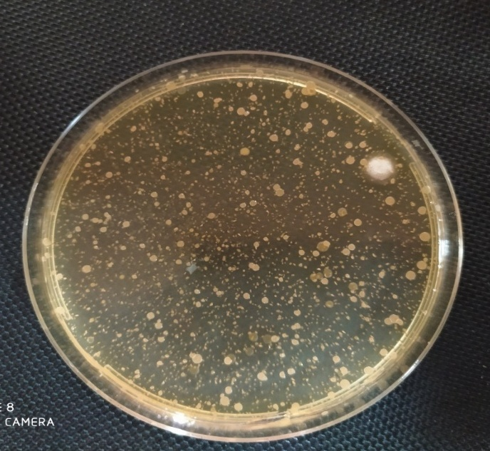
Figure S6: Representative image of bacterial colonies (E. faecalis) cultured on Mueller-Hinton agar plates from a sample prior to medicament application. Colonies were counted after 24-hour incubation at 37°C, and the bacterial load was expressed as log₁₀ CFU/mL. This baseline sampling (S1) ensured comparable bacterial counts across all experimental groups before treatment.

