Supplemental Materials
Supplemental Table 1. Model diagnostics for multivariate logistic regression analysis of eruption of ST.
 | Hosmer–Lemeshow statistic | AUC (Area under the ROC) | VIF
Age group | $χ^{2}$: 2.156  df: 8  P value: 0.976 | Area: 0.872  95% CI: 0.859~0.884  P value: ＜0.001 | 1.767
Dentition of Premaxillae | $χ^{2}$: 2.156  df: 8  P value: 0.976 | Area: 0.872  95% CI: 0.859~0.884  P value: ＜0.001 | 1.776
Morphology | $χ^{2}$: 2.156  df: 8  P value: 0.976 | Area: 0.872  95% CI: 0.859~0.884  P value: ＜0.001 | 1.014
Orientation | $χ^{2}$: 2.156  df: 8  P value: 0.976 | Area: 0.872  95% CI: 0.859~0.884  P value: ＜0.001 | 1.041

Supplemental Table 2. Lasso regression analysis of eruption of ST.
Variables  (by importance) | Coef | λ  (10-fold cross-validation) | ROC-AUC
Orientation_2 (Inverted) | -7.132 | 1.374  (lambda.min) | 0.860
Orientation_3 (Horizontal) | -4.791 | 1.374  (lambda.min) | 0.860
Orientation_4 (Sagittal) | -4.640 | 1.374  (lambda.min) | 0.860
Age group_4 (12-14 y) | -0.918 | 1.374  (lambda.min) | 0.860
Age group_3 (9-11 y) | -0.268 | 1.374  (lambda.min) | 0.860
Age group_2 (6-8y) | 0.255 | 1.374  (lambda.min) | 0.860
Dentition of Premaxillae_2 (PAP) | 0.125 | 1.374  (lambda.min) | 0.860
Morphology_2 (Conical) | 0.022 | 1.374  (lambda.min) | 0.860
Morphology_3 (Supplemental) | -0.019 | 1.374  (lambda.min) | 0.860

Supplemental Table 3. Model diagnostics for multivariate logistic regression analysis of ST number.
 | Hosmer–Lemeshow statistic | AUC (Area under the ROC) | VIF
Age group | $χ^{2}$: 6.14  df: 7  P value: 0.523 | Area: 0.583  95% CI: 0.562~0.604  P value: ＜0.001 | 1.762
Gender | $χ^{2}$: 6.14  df: 7  P value: 0.523 | Area: 0.583  95% CI: 0.562~0.604  P value: ＜0.001 | 1.001
Dentition of Premaxillae | $χ^{2}$: 6.14  df: 7  P value: 0.523 | Area: 0.583  95% CI: 0.562~0.604  P value: ＜0.001 | 1.763
Morphology | $χ^{2}$: 6.14  df: 7  P value: 0.523 | Area: 0.583  95% CI: 0.562~0.604  P value: ＜0.001 | 1.003

Supplemental Table 4. Lasso regression analysis of ST number.
Variables  (by importance) | Coef | λ  (10-fold cross-validation) | ROC-AUC
Dentition of Premaxillae_2 （PAP） | -0.585 | 0.016  (lambda.min) | 0.612
Dentition of Premaxillae_3 （AAP） | -0.520 | 0.016  (lambda.min) | 0.612
Morphology_3 (Supplemental) | -0.466 | 0.016  (lambda.min) | 0.612
Gender_2 (female) | -0.202 | 0.016  (lambda.min) | 0.612
Age group_2 (6-8y) | 0.198 | 0.016  (lambda.min) | 0.612
Age group_3 (9-11y) | 0.147 | 0.016  (lambda.min) | 0.612
Morphology_2 (Conical) | 0.140 | 0.016  (lambda.min) | 0.612
Age group_4 (12-14y) | 0.056 | 0.016  (lambda.min) | 0.612

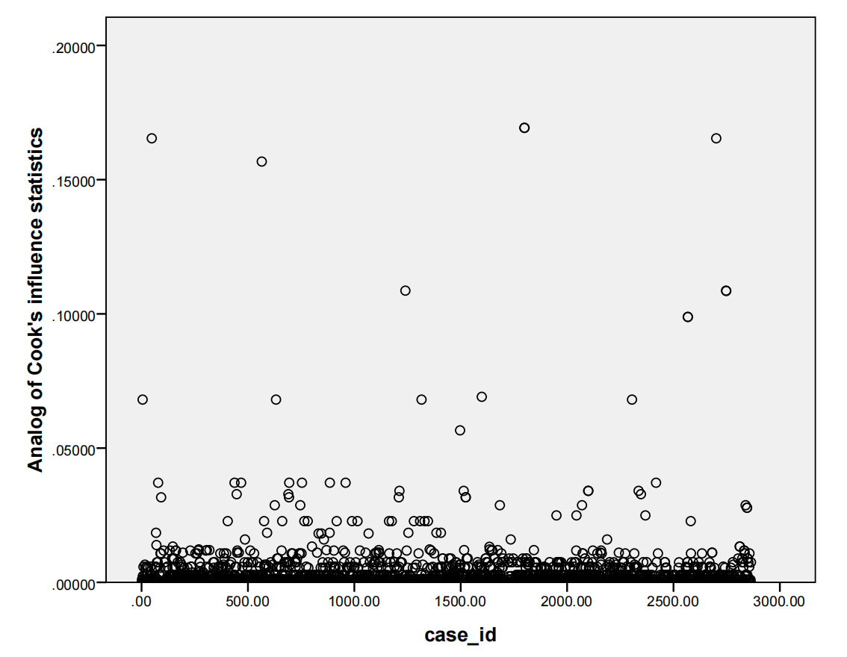
Supplemental Figure 1 Analog of Cook’s influence statistics.

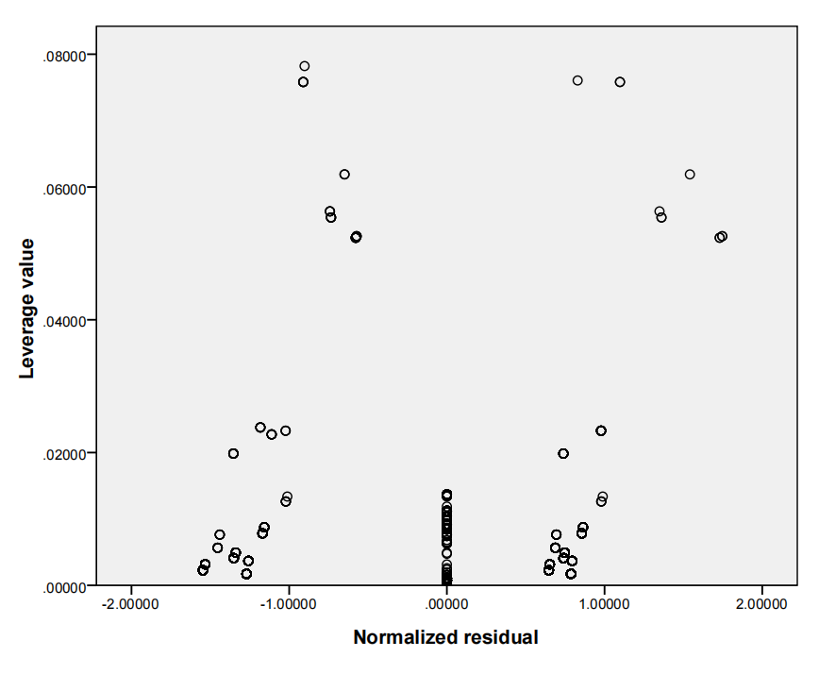
Supplemental Figure 2 Residual performance by leverage value.
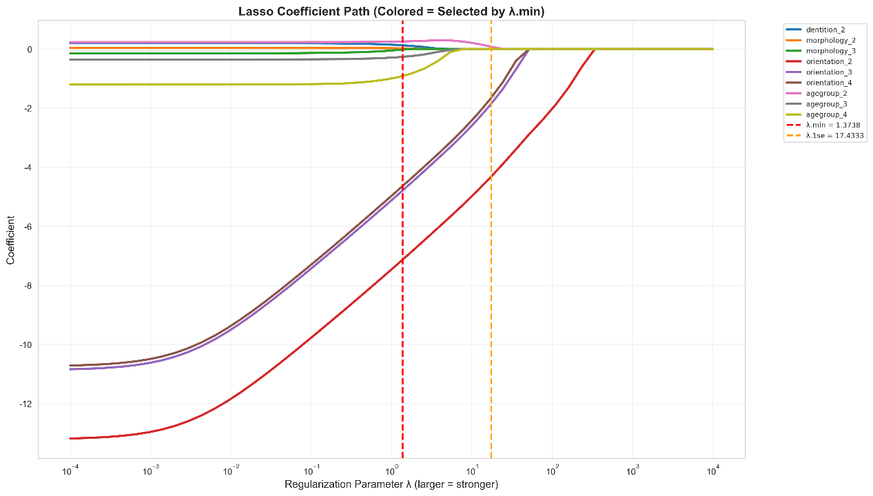
Supplemental Figure 3 Coefficient Profile plot of eruption by LASSO regression.

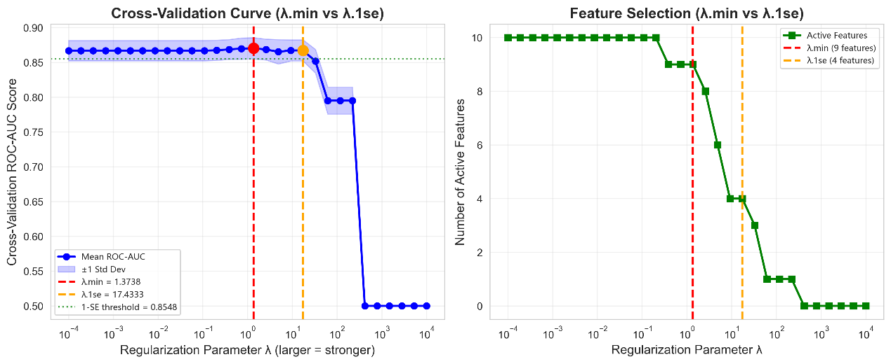
Supplemental Figure 4 Cross-validation plot of eruption by LASSO regression.

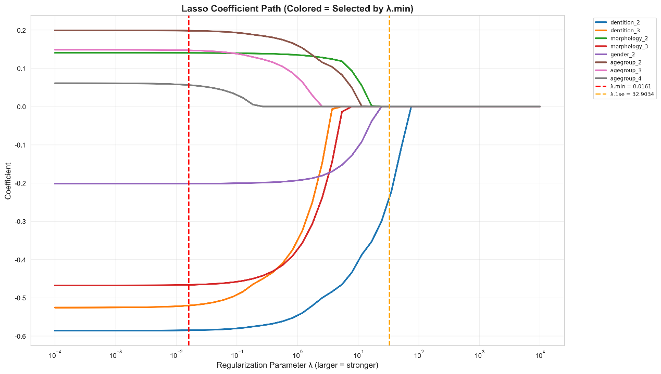
Supplemental Figure 5 Coefficient Profile plot of ST number by LASSO regression.
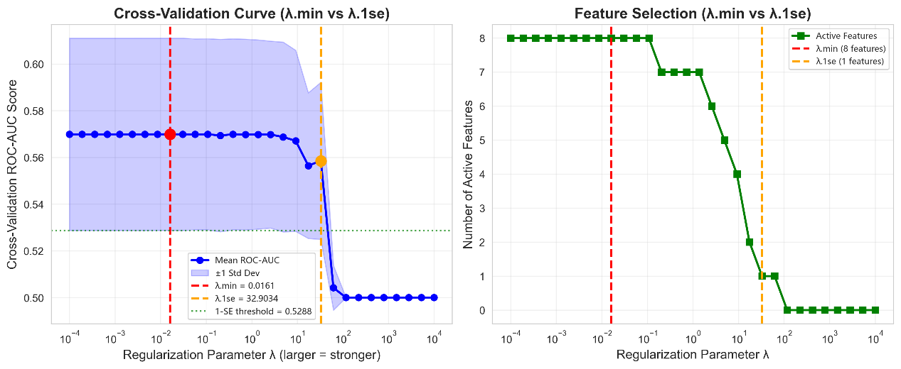
Supplemental Figure 6 Cross-validation plot of ST number by LASSO regression.

