Supplementary appendices
This is supplement to the article entitled: “Prevalence of xerostomia and hyposalivation in older people: A systematic review and meta-analysis”

Supplementary Appendix 1: Search strategies 5
Supplementary Appendix 2 : Criteria for quality assessment 6
Supplementary Appendix 3 : eReferences……………………………………………………..38

Supplementary Tables
Table S1 PRISMA checklist……………………………………………..……..……………..……..2
Table S2 Characteristics of included studies reporting prevalence of xerostomia in older adults (n= 116 studies)….……………………………………………………………………………8
Table S3 Characteristics of included studies reporting prevalence of hyposalivation in older adults (n=32 studies)………………………………………….……………………………..……..22
Table S4 Risk of bias of included studies reporting prevalence of xerostomia
in older adults (n=116)……….……….…………………………………………………….....……26

Table S5 Risk of bias of included studies reporting prevalence of hyposalivation in older adults (n=32)…………………………………………………………………………………..…….30
Table S6 Pooled prevalence of xerostomia in older adults and subgroup analysis (n=119 study populations obtained from 116 studies)…………………………………………………….….....31
Table S7 Pooled prevalence of hyposalivation in older adults and subgroup analysis (n=32)……………………………………………………………………………………………….. 33

Supplementary Figures
Fig. S1 Funnel plot for the meta-analysis of the overall prevalence of xerostomia in older adults…..………………………….…………………………………….…………….………….....35

Fig. S2 Funnel plot for the meta-analysis of the overall prevalence of hyposalivation in older adults…..………………………….………………………………………………….……………..35

Fig. S3 The leave-one-out analysis of the overall prevalence of xerosotmia of older adults (n= 119 study populations obtained from 116 studies)…………………….……………..…....36

Fig. S4 The leave-one-out analysis of the overall prevalence of hyposalivation of older adults (n=32)…………………….………………………………………………………..………. 37

Table S1 PRISMA checklist

Section and Topic | Item # | Checklist item | Location where item is reported
TITLE
Title | 1 | Identify the report as a systematic review. | Lines 1-2, Page 1
ABSTRACT
Abstract | 2 | See the PRISMA 2020 for Abstracts checklist. | Lines 33-58, Page 2
INTRODUCTION
Rationale | 3 | Describe the rationale for the review in the context of existing knowledge. | Lines 63-131, Page 4-5
Objectives | 4 | Provide an explicit statement of the objective(s) or question(s) the review addresses. | Lines 132-135, Page 5
METHODS
Eligibility criteria | 5 | Specify the inclusion and exclusion criteria for the review and how studies were grouped for the syntheses. | Lines 144-158, Page 5-6
Information sources | 6 | Specify all databases, registers, websites, organisations, reference lists and other sources searched or consulted to identify studies. Specify the date when each source was last searched or consulted. | Lines 162, Page 6
Search strategy | 7 | Present the full search strategies for all databases, registers and websites, including any filters and limits used. | Supplementary appendix 1
Selection process | 8 | Specify the methods used to decide whether a study met the inclusion criteria of the review, including how many reviewers screened each record and each report retrieved, whether they worked independently, and if applicable, details of automation tools used in the process. | Lines 171-175 , Page 6
Data collection process | 9 | Specify the methods used to collect data from reports, including how many reviewers collected data from each report, whether they worked independently, any processes for obtaining or confirming data from study investigators, and if applicable, details of automation tools used in the process. | Lines 175-176, Page 6
Data items | 10a | List and define all outcomes for which data were sought. Specify whether all results that were compatible with each outcome domain in each study were sought (e.g. for all measures, time points, analyses), and if not, the methods used to decide which results to collect. | Lines 177-181, Page 6
Data items | 10b | List and define all other variables for which data were sought (e.g. participant and intervention characteristics, funding sources). Describe any assumptions made about any missing or unclear information. | Lines 177-181, Page 6
Study risk of bias assessment | 11 | Specify the methods used to assess risk of bias in the included studies, including details of the tool(s) used, how many reviewers assessed each study and whether they worked independently, and if applicable, details of automation tools used in the process. | Lines 182-191, Page 7
Effect measures | 12 | Specify for each outcome the effect measure(s) (e.g. risk ratio, mean difference) used in the synthesis or presentation of results. | NA
Synthesis methods | 13a | Describe the processes used to decide which studies were eligible for each synthesis (e.g. tabulating the study intervention characteristics and comparing against the planned groups for each synthesis (item #5)). | Lines 172-175, Page 5-6
Synthesis methods | 13b | Describe any methods required to prepare the data for presentation or synthesis, such as handling of missing summary statistics, or data conversions. | NA
Synthesis methods | 13c | Describe any methods used to tabulate or visually display results of individual studies and syntheses. | NA
Synthesis methods | 13d | Describe any methods used to synthesize results and provide a rationale for the choice(s). If meta-analysis was performed, describe the model(s), method(s) to identify the presence and extent of statistical heterogeneity, and software package(s) used. | Lines 199-205 , Page 7
Synthesis methods | 13e | Describe any methods used to explore possible causes of heterogeneity among study results (e.g. subgroup analysis, meta-regression). | Lines 206-212 , Page 7-8
Synthesis methods | 13f | Describe any sensitivity analyses conducted to assess robustness of the synthesized results. | Lines 215-221 , Page 8
Reporting bias assessment | 14 | Describe any methods used to assess risk of bias due to missing results in a synthesis (arising from reporting biases). | NA
Certainty assessment | 15 | Describe any methods used to assess certainty (or confidence) in the body of evidence for an outcome. | NA
RESULTS
Study selection | 16a | Describe the results of the search and selection process, from the number of records identified in the search to the number of studies included in the review, ideally using a flow diagram. | Line 228-235, Page 8
Study selection | 16b | Cite studies that might appear to meet the inclusion criteria, but which were excluded, and explain why they were excluded. | NA
Study characteristics | 17 | Cite each included study and present its characteristics. | Line 284-300, Page 11
Risk of bias in studies | 18 | Present assessments of risk of bias for each included study. | Table S4 and S5
Results of individual studies | 19 | For all outcomes, present, for each study: (a) summary statistics for each group (where appropriate) and (b) an effect estimate and its precision (e.g. confidence/credible interval), ideally using structured tables or plots. | Table S6 and S7
Results of syntheses | 20a | For each synthesis, briefly summarise the characteristics and risk of bias among contributing studies. | Lines 255-294 , Page 10-11
Results of syntheses | 20b | Present results of all statistical syntheses conducted. If meta-analysis was done, present for each the summary estimate and its precision (e.g. confidence/credible interval) and measures of statistical heterogeneity. If comparing groups, describe the direction of the effect. | Lines 303-337 , Page 11-12  Lines 368-386. Page 15
Results of syntheses | 20c | Present results of all investigations of possible causes of heterogeneity among study results. | Lines 306-337 , Page 11-12  Lines 373-388. Page 15
Results of syntheses | 20d | Present results of all sensitivity analyses conducted to assess the robustness of the synthesized results. | Lines 429-437, Page 18
Reporting biases | 21 | Present assessments of risk of bias due to missing results (arising from reporting biases) for each synthesis assessed. | NA
Certainty of evidence | 22 | Present assessments of certainty (or confidence) in the body of evidence for each outcome assessed. | NA
DISCUSSION
Discussion | 23a | Provide a general interpretation of the results in the context of other evidence. | Lines 446-449 , Page 18
Discussion | 23b | Discuss any limitations of the evidence included in the review. | Lines 577-593 , Page 22-23
Discussion | 23c | Discuss any limitations of the review processes used. | Lines 577-593 , Page 22-23
Discussion | 23d | Discuss implications of the results for practice, policy, and future research. | Lines 605-609, Page 24
OTHER INFORMATION
Registration and protocol | 24a | Provide registration information for the review, including register name and registration number, or state that the review was not registered. | Lines 141-142, Page 5
Registration and protocol | 24b | Indicate where the review protocol can be accessed, or state that a protocol was not prepared. | NA
Registration and protocol | 24c | Describe and explain any amendments to information provided at registration or in the protocol. | NA
Support | 25 | Describe sources of financial or non-financial support for the review, and the role of the funders or sponsors in the review. | Lines 647
Competing interests | 26 | Declare any competing interests of review authors. | Lines 645
Availability of data, code and other materials | 27 | Report which of the following are publicly available and where they can be found: template data collection forms; data extracted from included studies; data used for all analyses; analytic code; any other materials used in the review. | Search strategy

From: Page MJ, McKenzie JE, Bossuyt PM, Boutron I, Hoffmann TC, Mulrow CD, et al. The PRISMA 2020 statement: an updated guideline for reporting systematic reviews. BMJ 2021;372:n71. doi: 10.1136/bmj.n71
For more information, visit: http://www.prisma-statement.org/

Supplementary Appendix 1: Search strategies

Pubmed/MEDLINE (the most recent search was on April 2026) = 18,006
Embase (the most recent search was on April 2026) = 4,758
Scopus (the most recent search was on April 2026) = 3,804
ProQuest (the most recent search was on April 2026) = 18,366

- Elderly AND xerostomia AND prevalence
- Dry mouth AND elderly AND prevalence
- Elderly AND hyposalivation AND prevalence
- Xerostomia AND Aged AND prevalence
- Xerostomia AND older adults AND prevalence
- Xerostomia AND geriatric AND prevalence
- Elderly AND xerostomia OR hyposalivation AND prevalence
- Elderly AND salivary AND gland AND hypofunction

MeSH Term

(“Xerostomia”[Mesh) OR “Hyposalivation”[Mesh] OR “Salivary gland hypofunction”[Mesh] OR “Dry mouth”[Mesh] OR “Mouth dryness”[Mesh] OR “Oral dryness”[Mesh] OR “Dryness of mouth”[Mesh]) AND (“Elderly”[Mesh] OR “Geriatric”[Mesh] OR “Aged”[Mesh] OR “Older adults”[Mesh] OR “Age over 60”[Mesh]) AND (“Prevalence”[Mesh] OR “Epidemiology”[Mesh])

Supplementary Appendix 2: Criteria for quality assessment developed by Hoy et al.

External validity

- Was the study's target population a close representation of the national relevant variables such as age, sex, occupation?

Low risk: If the study was a national health survey, multi-setting survey or national cancer registry.

High risk: If the study was conducted in one province, one hospital, 2-3 hospitals in one province or single institute

- Was the sampling frame a true or close representation of the target population?

Low risk: The sampling frame was every individual within the target population, cluster sampling.

High risk: The sampling frame was a list of one particular group

- Was some form of random selection used to select the sample, OR, was a census undertaken?

Low risk: A census was undertaken or some form of random selection was used to select the sample

High risk: A census was not undertaken and some form of random selection was not used to select the sample.

- Was the likelihood of non-response bias minimal?

Low risk: If included participants were ≥ 75% or less than 75% with table comparing characteristics of patients between the participated group VS non-participate group

High risk: Less than 75% of the study population participated in the present study

- Were data collected directly from the subjects (as opposed to a proxy)?

Low risk: All data were collected directly from the participants

High risk: Data were collected form a representative of group or household

- Was an acceptable case definition used in the study?

Low risk: Xerostomia was defined as a subjective symptoms of dry mouth.

Hyposalivation was defined as an objective reduction of salivary flow rate which was measured by any of standard methods (unstimulated and/or stimulated salivary flow rate).

High risk: Measurement of xerostomia or hyposalivation were not specified or described in details.

- Was the study instrument that measured the parameter of interest prevalence shown to have reliability and validity (if necessary)?

Low risk: Xerostomia: using of one the standard questionnaires (e.g. the Xerostomia Inventory (XI), the xerostomia questionnaires by Fox et al.) or inquiriing about symptoms of dry mouth.

Hyposalivation: Using sialometry (USW ≤ 0.1 mL/min, SW ≤ 0.7 mL/min).

High risk: Xerostomia: Questionnaires were not specified or described in details.

Hyposalivation: Using cotton roll method

- Was the same mode of data collection used for all subjects?

Low risk: Same method of specimen collection

High risk: Different method or not specified method of specimen collection

- Was the length of the shortest prevalence period for the parameter of interest appropriate?

Low risk: Point prevalence, one-week prevalence or one-year prevalence

High risk: Lifetime prevalence

- Were the numerator(s) and denominators (s) for the parameter of interest appropriate?

Low risk: Appropriate numerator(s) and denominator(s)

High risk: Inappropriate numerator(s) and denominator(s)

Table S2. Characteristics of included studies reporting prevalence of xerostomia in older adults (n= 116 studies).

No. | Authors/Year | Country | Study design | Setting | Age  cut-off for older adults | Methods of xerostomia  assessment | Xerostomia criteria | Total participants | Xerostomia  cases | Prevalence
1 | Rodríguez‐Oria et al., 2026  (Rodríguez-Oria et al., 2026) | Chile | Cross-sectional | Community dwelling | 65 | Questionnaire: The Xerostomia inventory (XI) | Positive answer for “My mouth feels dry” | 102 | 57 | 55.9%
2 | Zainuddin et al.,  (Zainuddin, Guan, Ting, & Thomson, 2026) | New Zealand | Cross-sectional | Institutionalized | 65 | Self-reported | Frequency  (Always, Frequently) | 50 | 17 | 34.0%
3 | Caetano-Santos et al., 2025  (Caetano-Santos et al., 2025) | Portugal | Cross-sectional | Community dwelling | 65 | Self-reported | Frequency  (Occasionally, Often) | 302 | 167 | 55.3%
4 | Grossmann et al., 2025 (Grossmann et al., 2025) | Brazil | Cross-sectional | Community dwelling | 60 | Questionnaire:  Ferreiro et al. | Frequency (Sometimes, Frequently, Always) | 153 | 99 | 64.7%
5 | Hasselgren et al., 2025  (Hasselgren et al., 2025) | Norway | Cross-sectional | Community dwelling | 65 | Self-reported | Frequency  (Sometimes, Often) | 1,189 | 328 | 27.6%
6 | Jiang et al., 2025 (Jiang, Huang, Reissmann, Schmalz, & Li, 2025) | China | Cross-sectional | Community dwelling | 65 | Self-reported | Presence/Absence | 423 | 95 | 22.5%
7 | Vandenbulcke et al.,2025 (Vandenbulcke et al., 2025) | Belgium | Prospective study | Institutionalized | 65 | Self-reported | Presence/Absence | 433 | 142 | 32.8%
8 | Beltrán et al., 2024 (Beltrán et al., 2024) | Chile | Cross-sectional | Community dwelling | 60 | Self-reported | Presence/Absence | 76 | 48 | 63.2%
9 | Blasi et al., 2024  (Blasi et al., 2024) | Germany | Prospective study | Institutionalized | 65 | Self-reported | Presence/Absence | 30 | 21 | 70.0%
10 | Dodderi et al., 2024 (Dodderi et al., 2024) | India | Cross-sectional | Community dwelling | 60 | Self-reported | Frequency  (Sometime, Always) | 361 | 93 | 25.8%
11 | Hu and Li, 2024 (Hu & Li, 2024) | China | Cross-sectional | Community dwelling | 60 | Self-reported | Presence/Absence | 380 | 152 | 40.0%
12 | Iwai et al., 2024 (Iwai et al., 2024) | Japan | Prospective study | Community dwelling | 65 | Self-reported | Presence/Absence | 3409 | 1019 | 29.9%
13 | Kubo et al., 2024  (Kubo et al., 2024) | Japan | Prospective study | Community dwelling | 65 | Self-reported | Presence/Absence | 3594 | 685 | 19.1%
14 | Kudo et al., 2024  (Kudo et al., 2024) | Japan | Cross-sectional | Community dwelling | 65 | Self-reported | Presence/Absence | 47,178 | 8,727 | 18.5%
15 | Lee et al., 2024  (Y.-H. Lee, Won, Auh, Noh, & Lee, 2024) | Korea | Cross-sectional | Community dwelling | 60 | Self-reported | Presence/Absence | 446 | 131 | 29.4%
16 | Guimarães et al., 2023 | Brazil | Cross-sectional | Community dwelling | 60 | Self-reported | Presence/Absence | 96 | 60 | 62.5%
17 | Mascarenhas et al., 2023 (Mascarenhas et al., 2023) | Brazil | Cross-sectional | Community dwelling | 60 | Self-reported | Presence/Absence | 1398 | 513 | 36.7%
18 | Morita et al., 2023 (Morita et al., 2023) | Japan | Cross-sectional | Community dwelling | 65 | Self-reported | Presence/Absence | 215 | 79 | 36.7%
19 | Muneshwar et al., 2023 (Muneshwar, Ashwinirani, Gole, & Suragimath, 2023) | India | Cross-sectional | Community dwelling | 60 | Self-reported | Presence/Absence | 65 | 14 | 21.5%
20 | Nishioka et al., 2023 (Nishioka et al., 2023) | Japan | Prospective study | Institutionalized | 65 | Self-reported | Presence/Absence | 199 | 89 | 44.7%
21 | Sonpanao et al., 2023 (Sonpanao, Janebodin, Namvichaisirikul, Thongjit, & Jitprasertwong, 2023) | Thailand | Cross-sectional | Community dwelling | 60 | Questionnaire:  Carvalho et al. | Positive answer for at least 1 question | 480 | 200 | 41.7%
22 | Tepox-Puga et al., 2023 (Tepox-Puga et al., 2023) | Mexico | Cross-sectional | Institutionalized | 60 | Self-reported | Presence/Absence | 225 | 75 | 33.3%
23 | Adolfsson et al., 2022 (Adolfsson, Lenér, Marklund, Mossberg, & Çevik‐Aras, 2022) | Sweden | Cross-sectional | Community dwelling | 65 | Self-reported | Presence/Absence | 158 | 25 | 15.8%
24 | Buhl et al., 2022  (Buhl et al., 2022) | Denmark | Cross-sectional | Community dwelling | 86 | Questionnaire  (The eating symptom questionnaire) | Severity  (Mild, Moderate, Severe) | 126 | 52 | 41.3%
25 | Drachev et al.,2022 (Drachev, Puriene, Aleksejuniene, Stankeviciene, & Stangvaltaite-Mouhat, 2022) | Lithuania | Cross-sectional | Community dwelling | 65 | Self-reported | Frequency  (Always, Often, Sometimes) | 370 | 109 | 29.5%
26 | Edman et al., 2022  (Edman, Norderyd, & Holmlund, 2022) | Sweden | Prospective study | Community dwelling | 65 | Self-reported | Frequency  (Often, Sometimes) | 262 | 80 | 30.5%
27 | Johansson et al., 2022 (A.-K. Johansson et al., 2022) | Sweden | Prospective study | Community dwelling | 65 | Self-reported | Frequency  (Often, Sometimes) | 3003 | 769 | 25.6%
28 | Kotronia et al., 2022 (Kotronia et al., 2022) | England & USA | Cross-sectional | Unspecified | England &  USA: 65 | England & USA : Self-reported | England : Presence/Absence  USA : Frequency(Occasionally, Often, Very often) | England: 2147  USA: 2998 | England: 735  USA: 107 | England: 34.2%  USA: 3.6%
29 | Kuze et al., 2022  (Kuze, Fornari, Collares, & Della Bona, 2023) | Brazil | Cross-sectional | Community dwelling | 60 | Self-reported | Presence/Absence | 455 | 196 | 43.1%
30 | Langari et al., 2022  (Langari et al., 2022) | Iran | Cross-sectional | Unspecified | 60 | Questionnaire:  Fox et al. &  Torres et al. | Positive answer for at least 5 question | 300 | 32 | 10.7%
31 | Lin et al., 2022 (Lin et al., 2022) | Taiwan | Cross-sectional | Community dwelling | 65 | Questionnaire:  Condensed version of The Xerostomia inventory (XI) | No further detail | 1100 | 128 | 11.6%
32 | Mello et al., 2022 (Mello et al., 2022) | Brazil | Cross-sectional | Community dwelling | 60 | Self-reported | Presence/Absence | 1395 | 512 | 36.7%
33 | Ohara et al., 2022 (Ohara et al., 2022) | Japan | Prospective study | Community dwelling | 65 | Self-reported | Presence/Absence | 609 | 166 | 27.3%
34 | Salmi et al., 2022 (Salmi et al., 2022) | Finland | Cross-sectional | Institutionalized | 65 | Self-reported | Frequency  (Occasionally, Continuously) | 250 | 140 | 56%
35 | Storbeck et al., 2022 (Storbeck, Qian, Marek, Caplan, & Marchini, 2022) | USA | Cross-sectional | Community dwelling | 65 | Self-reported | Presence/Absence | 11061 | 4246 | 38.4%
36 | Uathitirat and Korwanich, 2022 (Uathitirat & Korwanich, 2022) | Thailand | Cross-sectional | Community dwelling | 60 | Questionnaire:  Fox et al. | Positive answer for 4 questions that related to salivary flow rate | 297 | 26 | 8.8%
37 | Choi & Jung, 2021 (Choi & Jung, 2021) | Korea | Cross-sectional | Community dwelling | 65 | Self-reported | Presence/Absence | 117 | 43 | 36.8%
38 | Fornari et al., 2021 (Fornari, Bergonci, Stein, Agostini, & Rigo, 2021) | Brazil | Cross-sectional | Community dwelling | 60 | Questionnaire: The Xerostomia inventory (XI) | Positive answer for “My mouth feels dry” | 293 | 56 | 19.1%
39 | Kunrath & Silva, 2021 (Kunrath & Silva, 2021) | Brazil | Cross-sectional | Community dwelling | 60 | Self-reported | Presence/Absence | 438 | 91 | 20.8%
40 | Velázquez-Olmedo et al., 2021 (Velázquez-Olmedo et al., 2021) | Mexico | Prospective | Community dwelling | 60 | Questionnaire:  The Xerostomia inventory (XI) | Score ≥ 28 points | 539 | 74 | 13.7%
41 | Buranarom et al., 2020 (Buranarom, Komin, & Matangkasombut, 2020) | Thailand | Cross-sectional | Community dwelling | 65 | Self-reported | Presence/Absence | 53 | 38 | 71.7%
42 | Crews et al., 2020 (Crews, Chou, Naavaal, Griffin, & Saaddine, 2020) | USA | Cross-sectional | Community dwelling | 65 | Self-reported | Presence/Absence | 3863 | 629 | 16.3%
43 | Liang et al., 2020 (Liang et al., 2020) | Taiwan | Cross-sectional | Community dwelling | 65 | Self-reported | Presence/Absence | 166 | 45 | 27.1%
44 | Lu et al., 2020  (Lu et al., 2020) | Taiwan | Cross-sectional | Community dwelling | 65 | Questionnaire:  Condensed version of The Xerostomia inventory (XI) | No further detail | 1076 | 119 | 11.1%
45 | Rosa et al., 2020 (Rosa et al., 2020) | France | Prospective | Community dwelling | 65 | Questionnaire:  The Xerostomia inventory (XI) | No further detail | 87 | 21 | 24.1%
46 | Amanda et al., 2019 (Góis, Pernambuco, & de Lima, 2019) | Brazil | Cross-sectional | Community dwelling | 60 | Questionnaire | No further detail | 463 | 205 | 44.3%
47 | Åstrøm et al., 2019 (Åstrøm, Lie, Ekback, Gülcan, & Ordell, 2019) | Sweden & Denmark | Prospective study | Community dwelling | 65 | Self-reported | Frequency  (Often, Sometimes) | Sweden: 4862  Norway: 2947 | Sweden: 1333  Norway: 857 | Sweden: 27.4%  Norway: 29.1%
48 | Mao et al., 2019 (Mao et al., 2019) | USA | Cross-sectional | Community dwelling | 60 | Self-reported | Presence/Absence | 3157 | 805 | 25.5%
49 | Rech et al., 2019 (Rech, Hugo, Tôrres, & Hilgert, 2019) | Brazil | Cross-sectional | Community dwelling | 60 | Self-reported | Presence/Absence | 869 | 374 | 43.0%
50 | Saarela et al., 2019 (Saarela et al., 2019) | Finland | Cross-sectional | Institutionalized | 65 | Self-reported | Presence/Absence | 2401 | 360 | 15.0%
51 | Silva et al., 2019 (Silva et al., 2019) | Brazil | Cross-sectional | Community dwelling | 60 | Self-reported | Presence/Absence | 438 | 91 | 20.8%
52 | Barbe et al, 2018 (Barbe et al., 2018) | Germany | Cross-sectional | Institutionalized | 65 | Self-reported | Presence/Absence | 40 | 38 | 95.0%
53 | Iwasaki et al., 2018 (Masanori Iwasaki et al., 2018) | Japan | Prospective study | Community dwelling & institutionalized | 65 | Self-reported | Presence/Absence | 600 | 146 | 24.3%
54 | Lozano et al., 2018 (Lozano, Vergara, & Lee, 2018) | Chile | Cross-sectional | Community dwelling & institutionalized | 60 | Self-reported | Presence/Absence | 119 (all)  43 (c)  76 (i) | 57 (all)  22 (c)  35 (i) | 47.9% (all)  51.2% (c)  46.1% (i)
55 | Saintrain et al., 2018  (Saintrain et al., 2018) | Brazil | Cross-sectional | Community dwelling | 60 | Self-reported | Presence/Absence | 246 | 103 | 41.9%
56 | Castrejón-Pérez et al., 2017 (Castrejón-Pérez, Borges-Yáñez, Irigoyen-Camacho, & Cruz-Hervert, 2017) | Mexico | Cross-sectional | Community dwelling | 65 | Self-reported | Presence/Absence | 653 | 285 | 43.6%
57 | Herrmann et al., 2017  (Herrmann, Müller, Behr, & Hahnel, 2017) | Germany | Cross-sectional | Institutionalized | 60 | Self-reported | Presence/Absence | 62 | 46 | 74.2%
58 | Huppertz et al., 2017  (Huppertz, van der Putten, Halfens, Schols, & de Groot, 2017) | The Netherlands | Cross-sectional | Community dwelling | 65 | Self-reported | Presence/Absence | 3220 | 921 | 28.6%
59 | Matsushita et al., 2017  (Matsushita et al., 2017) | Japan | Cross-sectional | Community dwelling | 60 | Self-reported | Presence/Absence | 620 | 177 | 28.5%
60 | Niklander et al., 2017  (Niklander et al., 2017) | Chile | Cross-sectional | Community dwelling | 65 | Self-reported | Frequency  (Usually, Always) | 44 | 14 | 31.8%
61 | Petrović et al., 2017  (Petrovic, Stančić, Jelenković Popovac, & Vasovic, 2016) | Serbia | Cross-sectional | Institutionalized | 65 | Self-reported | Presence/Absence | 301 | 179 | 59.5%
62 | Gil-Montoya et al., 2016  (Gil-Montoya et al., 2016) | Spain | Cross-sectional | Institutionalized | 65 | Self-reported | Presence/Absence | 356 | 198 | 55.6%
63 | Iwasaki et al., 2016  (M. Iwasaki et al., 2016) | Japan | Cross-sectional | Community dwelling | 65 | Self-reported | Presence/Absence | 352 | 62 | 17.6%
64 | Lee et al., 2016  (Y. S. Lee, Kim, & Moreno, 2016) | Korea | Cross-sectional | Community dwelling | 65 | Self-reported | Presence/Absence | 9840 | 3943 | 40.1%
65 | Leung et al., 2016  (Leung, Leung, & Chi, 2016) | Hong Kong | Cross-sectional | Community dwelling | 60 | Self-reported | Presence/Absence | 3422 | 121 | 3.5%
66 | Ohara et al., 2016  (Ohara et al., 2016) | Japan | Cross-sectional | Community dwelling | 65 | Self-reported | Presence/Absence | 894 | 311 | 34.8%
67 | Benn et al., 2015  (Benn, Broadbent, & Thomson, 2015) | New Zealand | Cross-sectional | Community dwelling | 65 | Self-reported | Frequency  (Always, Frequently) | 2209 | 928 | 42.0%
68 | Hedna et al.,2015  (Hedna et al., 2015) | Sweden | Cross-sectional | Institutionalized | 65 | Self-reported | Presence/Absence | 813 | 7 | 0.9%
69 | Kamińska-Pikiewicz et al.,2015  (Kamińska-Pikiewicz, Bachanek, & Chałas, 2015) | Poland | Cross-sectional | Community dwelling & institutionalized | 65 | Self-reported | Presence/Absence | 240 (all)  123 (c)  117 (i) | 79 (all)  41 (c)  38 (i) | 32.9% (all)  33.3% (c)  32.5% (i)
70 | Porter et al., 2015  (Porter et al., 2015) | England | Cross-sectional | Institutionalized | 65 | Self-reported | Presence/Absence | 179 | 73 | 40.8%
71 | Al-Dwairi & Lynch, 2014  (Al‐Dwairi & Lynch, 2014) | Jordan | Cross-sectional | Community dwelling | 60 | Self-reported | Presence/Absence | 253 | 81 | 32.0%
72 | Deco et al., 2014  (Deco et al., 2014) | Brazil | Cross-sectional | Unspecified | 60 | Self-reported | Presence/Absence | 300 | 52 | 17.3%
73 | El Osta et al., 2014  (El Osta et al., 2014) | Lebanon | Cross-sectional | Community dwelling | 65 | Self-reported | Presence/Absence | 201 | 139 | 69.2%
74 | Lee et al., 2014  (E. Lee, Lee, Kim, & Kho, 2014) | Korea | Cross-sectional | Community dwelling | 60 | Self-reported | Presence/Absence | 217 | 80 | 36.9%
75 | Kongstad et al., 2013  (Kongstad et al., 2013) | Denmark | Cross-sectional | Community dwelling | 65 | Self-reported | Presence/Absence | 1089 | 209 | 19.2%
76 | Kossioni et al., 2013  (Kossioni, Kossionis, & Polychronopoulou, 2013) | Greece | Cross-sectional | Community dwelling | 65 | Self-reported | Presence/Absence | 74 | 25 | 33.8%
77 | Castrejón-Pérez et al., 2012  (Castrejón-Pérez, Borges-Yáñez, Gutiérrez-Robledo, & Avila-Funes, 2012) | Mexico | Cross-sectional | Community dwelling | 65 | Self-reported | Presence/Absence | 838 | 378 | 45.1%
78 | Desoutter et al., 2012  (Desoutter et al., 2012) | France | Cross-sectional | Community dwelling | 60 | Self-reported | Presence/Absence | 769 | 287 | 37.3%
79 | Johansson et al., 2012  (A. K. Johansson et al., 2012) | Sweden | Cross-sectional | Community dwelling | 65 | Self-reported | Frequency  (Often, Sometimes) | 9571 | 5372 | 56.1%
80 | Quandt et al., 2011(Quandt et al., 2011) | USA | Cross-sectional | Community dwelling | 60 | Self-reported | Frequency  (Always , Frequently) | 622 | 158 | 25.4%
81 | Van der Putten et al., 2011  (van der Putten, Brand, Schols, & de Baat, 2011) | The Netherlands | Cross-sectional | Institutionalized | 65 | Questionnaire:  Summated Xerostomia Inventory-Dutch version | Positive answer for item 4 | 16 | 11 | 68.8%
82 | Villa & Abati, 2011  (A. Villa & Abati, 2011) | Italy | Cross-sectional | Community dwelling | 60 | Self-reported | Presence/Absence | 167 | 50 | 29.9%
83 | Villa et al., 2011  (Alessandro Villa et al., 2011) | Italy | Cross-sectional | Community dwelling | 60 | Self-reported | Frequency  (Seldom, Sometimes, Often) | 1201 | 84 | 7.0%
84 | Lucena et al., 2010  (Lucena et al., 2010) | Brazil | Cross-sectional | Institutionalized | 60 | Self-reported | Presence/Absence | 98 | 45 | 45.9%
85 | Glažar et al., 2010  (Glazar, Urek, Brumini, & Pezelj‐Ribaric, 2010) | Croatia | Cross-sectional | Community dwelling & institutionalized | 60 | Self-reported | Presence/Absence | 341 (all)  61 (c)  280 (i) | 187 (all)  22 (c)  165 (i) | 54.8% (all)  36.1 (c)  58.9% (i)
86 | So et al., 2010  (So, Chung, Kho, Kim, & Chung, 2010) | Korea | Cross-sectional | Community dwelling | 65 | Questionnaire:  Fox et al. &  Torres et al. | ≥1 dry mouth symptom | 515 | 381 | 74.0%
87 | Sugihara et al., 2010  (Sugihara et al., 2010; Toida et al., 2010) | Japan | Cross-sectional | Unspecified | 60 | Self-reported | Presence/Absence | 153 | 48 | 31.4%
88 | Toida et al., 2010  (Toida et al., 2010) | Japan | Cross-sectional | Community dwelling | 60 | Self-reported | Presence/Absence | 483 | 258 | 53.4%
89 | Wiener et al., 2010  (Wiener et al., 2010) | USA | Cross-sectional | Community dwelling | 65 | Questionnaire:  Likert-style XI | Positive answer for “My mouth feels dry” | 224 | 43 | 19.2%
90 | Arslan et al., 2009  (Arslan, Orhan, Canpolat, Delilbasi, & Dural, 2009) | Turkey | Cross-sectional | Community dwelling | 67.24 | Self-reported | Presence/Absence | 229 | 80 | 34.9%
91 | Ekback et al., 2009  (Ekbäck, Astrøm, Klock, Ordell, & Unell, 2009) | Norway &  Sweden | Cross-sectional | Community dwelling | Norway &  Sweden : 65 | Self-reported | Frequency  (Often, Sometimes, Seldom) | Norway: 3974  Sweden: 5875 | Norway: 1201  Sweden: 1685 | Norway: 30.2%  Sweden: 28.7
92 | Hakuta et al., 2009  (Hakuta, Mori, Ueno, Shinada, & Kawaguchi, 2009) | Japan | Cross-sectional | Community dwelling | 65 | Self-reported | Presence/Absence | 122 | 19 | 15.6%
93 | Quandt et al., 2009  (Quandt et al., 2009) | USA | Cross-sectional | Community dwelling | 65 | Self-reported | Presence/Absence | 634 | 308 | 48.6%
94 | Flink et al., 2008  (Flink, Bergdahl, Tegelberg, Rosenblad, & Lagerlöf, 2008) | Sweden | Cross-sectional | Community dwelling | 60 | Self-reported | Presence/Absence | 337 | 109 | 32.3%
95 | Marino et al., 2008  (Mariño, Schofield, Wright, Calache, & Minichiello, 2008) | Australia | Cross-sectional | Community dwelling | 60 | Self-reported | Presence/Absence | 603 | 214 | 35.5%
96 | Yu et al., 2008  (Yu, Lee, Hong, Lau, & Leung, 2008) | Hong Kong | Cross-sectional | Institutionalized | 65 | Self-reported | Frequency  (Frequently, Always) | 155 | 24 | 15.5%
97 | Ikebe et al., 2007  (K. Ikebe et al., 2007) | Japan | Cross-sectional | Community dwelling | 60 | Self-reported | Presence/Absence | 278 | 23 | 8.3%
98 | Kruger et al., 2007  (Kruger, Tennant, Smith, & Peachey, 2007) | Australia | Cross-sectional | Community dwelling | 60 | Self-reported | Frequency  (Always, Frequently) | 78 | 37 | 47.4%
99 | Imazato et al., 2006 (Imazato, Ikebe, Nokubi, Ebisu, & Walls, 2006) | Japan | Cross-sectional | Community dwelling | 60 | Self-reported | Presence/Absence | 227 | 14 | 6.2%
100 | Thomson et al., 2006  (Murray Thomson, Chalmers, John Spencer, Slade, & Carter, 2006) | Australia | Prospective | Community dwelling | 60 | Self-reported | Frequency  (Occasionally, Frequently, Always) | 246 | 61 | 24.8%
101 | Gerdin et al., 2005  (Gerdin, Einarson, Jonsson, Aronsson, & Johansson, 2005) | Sweden | Cross-sectional | Institutionalized | 65 | Questionnaire:  VAS instrument | Score of ≥54 points | 41 | 17 | 41.5%
102 | Henrikson et al., 2004  (Henriksen, Ambjørnsen, Laake, & Axéll, 2004) | Norway | Cross-sectional | Institutionalized | 65 | Self-reported | Presence/Absence | 1910 | 322 | 16.9%
103 | Field et al., 2001  (Field et al., 2001) | England | Cross-sectional | Community dwelling | 60 | Self-reported | Presence/Absence | 427 | 75 | 17.6%
104 | Ikebe et al., 2001  (Kazunori Ikebe et al., 2001) | Japan | Cross-sectional | Community dwelling | 66.3 | Self-reported | Presence/Absence | 973 | 368 | 37.8%
105 | Thomson et al.,1999  (W Murray Thomson, Chalmers, Spencer, & Ketabi, 1999) | Australia | Cross-sectional | Community dwelling | 65 | Self-reported | Frequency  (Occasionally, Frequently, Always) | 684 | 140 | 20.5%
106 | Nederfors et al., 1997 (Nederfors, Isaksson, Mörnstad, & Dahlöf, 1997) | Sweden | Cross-sectional | Community dwelling | 60 | Self-reported | Presence/Absence | 1424 | 478 | 33.6%
107 | Billings et al., 1996  (R. Billings, Proskin, & Moss, 1996) | USA | Cross-sectional | Community dwelling | 65 | Self-reported | Presence/Absence | 160 | 45 | 28.1%
108 | Norlen et al., 1996  (Norlén, Johansson, & Birkhed, 1996) | Sweden | Cross-sectional | Community dwelling | 65 | Self-reported | Presence/Absence | 473 | 60 | 12.7%
109 | Loesche et al., 1995  (Loesche et al., 1995) | USA | Cross-sectional | Community dwelling & institutionalized | 60 | Self-reported | Presence/Absence | 529 (all)  322 (c)  207 (i) | 380 (all)  226 (c)  154 (i) | 71.8% (all)  70.2 (c)  74.4% (i)
110 | Närhi, 1994  (T. Närhi, 1994) | Finland | Cross-sectional | Community dwelling | 65 | Self-reported | Presence/Absence | 341 | 158 | 46.3%
111 | Gilbert et al., 1993  (Gilbert, Heft, & Duncan, 1993) | USA | Cross-sectional | Community dwelling | 65 | Self-reported | Presence/Absence | 600 | 234 | 39.0%
112 | Locker, 1993  (Locker, 1993) | Canada | Cross-sectional | Community dwelling | 65 | Self-reported | Presence/Absence | 372 | 84 | 22.6%
113 | Närhi et al., 1993  (T. O. Närhi, Ainamo, & Meurman, 1993) | Finland | Prospective | Community dwelling | 65 | Self-reported | Presence/Absence | 368 | 39 | 10.6%
114 | Thomson et al., 1993  (W. M. Thomson, Brown, & Williams, 1993) | New zealand | Cross-sectional | Community dwelling | 65 | Self-reported | Frequency  (Always or Frequently) | 284 | 57 | 20.1%
115 | Kreher et al., 1987  (Kreher, Graser, & Handelman, 1987) | USA | Cross-sectional | Institutionalized | 65 | Self-reported | Presence/Absence | 49 | 27 | 55.1%
116 | Österberg et al., 1984  (Osterberg, Landahl, & Hedegård, 1984) | Sweden | Cross-sectional | Community dwelling | 65 | Self-reported | Presence/Absence | 966 | 200 | 20.7%
Abbreviations: i: institutionalized, c: community dwelling

Table S3. Characteristics of included studies reporting prevalence of hyposalivation in older adults (n=32 studies).

No | Authors/Year | Country | Design | Setting | Age cut-off for older adults | Hyposalivation  assessment | Total participants | Hyposalivation cases | Prevalence
1 | Zainuddin et al.,  (Zainuddin et al., 2026) | New Zealand | Cross-sectional | Institutionalized | 65 | USF < 0.1 mL/min | 50 | 13 | 26.0%
2 | Dwipa et al., 2023(Dwipa et al., 2023) | Indonesia | Cross-sectional | Community dwelling | 60 | USF <0.1 ml/min  SSF <0.7 ml/min | 60  60 | 25  38 | 41.7%  63.3%
3 | Morita et al., 2023(Morita et al., 2023) | Japan | Cross-sectional | Community dwelling | 65 | SSF ≤2.00 g⁄2 min | 215 | 142 | 66.0%
4 | Buranarom et al., 2020  (Buranarom et al., 2020) | Thailand | Cross-sectional | Community dwelling | 65 | USF <0.1 mL/min  or SSF<0.7 mL/min | 53 | 22 | 41.5%
5 | Rech et al., 2019  (Rech et al., 2019) | Brazil | Cross-sectional | Community dwelling | 60 | USF <0.1 mL/min  SSF <0.7 mL/min | 783  776 | 513  495 | 65.5%  63.8%
6 | Barbe et al, 2018  (Barbe et al., 2018) | Germany | Cross-sectional | Institutionalized | 65 | USF <0.2 mL/min  SSF <0.7 mL/min | 28 | 18 | 64.3%
7 | Iwasaki et al., 2018  (Masanori Iwasaki et al., 2018) | Japan | Prospective study | Community dwelling | 65 | SSF <0.7 mL/min | 600 | 224 | 37.3%
8 | Ahmad et al., 2017  (Ahmad, Bhayat, Zafar, & Al-Samadani, 2017) | Saudi Arabia | Cross-sectional | Community dwelling | 60 | USF ≤0.9 mL/min | 138 | 89 | 64.5%
9 | Lone et al., 2017  (Lone, Shaikh, Lone, Afaq, & Lone, 2017) | Pakistan | Cross-sectional | Community dwelling | 60 | USF <0.1 mL/min | 110 | 77 | 70.0%
10 | Glažar et al., 2016  (Glažar et al., 2016) | Croatia | Cross-sectional | Community dwelling & institutionalized | 60 | USF <0.15 mL/min | 341 (all)  61 (c)  280 (i) | 237 (all)  27 (c)  210 (i) | 69.5% (all)  44.3% (c)  75.0% (i)
11 | Hayes et al., 2016  (Hayes et al., 2016) | Ireland | Cross-sectional | Community dwelling | 65 | SSF <0.7 mL/min | 334 | 24 | 7.2%
12 | Iwasaki et al., 2016  (M. Iwasaki et al., 2016) | Japan | Cross-sectional | Community dwelling | 65 | SSF <0.5 mL/min | 352 | 36 | 10.2%
13 | Ohara et al., 2016  (Ohara et al., 2016) | Japan | Cross-sectional | Community dwelling | 65 | USF <0.1g/30s | 894 | 103 | 11.5%
14 | Kongstad et al., 2013  (Kongstad et al., 2013) | Denmark | Cross-sectional | Community dwelling | 65 | SSF ≤0.5 mL/min | 1089 | 70 | 6.4%
15 | Solemdal et al., 2012  (Solemdal, Sandvik, Willumsen, Mowe, & Hummel, 2012) | Norway | Cross-sectional | Institutionalized | 65 | SSF ≤0.6 g/min. | 158 | 69 | 43.7%
16 | AAG LUCENA et al., 2010  (Lucena et al., 2010) | Brazil | Cross-sectional | Institutionalized | 60 | USF ≤0.1 mL/min | 98 | 45 | 45.9%
17 | Glažar et al., 2010  (Glazar et al., 2010) | Croatia | Cross-sectional | Community dwelling & institutionalized | 60 | USF <0.2 mL/min | 341 (all)  61 (c)  280 (i) | 83 (all)  7 (c)  76 (i) | 24.3% (all)  11.5%(c)  27.1% (i)
18 | Toida et al., 2010  (Toida et al., 2010) | Japan | Cross-sectional | Community dwelling | 60 | SSF ≤2.00 g⁄2 min | 483 | 90 | 18.6%
19 | Wiener et al., 2010  (Wiener et al., 2010) | USA | Cross-sectional | Community dwelling | 65 | USF <0.1 mL/min | 224 | 27 | 12.1%
20 | Flink et al., 2008  (Flink et al., 2008) | Sweden | Cross-sectional | Community dwelling | 60 | USF <0.1 mL/min  SSF <0.7 mL/min | 335  328 | 97  18 | 29.0%  5.5%
21 | Ikebe et al., 2007  (K. Ikebe et al., 2007) | Japan | Cross-sectional | Community dwelling | 60 | SSF <0.5 mL/min | 275 | 52 | 18.9%
22 | Imazato et al., 2006  (Imazato et al., 2006) | Japan | Cross-sectional | Community dwelling | 60 | SSF <0.5 mL/min | 224 | 32 | 14.3%
23 | Gerdin et al., 2005  (Gerdin et al., 2005) | Sweden | Cross-sectional | Institutionalized | 65 | USF <0.05 g/min | 41 | 18 | 43.9%
24 | Fure, 2003  (Fure, 2003) | Sweden | Cross-sectional | Unspecified | 65 | USF <0.1 mL/min  SSF<0.7 mL/min | 102  102 | 21  17 | 24.5%  16.7%
25 | Ikebe et al, 2002  (K. Ikebe et al., 2002) | Japan | Cross-sectional | Community dwelling | 60 | SSF <0.5 mL/min | 351 | 86 | 24.5%
26 | Thomson et al.,1999  (W Murray Thomson et al., 1999) | Australia | Cross-sectional | Community dwelling | 65 | USF <0.1 mL/min | 684 | 151 | 22.1%
27 | Caplan and Hunt, 1996  (Caplan & Hunt, 1996) | USA | Cross-sectional | Community dwelling | 65 | SSF ≤1.0 mL/min | 490 | 173 | 35.3%
28 | Billings, 1993  (R. J. Billings, 1993) | USA | Cross-sectional | Community dwelling | 65 | USF ≤0.5 mL/min  SSF ≤0.5 mL/min | 39  39 | 10  11 | 25.6%  28.2%
29 | MacEntee et al.,1993  (MacEntee, Clark, & Glick, 1993) | Canada | Cross-sectional | Unspecified | 65 | SSF <1.0 mL/min | 156 | 69 | 44.2%
30 | Närhi et al., 1993  (T. O. Närhi et al., 1993) | Finland | Prospective study | Community dwelling | 65 | USF <0.1 mL/min  SSF <0.8 mL/min | 306  307 | 143  82 | 46.7%  26.7%
31 | Österberg et al., 1992  (Osterberg, Birkhed, Johansson, & Svanborg, 1992) | Sweden | Prospective study | Community dwelling | 65 | SSF <0.5 mL/min | 931 | 176 | 18.9%
32 | Österberg et al., 1984  (Osterberg et al., 1984) | Sweden | Prospective study | Community dwelling | 65 | USF <0.1 mL/min  SSF <0.5 mL/min | 111  111 | 35  28 | 31.5%  25.2%
Abbreviations: USF, unstimulated salivary flow; SSF, stimulated salivary flow; CI, confidence interval; i, institutionalized; c, community dwelling.

Table S4 Risk of bias of included studies reporting prevalence of xerostomia in older adults (n=116, top) and summary risk of bias (bottom).
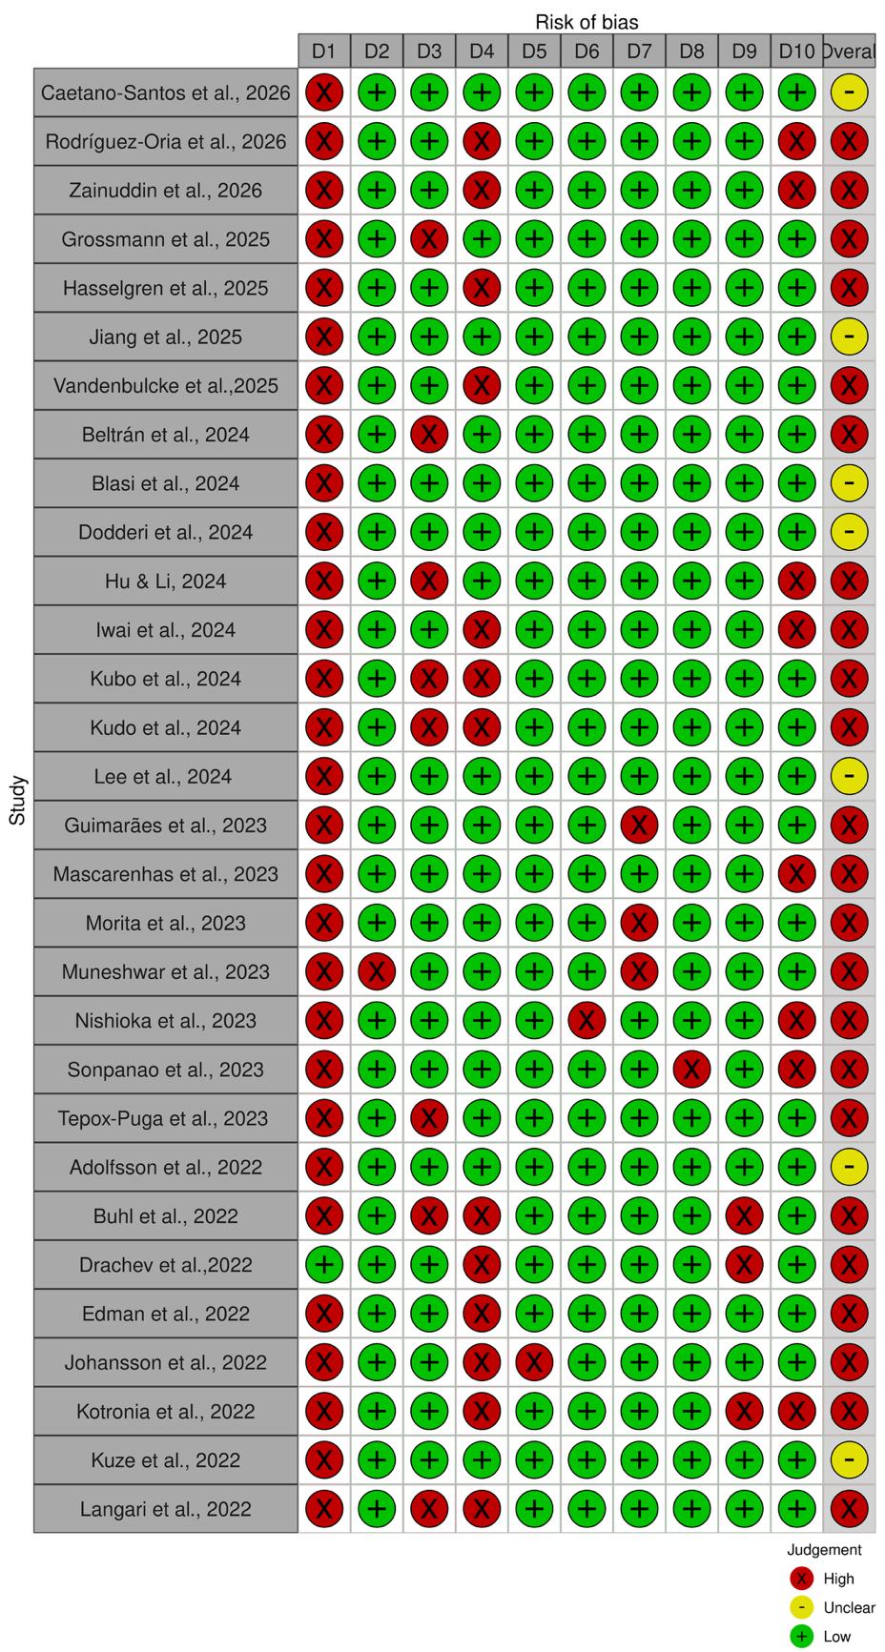

Table S4 Risk of bias of included studies reporting prevalence of xerostomia in older adults (n=116, top) and summary risk of bias (bottom) (cont).

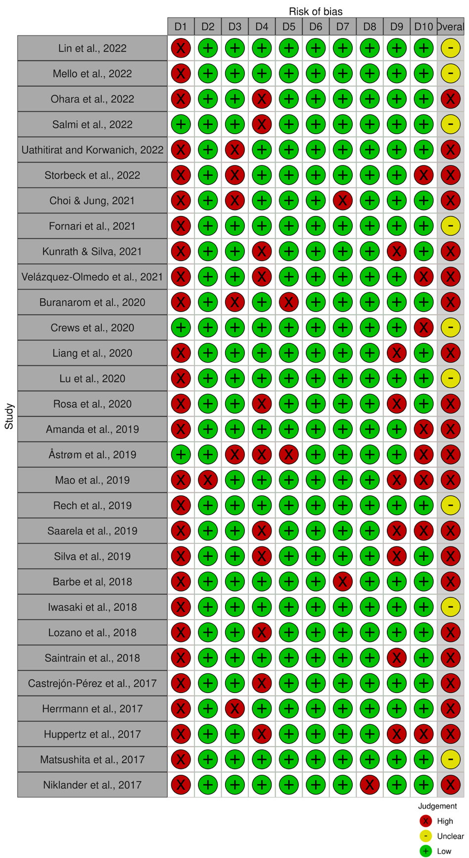

Table S4 Risk of bias of included studies reporting prevalence of xerostomia in older adults (n=116, top) and summary risk of bias (bottom) (cont).
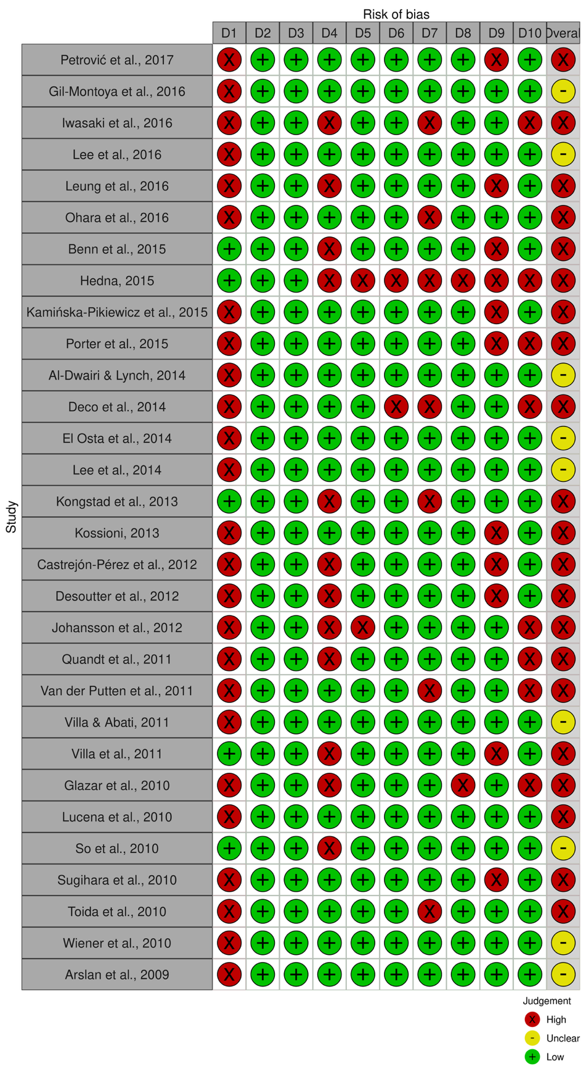

Table S4 Risk of bias of included studies reporting prevalence of xerostomia in older adults (n=116, top) and summary risk of bias (bottom) (cont).
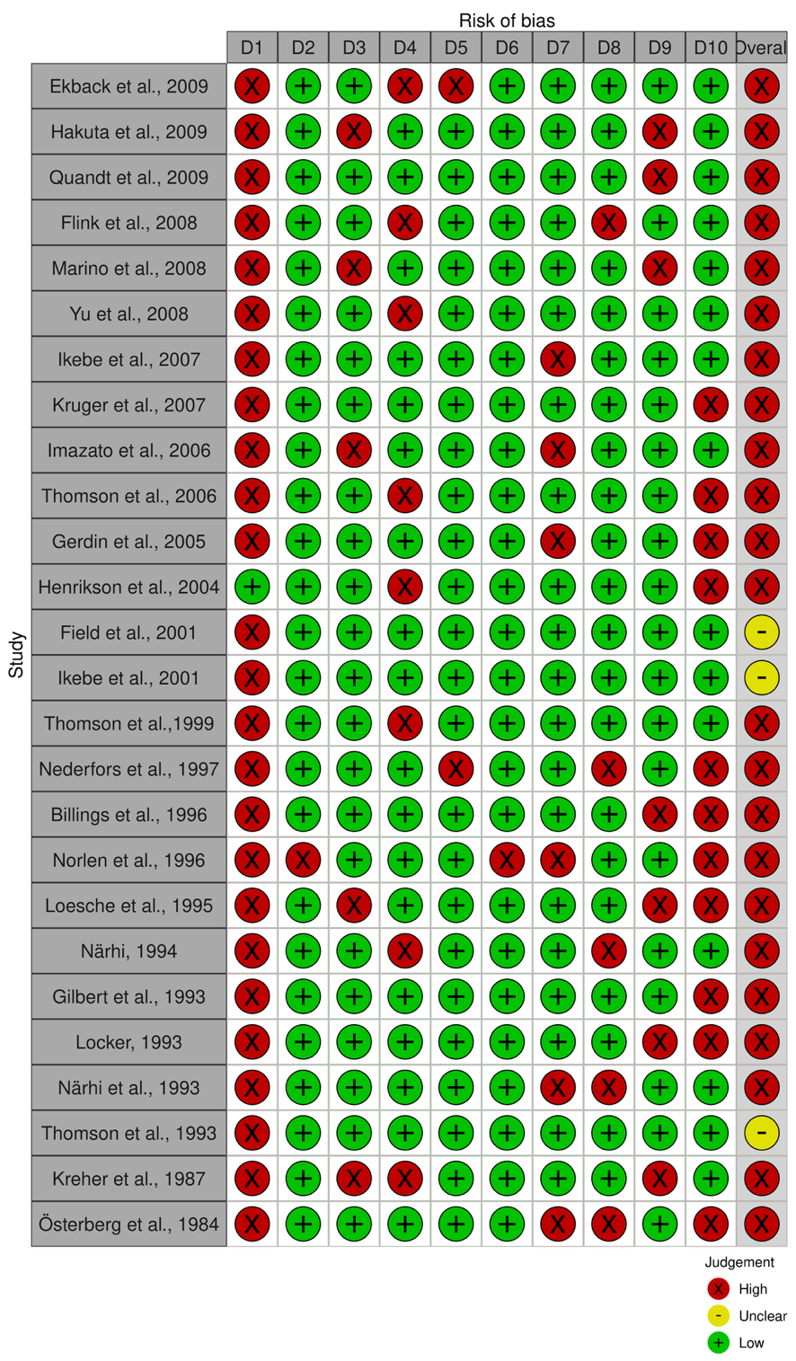

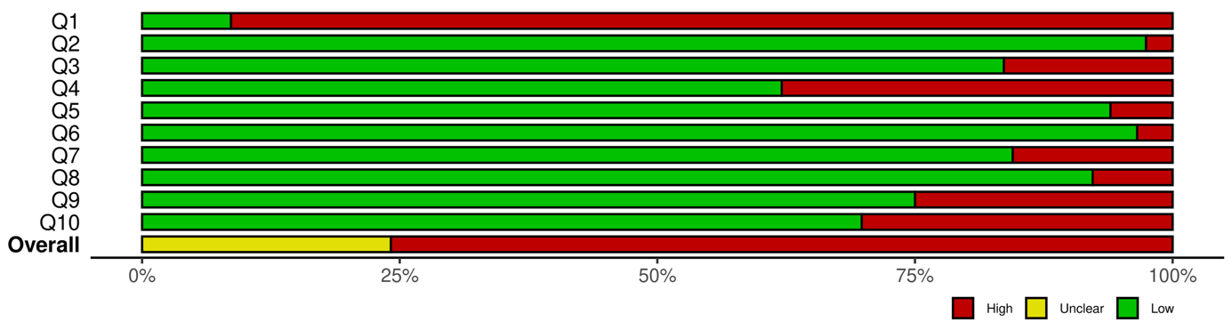

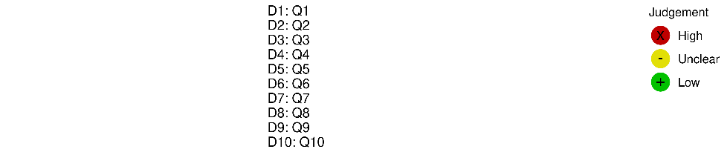

Table S5 Risk of bias of included studies reporting prevalence of hyposalivation in older adults (n=32, top) and summary risk of bias (bottom).
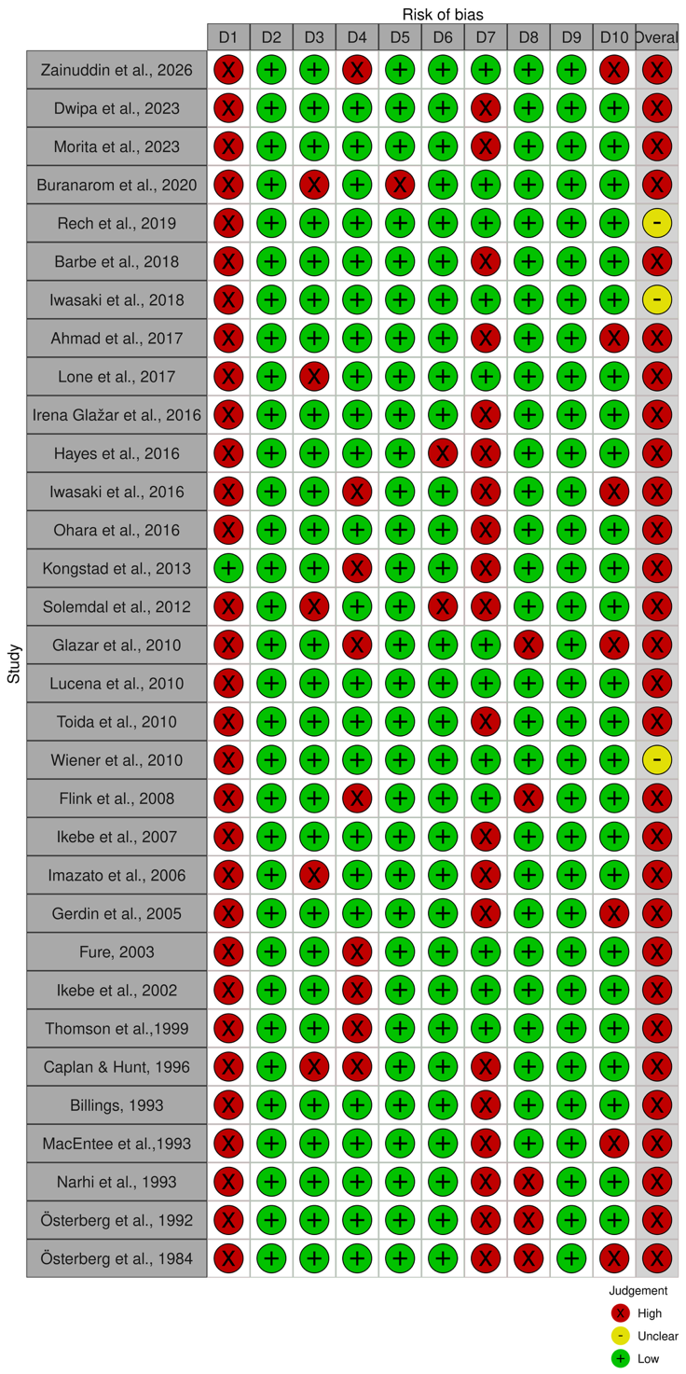

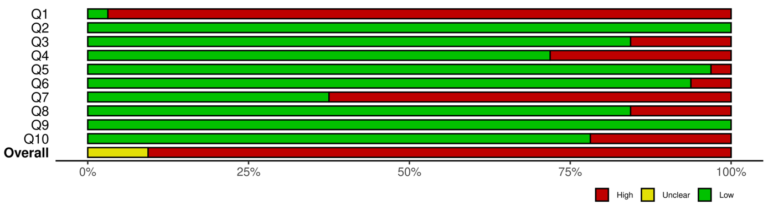

Table S6 Pooled prevalence of xerostomia in older adults and subgroup analysis
(n= 119 study populations obtained from 116 studies).
Findings | Study populations | Cases |  | Pooled prevalence  (95% CI) | I² | p-value
Findings | Study populations | Xerostomia | Participants | Pooled prevalence  (95% CI) | I² | p-value
Main findings* | 119 | 47,310 | 170,803 | 32.4 (29.6, 35.2) | 99.3% | <0.001
Subgroup analysis
Study design |  |  |  |  |  | 0.001§
Cross-sectional | 102 | 41,517 | 148,211 | 33.4 (30.2, 36.8) | 99.4% | <0.001
Prospective | 17 | 5,793 | 22,592 | 25.8 (22.9, 28.7) | 95.4% | <0.001
Setting** |  |  |  |  |  | 0.005§
Institutionalized | 25 | 2,567 | 9,341 | 43.6 (33.9, 53.5) | 98.8% | <0.001
Community-dwelling | 95 | 44,611 | 160,709 | 30.9 (28.0, 34.0) | 99.4% | <0.001
Combined | 3 | 132 | 753 | 18.9 (9.5, 30.6) | 92.8% | <0.001
Time** |  |  |  |  |  | <0.001§
Day | 119 | 47,216 | 170,803 | 32.2 (29.4, 35.0) | 99.3% | <0.001
Night | 5 | 5,777 | 12,367 | 45.5 (42.5, 48.5) | 89.7% | <0.001
Age cut-off point** |  |  |  |  |  | 0.96§
Cut-off point 60 | 48 | 7,520 | 26,748 | 32.4 (27.1, 37.9) | 98.9% | <0.001
Cut-off point 65 | 76 | 40,450 | 146,043 | 32.2 (28.9, 35.6) | 99.4% | <0.001
Sex** |  |  |  |  |  | 0.04§
Both | 87 | 29,408 | 118,586 | 33.5 (30.4, 36.7) | 99.1% | <0.001
Women | 30 | 10,283 | 26,643 | 33.2 (26.6, 40.0) | 99.2% | <0.001
Men | 30 | 7,604 | 25,574 | 25.5 (20.4, 31.0) | 98.9% | <0.001
Diagnostic method |  |  |  |  |  | 0.96§
Self-reported | 103 | 45,789 | 164,991 | 32.5 (29.6, 35.5) | 99.3% | <0.001
Questionnaires | 16 | 1,521 | 5,812 | 32.2 (21.2, 44.2) | 98.8% | <0.001
Risk of bias |  |  |  |  |  | 0.63§
Moderate | 28 | 8,504 | 25,927 | 33.7 (27.9, 39.7) | 98.9% | <0.001
High | 91 | 38,806 | 144,876 | 32.0 (28.8, 35.3) | 99.4% | <0.001
Country |  |  |  |  |  | <0.001§
Australia | 4 | 452 | 1,611 | 30.9 (21.3, 41.4) | 94.1% | <0.001
Belgium | 1 | 142 | 433 | 32.8 (28.5, 37.4) | NA | NA
Brazil | 13 | 2,397 | 6,642 | 37.2 (31.0, 43.7) | 96.3% | <0.001
Canada | 1 | 84 | 372 | 22.6 (18.6, 27.1) | NA | NA
Chile | 4 | 176 | 341 | 50.4 (39.2, 61.5) | 76.5% | 0.005
China | 3 | 1,052 | 3,960 | 28.9 (20.9, 37.7) | 94.6% | <0.001
Croatia | 1 | 187 | 341 | 54.8 (49.5, 60.0) | NA | NA
Denmark | 2 | 261 | 1,215 | 29.3 (10.7, 52.6) | 96.3% | <0.001
England | 3 | 883 | 2,753 | 30.2 (18.4, 43.5) | 96.6% | <0.001
Finland | 4 | 697 | 3,360 | 30.0 (12.1, 51.9) | 99.1% | <0.001
France | 2 | 308 | 856 | 31.3 (19.3, 44.9) | 84.5% | 0.01
Germany | 3 | 105 | 132 | 81.4 (62.6, 94.7) | 83.0% | 0.003
Greece | 1 | 25 | 74 | 33.8 (24.0, 45.1) | NA | NA
Hong Kong | 2 | 145 | 3,577 | 8.4 (7.0, 23.3) | 96.4% | <0.001
India | 2 | 107 | 426 | 25.1 (21.1, 29.3) | 0.0% | 0.46
Iran | 1 | 32 | 300 | 10.7 (7.7, 14.7) | NA | NA
Italy | 2 | 134 | 1,368 | 16.7 (1.3, 44.1) | 98.2% | <0.001
Japan | 16 | 12,191 | 59,906 | 26.2 (21.7, 30.9) | 98.5% | <0.001
Jordan | 1 | 81 | 253 | 32.0 (26.6, 38.0) | NA | NA
Lebanon | 1 | 139 | 201 | 69.2 (62.5, 75.1) | NA | NA
Lithuania | 1 | 109 | 370 | 29.5 (25.0, 34.3) | NA | NA
Mexico | 4 | 812 | 2,255 | 33.1 (18.3, 49.9) | 98.5% | <0.001
New Zealand | 3 | 1,002 | 2,543 | 31.6 (16.3, 49.4) | 96.6% | 0.001
Norway | 4 | 2,708 | 10,020 | 25.7 (19.9, 32.1) | 97.9% | <0.001
Poland | 1 | 79 | 240 | 32.9 (27.3, 39.1) | NA | NA
Portugal | 1 | 167 | 302 | 55.3 (49.7, 60.8) | NA | NA
Serbia | 1 | 179 | 301 | 59.5 (53.8, 64.9) | NA | NA
South Korea | 5 | 4,578 | 11,135 | 43.5 (29.3, 58.4) | 98.5% | <0.001
Spain | 1 | 198 | 356 | 55.6 (50.4, 60.7) | NA | NA
Sweden | 12 | 10,135 | 27,785 | 25.3 (16.3, 35.5) | 99.7% | <0.001
Taiwan | 3 | 292 | 2,342 | 15.3 (9.9, 21.5) | 92.3% | <0.001
Thailand | 3 | 264 | 830 | 38.2 (10.1, 71.5) | 98.8% | <0.001
The Netherlands | 2 | 932 | 3,236 | 46.7 (11.7, 83.7) | 90.8% | 0.001
Turkey | 1 | 80 | 229 | 34.9 (29.1, 41.3) | NA | NA
USA | 10 | 6,177 | 20,738 | 32.7 (19.7, 47.2) | 99.7% | <0.001
Continent |  |  |  |  |  | 0.11§
Asia | 38 | 19,060 | 83,231 | 28.7 (24.2, 33.4) | 99.3% | <0.001
Australia | 7 | 1,454 | 4,154 | 31.3 (22.9, 40.3) | 96.4% | <0.001
Europe | 42 | 17,150 | 53,070 | 33.2 (28.4, 38.1) | 99.2% | <0.001
North America | 12 | 6,336 | 21,335 | 31.9 (20.3, 44.7) | 99.6% | <0.001
South America | 20 | 3,310 | 9,013 | 38.9 (33.2, 44.7) | 96.7% | <0.001
Note: §P-value for heterogeneity between subgroups. * The total number of study populations (n = 119) exceeded the number of included studies (n = 116) because three studies reported data from more than one distinct study population, providing separate estimates across different study settings, time points, age cut-off points, and gender within the same study.
**The sum of study populations across individual subgroup categories exceeded the total of 119, as some studies contributed data to more than one subgroup category. Therefore, the number of study populations within each subgroup category may not equal the total number of study populations.
Abbreviations: CI; confidence interval, NA; not available.

Table S7 Pooled prevalence of hyposalivation in older adults and subgroup analysis (n=32 studies).

Findings | Studies | Cases |  | Pooled prevalence  (95% CI) | I² | p-value
Findings | Studies | Hyposalivation | Participants | Pooled prevalence  (95% CI) | I² | p-value
Main findings | 32 | 2,974 | 10,396 | 33.0 (25.7, 40.7) | 98.5% | <0.001
Subgroup analysis
Study design |  |  |  |  |  | 0.99§
Cross-sectional | 28 | 2,396 | 8,448 | 33.0 (24.6, 42.0) | 98.6% | <0.001
Prospective | 4 | 578 | 1,948 | 33.1 (20.2, 47.6) | 97.4% | <0.001
Setting* |  |  |  |  |  | 0.20§
Institutionalized | 7 | 449 | 935 | 46.4 (29.5, 63.7) | 96.2% | <0.001
Community-dwelling | 25 | 2,431 | 9,203 | 29.3 (21.6, 37.6) | 98.6% | <0.001
Combined | 2 | 94 | 258 | 34.2 (16.6, 54.5) | 90.8% | 0.001
Age* |  |  |  |  |  | 0.17§
Cut point 60 | 12 | 1,426 | 3,539 | 39.6 (26.6, 53.5) | 98.5% | <0.001
Cut point 65 | 21 | 1,570 | 6,946 | 28.8 (21.6, 36.5) | 97.8% | <0.001
Sex* |  |  |  |  |  | 0.14§
Both | 18 | 1,048 | 3,080 | 36.9 (25.4, 49.2) | 97.9% | <0.001
Women | 16 | 1,598 | 4,567 | 34.5 (23.4, 46.6) | 98.6% | <0.001
Men | 16 | 841 | 3,627 | 22.9 (14.3, 32.8) | 97.7% | <0.001
Collection Method* |  |  |  |  |  | 0.29
USF | 18 | 1,709 | 4,685 | 39.0 (27.9, 50.7) | 98.4% | <0.001
SSF | 20 | 1,917 | 7,057 | 29.9 (20.9, 39.7) | 98.6% | <0.001
Either USF or SSF | 1 | 22 | 53 | 41.5 (29.3, 54.9) | NA | NA
Risk of bias |  |  |  |  |  | 0.77§
Moderate | 3 | 764 | 1,607 | 36.9 (11.8, 66.7) | 99.3% | <0.001
High | 29 | 2,210 | 8,789 | 32.5 (25.5, 40.0) | 98.1% | <0.001
Country |  |  |  |  |  | <0.001§
Australia | 1 | 151 | 684 | 22.1 (19.1, 25.3) | NA | NA
Brazil | 2 | 558 | 881 | 56.4 (37.1, 74.7) | 92.7% | <0.001
Canada | 1 | 69 | 156 | 44.2 (36.7, 52.1) | NA | NA
Croatia | 2 | 320 | 682 | 46.5 (8.2, 87.6) | 99.3% | <0.001
Denmark | 1 | 70 | 1,089 | 6.4 (5.1, 8.0) | NA | NA
Finland | 1 | 143 | 306 | 46.7 (41.2, 52.3) | NA | NA
Germany | 1 | 18 | 28 | 64.3 (45.8, 79.3) | NA | NA
Indonesia | 1 | 25 | 60 | 41.7 (30.1, 54.3) | NA | NA
Ireland | 1 | 24 | 334 | 7.2 (4.9, 10.5) | NA | NA
Japan | 8 | 765 | 3,394 | 23.8 (14.0, 35.2) | 98.1% | <0.001
New Zealand | 1 | 13 | 50 | 26.0 (15.9, 39.6) | NA | NA
Norway | 1 | 69 | 158 | 43.7 (36.2, 51.5) | NA | NA
Pakistan | 1 | 77 | 110 | 70.0 (60.9, 77.8) | NA | NA
Saudi Arabia | 1 | 89 | 138 | 64.5 (56.2, 72.0) | NA | NA
Sweden | 5 | 351 | 1,520 | 27.9 (20.8, 35.6) | 85.8% | <0.001
Thailand | 1 | 22 | 53 | 41.5 (29.3, 54.9) | NA | NA
USA | 3 | 210 | 753 | 23.6 (8.5, 43.2) | 95.9% | <0.001
Continents |  |  |  |  |  | <0.002§
Asia | 12 | 978 | 3,755 | 33.2 (22.3, 45.1) | 98.2% | <0.01
Australia | 2 | 164 | 734 | 22.3 (19.4, 25.4) | 0.0% | 0.530
Europe | 12 | 995 | 4,117 | 32.2 (20.1, 45.5) | 98.6% | <0.01
North America | 4 | 279 | 909 | 28.5 (14.7, 44.8) | 95.4% | <0.01
South America | 2 | 558 | 881 | 56.4 (37.1, 74.7) | 92.7% | <0.01
Note: §P-value for heterogeneity between subgroups. *For study settings, age cut-off points, gender and the collection methods, the sum of study populations across individual subgroup categories exceeded the total of 32, as some studies contributed data to more than one subgroup category. Therefore, the number of study populations within each subgroup category exceeded the total number of study populations.

Abbreviations: USF, unstimulated salivary flow; SSF, stimulated salivary flow; CI; confidence interval, NA; not available.

Fig. S1 Funnel plot of the overall prevalence of xerostomia of older adults.
Egger’s test p-value = 0.04
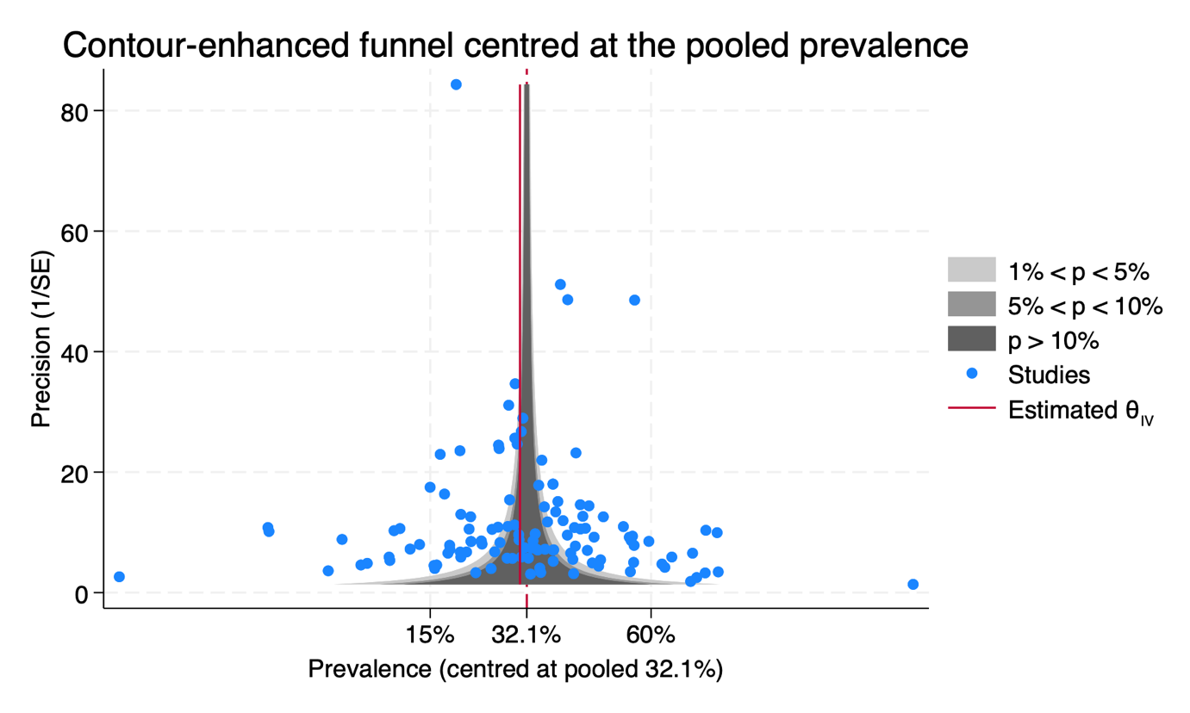

Fig. S2 Funnel plot of the overall prevalence of hyposalivation of older adults
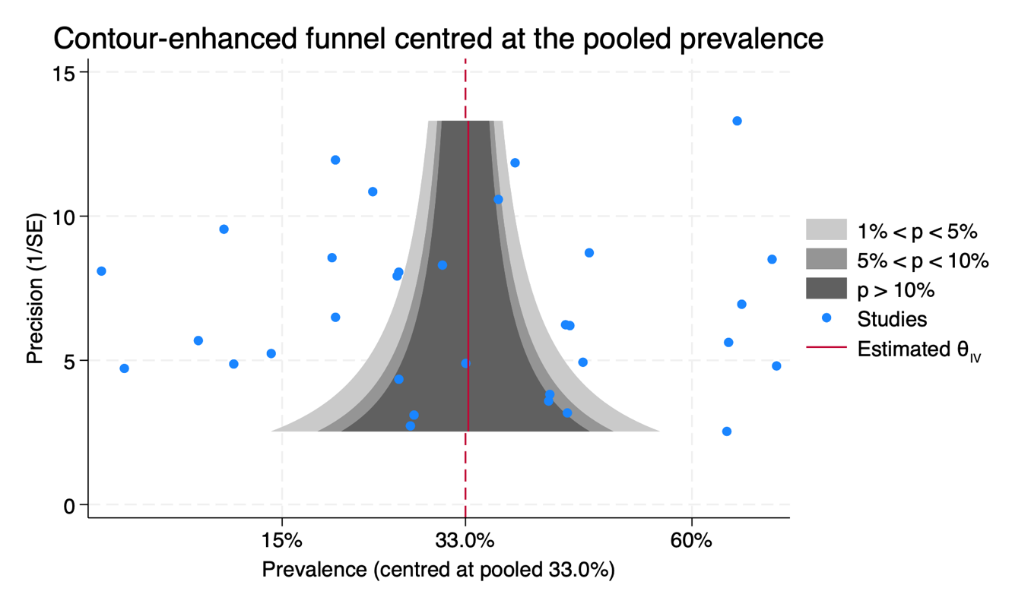
Egger’s test p-value = 0.08

Fig. S3 The leave-one-out analysis of the overall prevalence of xerostomia of older adults (n= 119 study populations obtained from 116 studies).

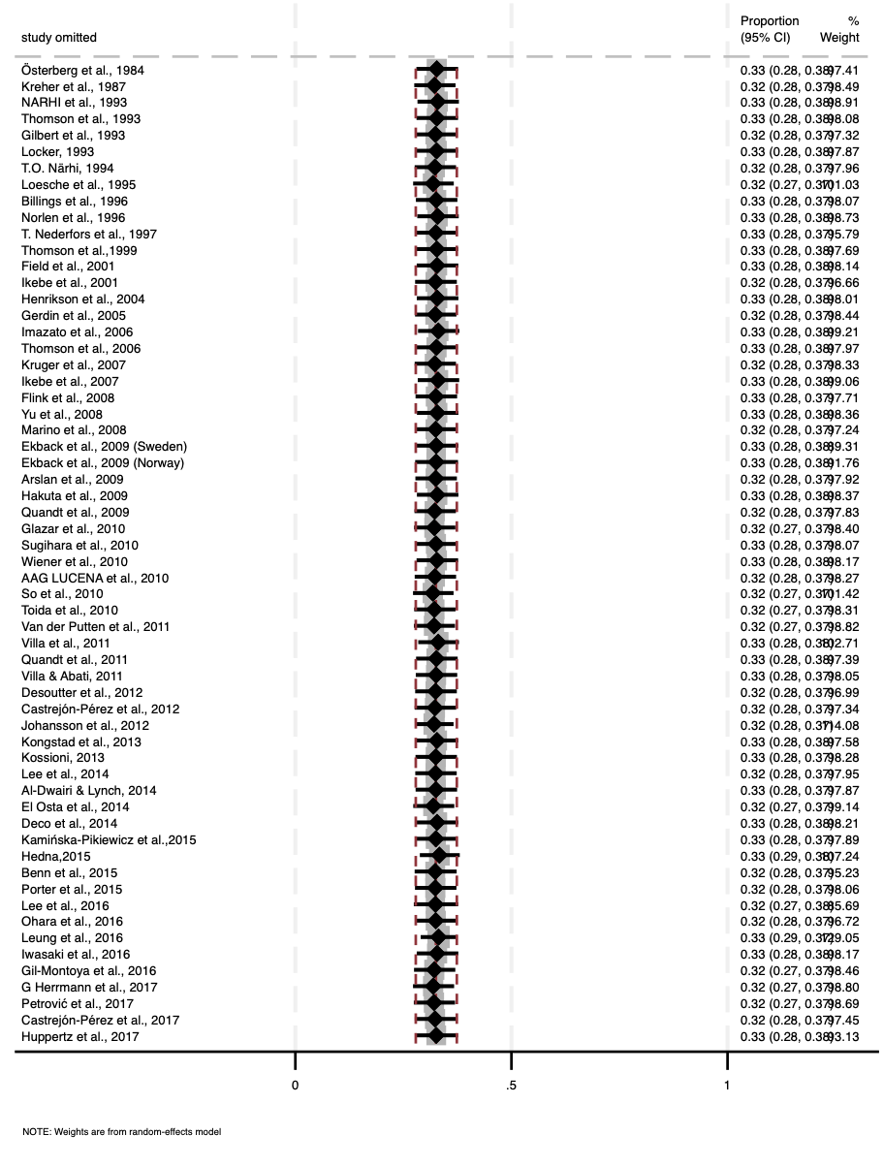
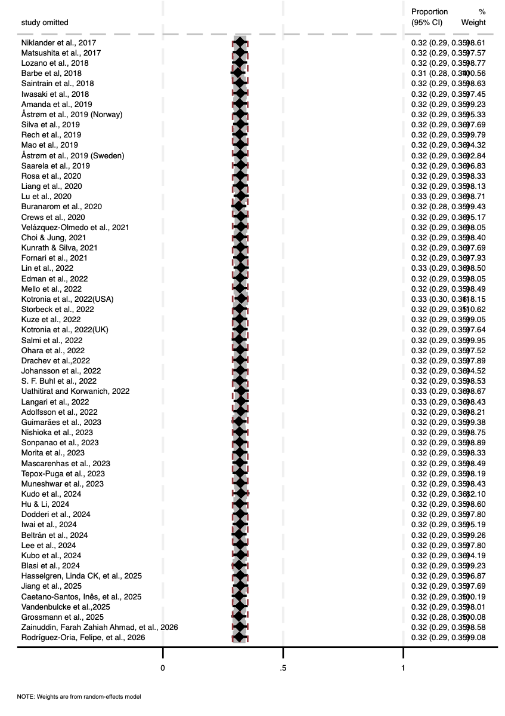

a)
b)

Fig. S4 The leave-one-out analysis of the overall prevalence of hyposalivation of older adults (n=32).

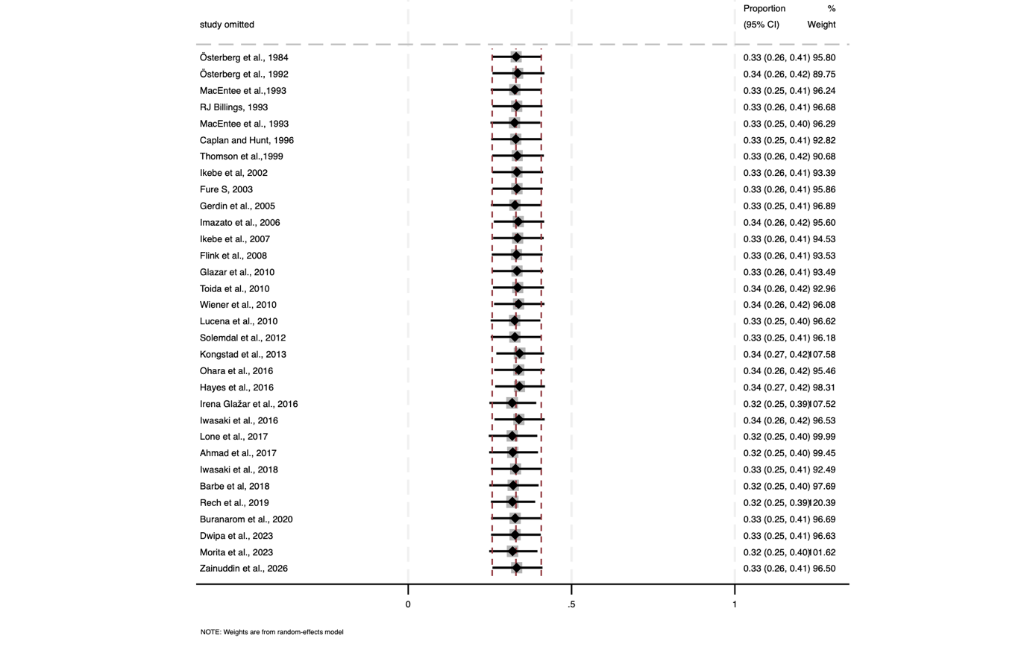

Supplementary Appendix 3: eReferences

Adolfsson, A., Lenér, F., Marklund, B., Mossberg, K., & Çevik‐Aras, H. (2022). Prevalence of dry mouth in adult patients in primary health care. Acta Odontologica Scandinavica, 80(8), 605-610.
Ahmad, M. S., Bhayat, A., Zafar, M. S., & Al-Samadani, K. H. (2017). The Impact of Hyposalivation on Quality of Life (QoL) and Oral Health in the Aging Population of Al Madinah Al Munawarrah. Int J Environ Res Public Health, 14(4). doi:10.3390/ijerph14040445
Al‐Dwairi, Z., & Lynch, E. (2014). Xerostomia in complete denture wearers: prevalence, clinical findings and impact on oral functions. Gerodontology, 31(1), 49-55.
Arslan, A., Orhan, K., Canpolat, C., Delilbasi, Ç., & Dural, S. (2009). Impact of xerostomia on oral complaints in a group of elderly Turkish removable denture wearers. Arch Gerontol Geriatr, 49(2), 263-267. doi:10.1016/j.archger.2008.09.008
Åstrøm, A. N., Lie, S. A., Ekback, G., Gülcan, F., & Ordell, S. (2019). Self‐reported dry mouth among ageing people: a longitudinal, cross‐national study. European Journal of Oral Sciences, 127(2), 130-138.
Barbe, A. G., Schmidt, P., Bussmann, M., Kunter, H., Noack, M. J., & Röhrig, G. (2018). Xerostomia and hyposalivation in orthogeriatric patients with fall history and impact on oral health-related quality of life. Clin Interv Aging, 13, 1971-1979. doi:10.2147/cia.S178370
Beltrán, V., Muñoz-Sepúlveda, F., Acevedo, C., Navarro, P., Venegas, B., Salgado, C., . . . Engelke, W. (2024). A rural teledentistry care experience: a geriatric approach to assessing oral health status and treatment needs in older adults from a Mapuche community in Chile. Frontiers in public health, 12, 1356622.
Benn, A., Broadbent, J., & Thomson, W. (2015). Occurrence and impact of xerostomia among dentate adult New Zealanders: findings from a national survey. Australian dental journal, 60(3), 362-367.
Billings, R., Proskin, H., & Moss, M. (1996). Xerostomia and associated factors in a community‐dwelling adult population. Community dentistry and oral epidemiology, 24(5), 312-316. doi:https://doi.org/10.1111/j.1600-0528.1996.tb00868.x
Billings, R. J. (1993). An epidemiologic perspective of saliva flow rates as indicators of susceptibility to oral disease. Crit Rev Oral Biol Med, 4(3-4), 351-356. doi:10.1177/10454411930040031301
Blasi, A. M., Derman, S. H. M., Kunnel, A., Pape, P., Röhrig, G., & Barbe, A. G. (2024). Oral Health and the Association with Blood Parameters in Neurogeriatric Inpatients without Relevant Systemic Inflammation: An Observational Study. Geriatrics, 9(3), 55.
Buhl, S. F., Beck, A. M., Christensen, B., Kock, G., Boyle, E., & Caserotti, P. (2022). Prevalence of low protein intake in 80+-year-old community-dwelling adults and association with dietary patterns and modifiable risk factors: a cross-sectional study. British Journal of Nutrition, 127(2), 266-277.
Buranarom, N., Komin, O., & Matangkasombut, O. (2020). Hyposalivation, oral health, and Candida colonization in independent dentate elders. PLoS One, 15(11), e0242832. doi:10.1371/journal.pone.0242832
Caetano-Santos, I., Canales, G. T., Proença, L., Polido, M., Mendes, J. J., Canhão, H., & Manso, A. C. (2025). Oral health behaviors and associated factors in older adults: a cross-sectional study. Front Oral Health, 6, 1716964. doi:10.3389/froh.2025.1716964
Caplan, D. J., & Hunt, R. J. (1996). Salivary flow and risk of tooth loss in an elderly population. Community Dent Oral Epidemiol, 24(1), 68-71. doi:10.1111/j.1600-0528.1996.tb00816.x
Castrejón-Pérez, R. C., Borges-Yáñez, S. A., Gutiérrez-Robledo, L. M., & Avila-Funes, J. A. (2012). Oral health conditions and frailty in Mexican community-dwelling elderly: a cross sectional analysis. BMC Public Health, 12, 773. doi:10.1186/1471-2458-12-773
Castrejón-Pérez, R. C., Borges-Yáñez, S. A., Irigoyen-Camacho, M. E., & Cruz-Hervert, L. P. (2017). Negative impact of oral health conditions on oral health related quality of life of community dwelling elders in Mexico city, a population based study. Geriatr Gerontol Int, 17(5), 744-752. doi:10.1111/ggi.12780
Choi, E., & Jung, D. (2021). Factors Influencing Oral Health-Related Quality of Life in Older Adults in Rural Areas: Oral Dryness and Oral Health Knowledge and Behavior. Int J Environ Res Public Health, 18(8). doi:10.3390/ijerph18084295
Crews, J. E., Chou, C.-F., Naavaal, S., Griffin, S. O., & Saaddine, J. B. (2020). Self-reported oral health status among adults aged 40+ years with and without vision impairment: National Health Interview Study, 2008. American Journal of Ophthalmology, 210, 184-191.
Deco, C. P. d., Reis, M. R. V. S., Marchini, A. M. P. d. S., Rocha, R. F. d., Santos, M. B. F. d., & Marchini, L. (2014). Taste alteration, mouth dryness and teeth staining as side effects of medications taken by elderly. Brazilian Journal of Oral Sciences, 13.
Desoutter, A., Soudain-Pineau, M., Munsch, F., Mauprivez, C., Dufour, T., & Coeuriot, J. L. (2012). Xerostomia and medication: a cross-sectional study in long-term geriatric wards. The journal of nutrition, health & aging, 16, 575-579.
Dodderi, T., Sreenath, D., Shetty, M. J., Chilwan, U., Rai, S. P., Moolambally, S. R., . . . Kothari, M. (2024). Prevalence of Self-Reported Swallowing Difficulties and Swallowing-Related Quality of Life Among Community-Dwelling Older Adults in India. Dysphagia, 39(6), 1144-1155. doi:https://doi.org/10.1007/s00455-024-10696-0
Drachev, S. N., Puriene, A., Aleksejuniene, J., Stankeviciene, I., & Stangvaltaite-Mouhat, L. (2022). Prevalence of and factors associated with dental service utilization among early elderly in Lithuania. BMC health services research, 22, 1-9.
Dwipa, L., Wardhani, R., Setiani, T., Sufiawati, I., Pratiwi, Y. S., Susandi, E., . . . Thomson, W. (2023). Summated Xerostomia Inventory to detect both xerostomia and salivary gland hypofunction. European Review for Medical & Pharmacological Sciences, 27(2).
Edman, K., Norderyd, O., & Holmlund, A. (2022). Periodontal health and disease in an older population: A 10‐year longitudinal study. Community dentistry and oral epidemiology, 50(4), 225-232.
Ekbäck, G., Astrøm, A. N., Klock, K., Ordell, S., & Unell, L. (2009). Variation in subjective oral health indicators of 65-year-olds in Norway and Sweden. Acta Odontol Scand, 67(4), 222-232. doi:10.1080/00016350902908780
El Osta, N., Hennequin, M., Tubert-Jeannin, S., Abboud Naaman, N. B., El Osta, L., & Geahchan, N. (2014). The pertinence of oral health indicators in nutritional studies in the elderly. Clin Nutr, 33(2), 316-321. doi:10.1016/j.clnu.2013.05.012
Field, E., Fear, S., Higham, S., Ireland, R., Rostron, J., Willetts, R., & Longman, L. (2001). Age and medication are significant risk factors for xerostomia in an English population, attending general dental practice. Gerodontology, 18(1), 21-24. doi:https://doi.org/10.1111/j.1741-2358.2001.00021.x
Flink, H., Bergdahl, M., Tegelberg, Å., Rosenblad, A., & Lagerlöf, F. (2008). Prevalence of hyposalivation in relation to general health, body mass index and remaining teeth in different age groups of adults. Community dentistry and oral epidemiology, 36(6), 523-531.
Fornari, C. B., Bergonci, D., Stein, C. B., Agostini, B. A., & Rigo, L. (2021). Prevalence of xerostomia and its association with systemic diseases and medications in the elderly: a cross-sectional study. Sao Paulo Medical Journal, 139(4), 380-387.
Fure, S. (2003). A ten-year cross-sectional and follow-up study of salivary flow rates and mutans streptococci and lactobacillus counts in elderly Swedish individuals. Oral Health Prev Dent, 1(3), 185-194.
Gerdin, E. W., Einarson, S., Jonsson, M., Aronsson, K., & Johansson, I. (2005). Impact of dry mouth conditions on oral health-related quality of life in older people. Gerodontology, 22(4), 219-226. doi:10.1111/j.1741-2358.2005.00087.x
Gil-Montoya, J. A., Barrios, R., Sánchez-Lara, I., Carnero-Pardo, C., Fornieles-Rubio, F., Montes, J., . . . Bravo, M. (2016). Prevalence of drug-induced xerostomia in older adults with cognitive impairment or dementia: an observational study. Drugs & aging, 33, 611-618.
Gilbert, G. H., Heft, M. W., & Duncan, R. P. (1993). Oral signs, symptoms, and behaviors in older Floridians. J Public Health Dent, 53(3), 151-157. doi:10.1111/j.1752-7325.1993.tb02694.x
Glažar, I., Muhvić Urek, M., Kuiš, D., Prpić, J., Mišković, I., Kovačević Pavičić, D., & Pezelj-Ribarić, S. (2016). Salivary Flow Rate, Oral Yeast Colonization and Dental Status in Institutionalized and Non-Institutionalized Elderly. Acta Clin Croat, 55(3), 390-395. doi:10.20471/acc.2016.55.03.06
Glazar, I., Urek, M., Brumini, G., & Pezelj‐Ribaric, S. (2010). Oral sensorial complaints, salivary flow rate and mucosal lesions in the institutionalized elderly. Journal of oral rehabilitation, 37(2), 93-99. doi:https://doi.org/10.1111/j.1365-2842.2009.02027.x
Góis, A. C. B., Pernambuco, L., & de Lima, K. C. (2019). Prevalence and Associated Factors With Voice Disorders in Brazilian Community-dwelling Older Adults. J Voice, 33(5), 806.e801-806.e807. doi:10.1016/j.jvoice.2018.02.025
Grossmann, S. d. M. C., Prado, L. C. S., SOUZA, L. d. A. e., Domingues, D. P., Bruzinga, F. F. B., Lopes, L. C., & Souto, G. R. (2025). Association between oral mucosal lesions and xerostomia: a cross-sectional study in a Brazilian population sample. Brazilian oral research, 39, e036.
Hakuta, C., Mori, C., Ueno, M., Shinada, K., & Kawaguchi, Y. (2009). Evaluation of an oral function promotion programme for the independent elderly in Japan. Gerodontology, 26(4), 250-258. doi:10.1111/j.1741-2358.2008.00269.x
Hasselgren, L. C. K., Berggreen, E., Elabdeen, H. Z., Kvalheim, S. F., Sulo, G., & Åstrøm, A. N. (2025). The Association Between Oral Diseases, Symptoms, and Oral Health-Related Quality of Life in 70-Year-Olds: A Cross-Sectional Study. Gerodontology, 42(4), 591-601. doi:10.1111/ger.70004
Hayes, M., Da Mata, C., Cole, M., McKenna, G., Burke, F., & Allen, P. F. (2016). Risk indicators associated with root caries in independently living older adults. Journal of Dentistry, 51, 8-14.
Hedna, K., Hakkarainen, K. M., Gyllensten, H., Jönsson, A. K., Petzold, M., & Hägg, S. (2015). Potentially inappropriate prescribing and adverse drug reactions in the elderly: a population-based study. European journal of clinical pharmacology, 71, 1525-1533.
Henriksen, B. M., Ambjørnsen, E., Laake, K., & Axéll, T. E. (2004). Oral hygiene and oral symptoms among the elderly in long‐term care. Special Care in Dentistry, 24(5), 254-259.
Herrmann, G., Müller, K., Behr, M., & Hahnel, S. (2017). [Xerostomia and its impact on oral health-related quality of life]. Z Gerontol Geriatr, 50(2), 145-150. doi:10.1007/s00391-015-0968-y
Hu, S., & Li, X. (2024). An analysis of influencing factors of oral frailty in the elderly in the community. BMC Oral Health, 24(1), 260.
Huppertz, V. A., van der Putten, G.-J., Halfens, R. J., Schols, J. M., & de Groot, L. C. (2017). Association between malnutrition and oral health in Dutch nursing home residents: results of the LPZ study. Journal of the American Medical Directors Association, 18(11), 948-954.
Ikebe, K., Matsuda, K., Morii, K., Wada, M., Hazeyama, T., Nokubi, T., & Ettinger, R. L. (2007). Impact of dry mouth and hyposalivation on oral health-related quality of life of elderly Japanese. Oral Surg Oral Med Oral Pathol Oral Radiol Endod, 103(2), 216-222. doi:https://doi.org/10.1016/j.tripleo.2005.12.001
Ikebe, K., Nokubi, T., Sajima, H., Kobayashi, S., Hata, K., Ono, T., & Ettinger, R. L. (2001). Perception of dry mouth in a sample of community‐dwelling older adults in Japan. Special Care in Dentistry, 21(2), 52-59.
Ikebe, K., Sajima, H., Kobayashi, S., Hata, K., Morii, K., Nokubi, T., & Ettinger, R. L. (2002). Association of salivary flow rate with oral function in a sample of community-dwelling older adults in Japan. Oral Surg Oral Med Oral Pathol Oral Radiol Endod, 94(2), 184-190.
Imazato, S., Ikebe, K., Nokubi, T., Ebisu, S., & Walls, A. W. (2006). Prevalence of root caries in a selected population of older adults in Japan. J Oral Rehabil, 33(2), 137-143. doi:10.1111/j.1365-2842.2006.01547.x
Iwai, K., Azuma, T., Yonenaga, T., Sasai, Y., Komatsu, Y., Tabata, K., . . . Matsumoto, Y. (2024). Predictive Factors Associated with Future Decline in Swallowing Function among Japanese Older People Aged≥ 75 Years. International Journal of Environmental Research and Public Health, 21(6), 674.
Iwasaki, M., Borgnakke, W. S., Yoshihara, A., Ito, K., Ogawa, H., Nohno, K., . . . Miyazaki, H. (2018). Hyposalivation and 10‐year all‐cause mortality in an elderly Japanese population. Gerodontology, 35(2), 87-94.
Iwasaki, M., Yoshihara, A., Ito, K., Sato, M., Minagawa, K., Muramatsu, K., . . . Miyazaki, H. (2016). Hyposalivation and dietary nutrient intake among community-based older Japanese. Geriatr Gerontol Int, 16(4), 500-507. doi:10.1111/ggi.12500
Jiang, L., Huang, S., Reissmann, D. R., Schmalz, G., & Li, J. (2025). Identification of Risk Group for Root Caries and Analysis of Associated Factors in Older Adults Using Unsupervised Machine Learning Clustering. Clinical Interventions in Aging, 483-493.
Johansson, A.-K., Omar, R., Mastrovito, B., Sannevik, J., Carlsson, G. E., & Johansson, A. (2022). Prediction of xerostomia in a 75-year-old population: a 25-year longitudinal study. Journal of Dentistry, 118, 104056.
Johansson, A. K., Johansson, A., Unell, L., Ekbäck, G., Ordell, S., & Carlsson, G. E. (2012). Self‐reported dry mouth in Swedish population samples aged 50, 65 and 75 years. Gerodontology, 29(2), e107-e115.
Kamińska-Pikiewicz, K., Bachanek, T., & Chałas, R. (2015). The incidence of oral dryness in people over 65 years living in Lublin. Current Issues in Pharmacy and Medical Sciences, 28(4), 250-253. doi:doi:10.1515/cipms-2015-0082
Kongstad, J., Ekstrand, K., Qvist, V., Christensen, L. B., Cortsen, B., Grønbaek, M., . . . Fiehn, N. E. (2013). Findings from the oral health study of the Danish Health Examination Survey 2007-2008. Acta Odontol Scand, 71(6), 1560-1569. doi:10.3109/00016357.2013.776701
Kossioni, A., Kossionis, G. E., & Polychronopoulou, A. (2013). Variation in oral health parameters between older people with and without mental disorders. Special Care in Dentistry, 33(5), 232-238.
Kotronia, E., Brown, H., Papacosta, O., Lennon, L. T., Weyant, R. J., Whincup, P. H., . . . Ramsay, S. E. (2022). Oral health problems and risk of incident disability in two studies of older adults in the United Kingdom and the United States. J Am Geriatr Soc, 70(7), 2080-2092. doi:10.1111/jgs.17792
Kreher, J. M., Graser, G. N., & Handelman, S. L. (1987). The relationship of drug use to denture function and saliva flow rate in a geriatric population. J Prosthet Dent, 57(5), 631-638. doi:10.1016/0022-3913(87)90350-7
Kruger, E., Tennant, M., Smith, K., & Peachey, J. (2007). The oral health and treatment needs of community-dwelling older people in a rural town in Western Australia. Australasian Journal on Ageing, 26(1), 15-20. doi:https://doi.org/10.1111/j.1741-6612.2007.00187.x
Kubo, Y., Fujii, K., Noguchi, T., Hayashi, T., Tomiyama, N., Ochi, A., & Hayashi, H. (2024). Longitudinal association between oral function and underweight onset among community‐dwelling older adults: Role of regular self‐weighing. Special Care in Dentistry.
Kudo, Y., Takeuchi, K., Kusama, T., Kojima, T., Waguri‐Nagaya, Y., Nagayoshi, M., . . . Kojima, M. (2024). Differences in prevalence of self‐reported oral hypofunction between older adult patients with rheumatoid arthritis and the general older population: A cross‐sectional study using propensity score matching. Journal of oral rehabilitation, 51(6), 924-930.
Kunrath, I., & Silva, A. E. R. (2021). Oral health and depressive symptoms among older adults: longitudinal study. Aging Ment Health, 25(12), 2265-2271. doi:10.1080/13607863.2020.1855104
Kuze, L. S., Fornari, F., Collares, K., & Della Bona, A. (2023). Association between masticatory dysfunction and gastroesophageal reflux disease: A population‐based study in the elderly. Journal of oral rehabilitation, 50(2), 150-156.
Langari, S. F., Hosseini, S. R., Bijani, A., Jenabian, N., Motalebnejad, M., Mahmoodi, E., . . . Ghadimi, R. (2022). Association between antihypertensive drugs and the elderly’s oral health-related quality of life: Results of Amirkola cohort study. Caspian Journal of Internal Medicine, 13(3), 582.
Lee, E., Lee, Y. H., Kim, W., & Kho, H. S. (2014). Self-reported prevalence and severity of xerostomia and its related conditions in individuals attending hospital for general health examinations. Int J Oral Maxillofac Surg, 43(4), 498-505. doi:10.1016/j.ijom.2013.10.011
Lee, Y.-H., Won, J. H., Auh, Q.-S., Noh, Y.-K., & Lee, S.-W. (2024). Prediction of xerostomia in elderly based on clinical characteristics and salivary flow rate with machine learning. Scientific reports, 14(1), 3423.
Lee, Y. S., Kim, H. G., & Moreno, K. (2016). Xerostomia Among Older Adults With Low Income: Nuisance or Warning? J Nurs Scholarsh, 48(1), 58-65. doi:10.1111/jnu.12185
Leung, D. Y., Leung, A. Y., & Chi, I. (2016). Factors associated with chewing problems and oral dryness among older C hinese people in H ong Kong. Gerodontology, 33(1), 106-115. doi:https://doi.org/10.1111/ger.12116
Liang, Y. H., Chou, C., Chen, Y. J., Chou, Y. F., Lin, C. Y., Chou, C., & Wang, T. F. (2020). Impact of periodontal disease and chewing ability on the quality of life of the elderly in an affluent community. J Formos Med Assoc, 119(11), 1693-1701. doi:10.1016/j.jfma.2020.01.002
Lin, Y. C., Huang, S. S., Yen, C. W., Kabasawa, Y., Lee, C. H., & Huang, H. L. (2022). Physical Frailty and Oral Frailty Associated with Late-Life Depression in Community-Dwelling Older Adults. J Pers Med, 12(3). doi:10.3390/jpm12030459
Locker, D. (1993). Subjective reports of oral dryness in an older adult population. Community dentistry and oral epidemiology, 21(3), 165-168.
Loesche, W., Bromberg, J., Terpenning, M., Bretz, W., Dominguez, B., Grossman, N., & Langmore, S. (1995). Xerostomia, xerogenic medications and food avoidances in selected geriatric groups. Journal of the American Geriatrics Society, 43(4), 401-407.
Lone, M. A., Shaikh, S., Lone, M. M., Afaq, A., & Lone, M. A. (2017). Association of salivary gland hypofunction with diabetes mellitus and drugs among the elderly in Karachi, Pakistan. J Investig Clin Dent, 8(2). doi:10.1111/jicd.12209
Lozano, C. P., Vergara, C., & Lee, X. (2018). Prevalence of oral lesions and chronic non-communicable diseases in a sample of Chilean institutionalized versus non-institutionalized elderly. Journal of Oral Research, 7(3), 108-113.
Lu, T. Y., Chen, J. H., Du, J. K., Lin, Y. C., Ho, P. S., Lee, C. H., . . . Huang, H. L. (2020). Dysphagia and masticatory performance as a mediator of the xerostomia to quality of life relation in the older population. BMC Geriatr, 20(1), 521. doi:10.1186/s12877-020-01901-4
Lucena, A. A. G. d., Costa, E. B. d., Alves, P. M., Figuêiredo, R. L. Q., Pereira, J. V., & Cavalcanti, A. L. (2010). Fluxo salivar em pacientes idosos. RGO. Revista Gaúcha de Odontologia (Online), 58(3), 301-305.
MacEntee, M., Clark, D., & Glick, N. (1993). Predictors of caries in old age. Gerodontology, 10(2), 90-97.
Mao, W., Chen, Y., Wu, B., Ge, S., Yang, W., Chi, I., & Dong, X. (2019). Perceived Stress, Social Support, and Dry Mouth Among US Older Chinese Adults. J Am Geriatr Soc, 67(S3), S551-s556. doi:10.1111/jgs.15890
Mariño, R., Schofield, M., Wright, C., Calache, H., & Minichiello, V. (2008). Self-reported and clinically determined oral health status predictors for quality of life in dentate older migrant adults. Community Dent Oral Epidemiol, 36(1), 85-94. doi:10.1111/j.1600-0528.2007.00378.x
Mascarenhas, M. K., Cademartori, M. G., Borges, R. d. C., Gonzalez, M. C., Bielemann, R. M., Thomson, W. M., & Demarco, F. F. (2023). Prevalence and Associations of Xerostomia in Older Adults in Southern Brazil. Gerodontology.
Matsushita, E., Okada, K., Ito, Y., Satake, S., Shiraishi, N., Hirose, T., & Kuzuya, M. (2017). Characteristics of physical prefrailty among Japanese healthy older adults. Geriatrics & gerontology international, 17(10), 1568-1574.
Mello, R. P., Xavier, M. O., Tomasi, E., Gonzalez, M. C., Demarco, F. F., & Bielemann, R. M. (2022). Dysphagia Perception Among Community-Dwelling Older Adults from a Municipality in Southern Brazil. Dysphagia, 37(4), 879-888. doi:10.1007/s00455-021-10347-8
Morita, I., Morioka, H., Abe, Y., Nomura, T., Nakashima, S., Sugiura, I., . . . Kondo, K. (2023). Discordance between hyposalivation and xerostomia among community-dwelling older adults in Japan. PLoS One, 18(3), e0282740.
Muneshwar, S. S., Ashwinirani, S., Gole, A. A., & Suragimath, G. (2023). Oral Manifestation in Postmenopausal Women of Maharashtra, Western Region. Journal of Mid-life Health, 14(1), 28-33. doi:https://doi.org/10.4103/jmh.jmh_194_22
Murray Thomson, W., Chalmers, J. M., John Spencer, A., Slade, G. D., & Carter, K. D. (2006). A longitudinal study of medication exposure and xerostomia among older people. Gerodontology, 23(4), 205-213.
Närhi, T. (1994). Prevalence of subjective feelings of dry mouth in the elderly. Journal of dental research, 73(1), 20-25. doi:https://doi.org/10.1177/00220345940730010301
Närhi, T. O., Ainamo, A., & Meurman, J. H. (1993). Salivary yeasts, saliva, and oral mucosa in the elderly. J Dent Res, 72(6), 1009-1014. doi:10.1177/00220345930720060301
Nederfors, T., Isaksson, R., Mörnstad, H., & Dahlöf, C. (1997). Prevalence of perceived symptoms of dry mouth in an adult Swedish population--relation to age, sex and pharmacotherapy. Community Dent Oral Epidemiol, 25(3), 211-216. doi:10.1111/j.1600-0528.1997.tb00928.x
Niklander, S., Veas, L., Barrera, C., Fuentes, F., Chiappini, G., & Marshall, M. (2017). Risk factors, hyposalivation and impact of xerostomia on oral health-related quality of life. Brazilian oral research, 31(0), e14.
Nishioka, E., Iwata, M., Kumai, N., Matsumoto, Y., Momoki, C., Yasui, Y., & Habu, D. (2023). Validation of the applicability of the mealtime observation checklist in predicting the risk of aspiration pneumonia in older adults receiving oral intake support: A retrospective cohort study of four long‐term care facilities. Geriatrics & gerontology international, 23(5), 376-382.
Norlén, P., Johansson, I., & Birkhed, D. (1996). Impact of medical and life-style factors on number of teeth in 68-year-old men in southern Sweden. Acta Odontologica Scandinavica, 54(1), 66-74.
Ohara, Y., Hirano, H., Yoshida, H., Obuchi, S., Ihara, K., Fujiwara, Y., & Mataki, S. (2016). Prevalence and factors associated with xerostomia and hyposalivation among community‐dwelling older people in J apan. Gerodontology, 33(1), 20-27. doi:https://doi.org/10.1111/ger.12101
Ohara, Y., Iwasaki, M., Shirobe, M., Kawai, H., Edahiro, A., Motokawa, K., . . . Obuchi, S. (2022). Xerostomia as a key predictor of physical frailty among community-dwelling older adults in Japan: a five-year prospective cohort study from The Otassha Study. Archives of Gerontology and Geriatrics, 99, 104608.
Osterberg, T., Birkhed, D., Johansson, C., & Svanborg, A. (1992). Longitudinal study of stimulated whole saliva in an elderly population. Scand J Dent Res, 100(6), 340-345. doi:10.1111/j.1600-0722.1992.tb01084.x
Osterberg, T., Landahl, S., & Hedegård, B. (1984). Salivary flow, saliva, pH and buffering capacity in 70-year-old men and women. Correlation to dental health, dryness in the mouth, disease and drug treatment. J Oral Rehabil, 11(2), 157-170. doi:10.1111/j.1365-2842.1984.tb00565.x
Petrovic, M., Stančić, I., Jelenković Popovac, A., & Vasovic, M. (2016). Oral health-related quality of life of institutionalized elderly in Serbia. Vojnosanitetski pregled, 74, 228-228. doi:10.2298/VSP150720228P
Porter, J., Ntouva, A., Read, A., Murdoch, M., Ola, D., & Tsakos, G. (2015). The impact of oral health on the quality of life of nursing home residents. Health Qual Life Outcomes, 13, 102. doi:10.1186/s12955-015-0300-y
Quandt, S. A., Chen, H., Bell, R. A., Anderson, A. M., Savoca, M. R., Kohrman, T., . . . Arcury, T. A. (2009). Disparities in oral health status between older adults in a multiethnic rural community: the rural nutrition and oral health study. J Am Geriatr Soc, 57(8), 1369-1375. doi:10.1111/j.1532-5415.2009.02367.x
Quandt, S. A., Savoca, M. R., Leng, X., Chen, H., Bell, R. A., Gilbert, G. H., . . . Arcury, T. A. (2011). Dry mouth and dietary quality in older adults in north Carolina. J Am Geriatr Soc, 59(3), 439-445. doi:10.1111/j.1532-5415.2010.03309.x
Rech, R. S., Hugo, F. N., Tôrres, L. H. d. N., & Hilgert, J. B. (2019). Factors associated with hyposalivation and xerostomia in older persons in South Brazil. Gerodontology, 36(4), 338-344.
Rodríguez-Oria, F., Bravo Riveros, F., Barrios Neira, P., Letelier Albornoz, M. I., Achondo Laage, B., Riffo Acuña, T., . . . Ortuño Borroto, D. (2026). Xerostomia and Oral Health-Related Quality of Life in Chilean Older Adults Living in Long-Term Care Facilities. Gerodontology. doi:10.1111/ger.70061
Rosa, R. W., Samot, J., Helmer, C., Pourtau, G., Dupuis, V., Fricain, J. C., . . . Arrivé, E. (2020). Important oral care needs of older French people: A cross-sectional study. Rev Epidemiol Sante Publique, 68(2), 83-90. doi:10.1016/j.respe.2020.01.135
Saarela, R. K. T., Savikko, N. M., Soini, H., Muurinen, S., Suominen, M. H., Kautiainen, H., & Pitkala, K. H. (2019). Burden of Oral Symptoms and Health-Related Quality of Life in Long-Term Care Settings in Helsinki, Finland. J Nutr Health Aging, 23(10), 1021-1025. doi:10.1007/s12603-019-1268-9
Saintrain, M. V. L., Bezerra, T. M. M., Santos, F. D. S., Saintrain, S. V., Pequeno, L. L., da Silva, R. M., & Vieira-Meyer, A. (2018). Subjective well-being and oral discomfort in older people. Int Psychogeriatr, 30(10), 1509-1517. doi:10.1017/s1041610218000145
Salmi, A., Komulainen, K., Nihtilä, A., Tiihonen, M., Nykänen, I., Hartikainen, S., & Suominen, A. L. (2022). Eating problems among old home care clients. Clinical and Experimental Dental Research, 8(4), 959-968.
Silva, A. E. R., Kunrath, I., Danigno, J. F., Cascaes, A. M., de Castillos, E. D., de Oliveira Langlois, C., & Demarco, F. F. (2019). Is oral health associated with the presence of depressive symptoms among the elderly?/A Saude bucal esta associada a presenca de sintomas depressivos em idosos? Ciência & Saúde Coletiva, 24(1), 181-189.
So, J. S., Chung, S. C., Kho, H. S., Kim, Y. K., & Chung, J. W. (2010). Dry mouth among the elderly in Korea: a survey of prevalence, severity, and associated factors. Oral Surgery, Oral Medicine, Oral Pathology, Oral Radiology, and Endodontology, 110(4), 475-483.
Solemdal, K., Sandvik, L., Willumsen, T., Mowe, M., & Hummel, T. (2012). The impact of oral health on taste ability in acutely hospitalized elderly. PLoS One, 7(5), e36557. doi:10.1371/journal.pone.0036557
Sonpanao, P., Janebodin, K., Namvichaisirikul, N., Thongjit, S., & Jitprasertwong, P. (2023). The Prevalence of Xerostomia in Older Thai Individuals with Type II Diabetes Mellitus and Its Association with Type of Toothpaste and Oral Functions: A Cross-Sectional Study Using Questionnaires. Geriatrics, 8(4), 76.
Storbeck, T., Qian, F., Marek, C., Caplan, D., & Marchini, L. (2022). Dose‐dependent association between xerostomia and number of medications among older adults. Special Care in Dentistry, 42(3), 225-231.
Sugihara, N., Maki, Y., Okawa, Y., Hosaka, M., Matsukubo, T., & Takaesu, Y. (2010). Factors associated with root surface caries in elderly. The Bulletin of Tokyo Dental College, 51(1), 23-30.
Tepox-Puga, S. M., Rocha-Ortiz, J. A., Medina-Solís, C. E., Castrejón-Pérez, R. C., Sánchez-García, S., & Borges-Yáñez, S. A. (2023). Prevalence, and Risk Indicators of Coronal and Root Caries in Mexican Older Adults in Nursing Homes. Clinical, Cosmetic and Investigational Dentistry, 333-347.
Thomson, W. M., Brown, R. H., & Williams, S. M. (1993). Medication and perception of dry mouth in a population of institutionalised elderly people. N Z Med J, 106(957), 219-221.
Thomson, W. M., Chalmers, J. M., Spencer, A. J., & Ketabi, M. (1999). The occurrence of xerostomia and salivary gland hypofunction in a population‐based sample of older South Australians. Special Care in Dentistry, 19(1), 20-23.
Toida, M., Nanya, Y., Takeda‐Kawaguchi, T., Baba, S., Iida, K., Kato, K., . . . Shibata, T. (2010). Oral complaints and stimulated salivary flow rate in 1188 adults. Journal of oral pathology & medicine, 39(5), 407-419.
Uathitirat, W., & Korwanich, N. (2022). Oral Health Status and Physical Frailty in Community-dwelling Older Adults. Journal of International Dental and Medical Research, 15(4), 1698-1703.
van der Putten, G.-J., Brand, H. S., Schols, J. M., & de Baat, C. (2011). The diagnostic suitability of a xerostomia questionnaire and the association between xerostomia, hyposalivation and medication use in a group of nursing home residents. Clinical oral investigations, 15, 185-192. doi:https://doi.org/10.1007/s00784-010-0382-1
Vandenbulcke, P. A. I., de Almeida Mello, J., Schoebrechts, E., De Lepeleire, J., Declercq, A., Declerck, D., & Duyck, J. (2025). Oral health of nursing home residents in Flanders, Belgium, and its associated factors. Scientific reports, 15(1), 5463.
Velázquez-Olmedo, L. B., Borges-Yáñez, S. A., Andrade Palos, P., García-Peña, C., Gutiérrez-Robledo, L. M., & Sánchez-García, S. (2021). Oral health condition and development of frailty over a 12-month period in community-dwelling older adults. BMC Oral Health, 21(1), 355. doi:10.1186/s12903-021-01718-6
Villa, A., & Abati, S. (2011). Risk factors and symptoms associated with xerostomia: a cross-sectional study. Aust Dent J, 56(3), 290-295. doi:10.1111/j.1834-7819.2011.01347.x
Villa, A., Polimeni, A., Strohmenger, L., Cicciù, D., Gherlone, E., & Abati, S. (2011). Dental patients’ self-reports of xerostomia and associated risk factors. The Journal of the American Dental Association, 142(7), 811-816.
Wiener, R. C., Wu, B., Crout, R., Wiener, M., Plassman, B., Kao, E., & McNeil, D. (2010). Hyposalivation and xerostomia in dentate older adults. J Am Dent Assoc, 141(3), 279-284. doi:10.14219/jada.archive.2010.0161
Yu, D. S., Lee, D. T., Hong, A. W., Lau, T. Y., & Leung, E. M. (2008). Impact of oral health status on oral health-related quality of life in Chinese hospitalised geriatric patients. Qual Life Res, 17(3), 397-405. doi:10.1007/s11136-008-9314-9
Zainuddin, F. Z. A., Guan, G., Ting, G. S., & Thomson, W. M. (2026). Measuring Dry Mouth in Older People in Residential Care. Gerodontology, 43(1), 103-109. doi:10.1111/ger.70021

