Supplementary information for
Title: Comparative assessment of four treatments for Post Orthodontic White Spot Lesions over a 24-month period: A randomized controlled clinical trial
Yang Zhou^{1,2†}, Qiqiu Wang^{1,2†}, Tianqiang Cui³, Jianbo Li⁴, E. C. M. Lo⁵, Gaofeng Hao⁶, Fang Huang^{1,2*}, Liangyue Pang^{1,2*}, Qinghui Zhi^{1,2*}
1 Hospital of Stomatology, Guanghua School of Stomatology, Sun Yat-sen University, Guangzhou, China
2 Guangdong Provincial Key Laboratory of Stomatology, Guanghua School of Stomatology, Sun Yat-Sen University, Guangzhou, China
3 Foshan Stomatological Hospital & School of Medicine, Foshan University, Foshan, China
4 Stomatological Hospital of Southern Medical University, Guangzhou, China
5 Faculty of Dentistry, The University of Hong Kong, Hong Kong Special Administrative Region, China
6 Oral Disease Prevention Center of Shenzhen Maternity and Child Healthcare Hospital, Shenzhen, China

⁎Corresponding author: Qinghui Zhi, Hospital of Stomatology, Guanghua School of Stomatology, Sun Yat-sen University, No. 56, Lingyuan Xi Road, Guangzhou, China
E-mail addresses: zhiqingh@mail.sysu.edu.cn, Pangly5@mail.sysu.edu.cn, hfang@mail.sysu.edu.cn.
† These authors contributed equally to this work.

Table S1. The WSLs area in all groups during follow-up.

Outcome | Fluoride varnish (FV) |  | Resin infiltration (RI) |  | CPP-ACP |  | Fluoride toothpaste
Outcome | Mean±SD | 95%CI | Mean±SD | 95%CI | Mean±SD | 95%CI | Mean±SD | 95%CI | p value² | partial eta square
WSLs area
baseline | 30.69±12.41 | 28.04, 33.33 | 28.69±10.44 | 25.76, 31.63 | 24.70±13.24^{A} | 21.67, 27.73 | 26.28±10.43^{A} | 23.22, 29.34 | 0.01 | 0.04
12 months | 22.65±9.79ª | 20.78, 24.52 | 15.13±7.54^{Aa} | 12.69, 17.57 | 16.99±8.97^{Aa} | 14.99, 18.98 | 19.54±8.08^{Ba} | 17.00, 22.08 | <0.001 | 0.10
24 months | 17.44±7.99^{ab} | 15.80, 19.07 | 12.10±7.00^{Aab} | 9.96, 14.24 | 13.10±7.53^{Aab} | 11.35, 14.86 | 16.88±8.44^{BCab} | 14.66, 19.11 | <0.001 | 0.08
p value¹ | <0.001 |  | <0.001 |  | <0.001 |  | <0.001
partial eta square | 0.47 |  | 0.45 |  | 0.37 |  | 0.19
1 One-way repeated measures ANOVA is used for within-group comparison. Lower-case letters indicate significant difference within-group comparisons at different follow-up times for each group.
2 One-way ANOVA is used for between-group comparisons. Upper-case letters indicate significant difference between-group comparisons in the columns.
Note: Within the same variable, values with different lowercase letters indicate significant differences (p<0.05). a indicates p<0.05 compared with baseline within the same column. b indicates p<0.05 compared with 12 months within the same column. Within the same variable, values with different lowercase letters indicate significant differences (p<0.05). A indicates p<0.05 compared with the FV group in the same row. B indicates p<0.05 compared with the RI group in the same row. C indicates p<0.05 compared with the CPP-ACP group in the same row.

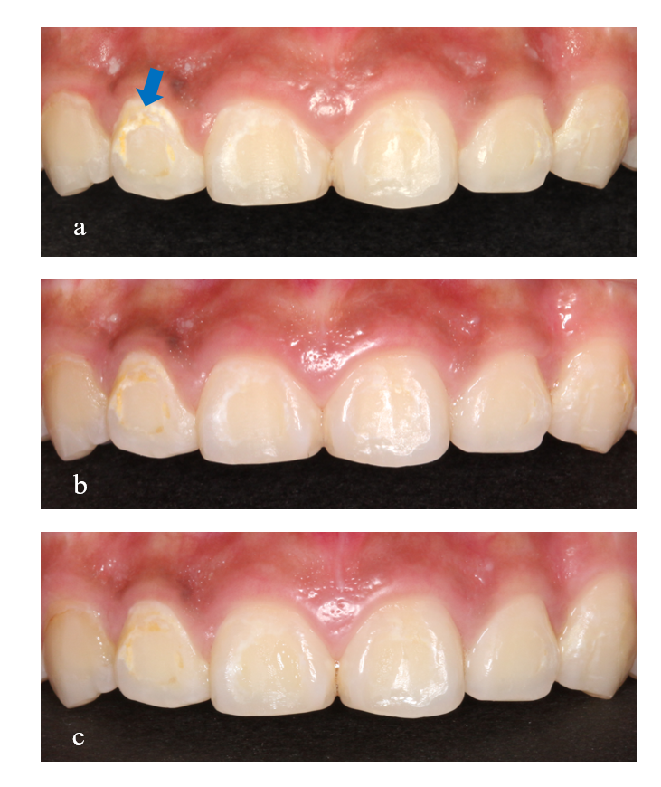
Fig S1. Illustration of the fluoride varnish group. (a) at baseline, (b) after 12 months follow-up, (c) after 24 months follow up. Blue arrows indicate white spot lesions.

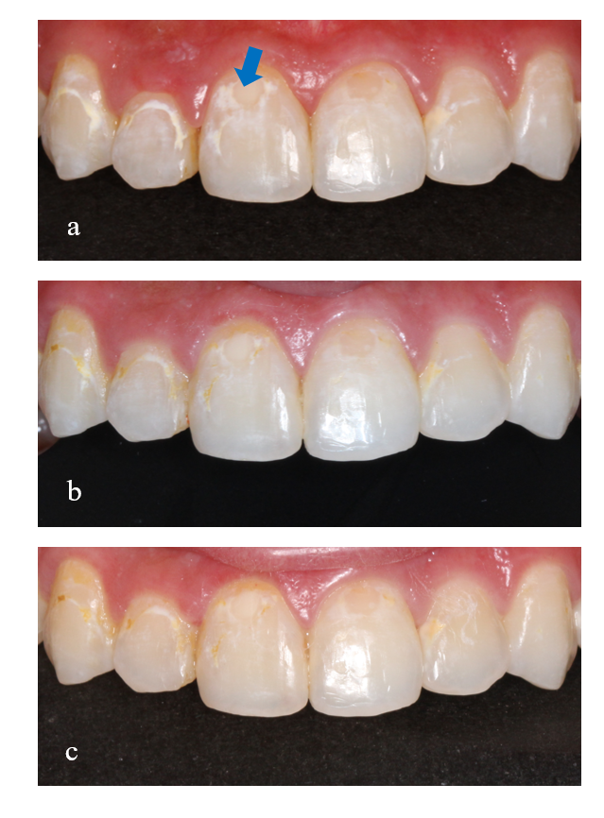
Fig S2. Illustration of the CPP-ACP group. (a) at baseline, (b) after 12 months follow-up, (c) after 24 months follow up. Blue arrows indicate white spot lesions.

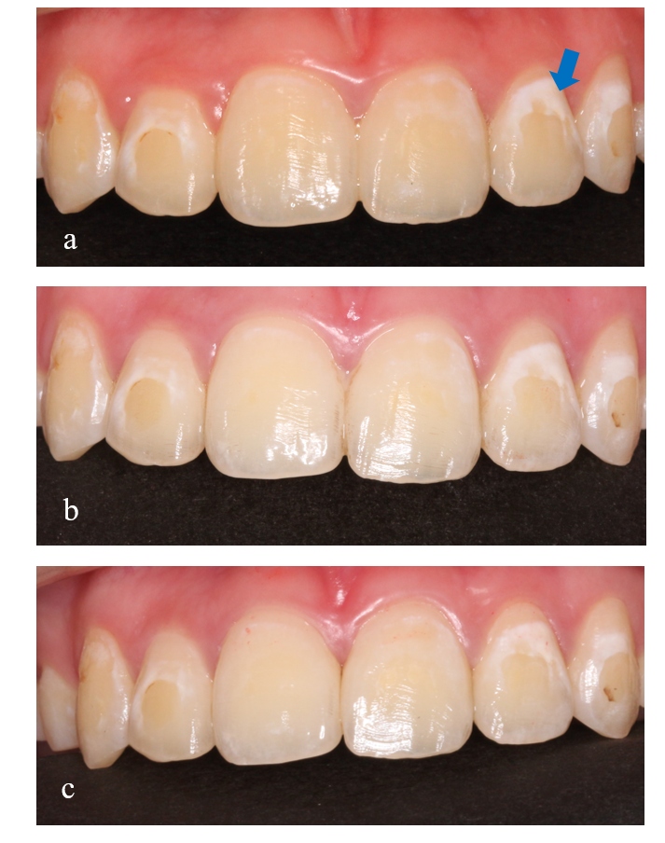
Fig S3. Illustration of the control group. (a) at baseline, (b) after 12 months follow-up, (c) after 24 months follow up. Blue arrows indicate white spot lesions.

