Initial pN and differentiation at recurrence as prognostic factors in patients with recurrent or metastatic tongue squamous cell cancer undergoing re-resection
Xiaohuang Yang¹, Hui Ye ², Hui Cao³, Wu Li⁴, Kai Zheng^{2*}, Xiaoping Yu^{1*}

- Department of Radiology, The Affiliated Cancer Hospital of Xiangya School of Medicine, Central South University/Hunan Cancer Hospital, Changsha, China
- PET Diagnosis center, The Affiliated Cancer Hospital of Xiangya School of Medicine, Central South University/Hunan Cancer Hospital, Changsha, China
- Health service center, The Affiliated Cancer Hospital of Xiangya School of Medicine, Central South University/Hunan Cancer Hospital, Changsha, China
- Department of Head and Neck Surgery, The Affiliated Cancer Hospital of Xiangya School of Medicine, Central South University/Hunan Cancer Hospital, Changsha, China

Kai Zheng and Xiaoping Yu contributed equally to this study and are co-corresponding authors. The e-mail address of Xiaoping Yu is listed below: yuxiaoping@hnca.org.cn. The mobile phone number of Xiaoping Yu is (86) 13607313419.

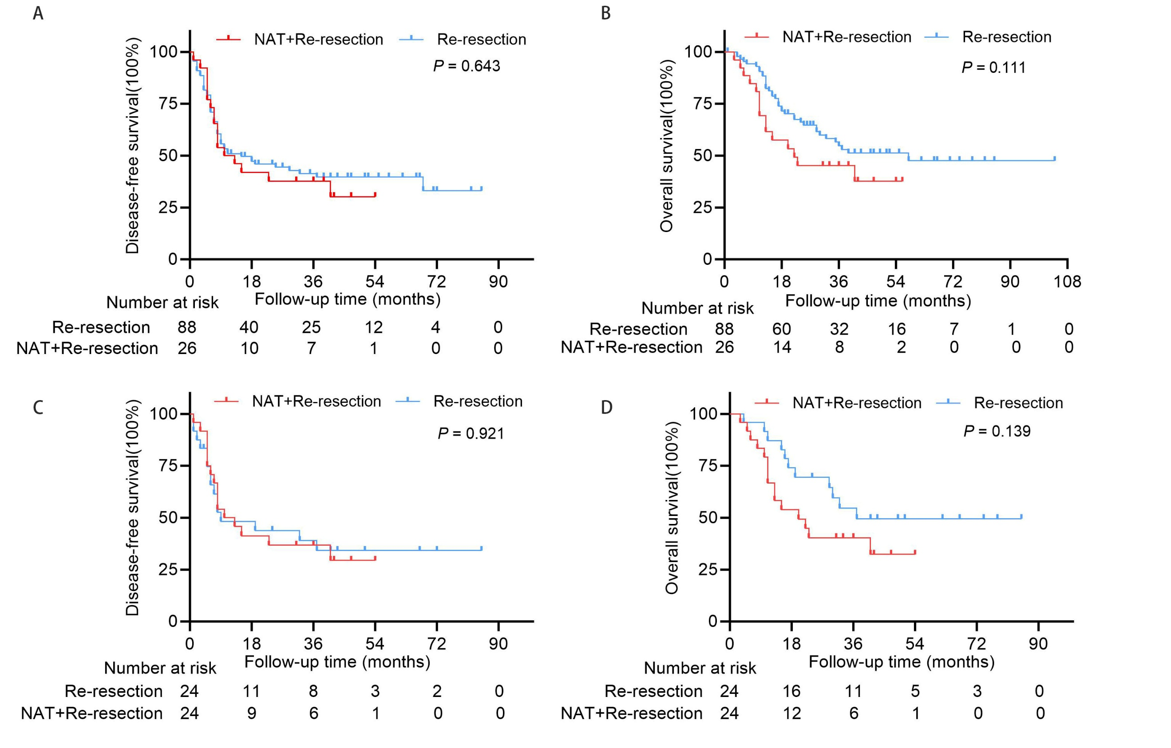
Supplementary Figure 1 Kaplan-Meier analysis of DFS and OS in recurrent or metastatic tongue squamous cell carcinoma patients who underwent direct re-resection versus those who received re-resection after neoadjuvant therapy. (A) DFS and (B) OS in the unmatched cohorts; (C) DFS and (D) OS in the matched cohorts.

