Figure S1 Propensity score distribution by treatment group
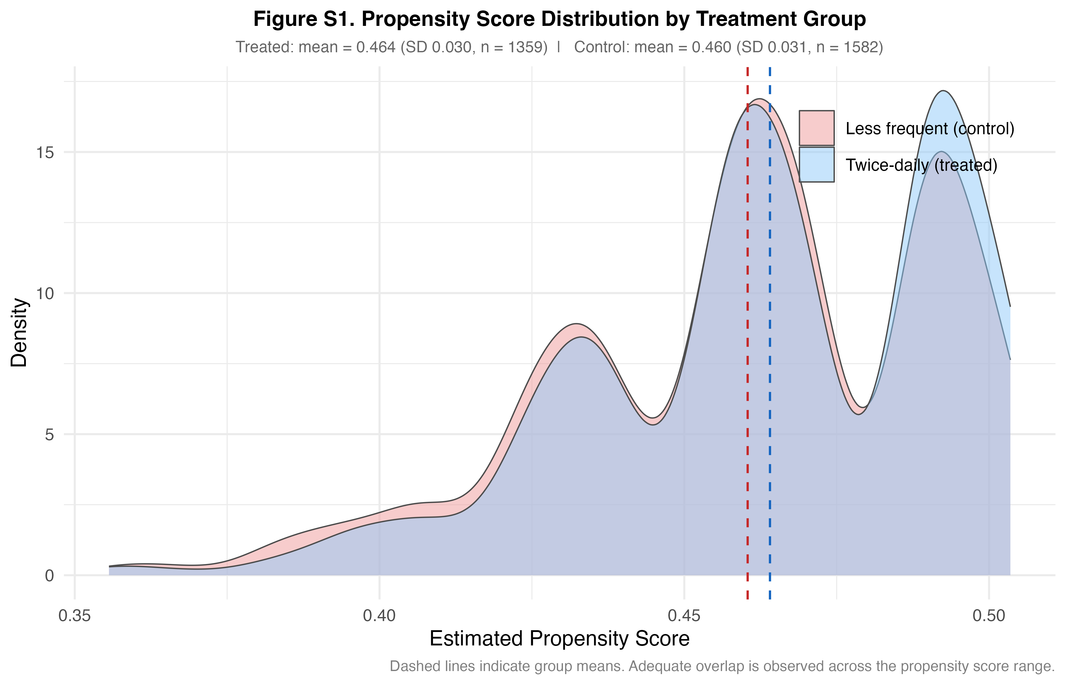

Figure S2 Heterogeneous treatment effects by subgroup
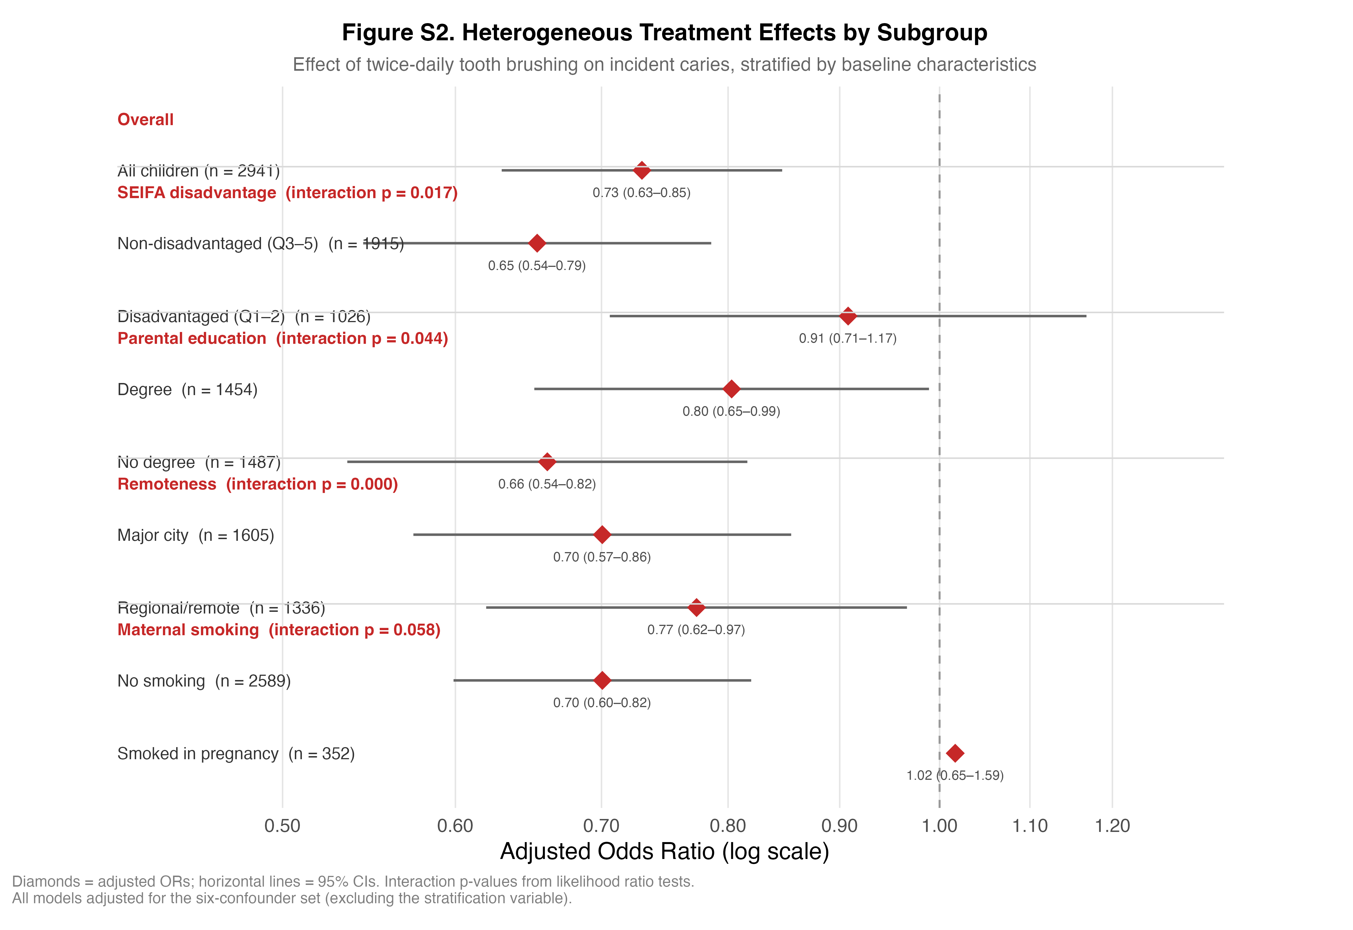
Figure S3 E-values for sensitivity to unmeasured confounding
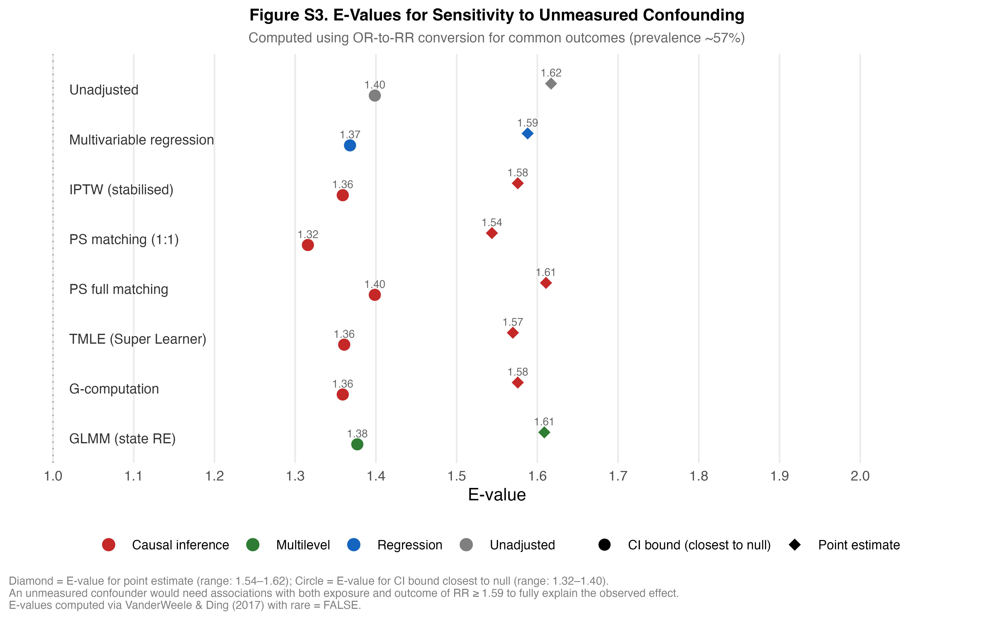
Figure S4 Directed acyclic graph (DAG) depicting assumed causal structure. Green node: exposure (tooth cleaning frequency, Wave 2). Blue node: outcome (incident dental caries, Wave 8). Grey ellipses: measured confounders (area-level socioeconomic position, parental education, household structure, remoteness, SSB consumption, maternal smoking during pregnancy). Grey dashed box: dental service utilisation positioned as a post-exposure mediator excluded from the primary adjustment set. Yellow dashed arrows: unmeasured confounders
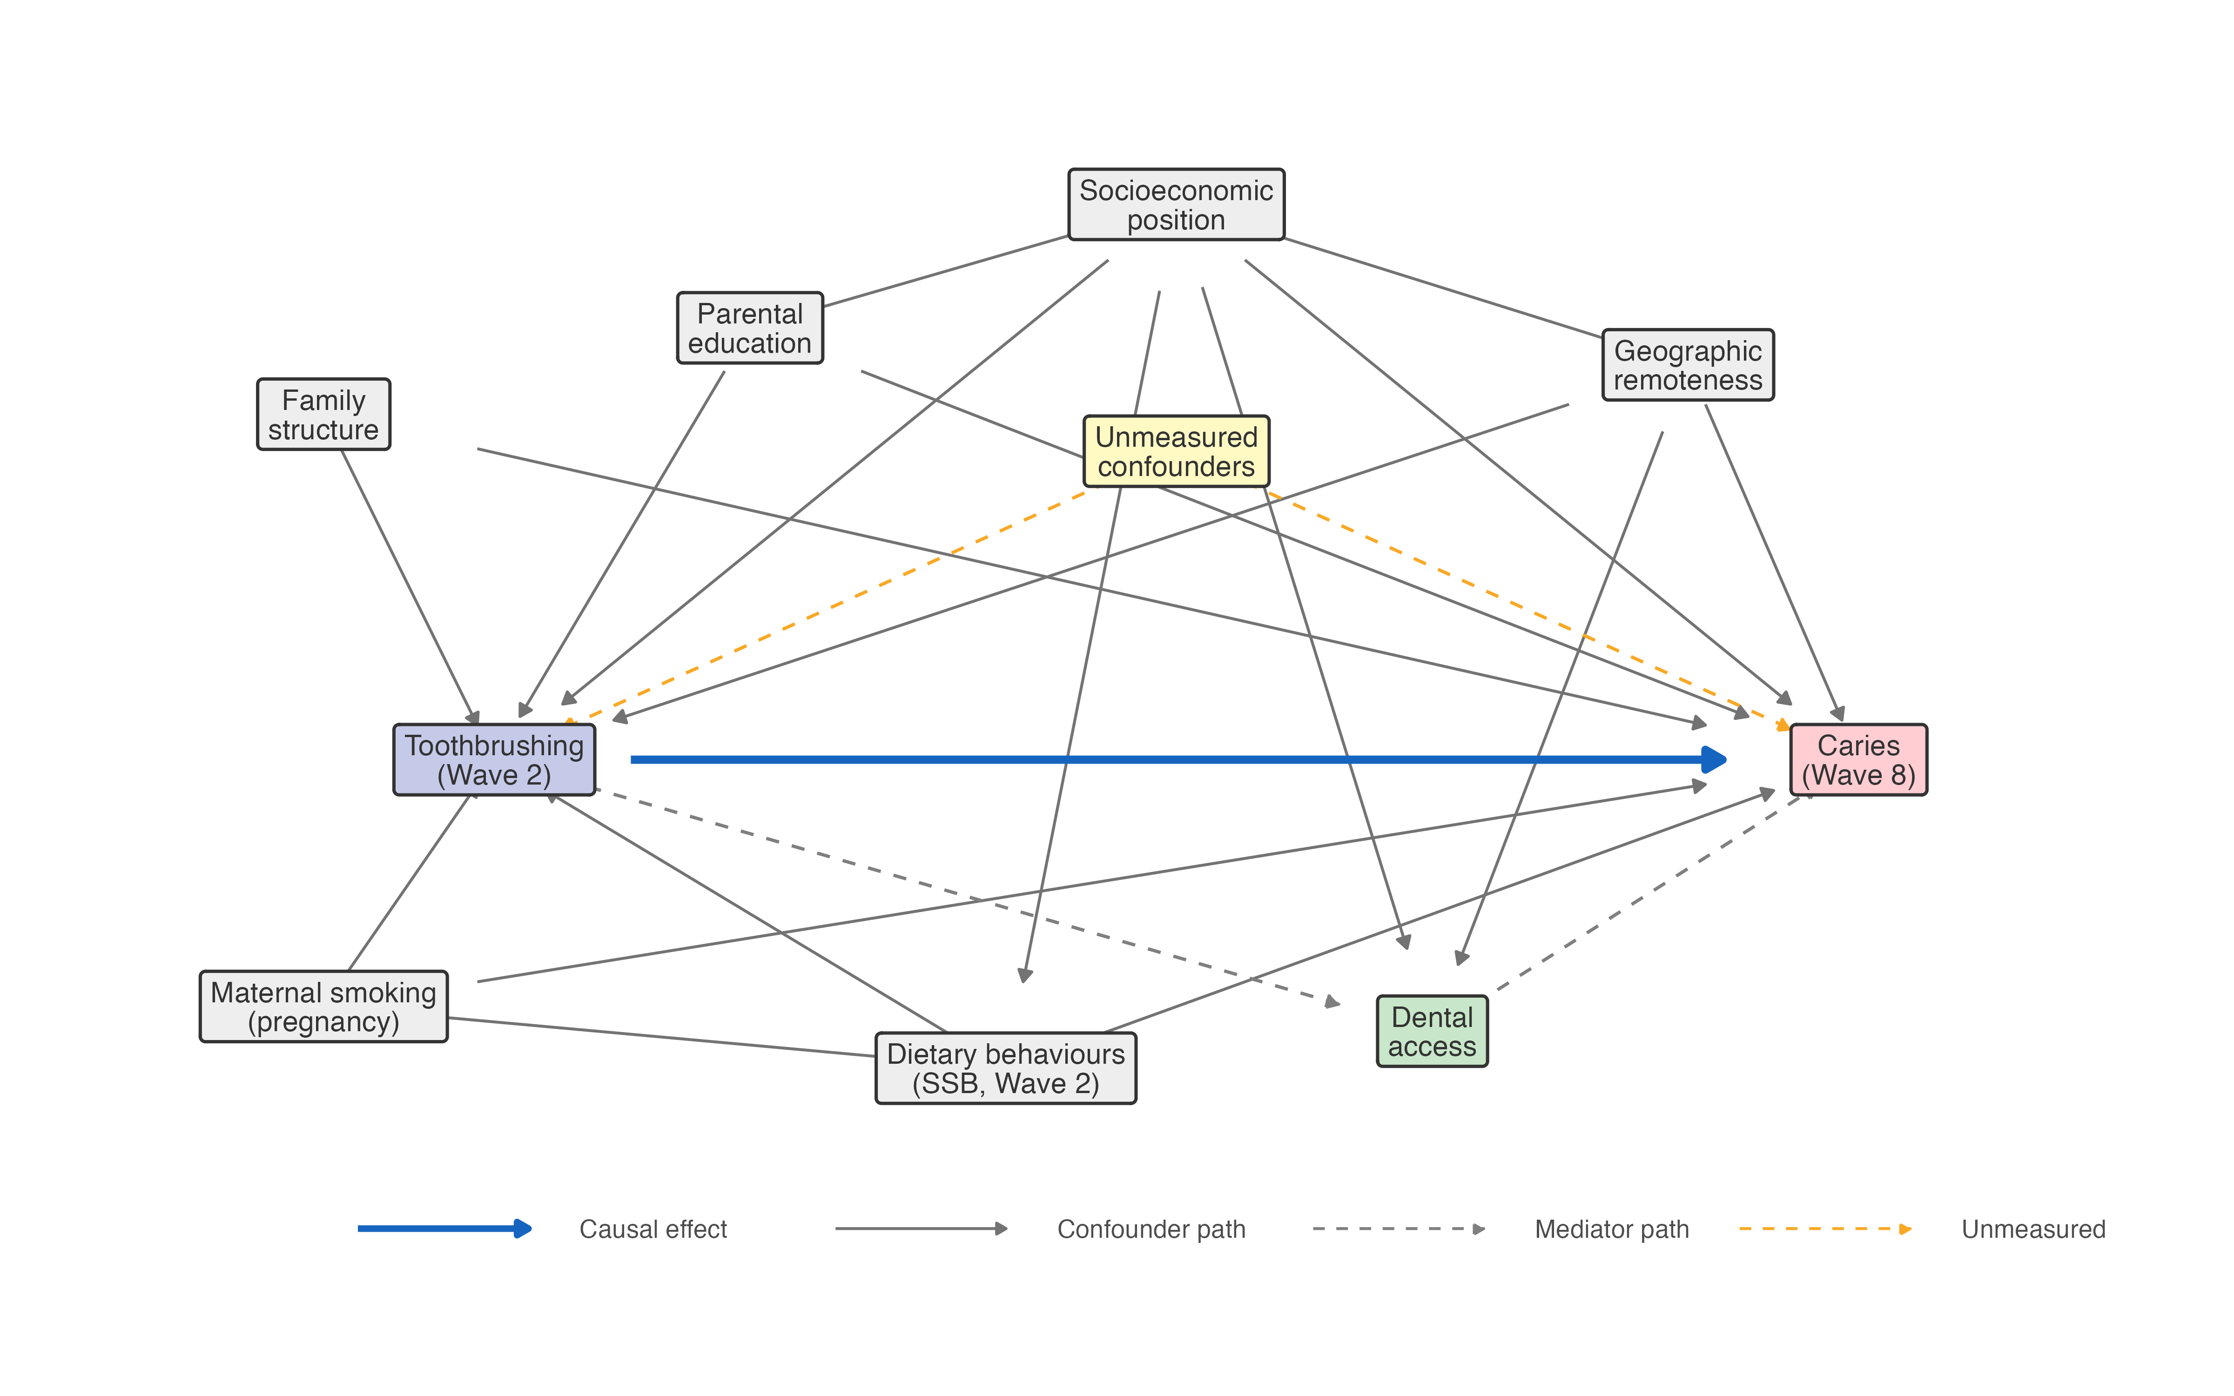

Table S1 Comparison of baseline characteristics between participants retained (N = 2,970) and lost to follow-up
Characteristic | Retained (N = 2,970) | Lost to follow-up (N = 1,595) | SMD | p-value
Female child, % | 1,452 (48.9) | 788 (49.4) | 0.010 | 0.763
Smoking during pregnancy, % | 352 (12.0) | 273 (17.5) | 0.157 | < 0.001
SEIFA disadvantaged (Q1–2), % | 1,041 (35.1) | 668 (41.9) | 0.141 | < 0.001
Parental degree, % | 1,465 (49.3) | 491 (30.8) | 0.385 | < 0.001
Two-parent household, % | 2,819 (94.9) | 1,376 (86.3) | 0.299 | < 0.001
Regional/remote, % | 1,343 (45.2) | 721 (45.2) | < 0.001 | 1.000
Ever breastfed, % | 2,530 (86.8) | 1,174 (75.7) | 0.287 | < 0.001
Daily SSB consumption, % | 1,022 (34.4) | 710 (44.5) | 0.208 | < 0.001
Twice-daily brushing, % | 1,373 (46.2) | 712 (44.6) | 0.032 | 0.319
Retained: participants with complete exposure and outcome data, caries-free at Wave 2. Lost to follow-up had exposure data but missing outcome. SMD > 0.1 indicates meaningful imbalance. Percentages for smoking during pregnancy and ever breastfed are calculated from non-missing observations (29 and 55 missing among retained; 38 and 44 missing among lost, respectively). SEIFA, Socio-Economic Indexes for Areas; SMD, standardised mean difference; SSB, sugar-sweetened beverages

Table S2 Covariate balance before and after propensity score matching
Covariate | Treated % (before) | Control % (before) | SMD (before) | Treated % (after) | Control % (after) | SMD (after) | VR before | VR after
Smoking during pregnancy | 11.0 | 12.8 | −0.058 | 11.1 | 11.4 | −0.009 | 0.88 | 0.98
SEIFA disadvantaged (Q1–2) | 34.5 | 35.2 | −0.015 | 34.9 | 35.0 | −0.002 | 0.99 | 1.00
Parental degree | 51.7 | 47.5 | 0.082 | 51.1 | 52.0 | −0.019 | 1.00 | 1.00
Two-parent household | 95.6 | 94.3 | 0.058 | 95.5 | 95.7 | −0.007 | 0.78 | 1.04
Regional/remote | 45.4 | 45.4 | −0.001 | 44.8 | 44.4 | 0.007 | 1.00 | 1.00
Daily SSB consumption | 32.4 | 36.2 | −0.080 | 32.8 | 33.6 | −0.017 | 0.95 | 0.99
1:1 nearest-neighbour matching (caliper = 0.2 SD of logit propensity score). 1,343 matched pairs. All post-matching |SMD| < 0.05. Variance ratios (VRs) for binary covariates close to 1 indicate similar residual variability after matching; post-matching VRs ranged from 0.98 to 1.04. SMD, standardised mean difference; SEIFA, Socio-Economic Indexes for Areas; SSB, sugar-sweetened beverages; VR, variance ratio.

Table S3 Comparison of unweighted and IPCW-weighted baseline characteristics in the retained subset with complete censoring-model covariates
Characteristic | Unweighted All  N = 2,886 | Unweighted  Brushers  (n = 1,339) | Unweighted  Non-brushers  (n = 1,547) | Unweighted  SMD | IPCW-weighted  All | IPCW-weighted  Brushers | IPCW-weighted  Non-brushers | IPCW-weighted  SMD
SEIFA disadvantaged (Q1-2) | 34.4% | 34.1% | 34.7% | -0.012 | 36.3% | 35.7% | 36.8% | -0.022
Parental degree | 49.9% | 52.1% | 48.0% | 0.082 | 44.1% | 46.4% | 42.1% | 0.086
Two-parent household | 95.0% | 95.7% | 94.4% | 0.060 | 92.7% | 93.7% | 91.9% | 0.070
Regional/remote residence | 45.5% | 45.6% | 45.3% | 0.006 | 45.4% | 45.6% | 45.3% | 0.006
Daily SSB consumption | 34.7% | 32.7% | 36.3% | -0.076 | 37.5% | 35.4% | 39.3% | -0.082
Maternal smoking in pregnancy | 11.9% | 10.9% | 12.7% | -0.057 | 13.4% | 12.3% | 14.3% | -0.059
Female child | 49.0% | 52.1% | 46.3% | 0.116 | 49.0% | 52.2% | 46.4% | 0.115
Ever breastfed | 86.9% | 88.1% | 85.8% | 0.070 | 83.5% | 85.1% | 82.2% | 0.080
Retained IPCW diagnostic subset: B-cohort children caries-free at Wave 2 with complete censoring-model covariates who were retained at Wave 8 (N = 2,886). This subset is smaller than the primary complete-case analytic sample (N = 2,941) because child sex and breastfeeding history were additionally included in the censoring model. IPCW weights were estimated from a logistic regression model predicting retention to Wave 8 using baseline brushing exposure, SEIFA, parental education, household structure, remoteness, maternal smoking during pregnancy, SSB consumption, child sex, and breastfeeding history. Stabilised weights were truncated at the 1st and 99th percentiles (range 0.82–1.72; mean 1.00, SD 0.18). IPCW reweighting modestly shifted the distribution toward the baseline cohort (slightly more SEIFA-disadvantaged, lower parental degree, more SSB consumption, less breastfeeding), consistent with socioeconomically patterned attrition. The pattern of differences between brushing groups was preserved after weighting (all absolute SMDs < 0.12), consistent with the IPCW-weighted effect estimate being close to the complete-case estimate. SEIFA, Socio-Economic Indexes for Areas; SSB, sugar-sweetened beverages; SMD, standardised mean difference.

