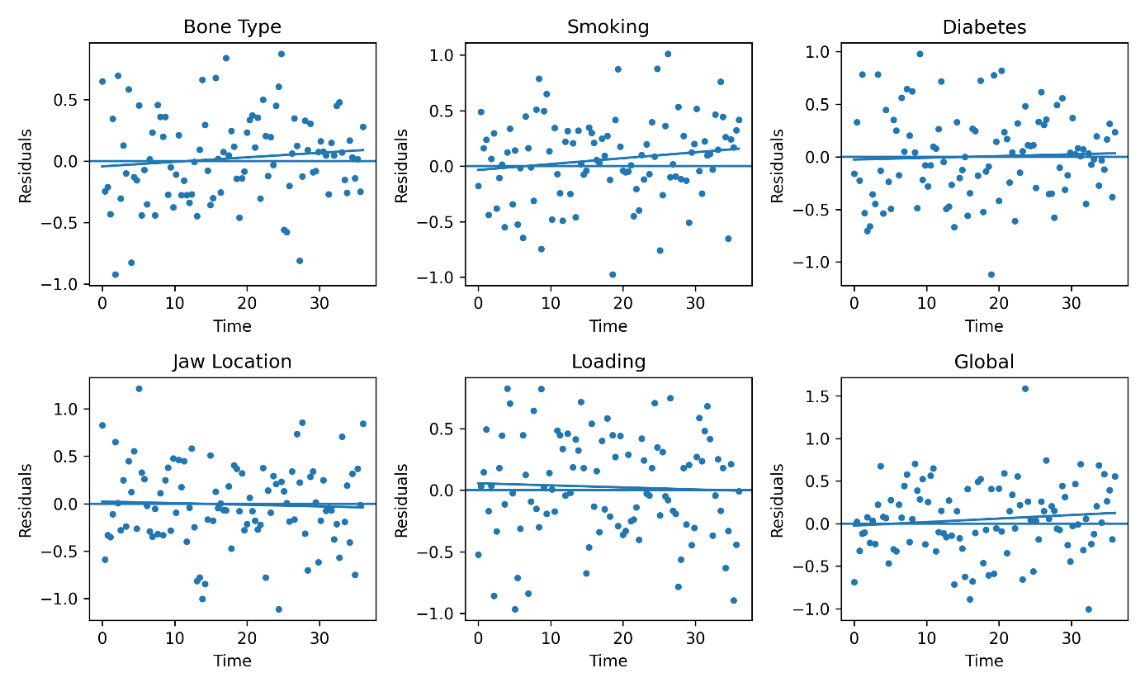
Supplementary Figure S1. Schoenfeld residual plots for the Cox proportional hazards model. The absence of systematic trends over time indicates no violation of the proportional hazards assumption.

