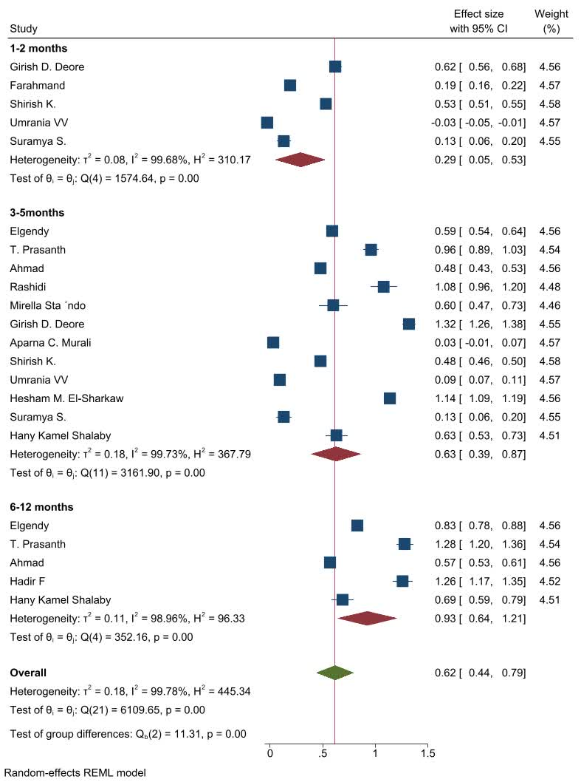
Figure 5. Forest plot of the mean difference CAL outcome measurement with intervention of dietary supplementation with omega-3 fatty acids comparison with controls in chronic periodontitis patients (removed studies with median (IQR))
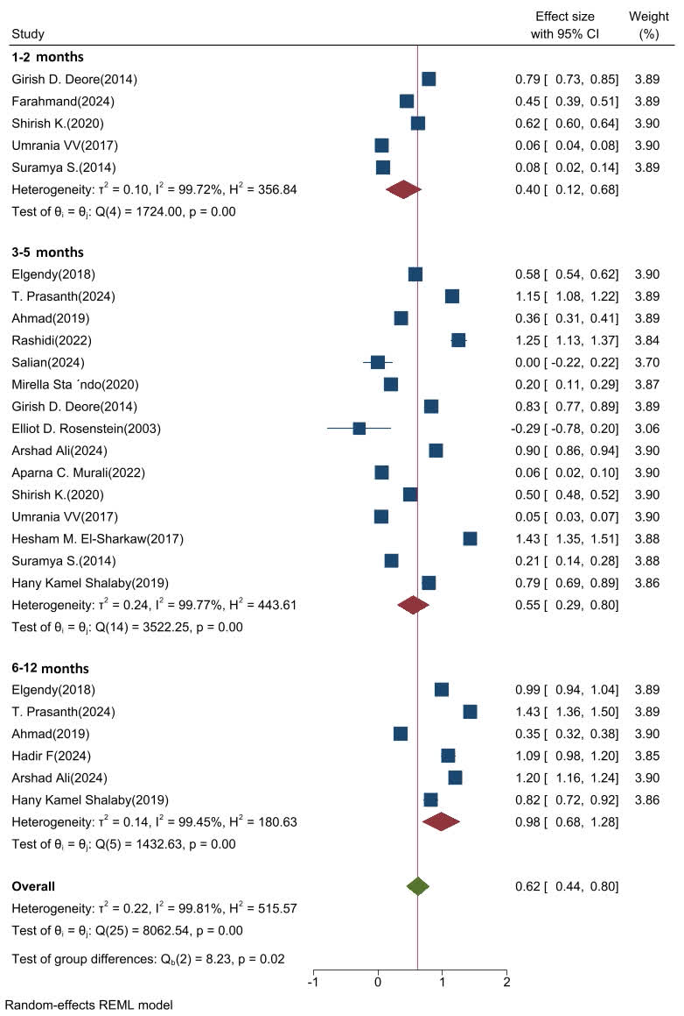
Figure 6. Forest plot of the mean difference PPD outcome measurement with intervention of dietary supplementation with omega-3 fatty acids comparison with controls in chronic periodontitis patients (removed studies with median (IQR))
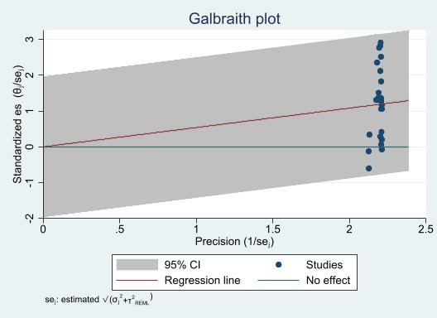
Figure 7. Galbraith plot of the mean difference CAL outcome measurement with intervention of dietary supplementation with omega-3 fatty acids comparison with controls in chronic periodontitis patients
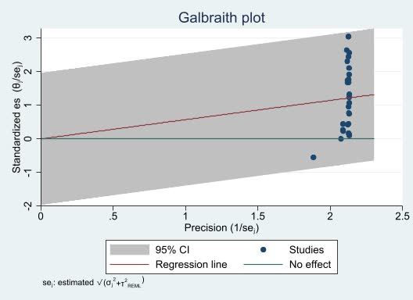
Figure 8. Galbraith plot of the mean difference PPD outcome measurement with intervention of dietary supplementation with omega-3 fatty acids comparison with controls in chronic periodontitis patients
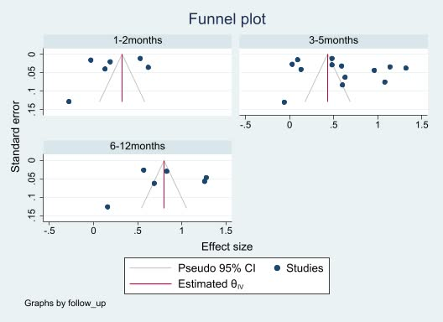
Figure 9. Funnel plot of the mean difference CAL outcome measurement with intervention of dietary supplementation with omega-3 fatty acids comparison with controls in chronic periodontitis patients
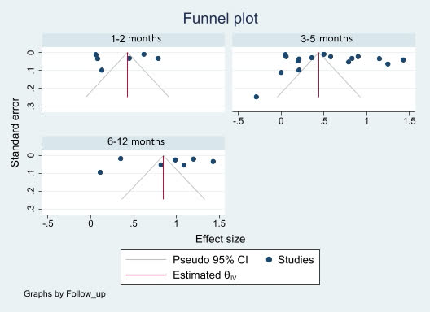
Figure 10. Funnel plot of the mean difference PPD outcome measurement with intervention of dietary supplementation with omega-3 fatty acids comparison with controls in chronic periodontitis patients
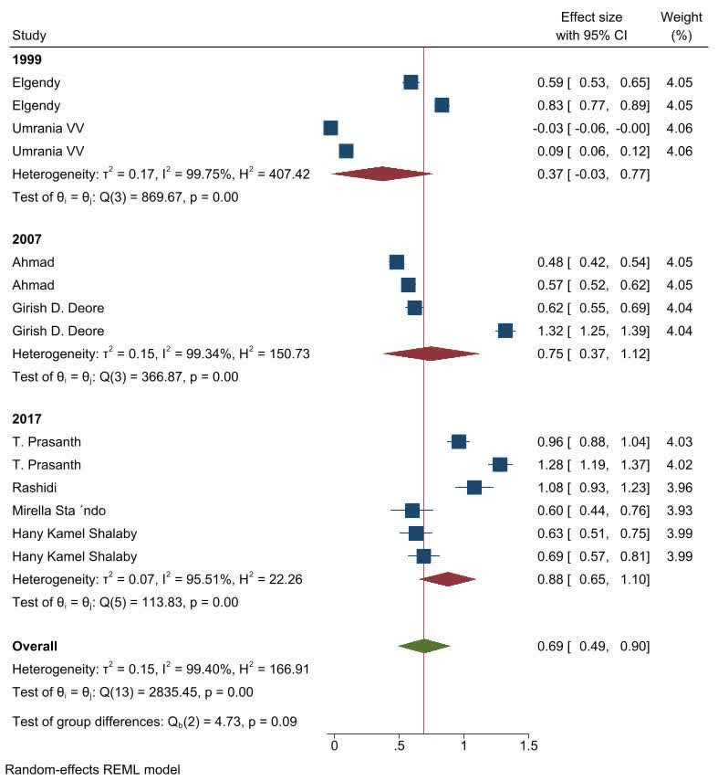
Figure 11. Forest plot of subgroup analysis for CAL gain according to periodontitis classification systems
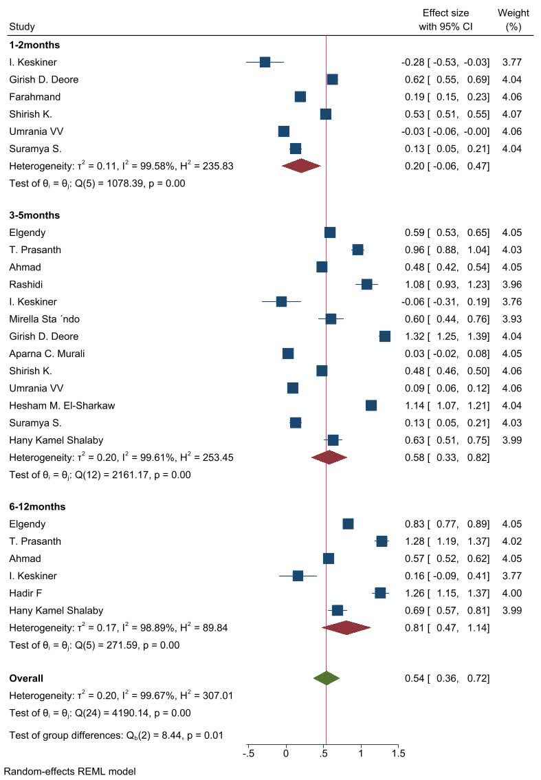
Figure 12. Sensitivity analysis for CAL. Multivariate random-effects meta-analysis for CAL gain assuming a more conservative within-study correlation of ρ = 0.25 between time points
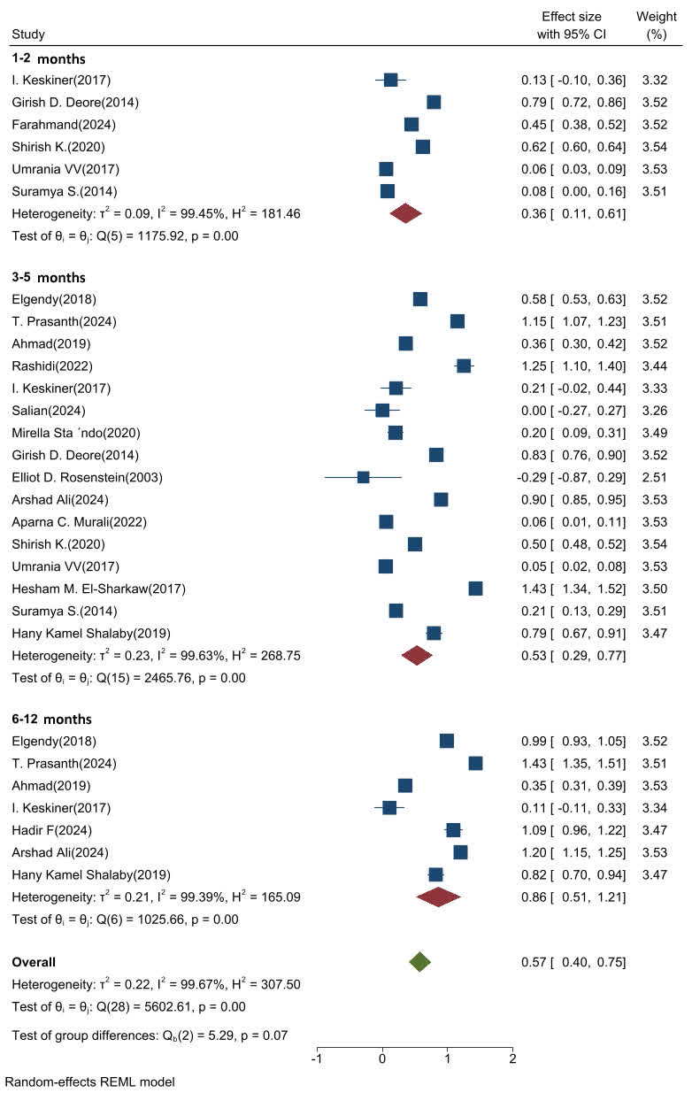
Figure 13. Sensitivity analysis for PPD. Multivariate random-effects meta-analysis for PPD reduction assuming a more conservative within-study correlation of ρ = 0.25 between time points

