Supplementary File 1. Standardized Prompt Template Used for AI Evaluation
To ensure consistency and reproducibility, all DUS questions were presented to each AI chatbot using an identical prompting procedure. Each question was entered into a new conversation in its original Turkish language exactly as published by ÖSYM. No role assignment, system prompt, additional contextual instructions, follow-up prompts, or clarifications were provided.

A. Text-Only Questions
For questions without images, the following standardized prompt was used:
Read the following question and select only the correct option.
[Original DUS question]
A. ...
B. ...
C. ...
D. ...
E. ...
The question was entered exactly as published by ÖSYM in Turkish, without translation into English.

B. Image-Based Questions
For questions containing radiographs, clinical photographs, or other images, the image was uploaded together with the original question using the following standardized prompt:
Read the following question and select only the correct option.
[Original DUS image]
[Original DUS question]
A. ...
B. ...
C. ...
D. ...
E. ...
No additional image description, explanation, or contextual information was provided.

Representative Examples of the Prompting Procedure

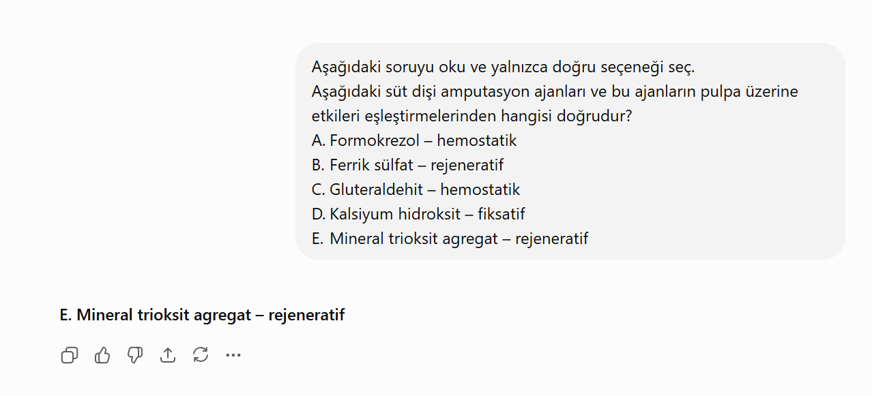
Supplementary Figure 1. Representative example of the standardized prompting procedure used for an text-only DUS question.

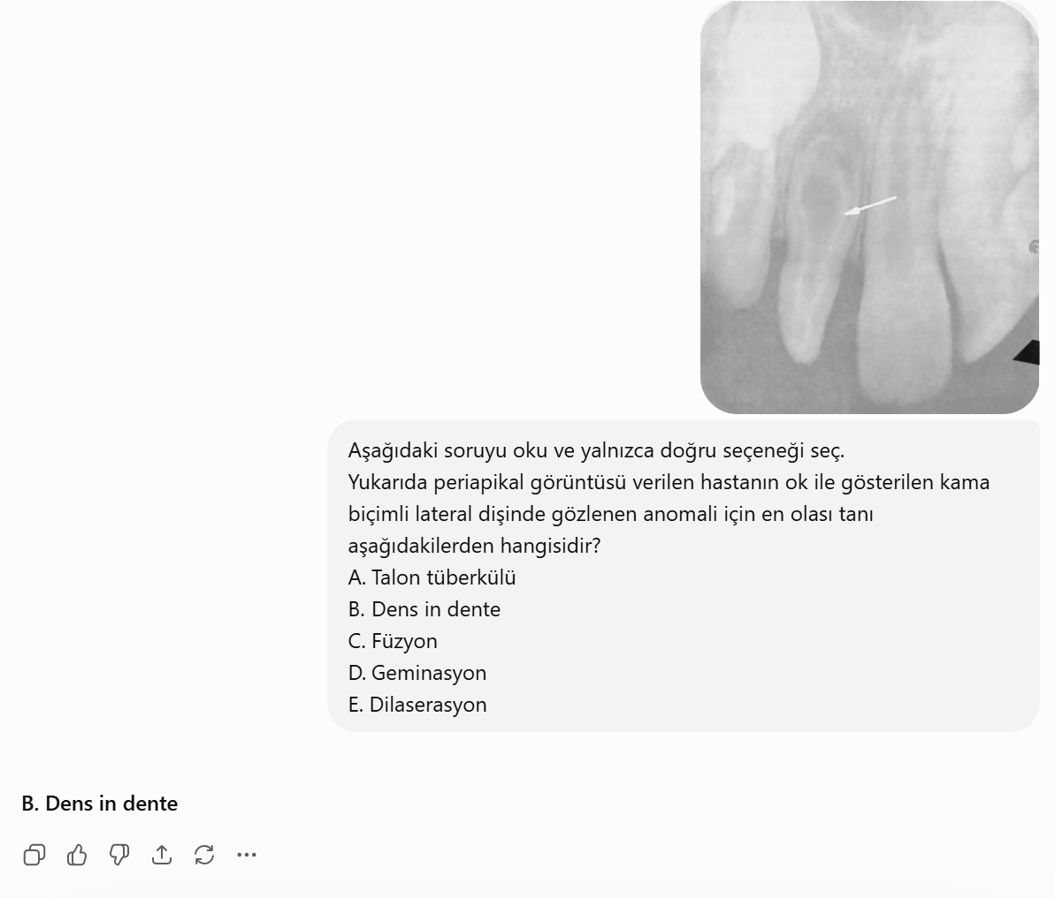
Supplementary Figure 2. Representative example of the standardized prompting procedure used for an image-based DUS question.

