Figure S1
Figure S1. Schematic diagram of the experimental protocol for the DPSC–THP-1 coculture model. DPSCs (2.5 x 10⁴ cells/well) were seeded in a 12-well plate overnight and stimulated with LPS (0.1 μg/mL) for 1 hour. THP-1 cells (2.5 x 10³ cells) were pretreated with PMA (100 ng/mL) for 30 minutes and cocultured with DPSCs at a 1:10 ratio for 24 hours. The medium was then replaced with fresh medium containing LPS (0.1 μg/mL) and either Biodentine (0.14 mg/mL) or MTA (0.13 mg/mL), and refreshed every 2 days. Analysis was performed at D2 and D28. Negative control consisted of DPSCs treated with PMA alone without THP-1 cells. Control consisted of DPSCs with PMA-treated THP-1 cells and LPS, without Biodentine nor MTA. All cultures were maintained at 37 °C, 5% CO₂ under serum-containing conditions.

Figure S2
Figure S2. Representative microscopy images of the DPSC–THP-1 coculture model at Day 28. Bright-field microscopy images showing the morphology of DPSCs and THP-1 cells following 28 days of coculture in DPSC-specific medium supplemented with LPS (0.1 μg/mL) and either Biodentine (0.14 mg/mL) or MTA (0.13 mg/mL). Both DPSCs and THP-1 cells remained viable throughout the culture period.

Figure S3
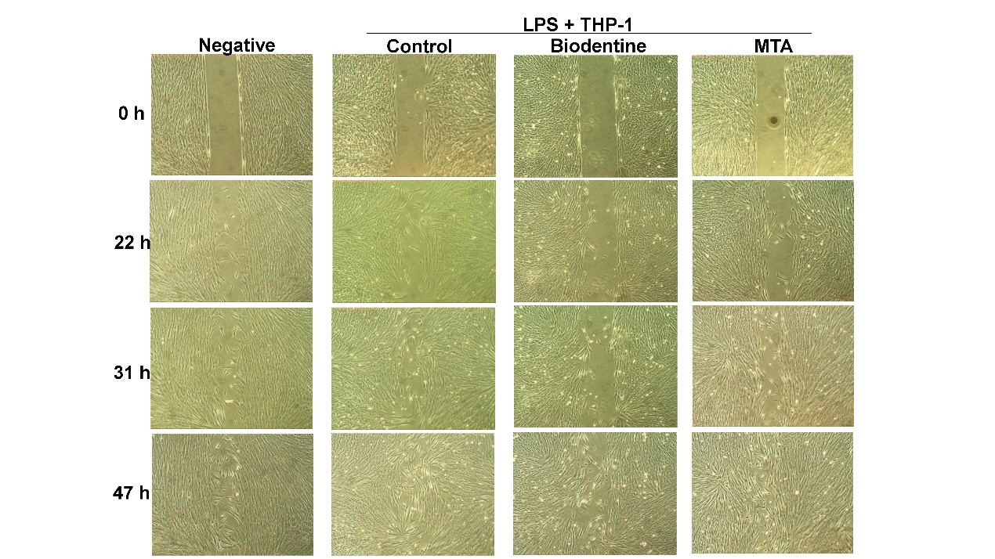
Figure S3. Effects of Biodentine and MTA on DPSC migration under inflammatory conditions, as assessed by the wound-healing assay. The cell borders were often irregular rather than straight, particularly after 31 hours of culture in all experimental groups. Therefore, ImageJ automatically identified multiple cell-free regions within each image and calculated their combined area in pixels. During this process, ImageJ first detected the boundaries automatically, after which the margins were manually adjusted when necessary to ensure accurate area measurements

