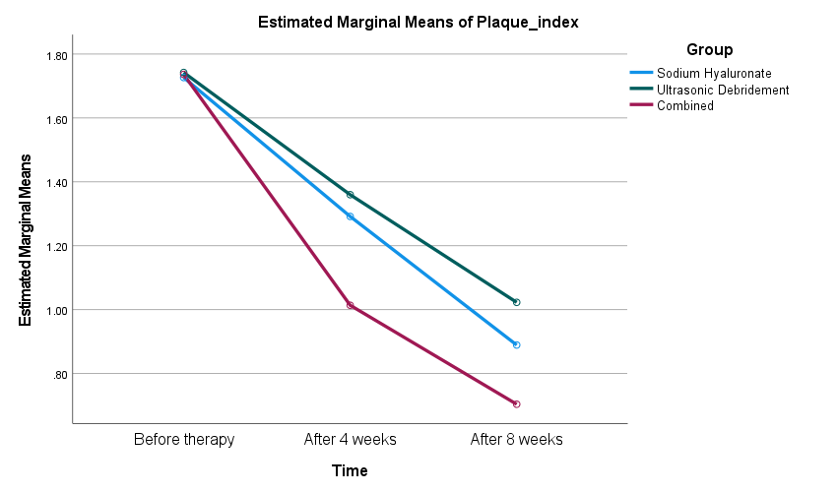
Figure S1: Changes in Plaque index by treatment group at baseline, 4 weeks, and 8 weeks (estimated marginal means; mixed repeated-measures ANOVA with Bonferroni adjustment).

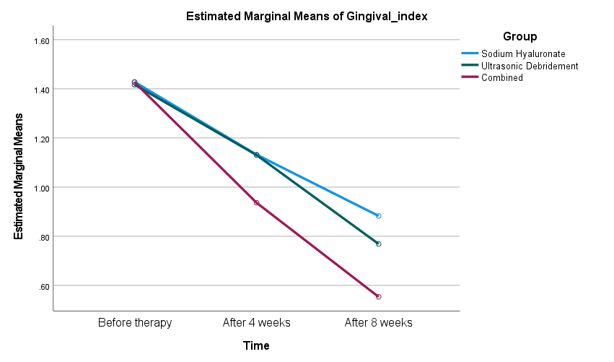
Figure S2: Changes in Gingival index by treatment group at baseline, 4 weeks, and 8 weeks (estimated marginal means; mixed repeated-measures ANOVA with Bonferroni adjustment).

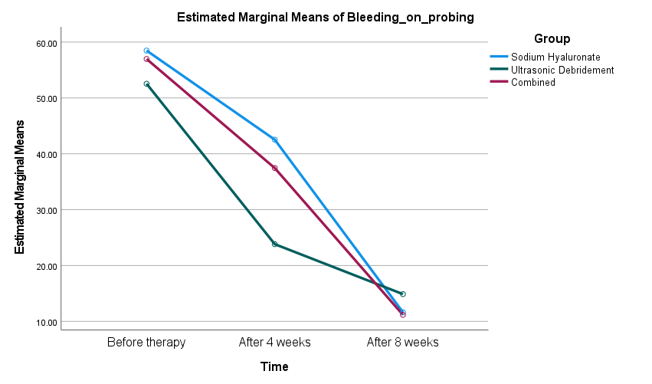
Figure S3: Changes in Bleeding on probing by treatment group at baseline, 4 weeks, and 8 weeks (estimated marginal means; mixed repeated-measures ANOVA with Bonferroni adjustment).

Figure S4: Changes in Probing pocket depth by treatment group at baseline, 4 weeks, and 8 weeks (estimated marginal means; mixed repeated-measures ANOVA with Bonferroni adjustment).

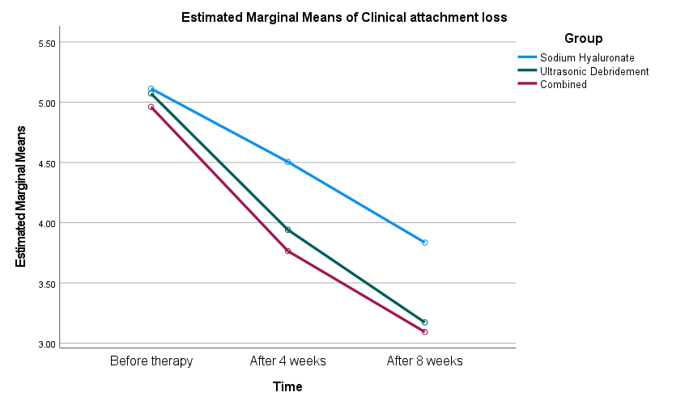
Figure S5: Changes in Clinical attachment loss by treatment group at baseline, 4 weeks, and 8 weeks (estimated marginal means; mixed repeated-measures ANOVA with Bonferroni adjustment).

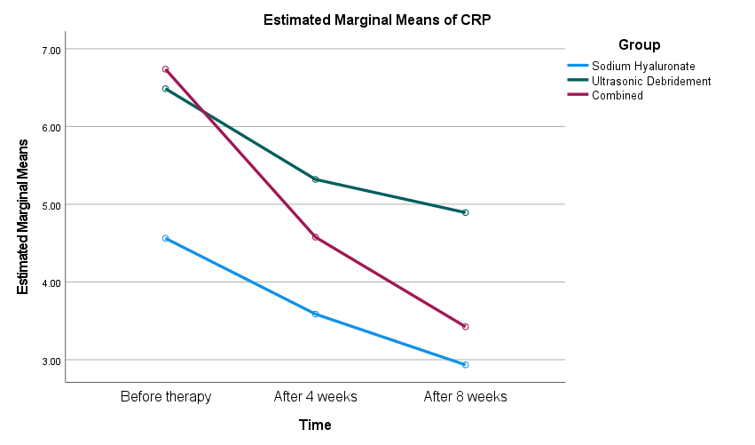
Figure S6: Changes in CRP by treatment group at baseline, 4 weeks, and 8 weeks (estimated marginal means; mixed repeated-measures ANOVA with Bonferroni adjustment).

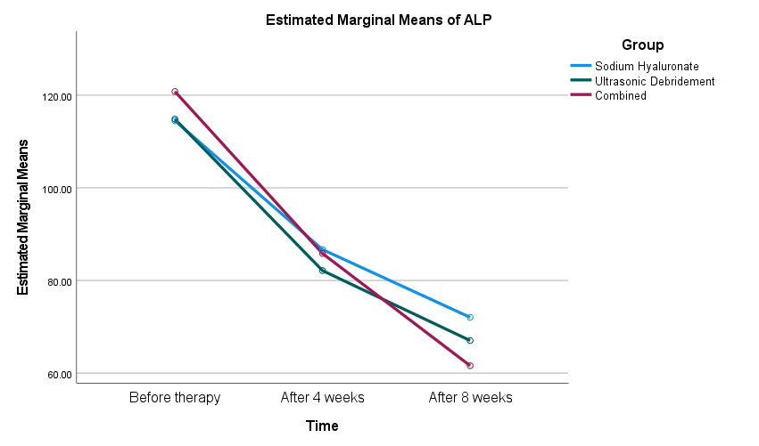
Figure S7: Changes in ALP by treatment group at baseline, 4 weeks, and 8 weeks (estimated marginal means; mixed repeated-measures ANOVA with Bonferroni adjustment).

