Supplementary Material
Meta-analyze 1 – subgroup analysis
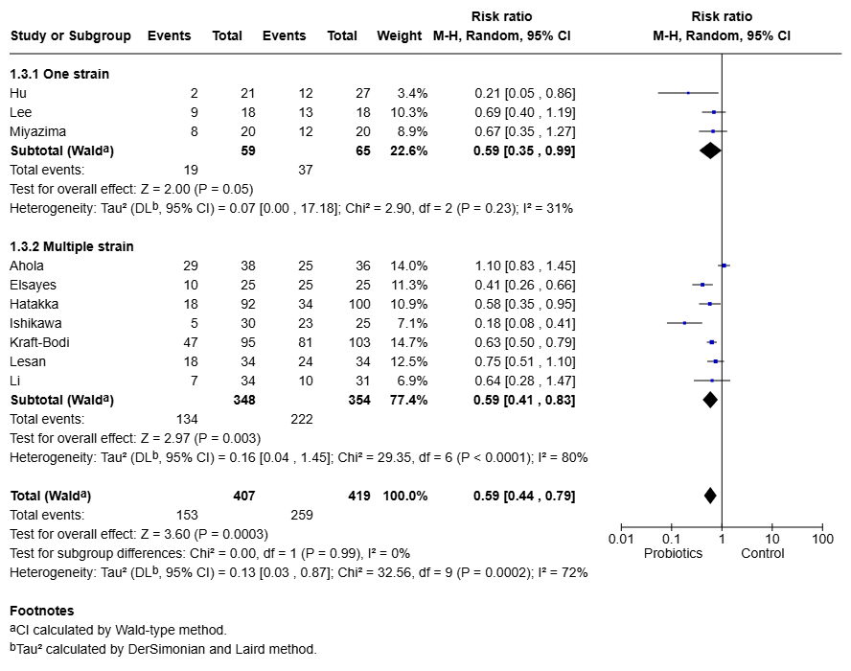
Figure S1. Subgroup analysis of Meta-analysis 1 according to the number of probiotic strains. Forest plot comparing the effect of single strain versus multispecies probiotic interventions on the prevalence of oral Candida colonization. No statistically significant subgroup differences were observed.
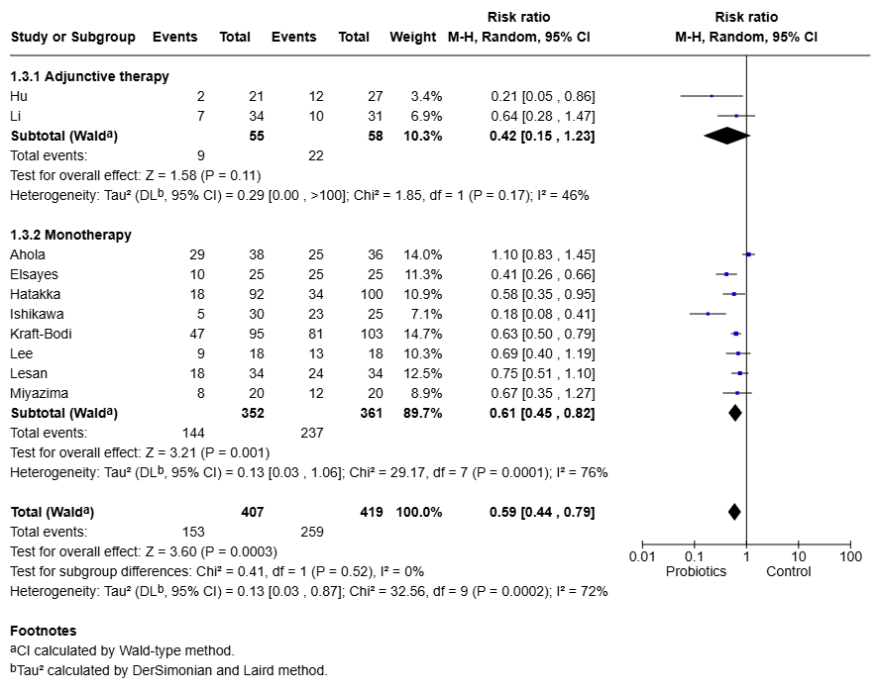
Figure S2. Subgroup analysis of Meta-analysis 1 according to treatment strategy. Forest plot comparing probiotic monotherapy and adjunctive probiotic therapy on the prevalence of oral Candida colonization. No statistically significant subgroup differences were identified.

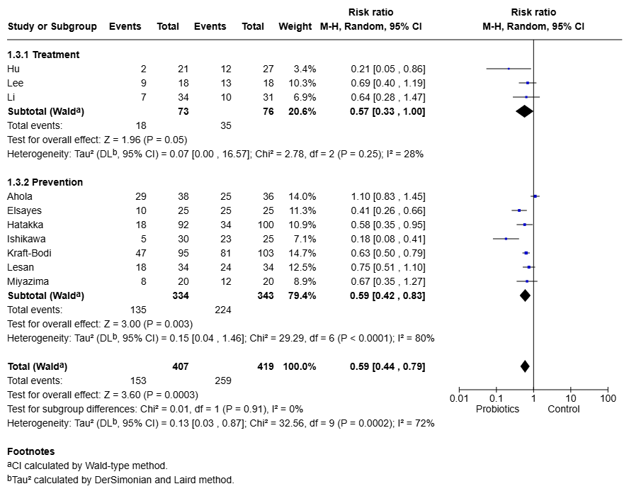
Figure S3. Subgroup analysis of Meta-analysis 1 according to clinical indication. Forest plot comparing studies evaluating probiotics for prevention and treatment of oral Candida colonization. No statistically significant subgroup differences were detected.

Meta-analyze 2 – subgroup analysis
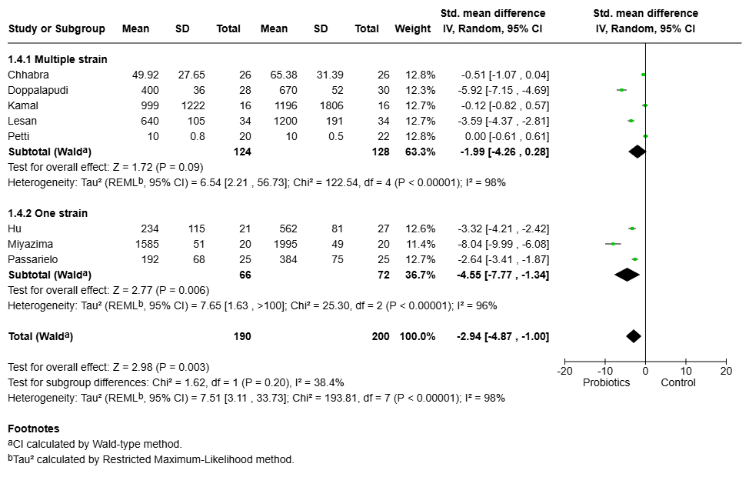
Figure S4. Subgroup analysis of Meta-analysis 2 according to the number of probiotic strains. Forest plot comparing the effects of single-strain and multispecies probiotics on quantitative oral Candida burden (CFU counts). No statistically significant subgroup differences were observed.

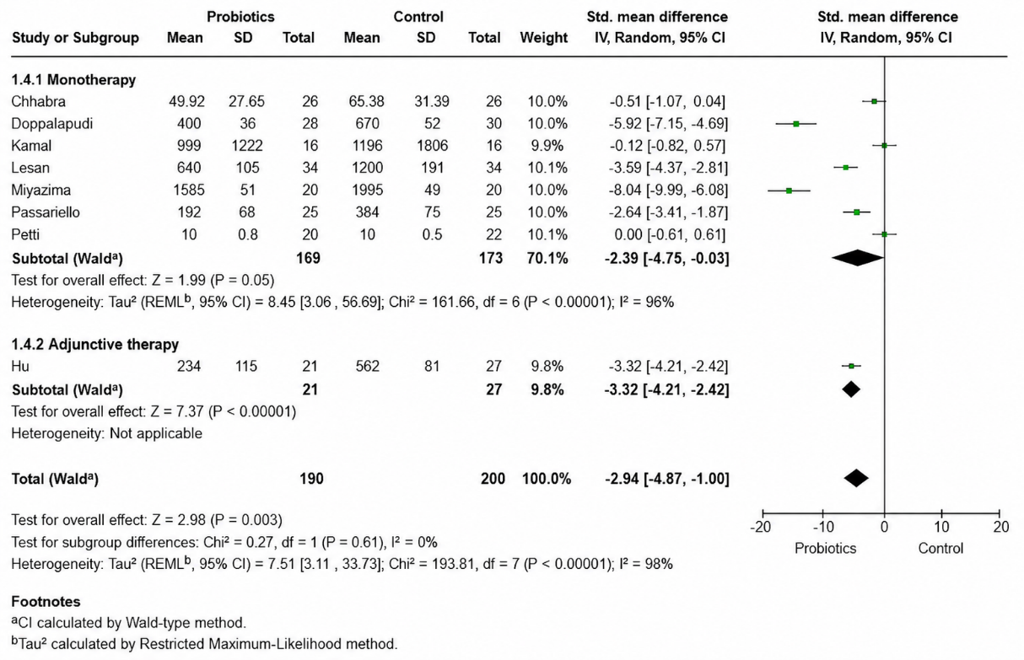
Figure S5. Subgroup analysis of Meta-analysis 2 according to treatment strategy. Forest plot comparing probiotic monotherapy and adjunctive probiotic therapy on quantitative oral Candida burden (CFU counts). No statistically significant subgroup differences were identified.

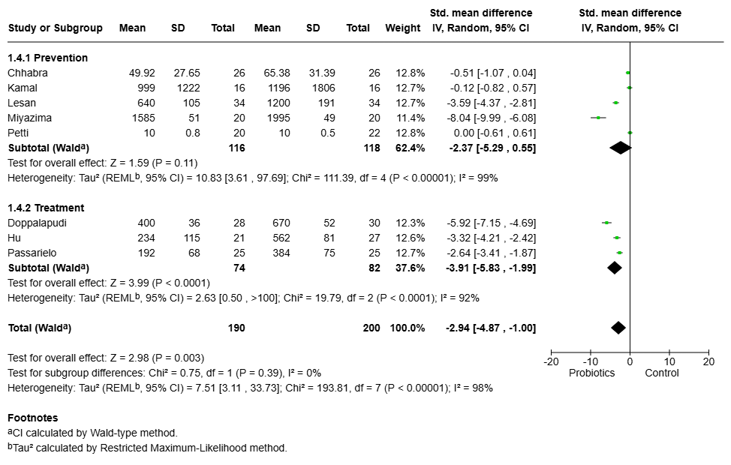
Figure S6. Subgroup analysis of Meta-analysis 2 according to clinical indication. Forest plot comparing studies evaluating probiotics for prevention and treatment on quantitative oral Candida burden (CFU counts). No statistically significant subgroup differences were detected.

Sensitivity analyses according to risk of bias
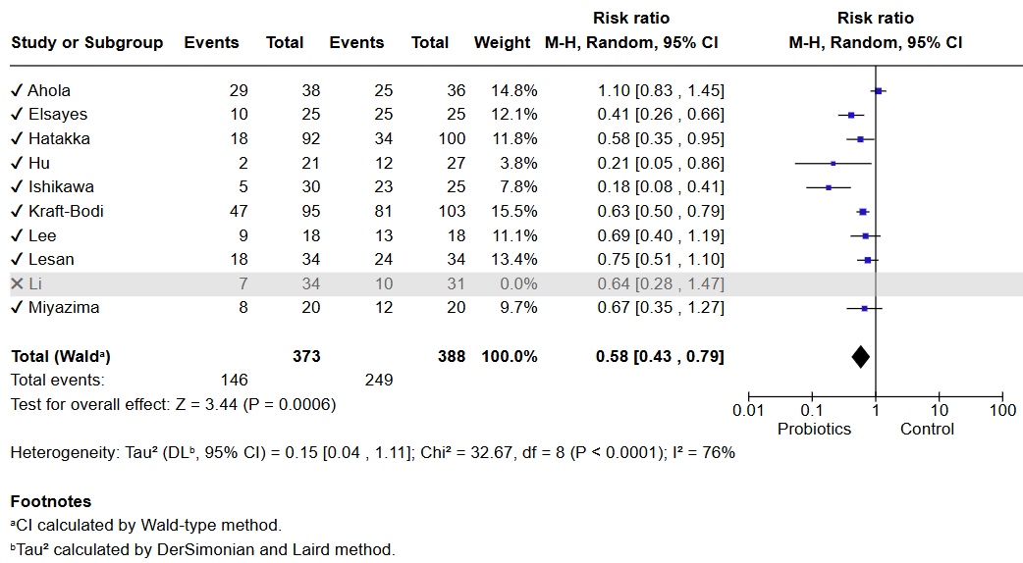
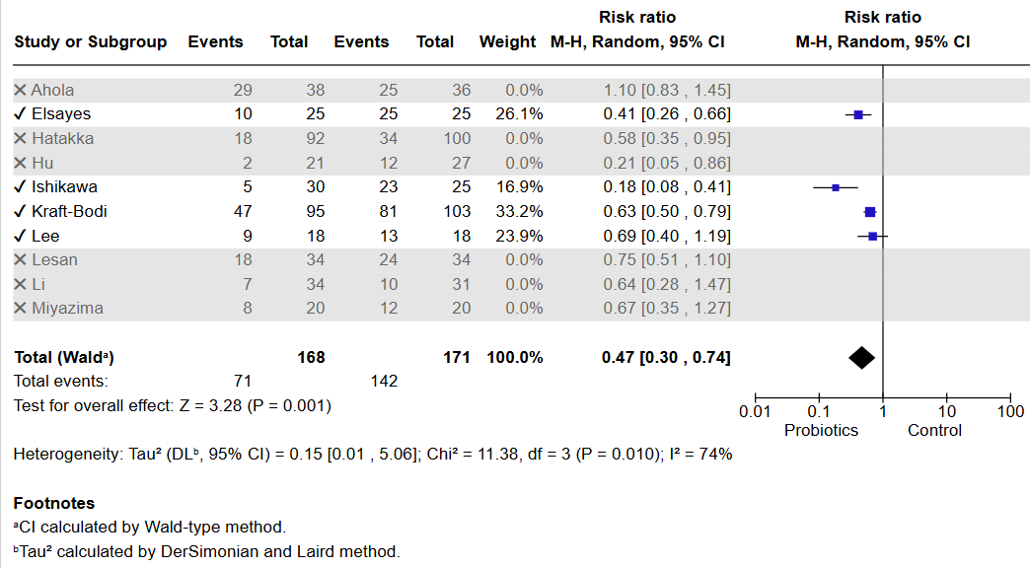
Figure S8. Sensitivity analyses according to risk of bias of Meta-analysis 1 (prevalence of oral Candida colonization) Sensitivity analyses were performed by sequentially excluding individual studies to evaluate the robustness of the pooled estimates (first excluding high risk bias studies, second excluding all studies that had some concerns). The overall effect remained consistent after the exclusion of each study, indicating that no single trial substantially influenced the results.
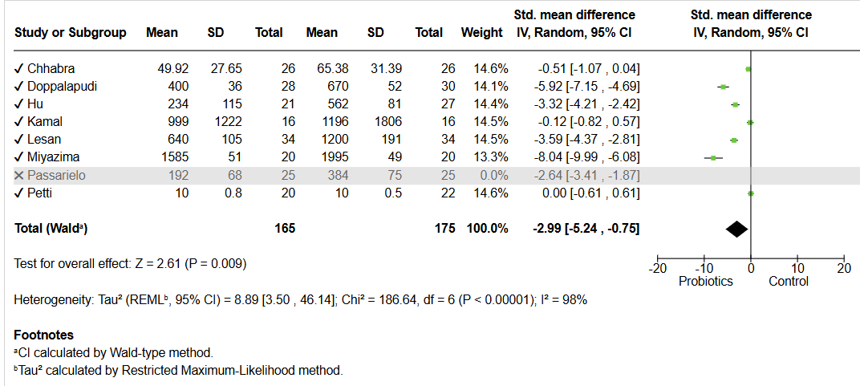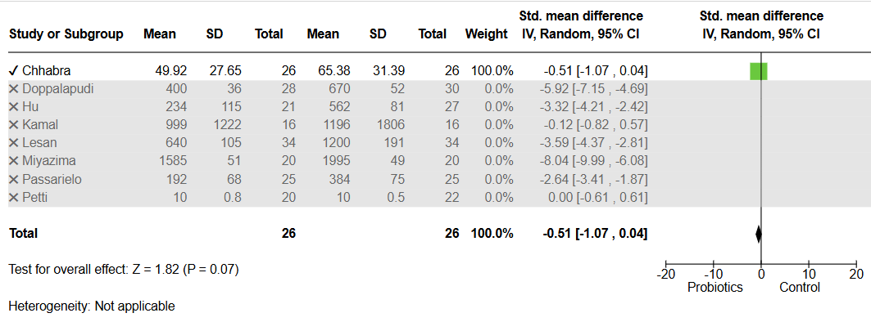

Figure S9. Sensitivity analyses according to risk of bias of Meta-analysis 2 (standardized mean difference in Candida spp. counts). The pooled estimates were reanalyzed after sequential exclusion of studies at high risk of bias and subsequently those with some concerns. Excluding studies at high risk of bias did not materially change the overall effect. However, after excluding all studies with some concerns, the difference between the probiotic and control groups was no longer statistically significant.

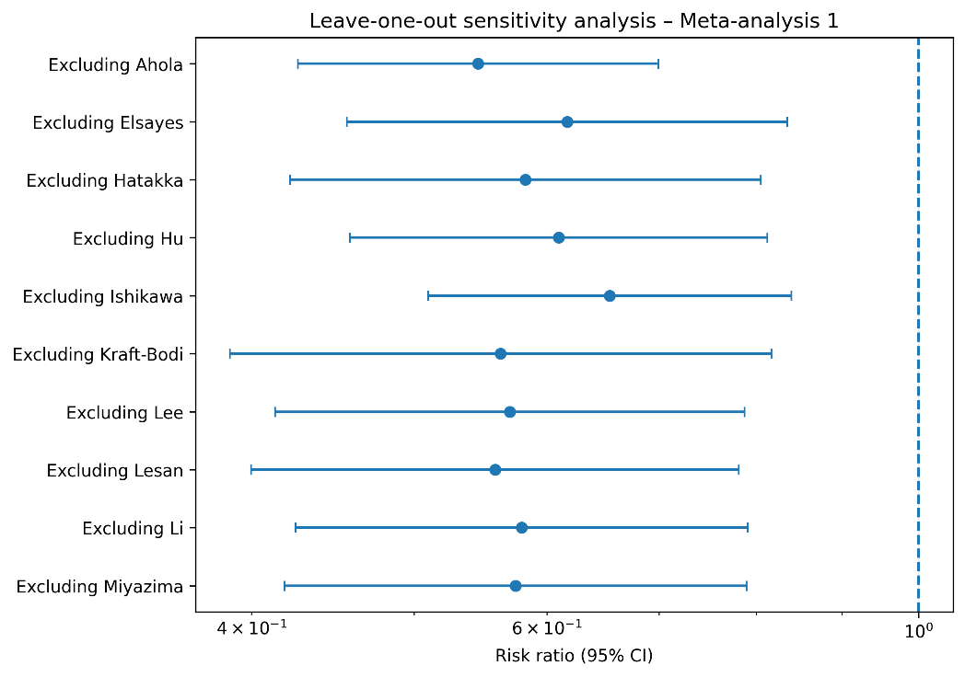
Figure S10. Leave-one-out sensitivity analysis of Meta-analysis 1 evaluating persistent oral Candida colonization.

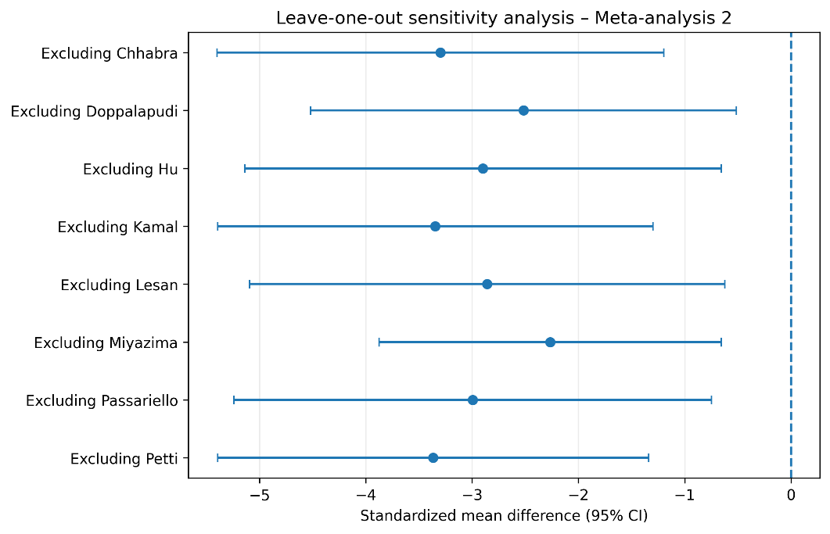
Figure S11. Leave-one-out sensitivity analysis of Meta-analysis 2 evaluating post-intervention Candida counts.

