Appendix File 1:
Search Strategy:
Cochrane Library
Search Line | Concept | Search Query
#1 | Population (MeSH) | [mh "Malocclusion, Angle Class II"] OR [mh "Malocclusion, Angle Class III"] OR [mh "Retrognathia"]
#2 | Population (Class II Keywords) | "Skeletal Class II" OR "Class II Malocclusion" OR "Mandibular Retrognathia"
#3 | Population (Class III Keywords) | "Skeletal Class III" OR "Class III Malocclusion" OR "Mandibular Prognathism"
#4 | Population (P) - Combined | #1 OR #2 OR #3
#5 | Asymmetry (MeSH) | [mh "Facial Asymmetry"]
#6 | Asymmetry (Keywords) | "Facial Asymmetry" OR "Mandibular Asymmetry" OR "Craniofacial Asymmetry" OR "Hemimandibular"
#7 | Asymmetry (Combined) | #5 OR #6
#8 | Cant (Keywords) | "Occlusal Cant" OR "Maxillary Cant" OR "Occlusal Plane Canting" OR "Occlusal Plane Inclination" OR "Transverse Occlusal Plane" OR "Dental Cant"
#9 | Exposure (E) - Combined | #7 AND #8
#10 | Final Search (P AND E) | #4 AND #9
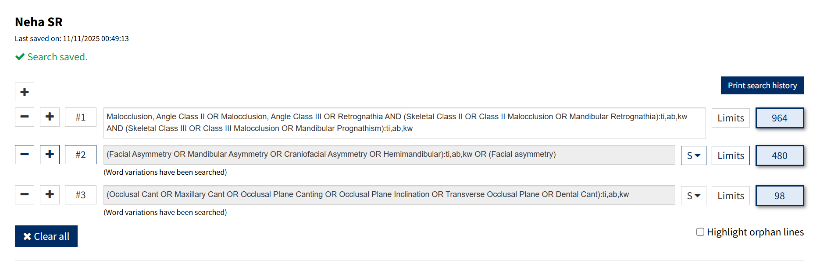
Google Scholar:
Search # | Search Query | Purpose
Search 1 (376) | "occlusal cant" AND ("facial asymmetry" OR "mandibular asymmetry") AND ("skeletal class II" OR "skeletal class III") | Primary search combining all PEO concepts using standard terms.
Search 2 (106) | "maxillary cant" AND "facial asymmetry" AND ("class II malocclusion" OR "class III malocclusion") | Secondary search using alternate keywords for the main concepts.
Search 3 (3) | allintitle: "occlusal cant" ("class II" OR "class III") ("asymmetry" OR "asymmetric") | Highly specific search to find articles with key terms in the title.
Search 4 | (Manual Step) | Find your most important 3-5 papers from PubMed/Scopus and click the "Cited by" link to find newer, relevant studies.
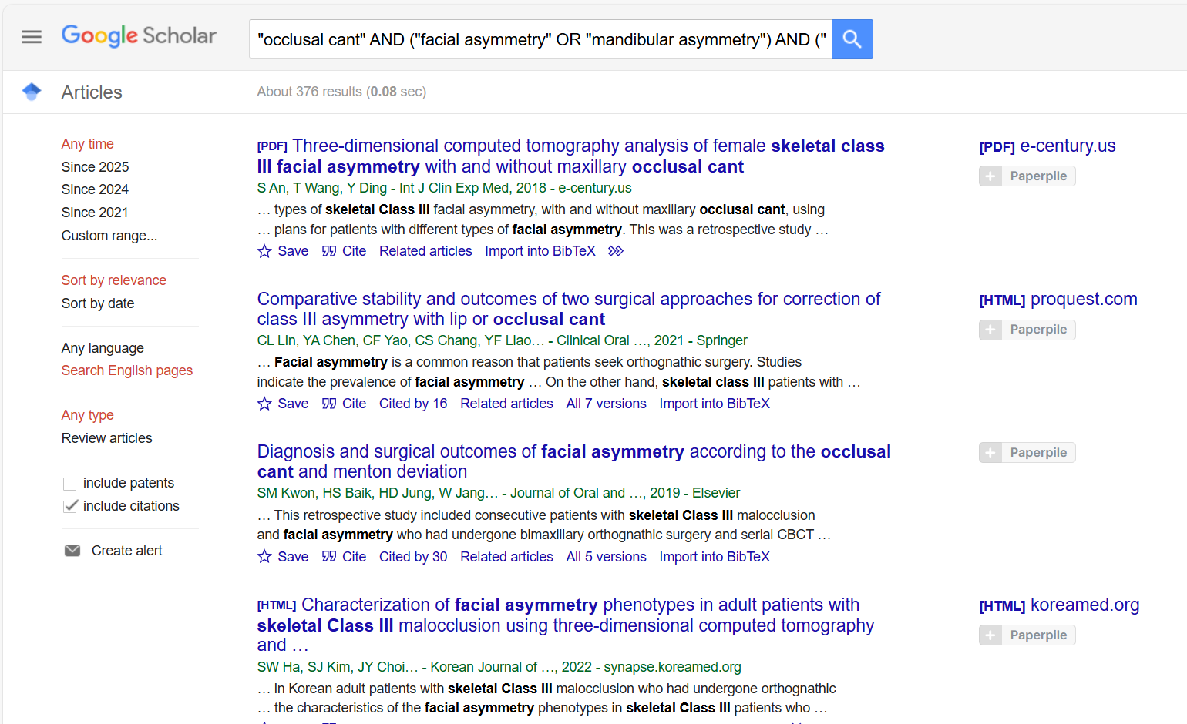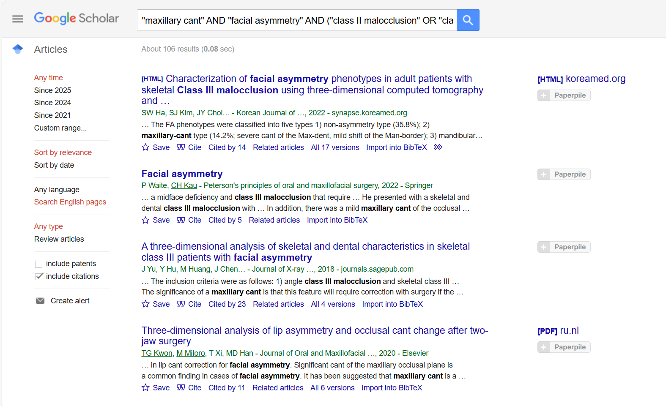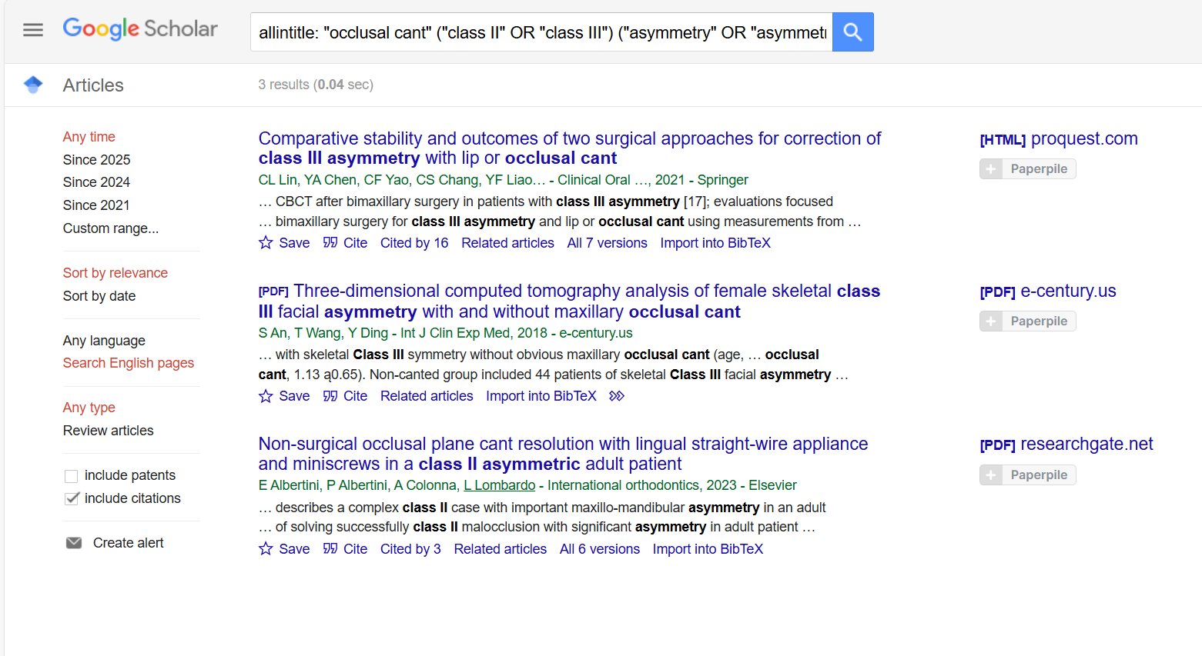

Pubmed:
Search number | Query | Search Details | Results | Time | Date
13 | (((( "Malocclusion, Angle Class II"[MeSH Terms] OR "Malocclusion, Angle Class III"[MeSH Terms] OR "Retrognathia"[MeSH Terms] OR "Skeletal Class II"[tiab] OR "Skeletal Class III"[tiab] OR "Class II Malocclusion"[tiab] OR "Class III Malocclusion"[tiab] OR "Mandibular Retrognathism"[tiab] OR "Mandibular Prognathism"[tiab] )) AND (("Facial Asymmetry"[Mesh] OR ( "Facial Asymmetry"[MeSH Terms] OR "Facial Asymmetry"[tiab] OR "Mandibular Asymmetry"[tiab] OR "Craniofacial Asymmetry"[tiab] OR "Hemimandibular"[tiab] )) AND (( "Occlusal Cant"[tiab] OR "Maxillary Cant"[tiab] OR "Occlusal Plane Canting"[tiab] OR "Occlusal Plane Inclination"[tiab] OR "Transverse Occlusal Plane"[tiab] OR "Dental Cant"[tiab] )))) AND ((((((("Index of Orthodontic Treatment Need"[Mesh]) OR ( "Orthognathic Surgery"[Mesh] OR "Orthognathic Surgical Procedures"[Mesh] )) OR "Orthodontic Anchorage Procedures"[Mesh]) OR (orthodontic therapy[Title/Abstract])) OR (temporary anchorage devices[Title/Abstract])) OR (TAD[Title/Abstract])) OR (orthognathic surgery[Title/Abstract]))) AND ((("Diagnosis"[Mesh] OR "Diagnosis, Oral"[Mesh]) OR ( "Diagnostic Imaging"[Mesh] OR "diagnostic imaging" [Subheading] )) OR "Imaging, Three-Dimensional"[Mesh]) | ("malocclusion, angle class ii"[MeSH Terms] OR "malocclusion, angle class iii"[MeSH Terms] OR "Retrognathia"[MeSH Terms] OR "Skeletal Class II"[Title/Abstract] OR "Skeletal Class III"[Title/Abstract] OR "Class II Malocclusion"[Title/Abstract] OR "Class III Malocclusion"[Title/Abstract] OR "Mandibular Retrognathism"[Title/Abstract] OR "Mandibular Prognathism"[Title/Abstract]) AND (("Facial Asymmetry"[MeSH Terms] OR ("Facial Asymmetry"[MeSH Terms] OR "Facial Asymmetry"[Title/Abstract] OR "Mandibular Asymmetry"[Title/Abstract] OR "Craniofacial Asymmetry"[Title/Abstract] OR "Hemimandibular"[Title/Abstract])) AND ("Occlusal Cant"[Title/Abstract] OR "Maxillary Cant"[Title/Abstract] OR "Occlusal Plane Canting"[Title/Abstract] OR "Occlusal Plane Inclination"[Title/Abstract] OR "Transverse Occlusal Plane"[Title/Abstract])) AND ("Index of Orthodontic Treatment Need"[MeSH Terms] OR ("Orthognathic Surgery"[MeSH Terms] OR "Orthognathic Surgical Procedures"[MeSH Terms]) OR "Orthodontic Anchorage Procedures"[MeSH Terms] OR "orthodontic therapy"[Title/Abstract] OR "temporary anchorage devices"[Title/Abstract] OR "TAD"[Title/Abstract] OR "Orthognathic Surgery"[Title/Abstract]) AND ("Diagnosis"[MeSH Terms] OR "diagnosis, oral"[MeSH Terms] OR ("Diagnostic Imaging"[MeSH Terms] OR "Diagnostic Imaging"[MeSH Subheading]) OR "imaging, three dimensional"[MeSH Terms]) | 14 | 13:54:12 | 10-11-2025
12 | ((( "Malocclusion, Angle Class II"[MeSH Terms] OR "Malocclusion, Angle Class III"[MeSH Terms] OR "Retrognathia"[MeSH Terms] OR "Skeletal Class II"[tiab] OR "Skeletal Class III"[tiab] OR "Class II Malocclusion"[tiab] OR "Class III Malocclusion"[tiab] OR "Mandibular Retrognathism"[tiab] OR "Mandibular Prognathism"[tiab] )) AND (("Facial Asymmetry"[Mesh] OR ( "Facial Asymmetry"[MeSH Terms] OR "Facial Asymmetry"[tiab] OR "Mandibular Asymmetry"[tiab] OR "Craniofacial Asymmetry"[tiab] OR "Hemimandibular"[tiab] )) AND (( "Occlusal Cant"[tiab] OR "Maxillary Cant"[tiab] OR "Occlusal Plane Canting"[tiab] OR "Occlusal Plane Inclination"[tiab] OR "Transverse Occlusal Plane"[tiab] OR "Dental Cant"[tiab] )))) AND ((("Diagnosis"[Mesh] OR "Diagnosis, Oral"[Mesh]) OR ( "Diagnostic Imaging"[Mesh] OR "diagnostic imaging" [Subheading] )) OR "Imaging, Three-Dimensional"[Mesh]) | ("malocclusion, angle class ii"[MeSH Terms] OR "malocclusion, angle class iii"[MeSH Terms] OR "Retrognathia"[MeSH Terms] OR "Skeletal Class II"[Title/Abstract] OR "Skeletal Class III"[Title/Abstract] OR "Class II Malocclusion"[Title/Abstract] OR "Class III Malocclusion"[Title/Abstract] OR "Mandibular Retrognathism"[Title/Abstract] OR "Mandibular Prognathism"[Title/Abstract]) AND (("Facial Asymmetry"[MeSH Terms] OR ("Facial Asymmetry"[MeSH Terms] OR "Facial Asymmetry"[Title/Abstract] OR "Mandibular Asymmetry"[Title/Abstract] OR "Craniofacial Asymmetry"[Title/Abstract] OR "Hemimandibular"[Title/Abstract])) AND ("Occlusal Cant"[Title/Abstract] OR "Maxillary Cant"[Title/Abstract] OR "Occlusal Plane Canting"[Title/Abstract] OR "Occlusal Plane Inclination"[Title/Abstract] OR "Transverse Occlusal Plane"[Title/Abstract])) AND ("Diagnosis"[MeSH Terms] OR "diagnosis, oral"[MeSH Terms] OR ("Diagnostic Imaging"[MeSH Terms] OR "Diagnostic Imaging"[MeSH Subheading]) OR "imaging, three dimensional"[MeSH Terms]) | 22 | 13:53:39 | 10-11-2025
11 | ((( "Malocclusion, Angle Class II"[MeSH Terms] OR "Malocclusion, Angle Class III"[MeSH Terms] OR "Retrognathia"[MeSH Terms] OR "Skeletal Class II"[tiab] OR "Skeletal Class III"[tiab] OR "Class II Malocclusion"[tiab] OR "Class III Malocclusion"[tiab] OR "Mandibular Retrognathism"[tiab] OR "Mandibular Prognathism"[tiab] )) AND (("Facial Asymmetry"[Mesh] OR ( "Facial Asymmetry"[MeSH Terms] OR "Facial Asymmetry"[tiab] OR "Mandibular Asymmetry"[tiab] OR "Craniofacial Asymmetry"[tiab] OR "Hemimandibular"[tiab] )) AND (( "Occlusal Cant"[tiab] OR "Maxillary Cant"[tiab] OR "Occlusal Plane Canting"[tiab] OR "Occlusal Plane Inclination"[tiab] OR "Transverse Occlusal Plane"[tiab] OR "Dental Cant"[tiab] )))) AND ((((((("Index of Orthodontic Treatment Need"[Mesh]) OR ( "Orthognathic Surgery"[Mesh] OR "Orthognathic Surgical Procedures"[Mesh] )) OR "Orthodontic Anchorage Procedures"[Mesh]) OR (orthodontic therapy[Title/Abstract])) OR (temporary anchorage devices[Title/Abstract])) OR (TAD[Title/Abstract])) OR (orthognathic surgery[Title/Abstract])) | ("malocclusion, angle class ii"[MeSH Terms] OR "malocclusion, angle class iii"[MeSH Terms] OR "Retrognathia"[MeSH Terms] OR "Skeletal Class II"[Title/Abstract] OR "Skeletal Class III"[Title/Abstract] OR "Class II Malocclusion"[Title/Abstract] OR "Class III Malocclusion"[Title/Abstract] OR "Mandibular Retrognathism"[Title/Abstract] OR "Mandibular Prognathism"[Title/Abstract]) AND (("Facial Asymmetry"[MeSH Terms] OR ("Facial Asymmetry"[MeSH Terms] OR "Facial Asymmetry"[Title/Abstract] OR "Mandibular Asymmetry"[Title/Abstract] OR "Craniofacial Asymmetry"[Title/Abstract] OR "Hemimandibular"[Title/Abstract])) AND ("Occlusal Cant"[Title/Abstract] OR "Maxillary Cant"[Title/Abstract] OR "Occlusal Plane Canting"[Title/Abstract] OR "Occlusal Plane Inclination"[Title/Abstract] OR "Transverse Occlusal Plane"[Title/Abstract])) AND ("Index of Orthodontic Treatment Need"[MeSH Terms] OR ("Orthognathic Surgery"[MeSH Terms] OR "Orthognathic Surgical Procedures"[MeSH Terms]) OR "Orthodontic Anchorage Procedures"[MeSH Terms] OR "orthodontic therapy"[Title/Abstract] OR "temporary anchorage devices"[Title/Abstract] OR "TAD"[Title/Abstract] OR "Orthognathic Surgery"[Title/Abstract]) | 19 | 13:53:13 | 10-11-2025
10 | (( "Malocclusion, Angle Class II"[MeSH Terms] OR "Malocclusion, Angle Class III"[MeSH Terms] OR "Retrognathia"[MeSH Terms] OR "Skeletal Class II"[tiab] OR "Skeletal Class III"[tiab] OR "Class II Malocclusion"[tiab] OR "Class III Malocclusion"[tiab] OR "Mandibular Retrognathism"[tiab] OR "Mandibular Prognathism"[tiab] )) AND ((("Diagnosis"[Mesh] OR "Diagnosis, Oral"[Mesh]) OR ( "Diagnostic Imaging"[Mesh] OR "diagnostic imaging" [Subheading] )) OR "Imaging, Three-Dimensional"[Mesh]) | ("malocclusion, angle class ii"[MeSH Terms] OR "malocclusion, angle class iii"[MeSH Terms] OR "Retrognathia"[MeSH Terms] OR "Skeletal Class II"[Title/Abstract] OR "Skeletal Class III"[Title/Abstract] OR "Class II Malocclusion"[Title/Abstract] OR "Class III Malocclusion"[Title/Abstract] OR "Mandibular Retrognathism"[Title/Abstract] OR "Mandibular Prognathism"[Title/Abstract]) AND ("Diagnosis"[MeSH Terms] OR "diagnosis, oral"[MeSH Terms] OR ("Diagnostic Imaging"[MeSH Terms] OR "Diagnostic Imaging"[MeSH Subheading]) OR "imaging, three dimensional"[MeSH Terms]) | 8,869 | 13:52:47 | 10-11-2025
9 | (( "Malocclusion, Angle Class II"[MeSH Terms] OR "Malocclusion, Angle Class III"[MeSH Terms] OR "Retrognathia"[MeSH Terms] OR "Skeletal Class II"[tiab] OR "Skeletal Class III"[tiab] OR "Class II Malocclusion"[tiab] OR "Class III Malocclusion"[tiab] OR "Mandibular Retrognathism"[tiab] OR "Mandibular Prognathism"[tiab] )) AND ((((((("Index of Orthodontic Treatment Need"[Mesh]) OR ( "Orthognathic Surgery"[Mesh] OR "Orthognathic Surgical Procedures"[Mesh] )) OR "Orthodontic Anchorage Procedures"[Mesh]) OR (orthodontic therapy[Title/Abstract])) OR (temporary anchorage devices[Title/Abstract])) OR (TAD[Title/Abstract])) OR (orthognathic surgery[Title/Abstract])) | ("malocclusion, angle class ii"[MeSH Terms] OR "malocclusion, angle class iii"[MeSH Terms] OR "Retrognathia"[MeSH Terms] OR "Skeletal Class II"[Title/Abstract] OR "Skeletal Class III"[Title/Abstract] OR "Class II Malocclusion"[Title/Abstract] OR "Class III Malocclusion"[Title/Abstract] OR "Mandibular Retrognathism"[Title/Abstract] OR "Mandibular Prognathism"[Title/Abstract]) AND ("Index of Orthodontic Treatment Need"[MeSH Terms] OR ("Orthognathic Surgery"[MeSH Terms] OR "Orthognathic Surgical Procedures"[MeSH Terms]) OR "Orthodontic Anchorage Procedures"[MeSH Terms] OR "orthodontic therapy"[Title/Abstract] OR "temporary anchorage devices"[Title/Abstract] OR "TAD"[Title/Abstract] OR "Orthognathic Surgery"[Title/Abstract]) | 3,289 | 13:52:23 | 10-11-2025
8 | (( "Malocclusion, Angle Class II"[MeSH Terms] OR "Malocclusion, Angle Class III"[MeSH Terms] OR "Retrognathia"[MeSH Terms] OR "Skeletal Class II"[tiab] OR "Skeletal Class III"[tiab] OR "Class II Malocclusion"[tiab] OR "Class III Malocclusion"[tiab] OR "Mandibular Retrognathism"[tiab] OR "Mandibular Prognathism"[tiab] )) AND (("Facial Asymmetry"[Mesh] OR ( "Facial Asymmetry"[MeSH Terms] OR "Facial Asymmetry"[tiab] OR "Mandibular Asymmetry"[tiab] OR "Craniofacial Asymmetry"[tiab] OR "Hemimandibular"[tiab] )) AND (( "Occlusal Cant"[tiab] OR "Maxillary Cant"[tiab] OR "Occlusal Plane Canting"[tiab] OR "Occlusal Plane Inclination"[tiab] OR "Transverse Occlusal Plane"[tiab] OR "Dental Cant"[tiab] ))) | ("malocclusion, angle class ii"[MeSH Terms] OR "malocclusion, angle class iii"[MeSH Terms] OR "Retrognathia"[MeSH Terms] OR "Skeletal Class II"[Title/Abstract] OR "Skeletal Class III"[Title/Abstract] OR "Class II Malocclusion"[Title/Abstract] OR "Class III Malocclusion"[Title/Abstract] OR "Mandibular Retrognathism"[Title/Abstract] OR "Mandibular Prognathism"[Title/Abstract]) AND (("Facial Asymmetry"[MeSH Terms] OR ("Facial Asymmetry"[MeSH Terms] OR "Facial Asymmetry"[Title/Abstract] OR "Mandibular Asymmetry"[Title/Abstract] OR "Craniofacial Asymmetry"[Title/Abstract] OR "Hemimandibular"[Title/Abstract])) AND ("Occlusal Cant"[Title/Abstract] OR "Maxillary Cant"[Title/Abstract] OR "Occlusal Plane Canting"[Title/Abstract] OR "Occlusal Plane Inclination"[Title/Abstract] OR "Transverse Occlusal Plane"[Title/Abstract])) | 27 | 13:52:03 | 10-11-2025
7 | (("Diagnosis"[Mesh] OR "Diagnosis, Oral"[Mesh]) OR ( "Diagnostic Imaging"[Mesh] OR "diagnostic imaging" [Subheading] )) OR "Imaging, Three-Dimensional"[Mesh] | "Diagnosis"[MeSH Terms] OR "diagnosis, oral"[MeSH Terms] OR "Diagnostic Imaging"[MeSH Terms] OR "Diagnostic Imaging"[MeSH Subheading] OR "imaging, three dimensional"[MeSH Terms] | 1,00,44,317 | 13:51:39 | 10-11-2025
6 | (((((("Index of Orthodontic Treatment Need"[Mesh]) OR ( "Orthognathic Surgery"[Mesh] OR "Orthognathic Surgical Procedures"[Mesh] )) OR "Orthodontic Anchorage Procedures"[Mesh]) OR (orthodontic therapy[Title/Abstract])) OR (temporary anchorage devices[Title/Abstract])) OR (TAD[Title/Abstract])) OR (orthognathic surgery[Title/Abstract]) | "Index of Orthodontic Treatment Need"[MeSH Terms] OR "Orthognathic Surgery"[MeSH Terms] OR "Orthognathic Surgical Procedures"[MeSH Terms] OR "Orthodontic Anchorage Procedures"[MeSH Terms] OR "orthodontic therapy"[Title/Abstract] OR "temporary anchorage devices"[Title/Abstract] OR "TAD"[Title/Abstract] OR "Orthognathic Surgery"[Title/Abstract] | 20,387 | 13:50:20 | 10-11-2025
5 | ("Facial Asymmetry"[Mesh] OR ( "Facial Asymmetry"[MeSH Terms] OR "Facial Asymmetry"[tiab] OR "Mandibular Asymmetry"[tiab] OR "Craniofacial Asymmetry"[tiab] OR "Hemimandibular"[tiab] )) AND (( "Occlusal Cant"[tiab] OR "Maxillary Cant"[tiab] OR "Occlusal Plane Canting"[tiab] OR "Occlusal Plane Inclination"[tiab] OR "Transverse Occlusal Plane"[tiab] OR "Dental Cant"[tiab] )) | ("Facial Asymmetry"[MeSH Terms] OR ("Facial Asymmetry"[MeSH Terms] OR "Facial Asymmetry"[Title/Abstract] OR "Mandibular Asymmetry"[Title/Abstract] OR "Craniofacial Asymmetry"[Title/Abstract] OR "Hemimandibular"[Title/Abstract])) AND ("Occlusal Cant"[Title/Abstract] OR "Maxillary Cant"[Title/Abstract] OR "Occlusal Plane Canting"[Title/Abstract] OR "Occlusal Plane Inclination"[Title/Abstract] OR "Transverse Occlusal Plane"[Title/Abstract]) | 103 | 13:48:11 | 10-11-2025
4 | ( "Occlusal Cant"[tiab] OR "Maxillary Cant"[tiab] OR "Occlusal Plane Canting"[tiab] OR "Occlusal Plane Inclination"[tiab] OR "Transverse Occlusal Plane"[tiab] OR "Dental Cant"[tiab] ) | "Occlusal Cant"[Title/Abstract] OR "Maxillary Cant"[Title/Abstract] OR "Occlusal Plane Canting"[Title/Abstract] OR "Occlusal Plane Inclination"[Title/Abstract] OR "Transverse Occlusal Plane"[Title/Abstract] | 224 | 13:47:54 | 10-11-2025
3 | "Facial Asymmetry"[Mesh] OR ( "Facial Asymmetry"[MeSH Terms] OR "Facial Asymmetry"[tiab] OR "Mandibular Asymmetry"[tiab] OR "Craniofacial Asymmetry"[tiab] OR "Hemimandibular"[tiab] ) | "Facial Asymmetry"[MeSH Terms] OR "Facial Asymmetry"[MeSH Terms] OR "Facial Asymmetry"[Title/Abstract] OR "Mandibular Asymmetry"[Title/Abstract] OR "Craniofacial Asymmetry"[Title/Abstract] OR "Hemimandibular"[Title/Abstract] | 6,857 | 13:47:42 | 10-11-2025
2 | ( "Malocclusion, Angle Class II"[MeSH Terms] OR "Malocclusion, Angle Class III"[MeSH Terms] OR "Retrognathia"[MeSH Terms] OR "Skeletal Class II"[tiab] OR "Skeletal Class III"[tiab] OR "Class II Malocclusion"[tiab] OR "Class III Malocclusion"[tiab] OR "Mandibular Retrognathism"[tiab] OR "Mandibular Prognathism"[tiab] ) | "malocclusion, angle class ii"[MeSH Terms] OR "malocclusion, angle class iii"[MeSH Terms] OR "Retrognathia"[MeSH Terms] OR "Skeletal Class II"[Title/Abstract] OR "Skeletal Class III"[Title/Abstract] OR "Class II Malocclusion"[Title/Abstract] OR "Class III Malocclusion"[Title/Abstract] OR "Mandibular Retrognathism"[Title/Abstract] OR "Mandibular Prognathism"[Title/Abstract] | 15,110 | 13:29:53 | 10-11-2025

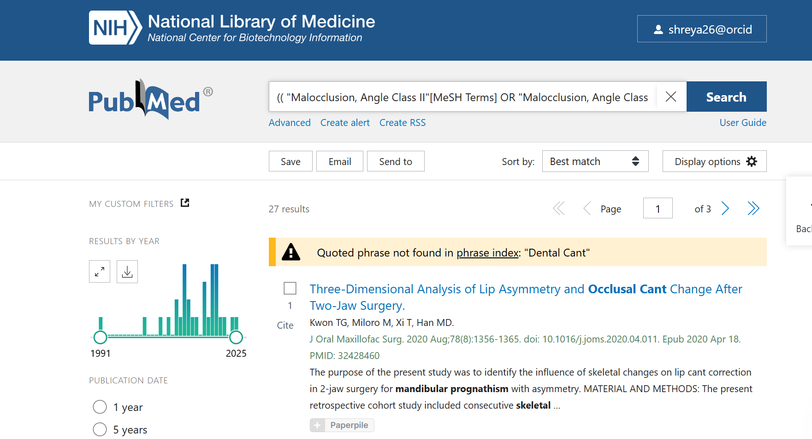

Web of Science:
Search Line | Concept | Search Query
#1 | Population (Keywords) | TITLE-ABS-KEY ( "Skeletal Class II" OR "Class II Malocclusion" OR "Mandibular Retrognathism" )
#2 | Population (Keywords) | TITLE-ABS-KEY ( "Skeletal Class III" OR "Class III Malocclusion" OR "Mandibular Prognathism" )
#3 | Population (Combined) | #1 OR #2
#4 | Asymmetry (Keywords) | TITLE-ABS-KEY ( "Facial Asymmetry" OR "Mandibular Asymmetry" OR "Craniofacial Asymmetry" OR "Hemimandibular" )
#5 | Cant (Keywords) | TITLE-ABS-KEY ( "Occlusal Cant" OR "Maxillary Cant" OR "Occlusal Plane Canting" OR "Occlusal Plane Inclination" OR "Transverse Occlusal Plane" OR "Dental Cant" )
#6 | Final Search | #3 AND #4 AND #5

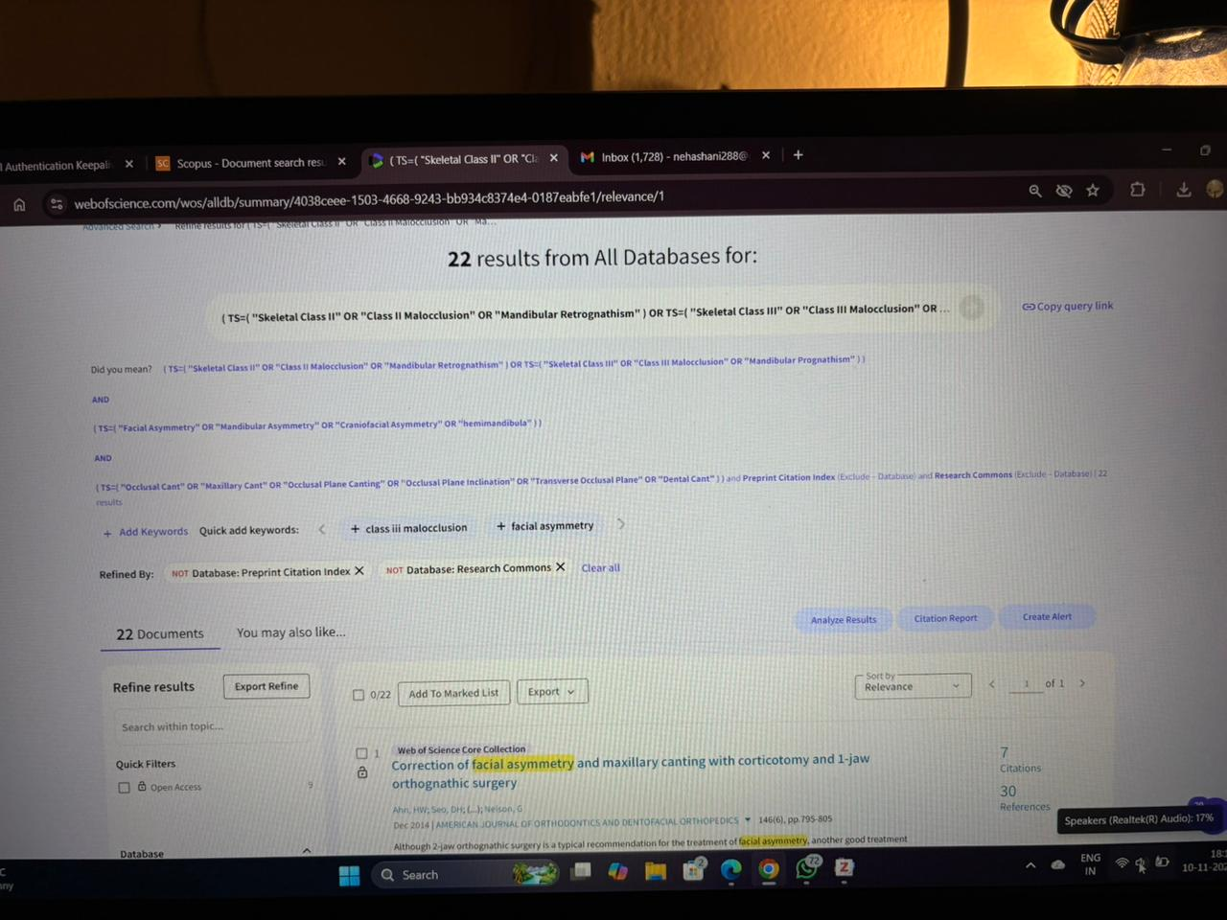

Scopus:
Search Line | Concept | Search Query
#1 | Population (Keywords) | TS=( "Skeletal Class II" OR "Class II Malocclusion" OR "Mandibular Retrognathism" )
#2 | Population (Keywords) | TS=( "Skeletal Class III" OR "Class III Malocclusion" OR "Mandibular Prognathism" )
#3 | Population (Combined) | #1 OR #2
#4 | Asymmetry (Keywords) | TS=( "Facial Asymmetry" OR "Mandibular Asymmetry" OR "Craniofacial Asymmetry" OR "Hemimandibular" )
#5 | Cant (Keywords) | TS=( "Occlusal Cant" OR "Maxillary Cant" OR "Occlusal Plane Canting" OR "Occlusal Plane Inclination" OR "Transverse Occlusal Plane" OR "Dental Cant" )
#6 | Final Search | #3 AND #4 AND #5

