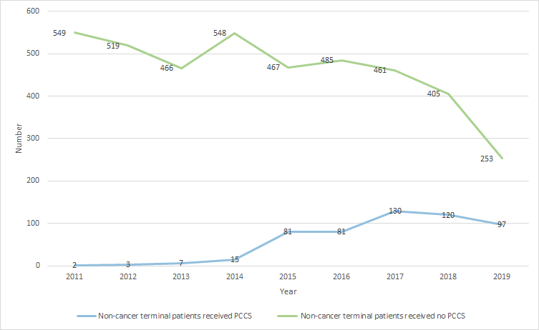
Supplementary Figure 1. Trend of Terminally Ill Non-Cancer Patients With/Without PCCS from 2011 to 2019

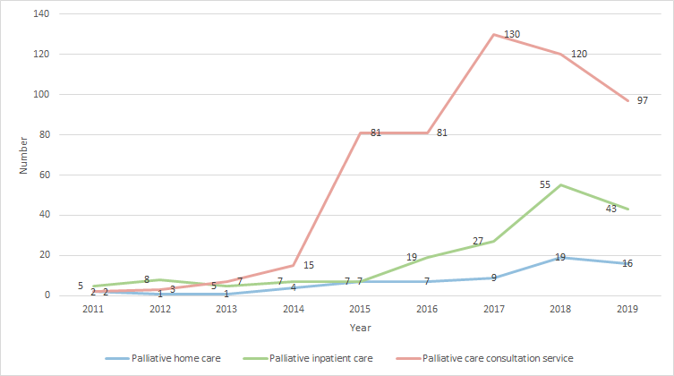
Supplementary Figure 2. Trend of Terminally Ill Non-Cancer Patients Receiving PCCS, Palliative Home Care and Palliative Inpatient Care from 2011 to 2019

