Appendix
Appendix 1: Inclusion and exclusion criteria
Inclusion criteria | Exclusion criteria
- Participant is aged 18 or over | - Healthcare professional working outside of the fields of oncology or palliative medicine
- Participant is a healthcare professional in the speciality of oncology or palliative medicine anywhere in the world | - Participant that does not want to give consent or take part in the survey
- Participant has undertaken virtual consultations in the last 18 months | - No experience of undertaking virtual consultations

Appendix 2: Survey
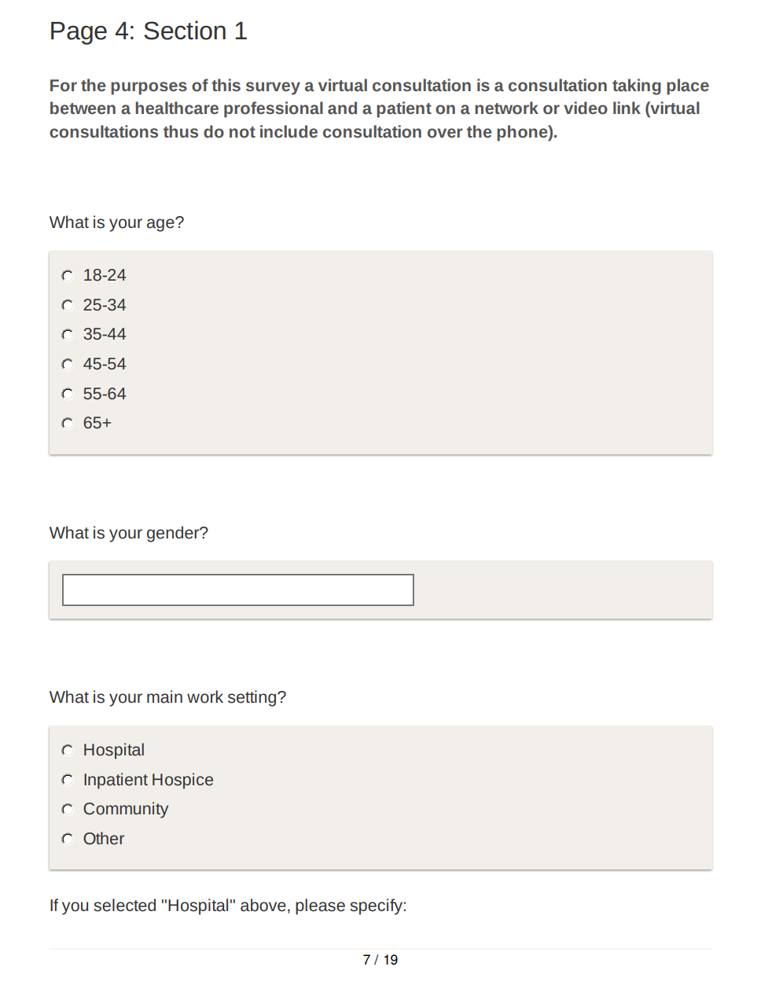
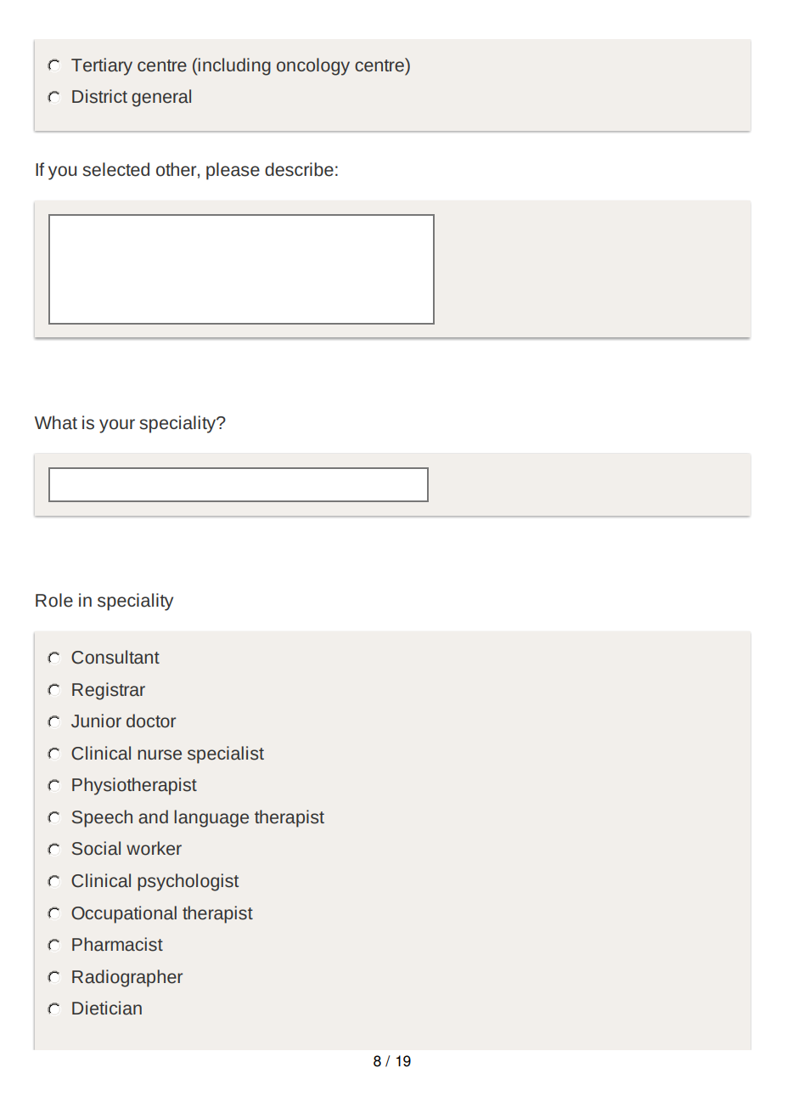

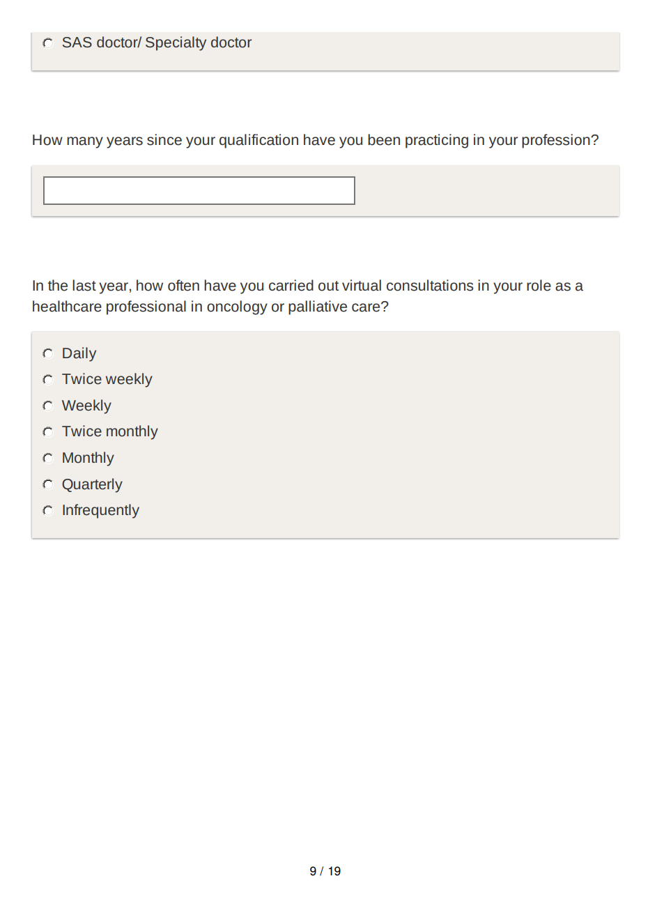

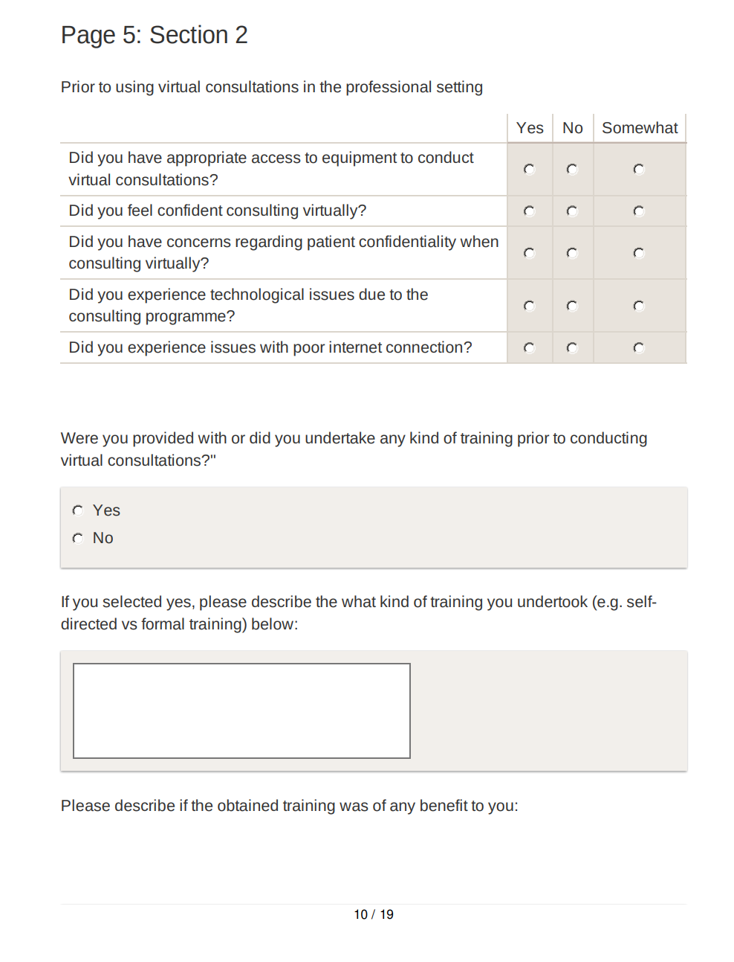

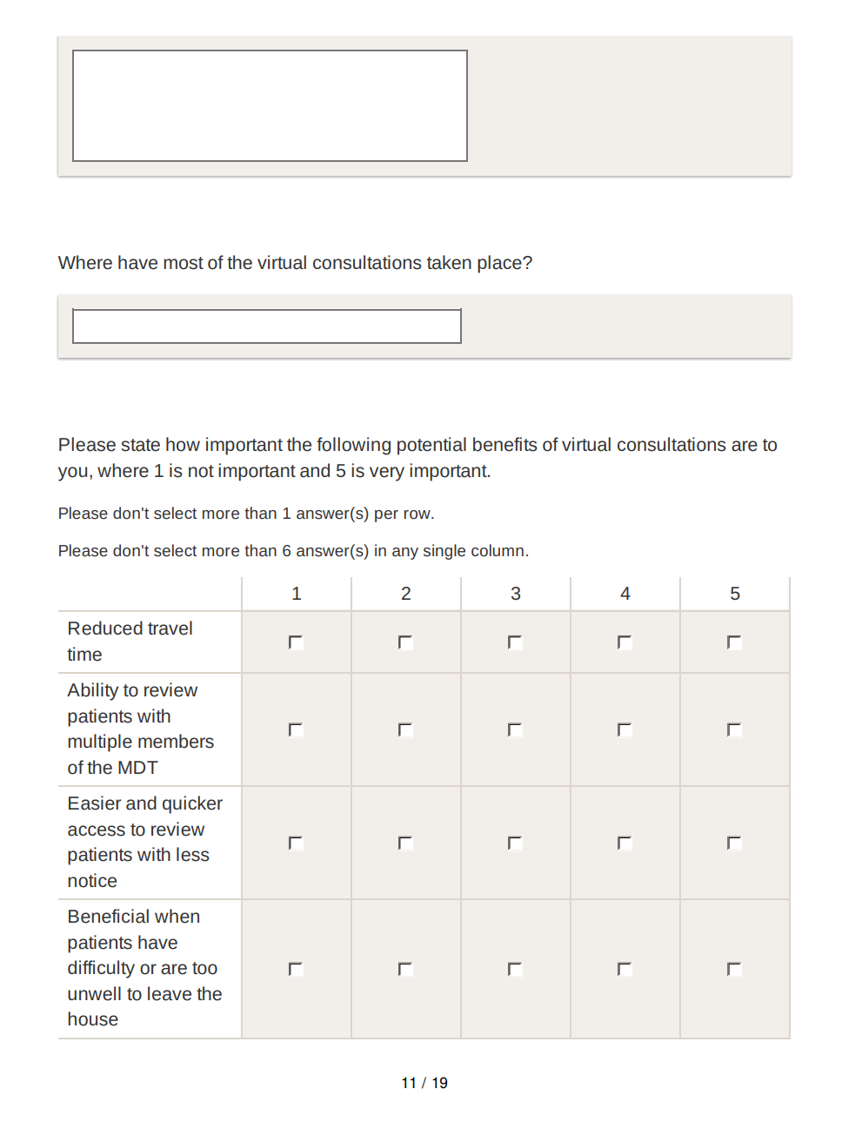

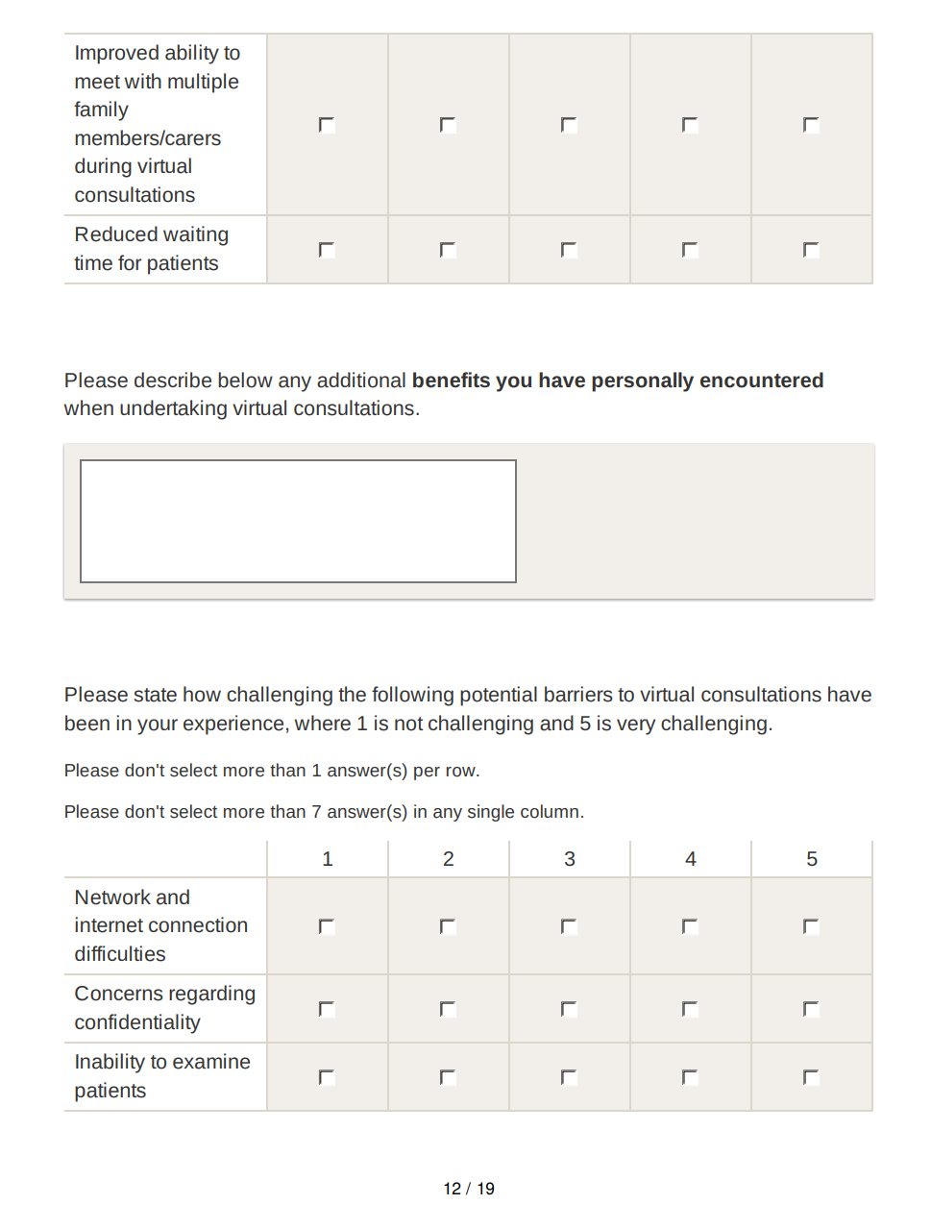

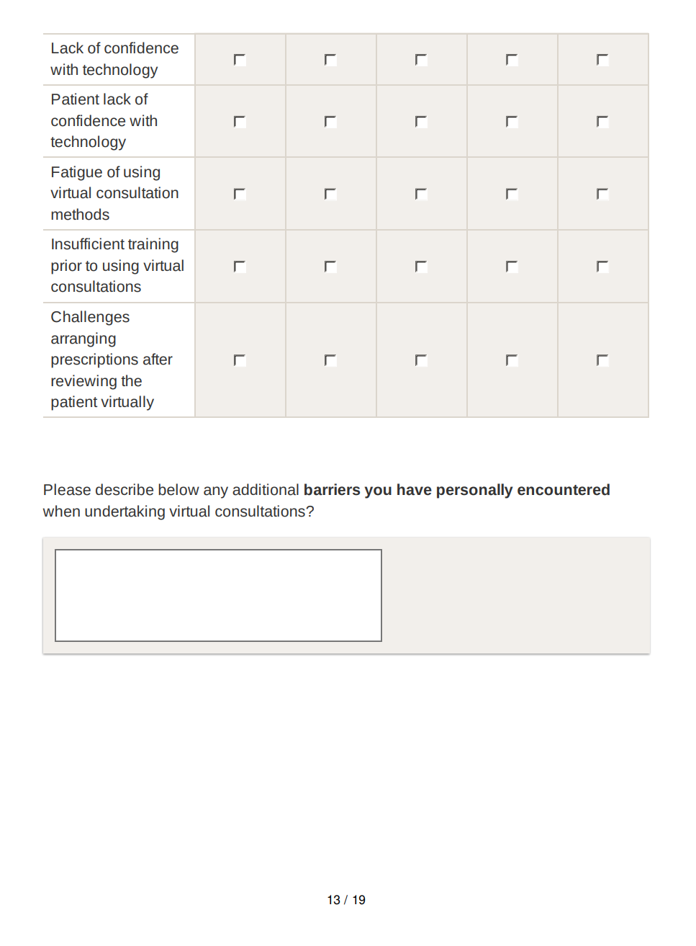

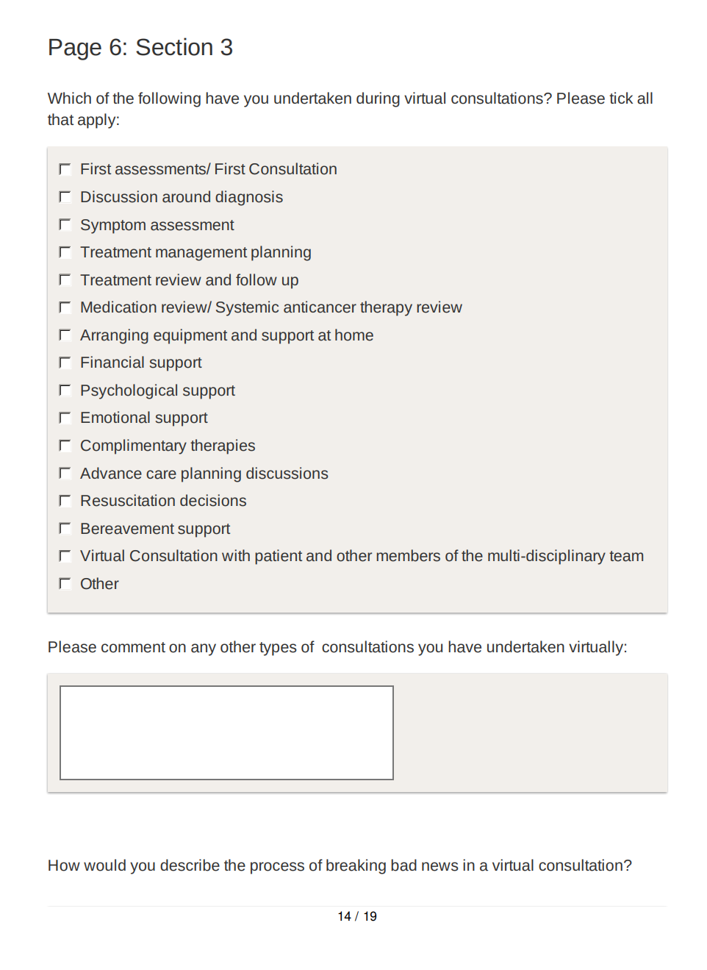

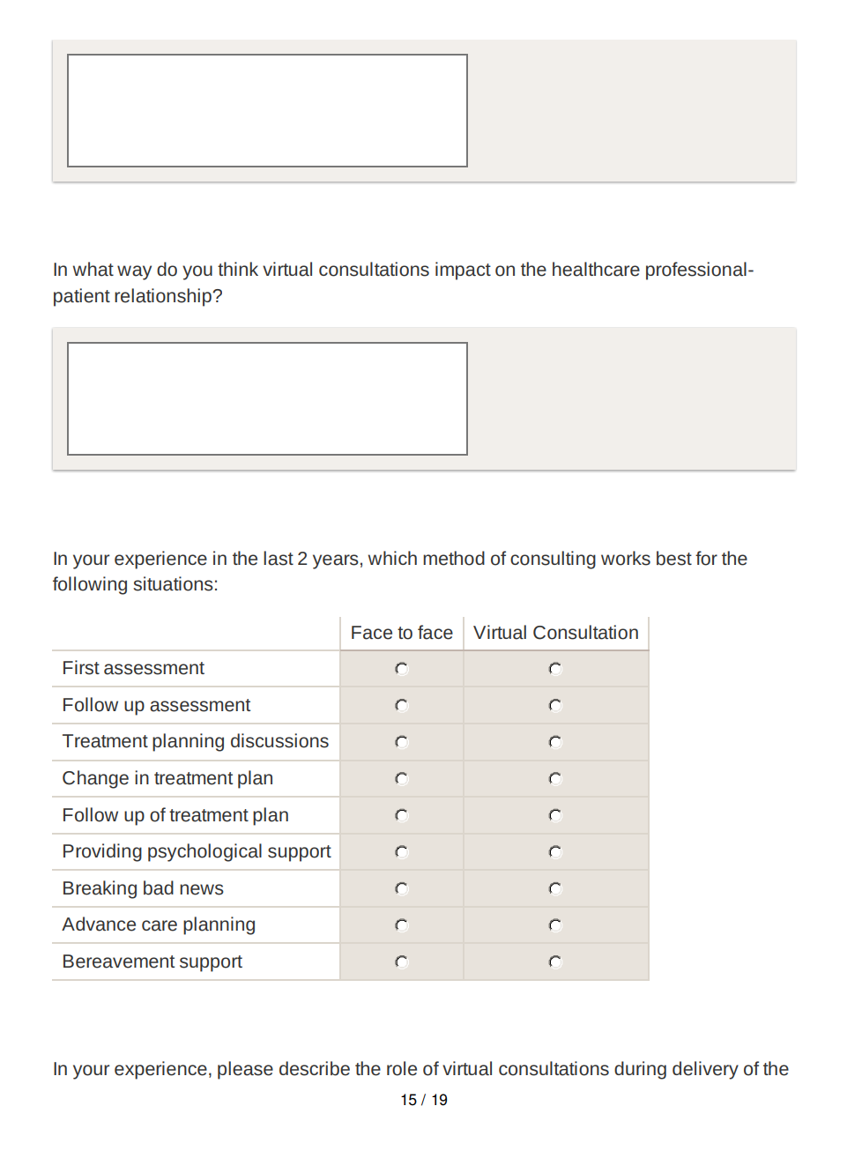

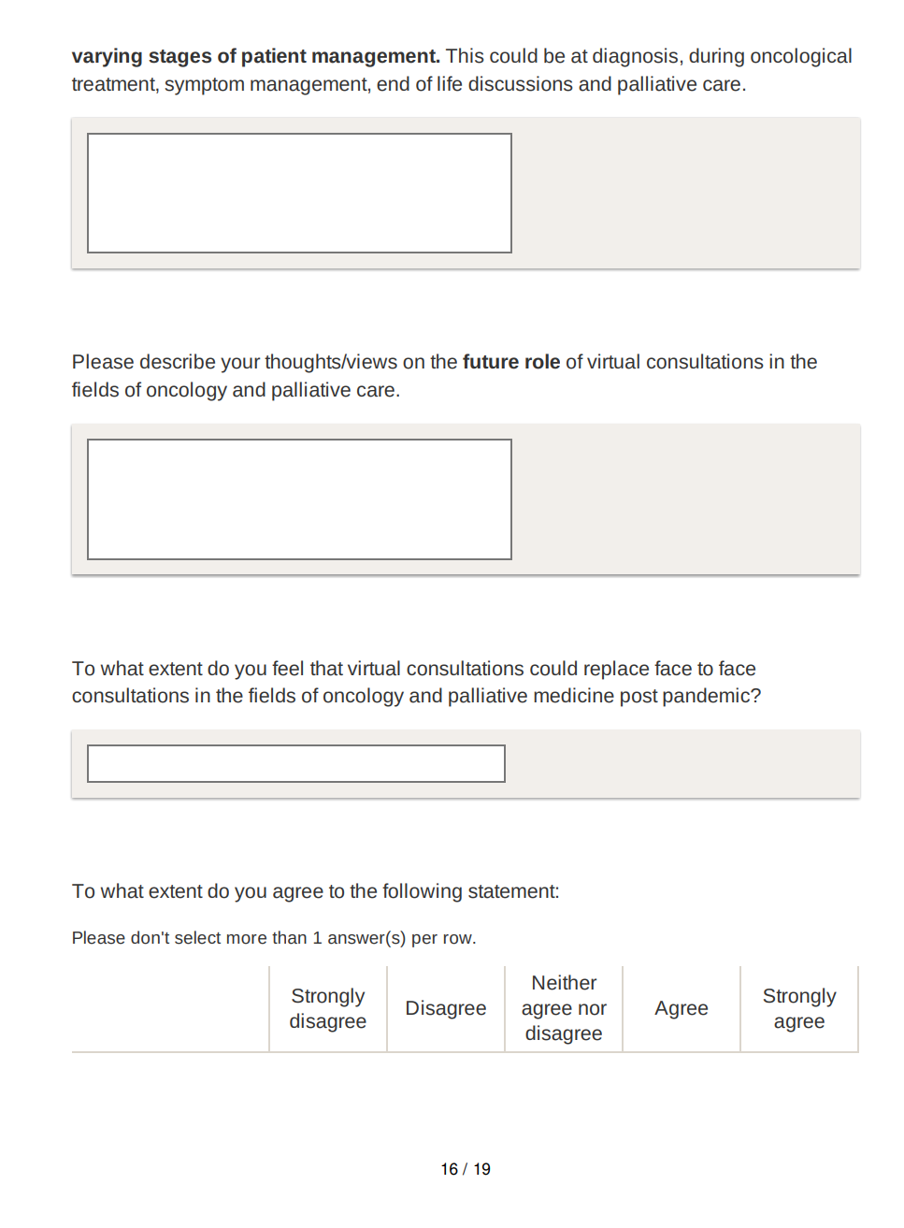

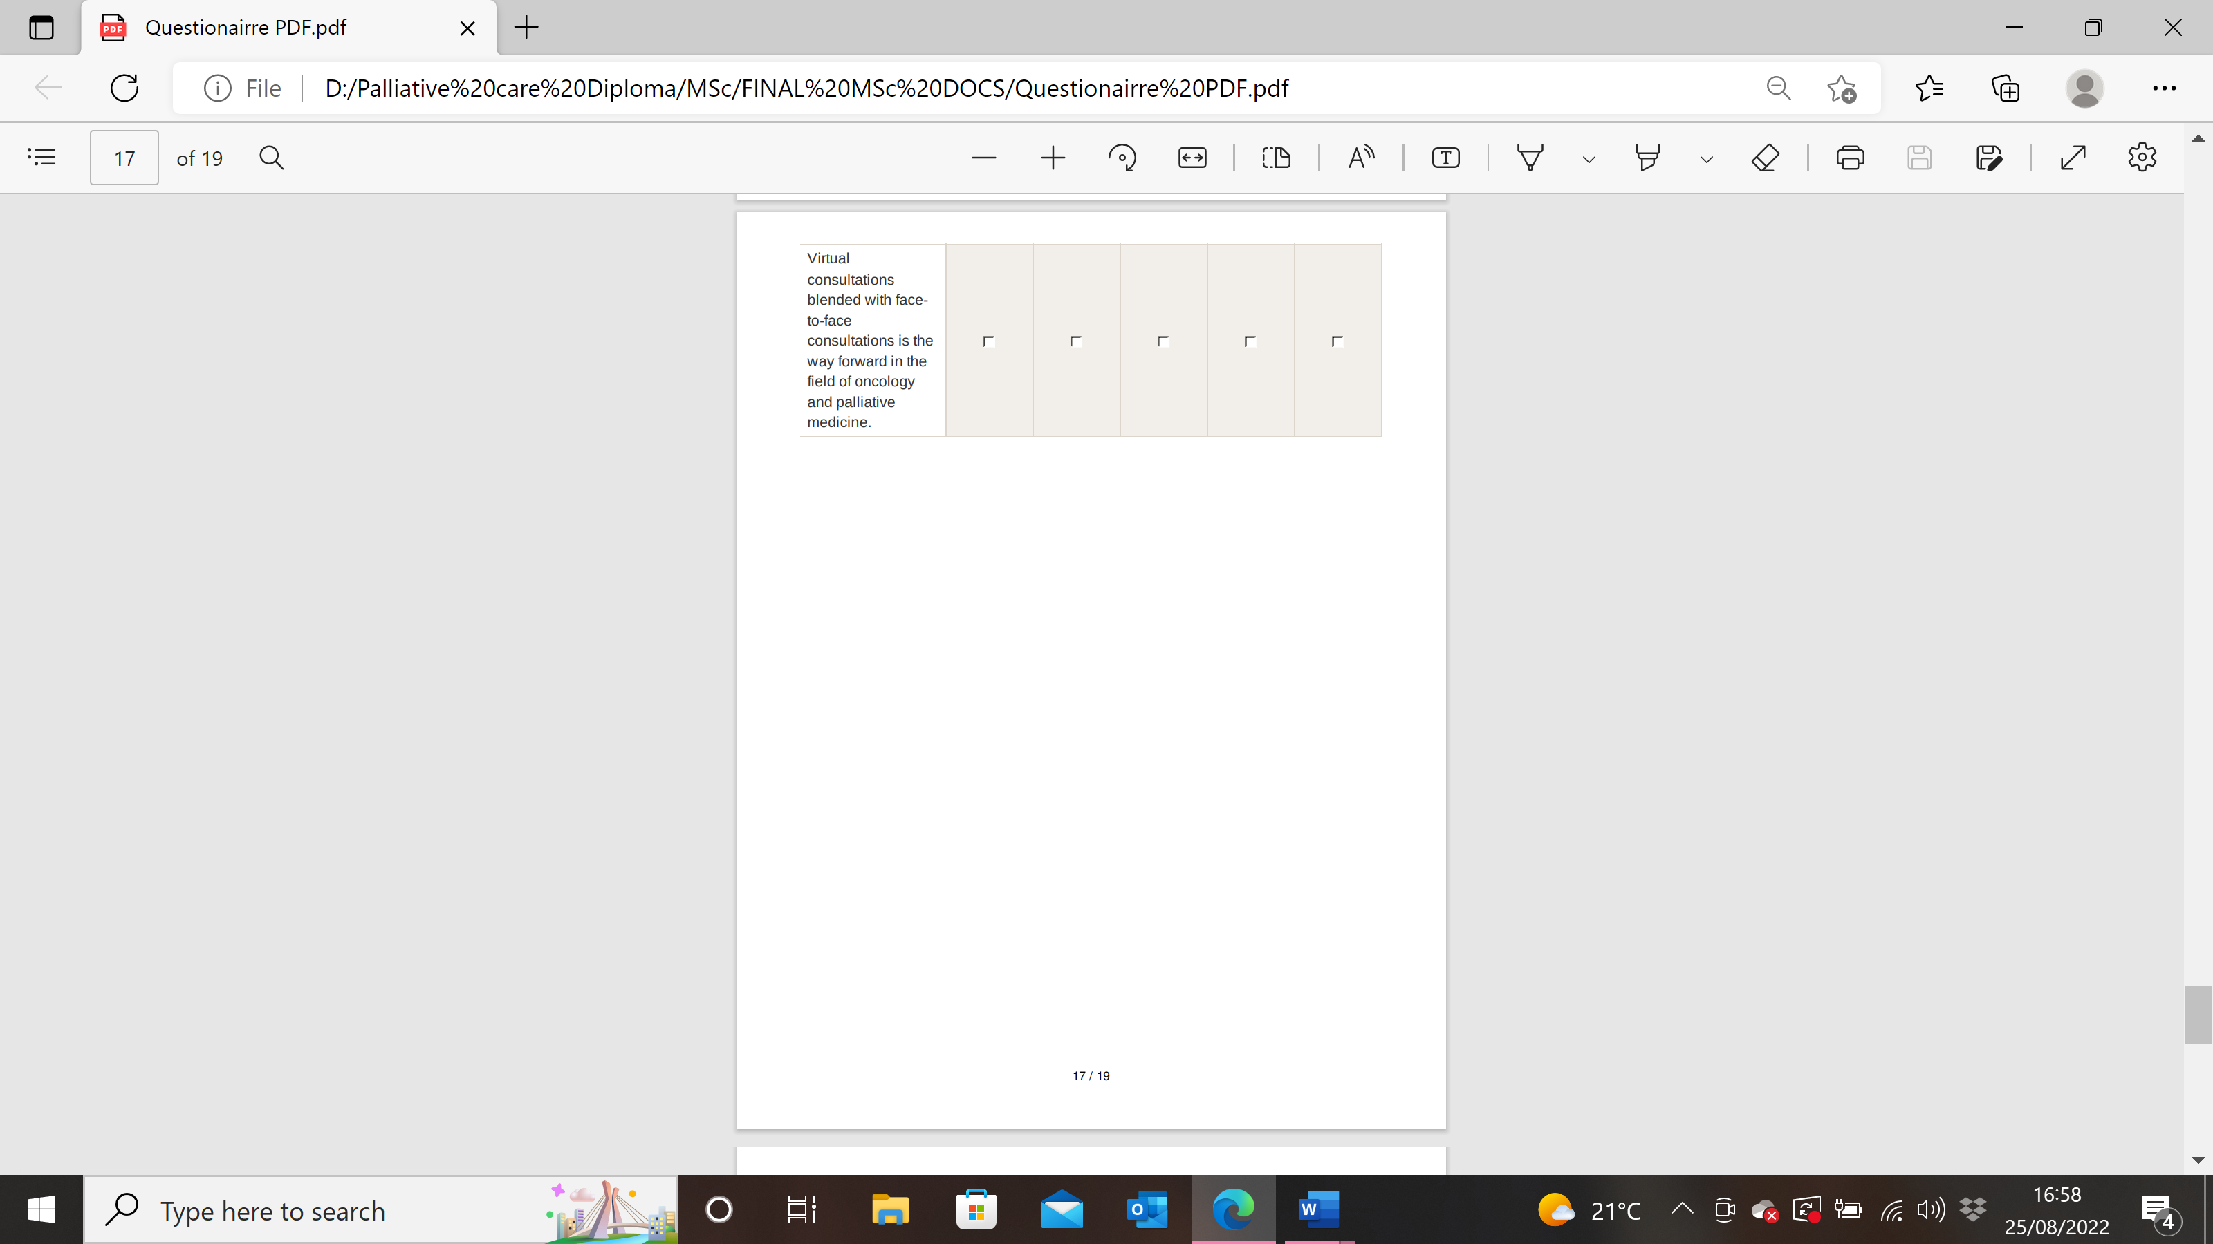

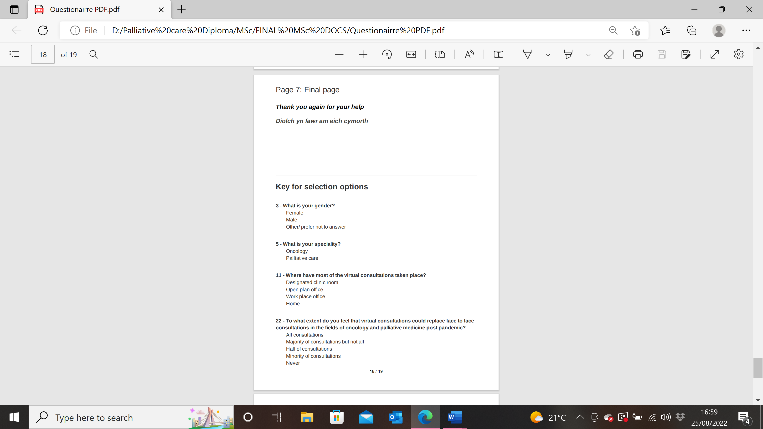
Appendix 3: Table of results

 | Number (%) | Percentage (%)
Age (n=87)
18-24 | 2 | 2.3%
25-34 | 9 | 10.3%
35-44 | 30 | 34.5%
45-54 | 35 | 40.2%
55-64 | 10 | 11.5%
65+ | 1 | 1.1%
Gender
Female | 66 | 75.9%
Male | 21 | 24.1%
Setting
Hospital | 55 | 63.2%
Inpatient hospice | 7 | 8%
Community | 24 | 27.6%
Other | 1 | 1.1% (equally divided between hospice, hospital and community palliative care)
Of those in a Hospital setting (n=55)
Tertiary centre (oncology centre) | 47 | 85.5%
District general | 8 | 14.5%
Specialty (n=86)
Oncology | 42 | 48.8%
Palliative care | 44 | 51.2%
Role (n=86)
Consultant | 37 | 43%
Registrar | 9 | 10.5%
Junior doctor | 0 | 0%
Clinical nurse specialist | 19 | 22.1%
Physiotherapist | 0 | 0%
Speech and language therapist | 5 | 5.8%
Social worker | 1 | 1.2%
Clinical psychologist | 1 | 1.2%
Occupational therapist | 2 | 2.3%
Pharmacist | 4 | 4.7%
Radiographer | 3 | 3.5%
Dietician | 0 | 0%
SAS/Specialty doctor | 5 | 5.8%
Years since qualification (n=85)
Mean |  | 17.89 years
Median |  | 18 years
In the last year how often have you carried out VC in your role as a HCP (n=87)
Daily | 6 | 6.9%
Twice weekly | 22 | 22%
Weekly | 21 | 24.1%
Twice monthly | 10 | 11.5%
Monthly | 4 | 4.6%
Quarterly | 4 | 4.6%
Infrequently | 20 | 23%
PRIOR TO USING VC in the professional setting
Did you have appropriate access to equipment (n=87)
Yes | 52 | 59.8%
No | 10 | 11.5%
Somewhat | 25 | 28.7%
Did you feel confident consulting virtually (n=87)
Yes | 49 | 56.3%
No | 16 | 18.4%
Somewhat | 22 | 25.3%
Did you have concerns re patient confidentiality (n=87)
Yes | 10 | 11.5%
No | 63 | 72.4%
Somewhat | 14 | 16.1%
Did you experience technological issues due to the consulting programme (n=86)
Yes | 39 | 45.3%
No | 25 | 28.7%
Somewhat | 22 | 25.6%
Did you experience issues with poor internet connection (n=87)
Yes | 39 | 44.8%
No | 31 | 35.6%
Somewhat | 17 | 19.5%
Were you provided with training prior to conducting VC (n=87)
Yes | 29 | 33.3%
No | 58 | 66.7%
If yes to above: What kind of training (n=29) | 29 | TEXT
Was the training of any benefit to you (n=27) | 27 | TEXT
Where have most of the VC taken place (n=87)
Designated clinic room | 39 | 44.8%
Open plan office | 9 | 10.3%
Work place office | 28 | 32.2%
Home | 11 | 12.6%
How important are these benefits of VC
Reduced travel time (n=87)
Not important | 16 | 18.4%
Slightly unimportant | 8 | 9.2%
Indifferent | 15 | 17.2%
Slightly important | 19 | 21.8%
Very important | 29 | 33.3%
Ability to review patients with multiple members of MDT (n=87)
Not important | 20 | 23%
Slightly unimportant | 13 | 14.9%
Indifferent | 18 | 20.7%
Slightly important | 20 | 23%
Very important | 16 | 18.4%
Easier and quicker access to review patients with less notice (n=86)
Not important | 10 | 11.6%
Slightly unimportant | 9 | 10.5%
Indifferent | 22 | 25.6%
Slightly important | 25 | 29.1%
Very important | 20 | 23.3%
Beneficial when patients have difficulty or are too unwell to leave the house (n=86)
Not important | 13 | 15.1%
Slightly unimportant | 8 | 9.3%
Indifferent | 12 | 14%
Slightly important | 16 | 18.6%
Very important | 37 | 43%

Improved ability to meet with multiple family members/carers during virtual consultations (n=86)
Not important | 8 |  | 9.3%
Slightly unimportant | 14 |  | 16.3%
Indifferent | 16 |  | 18.6%
Slightly important | 27 |  | 31.4%
Very important | 21 |  | 24.4%
Reduced waiting time for patients (n=86)
Not important | 19 |  | 21.8%
Slightly unimportant | 8 |  | 9.2%
Indifferent | 13 |  | 14.9%
Slightly important | 21 |  | 24.1%
Very important | 26 |  | 29.9%
Additional benefits encountered undertaking VC | 61 |  | TEXT
How challenging are these potential barriers to VC
Network and connection difficulties (n=87)
Not challenging | 8 |  | 9.2%
Slightly challenging | 17 |  | 19.5%
Indifferent | 28 |  | 32.3%
More challenging than not | 22 |  | 25.3
Very challenging | 12 |  | 13.8
Concerns re confidentiality (n=87)
Not challenging | 37 |  | 42.5%
Slightly challenging | 26 |  | 29.9%
Indifferent | 18 |  | 20.7%
More challenging than not | 5 |  | 5.7%
Very challenging | 1 |  | 1.1%
Inability to examine patients (n=86)
Not challenging | 5 |  | 5.8%
Slightly challenging | 9 |  | 10.5%
Indifferent | 16 |  | 18.6%
More challenging than not | 20 |  | 23.3%
Very challenging | 36 |  | 41.9%
HCP Lack of confidence with technology (n=87)
Not challenging | 33 |  | 37.9%
Slightly challenging | 24 |  | 27.6%
Indifferent | 21 |  | 24.1%
More challenging than not | 8 |  | 9.2%
Very challenging | 1 |  | 1.1%
Patient lack of confidence of technology (n=86)
Not challenging | 4 |  | 4.7%
Slightly challenging | 9 |  | 10.5%
Indifferent | 25 |  | 29.1%
More challenging than not | 35 |  | 40.7%
Very challenging | 13 |  | 15.1%
Fatigue of using VC methods (n=87)
Not challenging | 20 |  | 23%
Slightly challenging | 21 |  | 24.1%
Indifferent | 22 |  | 25.3%
More challenging than not | 17 |  | 19.5%
Very challenging | 7 |  | 8%
Insufficient training prior to using VC (n=87)
Not challenging | 29 |  | 33.3%
Slightly challenging | 26 |  | 29.9%
Indifferent | 14 |  | 16.1%
More challenging than not | 14 |  | 16.1%
Very challenging | 4 |  | 4.6%
Challenges arranging prescriptions VC (n=84): n=74 Prescribers
Not challenging | 25 |  | 29.8%
Slightly challenging | 17 |  | 20.2%
Indifferent | 19 |  | 22.6%
More challenging than not | 12 |  | 14.3%
Very challenging | 11 |  | 13.1%
Barriers encountered undertaking VC | 49 |  | TEXT
Which of the following have you undertaken during VC
First assessment | 56 |  | 64.4%
Discussion around diagnosis | 45 |  | 51.7%
Symptom assessment | 68 |  | 78.2%
Treatment management planning | 55 |  | 63.2%
Treatment review and follow up | 64 |  | 73.6%
Medication review/SACT review | 52 |  | 59.8%
Arranging equipment and support at home | 19 |  | 21.8%
Financial support | 8 |  | 9.2%
Psychological support | 33 |  | 37.9%
Emotional support | 41 |  | 47.1%
Complementary therapies | 2 |  | 2.3%
ACP | 32 |  | 36.8%
Resuscitation decisions | 18 |  | 20.7%
Bereavement support | 7 |  | 7%
VC with patient and MDT | 37 |  | 42.5%
Other | 4 |  | 4%
Please comment on any other types of consultations you have undertaken virtually | 9 |  | TEXT
How would you describe the process of breaking bad news in VC | 70 |  | TEXT
 | 57 had experience (N/A to role in 13 respondents)
Negative experience | 37 |  | 64.9%
Positive experience | 7 |  | 12.2%
Mixed experience | 13 |  | 22.8%
In what way to you think VC impact on HCP patient relationship | 71 |  | TEXT
In your experience in the last 2 years which method of consulting works best for the following situations | F2F | VC
First Assessment | 79 | 5 | F2f 94% VC 6%
Follow up assessment | 30 | 53 | F2f 36.1% VC 63.9%
Treatment planning discussions | 54 | 23 | F2f 70.1% VC 29.9%
Change in treatment plan | 58 | 20 | F2f 74.4% VC 25.6%
Follow up treatment plan | 18 | 62 | F2f 22.5% VC 77.5%
Providing psychological support | 63 | 17 | F2f 78.8% VC 21.3%
Breaking bad news | 79 | 0 | F2f 100% VC 0%
ACP | 64 | 11 | F2f 85.3% VC14.7%
Bereavement support | 53 | 19 | F2f 73.6% VC 26.4
Please describe the role of VC during the varying stages of patient management | 63 |  | TEXT
Please describe your thoughts views on the future role of VC in the fields of palliative care and oncology | 71 |  | TEXT
To what extent do you feel that VC could replace f2f consultations in the field of oncology and palliative medicine post pandemic (n=86) |  |  | TEXT
All | 0 |  | 0%
Majority of consultations but not all | 2 |  | 2.3%
Half of consultations | 46 |  | 53.5%
Minority of consultations | 35 |  | 40.7%
Never | 3.5 |  | 3.5%
To what extent do you agree to the following statement (n=87)
Strongly disagree | 7 |  | 8%
Disagree | 9 |  | 10.3%
Neither agree or disagree | 9 |  | 10.3%
Agree | 35 |  | 40.2%
Strongly agree | 27 |  | 31%

Appendix 4: Table summary of types of assessments undertaken by varying HCP’s using VC
Which of the following have you undertaken during VC | Consultant | Registrar | CNS | Speech and Language therapist | Social worker | Clinical psychologist | OT | Pharmacist | Radiographer | SAS Dr/Specialty Dr
First assessment | 27 | 5 | 9 | 4 | 1 | 1 | 2 | 0 | 1 | 5
Discussion around diagnosis | 26 | 5 | 6 | 1 | 1 | 0 | 0 | 2 | 0 | 3
Symptom assessment | 33 | 8 | 15 | 4 | 0 | 0 | 0 | 2 | 2 | 3
Treatment management planning | 30 | 7 | 8 | 2 | 0 | 0 | 0 | 2 | 2 | 3
Treatment review and follow up | 32 | 8 | 8 | 5 | 0 | 0 | 0 | 4 | 2 | 4
Medication review/SACT review | 27 | 7 | 9 | 0 | 0 | 0 | 0 | 4 | 2 | 2
Arranging equipment and support at home | 2 | 1 | 10 | 2 | 0 | 0 | 1 | 0 | 1 | 2
Financial support | 1 | 0 | 6 | 0 | 1 | 0 | 0 | 0 | 0 | 0
Psychological support | 8 | 1 | 13 | 2 | 1 | 1 | 2 | 1 | 2 | 1
Emotional support | 11 | 1 | 16 | 3 | 1 | 1 | 2 | 1 | 2 | 2
Complementary therapies | 0 | 0 | 0 | 1 | 0 | 0 | 0 | 0 | 1 | 0
ACP | 14 | 2 | 10 | 1 | 1 | 0 | 0 | 0 | 0 | 3
Resuscitation decisions | 9 | 2 | 5 | 0 | 0 | 0 | 0 | 0 | 0 | 1
Bereavement support | 1 | 0 | 3 | 1 | 1 | 1 | 0 | 0 | 0 | 1
VC with patient and MDT | 15 | 3 | 7 | 5 | 0 | 0 | 1 | 2 | 0 | 3
Other | 1 | 0 | 2 | 1 | 0 | 0 | 0 | 0 | 0 | 0
Total response | 237 | 50 | 127 | 31 | 7 | 4 | 8 | 18 | 15 | 33
*Further assessments included by participants included: swallow assessments and therapy reviews, administrative support for scheduling investigations or radiological tests, discharge planning and family meetings, review of patients at the end of life.

