Additional file 2
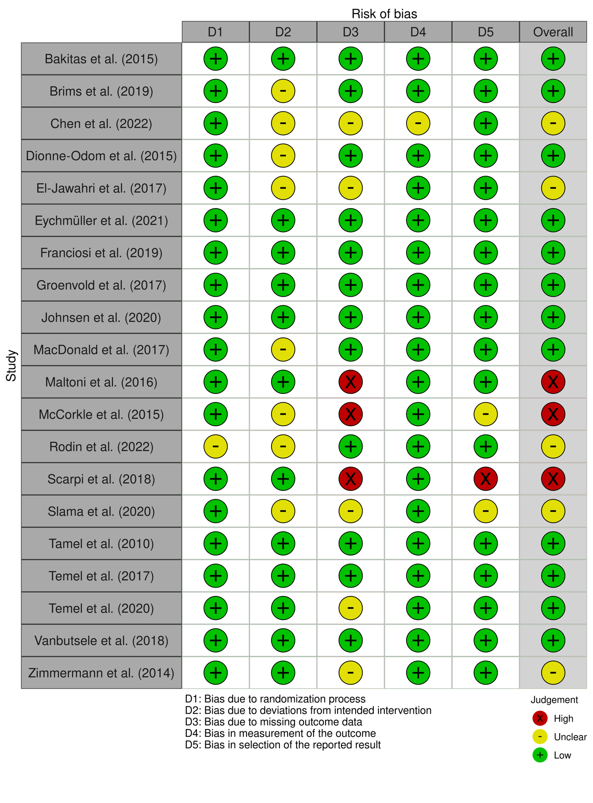
Risk of bias’s traffic light plot

