Additional File 3. Forest plot
Forest plot for anxiety (DASS-A) among cancer patient
Forest plot for depression among patient cancer, using SMD
Forest plot for depression (DASS-D) among cancer patient
Forest plot for depression (PHQ-9) among cancer patient
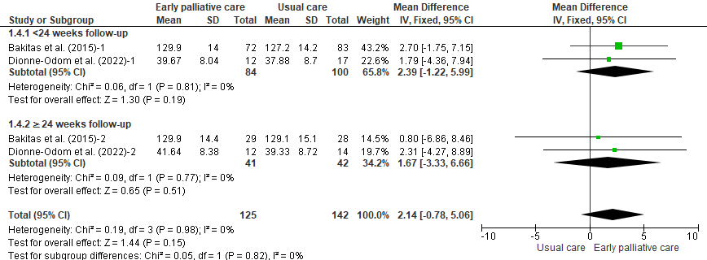
Forest plot for functional status (FACIT-PAL) among cancer patient
Forest plot for QoL among cancer patient, using SMD
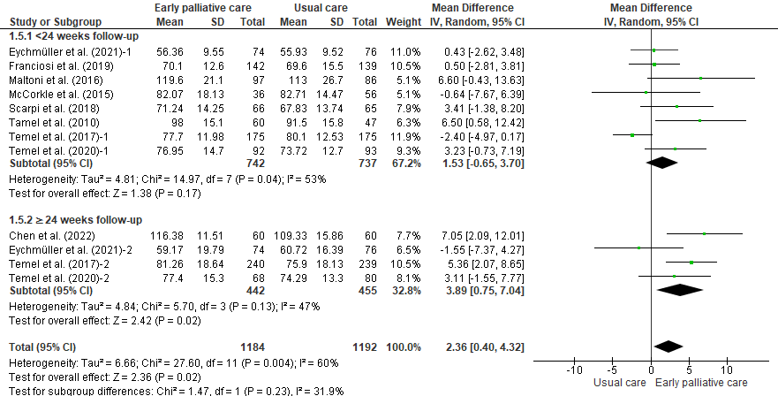
Forest plot for QoL (FACT) among cancer patient
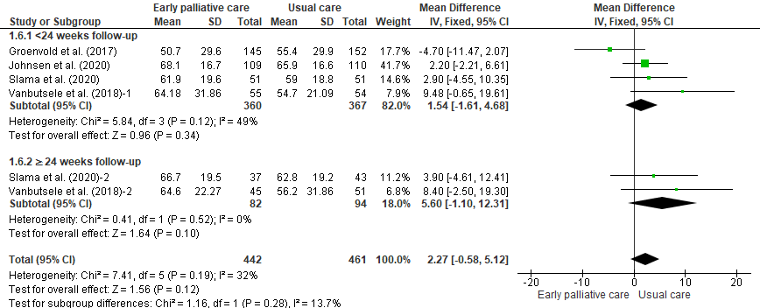
Forest plot for QoL (QLQ-C30) among cancer patient
Forest plot for QoL among caregiver, using SMD
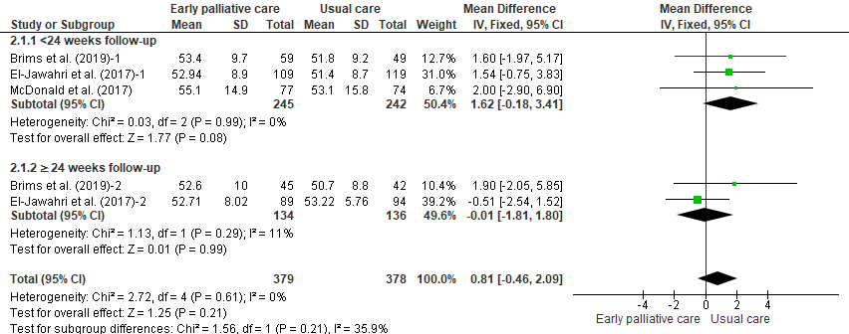
Forest plot for QoL (SF-36 physic) among family caregiver
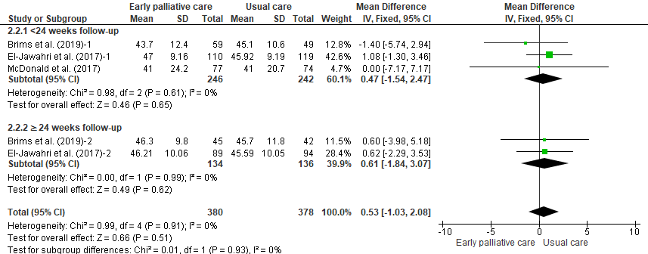
Forest plot for QoL (SF-36 mental) among family caregiver

Forest plot for QoL (CQOL-C) among family caregiver
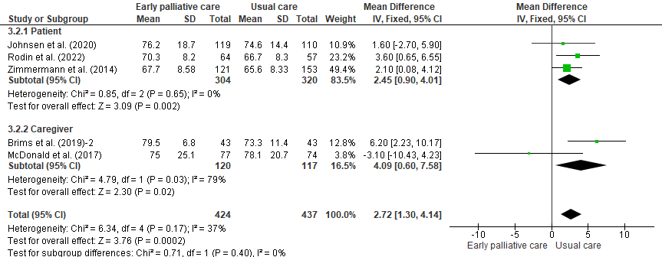
Forest plot for care satisfaction among patient and their family caregiver

