Supplementary Table 1: Reponses to each question across all time periods
Characteristic | Period 0  N = 120¹ | Period 1  N = 149¹ | Period 2  N = 125¹ | Period 3  N = 153¹ | Period 4  N = 190¹
How would you rate our attention to your physical problems?
Very Bad | 0 (0.0%) | 1 (0.7%) | 1 (0.8%) | 0 (0.0%) | 0 (0.0%)
Bad | 5 (4.2%) | 7 (4.7%) | 3 (2.4%) | 3 (2.0%) | 3 (1.6%)
Good | 57 (47.5%) | 44 (29.5%) | 35 (28.0%) | 47 (30.7%) | 66 (34.7%)
Very Good | 57 (47.5%) | 97 (65.1%) | 85 (68.0%) | 102 (66.7%) | 121 (63.7%)
Doesn't Apply | 1 (0.8%) | 0 (0.0%) | 1 (0.8%) | 1 (0.7%) | 0 (0.0%)
How would you rate our attention to your feelings?
Very Bad | 1 (0.8%) | 0 (0.0%) | 1 (0.8%) | 1 (0.7%) | 0 (0.0%)
Bad | 3 (2.5%) | 10 (6.7%) | 6 (4.8%) | 7 (4.6%) | 7 (3.7%)
Good | 77 (64.2%) | 65 (43.6%) | 40 (32.0%) | 57 (37.3%) | 76 (40.0%)
Very Good | 38 (31.7%) | 63 (42.3%) | 66 (52.8%) | 74 (48.4%) | 82 (43.2%)
Doesn't Apply | 1 (0.8%) | 11 (7.4%) | 12 (9.6%) | 14 (9.2%) | 25 (13.2%)
How would you rate our attention to your surroundings?
Very Bad | 1 (0.8%) | 4 (2.7%) | 0 (0.0%) | 0 (0.0%) | 1 (0.5%)
Bad | 20 (16.7%) | 14 (9.4%) | 9 (7.2%) | 12 (7.8%) | 10 (5.3%)
Good | 80 (66.7%) | 76 (51.0%) | 46 (36.8%) | 70 (45.8%) | 78 (41.1%)
Very Good | 19 (15.8%) | 55 (36.9%) | 67 (53.6%) | 68 (44.4%) | 98 (51.6%)
Doesn't Apply | 0 (0.0%) | 0 (0.0%) | 3 (2.4%) | 3 (2.0%) | 3 (1.6%)
How would you rate our respect for what matters to you?
Very Bad | 1 (0.8%) | 0 (0.0%) | 0 (0.0%) | 0 (0.0%) | 0 (0.0%)
Bad | 3 (2.5%) | 5 (3.4%) | 4 (3.2%) | 5 (3.3%) | 5 (2.6%)
Good | 79 (65.8%) | 58 (38.9%) | 44 (35.2%) | 65 (42.5%) | 69 (36.3%)
Very Good | 35 (29.2%) | 72 (48.3%) | 74 (59.2%) | 81 (52.9%) | 112 (58.9%)
Doesn't Apply | 2 (1.7%) | 14 (9.4%) | 3 (2.4%) | 2 (1.3%) | 4 (2.1%)
How would you rate our communication about your plans?
Very Bad | 0 (0.0%) | 1 (0.7%) | 0 (0.0%) | 0 (0.0%) | 2 (1.1%)
Bad | 10 (8.3%) | 10 (6.7%) | 5 (4.0%) | 14 (9.2%) | 12 (6.3%)
Good | 77 (64.2%) | 63 (42.3%) | 49 (39.2%) | 66 (43.1%) | 84 (44.2%)
Very Good | 33 (27.5%) | 74 (49.7%) | 69 (55.2%) | 71 (46.4%) | 91 (47.9%)
Doesn't Apply | 0 (0.0%) | 1 (0.7%) | 2 (1.6%) | 2 (1.3%) | 1 (0.5%)
How would you rate our attention to your affairs?
Very Bad | 0 (0.0%) | 1 (0.7%) | 0 (0.0%) | 0 (0.0%) | 1 (0.5%)
Bad | 2 (1.7%) | 4 (2.7%) | 5 (4.0%) | 1 (0.7%) | 3 (1.6%)
Good | 49 (40.8%) | 40 (26.8%) | 15 (12.0%) | 41 (26.8%) | 59 (31.1%)
Very Good | 12 (10.0%) | 36 (24.2%) | 37 (29.6%) | 37 (24.2%) | 32 (16.8%)
Doesn't Apply | 57 (47.5%) | 68 (45.6%) | 68 (54.4%) | 74 (48.4%) | 95 (50.0%)
How would you rate our attention to what you can expect?
Very Bad | 0 (0.0%) | 1 (0.7%) | 0 (0.0%) | 0 (0.0%) | 0 (0.0%)
Bad | 9 (7.5%) | 8 (5.4%) | 5 (4.0%) | 4 (2.6%) | 6 (3.2%)
Good | 87 (72.5%) | 60 (40.3%) | 38 (30.4%) | 43 (28.1%) | 71 (37.6%)
Very Good | 17 (14.2%) | 50 (33.6%) | 45 (36.0%) | 43 (28.1%) | 55 (29.1%)
Doesn't Apply | 7 (5.8%) | 30 (20.1%) | 37 (29.6%) | 63 (41.2%) | 57 (30.2%)
¹n (%)

Supplementary Figure 1: Proportion of patients reporting ‘very good’ experiences at each two-month time period, per participating ward

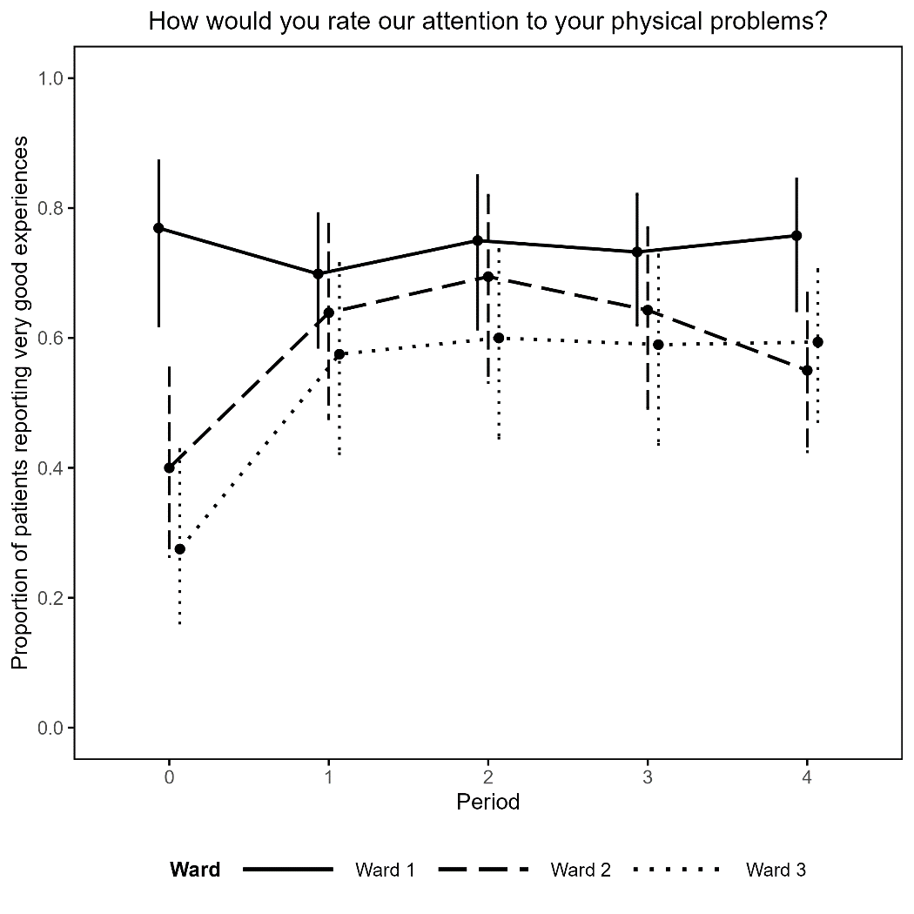 | 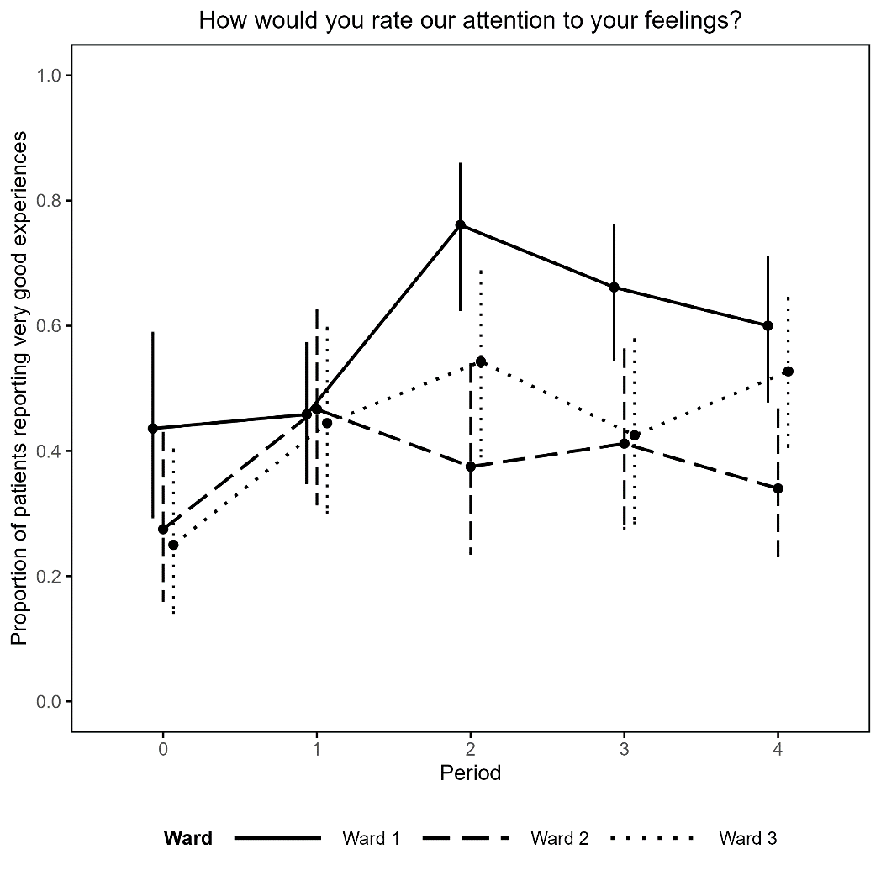
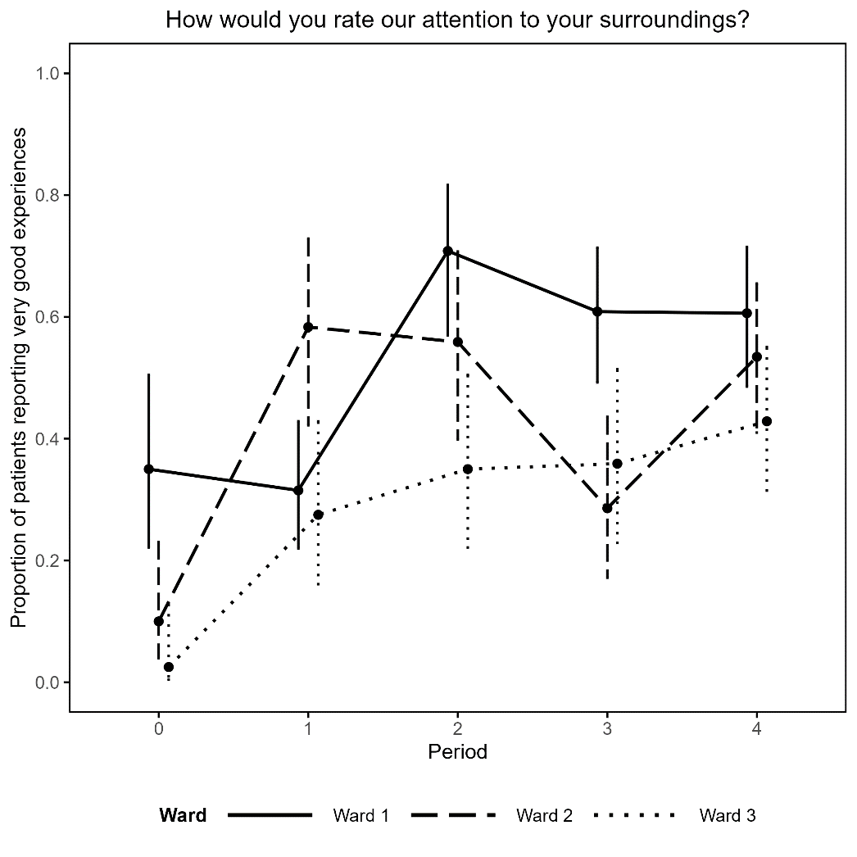 | 