Appendix 1: Programme IMPACT and organ specific criteria
Traditionally, hospice homecare comprises of a multi-disciplinary team ensuring symptom control and providing psychosocial support by making home visits, medication titrations, Advance Care Planning discussions and providing phone-call consultations including after office-hours phone and on-site support for crisis calls. Programme IMPACT comprised of 1 doctor of senior consultant grade specialising in palliative care, 1 resident physician, 1 doctor of medical officer grade, 1 nursing manager, 3 senior staff nurses, 1 senior medial social worker (MSW). These are the additional features of Programme IMPACT:
- As we are a homecare team embedded in the hospital rather one which is based in the community, we have a close working relationship with patient’s primary organ specialist allowing easier medication titrations of their chronic diseases that we are actively managing. There is seamless transition from home to our acute palliative ward in the hospital, allowing patients to by-pass the Emergency Department. There is also a face of familiarity when our palliative doctors and MSW from homecare continued to support our patients even when they are admitted in the hospital. This is essential as we continue to build trust and rapport in what seemed like a roller-coaster trajectory from the patient’s perspective.
- We identified community service providers and formed unique partnership that allowed us to have quick confirmation of home personal care services to help our patients. We also have real-time feedback from these providers about our clients.
- We perform intravenous administration of medications like frusemide for heart failure and hydrocortisone for COPD exacerbations and perform blood test if patients are assessed to benefit from it.
- In addition to indicators routinely assessed under Edmonton Symptom Assessment System-revised (ESAS-r), we also actively screen and manage symptoms distinctive in ESOF patients. These includes itch (uremic itch in end-stage kidney failure), lower limb edema (fluid overload in end-stage heart failure) and constipation.
Organ specific screening criteria
Organ failure | Screening Criteria
End-stage Heart Failure | - Limited functional capacity with increased symptom burden (NYHA Class III or IV)  - Medical treatment of heart condition has been fully optimized  - Not a candidate for surgical procedures OR has declined surgery  - Repeated emergency visits or hospitalizations for treatment of fluid overload or acute decompensation  - Documented EF of less than 20%
End-stage Respiratory Failure | - Resting dyspnoea poorly responsive to bronchodilators  - Decreased functional capacity eg.  • Predicted FEV1 <30% (if available)  • Assistance with transfer  • Presence of cough, fatigue from activity intolerance  - Repeated emergency visits or hospitalizations for treatment of chest infections, exacerbations or respiratory failure (2 or > ED visits/ hospitalisations in the past 1 year)  - Meets criteria for long-term oxygen therapy  - Right ventricular failure resulting from respiratory condition (cor pulmonale)  - Unintentional weight loss of > 10% body weight over past 6 months
End-stage Renal failure | - Renal Replacement Therapy (RRT) has to be discontinued (e.g. persistent hypotension from RRT)  - Patient declines RRT  - Creatinine clearance of < 10mls/min OR estimated glomerular filtration rate (eGFR) of < 10ml/min/1.73m2  - Presence of any one of the symptoms: Anorexia, Delirium, Dyspnoea, Nausea or vomiting, Pruritus, Seizures  - Functional decline (chair-bound or bed-bound)
Severe Frailty | - Clinical frailty scale (CFS) score 7 or more (ie. completely dependent in basic instrumental activities of living).  - History of 2 or more hospitalisations in the past 12 months for infection/sepsis.

Appendix 2: Logic model
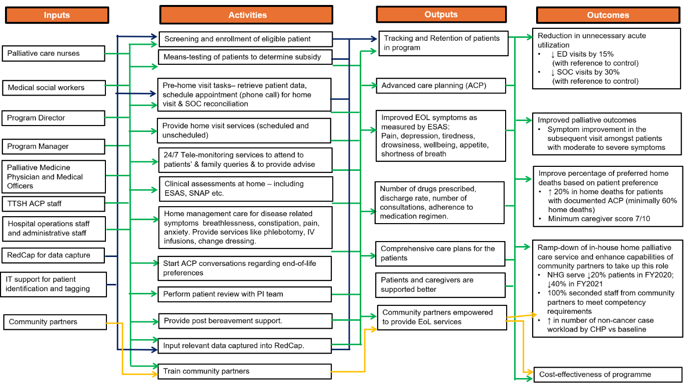
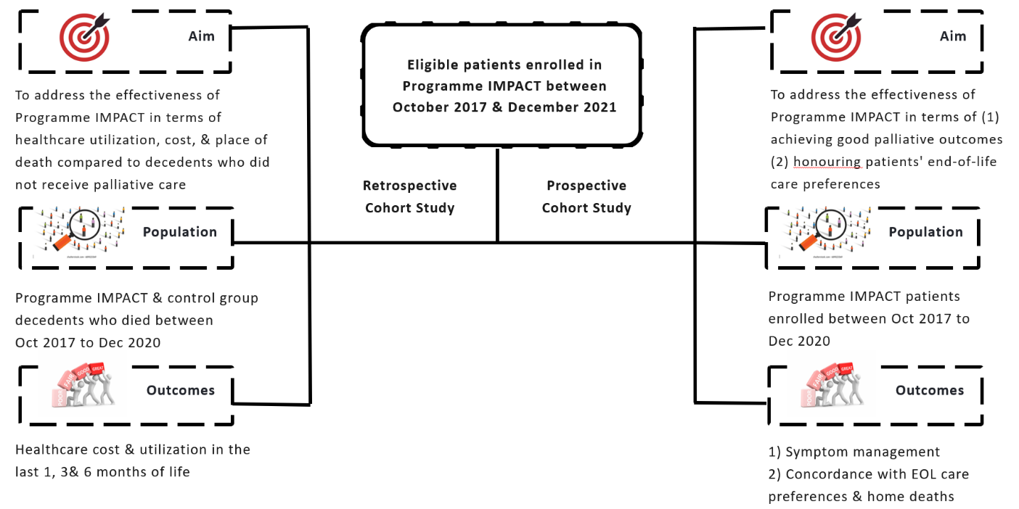
Appendix 3: Overview of evaluation study
Appendix 4: Process of assembling Programme IMPACT and control group decedents for sub-set analysis.
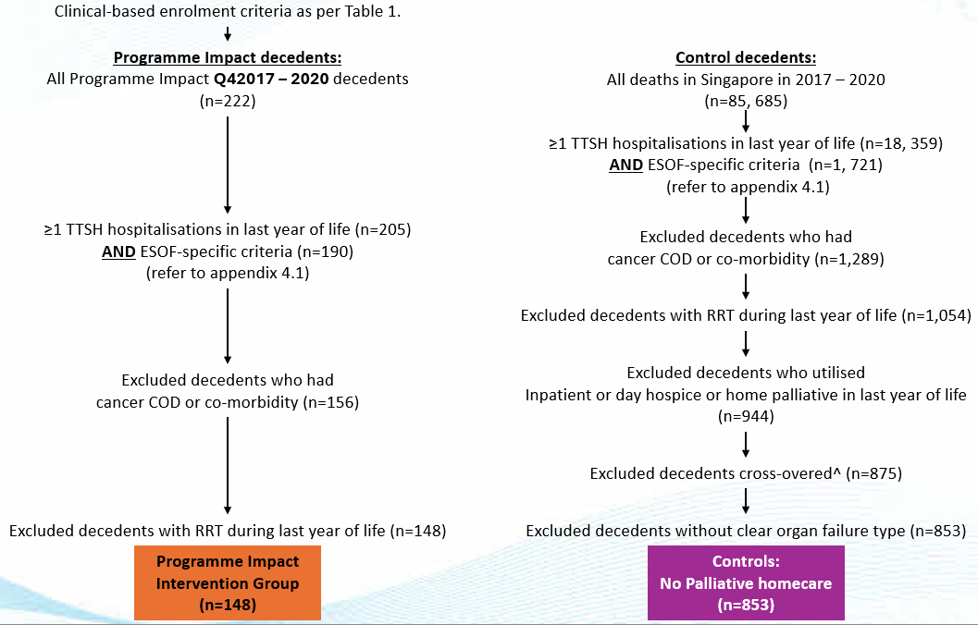
Appendix 4.1: ESOF Specific Inclusion Criteria for Control group and Programme IMPACT patients
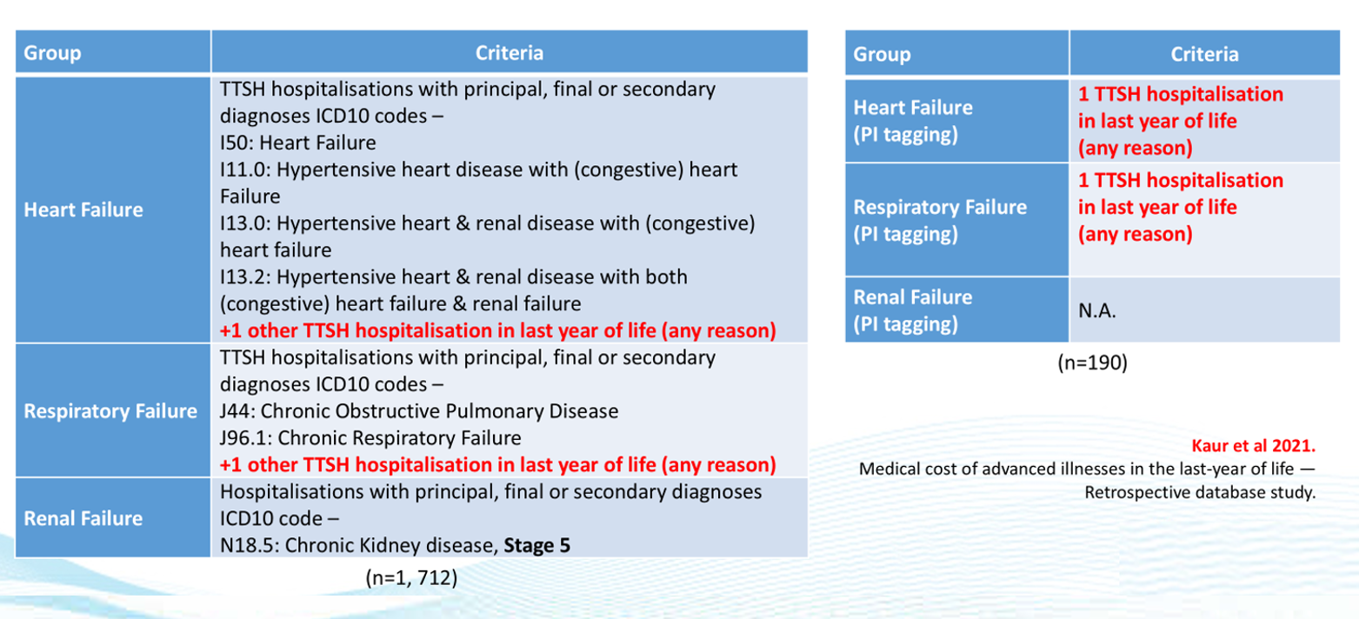
Appendix 5: Patient flow between October 2017 and December 2021
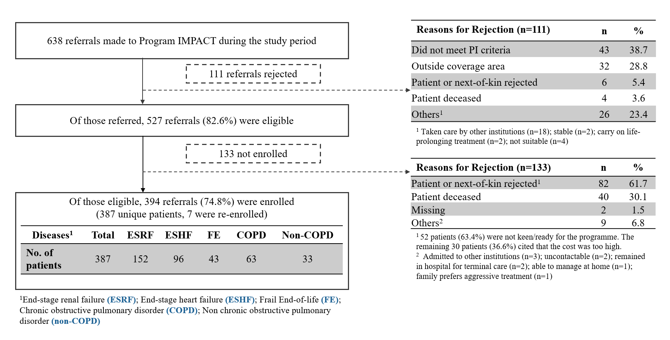
Appendix 6: Change in ESAS score (by ESOF type).
Symptoms | No. of exacerbations | Mod-high ESAS score |  | Next ESAS score |  | Δ Scores (95% CI)⁺ | % Change#
Symptoms | No. of exacerbations | Mean | SD | Mean | SD | Δ Scores (95% CI)⁺ | Decrease | No Change | Increase
ESHF | 482 | 6.4 | 1.2 | 3.9 | 3.0 | 2.5 (95% CI: 2.3 to 2.8) | 6.2 | 33.2 | 60.6
ESRF | 763 | 6.5 | 1.2 | 4.2 | 3.0 | 2.3 (95% CI: 2.1 to 2.5) | 7.0 | 37.2 | 55.8
FE | 112 | 6.8 | 1.4 | 4.8 | 3.4 | 2.0 (95% CI: 1.4 to 2.5) | 8.0 | 42.9 | 49.1
COPD | 459 | 6.3 | 1.1 | 3.5 | 2.8 | 2.8 (95% CI: 2.6 to 3.1) | 2.4 | 34.2 | 63.4
Non-COPD | 228 | 6.4 | 1.1 | 3.9 | 2.7 | 2.5 (95% CI: 2.1 to 2.8) | 4.8 | 35.1 | 60.1

Abbreviations: Edmonton Symptom Assessment System (ESAS); Confidence Interval (CI); End-stage heart failure (ESHF); End-stage renal failure (ESRF); Frail end-of- life (FE); Chronic obstructive pulmonary disorder (COPD); Non-chronic obstructive pulmonary disorder (Non-COPD)
⁺Δ Score is defined as the difference between the baseline moderate-to-high ESAS score and the subsequent ESAS score. Mean Δ Scores were calculated across all symptom exacerbation episodes. A positive Δ Score reflects improvement (reduced symptom severity), whereas a negative Δ Score indicates worsening.
#For the percentage categories, “decrease” refers to episodes where symptoms worsened, “no change” indicates stability, and “increase” denotes episodes with improved symptom control

Appendix 7: Baseline and Clinical characteristics of all Control and Programme IMPACT patients
Characteristics | Control (n=853) |  | Programme Impact (n=148) |  | p-value
 | mean | SD | mean | SD
Age at death (years) | 77.2 | 11.5 | 82.3 | 9.4 | <0.001ª
ESOF illness^ | n | % | n | % | <0.001^{b}
ESHF | 554 | 64.9 | 38 | 25.7
ESRespF (COPD + non-COPD) | 177 | 20.8 | 26 | 17.6
ESRF | 122 | 14.3 | 84 | 56.8
Gender | n | % | n | % | 0.001^{b}
Male | 500 | 58.6 | 65 | 43.9
Race | n | % | n | % | 0.034 ^{b}
Chinese | 644 | 75.5 | 126 | 85.1
Malay | 93 | 10.9 | 14 | 9.5
Indian | 106 | 12.4 | 7 | 4.7
Others | 10 | 1.2 | 1 | 0.7
Housing Type | n | % | n | % | 0.143 ^{b}
1- or 2-Room | 166 | 19.5 | 15 | 10.1
3-Room | 275 | 32.2 | 51 | 34.5
4-Room | 222 | 26.0 | 47 | 31.8
5-Rooom/Executive | 105 | 12.3 | 21 | 14.2
Condo | 22 | 2.6 | 4 | 2.7
Landed | 49 | 5.7 | 10 | 6.8
Citizenship | n | % | n | % | >0.950 ^{c}
SG Citizen | 827 | 97 | 144 | 97.3
SG Permanent Resident | 20 | 2.3 | 3 | 2.0
Cause of death | n | % | n | % | <0.001^{b}
Congestive Heart Failure (CHF) | 88 | 10.3 | 13 | 8.8
COPD | 79 | 9.3 | 23 | 15.5
ESRF | 55 | 6.4 | 30 | 20.3
Neurological cause | 41 | 4.8 | 4 | 2.7
Others | 590 | 69.2 | 78 | 52.7
Place of death | n | % | n | % | <0.001^{c}
Home | 88 | 10.3 | 94 | 63.5
Public hospital | 707 | 82.9 | 51 | 34.5
Private hospital | 16 | 1.9 | 2 | 1.4
Charitable organisations | 15 | 1.8 | 1 | 0.7
Others | 27 | 3.2 | 0 | 0.0
Years of Death | n | % | n | % | <0.001^{b}
2017 | 299 | 35.1 | 6 | 4.1
2018 | 243 | 28.5 | 55 | 37.2
2019 | 168 | 19.7 | 52 | 35.1
2020 | 143 | 16.8 | 35 | 23.6
Concomitant Treatment | n | % | n | % | N.A.
Day hospice/ILTC Palliative Homecare | - | - | 6 | 4.1

Abbreviations: End-stage heart failure (ESHF); End-stage renal failure (ESRF); End-stage Respiratory failure (ESRespF); Chronic obstructive pulmonary disorder (COPD); Non-chronic obstructive pulmonary disorder (Non-COPD)
^Control illness type defined using ICD10 codes of hospitalisations (inpatient episodes) in last year of life; Intervention illness type defined using Programme Impact enrolment information.
ª t-test; ^{b} chi-squared; ^{c} fisher’s exact

Table 8A: Results of between-group comparisons with multivariate analysis of healthcare utilisation and associated cost outcomes (heart failure)
Heart failure | Reference = Controls | Incident risk ratios | Lower 95% CI | Upper 95% CI | p-value | Result
Inpatient Admissions
last 1-month | Programme Impact | 0.68 | 0.44 | 1.04 | 0.074 | Non-significant
last 3-month | Programme Impact | 0.80 | 0.61 | 1.04 | 0.099 | Non-significant
last 6-month | Programme Impact | 0.78 | 0.63 | 0.97 | 0.028 | Significant
Inpatient Length of stay
last 1-month | Programme Impact | 0.66 | 0.57 | 0.76 | <0.001 | Significant
last 3-month | Programme Impact | 0.96 | 0.89 | 1.03 | 0.273 | Non-significant
last 6-month | Programme Impact | 0.98 | 0.93 | 1.05 | 0.591 | Non-significant
Emergency department visits
last 1-month | Programme Impact | 0.76 | 0.52 | 1.12 | 0.162 | Non-significant
last 3-month | Programme Impact | 0.81 | 0.63 | 1.05 | 0.112 | Non-significant
last 6-month | Programme Impact | 0.79 | 0.64 | 0.97 | 0.025 | Significant
Specialist outpatient clinic visits
last 1-month | Programme Impact | 0.90 | 0.47 | 1.73 | 0.756 | Non-significant
last 3-month | Programme Impact | 0.92 | 0.67 | 1.26 | 0.601 | Non-significant
last 6-month | Programme Impact | 0.90 | 0.73 | 1.11 | 0.311 | Non-significant
Total healthcare utilisation associated cost
last 1-month | Programme Impact | 0.54 | 0.33 | 0.89 | 0.015 | Significant
last 3-month | Programme Impact | 0.87 | 0.56 | 1.03 | 0.072 | Non-significant
last 6-month | Programme Impact | 0.86 | 0.70 | 1.07 | 0.173 | Non-significant
Inpatient associated cost
last 1-month | Programme Impact | 0.54 | 0.32 | 0.89 | 0.015 | Significant
last 3-month | Programme Impact | 0.76 | 0.55 | 1.04 | 0.082 | Non-significant
last 6-month | Programme Impact | 0.87 | 0.70 | 1.08 | 0.208 | Non-significant
Emergency department associated cost
last 1-month | Programme Impact | 0.75 | 0.49 | 1.16 | 0.196 | Non-significant
last 3-month | Programme Impact | 0.81 | 0.64 | 1.03 | 0.082 | Non-significant
last 6-month | Programme Impact | 0.77 | 0.63 | 0.94 | 0.010 | Significant
Specialist outpatient clinic associated cost
last 1-month | Programme Impact | 1.00 | 0.19 | 5.12 | 0.997 | Non-significant
last 3-month | Programme Impact | 0.96 | 0.56 | 1.63 | 0.876 | Non-significant
last 6-month | Programme Impact | 0.78 | 0.51 | 1.19 | 0.253 | Non-significant
Utilisation modelled using poisson regressions & cost with generalised linear models, adjusted for gender, race, housing type, death age and year.
Abbreviation: Confidence Interval (CI)

Table 8B: Results of between-group comparisons with multivariate analysis of healthcare utilisation and associated cost outcomes (respiratory failure)
Respiratory failure |  | Reference = Controls |  | Incident risk ratios |  | Lower 95% CI |  |  | Upper 95% CI |  |  | p-value |  |  | Result
Inpatient admissions
last 1-month |  | Programme Impact |  | 1.20 |  |  | 0.76 |  |  | 1.90 |  |  | 0.436 |  | Non-significant
last 3-month |  | Programme Impact |  | 1.15 |  |  | 0.85 |  |  | 1.57 |  |  | 0.355 |  | Non-significant
last 6-month |  | Programme Impact |  | 1.11 |  |  | 0.86 |  |  | 1.42 |  |  | 0.429 |  | Non-significant
Inpatient LOS
last 1-month |  | Programme Impact |  | 0.95 |  | 0.81 |  |  | 1.12 |  |  | 0.557 |  |  | Non-significant
last 3-month |  | Programme Impact |  | 1.03 |  | 0.94 |  |  | 1.14 |  |  | 0.482 |  |  | Non-significant
last 6-month |  | Programme Impact |  | 1.19 |  | 1.11 |  |  | 1.29 |  |  | <0.001 |  |  | Significant Negative
Emergency department visits
last 1-month |  | Programme Impact |  | 1.16 |  | 0.75 |  |  | 1.79 |  |  | 0.518 |  |  | Non-significant
last 3-month |  | Programme Impact |  | 1.02 |  | 0.75 |  |  | 1.38 |  |  | 0.897 |  |  | Non-significant
last 6-month |  | Programme Impact |  | 0.95 |  | 0.74 |  |  | 1.22 |  |  | 0.684 |  |  | Non-significant
Specialist outpatient clinic visits
last 1-month |  | Programme Impact |  | 1.10 |  | 0.49 |  |  | 2.51 |  |  | 0.814 |  |  | Non-significant
last 3-month |  | Programme Impact |  | 1.06 |  | 0.69 |  |  | 1.64 |  |  | 0.788 |  |  | Non-significant
last 6-month |  | Programme Impact |  | 1.03 |  | 0.77 |  |  | 1.37 |  |  | 0.837 |  |  | Non-significant
Total healthcare utilisation associated cost
last 1-month |  | Programme Impact |  | 0.82 |  | 0.52 |  |  | 1.28 |  |  | 0.384 |  |  | Non-significant
last 3-month |  | Programme Impact |  | 0.94 |  | 0.65 |  |  | 1.36 |  |  | 0.745 |  |  | Non-significant
last 6-month |  | Programme Impact |  | 1.09 |  | 0.77 |  |  | 1.55 |  |  | 0.609 |  |  | Non-significant
Inpatient associated cost
last 1-month |  | Programme Impact |  | 0.81 |  | 0.50 |  |  | 1.30 |  |  | 0.378 |  |  | Non-significant
last 3-month |  | Programme Impact |  | 0.94 |  | 0.64 |  |  | 1.38 |  |  | 0.757 |  |  | Non-significant
last 6-month |  | Programme Impact |  | 1.11 |  | 0.77 |  |  | 1.58 |  |  | 0.583 |  |  | Non-significant
Emergency department associated cost
last 1-month |  | Programme Impact |  | 0.90 |  | 0.58 |  |  | 1.39 |  |  | 0.643 |  |  | Non-significant
last 3-month |  | Programme Impact |  | 0.91 |  | 0.70 |  |  | 1.18 |  |  | 0.458 |  |  | Non-significant
last 6-month |  | Programme Impact |  | 0.86 |  | 0.66 |  |  | 1.12 |  |  | 0.260 |  |  | Non-significant
Specialist outpatient clinic associated cost
last 1-month | Programme Impact |  |  | Non-Convergence
last 3-month | Programme Impact
last 6-month | Programme Impact
Utilisation modelled using poisson regressions & cost with generalised linear models, adjusted for gender, race, housing type, death age and year.
Abbreviation: Confidence Interval (CI)
Table 8C: Results of between-group comparisons with multivariate analysis of healthcare utilisation and associated cost outcomes (renal failure)
Renal failure |  | Reference = Controls | Incident risk ratios |  | Lower 95% CI |  |  | Upper 95% CI |  |  | p-value |  |  | Result
Inpatient admissions
last 1-month |  | Programme Impact | 0.56 |  | 0.37 |  |  | 0.85 |  |  | 0.006 |  |  | Significant
last 3-month |  | Programme Impact | 0.56 |  | 0.42 |  |  | 0.74 |  |  | <0.001 |  |  | Significant
last 6-month |  | Programme Impact | 0.64 |  | 0.51 |  |  | 0.80 |  |  | <0.001 |  |  | Significant
Inpatient LOS
last 1-month |  | Programme Impact | 0.52 |  | 0.45 |  |  | 0.60 |  |  | <0.001 |  |  | Significant
last 3-month |  | Programme Impact | 0.50 |  | 0.46 |  |  | 0.54 |  |  | <0.001 |  |  | Significant
last 6-month |  | Programme Impact | 0.57 |  | 0.53 |  |  | 0.61 |  |  | <0.001 |  |  | Significant
Emergency department visit
last 1-month |  | Programme Impact | 0.56 |  | 0.37 |  |  | 0.85 |  |  | 0.006 |  |  | Significant
last 3-month |  | Programme Impact | 0.54 |  | 0.41 |  |  | 0.72 |  |  | <0.001 |  |  | Significant
last 6-month |  | Programme Impact | 0.70 |  | 0.57 |  |  | 0.88 |  |  | 0.002 |  |  | Significant
Specialist outpatient clinic visits
last 1-month |  | Programme Impact | 0.65 |  | 0.31 |  |  | 1.34 |  |  | 0.240 |  |  | Non-significant
last 3-month |  | Programme Impact | 0.78 |  | 0.56 |  |  | 1.09 |  |  | 0.142 |  |  | Non-significant
last 6-month |  | Programme Impact | 0.82 |  | 0.67 |  |  | 1.02 |  |  | 0.069 |  |  | Non-significant
Total healthcare utilisation associated cost
last 1-month |  | Programme Impact | 0.38 |  | 0.23 |  |  | 0.64 |  |  | <0.001 |  |  | Significant
last 3-month |  | Programme Impact | 0.45 |  | 0.33 |  |  | 0.62 |  |  | <0.001 |  |  | Significant
last 6-month |  | Programme Impact | 0.53 |  | 0.41 |  |  | 0.70 |  |  | <0.001 |  |  | Significant
Inpatient associated cost
last 1-month |  | Programme Impact | 0.37 |  | 0.22 |  |  | 0.64 |  |  | <0.001 |  |  | Significant
last 3-month |  | Programme Impact | 0.44 |  | 0.32 |  |  | 0.62 |  |  | <0.001 |  |  | Significant
last 6-month |  | Programme Impact | 0.52 |  | 0.39 |  |  | 0.70 |  |  | <0.001 |  |  | Significant
Emergency department associated cost
last 1-month |  | Programme Impact | 0.51 |  | 0.35 |  |  | 0.76 |  |  | 0.001 |  |  | Significant
last 3-month |  | Programme Impact | 0.51 |  | 0.39 |  |  | 0.67 |  |  | <0.001 |  |  | Significant
last 6-month |  | Programme Impact | 0.68 |  | 0.54 |  |  | 0.85 |  |  | 0.001 |  |  | Significant
Specialist outpatient clinic associated cost
last 1-month |  | Programme Impact | 0.04 |  | 0.00 |  |  | 1.73 |  |  | 0.095 |  |  | Non-significant
last 3-month |  | Programme Impact | 0.72 |  | 0.33 |  |  | 1.56 |  |  | 0.400 |  |  | Non-significant
last 6-month |  | Programme Impact | 0.95 |  | 0.62 |  |  | 1.46 |  |  | 0.802 |  |  | Non-significant
Utilisation modelled using poisson regressions & cost with generalised linear models, adjusted for gender, race, housing type, death age & year.
Abbreviation: Confidence Interval (CI)

Appendix 9: Home death percentages (across ESOF type), by groups in sub-set analysis.

Abbreviations: Programme Impact (PI); Heart Failure (HF); Respiratory failure (RespF); Renal failure (RF)

