Theoretical framework: Wu-Xing theory

Wu-Xing theory, an ancient Chinese philosophical framework was used to analyze the dynamic evolution of facilitators and barriers in China’s hospice care practice. This framework (See Fig. 1) conceptualizes complex systems through five dynamic, interconnected elements, each with distinct attributes: Metal (金, jīn) represents rigidity, authority, and order; Water (水, shuǐ) symbolizes adaptability, fluidity, and nourishment; Wood (木, mù) signifies growth, vitality, and accessibility; Fire (火, huǒ) embodies light, passion, and diffusion; and Earth (土, tǔ) symbolizes nurturing, bearing, and stability.
The Wu Xing elements do not exist in isolation; they interact through two fundamental cycles(See Fig. 1-a): the Generating (相生, xiāngshēng) Cycle(See Fig. 1-b) and the Controlling (相克, xiāngkè) Cycle(See Fig. 1-c) which together explain the dynamic relationships among the elements. The Generating Cycle, also known as the “nourishing” or “creation” cycle, describes how one element fosters the growth and development of another: Metal generates Water (Metal, such as condensation on cold surfaces, can produce water); Water generates Wood (Water nourishes plants and trees, promoting growth.); Wood generates Fire(Wood serves as fuel for Fire.); Fire generates Earth (The ashes from burning wood enrich the soil.); Earth generates Metal (Minerals and metals are extracted from the earth.) . This cycle reflects harmony and support, ensuring a balanced flow of energy. The Controlling Cycle also called the “overcoming” or “restraining” cycle, maintains balance by preventing excessive dominance of any one element: Metal controls Wood (Metal tools cut and shape wood.); Wood controls Earth (Tree roots penetrate and stabilize soil.); Earth controls Water (Dams and soil absorb and direct water flow.); Water controls Fire (Water extinguishes flames.); Fire controls Metal (Heat melts and shapes metal.); This cycle ensures that no single element overpowers the others. Together, these cycles offer a holistic lens for understanding dynamic balance, reciprocal influence, and continuous transformation within complex systems—principles that guided our analysis of hospice care development.

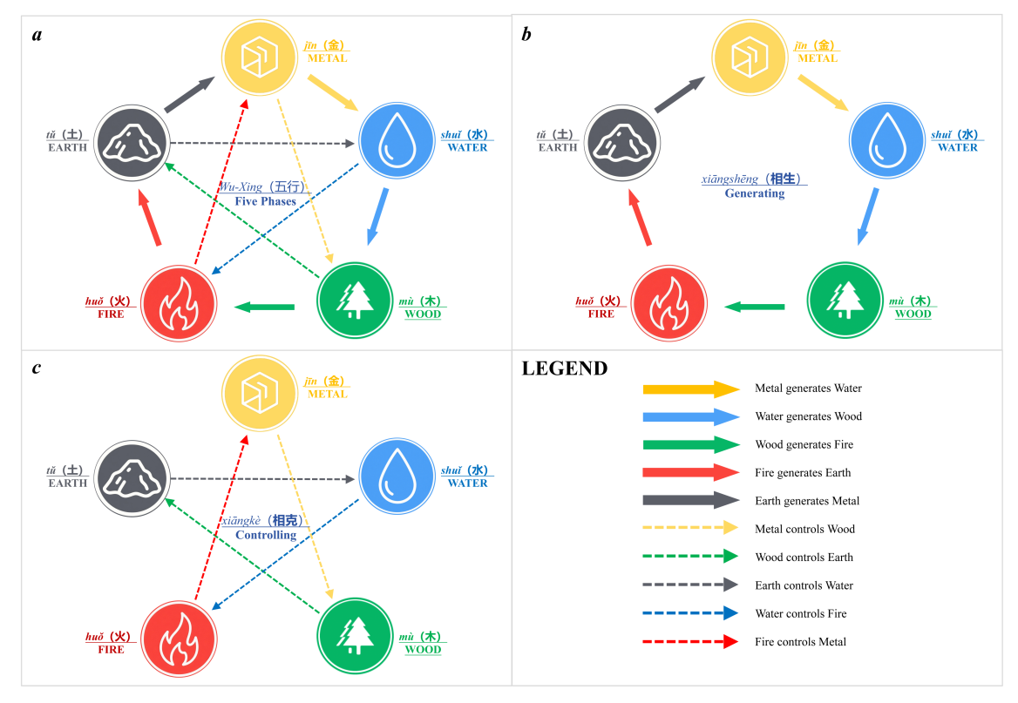

Fig. 1. Overview of the Chinese Wu-Xing theoretical framework. This figure illustrates the traditional Chinese philosophy-the Wu-Xing theory. This framework conceptualizes complex systems through five dynamic, interconnected phases and two primary cycles the Generating Cycle and the Controlling Cycle (a = the whole framework ; b = the Generating Cycle; c = the Controlling Cycle).

A core tenet of this theory is that each element inherently embodies dual properties of facilitation and obstruction, an attribute that aligns precisely with our analytical focus on the dialectical nature of factors in hospice care. Rather than treating facilitators and barriers as static entities, we employed this framework to examine them as dynamic phases capable of transforming into one another, with their interactions being shaped by these generative and restraining relationships. Specifically, this approach enabled us to: (1) identify the five core elements corresponding to key hospice care factors; (2) dialectically examine their dual roles as both facilitators and barriers; and (3) explore the intricate dynamic relationships among them. This theoretical application addresses a critical gap in existing research namely, the neglect of dynamic interactions and transformations between facilitators and barriers by leveraging Wu-Xing’s emphasis on process and relationality.

