Appendix A – USD-z (English version)
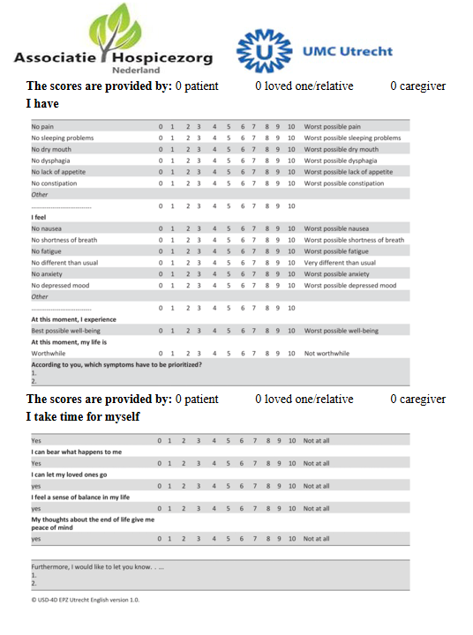
Appendix B – Interview Questions – After Death
Roles and Collaboration in Care
In this interview, we aim to gain a comprehensive understanding of the care and support provided to this participant during the final phase of life. By "care pathway," we refer not only to medical care (such as care provided by physicians, nurses, and medical services) but also to daily support and guidance, such as group supervision and individual care. We are interested in how decisions were made at various levels and how wellbeing and support were organized during this period.
- Could you briefly describe your role in the care and support of this participant? How did the collaboration with other professionals and volunteers involved in the participant’s care proceed? Were there specific agreements regarding task division and communication?
- Which other care and/or support professionals were involved in the care for this participant?
- How was communication about the care pathway and important decisions organized?
- Who took the lead in decision-making, and was this clear to everyone involved? Did this change during the course of care?
- Were there situations where there was uncertainty or disagreement? How were these situations handled?

Disease Progression and Care Needs
- Could you briefly describe the course of the illness from the moment the palliative phase was marked, as indicated in the questionnaires? Were there earlier signs or moments when palliative care was considered?
- What were the first indicators that the participant had entered the palliative phase?
- How did the participant’s care needs change throughout the course of the illness?
- Were there any unexpected developments or difficult moments during the progression of the illness? For example, sudden decline, hard-to-treat symptoms, treatment decisions or palliative sedation, or moments of uncertainty in care?

Observations and Impact
- Could you describe how symptoms such as pain, anxiety, delirium, and epilepsy evolved during the entire period from inclusion to death?
- We observed a rise/drop in [xxx] in the questionnaires. Could you elaborate on this and suggest possible explanations?
- Did you observe that non-physical factors (such as psychological, social, or spiritual aspects) influenced the course of symptoms? To what extent did the environment, such as the group, family members, or other involved persons, play a role?

- How did the care pathway progress during the participant’s dying phase?
- How was it determined that the participant had entered the dying phase? Were there doubts? Which signs were considered decisive?
- Could you describe how symptoms (pain, anxiety, delirium, epilepsy) evolved in the final weeks/days, and how this corresponded to what was reported in the questionnaires? Were there aspects that were experienced differently in daily practice than the measurements suggest?
- Which moments during the care trajectory were difficult or unexpected? How were such situations handled, and how were decisions made? Could you provide an example of a specific situation in which a significant decision had to be made?
- How was the collaboration between care providers and family members during the dying phase? What went well, and what were the challenges?
- Was a spiritual caregiver involved? If so, what was their role (e.g., in the dying process)?

Reflection and Lessons Learned
- How do you reflect on the entire care trajectory for this participant?
- How did the transition from one phase to another take place in terms of decision-making?
- What lessons or insights did you gain from this case?
- Do you have any additional comments or important points you would like to share with us?

Only if palliative sedation was applied
Indications and Decision-Making
- What were the main reasons for considering palliative sedation for this participant?
- Which symptoms could no longer be alleviated with other treatments at that point?
- How did the decision-making process unfold? Who was involved and how was the final decision made?

Implementation and Process
- When was sedation initiated, and how did the process go?
- How was it decided that this was the appropriate moment to begin sedation?
- How did you experience the timing and implementation of the palliative sedation? Do you feel it was initiated at the right time and in an appropriate manner?

Communication and Involvement
- In what way and at what moment were family members involved in the considerations surrounding palliative sedation?
- Do you have any suggestions for how this process could be improved in the future?

Reflection on the Guideline for Palliative Sedation
- Are you familiar with the national guideline for palliative sedation?
  - (If yes): How was this guideline applied in this case? Were there considerations or decisions that could have been made differently or more effectively?
  - (If no): What considerations played a role in the decision-making process regarding palliative sedation?
STROBE Statement—Checklist of items that should be included in reports of cohort studies
 |  | Item No | Recommendation | Page No
Title and abstract |  | 1 | (a) Indicate the study’s design with a commonly used term in the title or the abstract | p. 1-2
 |  | 1 | (b) Provide in the abstract an informative and balanced summary of what was done and what was found
  p. 2 (protocol, no results yet)
Introduction
Background/rationale |  | 2 | Explain the scientific background and rationale for the investigation being reported | p. 3-4
Objectives |  | 3 | State specific objectives, including any prespecified hypotheses | p. 4
Methods
Study design |  | 4 | Present key elements of study design early in the paper | p. 4
Setting |  | 5 | Describe the setting, locations, and relevant dates, including periods of recruitment, exposure, follow-up, and data collection | p. 5
Participants |  | 6 | (a) Give the eligibility criteria, and the sources and methods of selection of participants. Describe methods of follow-up | p. 5-6
 |  | 6 | (b) For matched studies, give matching criteria and number of exposed and unexposed | N/A
Variables |  | 7 | Clearly define all outcomes, exposures, predictors, potential confounders, and effect modifiers. Give diagnostic criteria, if applicable | p. 7-10
Data sources/ measurement |  | 8* | For each variable of interest, give sources of data and details of methods of assessment (measurement). Describe comparability of assessment methods if there is more than one group | p. 6-10
Bias |  | 9 | Describe any efforts to address potential sources of bias | p. 9, 11-12
Study size |  | 10 | Explain how the study size was arrived at | p. 5
Quantitative variables |  | 11 | Explain how quantitative variables were handled in the analyses. If applicable, describe which groupings were chosen and why | p. 8-10
Statistical methods |  | 12 | (a) Describe all statistical methods, including those used to control for confounding | p. 8-10
 |  | 12 | (b) Describe any methods used to examine subgroups and interactions | N/A
 |  | 12 | (c) Explain how missing data were addressed | p. 9
 |  | 12 | (d) If applicable, explain how loss to follow-up was addressed | N/A
 |  | 12 | (e) Describe any sensitivity analyses | p. 9
Results
Participants |  | 13* | (a) Report numbers of individuals at each stage of study—eg numbers potentially eligible, examined for eligibility, confirmed eligible, included in the study, completing follow-up, and analysed
  N/A (protocol)
 |  | 13* | (b) Give reasons for non-participation at each stage | N/A
 |  | 13* | (c) Consider use of a flow diagram | N/A
Descriptive data |  | 14* | (a) Give characteristics of study participants (eg demographic, clinical, social) and information on exposures and potential confounders | N/A (protocol)
 |  | 14* | (b) Indicate number of participants with missing data for each variable of interest | N/A
 |  | 14* | (c) Summarise follow-up time (eg, average and total amount) | N/A
Outcome data |  | 15* | Report numbers of outcome events or summary measures over time
  N/A (protocol)
Main results | 16 | (a) Give unadjusted estimates and, if applicable, confounder-adjusted estimates and their precision (eg, 95% confidence interval). Make clear which confounders were adjusted for and why they were included
  N/A (protocol)
Main results | 16 | (b) Report category boundaries when continuous variables were categorized |  | N/A
Main results | 16 | (c) If relevant, consider translating estimates of relative risk into absolute risk for a meaningful time period |  | N/A
Other analyses | 17 | Report other analyses done—eg analyses of subgroups and interactions, and sensitivity analyses
  N/A (protocol)
Discussion
Key results | 18 | Summarise key results with reference to study objectives |  | N/A (protocol)
Limitations | 19 | Discuss limitations of the study, taking into account sources of potential bias or imprecision. Discuss both direction and magnitude of any potential bias |  | p. 11-12
Interpretation | 20 | Give a cautious overall interpretation of results considering objectives, limitations, multiplicity of analyses, results from similar studies, and other relevant evidence |  | p. 10-12
Generalisability | 21 | Discuss the generalisability (external validity) of the study results |  | p. 10-12
Other information
Funding | 22 | Give the source of funding and the role of the funders for the present study and, if applicable, for the original study on which the present article is based |  | p. 13

*Give information separately for exposed and unexposed groups.
Note: An Explanation and Elaboration article discusses each checklist item and gives methodological background and published examples of transparent reporting. The STROBE checklist is best used in conjunction with this article (freely available on the Web sites of PLoS Medicine at http://www.plosmedicine.org/, Annals of Internal Medicine at http://www.annals.org/, and Epidemiology at http://www.epidem.com/). Information on the STROBE Initiative is available at http://www.strobe-statement.org.

