Appendix A
Supplementary Table 1. Invariance of Model 2 of the Bergen Facebook Addiction Scale (BFAS) across groups of eating disorders
Groups | Invariance levels | χ² | df | P | Δχ² | Δdf | p(Δχ²) | CFI | ΔCFI | TLI | ΔTLI | RMSEA | ΔRMSEA | SRMR
Eating disorders | Configural  Metric  Strong  Strict | 16.690  20.690  25.783  31.374 | 16  21  22  28 | 0.406  0.478  0.261  0.301 | 4.000  5.094  5.591 | 5  1  6 | 0.549  0.024  0.471 | .999  1.000  .996  .996 | -0.001  0.004  0.000 | .999  1.001  .994  .996 | -0.002  0.007  -0.002 | 0.019  0.000  0.038  0.032 | 0.019  -0.038  0.006 | 0.0216  0.0266  0.0581  0.0683
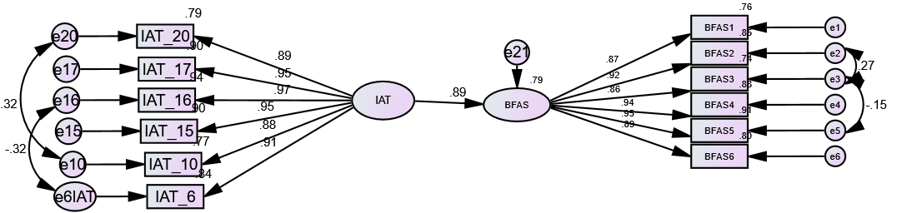  (a) | 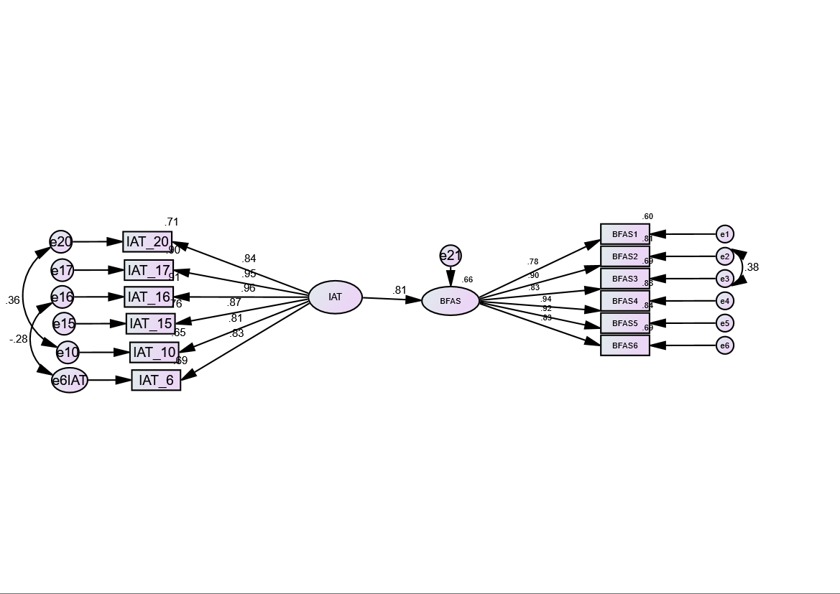  (b)
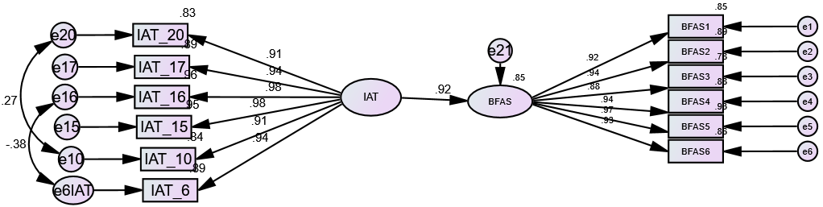
(c)
Supplementary Figure 1. Structural equation models using the Six-item Internet Addiction Test (S-IAT) to predict the Bergen Facebook Addiction Scale (BFAS) in all the participants (a), women with anorexia nervosa (b), and women with binge eating and bulimia nervosa(c).

