Supplement

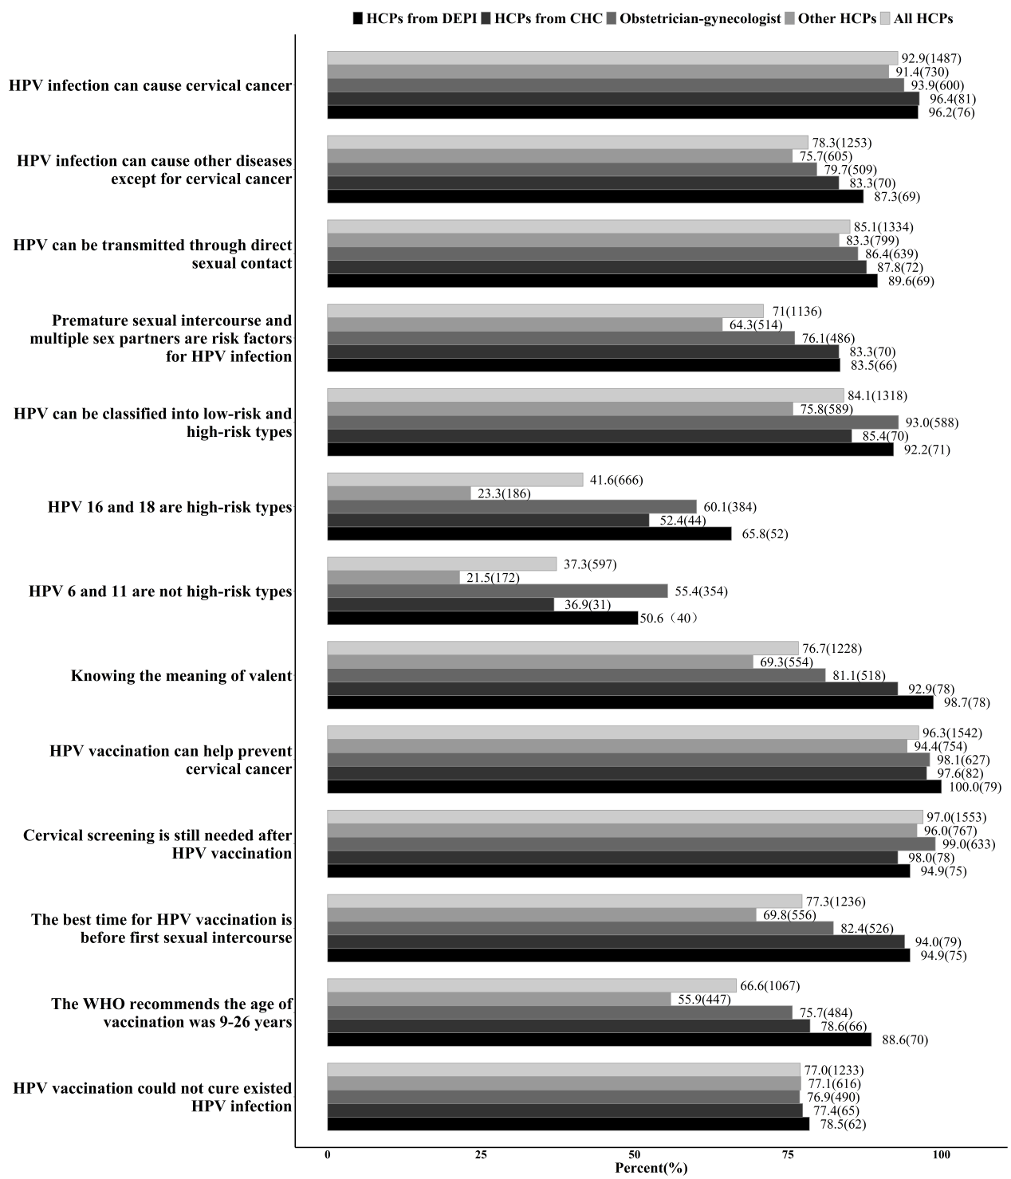
Fig S1 Correct responses to HPV and HPV vaccine knowledge items(N=1601)

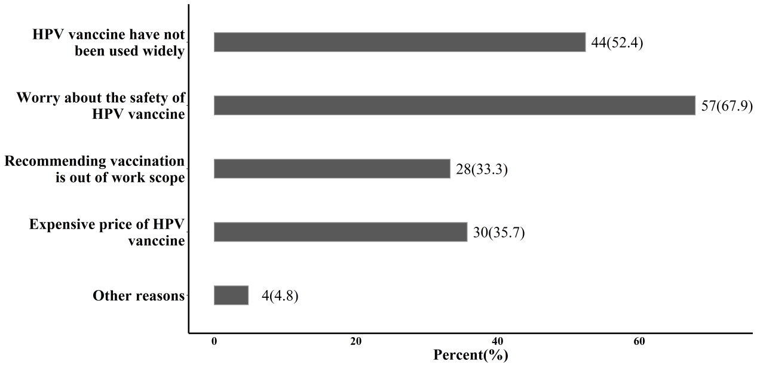
Fig S2 Barriers forward willingness to recommend HPV vaccination

