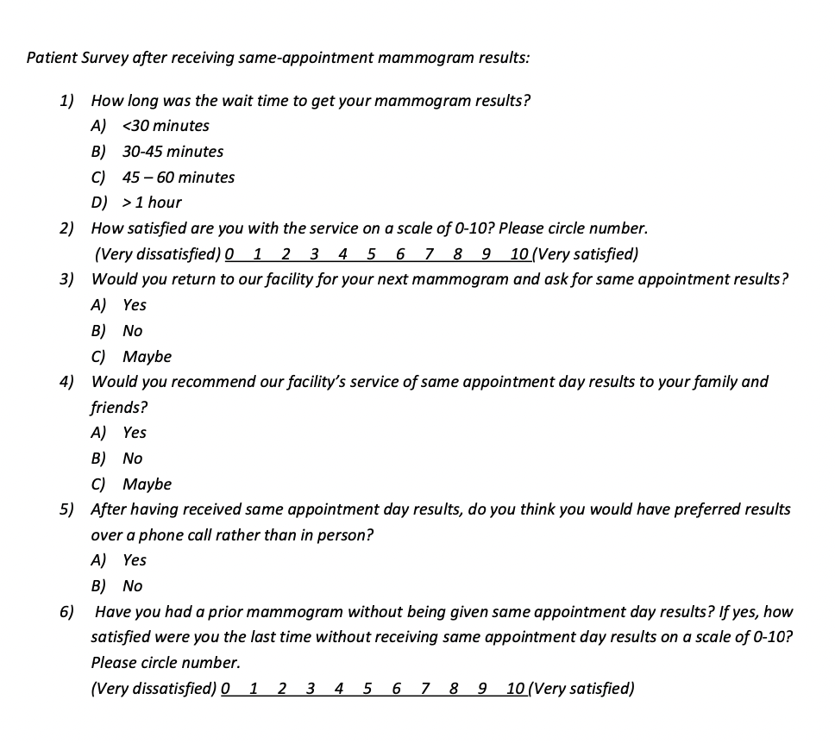
Survey enlisting all questions that were used to conduct this quality improvement study.

