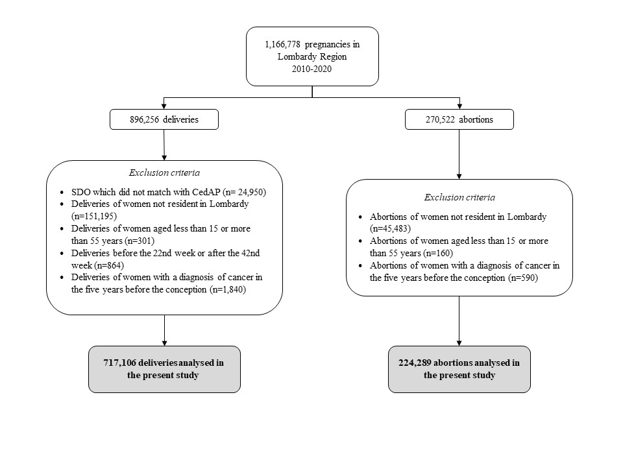
Figure S1. Flow-chart of selection of study cohort. Lombardy, Italy, 2010-2020.
Table S1. Timing of diagnosis of pregnancy-associated cancer (PAC) among women who delivered and women who aborted. Lombardy, Italy, 2010-2020.
 | PAC
 | N | %
Births
Diagnosis during gestation
First trimester | 21 | 11.6
Second trimester | 50 | 27.6
Third trimester | 110 | 60.8
Diagnosis post-partum
0-6 months | 329 | 44.2
7-12 months | 416 | 55.8
Abortions
Diagnosis during gestation* | 34 | -
Diagnosis post-partum
0-6 months | 168 | 54.7
7-12 months | 139 | 45.3
* Three months before the date of abortion.
Table S2. Chemoterapy patterns according to pregnancy outcome and timing of treatment. Lombardy, Italy, 2010-2020.
 | Births, N=407 |  | Abortions, N=155
Timing of treatment | n | % | n | %
Only during pregnancy | 10 | 2.5 | 2 | 1.3
Only during postpartum | 361 | 88.7 | 95 | 61.3
During pregnancy and postpartum | 36 | 8.8 | 58 | 37.4

