Fig. S1 UPLC-MS system stability assessment.
Yellow, samples; Red, QCs.
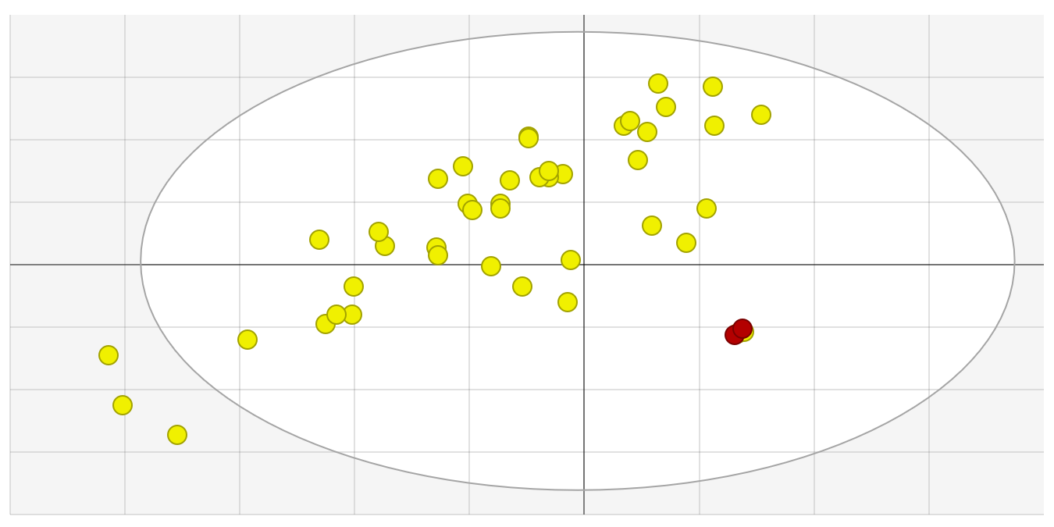

Fig. S2 Box plots for metabolites consisting of biomarker panel
A. Box plot for Baicalin; B. Box plot for 5beta-1,3,7(11)-Eudesmatrien-8-one; C. Box plot for Indolylacryloylglycine; D. Box plot for Edulitine; E. Box plot for Physapubenolide.
