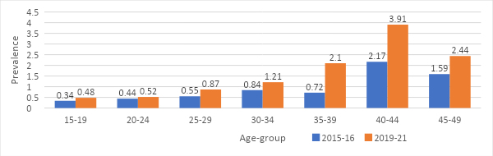
FigA1: Changes in prevalence across age-group
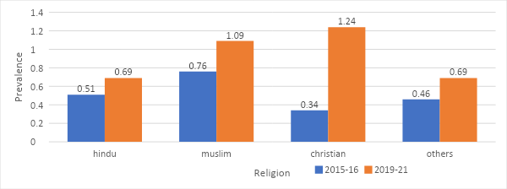
FigA2: Change in prevalence across religious group
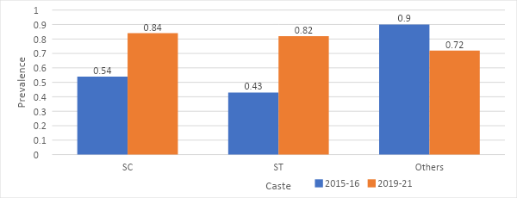
FigA3: Change in Prevalence across Social group
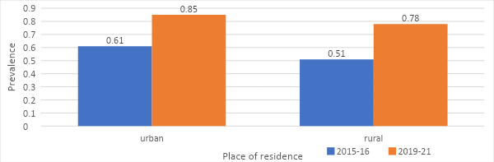
FigA4: Changes in prevalence across places of residence

