Validation procedure of TCS behavior Scale

Exploratory factor analysis

Table 1 Exploratory factor analysis of the TCS Behavior Scale

Dimension | KMO | Bartlett's Test of Sphericity |  |  | Extraction eigen values
 |  | Approximation χ² | Degrees of freedom | P | Total | Variance （%）
TCS behavior | 0.751 | 607.779 | 3 | 0.000 | 2.523 | 84.114
TCS, two-cancer screening; p, p value.

Validation factor analysis

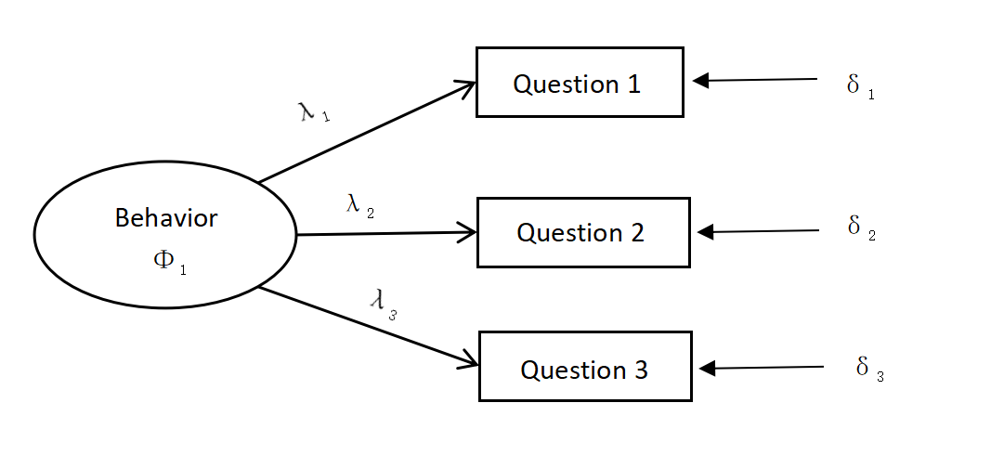
Figure 1 Conceptual model of the validated factor analysis of the TCS Behavior Scale.
λ1 to λ5 represent the factor loading, while δ1 to δ2 represent the residuals of each observed variable, which can be regarded as the measurement error of each observed variable to estimate the latent variable. Φ₁ represents behavior.

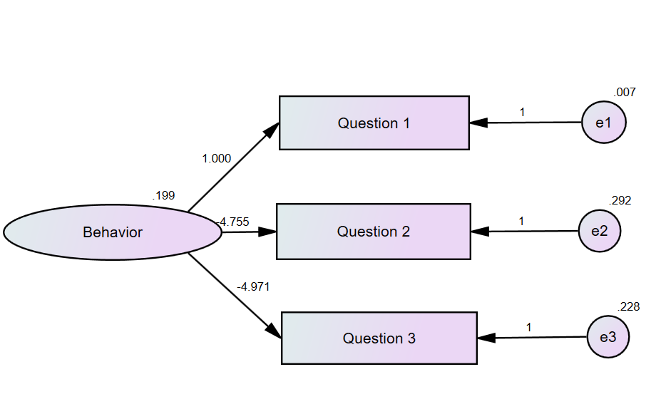
Figure 2 Model effect fit for the validated factor analysis of the TCS Behavior Scale.

Table 2 Summary of model parameters

 | Weights | Covariances | Variances | Means | Intercepts | Total
Fixed | 4 | 0 | 0 | 0 | 0 | 4
Labeled | 2 | 0 | 4 | 0 | 0 | 6
Unlabeled | 0 | 0 | 0 | 0 | 0 | 0
Total | 6 | 0 | 4 | 0 | 0 | 10

Table 2 presents the six regression coefficient parameters in the model, of which four are fixed parameters and two are parameters to be estimated. The number of covariance and variance parameters to be estimated are 0 and 4, respectively. Thus, the number of parameters to be estimated is 2+0+4=6 parameters, and including the four fixed parameters, the total number of parameters is 4+6=10 parameters.

Table 3 Unstandardized regression coefficients of the model
 | Estimate | SE | CR | P
λ1 | 1.000
λ2 | -4.755 | 0.008 | -53.926 | 0.000
λ3 | -4.971 | 0.084 | -59.075 | 0.000
C, critical ratio; SE, standard error; p, p value.
The unstandardized regression coefficient of λ1 is set as a fixed parameter in the model setting, and the value of the fixed parameter is 1. The value of the critical ratio (C.R.) is equal to the ratio of the estimate to the standard error (S.E.) of the estimation, which is equivalent to the t-test value. The path coefficient estimate test aims to identify whether the regression path coefficient estimate is equal to 0. If it reaches the level of significance, it implies that the regression coefficient is significantly not equal to 0. Table 3 shows that the path coefficients of λ2 and λ3 are significant.

Table 4 Standardized regression coefficients of the model
 | Estimate
λ₁ | 0.982
λ₂ | -0.969
λ₃ | -0.978

Table 4 shows the standardized regression coefficients of the model, also known as factor loading, and the standardized path coefficients represent the effect of common factors on the measured variables. Factor loading values between 0.50 and 0.95 indicate that the model has good basic fit. The factor loading of the model in this study is close to 0.95.

Table 5 Measurement Residual Variance Estimates
 | Estimate | SE | CR | P
Φ₁ | 0.199 | 0.017 | 12.009 | 0.000
δ₁ | 0.007 | 0.001 | 6.601 | 0.000
δ₂ | 0.292 | 0.032 | 9.167 | 0.000
δ₃ | 0.228 | 0.030 | 7.637 | 0.000
CR, critical ratio; SE, standard error; p, p value.
Table 5 shows the estimates of the variances of the measurement residuals for one latent variable and three error variables.The error values are all positive and significant, and the S.E. of variance estimates are all small, ranging from 0.001 to 0.032, indicating no problem of model identification error and favorable basic fitness of the model.

Table 6 Squares of multivariate correlations of observed variables

 | Estimate
Question 1 | 0.956
Question 2 | 0.939
Question 3 | 0.964

Table 6 shows the square of the multivariate correlation of the observed variables, which is of the same nature as R² in compound regression, indicates the amount of variance explained by the individual observed variables by the latent variables, and the value of this explained variance is also known as the reliability coefficient of the individual measured variables. A confidence value above 0.50 for individual measures in the model indicates a good intrinsic quality test of the model.

Table 7 Summary table of model parameter estimates
Parameters | Unstandardized parameter estimates | S.E. | t | R2 | Standardized parameter estimates
λ₂ | -4.755 | 0.088 | -53.926* | 0.939 | -0.969
λ₃ | -4.971 | 0.084 | -59.075* | 0.956 | -0.978
δ₁ | 0.007 | 0.001 | 6.601* |  | 0.956
δ₂ | 0.292 | 0.032 | 9.167* |  | 0.939
δ₃ | 0.228 | 0.030 | 7.637* |  | 0.964
Φ₁ | 0.199 | 0.017 | 12.009*
SE, standard error; *, p＜0.000.
Whether each estimated parameter within the model reaches a significant level is an important indicator to test the intrinsic quality of the model. Table 7 shows that in addition to the four fixed parameters, the remaining six parameters to be estimated reach a significant level, with no negative error variance in the estimation of the unstandardized parameter and a very small standard error of each estimated parameter, indicating that the model's intrinsic quality is good.

