Interview Guide

„ Ideal Body Image and Socio-Economic Status:
Exploring perceptions of Kenyan women in a qualitative study“

Behavioural Patterns:

- How would you describe your diet and eating habits?
  - What do you usually eat in a week?
- What are the main factors influencing these dietary habits?

Perception of Body Image:

- How would you describe your body size currently?
- How would you describe your ideal body size?
- What influences your desired body size/body image?
- Is there something you do to achieve the body image that you desire?
- Are there certain attributes that you expect of a person with a big body or thin body?
- From your perspective, how are body weight and wealth related?
- How do you think wealth and health are related?
- Where and when have you felt that your body weight has brought you benefits/advantages or barriers/disadvantages?

Questionnaire

After the interview (please fill in the form)
---------------------------------------------------------------------------------------------
Age:
Educational background:
Occupation:
Cultural upbringing / tribe:
Grown up in urban or rural setting:
Self-reported BMI:

Nutrition Education:

- On a scale from 1-10 (1= lowest, 10 = highest) how much do you know about nutrition and health?

- What is more healthy, thin or big body?

- What do you think are the health risks related to a thin body? (please name two aspects)

- What do you think are the health risks related to a big body? (please name two aspects)

Do you have any questions or anything to add?

Body Silhouettes

- How would you describe your body size currently?
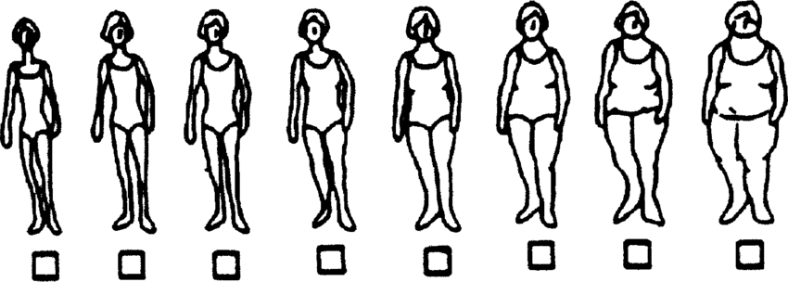

- How would you describe your Desired Body Size?
(Stunkard et al., 1983)

