Additional data–Appendix A
Additional file 1: Overview of the complete search strategy

Databases: PubMed, Web of Science and Scopus
Search date: 09 October 2023
Search period: 1 January 2006 to 09 October 2023
Search filter: Publication date from 1 January 2006 to 31 December 2023
Species Humans
Language Englisch and German

Search strategy (PubMed)
Set # | MeSH/tiab terms | Results
1 | "Parents"[Mesh] OR "parent*"[tiab] OR "caregiver*"[tiab] OR parental[tiab] OR mother*[tiab] OR father*[tiab] OR "Child"[Mesh] OR "children"[tiab] OR daughter*[tiab] OR son[tiab] | 1,244,222
2 | "health knowledge"[tiab] OR "health information"[tiab] OR information[tiab] OR inform*[tiab] OR knowledge*[tiab] OR attitude*[tiab] OR awareness*[tiab] OR perception[tiab] OR perceive*[tiab] OR refusal[tiab] OR refuse*[tiab] OR acceptance[tiab] OR accept*[tiab] OR willingness[tiab] OR willing*[tiab] OR intention*[tiab] | 1,760,799
3 | "Papillomavirus Infections"[Mesh] OR "human papilloma virus"[tiab] OR "human papillomavirus"[tiab] OR "papillomavirus"[All Fields] OR "HPV"[All Fields] OR "sexually transmitted infection"[All Fields] OR "STI" [All Fields] OR "sexually transmitted disease"[All Fields] OR "STD"[All Fields] | 66,201
4 | "Papillomavirus Vaccines"[Mesh] OR "Vaccines"[Mesh] OR "Vaccination"[Mesh] OR "Immunization"[Mesh] OR "Immunization Schedule"[Mesh] OR vaccine*[tiab] OR vaccination[tiab] OR vaccinate*[tiab] OR immunization*[tiab] OR immunisation*[tiab] OR HPV[tiab] OR "HPV vaccination*"[tiab] OR "HPV vaccine*"[tiab] OR "HPV immunization*"[tiab] OR "human papilloma virus vaccine*"[tiab] OR "human papilloma virus vaccination"[tiab] OR "human papilloma virus immunization*"[tiab] OR "HPV prevention*" OR "human papilloma virus prevention*" | 228,724
5 | systematic review[tiab] OR systematic literature review[tiab] OR literature review[tiab] OR narrative review[tiab] OR scoping review[tiab] | 302,577
6 | #1 AND #2 AND #3 AND #4 NOT #5 | 2,063

Search strategy (Web of Science)
Set # | MeSH/tiab terms | Results
1 | TS=(Parents OR Child) OR TI=(parent* OR caregiver* OR parental OR mother*OR father*OR children OR daughter* OR son) OR AB=( parent* OR caregiver* OR parental OR mother*OR father*OR children* OR daughter* OR son) | 1,722,294
2 | TI=(health knowledge OR health information OR information OR inform* OR knowledge* OR attitude* OR awareness*OR perception OR perceive* OR refusal OR refuse* OR acceptance OR accept* OR willingness OR willing* OR intention*) OR AB=(health knowledge OR health information OR information OR inform* OR knowledge* OR attitude* OR awareness*OR perception OR perceive* OR refusal OR refuse* OR acceptance OR accept* OR willingness OR willing* OR intention*) | 6,558,540
3 | TS=(Papillomavirus Infections OR papillomavirus OR HPV OR sexually transmitted infection OR STI OR sexually transmitted disease OR STD) OR TI=(human papilloma virus OR human papillomavirus) OR AB=(human papilloma virus OR human papillomavirus) | 132,288
4 | TS=(Papillomavirus Vaccines OR Vaccines OR Vaccination OR Immunization OR Immunization Schedule) OR TI=(vaccine* OR vaccination OR vaccinate* OR immunization* OR immunisation* OR HPV OR HPV vaccination* OR HPV vaccine* OR HPV immunization* OR "human papilloma virus vaccine* OR human papilloma virus vaccination OR human papilloma virus immunization* OR HPV prevention* OR human papilloma virus prevention*) OR AB=(vaccine* OR vaccination OR vaccinate* OR immunization* OR immunisation* OR HPV OR HPV vaccination* OR HPV vaccine* OR HPV immunization* OR "human papilloma virus vaccine* OR human papilloma virus vaccination OR human papilloma virus immunization* OR HPV prevention* OR human papilloma virus prevention*) | 488,019
5 | TI=(systematic review OR systematic literature review OR literature review[tiab] OR narrative review OR scoping review) | 292,451
6 | #1 AND #2 AND #3 AND #4 NOT #5 | 1,884

Search strategy (Scopus)
Set # | Terms | Results
1 | ALL (parents OR parent* OR caregiver* OR parental OR mother* OR father*OR child OR children OR daughter* OR son) | 1,604,896
2 | ALL (health AND knowledge OR health AND information OR information OR inform* OR knowledge OR attitude* OR awareness* OR perception OR perceive* OR refusal OR refuse* OR acceptance OR accept* OR willingness OR willing* OR intention*) | 6,122,590
3 | ALL (papillomavirus AND infections OR human AND papilloma AND virus OR human AND papillomavirus OR papillomavirus OR HPV OR sexually AND transmitted AND infection OR STI OR sexually AND transmitted AND disease OR STD) | 7,024
4 | ALL (papillomavirus AND vaccines OR vaccines OR vaccination OR immunization OR immunization AND schedule OR vaccine* OR vaccination OR vaccinate* OR immunization* OR immunisation* OR HPV OR HPV AND vaccination OR HPV AND vaccine* OR HPV AND immunization* OR human AND papilloma AND virus AND vaccine* OR human AND papilloma AND virus AND vaccination OR human AND papilloma AND virus AND immunization OR HPV AND prevention OR human AND papilloma AND virus AND prevention*) | 11,684
5 | ALL (systematic review OR systematic literature review OR literature review OR narrative review OR scoping review) | 1,982,915
6 | #1 AND #2 AND #3 AND #4 NOT #5 | 668

Additional file 2: Newcastle-Ottawa Scale for cohort studies

Note: A study can be awarded a maximum of one star for each numbered item within the Outcome categories. A maximum of two stars can be given for Comparability.

Selection (Maximum 3 stars):

- Representativeness of the cohort
- truly representative of the average in the community
- somewhat representative of the average in the community
- selected group of users
- no description of the derivation of the cohort

- Ascertainment of the exposure
- secure record (e.g. medical records)
- structured interview
- written self report
- no description

- Demonstration that outcome of interest was not present at start of study
- yes
- no

Comparability (Maximum 2 stars):

- The subjects in different cohorts (e.g. intenders and non-intenders; "undecided" or "hesitant" group) are comparable, based on the study design or analysis. Confounding factors are controlled.
- the study controls for the most important factor
- the study control for any additional factor
- data/results not adjusted for all relevant confounders/risk; factors/information not provided

Outcome (Maximum 3 stars):

- Assessment of outcome
- independent blind assessment
- record linkage
- self-report
- no description

- The follow-up was long enough to occur the outcomes
- yes
- no

- Adequacy of follow up of cohorts
- complete follow up (all subjects accounted for)
- subjects lost to follow up unlikely to introduce bias, description provided of those lost
- no description of those lost
- no statement

Rating:

Very Good: 7 to 9 stars
Good: 5 to 6 stars
Satisfactory: 3 to 4 stars
Unsatisfactory: 0 to 2 stars

Additional file 3: Newcastle-Ottawa Scale adapted for cross-sectional studies

Note: This scale has been adapted from the Newcastle-Ottawa Scale for cohort studies to provide quality assessment of cross-sectional studies. A study can be awarded a maximum of one star for each numbered item within the Selection and Outcome categories. A maximum of two stars can be given for Comparability.

Selection (Maximum 5 stars):

- Representativeness of the sample
- truly representative of the average in the target population
(all subjects or random sampling)
- somewhat representative of the average in the target population
(non-random sampling)
- selected group of users
- no description of the sampling strategy

- Sample size
- justified and satisfactory (including sample size calculation)
- not justified
- no information provided

- Non-respondents
- comparability between respondents and non-respondents’ characteristics is established, and the response rate is satisfactory
- the response rate is unsatisfactory, or the comparability between respondents and non-respondents is unsatisfactory
- no description of the response rate or the characteristics of the responders and the non-responders

- Ascertainment of the exposure (risk factor)
- validated measurement tool
- non-validated measurement tool, but the tool is available or described
- no description of the measurement tool

Comparability (Maximum 2 stars):

- The subjects in different outcome groups are comparable, based on the study
design or analysis. Confounding factors are controlled.
- the study controls for the most important factor (select one)
- the study control for any additional factor
- data/results not adjusted for all relevant confounders/risk; factors/information not provided

Outcome (Maximum 3 stars):

- Ascertainment of the exposure (risk factor)
- independent blind assessment
- record linkage
- self-report
- no description

- Statistical test
- the statistical test used to analyse the data is clearly described and appropriate, and the measurement of the association is presented, including confidence intervals and the probability level (p value)
- the statistical test is not appropriate, not described or incomplete

Rating:

Very Good: 9 to 10 stars
Good: 7 to 8 stars
Satisfactory: 5 to 6 stars
Unsatisfactory: 0 to 4 stars

Additional file 4: Overall and stratified pooled vaccine acceptance by the investigated variables including the prediction intervals, publication bias and quality assessment
Vaccine acceptance | Strata | Number of studies | Pooled vaccine acceptance (95% CI) | Predicition interval of vaccine acceptance (%) | Publication bias | Quality of evidence (GRADE)ª
Overall |  | 62 | 67.2% (95% CI: 62.6–71.7) | 30.1–94.8 | Undetected | ⨁⨁⨁⨀ moderate
Subgroup analysis
Stratified by | Africa | 17 | 79.6% (95% CI: 73.5–85.2) | 51.1–97.4 | Undetected | ⨁⨁⨁⨀ moderate
 | Asia | 13 | 63.7% (95% CI: 55.4–71.6) | 32.8–89.4 | Undetected | ⨁⨀⨁⨀ low
 | Europe | 11 | 65.9% (95% CI: 51.7–78.8) | 18.8–98.5 | Undetected | ⨀⨀⨁⨀ very low
 | North America | 18 | 56.7% (95% CI: 49.3–64.0) | 25.8–85.0 | Undetected | ⨁⨀⨁⨀ low
Sensitivity analyses
Stratified by | Parents and children | 17 | 63.3% (95% CI: 52.9–73.1) | 21.0–95.8 | Undetected | ⨁⨀⨁⨀ low
 | Parents and daughters | 22 | 70.3% (95% CI: 62.9–77.1) | 34.1–95.8 | Undetected | ⨁⨀⨁⨀ low
 | Parents and sons | 10 | 57.7% (95% CI: 4.77–67.5) | 25.7–86.5 | Undetected | ⨀⨀⨁⨀ very low
 | Mothers and daughters | 13 | 73.9% (95% CI: 65.7–81.3) | 41.8–95.9 | Undetected | ⨁⨀⨁⨀ low
 | Parents and children + Asia | 7 | 58.4% (95% CI: 45.4–70.8) | 23.4–89.1 | Undetected | ⨀⨀⨁⨀ very low
 | Parents and children + Asia | 7 | 58.4% (95% CI: 45.4–70.8) | 23.4–89.1 | Undetected | ⨀⨀⨁⨀ very low
 | Parents and children + North America | 3 | 52.0% (95% CI: 16.6–86.3) | 0.1–100.0 | Undetected | ⨁⨀⨁⨀ low
 | Parents and daughters + Africa | 9 | 76.4% (95% CI: 66.3–85.3) | 40.7–98.2 | Undetected | ⨁⨀⨁⨀ low
 | Parents and daughters + Asia | 2 | 75.8% (95% CI: 67.1–83.6) | 60.7–88.2 | Undetected | ⨀⨁⨀⨀ very low
 | Parents and daughters + Europe | 2 | 66.3% (95% CI: 11.1–100) | 0.0–100.0 | Undetected | ⨀⨀⨀⨀ very low
 | Parents and daughters + North America | 7 | 60.7% (95% CI: 51.5–69.6) | 34.9–83.7 | Detected | ⨁⨀⨁⨀ low
 | Parents and sons + Europe | 3 | 63.9% (95% CI:38.1–86.0) | 15.7–98.4 | Detected | ⨀⨀⨀⨀ very low
 | Parents and sons + North America | 5 | 51.2% (95% CI:42.2–-60.2) | 29.9–72.3 | Undetected | ⨀⨁⨀⨀ very low
 | Mothers and daughters + Africa | 5 | 86.3% (95% CI: 81.6–90.5) | 75.5–94.9 | Undetected | ⨀⨁⨀⨀ very low
 | Mothers and daughters + Asia | 3 | 71.5% (95% CI: 66.2–76.5) | 60.9–81.0 | Undetected | ⨀⨀⨀⨀ very low
 | Mothers and daughters + North America | 3 | 61.2% (95% CI:48.7–73.0) | 36.7–83.0 | Detected | ⨀⨁⨀⨀ very low
ª Limitation, inconsistency, indirectness, imprecision in the order listed in the table: ⨀—serious or ⨁—non-serious.

Additional file 5: Funnel plot of HPV vaccine acceptance rates (n = 62)

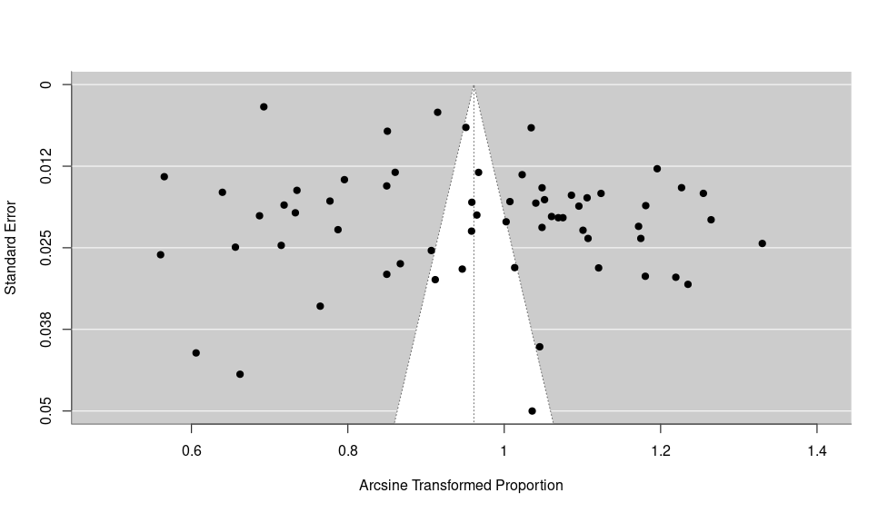

Additional file 6: Characteristics of the included studies and vaccine acceptance rate
Reference | Study  region | Study  period | Study setting | Parents sample size (n) | Parents’ age  (years) | Children’s age (years) | Parents’ sex | Children’s sex | Parents’ ethnicity | Survey  instrument | Acceptance rate (%) | Parents sample size (n) for  acceptance rate (%) | Intention vs. already vaccinated | Sampling  method
Brabin  (2006) | Manchester, England | 2005 | Parents of year 7 (age 11–12) pupils in the city of Manchester, school data of Manchester City Council Education Department | 317 | ≤ 30 to > 45 | 11–12 | F/M | F/M | 65.3% White,  7.9% Black-Caribbean,  8.8% Black-African,  12.3% Indian,  4.1% Others | Paper-based questionnaire | 81.1 | 257 | Intention | Stratified sampling
Constantine (2007) | California, USA | 2005–2006 | Subset of data from survey on sexual health in California | 522 | < 30 to > 50 | ≤ 18 | F/M | F | 40.5% White,  38.2% Hispanic,  6.9% Black,  7.7% Asian,  5.4% Other | Interviewer-administered questionnaire  (telephone interview) | 75.1 | 392 | Intention | Stratified sampling
Hopenhayn (2007) | Appalachian Kentucky, USA | 2005 | Two counties in Appalachian Kentucky | 626 | 18 to > 70 | 10–15 | F | F | 95% White | Computer assisted telephone interview (CATI) | 67.6 | 423 | Intention | Simple  random sampling
Marshall (2007) | Not specified, Australia | 2006 | Households in South  Australia | 601 | 47 (mean) | N/A | F/M | F/M | N/A | Interviewer-administered questionnaire  (telephone interview) | 76.9 | 462 | Intention | Simple  random sampling
Woodhall (2007) | Tampere, Finland | 2005 | Survey-based study among adolescents born in 1990 and their parents, targeting households | 727 | 45 (mean) | 15 (mean) | F/M | F/M | N/A | Paper-based questionnaire | 85.6 | 622 | Intention | Stratified sampling
Ogilvie (2008) | Not specified, Canada | 2006–2007 | National survey in Canada | 1381 | 19 to > 60 | 8–18 | F/M | M | 83.4% White,  2.3% Aboriginal,  14.3% Other | Computer assisted telephone interview (CATI) | 67.8 | 936 | Intention | Simple  random sampling
Bernat (2009) | Minnesota, USA | 2006–2007 | Random sample of parents of school-age children in Minnesota | 1504 | ≤ 30 to ≥ 50 | 5–18 | F/M | F/M | 96.8% White,  3.2% Non-White,  1.9% Hispanic | Interviewer-administered questionnaire  (telephone interview) | 86.6 | 1302 | Intention | Stratified sampling
Gottlieb (2009) | North  Carolina, USA | 2007 | Five North Carolina counties with high cervical cancer incidence | 780 | ≤ 39 to ≥ 50 | 10–18 | F/M | F | 52% White,  38% Black,  5% Hispanic,  5% Other | Interviewer-administered questionnaire  (telephone interview) | 62.1 | 484 | Vaccinated | Clustered sampling
Reiter  (2009) | North  Carolina, USA | 2007 | Counties with high risk of cervical cancer | 886 | < 40 to > 40 | 10–18 | F/M | F | 70.2% White,  23.2% Black,  6.6% Other | Interviewer-administered questionnaire  (telephone interview) | 12.0 | 106 | Vaccinated | Clustered sampling
Allen  (2010) | Not specified, USA | 2007–2008 | National internet-based survey in the USA | 448 | N/A | 9–17 | F/M | F | 48% White,  30% Black,  22% Hispanic | Web-based questionnaire | 52.9 | 237 | Mixed | Simple random sampling
Askelson (2010) | Iowa, USA | 2007 | Rural, Midwest state in the USA | 217 | 27–56 | 9–15  11.21 ± 1.82 (mean) | F | F | N/A | Paper-based questionnaire | 47.9 | 104 | Intention | Simple random sampling
Dahlström (2010) | Stockholm, Sweden | 2007 | Data from Swedish Population Register | 13840 | < 41 to > 45 | 12–15 | F/M | F/M | 86.5% Sweden,  3.1% Other Nordic country,  6.1% Other country | Paper-based questionnaire and telephone interview | 62.8 | 8691 | Intention | Simple random sampling
Fang  (2010) | Not specified, USA | 2007 | Data from the 2007 Health Information National Trends Survey | 1383 | 44 (mean) | ≤ 18 | F/M | F | 58.9% White,  12.6% Black,  20.4% Hispanic,  8.1% Other | Paper-based questionnaire and telephone interview | 57.5 | 795 | Intention | Simple random sampling
Mortensen (2010) | Not specified, Denmark | 2010 | Four countries (UK, Germany, France and Italy) randomly extracted from Yellow Pages, omnibus and door to door | 450 | N/A | 12–15 | F/M | M | N/A | Computer assisted telephone interview (CATI) | 80.0 | 360 | Intention | Simple random sampling
Oh  (2010) | Not specified, Korea | 2007 | National population-based cross-sectional survey in Korea | 1000 | 20 to ≥ 50 | N/A | F/M | F/M | N/A | Interviewer-administered questionnaire  (face-to-face interview) | 75.1 | 751 | Intention | Stratified sampling
Reiter  (2010) | North Carolina, USA | N/A | North Carolina residents’ data from the BRFSS and CHAMP surveys | 617 | ≤ 39 to ≥ 50 | 10–17  13.6 ± 2.4 (mean) | F/M | F | N/A | Interviewer-administered questionnaire  (telephone interview) | 32.1 | 198 | Vaccinated | Simple random sampling
Dempsey (2011) | Michigan, USA | 2009 | Data from national, cross-sectional, web-based survey in the USA | 1178 | 18 to ≥ 60 | 0–17 | F/M | M | 65% White,  11% Black,  17% Hispanic,  7% Other | Web-based questionnaire | 51.0 | 601 | Intention | Simple random sampling
Guerry (2011) | Los Angeles, USA | 2008–2009 | Data from study to prevent pregnancy and sexually transmitted infections in middle and high school students | 387 | 22–71 | 11–18  14.5 ± 1.92 (mean) | F/M | F | 81% Hispanic,  16% Black | Interviewer-administered questionnaire  (telephone interview) | 62.0 | 240 | Intention | Clustered sampling
Kadis  (2011) | Not specified, USA | 2009 | National survey of mothers of adolescent females in the USA | 496 | 41.7 ± 7.4 (mean) | 11–14 | F | F | 54.5% White,  17.3% Black,  8.0% Hispanic | Web-based questionnaire | 66.9 | 332 | Intention | Simple random sampling
Litton  (2011) | Alabama, USA | 2008–2009 | National survey on female caregiver’s intention to vaccinate their daughters | 403 | < 40 to ≥ 50 | 11–14 | F | F/M | 89.8% White,  9.0% Black | Interviewer-administered questionnaire  (telephone interview) | 37.3 | 150 | Intention | Simple random sampling
M’Imunya (2011) | Nairobi,  Kenya | 2010 | Four primary schools within the Langata constituency in Nairobi County, Kenya focusing on girls in Standard five to eight and their parents/guardians | 332 | < 20.4 to > 50.14 | < 10.38 to > 15.3 | F/M | F | N/A | Self-administered questionnaire | 58.0 | 193^{d} | Intention | Simple random sampling
Arrossi (2012) | Buenos Aires,  Argentina | 2009–2010 | Population-based survey among women in Metropolitan Buenos Aires | 100 | 18–49 | 9–15 | F | F | N/A | Paper-based questionnaire and  face-to-face interview | 74.0 | 74 | Intention | Stratified sampling
Gefenaite (2012) | Not specified, Netherlands | 2009 | National survey of parents of girls born in 1996 targeted for HPV vaccination in the Netherlands | 469 | 35–55 | N/A | F | F | N/A | Paper-based questionnaire | 65.5 | 307 | Vaccinated | Simple random sampling
Gilkey  (2012) | North  Carolina, USA | 2010 | Data from population-based surveys (BRFSS and CHAMP) | 751 | 44 (mean) | 11–17  14.0 (mean) | F/M | F/M | N/A | Interviewer-administered questionnaire  (telephone interview) | 29.7 | 223 | Vaccinated | Simple random sampling
Pourat (2012) | California, USA | N/A | Subanalysis of females in 2007 California Health Interview Survey | 4896 | 18 to ≥ 56 | 8–17 | F/M | F | 38% White,  5% Black,  44% Latino,  11% Asian,  2% Other | Interviewer-administered questionnaire (telephone interview) | 56.5 | 2766 | Intention | Simple random sampling
Rose  (2012) | Not specified, New Zealand | 2008–2009 | Parents of students in Wellington, New Zealand | 769 | 20 to ≥ 55 | ≥ 8 | F/M | F | 16.4% Maori,  7.4% Pacific,  62.0% New Zealand European,  14.2% Other | Paper-based questionnaire | 67.0 | 515 | Intention | Stratified sampling
Sadigh (2012) | Not specified, USA | 2006–2008 | National Survey of Family Growth, recruited by random digit dialing, USA | 444 | 15–44 | 9–18 | F | F | N/A | Paper-based questionnaire | 56.3 | 250 | Mixed | Simple random sampling
Songthap (2012) | Bangkok, Thailand | 2009 | School-based cross-sectional study among students, parents, and teachers in Bangkok, Thailand | 648 | < 40 to ≥ 50 | 12–15 | F/M | F/M | N/A | Self-administered questionnaire | 44.8 | 290 | Intention | Simple random sampling
Ezat  (2013) | Kuala  Lumpur, Malaysia | 2012 | Tertiary referral center in Malaysia, specifically targeting mothers who attended the Obstetrics and Gynecology (O&G) clinics | 155 | 24 to >33 | N/A | F | F/M | 82.6% Malaysian,  11.6% Chinese,  4.5% Indian,  1.3% Others | Self-administered questionnaire | 74.8ª | 116ª | Intention | Clustered sampling
Ezenwa (2013) | Lagos,  Nigeria | 2012 | Community-based survey with multistage sampling in Lagos State, Nigeria | 290 | 24–62 | 10–19 | F | F | 10.5% Hausa,  27.7% Igbo,  38.4% Yoruba,  23.5% Other | Paper-based questionnaire | 85.5 | 248 | Intention | Simple random sampling
Lai  (2013) | Not specified, USA | 2009 | National survey with data from Health Information National Trends  Survey, USA | 804 | 18 to ≥ 65  44.9 ± 2.53 (mean) | N/A | F/M | F | 73% White,  24% Non-White,  3% Unreported | Paper-based questionnaire | 75.4 | 606 | Intention | Simple random sampling
McRee (2013) | Not specified, USA | 2010 | National survey with data from the HPV Immunization in Sons (HIS) study, USA | 506 | 40.1 ± 6.9 (mean) | 11–17 | F/M | M | 67.2% White,  12.3% Black,  15.4% Hispanic,  5.1% Other | Web-based questionnaire | 50.2 | 254 | Intention | Simple random sampling
van Keulen (2013) | Not specified, Netherlands | 2009–2010 | National survey with random sample from Dutch vaccination register | 952 | < 45 to ≥ 45 | 13–16  13 ± 0.5 (mean) | F | F | N/A | Paper-based questionnaire | 45.0 | 428 | Intention | Stratified sampling
Bianco (2014) | Calabria, Italy | 2012 | Seven public secondary schools | 566 | 42.9 (mean) | 10–14 | F/M | M | N/A | Paper-based questionnaire | 71.0 | 402 | Intention | Clustered sampling
Kruiroongroj (2014) | Bangkok, Thailand | N/A | Cross-sectional survey with eight secondary schools in Bangkok | 758 | 43.47 ± 6.6 (mean) | 12–15  13.72 ± 2 1.3 (mean) | F | F | N/A | Paper-based questionnaire | 74.4 | 564 | Intention | Clustered sampling
Madhivanan (2014) | Mysore City, India | 2010 | Parents of children in one of 12 schools in Mysore, India | 778 | ≤ 35 to ≥ 46 | 11–15 | F/M | F | N/A | Paper-based questionnaire | 71.5 | 556 | Intention | Clustered sampling
Muhwezi (2014) | Ibanda, Nakasongola, Mbarara,  Luwero, Uganda | 2008–2009 | Cross-sectional study conducted in four districts of Uganda | 870 | 40.77 (mean) | 10–23 | F/M | M | N/A | Self-administered questionnaire | 78.3 | 681 | Intention | Simple random sampling
Taylor  (2014) | Not specified, USA | 2012 | National sample of parents who were part of the SSI national sample | 758 | 42.2 ± 11.5 (mean) | 11–17  13.8 ± 2.0 (mean) | F/M | M | 73.8% White,  10.0% Black,  9.8% Hispanic,  6.5% Other | Web-based questionnaire | 34.3 | 260 | Vaccinated | Simple random sampling
Vermandere (2014) | Eldoret,  Kenya | 2012 | Randomly selected primary schools in Kenya | 287 | 21–59 | 8–18 | F | F | N/A | Interviewer-administered questionnaire  (face-to-face interview) | 88.2 | 253 | Intention | Clustered sampling
Krawczyk (2015) | Quebec,  Canada | 2008–2009 | Cross-sectional survey of parents of girls in Quebec, Canada | 774 | 35 (median) | 8–18 | F | F | 88.5% White,  1.4% Black,  1.8% Arabic,  2.1% Aboriginal,  2.5% Other | Paper-based questionnaire | 88.2 | 683 | Vaccinated | Simple random sampling
La Vincente (2015) | Melanesia, Republic of Fiji | 2009–2010 | Parents of vaccine-eligible girls in primary schools in Fiji | 293 | 40 (median) | 9–10 | F/M | F | N/A | Interviewer-administered questionnaire  (telephone interview) | 78.5 | 230 | Vaccinated | Clustered sampling
Morhason-Bello (2015) | Mokola Ibadan,  Nigeria | 2012 | Data from HPV Vaccine and Cervical Cancer Prevention household Survey in Mokala, Nigeria | 1002 | < 25 to ≥ 40 | 9–12 | F/M | F | 70.6% Yoruba,  11.4% Hausa,  4.2% Igbo,  10.4% Others,  3.4% No response | Web-based questionnaire | 88.6 | 888 | Intention | Clustered sampling
Moss  (2015) | Not specified, USA | 2010 | Data from HPV Immunization in Sons survey, USA | 412 | < 45 to ≥ 45 | 11–17 | F/M | M | N/A | Web-based questionnaire | 43.0 | 177 | Intention | Simple random sampling
Selmouni (2015) | Not specified, Morocco | 2011 | National cross-sectional surveys of mothers and fathers of girls at middle school in Morocco | 1312 | 41.8 ± 6.9 (mean) | 12–15 | F/M | F | N/A | Interviewer-administered questionnaire  (face-to-face interview) | 72.9 | 956 | Intention | Clustered sampling
Wang L.D-L. (2015) | Hong Kong, China | 2014 | Survey of Chinese parents with at least one daughter in Hongkong | 368 | 49.3 ± 8.2 (mean) | 12–17 | F/M | F/M | 98.3% Han Chinese | Interviewer-administered questionnaire  (telephone interview) | 28.3 | 104 | Intention | Simple random sampling
Borena (2016) | Tyrol, Austria | 2015 | Parents of fourth grade school children from 20 primary schools in Tyrol – a region in west Austria. | 148 | 40.8 ± 5.7 (mean) | N/A | F/M | F/M | N/A | Self-administered questionnaire | 32.4 | 48 | Intention | Simple random sampling
Clark  (2016) | Michigan, USA | 2012 | National, cross-sectional survey of parents of children aged 9–17, USA | 734 | 24 to ≥ 45 | 11–17 | F/M | M | 60.74% White,  12.03% Black,  22.37% Hispanic,  4.87% Other | Web-based questionnaire | 43.3 | 318 | Intention | Simple random sampling
Dairo  (2016) | Ibadan,  Nigeria | N/A | Community-based study of parents of adolescents residing in the community in Ibadan North Local Government Area | 612 | 20 to > 50  37.3 ± 6.5 (mean) | 10–18 | F/M | F/M | 88% Yoruba,  9.3% Igbo,  1.1% Hausa,  1.6% Others | Interviewer-administered questionnaire | 76.1 | 466 | Intention | Systematic random sampling
Oddsson  (2016) | Not specified, Iceland | 2008 | Parents or guardians of 12-year-old girls from a cohort of total 2,092 girls born in 1995 and registered in the Icelandic National Register | 583 | 30 to ≥ 60 | 12 | F/M | F | N/A | Self-administered questionnaire | 90.9 | 530 | Intention | Simple random sampling
Voidăzan (2016) | Tîrgu Mureş, Romania | 2014 | Parents of students grades 5 to 8 in Tîrgu Mureş, Romania | 918 | 28–57 | N/A | F/M | F | 66.0% Romanian,  33.3% Hungarian,  0.7% Roma | Paper-based questionnaire | 35.6 | 327 | Intention | Clustered sampling
Calo  (2017) | Not specified, USA | 2014–2015 | National survey of parents of adolescents, USA | 1255 | N/A | 11–17  14 (mean) | F/M | F/M | 71% White,  9% Black,  13% Hispanic,  7% Other | Web-based questionnaire | 28.7 | 360 | Intention | Simple random sampling
Cheruvu (2017) | Not specified, USA | 2008–2012 | Sub-sample of unvaccinated females from the National Immunization Survey-Teen (NIS-Teen) | 21467 | ≤34 to ≥ 45 | 13 –17  14.3 (mean) | F/M | F | 60.1% White  15.5% Black  16.8% Hispanic  7.6% Other | Paper-based questionnaire and telephone interview | 40.8 | 8751 | Intention | Simple random sampling
Gilkey  (2017) | Not specified, USA | 2014–2015 | National survey of parents of adolescents, USA | 1484 | N/A | 11–17  14 (mean) | F/M | F/M | 71% White,  9% Black,  13% Hispanic,  7% Other | Web-based questionnaire | 46.2 | 685 | Vaccinated | Simple random sampling
Ndejjo  (2017) | Bugiri and Mayuge, Uganda | N/A | Cross-sectional study on females aged 25 to 49 years in eastern Uganda | 900 | 25–49 | N/A | F | F | N/A | Paper-based questionnaire | 90.3 | 813 | Intention | Clustered sampling
Perez  (2017) | Not specified, Canada | 2014 | Nationally representative sample of Canadian parents of boys at baseline (February 2014: T1) and at follow-up (November 2014: T2) | 3011 (T1)  1336 (T2) | N/A | 9–16 | F/M | M | N/A | Web-based questionnaire | 5.0 (T1)  9.8 (T2) | 157 (T1)  140 (T2) | Mixed | Simple random sampling
VanWormer (2017) | Wisconsin, USA | 2015–2016 | Data from medical care quality improvement survey on HPV vaccine coverage in seven communities in Wisconsin, USA | 164 | 43.7 ± 6.1 (mean) | 11 to ≥ 14 | F/M | F/M | 96% White,  3% Hispanic,  1% Unknown | Paper-based questionnaire | 59.8 | 98 | Vaccinated | Stratified sampling
Degarege (2018) | Mysore, India | 2011 | Cross-sectional survey of parents of adolescent girls in Karnataka state, India | 831 | ≤ 35 to ≥ 50  37.1 ± 6.67 (mean) | 11–15 | F/M | F | N/A | Paper-based questionnaire | 79.9 | 664 | Intention | Clustered sampling
Ganczak (2018) | Zgorzelec, Poland | 2013–2014 | Cross-sectional study among parents of first-grade high school students from three high schools in the city of Zgorzelec, southwestern Poland | 450 | 29–67  42 (mean) | N/A | F/M | F/M | N/A | Self-administered questionnaire | 85.1 | 383 | Intention | Simple random sampling
Mansfield (2018) | Not specified, USA | 2006–2007 | Retrospective, cross-sectional study based on a national dataset, the Health Information National Trends Survey (HINTS) | 1037 | 18 to ≥ 48 | N/A | F/M | F | 68.9% White,  11.4% African American,  11.6% Hispanic,  8.1% Others | Interviewer-administered questionnaire | 56.4 | 585 | Intention | Simple random sampling
Mendes Lobão  (2018) | Belém, Belo Horizonte, Brasília, Porto Alegre, Rio de  Janeiro, São Paulo,  Salvador, Brazil | 2015–2016 | Random-digit-dial study of parents conducted in seven major Brazilian cities | 826 | 18–82  43.8 (mean) | 9–14 | F/M | F/M | 44% White,  41% Mixed,  14% Black,  1% Asian,  0.3% Indigenous​​ | Interviewer-administered questionnaire | 89.0ª | 735ª | Mixed | Simple random sampling
Mohd Sopian (2018) | Kota Bharu, Malaysia | 2015 | Cross-sectional study among parents of standard 5 at 10 primary schools in Malaysia | 280 | 42.5 ± 6.22 (mean) | 11 | F/M | F/M | 100% Malaysian | Paper-based questionnaire | 62.5 | 175 | Intention | Systematic random sampling
O'Leary (2018) | Denver, Colorado, USA | 2013 | Cross-sectional study among parents of girls selected from administrative data in a Denver, Colorado safety net system | 40 | N/A | 12–15 | F/M | F | 20.8% White,  57.5% Hispanic,  21.6% Others | Web-based questionnaire | 97.5 | 39 | Vaccinated | Simple random sampling
Shapiro (2018) | Not specified, Canada | 2016 | Nationally representative sample of Canadian parents | 3779 | 18–81  43.51 ± 6.86 (mean) | 9–16 | F/M | F/M | 85.3% White  14.8% Other | Web-based questionnaire | 46.3 | 1750 | Mixed | Simple random sampling
Wang Z. (2018) | China, Hong Kong | 2016 | Chinese parents of children aged 9–13 years in Hongkong, recruited by random calling | 296 | < 40 to ≥ 50 | 9–13 | F/M | F/M | N/A | Interviewer-administered questionnaire  (telephone interview) | 56.4 | 167 | Intention | Simple random sampling
Azuogu (2019) | Ebonyi, Nigeria | 2018 | Cross sectional study of mothers of female senior secondary school students in Ebonyi, Nigeria | 267 | 20 to ≥ 49  42 ± 8 (mean) | 1 to ≥ 29 | F | F | N/A | Paper-based questionnaire | 89.1 | 238 | Intention | Stratified sampling
Hirth  (2019) | Not specified, USA | 2008–2016 | Longitudinal study using data from the 2008–2018 National Immunization Survey-Teen (NIS-Teen) | 143721 | N/A | 13–17  14.9 (mean) | F/M | F/M | Hispanic | Interviewer-administered questionnaire  (telephone interview) | 36.8^{b} | 52855 | Intention | Stratified sampling
Lin  (2019) | Shenzhen, China | 2015 | Multistage, stratified cluster sampling from Cervical Cancer Prevention Network data in Shenzhen city, China | 5799 | < 30 to ≥ 40  37.09 ± 7.48 (mean) | N/A | F | F | 92.7% Han,  7.3% Other | Self-administered questionnaire | 66.3 | 3842 | Intention | Clustered sampling
Shibli  (2019) | Haifa, Israel | 2016–2017 | Cross-sectional study among mothers of 8th graders in Jewish and Arab schools in Haifa and Northern districts of Israel, during the school year | 313 | 42.9 ± 4.8 (mean) | 12–13 | F | F/M | N/A | Interviewer-administered questionnaire  (telephone interview) | 65.8 | 206 | Intention | Simple random sampling
Tatar  (2019) | Canada | 2016–2017 | Nationally representative sample of Canadian parents | 497 | 42.5 ± 6.9 (mean) | 9–16 | F/M | F | 83.6% White,  16.4% Other | Web-based questionnaire | 18.9 (Intention)  14.9 (Vaccinated) | 94  (Intention)  74 (Vaccinated) | Mixed | Simple random sampling
Alene  (2020) | Gondar town, Ethiopia | 2019 | Parents who had daughters living in Gondar town, specifically selected from both urban and rural kebeles | 899 | 21 to ≥ 40  39.9 ± 0.30 (mean) | 9 –17 | F/M | F | N/A | Interviewer-administered questionnaire | 81.3 | 731 | Intention | Simple random sampling
Della Polla (2020) | Naples and Salerno, Italy | 2019 | Parents with at least one child attending six randomly selected middle public schools | 435 | 29–63  44.3 ± 5.8 (mean) | 12 –13 | F/M | F/M | N/A | Paper-based questionnaire | 57.9 | 252 | Mixed | Simple random sampling
Huon  (2020) | Loire-Atlantique, France | 2017–2018 | Sample of middle and high school students in the Loire-Atlantique department, France | 127 | 44–48 | 13–18 | F/M | M | N/A | Paper-based questionnaire | 37.8 | 48 | Intention | Clustered sampling
Lin  (2020) | Shenzhen, China | 2015 | Representative females with children recruited from healthcare institutions through the Cervical Cancer Prevention Network | 5702 | 21–60  37.60 ± 7.36 (mean) | N/A | F | F | 92.7% Han,  7.3% Other | Self-administered questionnaire | 73.9 | 4213 | Intention | Stratified sampling
Rabiu  (2020) | Lagos State, Nigeria | N/A | Cross-sectional study focusing on two urban and two rural secondary schools | 318 | 30–59 | N/A | F/M | F | N/A | Paper-based questionnaire | 72.0 | 229 | Intention | Simple random sampling
Dereje (2021) | Addis Ababa, Ethiopia | 2021 | Community-based cross-sectional study conducted among parents or guardians with daughters Akaki Kality sub-city | 422 | 39.0 ± 9.9 (mean) | 9 –17 | F/M | F | N/A | Interviewer-administered questionnaire | 94.3 | 398 | Intention | Systematic random sampling
Destaw (2021) | Bench-Sheko zone, Ethiopia | 2020–2021 | Community-based cross-sectional study conducted among residents in the Bench Sheko zone, southwest Ethiopia | 502 | 28.6 ± 6.0 (mean) | 9–13 | F/M | F | N/A | Interviewer-administered questionnaire | 79.5 | 399 | Intention | Systematic random sampling
Humnesa (2022) | Not specified, Ethiopia​ | 2021 | Randomly selected kebele in Central Ethiopia, focusing on households with daughters aged 9 to 14 years | 619 | < 30 to ≥ 40  35.13 ± 7.69 (mean) | 9–14 | F/M | F | 91.4% Oromo,  8.6% Amhara | Interviewer-administered questionnaire | 40.2 | 249 | Intention | Simple random sampling
Larebo (2022) | Hossana, Ethiopia | 2021 | Community-based cross-sectional study conducted among parents and daughters in the Hadiya zone, southern Ethiopia | 530 | 18 to ≥ 40  38 ± 9.45 (mean) | 9–14 | F/M | F | 73.4% Hadiya,  9.4% Kembata,  1.5% Amhara,  2.1% Tigre,  1.9% Gurage,  1.7% Oromo,  3% Wolaita,  6% Gurage,  3% Silte | Interviewer-administered questionnaire | 84.9 | 450 | Intention | Stratified sampling
López  (2022) | Not specified, Spain | 2020 | Cross-sectional, multicenter study at twenty-four (public and private) pediatric offices in Spain | 1405 | ≤ 29 to ≥ 60 | 9–14  11.5 ± 1.6 (mean) | F/M | F/M | 97.4% Spanish,  2.6% Others | Paper-based questionnaire or web-based questionnaire | 86.0^{c} | 1209^{c} | Mixed | Stratified sampling
Mihretie (2022) | Debre Tabor, Ethiopia | 2015–2016 | Community-based cross-sectional study among parents of girls | 638 | 23–46 | 9–14 | F/M | F/M | N/A | Interviewer-administered questionnaire | 44.8 | 286 | Mixed | Simple random sampling
Nguyen (2022) | Huế, Vietnam | 2020 | Cross-sectional study conducted at secondary schools in Hue city, involving parents of male students | 785 | 29–62  42.9 ± 6.1 (mean) | 11–15  12.4 ± 1.2 (mean) | F/M | M | N/A | Self-administered questionnaire | 49.2 | 386 | Intention | Simple random sampling
Sinshaw (2022) | Debre Markos, Ethiopia | 2021 | Mothers who had eligible daughters living in Debre Markos town in selected kebeles | 601 | 39.4 ± 8.95 (mean) | 9–14 | F | F | N/A | Interviewer-administered questionnaire | 77.4 | 465 | Intention | Simple random sampling
Alaamri (2023) | Tabuk City, Saudi Arabia | 2022–2023 | Community-based study conducted in 65 intermediate schools in Tabuk City​ | 947 | 24–55  42.28 ± 6.82 (mean) | N/A | F/M | F | 91.7% Saudi,  8.3% Non-Saudi | Web-based questionnaire | 35.7 | 338 | Mixed | Simple random sampling
Aragaw (2023) | Debre Tabor, Ethiopia | 2021–2022 | Parents who had daughters living in Debre town, specifically selected from three kebeles | 721 | ≤ 29 to ≥ 40  40.88 ± 6.72 (mean) | 9 –14 | F/M | F | N/A | Interviewer-administered questionnaire  (face-to-face interview) | 79.1 | 570 | Intention | Simple random sampling
Lubeya (2023) | Lusaka, Zambia | 2021 | Cross-sectional study conducted in Lusaka district, enrolled participants from various social settings such as markets, saloons, and barber shops across six sub-districts and twelve zones | 400 | 44.3–47.1 (mean) | 15–18 | F/M | F | N/A | Interviewer-administered questionnaire | 53.8 | 215 | Vaccinated | Clustered sampling
Sobierajski (2023) | Not specified, Poland | 2022 | Representative of parents of children aged 9–15 in Poland | 360 | <30 to >49 | 9–15 | F/M | F/M | N/A | Interviewer-administered questionnaire  (telephone interview) | 59.2 | 213 | Mixed | Stratified sampling
ª An average acceptance rate has been calculated to account for parents providing multiple responses for daughters and sons. The parent sample size (n) for the acceptance rate was calculated based on the average acceptance rate, due to missing data regarding separate responses for daughters and sons.
^{b} Based on the percentage data of non-intenders.
^{c} The acceptance rate was based on responses categorized as 'agree' and 'strongly agree'. The parent sample size (n) for the acceptance rate was calculated based on the average acceptance rate, due to missing data.
^{d} The parent sample size (n) for the acceptance rate was calculated based on the reported acceptance rate.
Additional file 7: Quality assessment results using the modified Newcastle-Ottawa Scale
Modified Newcastle-Ottawa Scale for cross-sectional studies
 | Selection |  |  |  | Comparability | Outcome
Reference | Representativeness of the sample  (Maximum:) | Sample size  (Maximum:) | Non-respondents  (Maximum:) | Ascertainment of exposure  (Maximum:) | Comparability of subjects on the basis of design or analysis  (Maximum:) | Assessment of outcome  (Maximum:) | Statistical test  (Maximum:) | Total score  (out of 10) | Power
Brabin (2006) | ★ | ★ |  |  |  | ★ | ★ | (8) | Good
Constantine (2007) | ★ | ★ |  |  |  | ★ | ★ | (6) | Satisfactory
Hopenhayn (2007) | ★ | ★ |  | ★ | ★ | ★ | ★ |  (6) | Satisfactory
Marshall (2007) | ★ |  | ★ |  | ★ | ★ | ★ | (7) | Good
Woodhall (2007) | ★ |  |  | ★ | ★ | ★ | ★ | (5) | Satisfactory
Ogilvie (2008) | ★ | ★ |  |  |  | ★ | ★ | (8) | Good
Bernat (2009) | ★ |  |  | ★ | ★ | ★ | ★ | (8) | Good
Gottlieb (2009) | ★ |  | ★ | ★ |  | ★ | ★ | (5) | Satisfactory
Reiter (2009) | ★ |  | ★ | ★ |  | ★ | ★ | (7) | Good
Allen (2010) | ★ |  |  |  |  | ★ | ★ | (7) | Good
Askelson (2010) | ★ | ★ |  |  |  | ★ | ★ |  (6) | Satisfactory
Dahlström (2010) | ★ |  | ★ | ★ | ★ | ★ | ★ |  (6) | Satisfactory
Fang (2010) | ★ |  | ★ | ★ | ★ | ★ | ★ |  (6) | Satisfactory
Mortensen (2010) | ★ |  |  | ★ |  | ★ |  | (3) | Unsatisfactory
Oh (2010) | ★ |  |  | ★ | ★ | ★ | ★ | (5) | Satisfactory
Reiter (2010) | ★ |  |  | ★ |  | ★ | ★ |  (6) | Satisfactory
Dempsey (2011) | ★ | ★ |  |  |  | ★ | ★ | (8) | Good
Guerry (2011) | ★ |  |  | ★ |  | ★ | ★ | (6) | Satisfactory
Kadis (2011) | ★ |  |  | ★ | ★ | ★ | ★ | (5) | Satisfactory
Litton (2011) | ★ | ★ |  |  | ★ | ★ | ★ | (7) | Good
M’Imunya (2011) | ★ | ★ |  |  | ★ | ★ | ★ | (5) | Satisfactory
Arrossi (2012) | ★ |  |  |  | ★ | ★ | ★ | (6) | Satisfactory
Gefenaite (2012) | ★ |  |  | ★ | ★ |  | ★ | (6) | Satisfactory
Gilkey (2012) | ★ |  |  | ★ |  | ★ | ★ | (6) | Satisfactory
Pourat (2012) | ★ |  |  | ★ | ★ | ★ | ★ | (5) | Satisfactory
Rose (2012) | ★ |  |  | ★ | ★ | ★ | ★ | (5) | Satisfactory
Sadigh (2012) | ★ |  |  |  | ★ | ★ | ★ |  (6) | Satisfactory
Songthap (2012) | ★ |  |  |  | ★ | ★ | ★ |  (6) | Satisfactory
Ezat (2013) | ★ | ★ |  |  | ★ | ★ | ★ | (7) | Good
Ezenwa (2013) | ★ | ★ |  | ★ |  | ★ | ★ | (5) | Satisfactory
Lai (2013) | ★ |  |  | ★ | ★ | ★ | ★ | (5) | Satisfactory
McRee (2013) | ★ |  |  |  | ★ | ★ | ★ |  (6) | Satisfactory
van Keulen (2013) | ★ |  |  |  |  |  | ★ | (8) | Good
Bianco (2014) | ★ |  |  |  | ★ | ★ | ★ |  (6) | Satisfactory
Kruiroongroj (2014) | ★ | ★ | ★ | ★ |  | ★ | ★ |  (6) | Satisfactory
Madhivanan (2014) | ★ |  | ★ | ★ |  | ★ | ★ | (7) | Good
Muhwezi (2014) | ★ | ★ |  |  |  | ★ | ★ | (6) | Satisfactory
Taylor (2014) | ★ |  |  | ★ | ★ | ★ | ★ | (5) | Satisfactory
Vermandere (2014) | ★ | ★ |  |  | ★ | ★ | ★ | (7) | Good
Krawczyk (2015) | ★ |  |  |  |  | ★ | ★ | (7) | Good
La Vincente (2015) | ★ |  | ★ | ★ | ★ | ★ | ★ | (6) | Satisfactory
Morhason-Bello (2015) | ★ |  |  |  | ★ | ★ | ★ | (6) | Satisfactory
Moss (2015) | ★ |  | ★ | ★ | ★ | ★ | ★ | (6) | Satisfactory
Selmouni (2015) | ★ |  | ★ |  | ★ | ★ | ★ | (7) | Good
Wang L.D-L. (2015) | ★ |  |  | ★ | ★ | ★ | ★ | (5) | Satisfactory
Borena (2016) | ★ |  |  | ★ | ★ | ★ | ★ | (5) | Satisfactory
Clark (2016) | ★ |  |  | ★ |  | ★ | ★ | (4) | Unsatisfactory
Dairo (2016) | ★ | ★ |  |  |  | ★ | ★ | (6) | Satisfactory
Oddsson (2016) | ★ |  |  |  |  | ★ |  | (4) | Unsatisfactory
Voidăzan (2016) | ★ |  | ★ | ★ | ★ | ★ | ★ | (6) | Satisfactory
Calo (2017) | ★ |  |  |  | ★ | ★ | ★ | (6) | Satisfactory
Cheruvu (2017) | ★ |  |  |  | ★ | ★ | ★ | (7) | Good
Gilkey (2017) | ★ |  |  | ★ | ★ | ★ | ★ | (5) | Satisfactory
Ndejjo (2017) | ★ | ★ |  |  | ★ | ★ | ★ | (7) | Good
VanWormer (2017) | ★ |  |  |  |  |  | ★ | (8) | Good
Degarege (2018) | ★ | ★ | ★ |  |  | ★ | ★ | (9) | Very Good
Ganczak (2018) | ★ |  | ★ |  |  | ★ | ★ | (6) | Satisfactory
Mansfield (2018) | ★ |  |  |  |  | ★ | ★ | (5) | Satisfactory
Mendes Lobão (2018) | ★ | ★ |  |  |  | ★ | ★ | (6) | Satisfactory
Mohd Sopian (2018) | ★ | ★ | ★ |  |  | ★ | ★ | (9) | Very Good
O'Leary (2018) | ★ |  |  |  |  |  | ★ | (6) | Satisfactory
Shapiro (2018) | ★ |  |  |  |  | ★ | ★ | (5) | Satisfactory
Wang Z. (2018) | ★ |  |  | ★ | ★ | ★ | ★ | (5) | Satisfactory
Azuogu (2019) | ★ | ★ |  |  |  | ★ | ★ | (6) | Satisfactory
Lin (2019) | ★ |  | ★ | ★ |  | ★ | ★ | (7) | Good
Shibli (2019) | ★ |  | ★ |  |  | ★ | ★ | (6) | Satisfactory
Alene (2020) | ★ | ★ | ★ |  | ★ |  | ★ | (9) | Very Good
Della Polla (2020) | ★ | ★ | ★ |  | ★ | ★ | ★ | (8) | Good
Huon (2020) | ★ |  |  | ★ |  | ★ | ★ | (4) | Unsatisfactory
Lin (2020) | ★ |  | ★ |  |  | ★ | ★ | (8) | Good
Rabiu (2020) | ★ |  |  |  |  | ★ | ★ | (5) | Satisfactory
Dereje (2021) | ★ | ★ | ★ | ★ | ★ | ★ | ★ | (7) | Good
Destaw (2021) | ★ | ★ | ★ | ★ | ★ |  | ★ | (8) | Good
Humnesa (2022) | ★ | ★ | ★ |  | ★ | ★ | ★ |  (8) | Good
Larebo (2022) | ★ | ★ | ★ |  | ★ | ★ | ★ | (8) | Good
López (2022) | ★ | ★ |  |  |  |  | ★ | (9) | Very Good
Mihretie (2022) | ★ | ★ | ★ | ★ | ★ |  | ★ | (8) | Good
Nguyen (2022) | ★ |  | ★ |  | ★ | ★ | ★ | (7) | Good
Sinshaw (2022) | ★ | ★ | ★ |  | ★ |  | ★ | (9) | Very Good
Alaamri (2023) | ★ | ★ |  | ★ |  | ★ | ★ | (7) | Good
Aragaw (2023) | ★ | ★ | ★ | ★ |  | ★ | ★ | (8) | Good
Lubeya (2023) | ★ | ★ |  |  |  | ★ | ★ | (8) | Good
Sobierajski (2023) | ★ | ★ |  |  | ★ | ★ | ★ | (7) | Good

Modified Newcastle-Ottawa Scale for cohort studies
 | Selection |  |  | Comparability |  | Outcome
Reference | Representativeness of the cohort  (Maximum:) | Ascertainment of exposure  (Maximum:) | Demonstration that outcome of interest was not present at start of study (Maximum:) | Comparability of subjects on the basis of design or analysis  (Maximum:) | Assessment of outcome  (Maximum:) | Follow-up long enough to occur the outcomes  (Maximum:) | Adequacy of follow up of cohorts  (Maximum:) | Total score  (out of 9) | Power
Perez (2017) | ★ | ★ | ★ |  |  | ★ | ★ | (7) | Good
Hirth (2019) | ★ |  | ★ |  | ★ | ★ | ★ | (9) | Very Good
Tatar (2019) | ★ | ★ | ★ |  |  | ★ | ★ | (7) | Good

Additional file 8: Forest plot of HPV vaccine acceptance rates by publication year
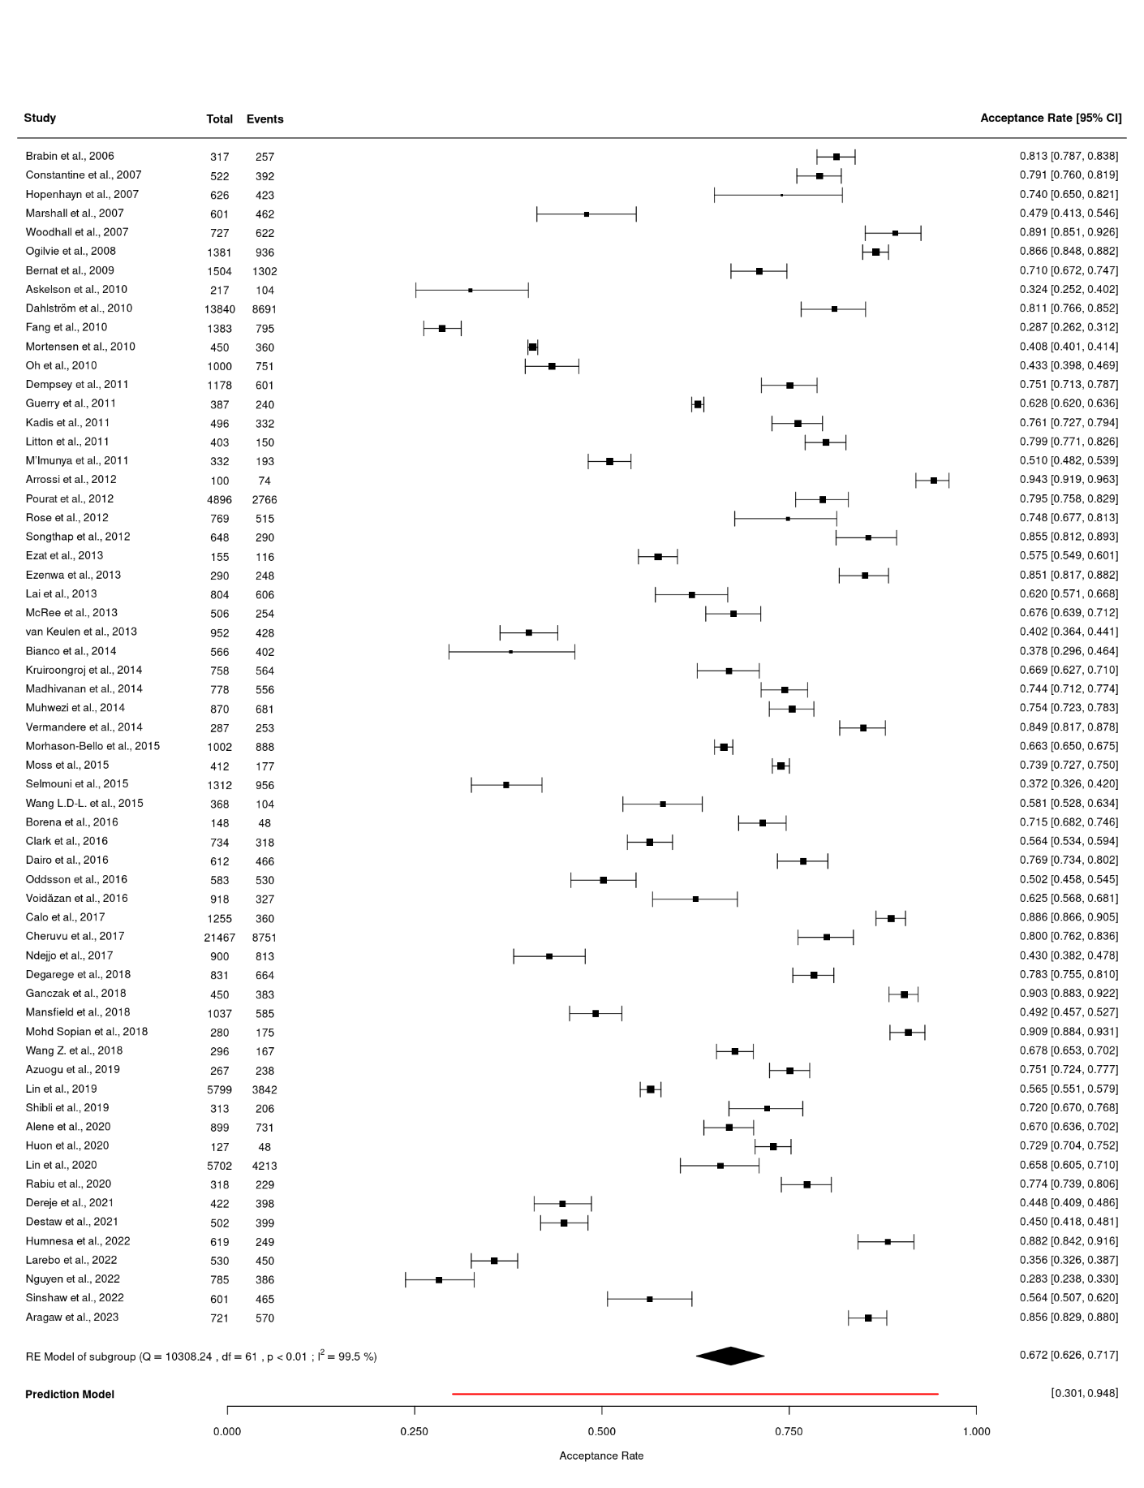
(random-effects model) (n = 62)

CI = Confidence interval
df = Degrees of freedom
Events = The number of parents/guardians in each study who reported acceptance of the HPV vaccine for their children
I² = I-squared statistic, indicating the percentage of variation due to heterogeneity
p < 0.01 = p-value, indicating statistical significance
Q = Cochran's Q statistic for heterogeneity
RE Model = Random-effects model
Total = The total number of parents/guardians in each study included in the meta-analysis

Additional file 9: Forest plot of HPV vaccine acceptance rates by sex of participants and world region
(random-effects model) (n = 62)

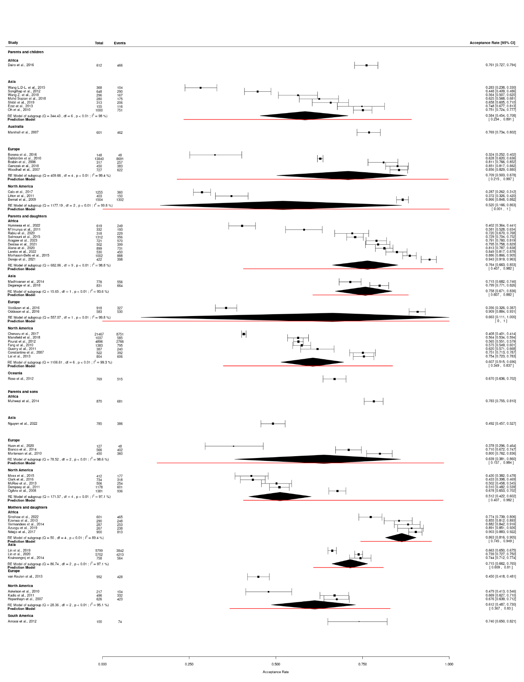

CI = Confidence interval
df = Degrees of freedom
Events = The number of parents/guardians in each study who reported acceptance of the HPV vaccine for their children
I² = I-squared statistic, indicating the percentage of variation due to heterogeneity
p < 0.01 = p-value, indicating statistical significance
Q = Cochran's Q statistic for heterogeneity
RE Model = Random-effects model
Total = The total number of parents/guardians in each study included in the meta-analysis

