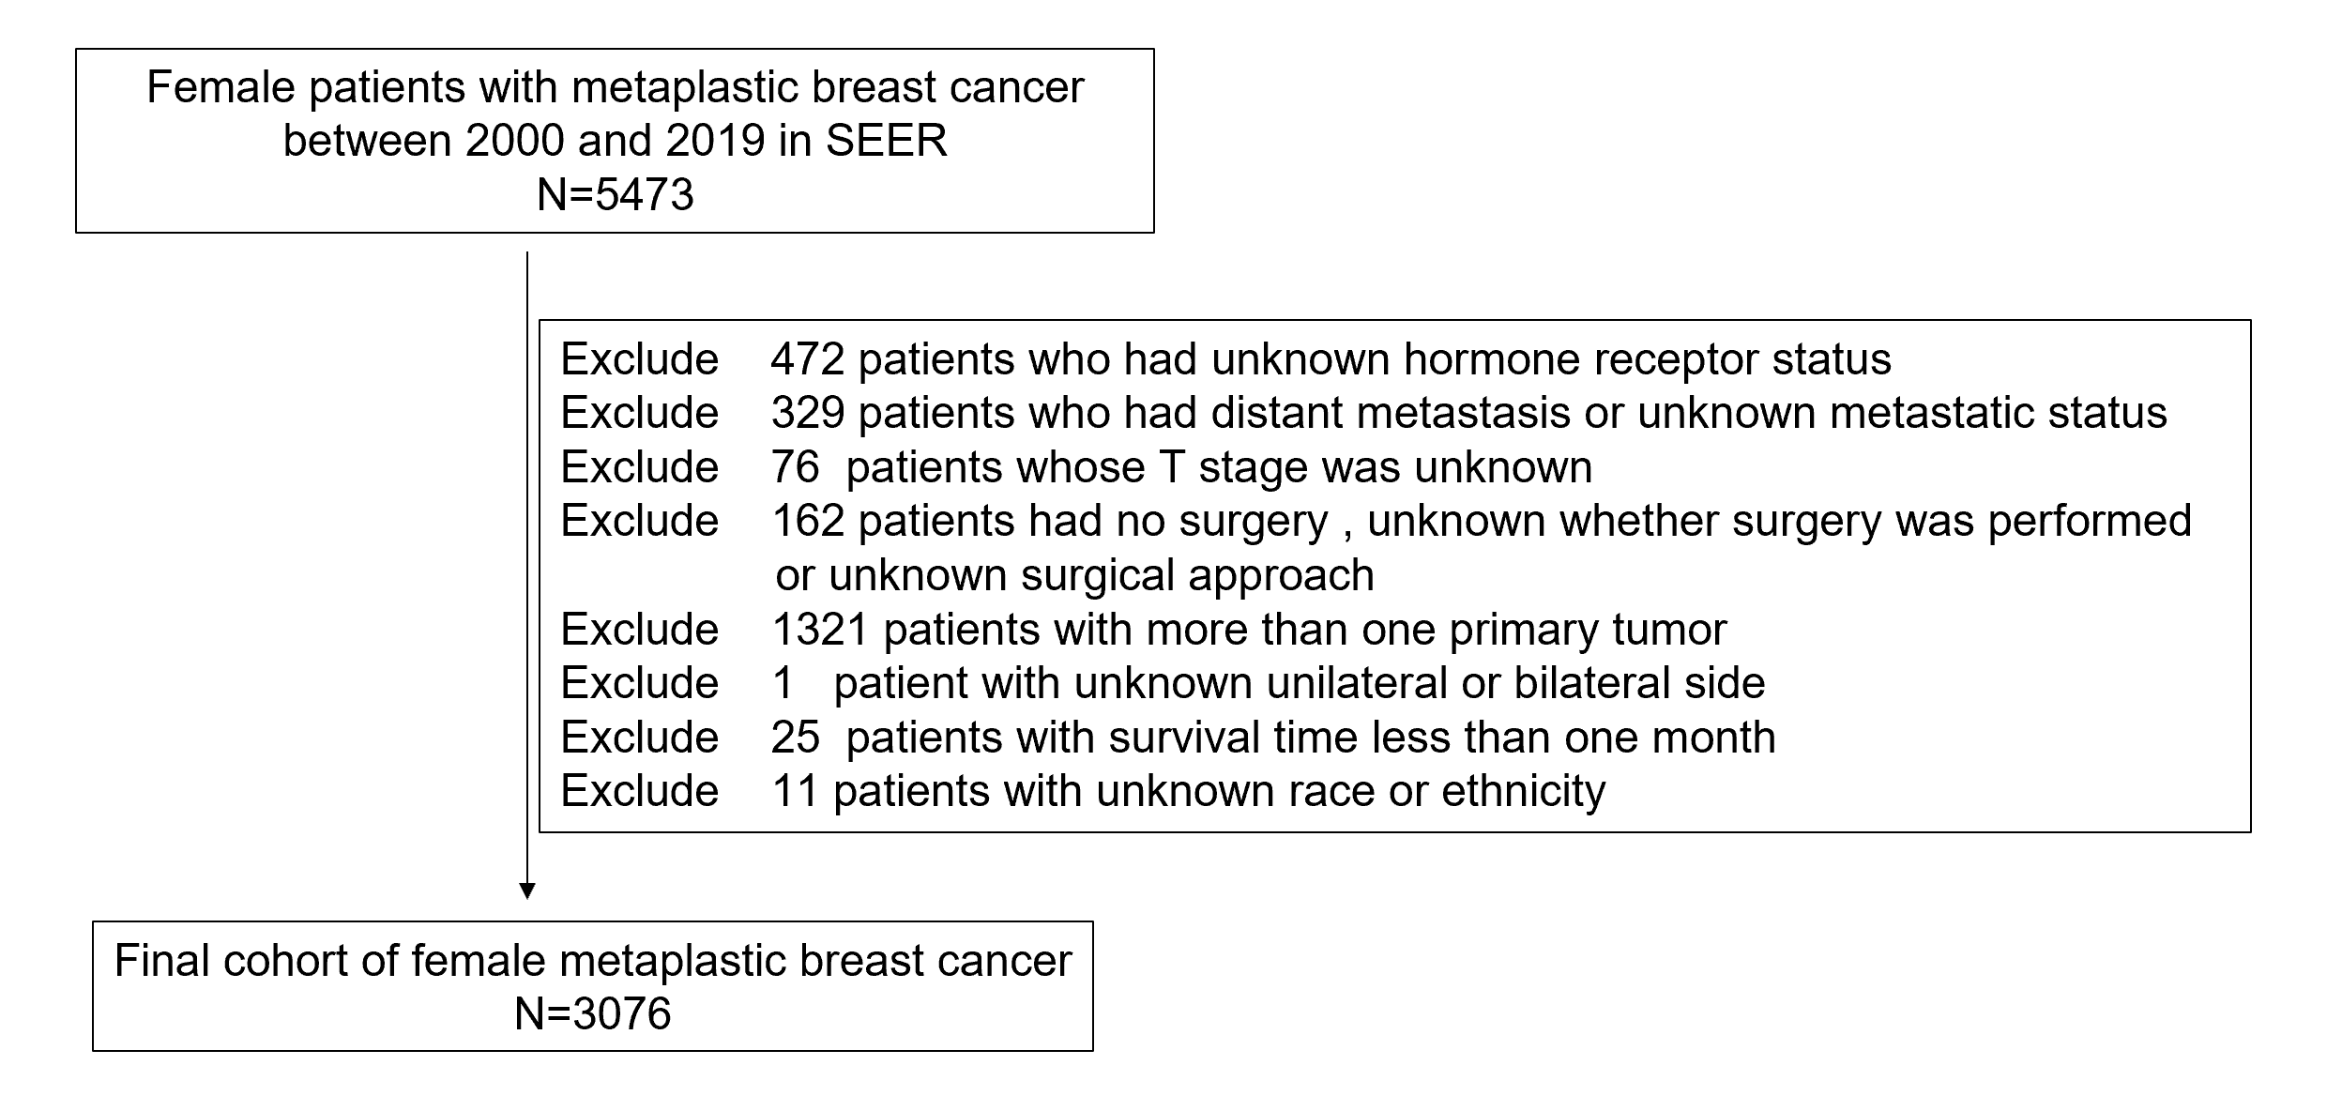
Supplementary Figure 1 Flow diagram for this study cohort.

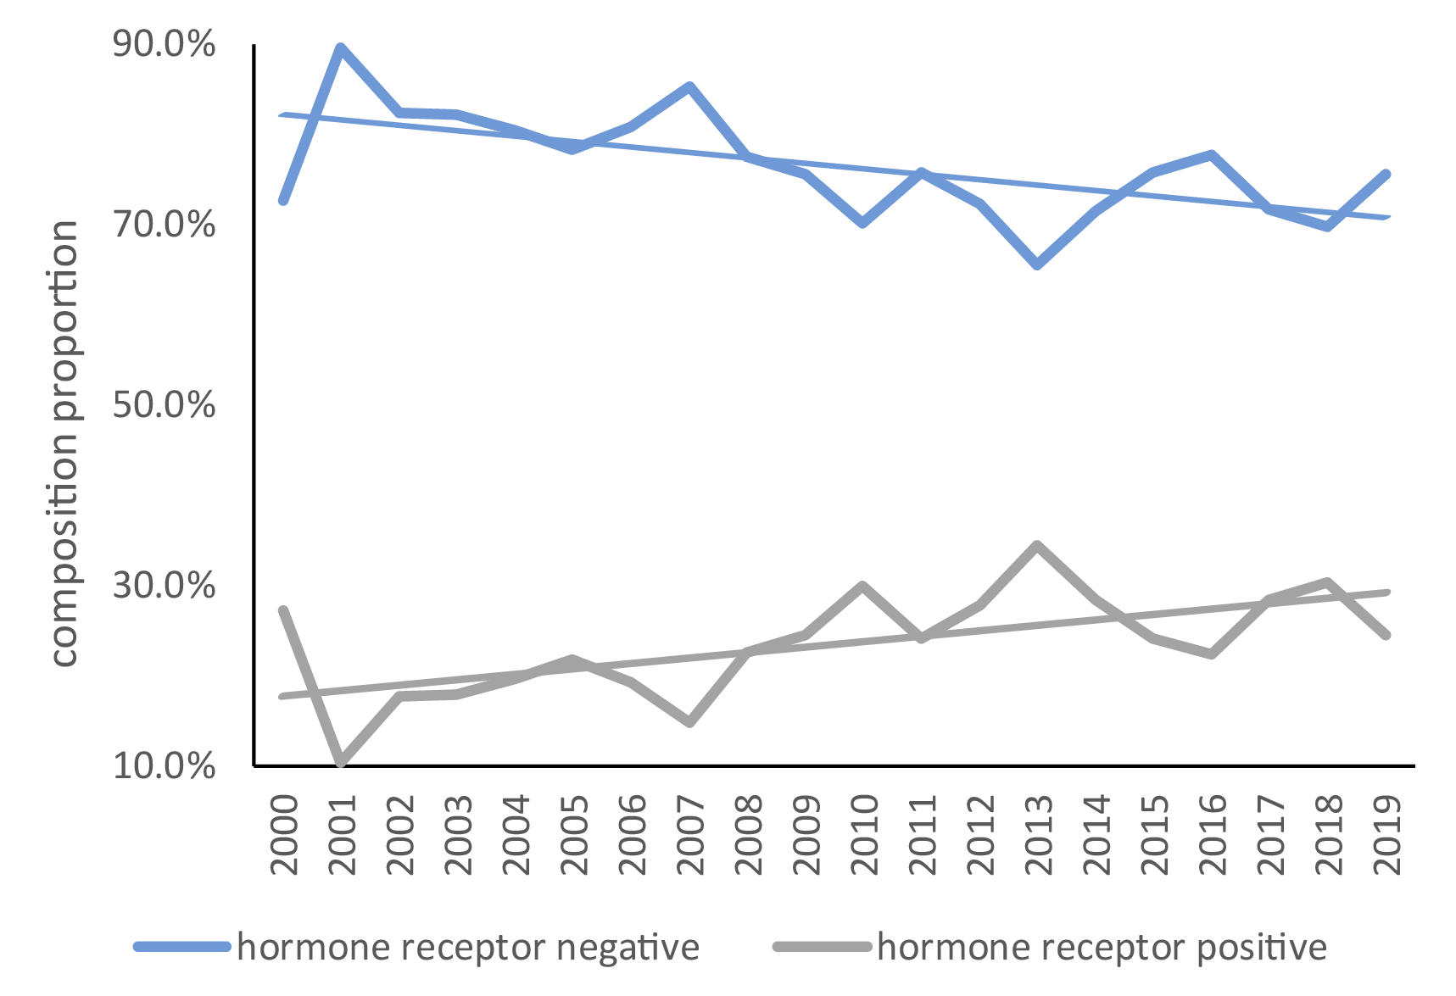
Supplementary Figure 2 Trends of the proportion of metaplastic breast cancer patients with different hormone receptor statuses (P= 0.004).

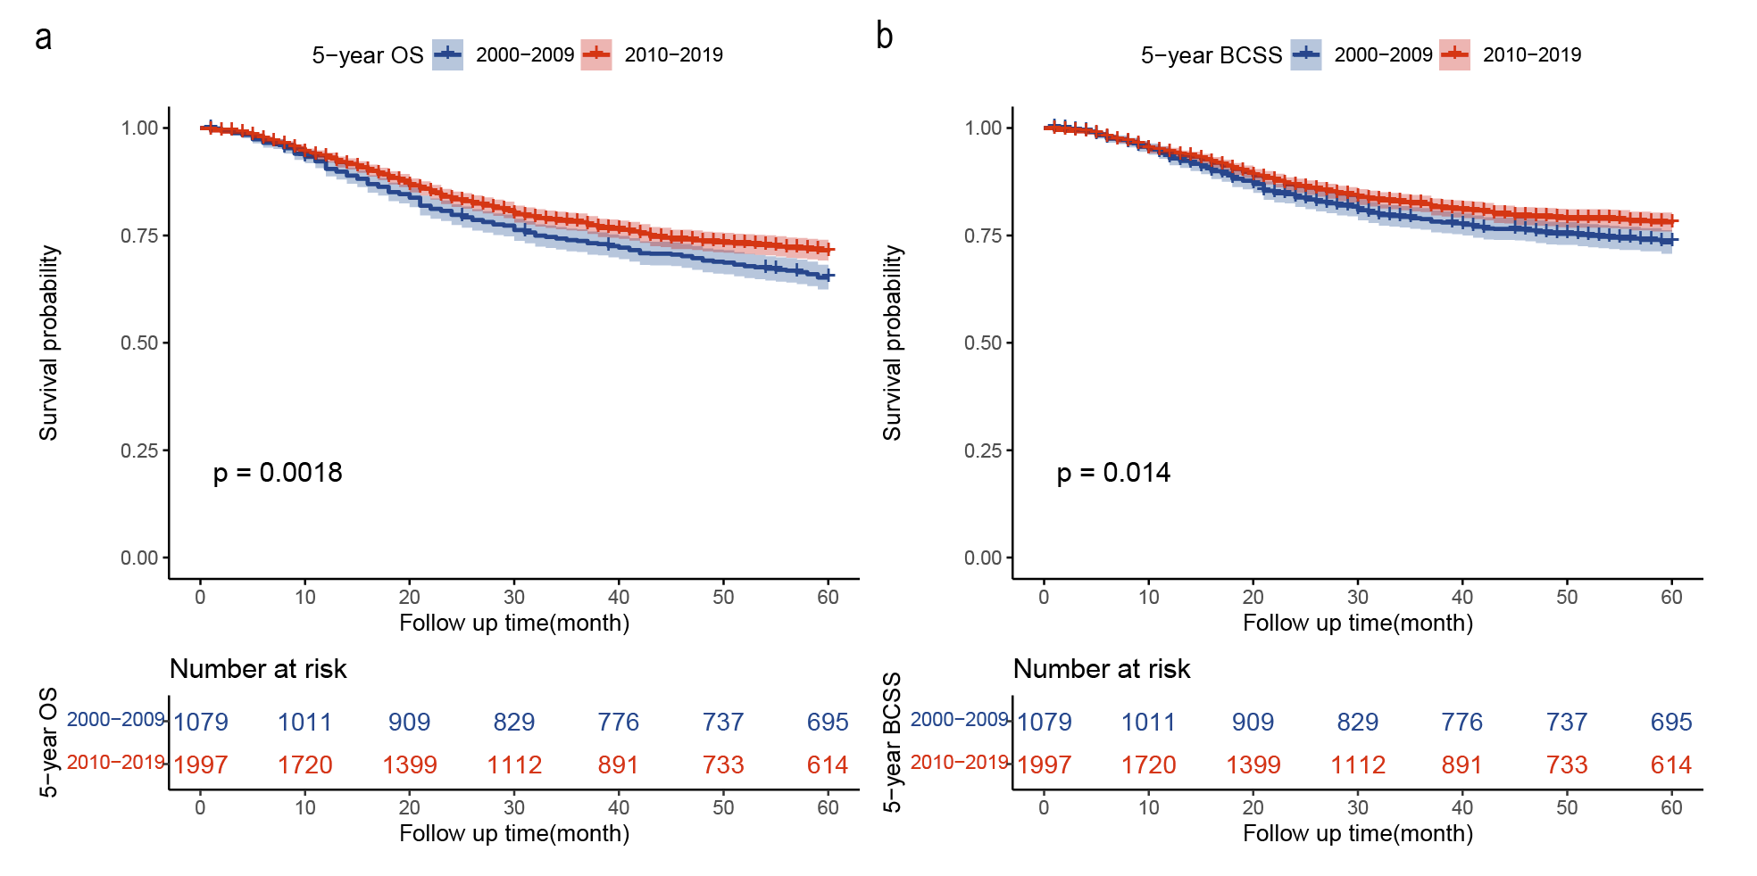
Supplementary Figure 3 Survival trends of all metaplastic breast cancer patients. (a)Five-year overall survival; (b) five-year breast cancer-specific survival. P-values were determined via the univariate log-rank test.

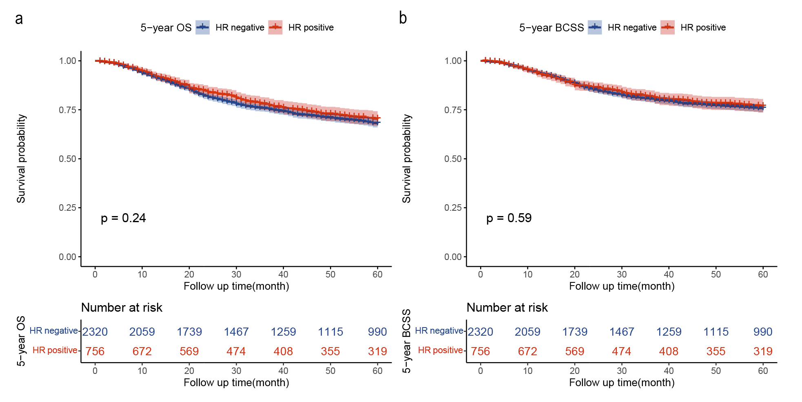
Supplementary Figure 4 The survival of metaplastic breast cancer patients with different hormone receptor statuses. (a) Five-year overall survival; (b) five-year breast cancer-specific survival. P-values were determined via the univariate log-rank test.

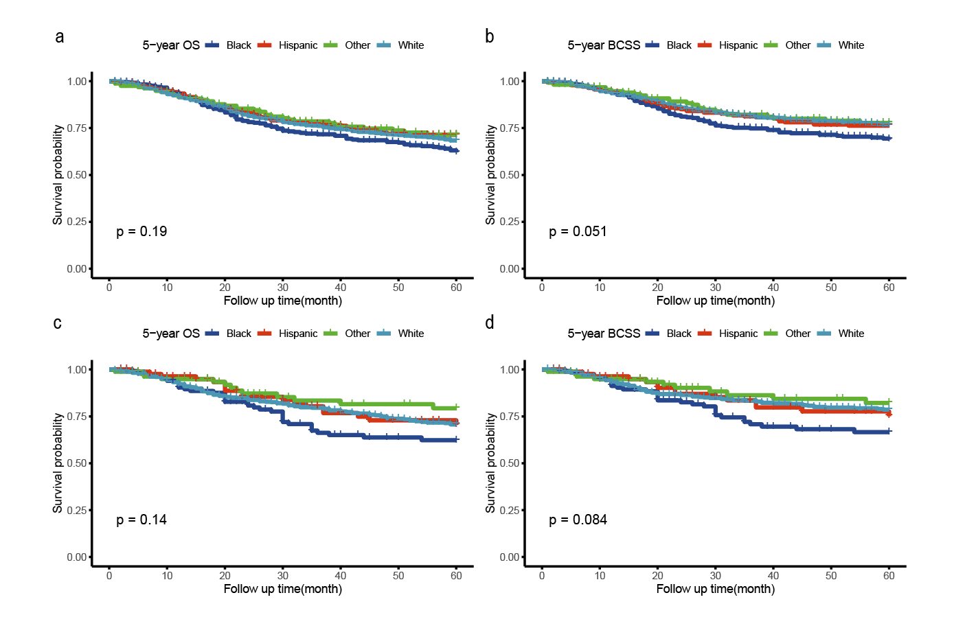
Supplementary Figure 5 The survival of metaplastic breast cancer patients by race groupings. (a, b) Five-year overall survival and breast cancer-specific survival of hormone receptor-negative patients by race groupings; (c, d) five-year overall survival and breast cancer-specific survival of hormone receptor-positive patients by race groupings. P-values were determined via univariate log-rank test.

