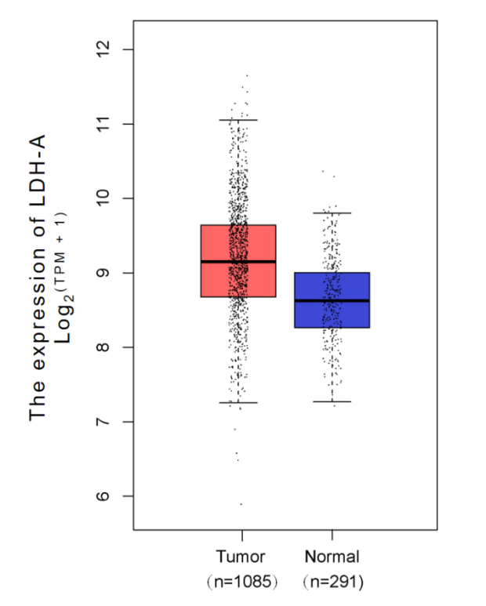
Supplementary Fig.1 LDHA expression in BC and normal tissues in the GTEx and TCGA databases. Abbreviation: BC, breast cancer; LDHA, lactate dehydrogenase A.

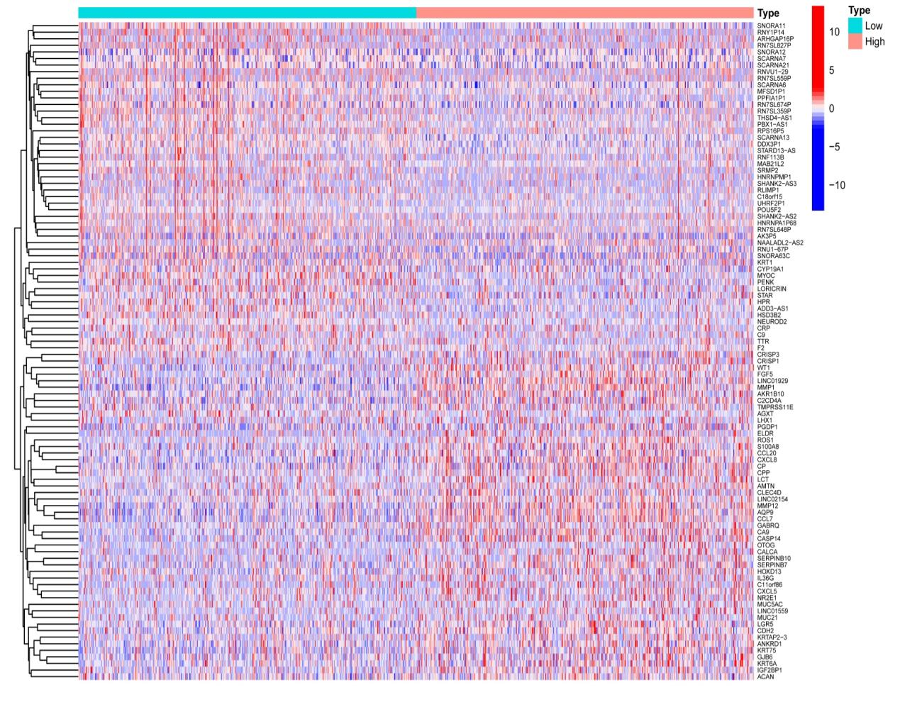
Supplementary Fig.2 Heatmap of LDHA differential genes. LDHA, lactate dehydrogenase A.

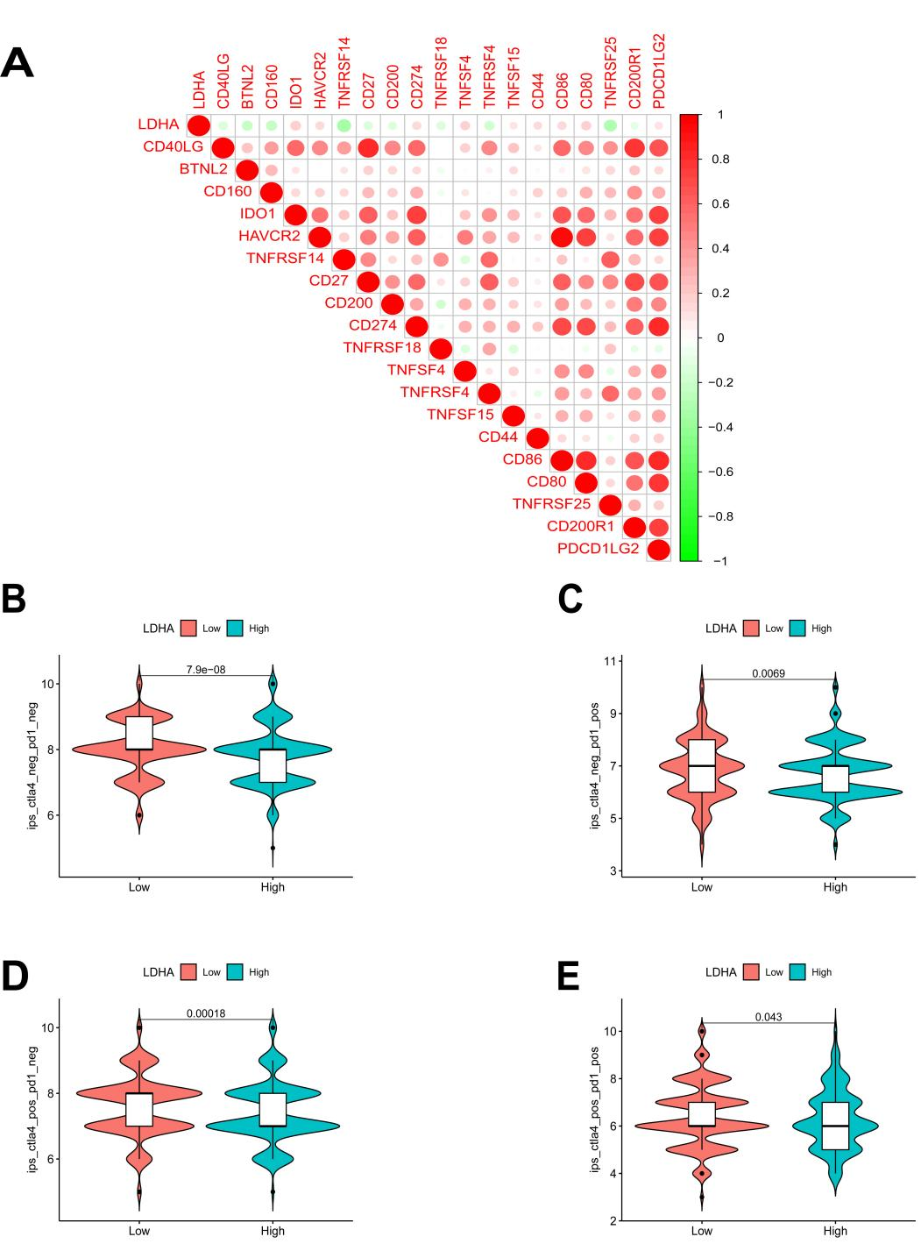
Supplementary Fig.3 Correlation between LDHA expression and immunotherapy in BC. A. Correlation between LDHA expression and immune checkpoints; B-E. Correlation between LDHA expression and CTLA-4 and PD-1. P < 0.05 indicates that the difference is statistically significant. Abbreviation: BC, breast cancer; CTLA-4, Cytotoxic T Lymphocyte-Associated Antigen-4; LDHA, lactate dehydrogenase A; PD-1, Programmed Death-1.

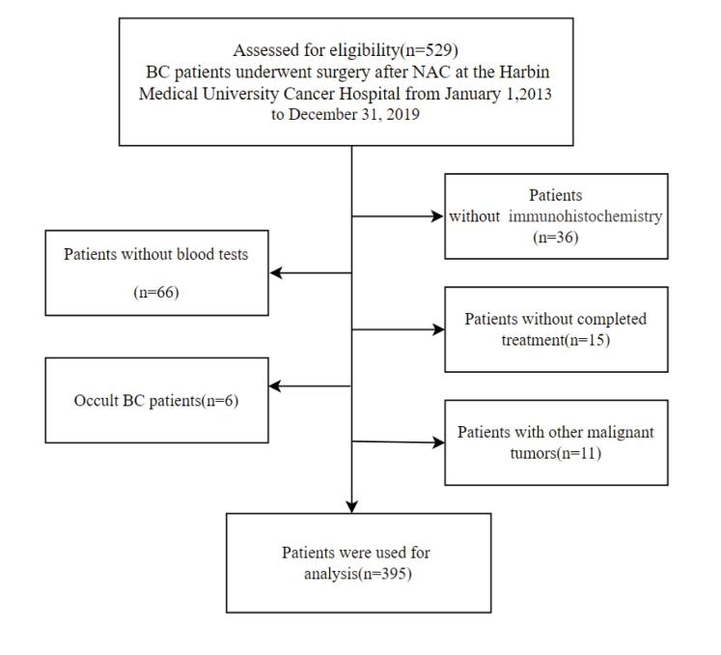
Supplementary Fig.4 Grouping flow chart of 395 BC patients collected. Abbreviation: BC, breast cancer; LDHA, lactate dehydrogenase A; NAC, neoadjuvant chemotherapy.

Supplementary Fig.5 ROC curve analysis for serum LDH levels. A. ROC curve of serum LDH levels before NAC; B. ROC curve of mid-NAC serum LDH levels; C. ROC curve for preoperative serum LDH levels. Abbreviation: BC, breast cancer; LDH, lactate dehydrogenase; NAC, neoadjuvant chemotherapy; ROC, receiver operating characteristic.

Supplementary Fig. 6 ROC curve analysis of clinical-pathological features in the NHANES cohort. A. ROC curve of serum LDH levels; B. ROC curve of serum total protein level; C. ROC curve of serum albumin levels; D. ROC curve of serum globulin levels; E. ROC curve of serum uric acid levels. Abbreviation: BC, breast cancer; LDH, lactate dehydrogenase; NAC, neoadjuvant chemotherapy; ROC, receiver operating characteristic.

