Long-term Waist Circumference and Diabetes Risk in Premenopausal Women: Role of Shared Risk Factors

Hye Ah Lee, Ph.D.^{1,2}

¹Clinical Trial Center, Ewha Womans University Mokdong Hospital, Seoul, Republic of Korea,
²Ewha Womans University College of Medicine, Seoul, Republic of Korea

Supplemental Table 1. Basic characteristics of study subjects by study area
 | Rural region
 | Yes | No | p
n | 538 (36.3%) | 944 (63.7%)
Age (range 40–55 years) | 44.6 ± 3.1 | 43.5 ± 2.9 | <0.001
Education level
Did not graduate high school | 373 (69.9%) | 297 (31.5%) | <0.001
Graduated high school | 142 (26.6%) | 508 (53.9%)
Some college or higher | 19 (3.6%) | 137 (14.5%)
Parental diabetes | 55 (10.2%) | 130 (13.8%) | 0.047
Current smoking | 12 (2.3%) | 27 (2.9%) | 0.552
Alcohol intake
None | 354 (69.1%) | 597 (64.2%) | 0.128
≤14 g/day | 146 (28.5%) | 301 (32.4%)
>14 g/day | 12 (2.3%) | 32 (3.4%)
Physical activity
Inactive | 120 (23.2%) | 413 (44.0%) | <0.001
Insufficiently active | 86 (16.6%) | 121 (12.9%)
Meets guidelines | 312 (60.2%) | 405 (43.1%)
Sleep time < 7 hrs | 182 (34.3%) | 547 (58.1%) | <0.001
Total energy (kcal) | 2029.9 ± 771.4 | 1870.1 ± 510.8 | <0.001
Dietary diversity score (range 0–12) | 7.1 ± 2.2 | 8.0 ± 1.8 | <0.001
≤5 | 124 (24.0%) | 83 (9.0%) | <0.001
6–8 | 249 (48.3%) | 464 (50.2%)
≥9 | 143 (27.7%) | 377 (40.8%)
Dietary inflammatory index | 0.7 ± 11.5 | -0.7 ± 8.5 | 0.018
Q1 (low) | 158 (30.7%) | 356 (38.4%) | <0.001
Q2 | 130 (25.2%) | 262 (28.2%)
Q3 | 126 (24.5%) | 203 (21.9%)
Q4 (high) | 101 (19.6%) | 107 (11.5%)
Unweighted genetic risk score
Missing | 97 (18.0%) | 165 (17.5%) | 0.613
Q1 (low) | 114 (21.2%) | 233 (24.7%)
Q2 | 106 (19.7%) | 167 (17.7%)
Q3 | 138 (25.7%) | 238 (25.2%)
Q4 (high) | 83 (15.4%) | 141 (14.9%)
FBG, mg/dL | 80.9 ± 7.2 | 80.0 ± 6.8 | 0.013
HbA1c, % | 5.4 ± 0.3 | 5.4 ± 0.3 | 0.254
HDL-C, mg/dL | 46.6 ± 9.5 | 47.1 ± 9.7 | 0.262
MAP, mmHg | 90.2 ± 11.2 | 84.6 ± 11.2 | <0.001
TG, mg/dL | 101.0 (82.0-132.0) | 107.0 (84.0-140.0) | 0.166*
BMI, kg/m² | 24.6 ± 3.2 | 24.2 ± 2.9 | 0.004
WC, cm (min-max) | 80.4 ± 8.4 (55.7-113.0) | 75.7 ± 8.1 (58.0-120.7) | <0.001
Mean WC, cm (min-max) | 83.4 ± 7.8 (59.2-110.5) | 75.4 ± 6.6 (58.3-108.3) | <0.001
Incident diabetes | 41 (7.6%) | 47 (5.0%) | 0.039
FBG: fasting blood glucose, HbA1c: hemoglobin A1c, HDL-C: high-density lipoprotein cholesterol, MAP: Mean arterial pressure, TG: triglycerides, BMI: body mass index, WC: waist circumference.
*P value was obtained from the Mann-Whitney U test.
Values are expressed as mean with standard deviation and median with interquartile range, according to the normal distribution of numerical variables and the number of subjects with percentages for categorical variables.
Supplemental Table 2. Sensitivity analysis results regarding characteristics associated with the mean waist circumference
 | Sensitivity analysis 1 |  | Sensitivity analysis 2
 | Mean WCª |  | Mean WC^{b}
 | β (SE) | p | β (SE) | p
Age, years | 0.21 (0.07) | 0.002 | 0.23 (0.08) | 0.005
Rural region=Yes | 6.47 (0.45) | <0.001 | 6.82 (0.56) | <0.001
Education level
Did not graduate high school | 1.00 |  | 1.00
Graduated high school | -1.48 (0.42) | 0.001 | -1.64 (0.52) | 0.002
Some college or higher | -2.12 (0.65) | 0.001 | -2.07 (0.89) | 0.021
Parental diabetes | 1.57 (0.56) | 0.005 | 1.41 (0.72) | 0.050
Current smoking | -0.96 (1.24) | 0.438 | 0.09 (1.53) | 0.955
Alcohol intake
None | 1.00 |  | 1.00
≤14 g/day | 1.21 (0.40) | 0.003 | 1.40 (0.51) | 0.006
>14 g/day | 3.11 (1.10) | 0.005 | 2.75 (1.34) | 0.041
Physical activity
Inactive | 1.00 |  | 1.00
Insufficiently active | -0.48 (0.59) | 0.418 | -0.88 (0.76) | 0.247
Meets guidelines | 0.55 (0.41) | 0.175 | 0.80 (0.52) | 0.127
Sleep time < 7 hrs | 0.05 (0.38) | 0.895 | -0.14 (0.48) | 0.769
Total energy, per 100 kcal | 0.10 (0.04) | 0.007 | 0.03 (0.05) | 0.540
Dietary diversity score (range 0–12) | -0.20 (0.12) | 0.083 | -0.13 (0.14) | 0.366
Dietary inflammatory index | 0.01 (0.02) | 0.805 | -0.01 (0.03) | 0.847
Unweighted genetic risk score
Missing | 0.99 (0.60) | 0.100 | 0.04 (0.78) | 0.960
Q1 (low) | 1.00
Q2 | 0.01 (0.55) | 0.980 | 0.31 (0.69) | 0.649
Q3 | -0.53 (0.52) | 0.303 | -0.37 (0.64) | 0.567
Q4 (high) | -0.36 (0.60) | 0.541 | -0.79 (0.74) | 0.284
FBG, mg/dL | 0.06 (0.03) | 0.024 | 0.10 (0.03) | 0.004
HbA1c, per 0.1 % | 0.21 (0.06) | 0.001 | 0.13 (0.08) | 0.096
HDL-C, mg/dL | -0.11 (0.02) | <0.001 | -0.10 (0.03) | <0.001
MAP, mmHg | 0.09 (0.02) | <0.001 | 0.06 (0.02) | 0.004
TG, per 10 mg/dL | 0.15 (0.04) | <0.001 | 0.18 (0.05) | <0.001
WC: waist circumference, SE: standard error, FBG: fasting blood glucose, HbA1c: hemoglobin A1c, HDL-C: high-density lipoprotein cholesterol, MAP: Mean arterial pressure, TG: triglycerides
Numbers in bold indicate statistical significance.
ª Sensitivity analysis 1 was conducted using data from 1,312 women who had their WC measured at least three times over ten years. Beta coefficients with standard errors for mean waist circumference were obtained using multivariate linear regression.
^{b} Sensitivity analysis 2 was conducted using data from 829 women who had experienced menopause over ten years. Beta coefficients with standard errors for mean waist circumference were obtained using multivariate linear regression.

Supplemental Table 3. Sensitivity analysis results for the effect of mean waist circumference over ten years on incident diabetes
 | Original subjects |  | Sensitivity analysis 1 ª |  | Sensitivity analysis 2 ^{b}
 | AHR (95% CI) | P for global test^{d} | AHR (95% CI) ª | P for global test^{d} | AHR (95% CI) ^{b} | P for global test^{d}
Mean WC, cm | 1.08 (1.05-1.11)^{c} | 0.670 | 1.08 (1.05-1.12) | 0.560 | 1.07 (1.02-1.11) | 0.843
Mean WC ≥ 80 cm | 3.16 (1.81-5.50) | 0.468 | 3.28 (1.85-5.81) | 0.480 | 2.28 (1.04-4.97) | 0.862
Baseline WC, cm | 1.04 (1.01-1.07)^{c} | 0.591 | 1.04 (1.01-1.07) | 0.510 | 1.04 (0.99-1.08) | 0.867
Baseline WC ≥ 80 cm | 1.76 (1.07-2.89) | 0.548 | 1.76 (1.05-2.94) | 0.490 | 1.67 (0.82-3.39) | 0.861
WC: waist circumference, AHR: adjusted hazard ratio, 95% CI: 95% confidence interval
Mean WC represents the average value of waist circumference calculated from repeated measurements.
Numbers in bold indicate statistical significance.
ª Sensitivity analysis 1 was conducted using data from 1,312 women who had their WC measured at least three times over ten years.
^{b} Sensitivity analysis 2 was conducted using data from 829 women who had experienced menopause over ten years.
^{c} Model fit using mean WC showed a Bayesian Information Criterion (BIC) of 1071.0, and the model using baseline WC showed a BIC of 1085.6.
^{d} P values obtained from the Schoenfeld test for the proportional hazards assumption.
Adjusted hazard ratios with 95% confidence intervals were calculated after adjusting for age, study region, education level, parental diabetes, current smoking, alcohol intake, physical activity, sleep time, total energy intake, dietary diversity score, dietary inflammatory index, unweighted genetic risk score, fasting blood glucose, hemoglobin A1c, high-density lipoprotein cholesterol, mean arterial pressure, and triglycerides.

Supplemental Table 4. Node predictability estimated from the mixed graphical model network
Variable | label | R² | CC
Age | Age | 0.124
Rural region | Rural |  | 0.808
Education level | Edu |  | 0.608
Parental diabetes | PA |  | 0.873
Current smoking | Smoking |  | 0.972
Alcohol intake | Alcohol |  | 0.667
Physical activity | PA |  | 0.539
Sleep time < 7 hrs | Sleep |  | 0.61
Total energy | kcal | 0.346
Dietary diversity score | DDS | 0.402
Dietary inflammatory index | DII | 0.174
Unweighted genetic risk score | SNP level |  | 0.277
FBG | FBG | 0.115
HbA1c | HbA1c | 0.139
HDL-C | HDL-C | 0.228
MAP | MAP | 0.163
TG | TG | 0.253
Mean WC | Mean WC | 0.364
Incident diabetes | DM |  | 0.94
FBG: fasting blood glucose, HbA1c: hemoglobin A1c, HDL-C: high-density lipoprotein cholesterol, MAP: Mean arterial pressure, TG: triglycerides, WC: waist circumference.
Values indicate the predictability of each variable, with explained variance (R²) for continuous variables and correct classification (CC) for categorical variables.
Supplemental Figure 1. Tracking of waist circumference in women over ten years by study area
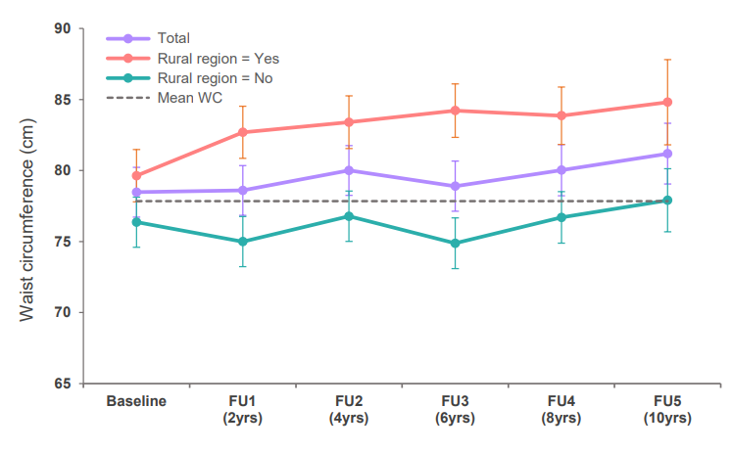
FU: follow-up, WC: waist circumference.
Adjusted mean waist circumference (circles) and 95% confidence intervals (bars) during the follow-up period are presented. These values were obtained from a linear mixed model with a random intercept, using an unstructured covariance matrix (Bayesian Information Criterion (BIC) = 40,942.6 for the total population and BIC = 40,500.1 for the model including the interaction term of time and study region). The model was adjusted for age, study region, education level, parental diabetes, current smoking, alcohol intake, physical activity, sleep time, total energy intake, dietary diversity score, dietary inflammatory index, unweighted genetic risk score, fasting blood glucose, hemoglobin A1c, high-density lipoprotein cholesterol, mean arterial pressure, triglycerides, and time as fixed effects. The estimated values for the time-specific study regions were obtained by including the interaction term of time and study region (time × study region) in a linear mixed model. This parameter was statistically significant (P<0.001). The mean waist circumference (dashed line) represents the summarized value of the waist circumference measured multiple times for each individual during the follow-up period.

Supplemental Figure 2. Subgroup differences in the impact of mean waist circumference over ten years on incident diabetes
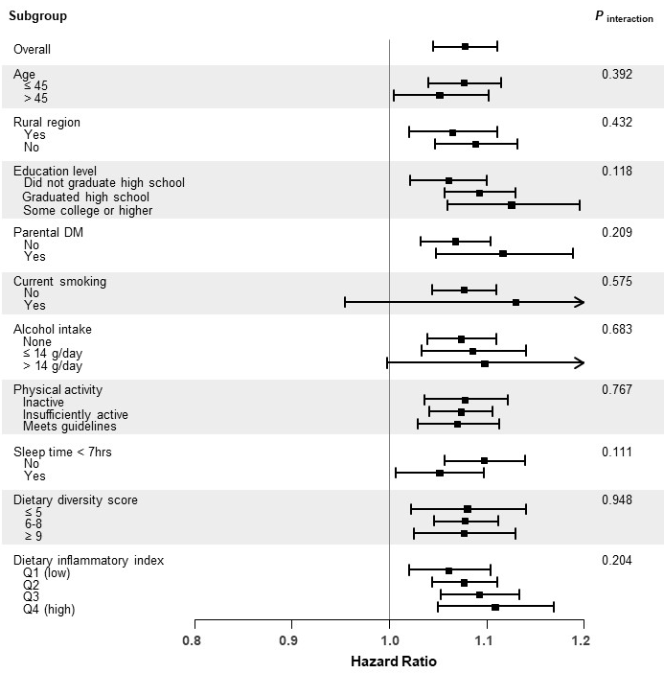

Hazard ratios (squares) with 95% confidence intervals (bars) were obtained, adjusted for age, study region, education level, parental diabetes, current smoking, alcohol intake, physical activity, sleep time, total energy intake, dietary diversity score, dietary inflammatory index, unweighted genetic risk score, fasting blood glucose, hemoglobin A1c, high-density lipoprotein cholesterol, mean arterial pressure, and triglycerides.

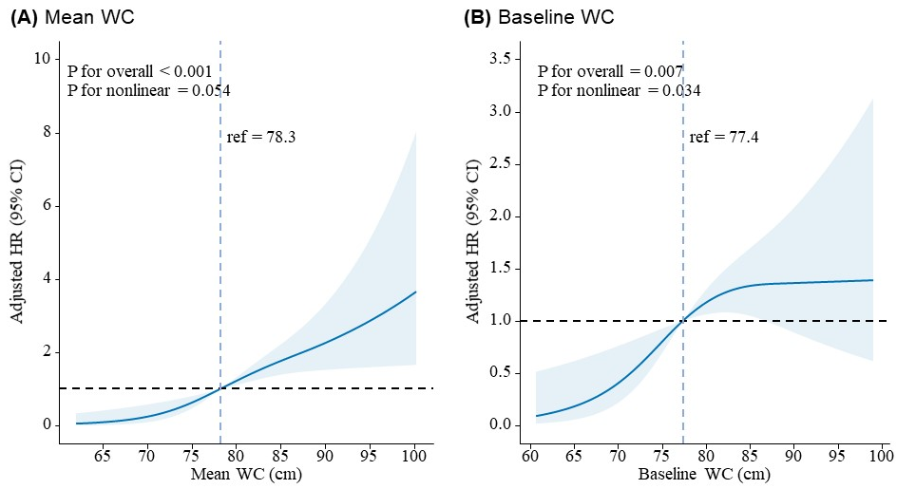
Supplemental Figure 3. Nonlinear associations of long-term mean and baseline waist circumference with type 2 diabetes risk using restricted cubic splines
WC: waist circumference, ref: reference, HR: hazard ratio, 95% CI: 95% confidence interval.
Knots for long-term mean and baseline waist circumference were selected based on the lowest Bayesian Information Criterion (BIC). As a result, hazard ratios were estimated using three knots. For the hazard ratios, the average values of mean and baseline waist circumference were used as the reference. Adjusted hazard ratios with 95% confidence intervals were calculated after adjusting for age, study region, education level, parental diabetes, current smoking, alcohol intake, physical activity, sleep time, total energy intake, dietary diversity score, dietary inflammatory index, unweighted genetic risk score, fasting blood glucose, hemoglobin A1c, high-density lipoprotein cholesterol, mean arterial pressure, and triglycerides.

Supplemental Figure 4. Edge selection probabilities in the mixed graphical model network
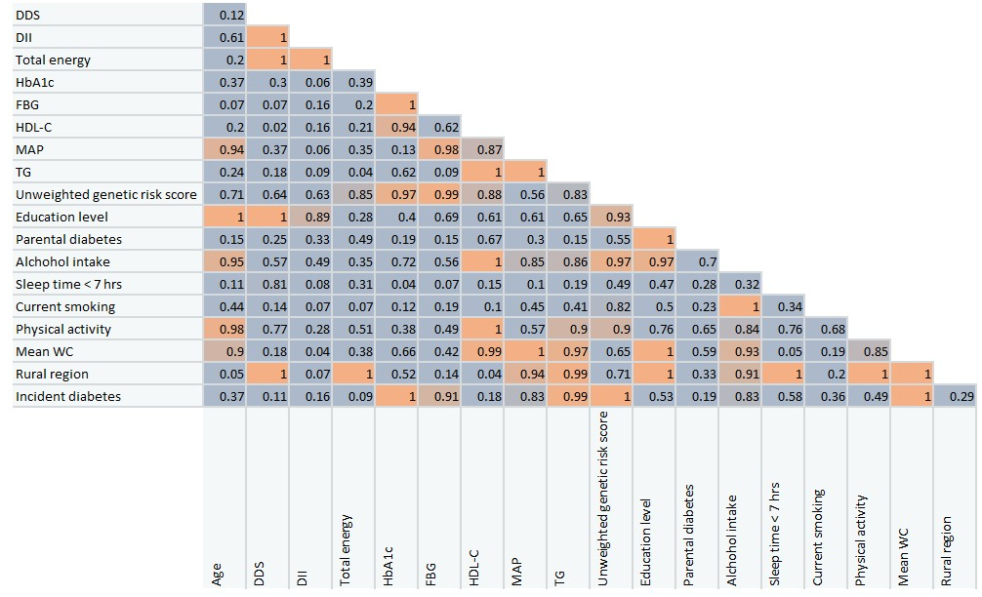
DDS: dietary diversity score, DII: dietary inflammatory index, HbA1c: hemoglobin A1c, FBG: fasting blood glucose, HDL-C: high-density lipoprotein cholesterol, MAP: Mean arterial pressure, TG: triglycerides, WC: waist circumference.
Values indicate edge selection probabilities, which were calculated using 100 bootstrap samples. Values higher than 0.9 indicate edge stability.

Supplemental Figure 5. Network structure of incident diabetes, mean waist circumference, and associated risk factors among women by study area
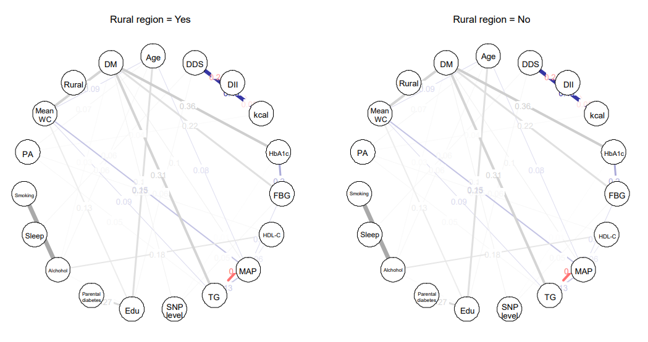
DDS: dietary diversity score, DII: dietary inflammatory index, FBG: fasting blood glucose, HbA1c: hemoglobin A1c, HDL-C: high-density lipoprotein cholesterol, MAP: Mean arterial pressure, TG: triglycerides, PA: Physical activity, SNP: single nucleotide polymorphism, WC: waist circumference
The edges represent conditional dependence relationships, with their widths proportional to the strength of the association. Blue edges indicate positive relationships, red edges indicate negative relationships, and grey edges indicate relationships involving categorical variables for which the signs are undefined.

