Supplementary materials
Table S1: Primer and probe sequences, standard curve slopes, R² values, LOD, and LOQ for bacterial quantification
Target Bacterium | Forward Primer  (5'-3') | Reverse Primer  (5'-3') | Standard Curve Slope | R²  Value | LOD (copies/reaction) | LOQ (copies/reaction)
Lactobacillus | AGCAGTAGGGAATCTTCCA | CACCGCTACACATGGAG | -3.35 | 0.996 | 100 | 500
Bifidobacterium | TCGCGTCYGGTGTGAAAG | CTGATAGGACGCGACCC | -3.32 | 0.998 | 100 | 500
Enterococcus | ATCACGGTCCAGACAAAGAG | ACGCTCGTTGCGGGACTTAACCCAAC | -3.47 | 0.995 | 100 | 500
Escherichia coli | CATTGACGTTACCCGCAGAAGAAGC | CTCTACGAGACTCAAGCTTGC | -3.4 | 0.997 | 100 | 500

Table S2: Kolmogorov–Smirnov test statistics and normality classification for each variable
Variable | K-S Statistic | p-value | Normal Distribution
gmGUS activity | 0.162 | 0.018 | No
Lactobacillus abundance | 0.088 | 0.2 | Yes
Bifidobacterium abundance | 0.074 | 0.2 | Yes
Enterococcus abundance | 0.193 | 0.005 | No
E. coli abundance | 0.215 | 0.002 | No
Serum FSH | 0.096 | 0.2 | Yes
Serum E2 | 0.134 | 0.045 | No

Table S3: both Pearson and Spearman correlation coefficients and p-values for key variable pairs
Variable Pair | Pearson r | Pearson p | Spearman r | Spearman p
gmGUS vs FSH | 0.42 | 0.012 | 0.45 | 0.008
gmGUS vs E2 | -0.37 | 0.026 | -0.35 | 0.031
Lactobacillus vs FSH | -0.18 | 0.311 | -0.2 | 0.271
Bifidobacterium vs E2 | 0.22 | 0.173 | 0.24 | 0.148
Enterococcus vs FSH | 0.4 | 0.018 | 0.42 | 0.014
E. coli vs E2 | -0.33 | 0.035 | -0.3 | 0.042

Table S4: Sensitivity analysis by amenorrhea duration
Groups | gmGUS vs FSH (r, p) | gmGUS vs E2 (r, p) | Enterococcus vs FSH (r, p) | E. coli vs E2 (r, p)
Amenorrhea <6 months (n=18) | 0.41, 0.047 | -0.36, 0.066 | 0.38, 0.059 | -0.32, 0.084
Amenorrhea ≥6 months (n=22) | 0.43, 0.031 | -0.39, 0.049 | 0.42, 0.034 | -0.35, 0.052

Table S5: A full logistic regression results
Predictor | Coefficient (β) | SE | OR | 95% CI Lower | 95% CI Upper | p-value | VIF
gmGUS activity | 0.82 | 0.29 | 2.27 | 1.286 | 4.008 | 0.004 | 1.45
Lactobacillus abundance | -0.45 | 0.21 | 0.638 | 0.422 | 0.962 | 0.032 | 1.32
Bifidobacterium abundance | -0.28 | 0.25 | 0.756 | 0.463 | 1.234 | 0.161 | 1.28
Enterococcus abundance | 0.67 | 0.3 | 1.954 | 1.085 | 3.518 | 0.019 | 1.51
E. coli abundance | 0.54 | 0.27 | 1.716 | 1.011 | 2.913 | 0.041 | 1.47
Note: standard errors (SE), odds ratios (OR), 95% confidence intervals (CI), and variance inflation factors (VIFs)
Table S6: PPV And NPV At Different Assumed Prevalences
Assumed Prevalence (%) | Sensitivity (%) | Specificity (%) | PPV (%) | NPV (%)
1 | 95.2 | 71.2 | 3.2 | 99.9
5 | 95.2 | 71.2 | 15 | 99
10 | 95.2 | 71.2 | 26.4 | 97.5

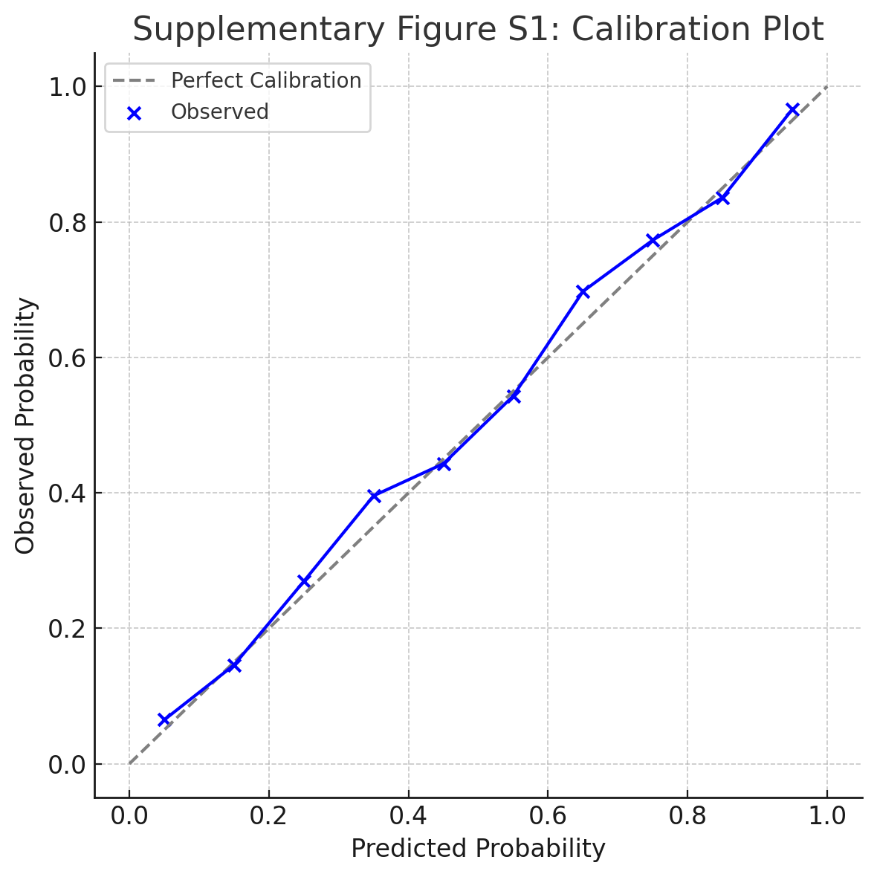
Figure S1 A calibration plot showing predicted vs. observed probabilities, with the reference line for perfect calibration.

Table S7: Anonymized Numeric Data
Group | Lactobacillus (log CFU/g) | Bifidobacterium (log CFU/g) | Enterococcus (log CFU/g) | Escherichia coli (log CFU/g) | gmGUS activity (U/mL) | AMH (ng/mL) | FSH (U/mL) | LH (U/L) | E2 (pmol/L)
POF | 8.75 | 8.03 | 8.31 | 10.69 | 478.25 | 2.41 | 61.11 | 42.95 | 46.87
POF | 8.18 | 8.47 | 9.85 | 9.49 | 445.77 | 3.07 | 81.04 | 42.96 | 55.24
POF | 8.88 | 8.17 | 8.3 | 9.55 | 462.62 | 2.53 | 71.22 | 47.87 | 44.7
POF | 9.67 | 7.15 | 9.34 | 10.67 | 440.07 | 2.31 | 69.84 | 40.01 | 47.06
POF | 8.09 | 9.23 | 9.15 | 7.98 | 550.77 | 2.73 | 81.02 | 43.32 | 49.13
POF | 8.09 | 8.88 | 8.38 | 8.05 | 483.23 | 1.52 | 78.28 | 40.3 | 46.48
POF | 9.72 | 8.91 | 11.46 | 9.15 | 457.51 | 2.49 | 69.98 | 40.45 | 42.49
POF | 8.99 | 7.38 | 9.8 | 9.96 | 489.49 | 2.71 | 85.64 | 41.13 | 46.52
POF | 7.88 | 9.46 | 6.87 | 10.8 | 478.07 | 1.81 | 62.57 | 44 | 52.06
POF | 8.79 | 6.94 | 9.31 | 12.66 | 474.27 | 2.86 | 80.04 | 40.21 | 38.83
POF | 7.88 | 8.73 | 8.37 | 11.67 | 503.5 | 2.54 | 79.81 | 49.58 | 46.14
POF | 7.88 | 10.17 | 10.04 | 10.04 | 508.51 | 2.23 | 70.51 | 37.97 | 40.89
POF | 8.52 | 7.31 | 8.23 | 10.27 | 463.43 | 2.65 | 77.06 | 41.79 | 52.83
POF | 6.58 | 7.69 | 8.97 | 8.7 | 461.85 | 3.31 | 60.81 | 40.43 | 35.7
POF | 6.75 | 8.29 | 9.66 | 10.27 | 472.37 | 2.47 | 83.22 | 50.61 | 41.78
POF | 7.79 | 7.75 | 10.05 | 9.84 | 401.43 | 2.5 | 71.8 | 43.86 | 47.68
POF | 7.39 | 6.8 | 7.78 | 10.82 | 428.97 | 2.22 | 68.32 | 48.37 | 55.16
POF | 8.58 | 8.26 | 8.73 | 8.98 | 529.84 | 2.06 | 84.5 | 34.78 | 44.89
POF | 7.48 | 7.24 | 8.58 | 11.13 | 539.57 | 2.73 | 66.45 | 44.24 | 41.8
POF | 7.03 | 8.63 | 8.38 | 12.75 | 473.28 | 2.06 | 59.19 | 47.6 | 57.15
POF | 9.62 | 7.37 | 11.04 | 10.13 | 502.18 | 2.43 | 57.67 | 43.24 | 36.18
POF | 8.1 | 9.59 | 9.55 | 10.94 | 492.89 | 2.21 | 79.94 | 48.55 | 31.45
POF | 8.36 | 7.5 | 7.71 | 11.4 | 589.76 | 2.59 | 60.51 | 40.01 | 48.07
POF | 7.02 | 7.91 | 10.11 | 9.66 | 521.19 | 2.53 | 91.77 | 50.41 | 42.14
POF | 7.81 | 8.93 | 11.43 | 10.66 | 477.52 | 2.82 | 52.26 | 55.21 | 38.87
POF | 8.4 | 7.09 | 10.24 | 10.32 | 448.56 | 2.2 | 91.17 | 40.84 | 49.76
POF | 7.26 | 8.4 | 7.43 | 10.46 | 425.77 | 2.29 | 75.87 | 40.39 | 46.84
POF | 8.64 | 9.38 | 8.57 | 9.06 | 489.12 | 2.01 | 72.7 | 50.65 | 41.75
POF | 7.76 | 6.75 | 10.49 | 10.34 | 455.53 | 2.22 | 68.09 | 51.33 | 37.23
POF | 8.04 | 8.37 | 8.32 | 11.1 | 432.22 | 2.55 | 77.81 | 39.98 | 50.8
POF | 7.76 | 8.43 | 9.59 | 12.62 | 459.37 | 2.7 | 73.31 | 40.53 | 49.4
POF | 9.97 | 8.9 | 9.95 | 11.83 | 444.15 | 2.03 | 85.06 | 41.28 | 44.68
POF | 8.29 | 7.09 | 8.08 | 13.75 | 541.05 | 2.75 | 74.88 | 35.54 | 56.93
POF | 7.35 | 7.01 | 9.03 | 9.07 | 512.86 | 2.94 | 75.25 | 37.84 | 38.56
POF | 9.04 | 8.67 | 5.53 | 11.7 | 481.72 | 2.57 | 69.95 | 37.38 | 35.69
POF | 7.2 | 8.47 | 7.97 | 10.59 | 533.8 | 3.15 | 73.11 | 38.65 | 40.94
POF | 8.49 | 8.43 | 8.82 | 13.8 | 484.71 | 2.09 | 76.87 | 42.61 | 45.01
POF | 6.54 | 8.51 | 7.73 | 9.01 | 451.86 | 1.9 | 56.09 | 44.06 | 46.83
POF | 7.1 | 7.59 | 10.9 | 8.96 | 535.31 | 1.69 | 59.81 | 51.17 | 43.78
POF | 8.48 | 8.41 | 7.53 | 9.34 | 500.86 | 3 | 81.36 | 37.41 | 47.52
POF | 8.96 | 8.46 | 8.62 | 6.9 | 445.7 | 2.66 | 75.46 | 48.12 | 37.42
POF | 8.45 | 7.56 | 9.24 | 9.46 | 475.34 | 2.38 | 71.8 | 41.64 | 54.4
POF | 8.2 | 9.88 | 10.69 | 9.09 | 451.35 | 2.51 | 73.89 | 42.53 | 44.78
POF | 8.03 | 8.63 | 7.52 | 10.54 | 433.6 | 1.95 | 77.28 | 46.44 | 52.34
POF | 6.97 | 7.13 | 10.38 | 10.85 | 514.42 | 3.38 | 68.14 | 36.74 | 47.46
POF | 7.65 | 8.79 | 9.11 | 13.3 | 548.83 | 2.45 | 65.68 | 44.87 | 48.18
POF | 7.89 | 7.32 | 8.02 | 11.82 | 433.05 | 2.44 | 75.72 | 43.7 | 48.89
POF | 9.25 | 8.91 | 9.61 | 9.38 | 501.7 | 2.69 | 63.62 | 45.46 | 48.12
POF | 8.61 | 9.24 | 9.32 | 8.86 | 459.23 | 2.59 | 77.91 | 44.36 | 49.35
POF | 6.71 | 7.46 | 8.44 | 11.09 | 464.95 | 2.49 | 56.16 | 56.06 | 53.67
POF | 8.59 | 9.07 | 9.18 | 8.19 | 461.27 | 2.08 | 84.3 | 39.36 | 46.54
POF | 7.95 | 8.57 | 8.68 | 13.23 | 451.76 | 2.59 | 78.57 | 39.93 | 49.77
POF | 7.69 | 8.94 | 9.22 | 12.19 | 483.7 | 3.15 | 76.34 | 39.44 | 44.73
POF | 8.85 | 9.91 | 9.83 | 9.55 | 452.92 | 2.94 | 83.82 | 39.8 | 54.37
POF | 9.23 | 7.98 | 10.84 | 7.56 | 491.47 | 3.04 | 90.85 | 39.36 | 41.04
POF | 9.14 | 7.52 | 7.74 | 12.47 | 480.24 | 2.2 | 84.15 | 49.22 | 56.65
POF | 7.54 | 7.4 | 11.45 | 10.12 | 473.64 | 2 | 54.74 | 50.47 | 45.05
POF | 8.02 | 7.47 | 6.95 | 12.28 | 450.24 | 2.35 | 60.52 | 39.72 | 36.29
POF | 8.6 | 8.13 | 8.93 | 7.75 | 461.81 | 2.42 | 67.26 | 38.31 | 46.11
POF | 9.18 | 8.51 | 9.75 | 9.34 | 508.44 | 2.84 | 73.97 | 45.35 | 41.01
POF | 7.87 | 8.45 | 9.41 | 10.31 | 499.53 | 1.72 | 79.03 | 39.82 | 50.6
POF | 8.13 | 8.94 | 8.42 | 10.38 | 447.79 | 3.01 | 66.22 | 46.22 | 41.19
Control | 8.87 | 10.12 | 8.59 | 9.21 | 1756.11 | 12.24 | 6.52 | 4.38 | 166.34
Control | 8.76 | 11.84 | 8.31 | 10.61 | 1848.7 | 11.46 | 5.39 | 2.84 | 125.06
Control | 11.18 | 9.78 | 8.21 | 8.41 | 1504.94 | 9.76 | 5.57 | 5.59 | 166.16
Control | 11.83 | 13.36 | 9.65 | 9.61 | 1819.16 | 7.9 | 4.61 | 5.82 | 109.78
Control | 10.11 | 10.85 | 9.16 | 9.96 | 1647.91 | 15.09 | 5.19 | 3.65 | 133.8
Control | 11.4 | 9.07 | 8.11 | 10.47 | 1823.03 | 12.91 | 4.68 | 3.85 | 200.85
Control | 10.63 | 8.81 | 9.7 | 10.73 | 1633.62 | 8.96 | 5.13 | 4.46 | 201.57
Control | 9.43 | 10.68 | 9.11 | 8.34 | 1485.71 | 8.94 | 7.56 | 4.5 | 191.27
Control | 10.63 | 9.83 | 9.61 | 7.81 | 1510.89 | 11.73 | 5.16 | 4.79 | 151.44
Control | 12.05 | 10.96 | 9.43 | 11.46 | 1748.83 | 17.54 | 9.46 | 6.01 | 177.74
Control | 10.16 | 10.67 | 7.97 | 10.23 | 1778.88 | 11.95 | 6.89 | 4.04 | 179
Control | 12.08 | 10.01 | 8.24 | 8.83 | 1613.59 | 8.34 | 6.52 | 3.48 | 145.97
Control | 7.06 | 9.08 | 9.55 | 11.82 | 1832.68 | 11.99 | 5.27 | 2.96 | 222.1
Control | 11.19 | 8.28 | 9.41 | 9.95 | 1506.06 | 11.91 | 7.14 | 3.54 | 204.19
Control | 10.3 | 9.56 | 8.78 | 11.33 | 1732.62 | 4.88 | 5.61 | 4.17 | 172.78
Control | 9.84 | 11.13 | 8.92 | 9.89 | 1570.04 | 12.54 | 6.45 | 5.82 | 179.87
Control | 10.31 | 10.36 | 10.08 | 12.48 | 1649.44 | 12.03 | 9.37 | 3.73 | 185.06
Control | 7.81 | 8.61 | 8.21 | 12.08 | 1748.73 | 14.72 | 6.18 | 4.4 | 120.71
Control | 9.94 | 10.31 | 9.35 | 9.48 | 1619.82 | 18.06 | 7.68 | 4.19 | 172.03
Control | 10.63 | 10.56 | 8.6 | 11.06 | 1687.39 | 15.97 | 5.46 | 5.27 | 159.6
Control | 11.97 | 9.04 | 8.58 | 10.64 | 1884.89 | 11.92 | 6.26 | 6.47 | 150.45
Control | 9.58 | 10.28 | 9.9 | 11.58 | 1660.08 | 9.49 | 8.42 | 3.72 | 171.06
Control | 9.23 | 10.17 | 9.63 | 8.55 | 1860.67 | 20.16 | 5.55 | 3.76 | 230.51
Control | 9.6 | 8.73 | 9.61 | 10.69 | 1581.58 | 12.87 | 8.47 | 5.14 | 197.43
Control | 11.3 | 10.53 | 10.11 | 11.18 | 1817.23 | 12.74 | 7.15 | 4.81 | 162.76
Control | 10.59 | 10.77 | 8.82 | 7.51 | 1946.7 | 12.63 | 5.63 | 5.86 | 195.48
Control | 9.56 | 11.4 | 9.48 | 8.26 | 1391.03 | 13.27 | 7.06 | 4.73 | 219.12
Control | 10.82 | 11.36 | 8.49 | 7.15 | 1628.84 | 12.28 | 7.47 | 3.88 | 205.54
Control | 10.32 | 8.45 | 9.12 | 9.45 | 1823.94 | 11.04 | 7.05 | 4.73 | 180.81
Control | 11.36 | 8.97 | 8.67 | 10.73 | 1713.17 | 11.11 | 4.42 | 5.2 | 160.6
Control | 9.36 | 10.72 | 8.9 | 11.75 | 1794.7 | 12.61 | 5.43 | 4.94 | 199.07
Control | 9.81 | 10.72 | 9.4 | 9.9 | 1656.23 | 11.12 | 6 | 4.66 | 190.35
Control | 9.73 | 10.72 | 7.98 | 11.92 | 1754.3 | 10.63 | 6.21 | 5.16 | 204.7
Control | 8.44 | 14.72 | 10.89 | 8.01 | 1719.89 | 13.01 | 7.04 | 5.25 | 197.27
Control | 10.56 | 10.79 | 7.79 | 7.59 | 1907.83 | 11.96 | 6.51 | 5.44 | 209.12
Control | 10.51 | 11.46 | 7.59 | 9.73 | 1778.13 | 17.06 | 4.7 | 4.78 | 163.79
Control | 10.21 | 11.24 | 9.96 | 10.3 | 1789.94 | 5.01 | 6.76 | 4.05 | 216.78
Control | 9.92 | 10.88 | 9.59 | 9.76 | 1683.51 | 15.87 | 7.03 | 4.33 | 184.75
Control | 8.5 | 9.72 | 9.42 | 7.11 | 1672.76 | 16.31 | 6.97 | 5.29 | 238.45
Control | 9.7 | 11.01 | 9.43 | 9.68 | 1680.58 | 6.69 | 7.6 | 3.46 | 159.39
Control | 9.79 | 9.17 | 8.79 | 8.1 | 1798.01 | 11.71 | 7.3 | 4.53 | 228.75
Control | 9.24 | 9.82 | 7.9 | 10.67 | 1682.22 | 11.62 | 6.85 | 3.85 | 184.76
Control | 10.01 | 9.52 | 8.88 | 10.28 | 1783.15 | 8.62 | 6.22 | 4.23 | 160.47
Control | 10.68 | 10.2 | 8.12 | 8.58 | 2036.71 | 10.44 | 4.31 | 5.35 | 165.26
Control | 12.46 | 12.88 | 9.78 | 9.13 | 1865.7 | 9.48 | 6.82 | 4.37 | 169.94
Control | 10.41 | 7.86 | 8.65 | 8.42 | 1695.7 | 17.78 | 6.55 | 4.24 | 191.23
Control | 10.51 | 10.92 | 7.97 | 9.72 | 1912.57 | 15.41 | 6.63 | 2.98 | 194.05
Control | 10.11 | 8.16 | 8.48 | 11.04 | 1684.05 | 16.39 | 4.77 | 4.87 | 162.69
Control | 7.9 | 9.53 | 9.21 | 8.52 | 1452.59 | 14.79 | 5 | 4.78 | 178.4
Control | 10.17 | 11.41 | 8.24 | 10.46 | 1598.85 | 9.43 | 7.56 | 6.15 | 240.37
Control | 10.27 | 10.18 | 7.98 | 9.11 | 1476.35 | 11.18 | 6.25 | 3.92 | 228.51
Control | 13.16 | 8.81 | 9.04 | 8.77 | 1692.09 | 14.12 | 7.12 | 4.4 | 191.58

